**Azure Resource Creation**

**Step-by-Step Guide**

**1.** **Resource Creation: Storage Account** 4

**1.1.** **Storage Creation: Containers** 13

**2.** **Resource Creation: Data Factory** 18

**2.1.** **Configuration: Managed VNet** 27

**2.1.1.** **Resource Creation: Virtual Network** 27

**2.1.2.** **Network Configuration: Virtual network to on-premises network** 33

**3.** **Resource Creation: Databricks** 34

**4.** **Resource Creation: KeyVault** 43

**4.1.** **Objects Creation: Secrets** 51

**5.** **Resource Creation: SQL Database** 57

**5.1.** **Installation: Azure Data Studio** 68

**5.2.** **Connection: Azure Data Studio to Azure SQL Database** 74

**5.3.** **Connection: Azure Data Studio to On-Premises SQL Database** 80

**5.4.** **Database Migration: SQL Data Sync for Azure** 82

**5.4.1.** **Database Creation: Metadata database** 82

**5.4.2.** **SQL Data Sync Creation** 88

**5.5.** **Database Migration: Azure SQL Migration extension for Azure Data Studio** 112

**5.6.** **Database Migration: SQL Server dacpac extension for Azure Data Studio** 118

**5.6.1.** **Option 1: dacpac file** 121

**5.6.2.** **Option 2: bacpac file** 127

**6.** **Resource Creation: SQL Managed Instance** 130

**6.1.** **Connection: On-Premises to SQL Managed Instance** 139

**6.1.1.** **Network Configuration: Public Endpoint** 139

**6.1.2.** **Network Configuration: Inbound Security Rules** 140

**6.1.3.** **Connection: On-Premises SSMS to SQL Managed Instance** 145

**6.2.** **Connection: Databricks to SQL Managed Instance** 148

**6.2.1.** **Network Configuration: Inbound Security Rules** 148

**6.2.2.** **Network Configuration: Outbound Security Rules** 152

**6.2.3.** **Connection: Databricks Notebook to SQL Managed Instance** 155

**6.3.** **Database Creation** 157

**6.4.** **Installation: Azure CLI** 163

**6.5.** **Installation: Azure Commands in PowerShell** 166

**6.6.** **Installation: SQL Server in PowerShell** 168

**6.7.** **Database Migration: Log Replay Service** 169

**6.7.1.** **Migration Assessment: Azure SQL Migration extension for Azure Data Studio** 169

**6.7.2.** **Authentication Tokens: Storage Account** 174

**6.7.3.** **Backup: On-Premises SQL Server to Storage Account** 179

**6.7.4.** **Restore: Storage Account to SQL Managed Instance** 181

**6.8.** **Database Migration: PowerShell** 187

**7.** **Resource Creation: Log Analytics Workspace** 190

**8.** **CI/CD Configuration – GitHub** 196

**8.1.** **Data Factory: Git Configuration** 197

**8.2.** **Data Factory: Continuous Integration (CI)** 206

**8.2.1.** **Code Development in Working Branch (Responsible: Developer)** 206

**8.2.2.** **Code Pull Request from Working Branch (Responsible: Developer)** 209

**8.2.3.** **Code Review in Review Branch (Responsible: Reviewer)** 211

**8.2.4.** **Code Merge with Review Branch (Responsible: Approver)** 214

**8.2.5.** **Code Pull Request from Collaboration Branch (Responsible: Approver)** 219

**8.2.6.** **Code Review in Collaboration Branch (Responsible: Approver)** 220

**8.2.7.** **Code Merge with Collaboration Branch (Responsible: Approver)** 221

**8.2.8.** **Code Push to ADF (Responsible: Approver)** 224

**8.3.** **Databricks: Git Configuration** 231

**8.4.** **Databricks: Continuous Integration (CI)** 246

**8.4.1.** **Code Development in Working Branch (Responsible: Developer)** 246

**8.4.2.** **Code Pull Request from Working Branch (Responsible: Developer)** 249

**8.4.3.** **Code Review in Review Branch (Responsible: Reviewer)** 251

**8.4.4.** **Code Merge with Review Branch (Responsible: Approver)** 255

**8.4.5.** **Code Pull Request from Collaboration Branch (Responsible: Approver)** 261

**8.4.6.** **Code Review in Collaboration Branch (Responsible: Approver)** 262

**8.4.7.** **Code Merge with Collaboration Branch (Responsible: Approver)** 262

**9.** **CI/CD Configuration – Azure DevOps Git** 267

**9.1.** **Data Factory: Git Configuration** 268

**9.2.** **Data Factory: Continuous Integration (CI)** 280

**9.2.1.** **Code Development in Working Branch (Responsible: Developer)** 280

**9.2.2.** **Code Pull Request from Working Branch (Responsible: Developer)** 282

**9.2.3.** **Code Review in Review Branch (Responsible: Reviewer)** 284

**9.2.4.** **Code Merge with Review Branch (Responsible: Approver)** 287

**9.2.5.** **Code Pull Request from Collaboration Branch (Responsible: Approver)** 291

**9.2.6.** **Code Review in Collaboration Branch (Responsible: Approver)** 293

**9.2.7.** **Code Merge with Collaboration Branch (Responsible: Approver)** 293

**9.2.8.** **Code Push to ADF (Responsible: Approver)** 297

**9.3.** **Databricks: Git Configuration** 305

**9.4.** **Databricks: Continuous Integration (CI)** 313

**9.4.1.** **Code Development in Working Branch (Responsible: Developer)** 313

**9.4.2.** **Code Pull Request from Working Branch (Responsible: Developer)** 317

**9.4.3.** **Code Review in Review Branch (Responsible: Reviewer)** 317

**9.4.4.** **Code Merge with Review Branch (Responsible: Approver)** 318

**9.4.5.** **Code Pull Request from Collaboration Branch (Responsible: Approver)** 319

**9.4.6.** **Code Review in Collaboration Branch (Responsible: Approver)** 320

**9.4.7.** **Code Merge with Collaboration Branch (Responsible: Approver)** 320

# **Resource Creation: Storage Account**

1. Open *Resource Groups* and search for *rg-cda-test-westeurope-001*

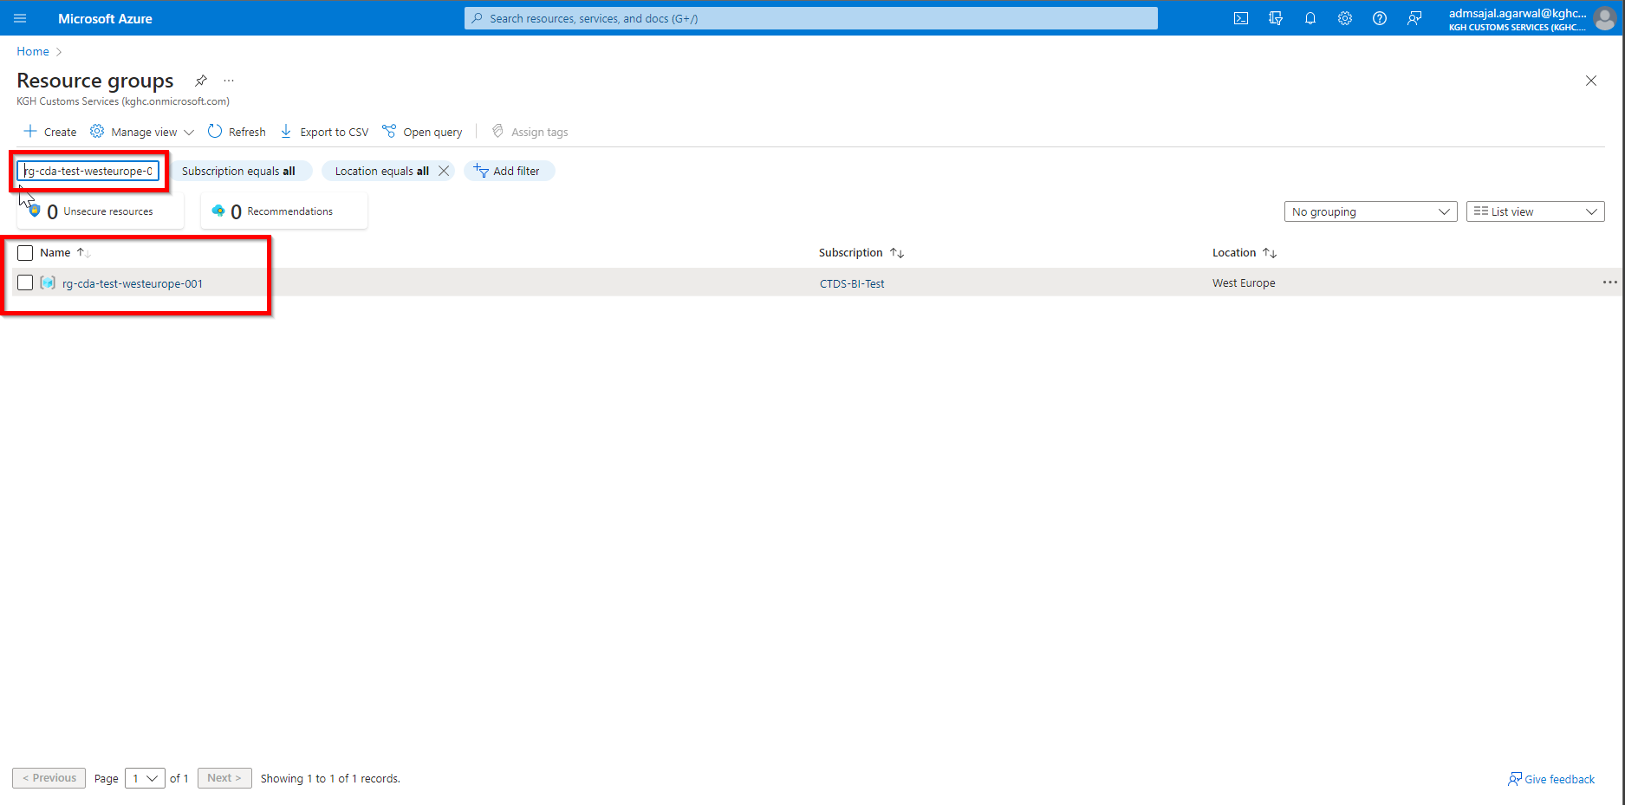

1. Click on *Create resources*

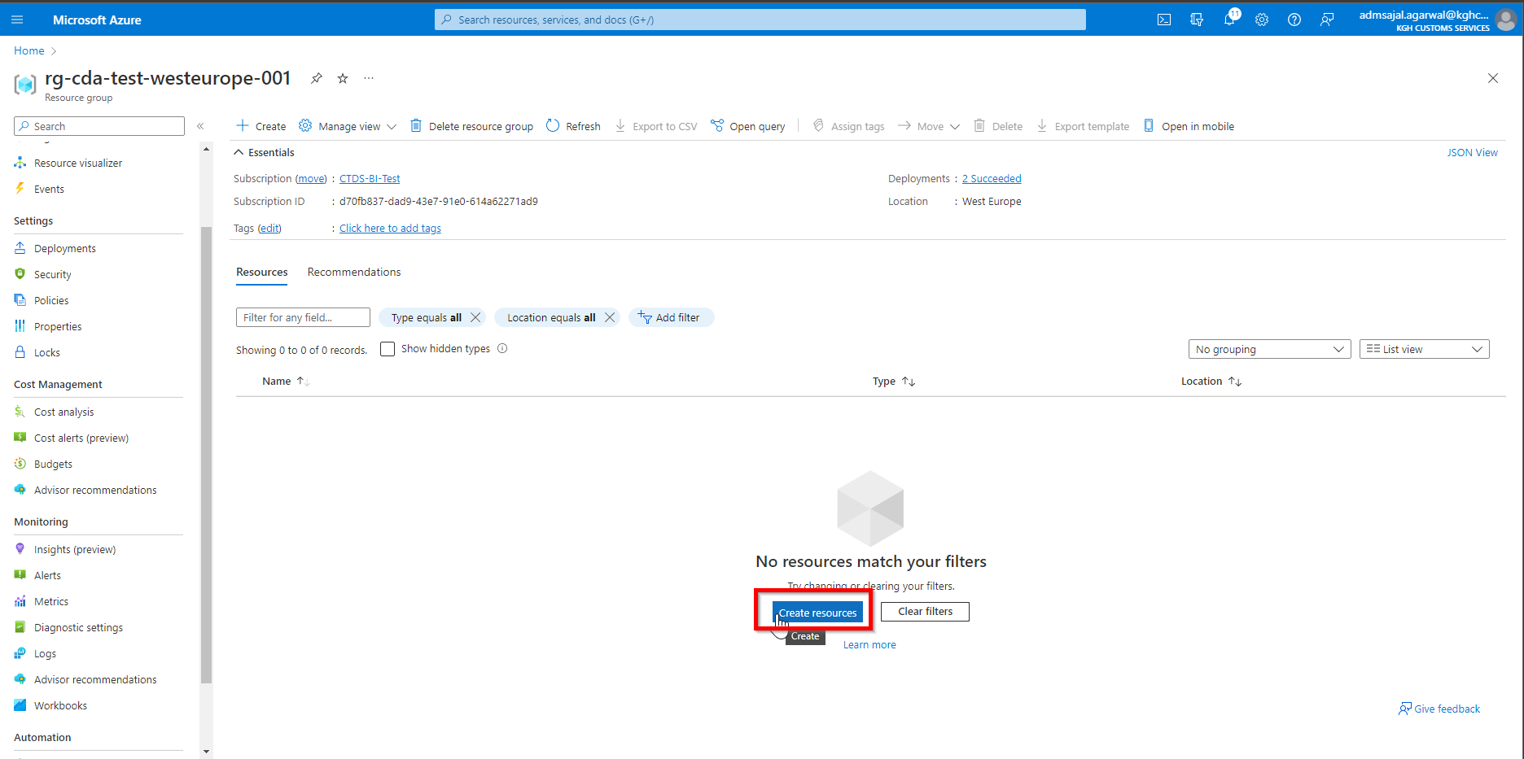

1. Below screen will appear:

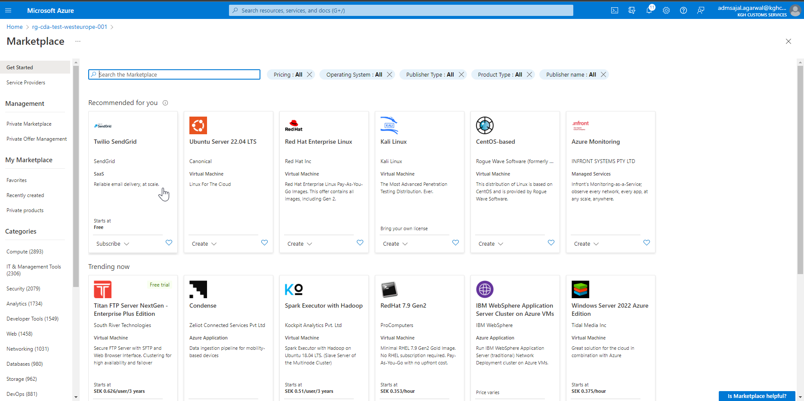

1. Search for *storage account*

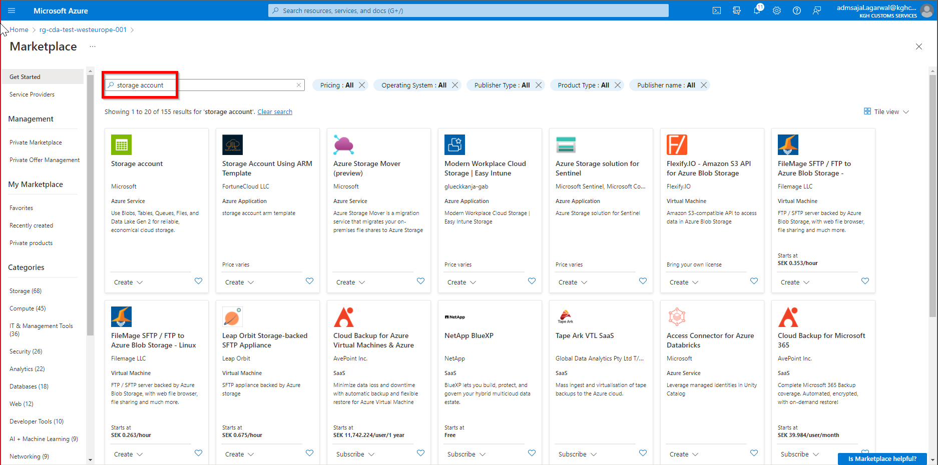

1. Click on *Create* 🡪 *Storage account* in *Storage account* tile

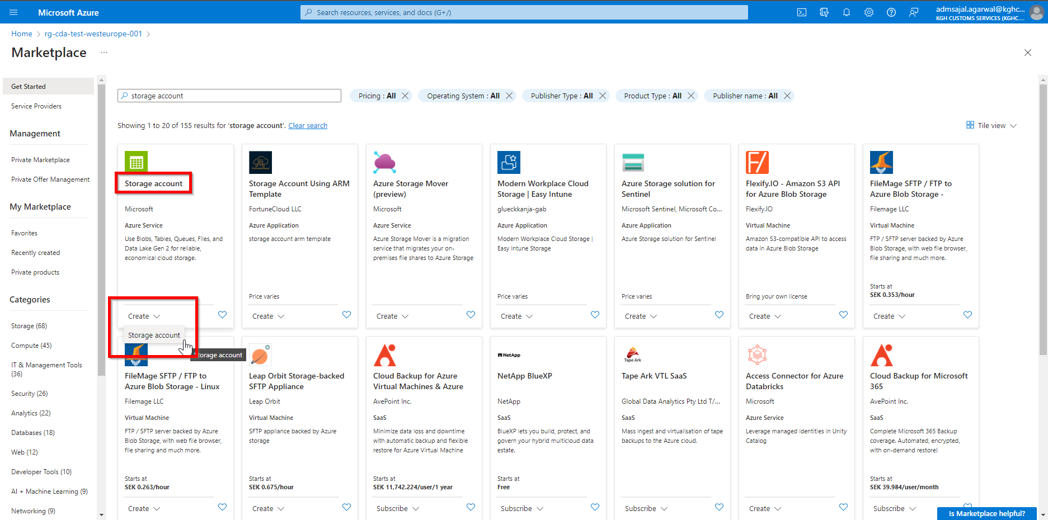

1. Fill the details as below:

Subscription: *CTDS-BI-Test*

Resource Group: *rg-cda-test-westeurope-001*

Storage account name: *stcdadatalakeraw001*

Region: *(Europe) West Europe*

Performance: *Standard*

Redundancy: *Locally-redundant storage (LRS)*

Click on *Next: Advanced*

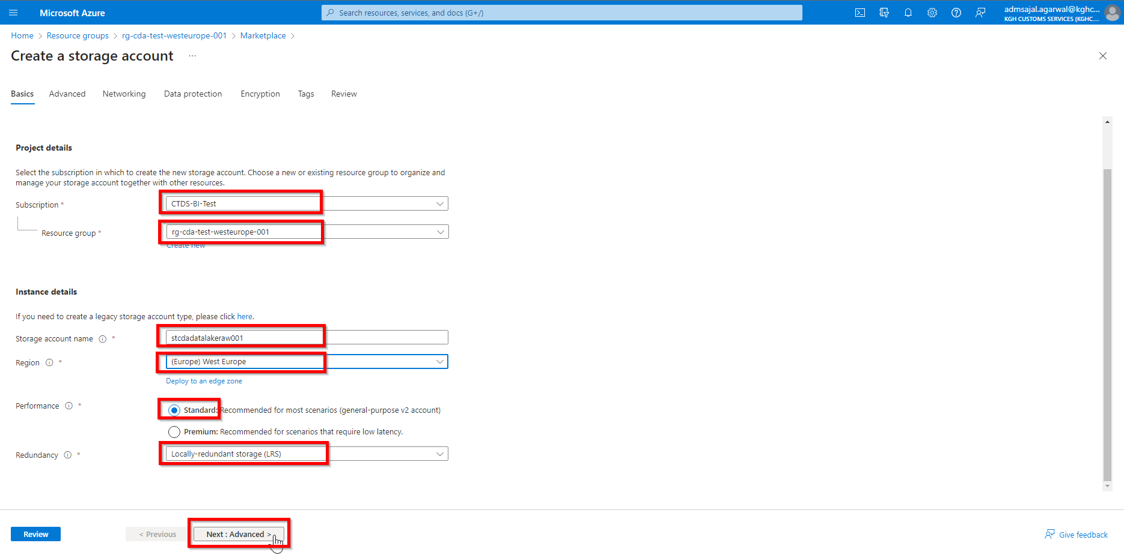

1. On the *Advanced* tab, tick mark the *Enable hierarchical namespace*

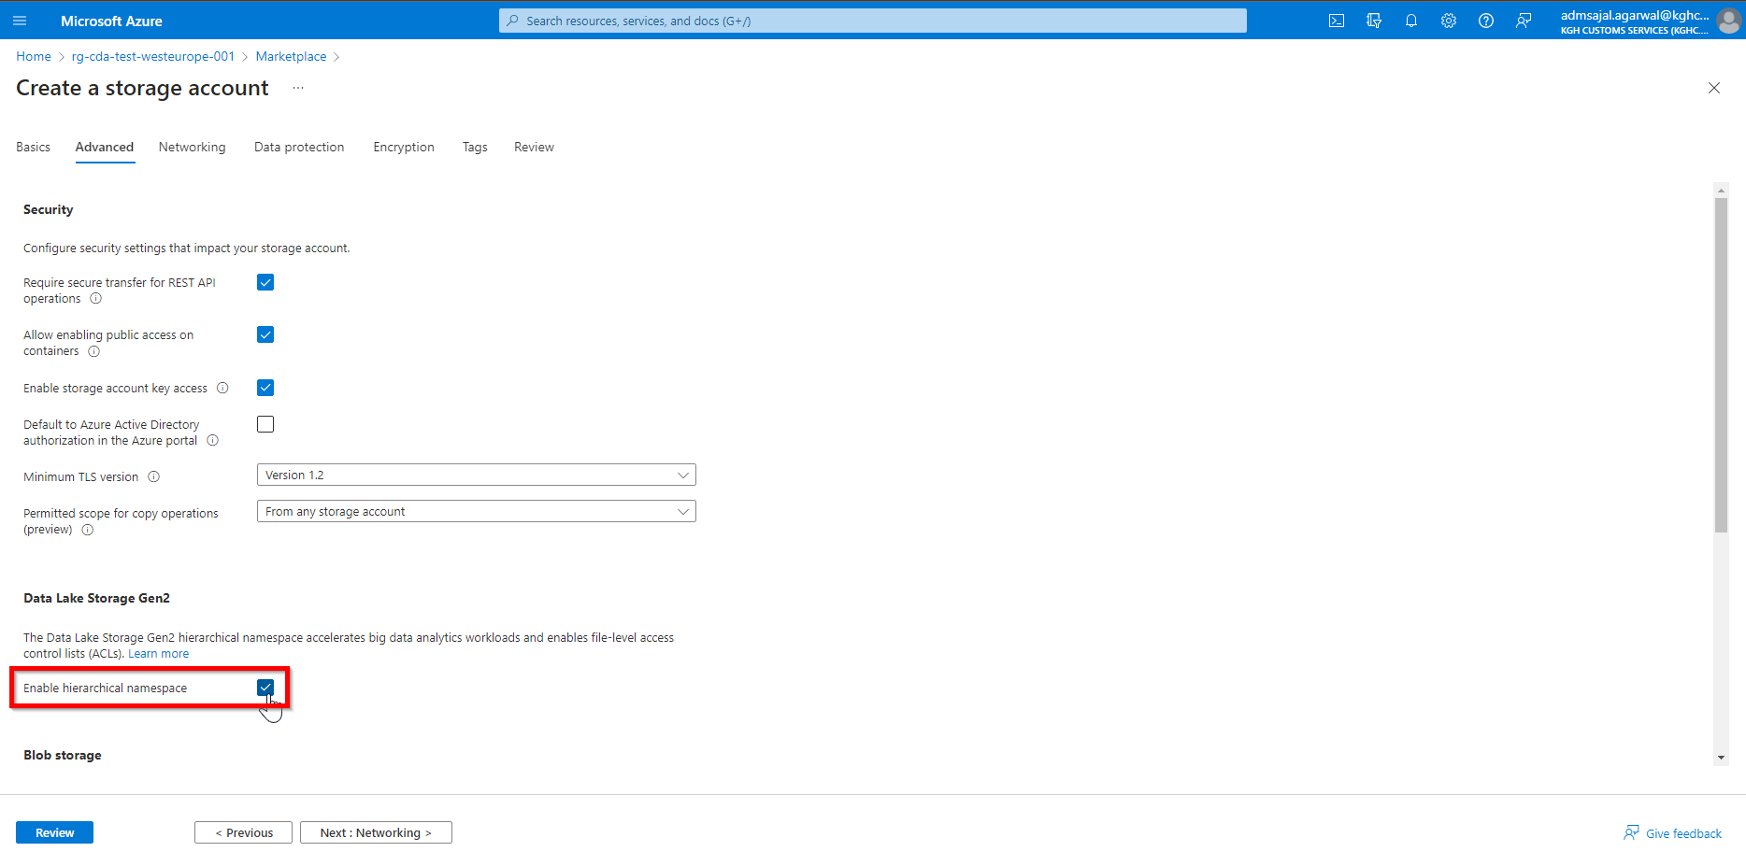

1. Keeping all other options as default, click on *Next : Networking*

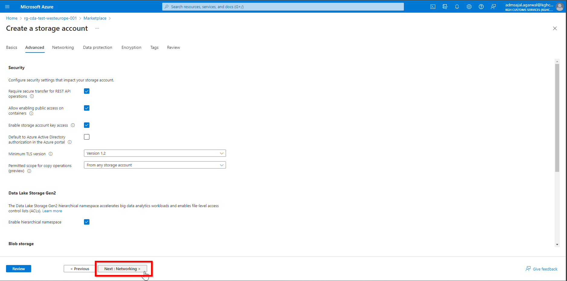

1. Keeping all options as default, click on *Next : Data Protection*

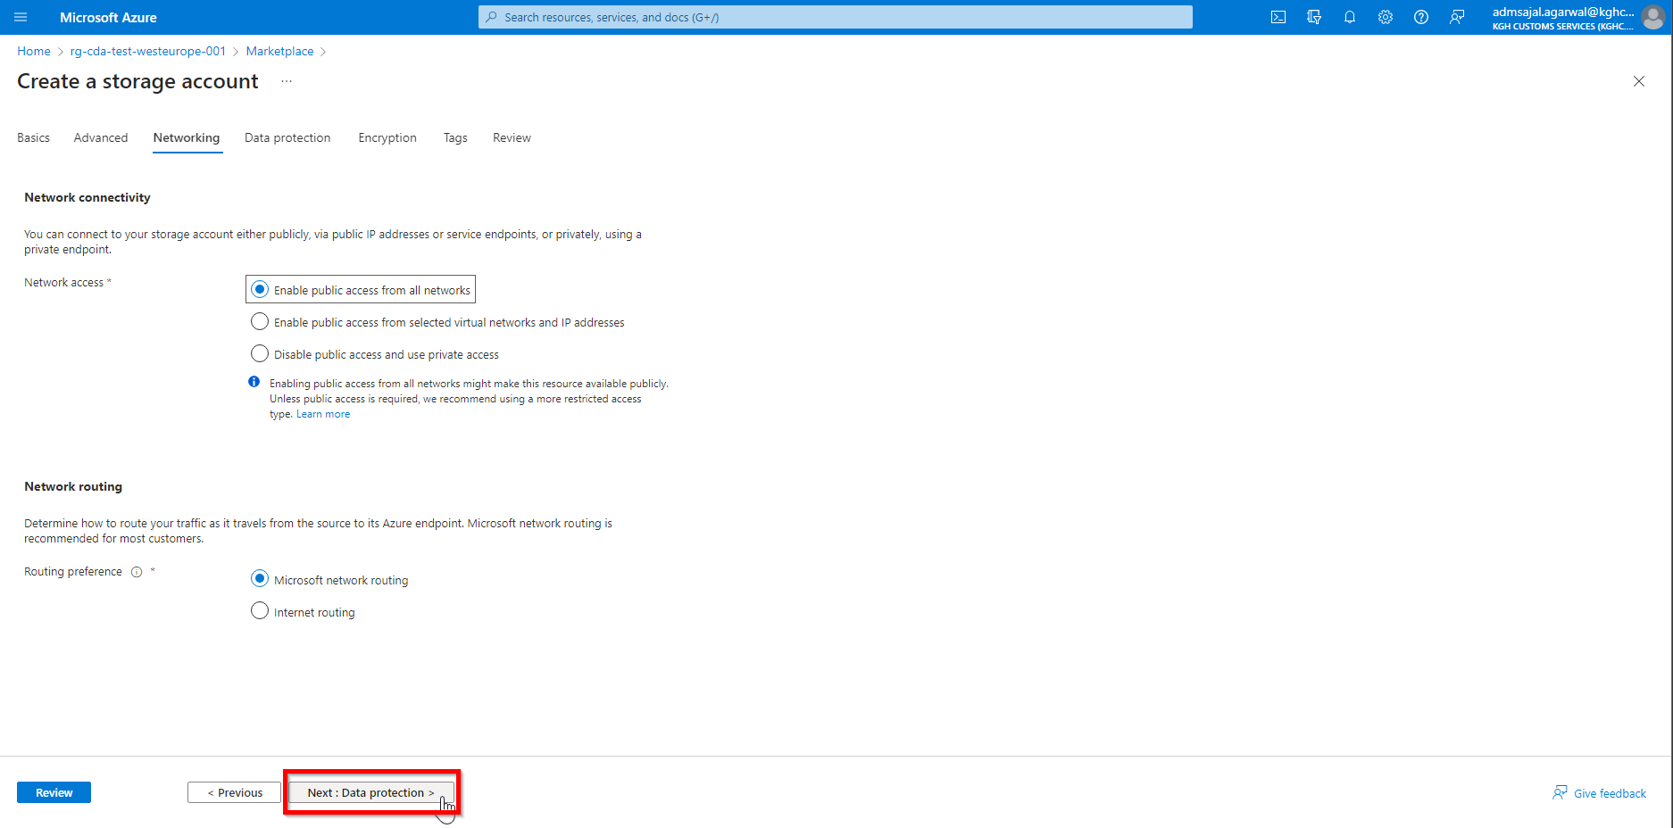

1. Keeping all options as default, click on *Next : Encryption*

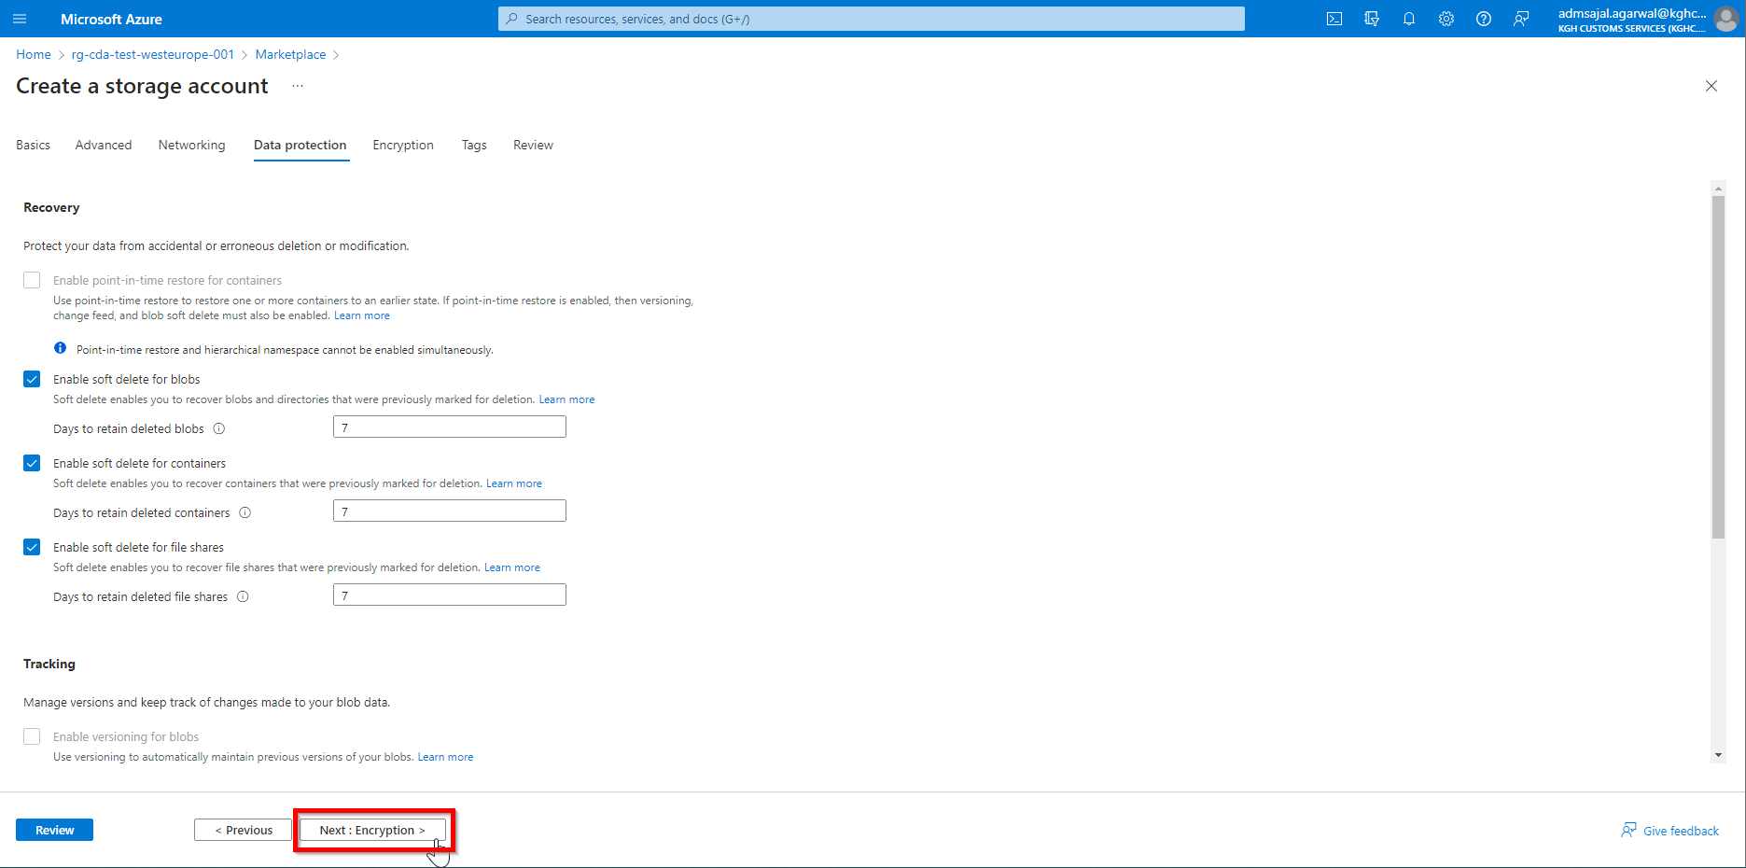

1. Keeping all options as default, click on *Next : Tags*

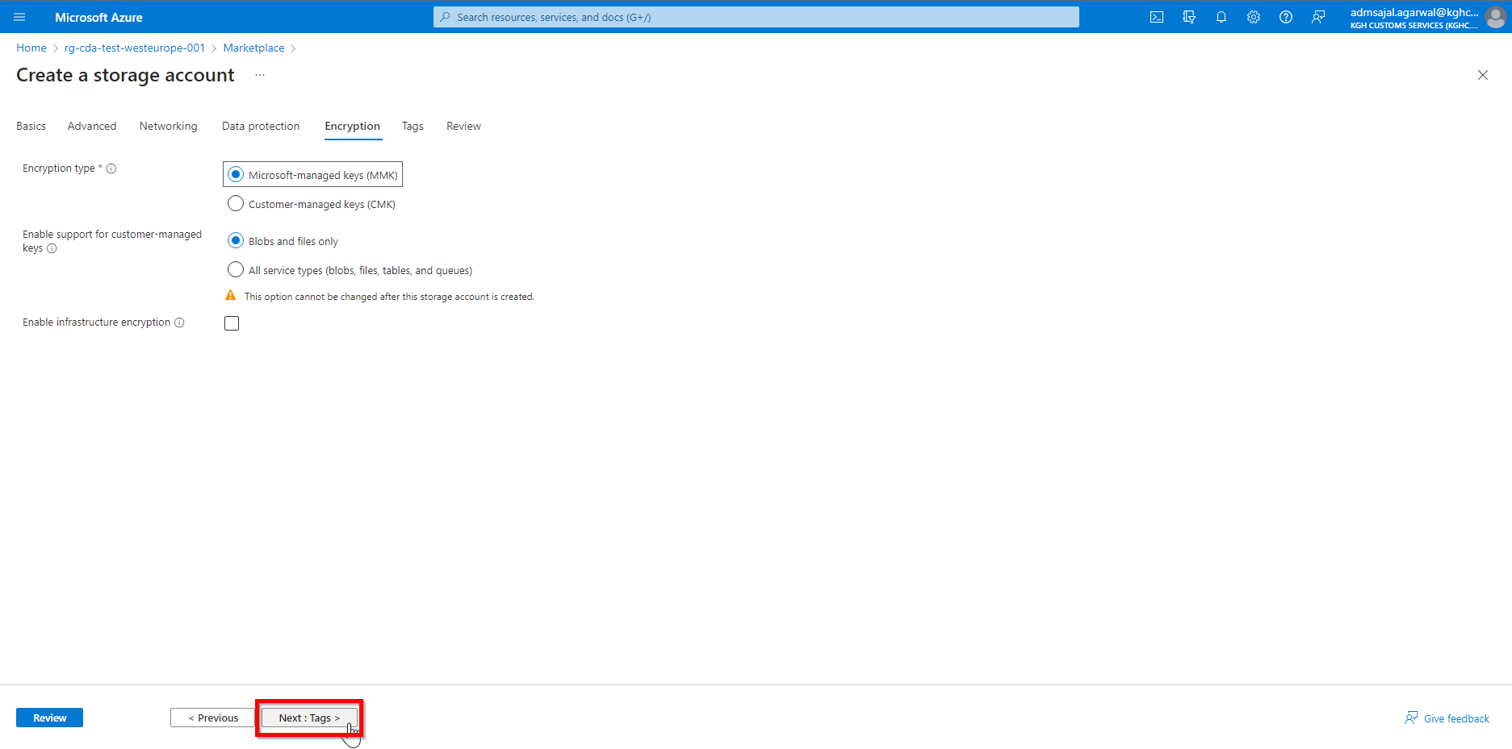

1. Add the tags as shown below:

application 🡪 *cda*

owner 🡪 *KGH BI Team*

environment 🡪 *test*

Click on *Review*

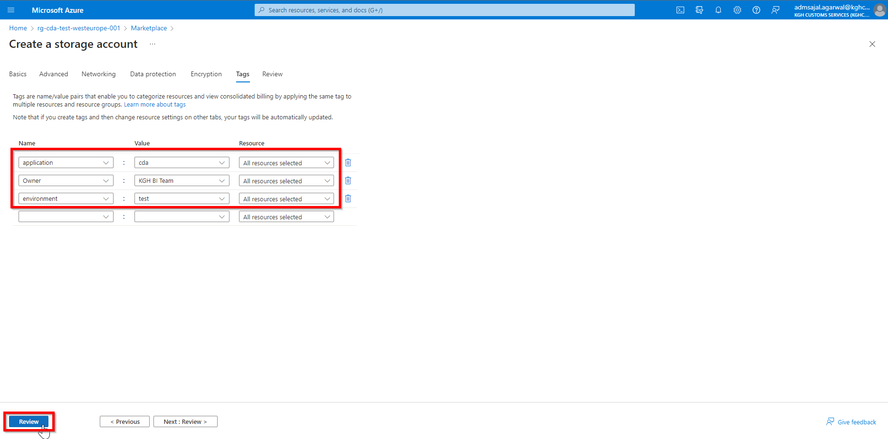

1. Wait for the *Validation* to complete and *Create* button to be enabled

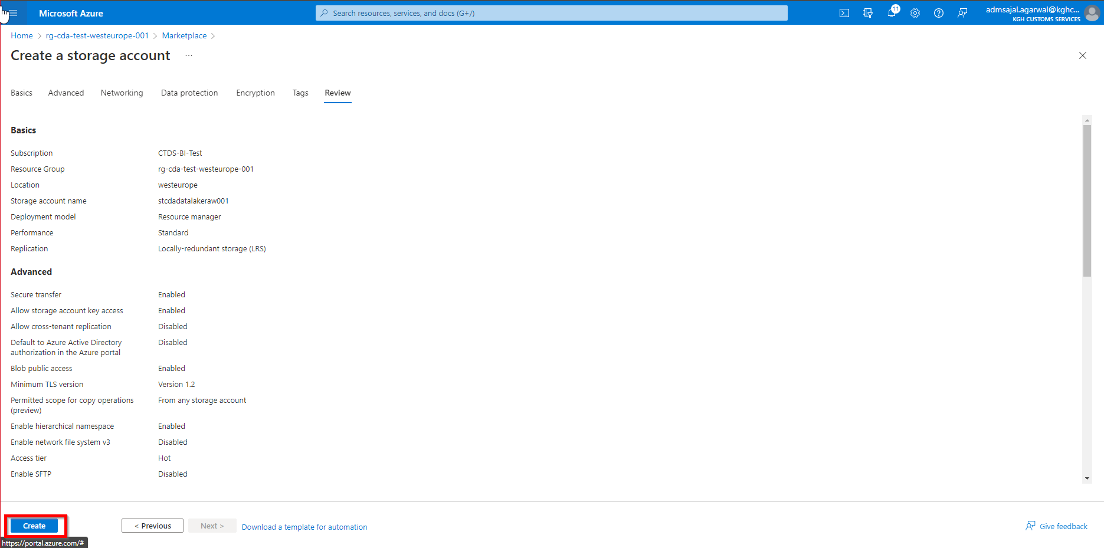

1. Click on *Create*. It will initialize the deployment of the resource.

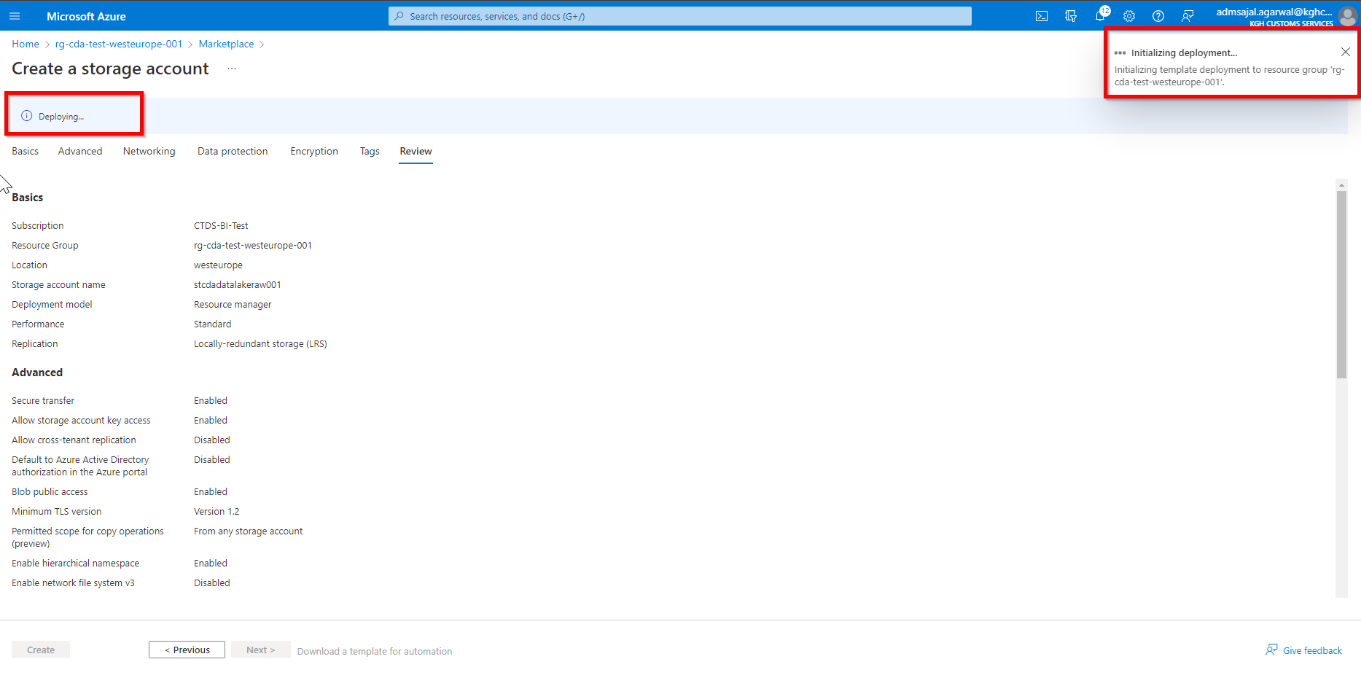

1. It will auto-redirect to deployment screen

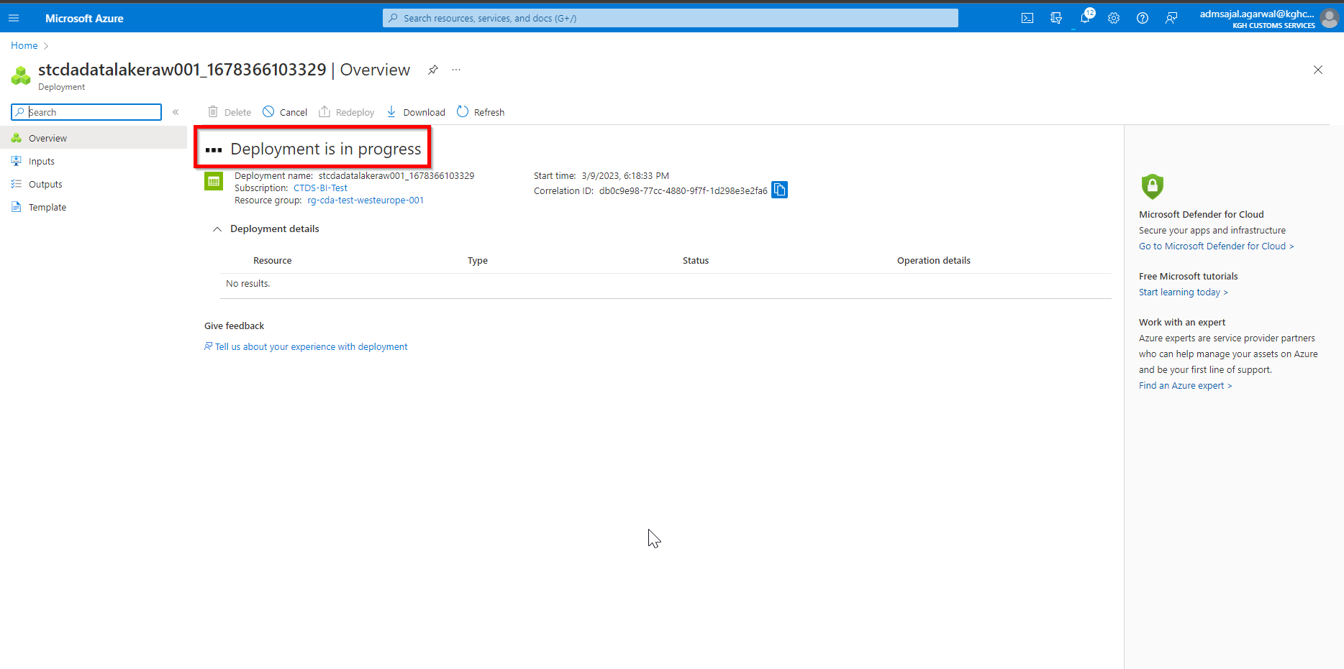

1. When the message changes to *Your deployment is complete*, click on *Go to resource*

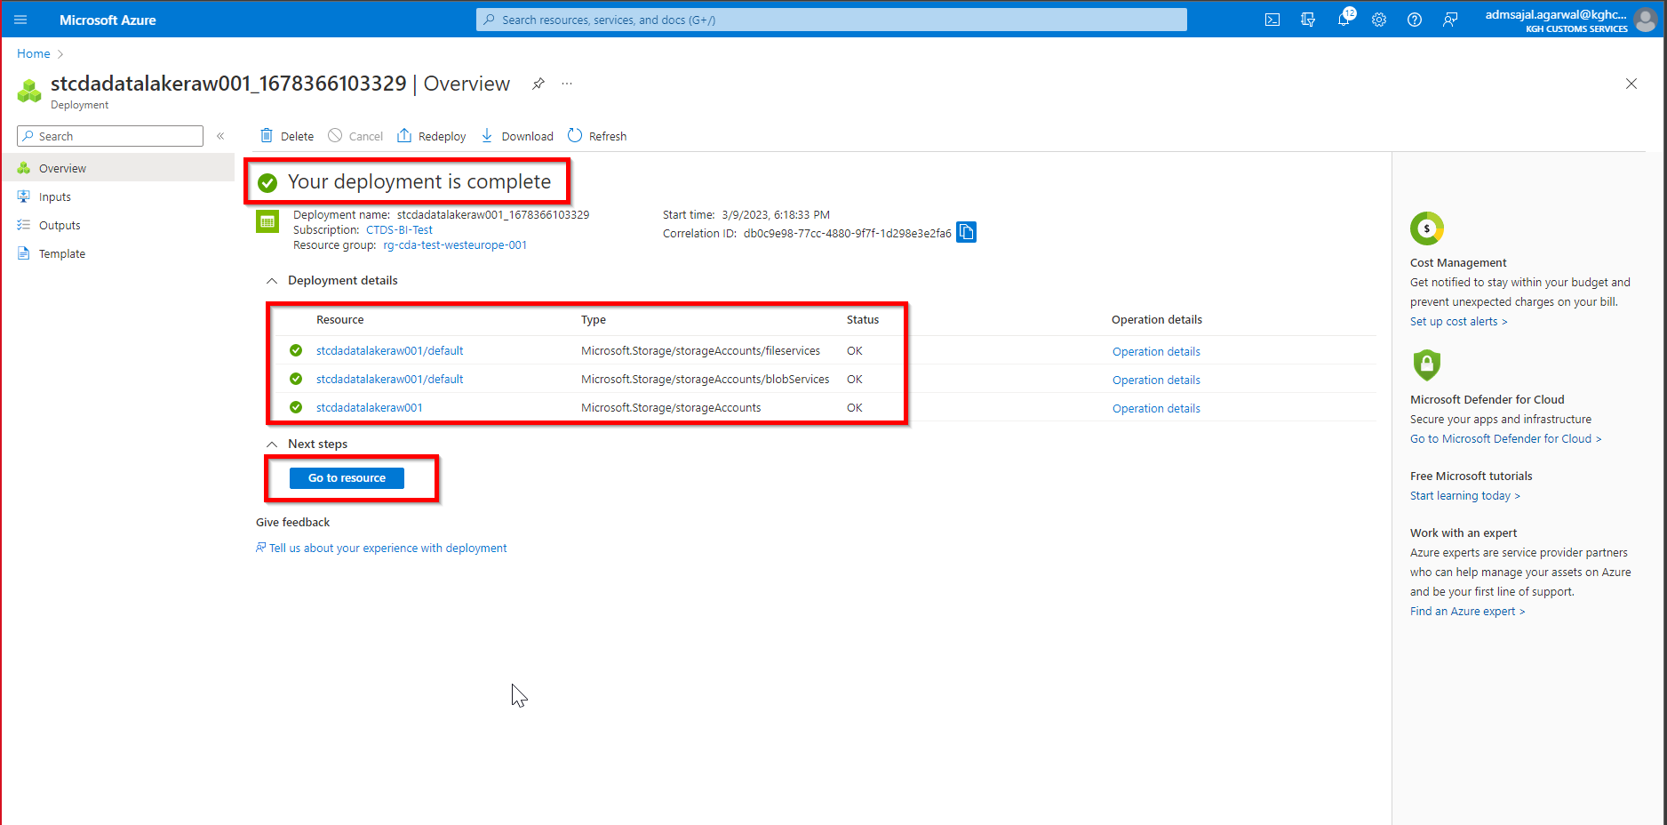

1. It will take to *Overview* page of created resource.

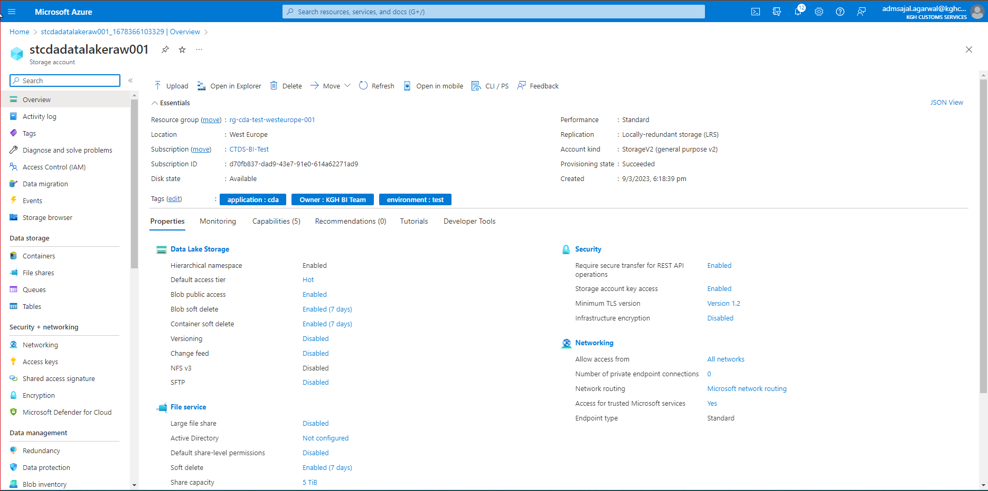

## **Storage Creation: Containers**

1. Click on *Containers* from resource *Overview* page

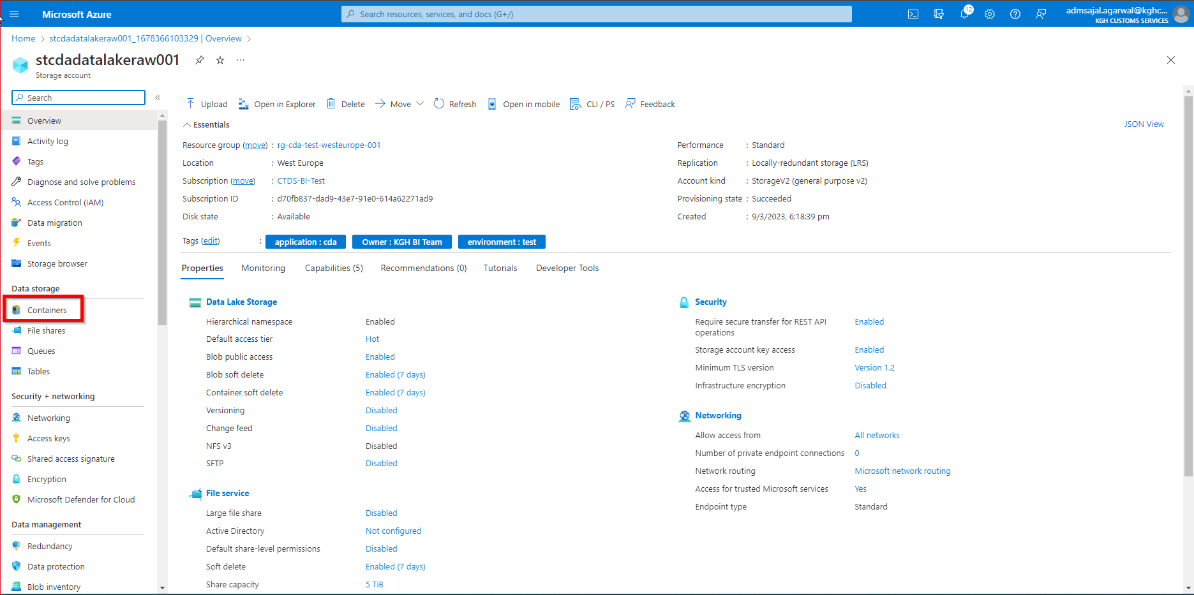

1. Click on *Container*

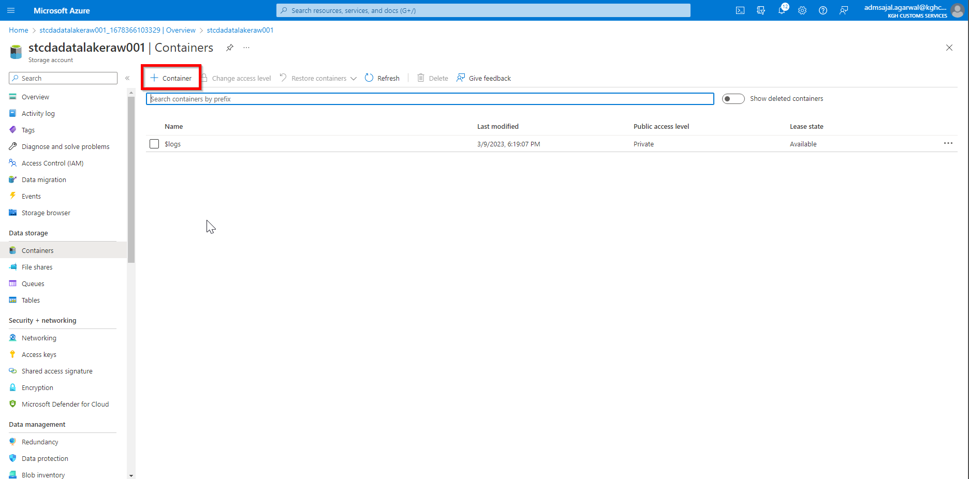

1. Enter the details as shown below:

Name 🡪 *cda*

Click on *Create*

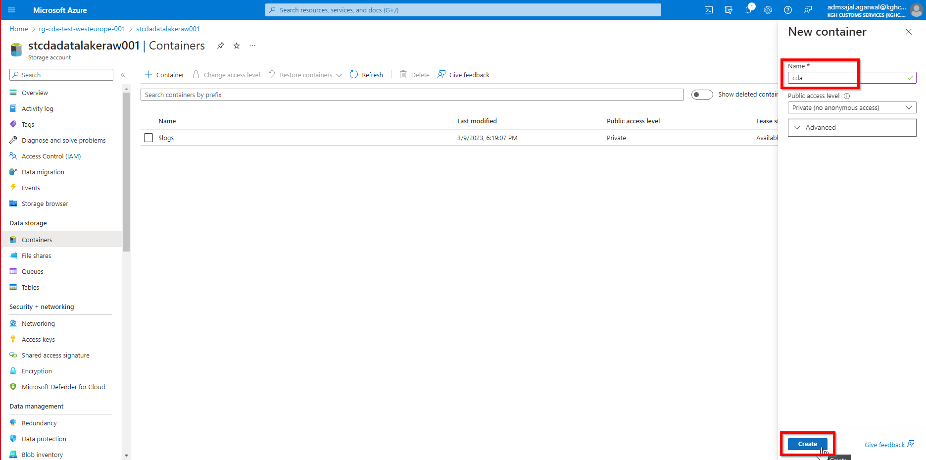

1. It will start creating the container

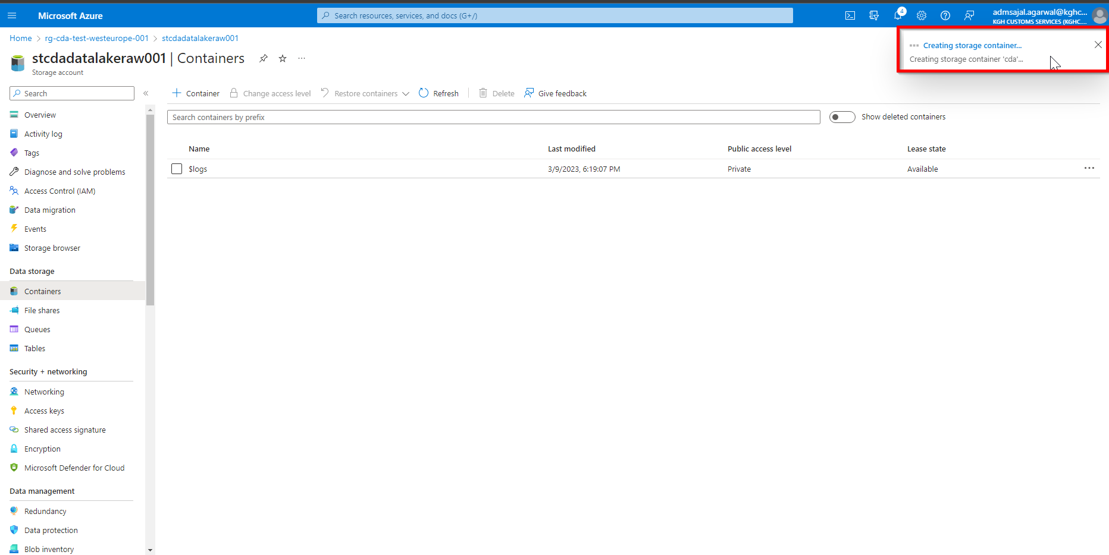

1. When the message changes to *Successfully created storage container*, container named *cda* will appear in the list

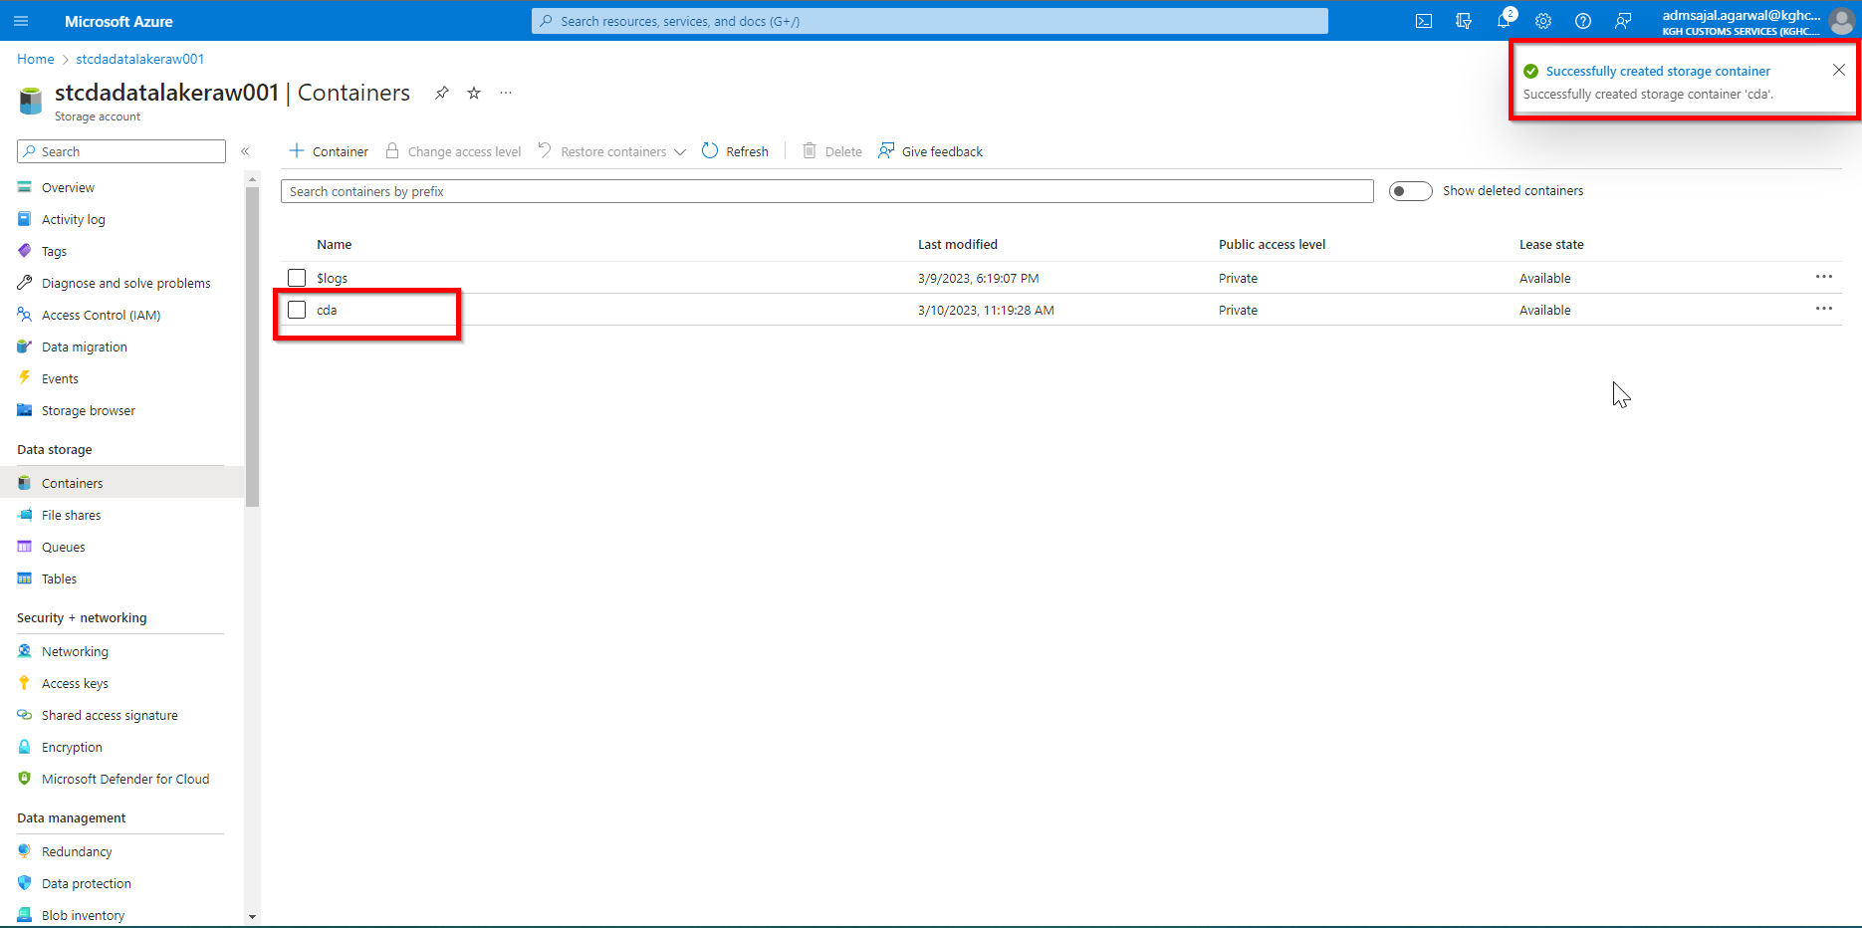

1. Click on Container *cda*

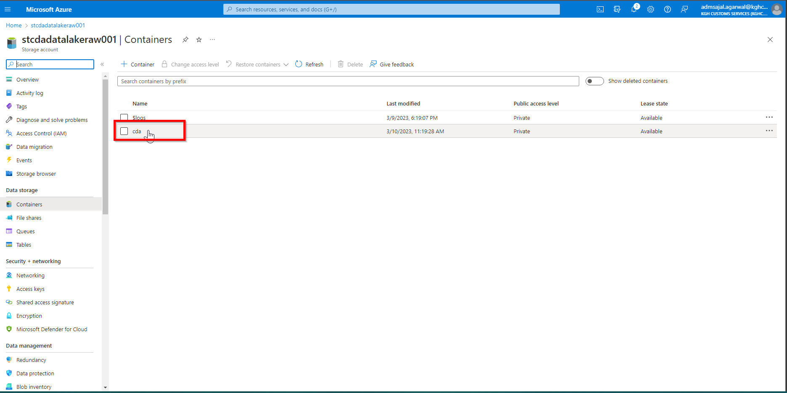

1. Click on *Add Directory*

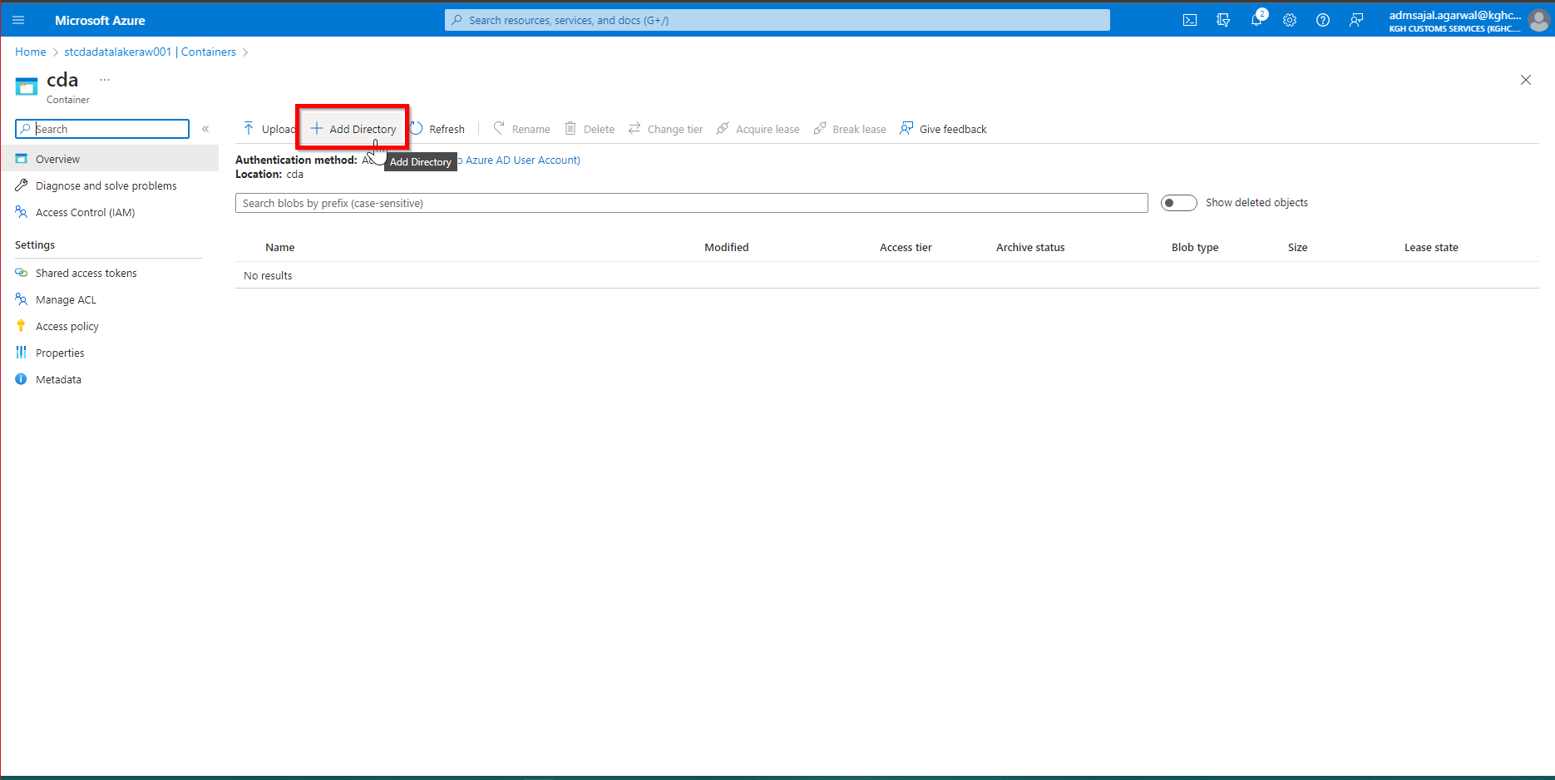

1. Enter the details as shown below:

Name 🡪 *initial*

Click on *Save*

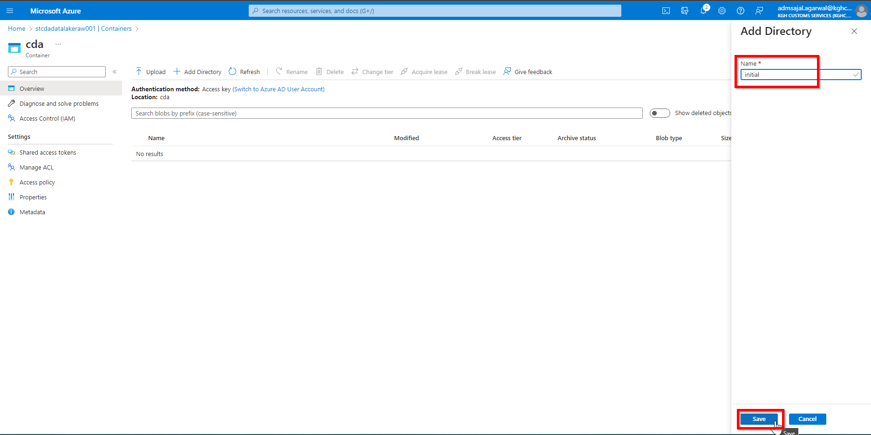

1. Repeat step 23 and 24 to add more directories as below:

Name 🡪 *data*

Name 🡪 *test*

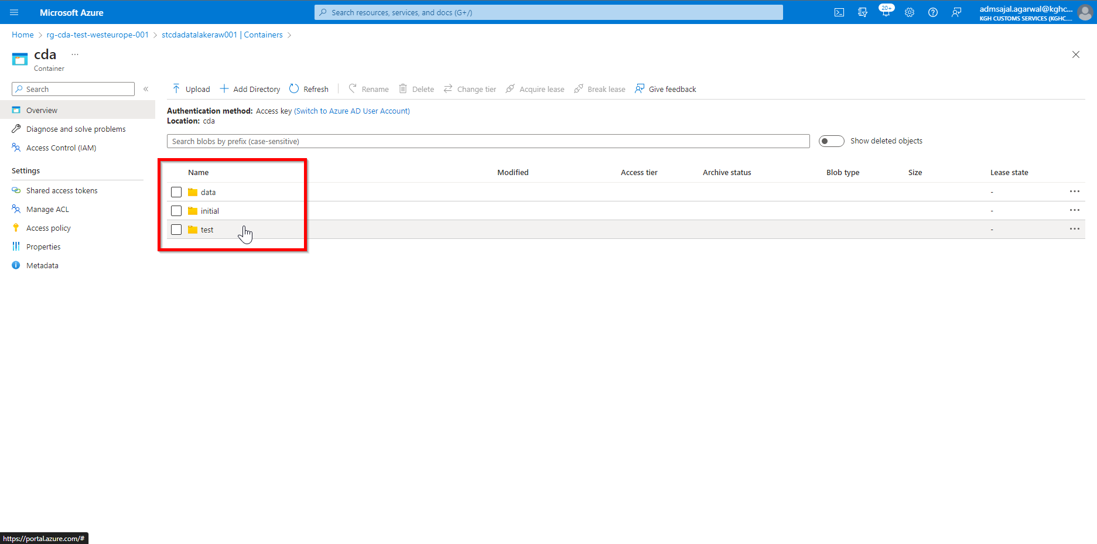

1. Repeat steps 1 to 9 to create other Storage accounts

# **Resource Creation: Data Factory**

1. Open *Resource Groups* and search for *rg-cda-test-westeurope-001*



1. Click on *Create*

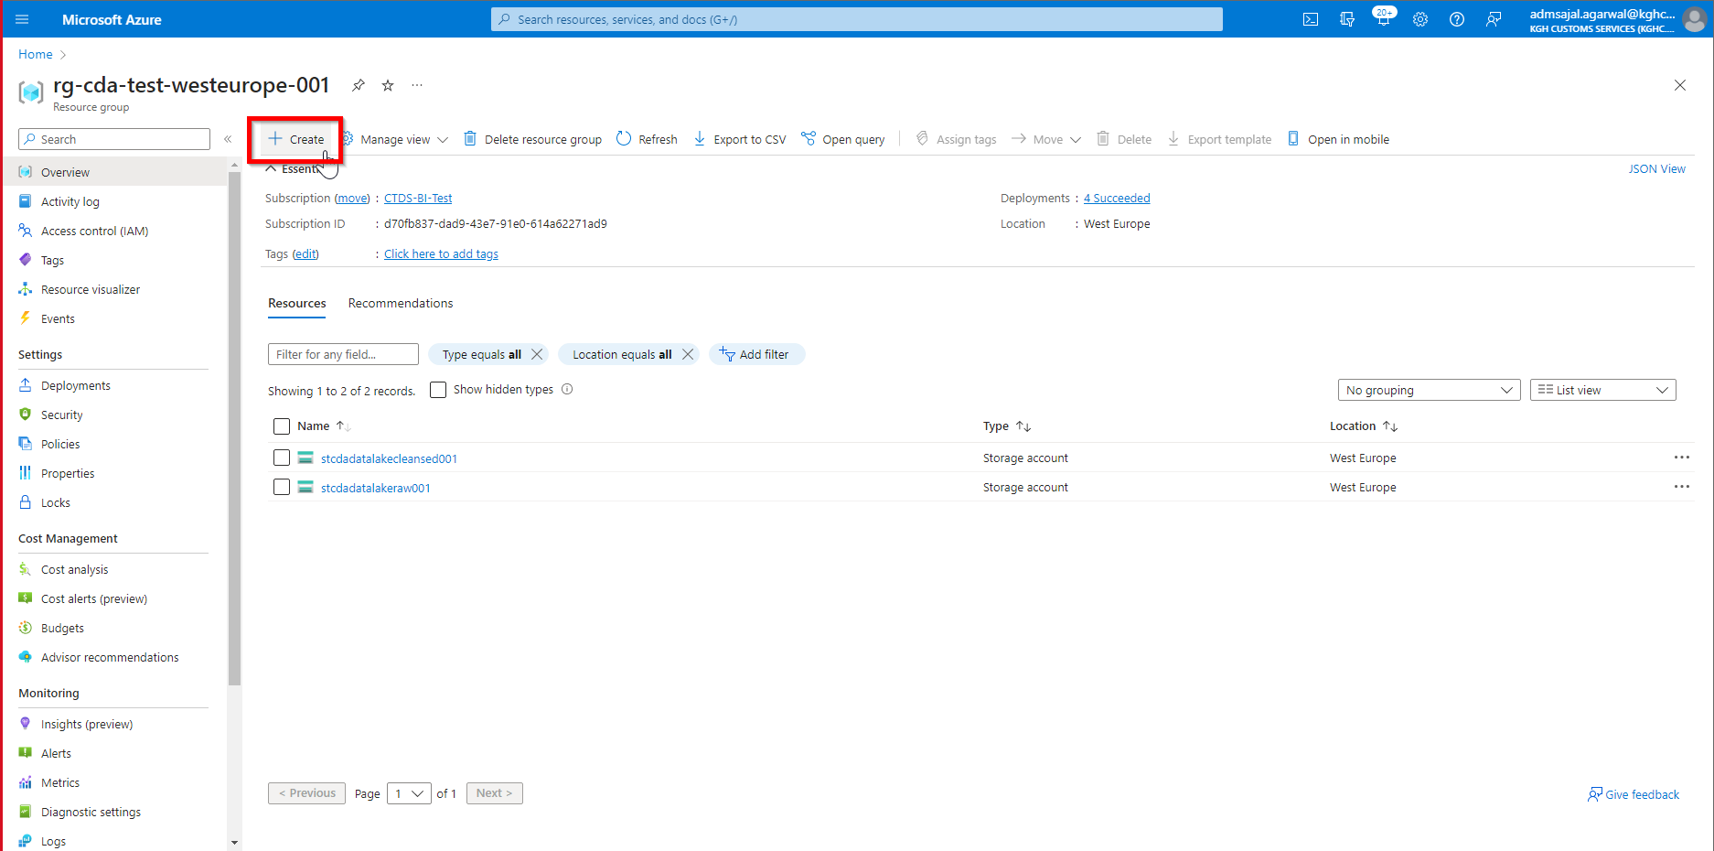

1. Below screen will appear:



1. Search for *data factory*

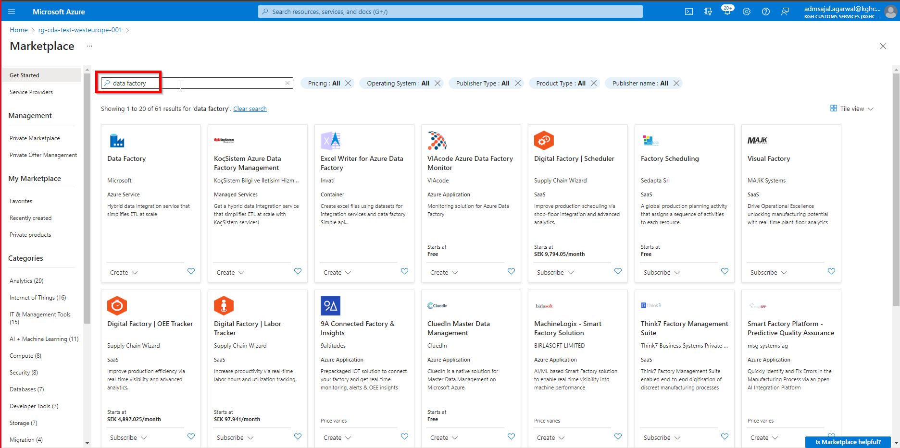

1. Click on *Create* 🡪 *Data Factory* in *Data Factory* tile

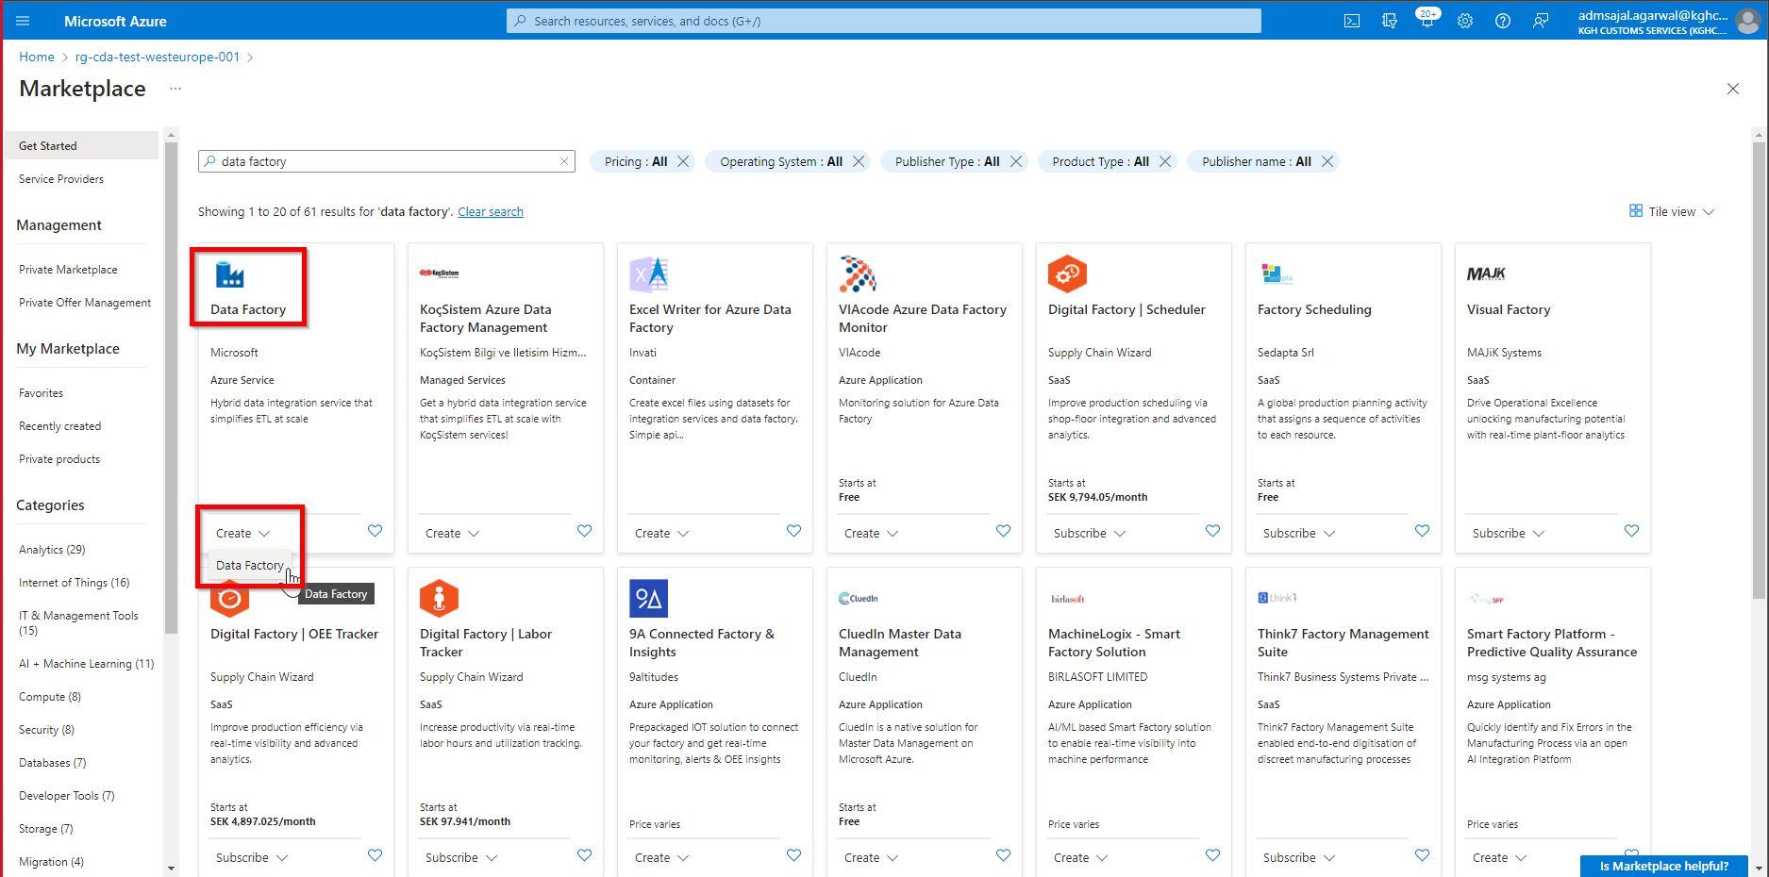

1. Fill the details as below:

Subscription: *CTDS-BI-Test*

Resource Group: *rg-cda-test-westeurope-001*

Name: *adfcdapipeline001*

Region: *West Europe*

Version: *V2*

Click on *Next: Git configuration*

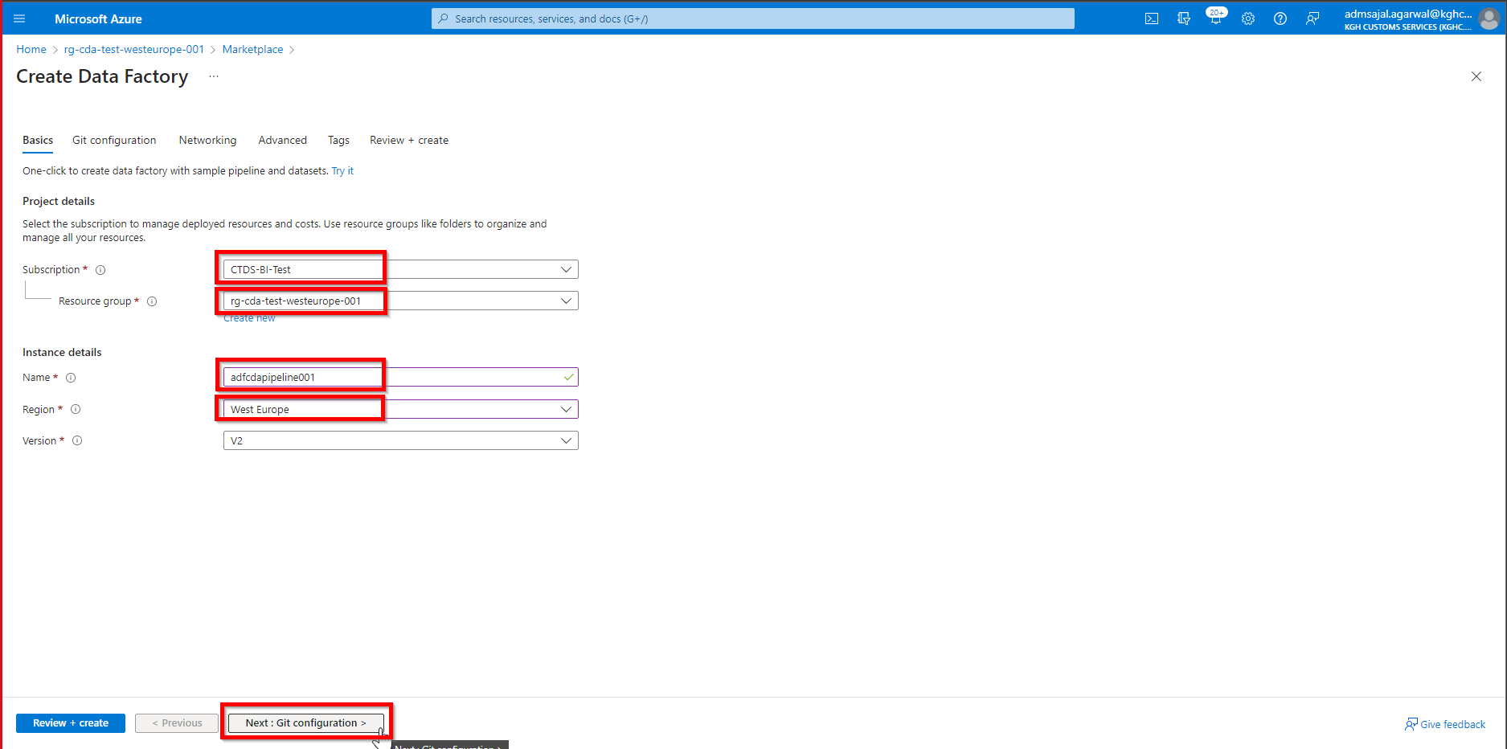

1. Keeping all options as default, click on *Next : Networking*

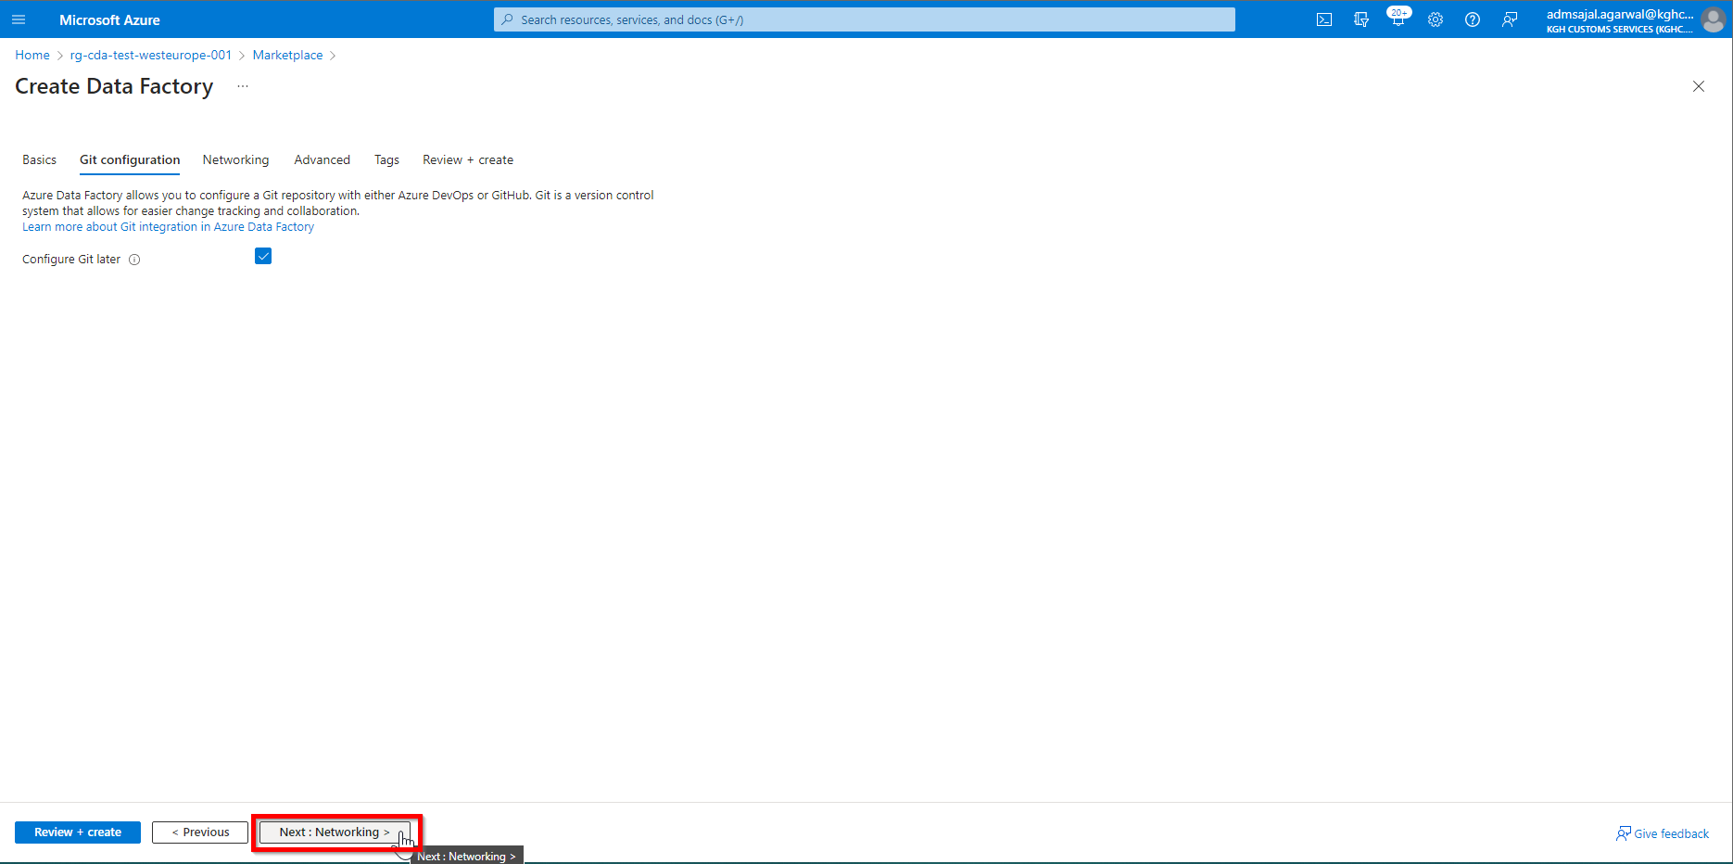

1. Keeping all options as default, click on *Next : Advanced*

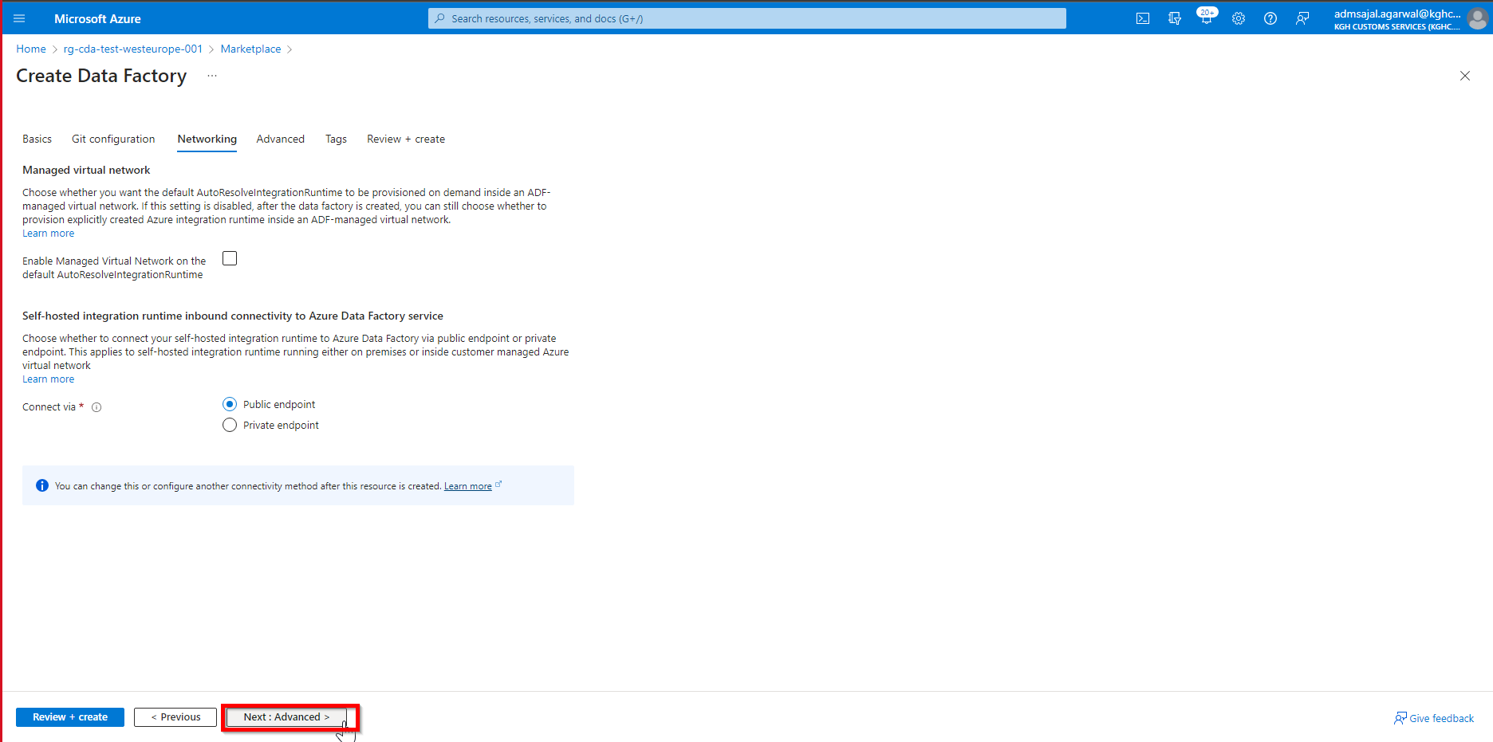

1. Keeping all options as default, click on *Next : Tags*

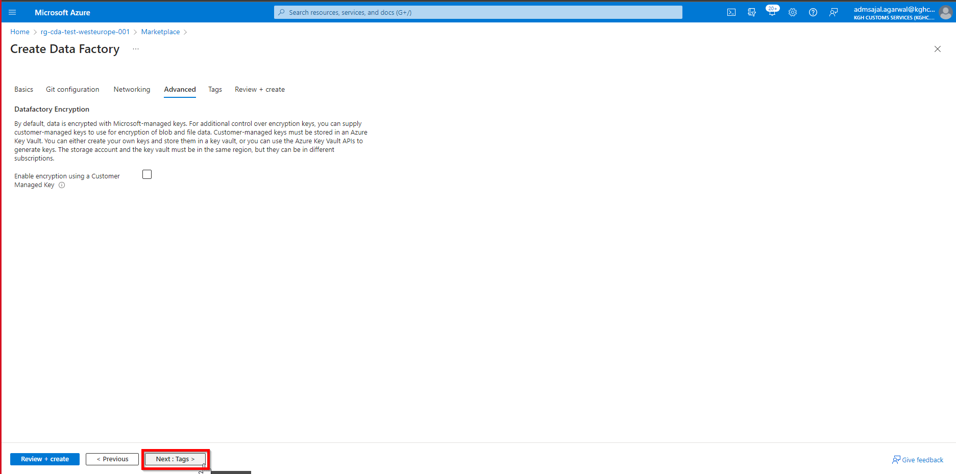

1. Add the tags as shown below:

application 🡪 *cda*

owner 🡪 *KGH BI Team*

environment 🡪 *test*

Click on *Next : Review + create*

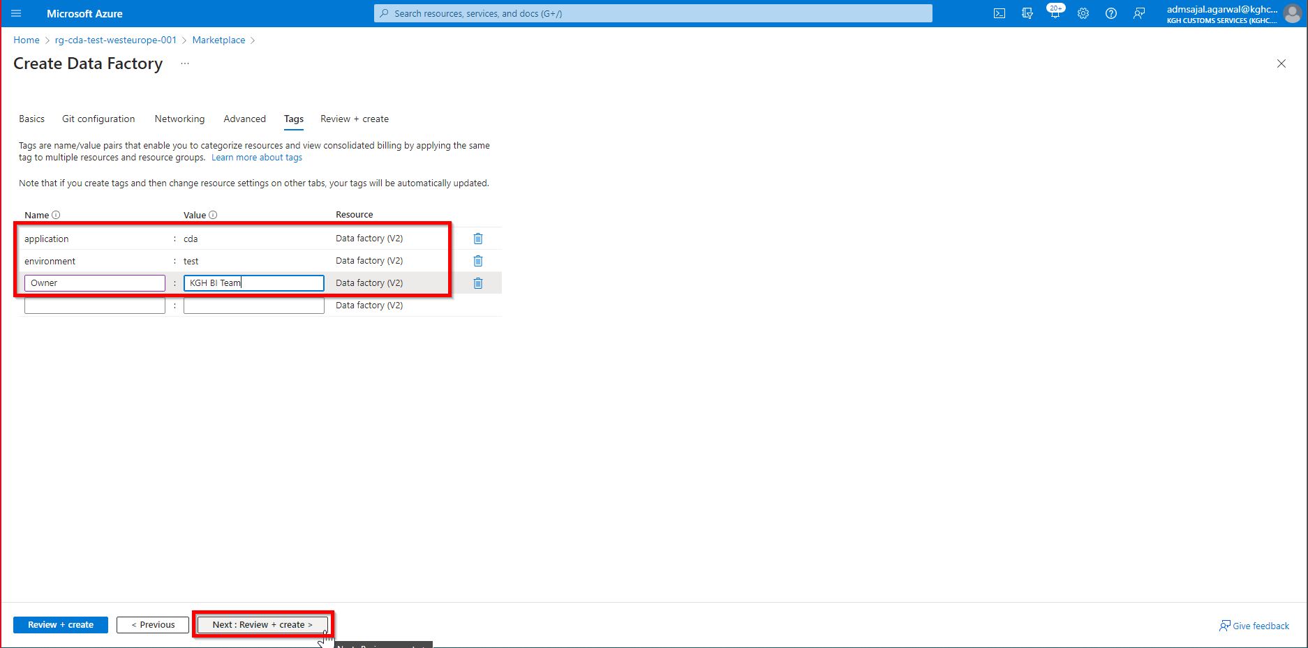

1. Wait for the *Validation* to complete and *Create* button to be enabled

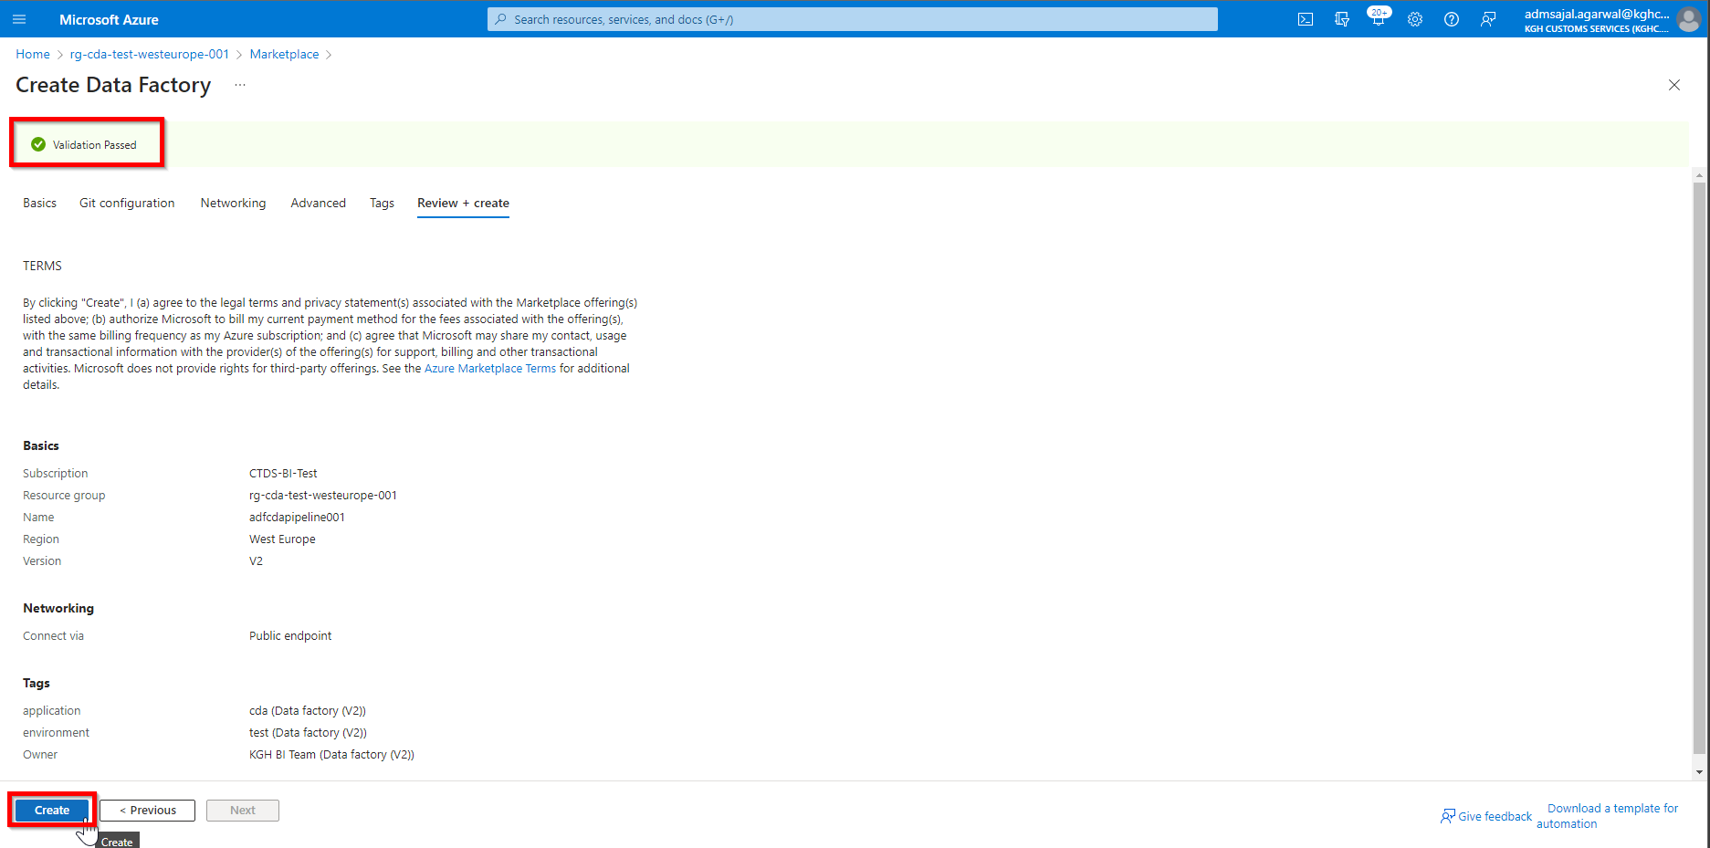

1. Click on *Create*. It will initialize the deployment of resource.

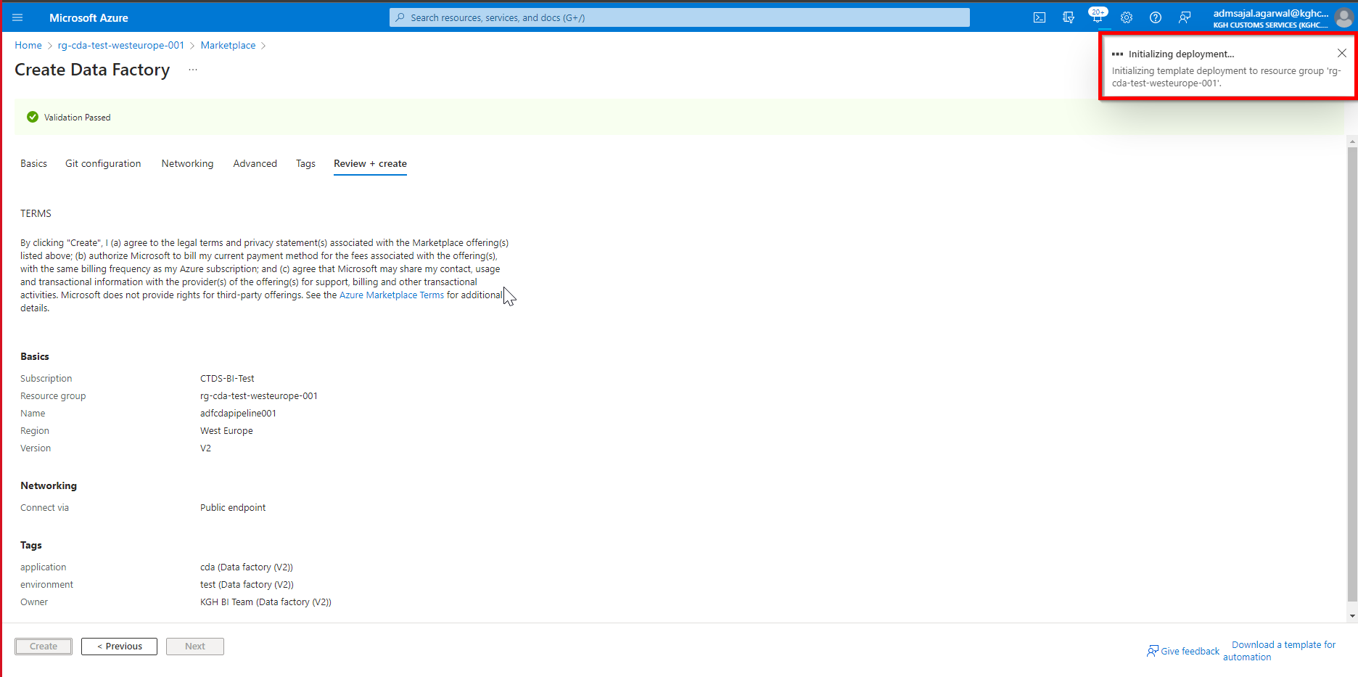

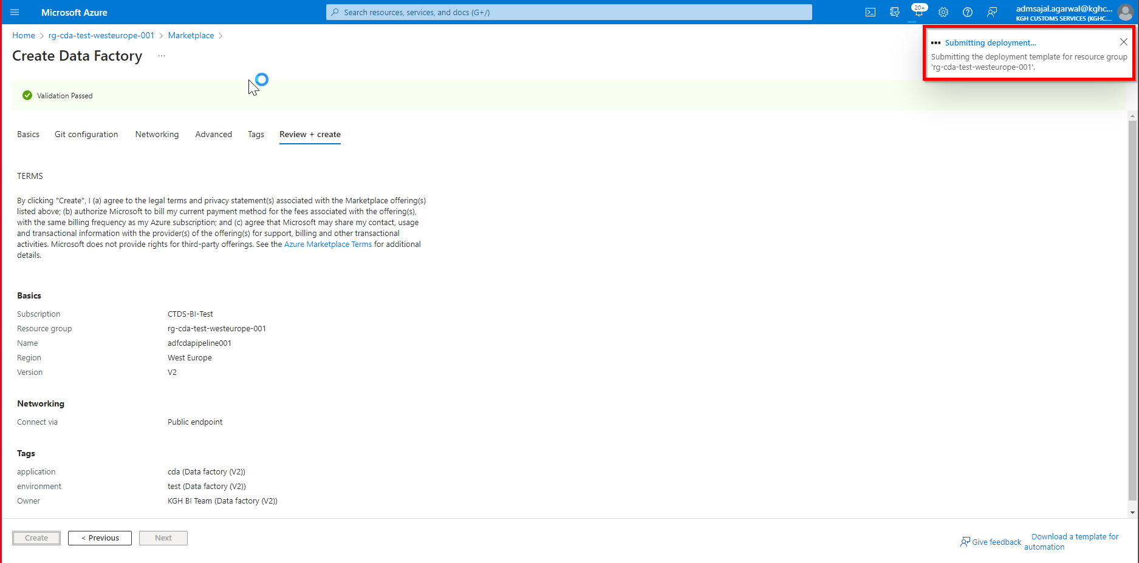

1. It will auto-redirect to deployment screen

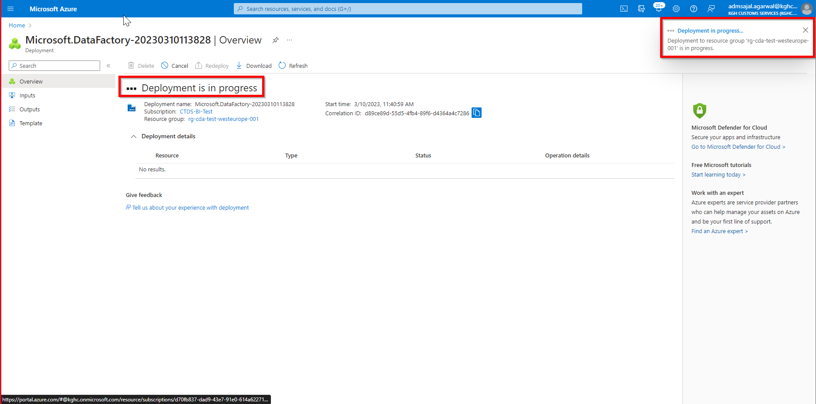

1. When the message changes to *Your deployment is complete*, click on *Go to resource*

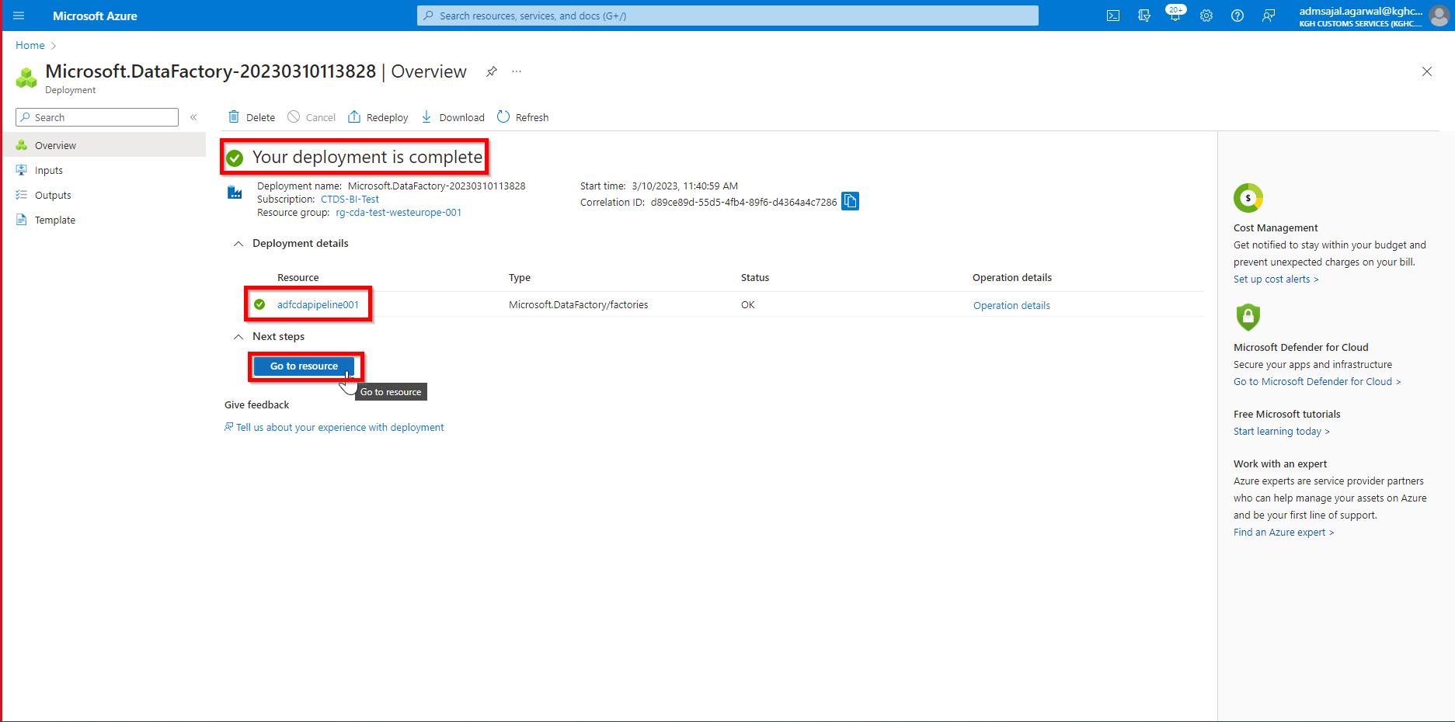

1. Click on *Launch studio* from resource *Overview* page

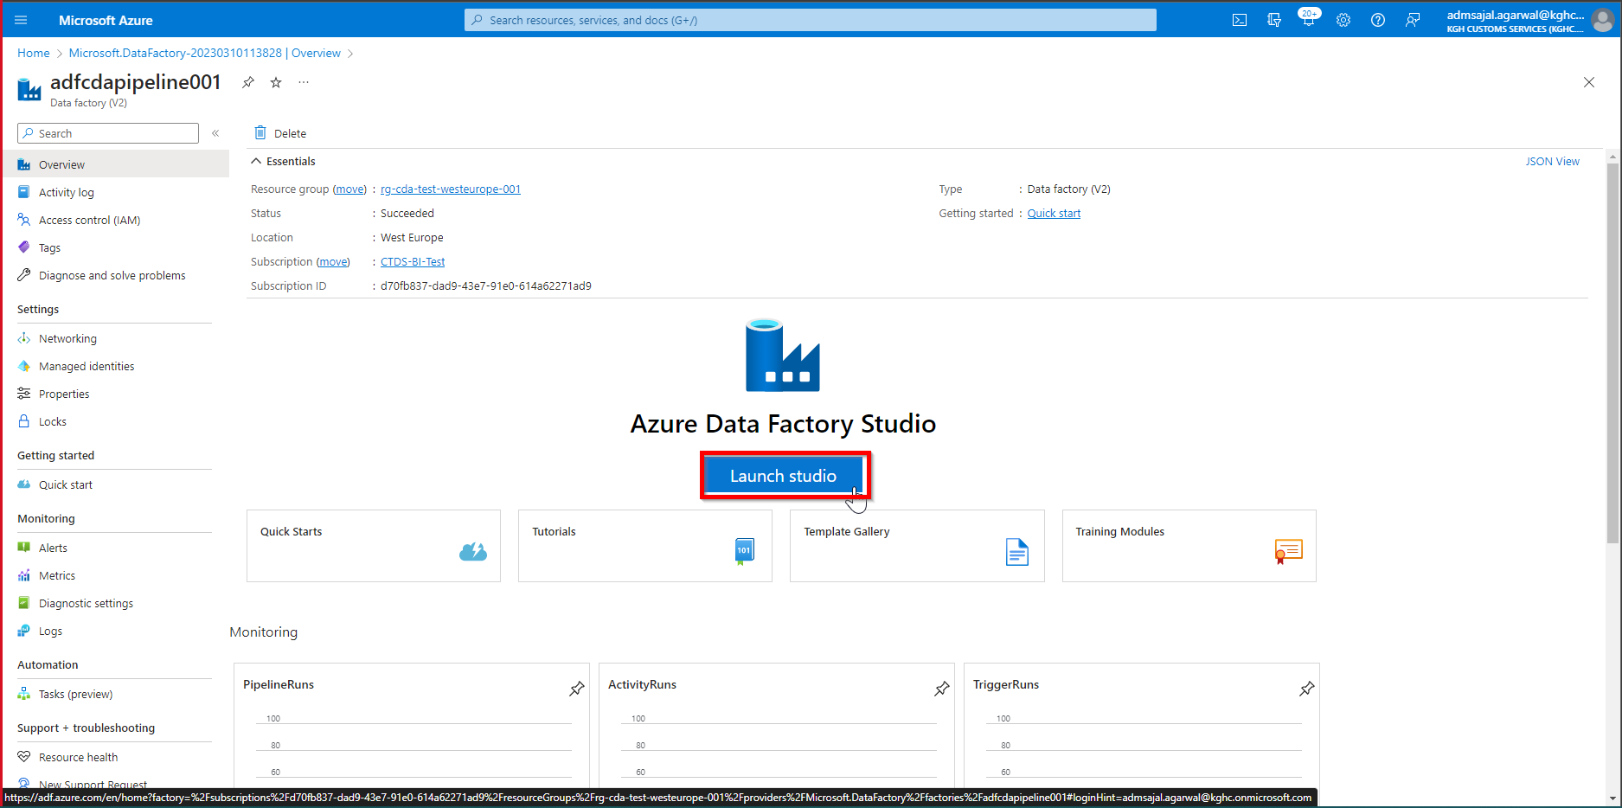

1. Data Factory studio is launched

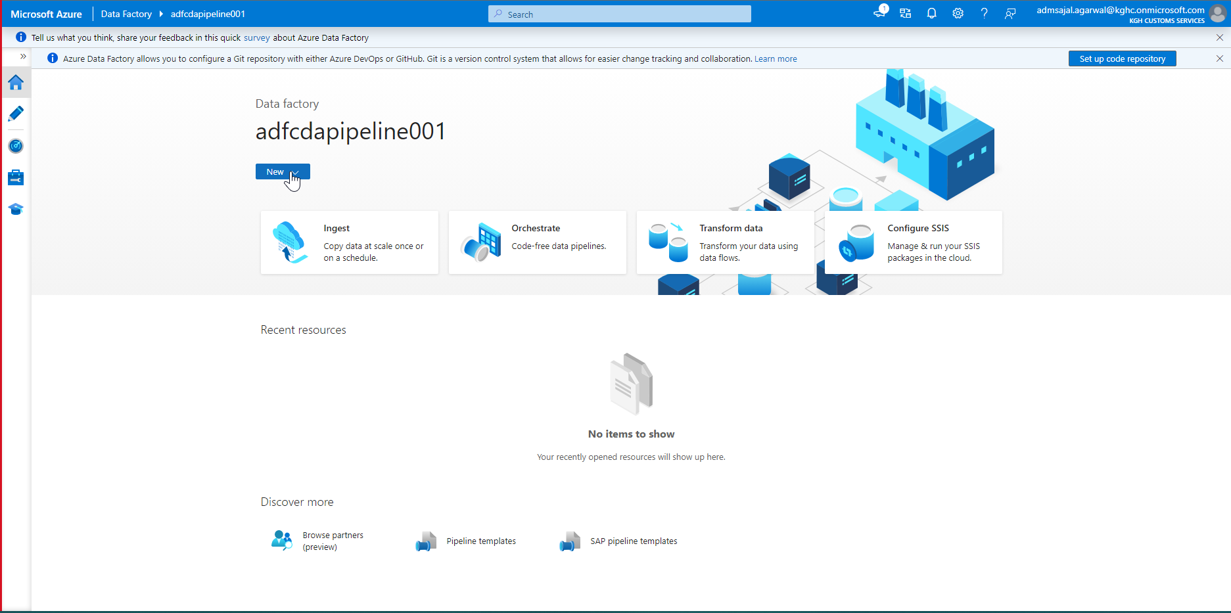

## **Configuration: Managed VNet**

[Access on-premises SQL Server from Data Factory Managed VNet using Private Endpoint - Azure Data Factory | Microsoft Learn](https://learn.microsoft.com/en-us/azure/data-factory/tutorial-managed-virtual-network-on-premise-sql-server)

### **Resource Creation: Virtual Network**

[Quickstart: Use the Azure portal to create a virtual network - Azure Virtual Network | Microsoft Learn](https://learn.microsoft.com/en-us/azure/virtual-network/quick-create-portal#create-a-virtual-network)

1. Open *Resource Groups* and search for *rg-cda-test-westeurope-001*
2. Click on *Create*

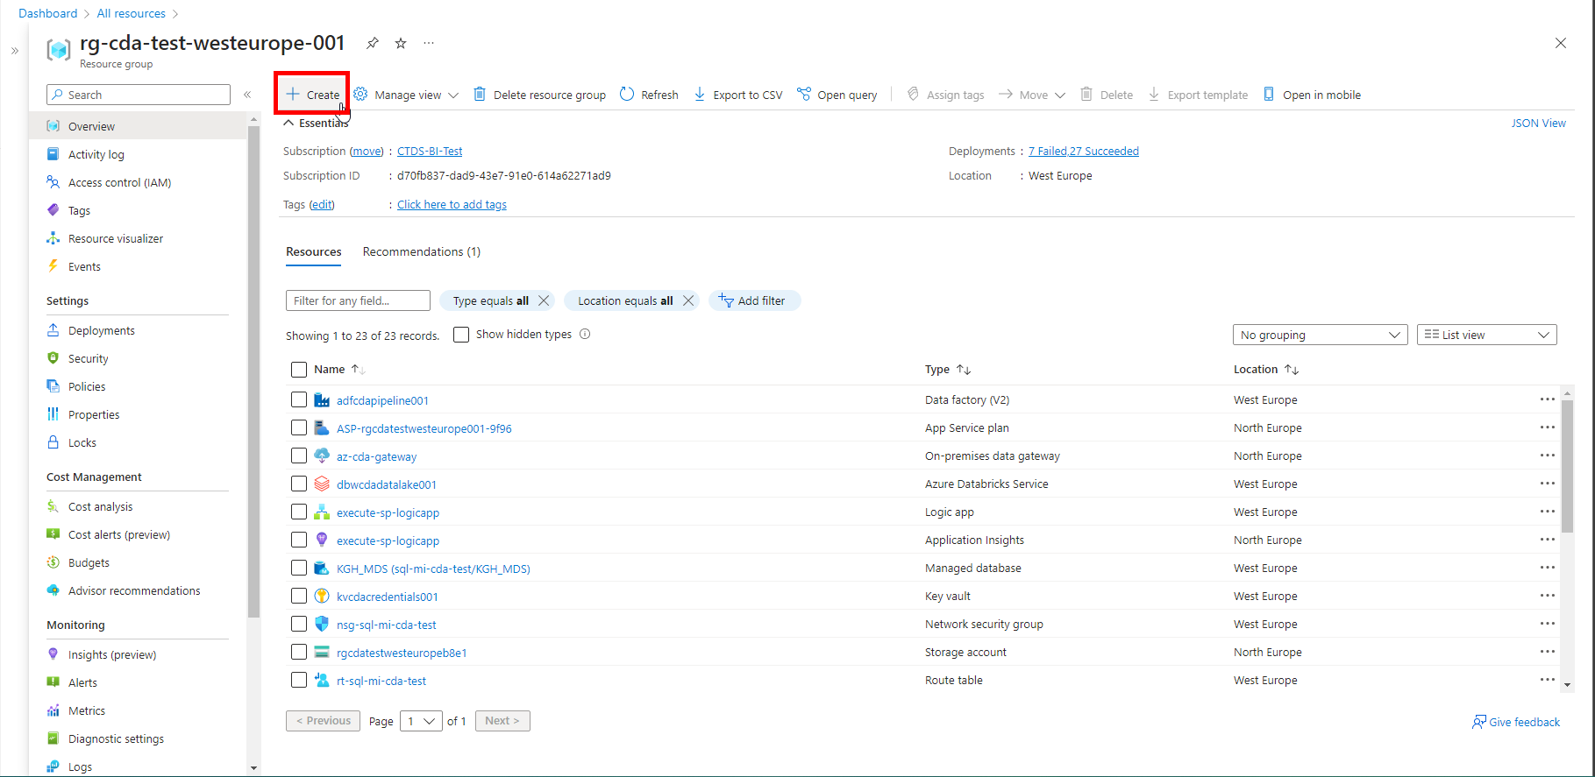

1. Search for *key vault*
2. Click on *Create* à *Virtual network* in *Virtual network* tile

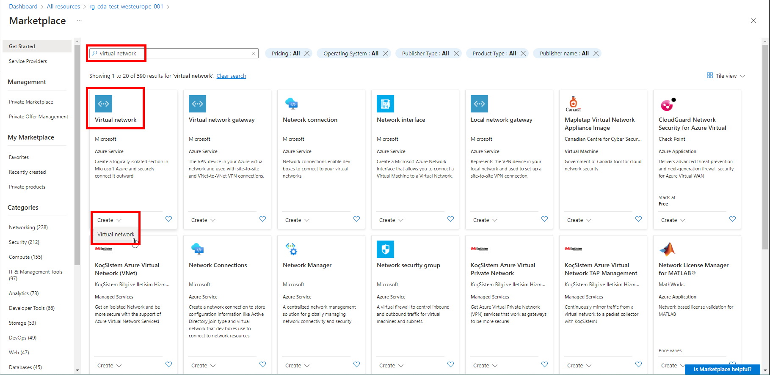

1. Fill the details as below:

Subscription: *CTDS-BI-Test*

Resource Group: *rg-cda-test-westeurope-001*

Virtual Network name: *vnet_cda_test*

Region: *(Europe) West Europe*

Click on *Next*

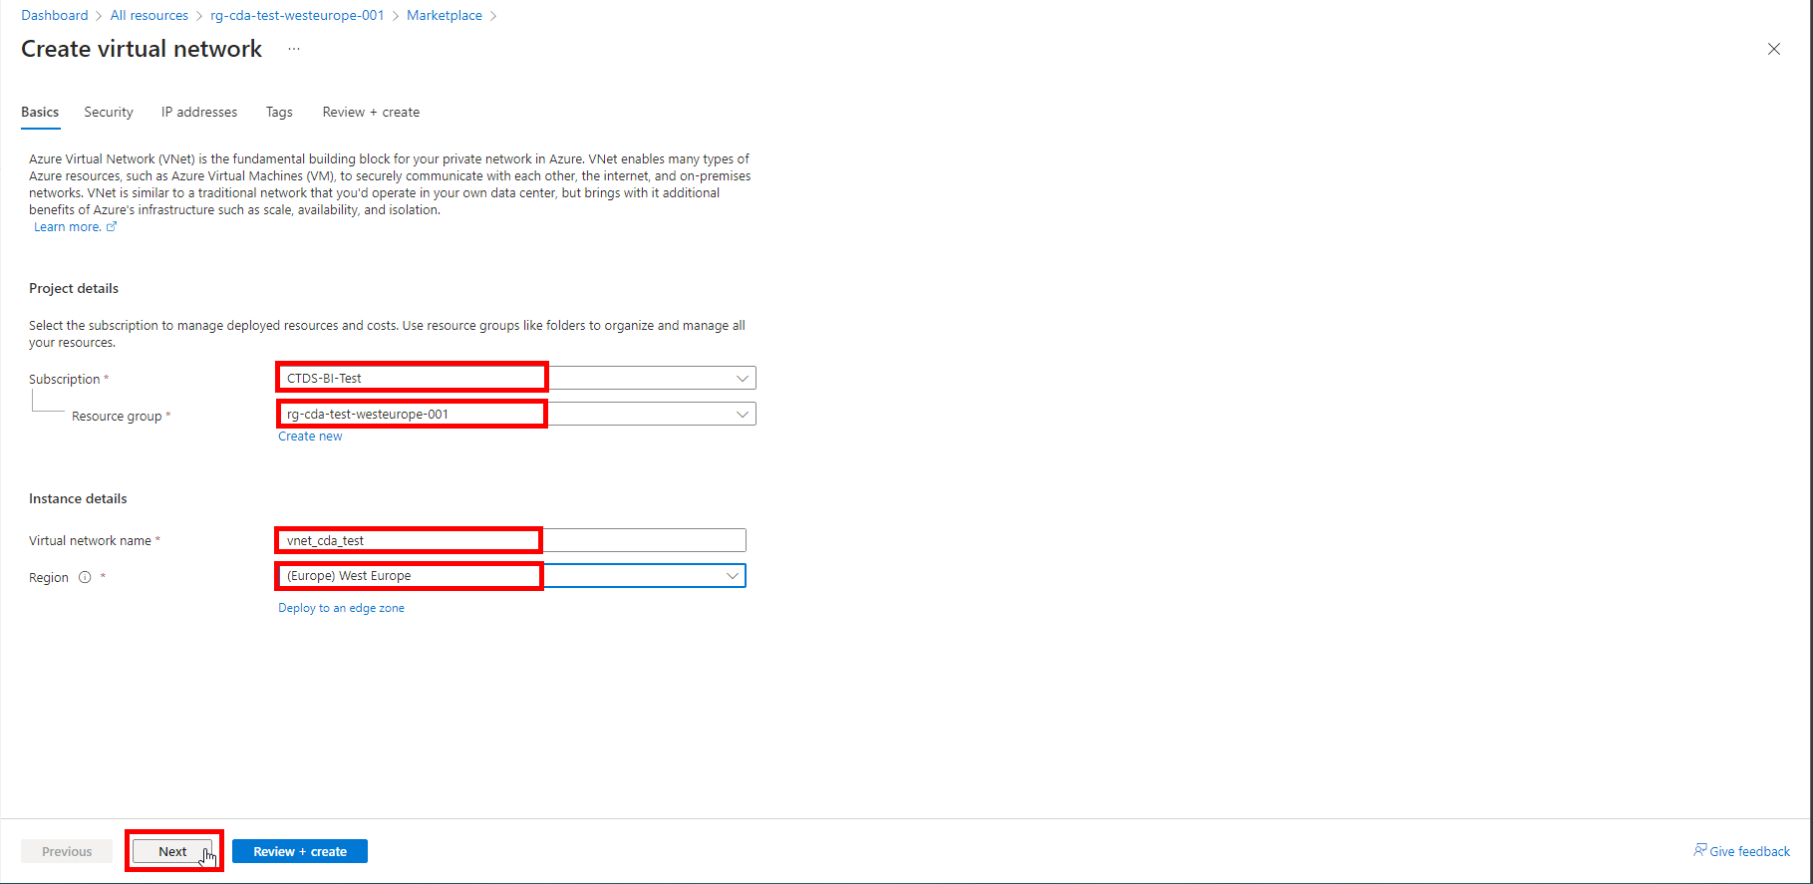

1. Tick-mark the *Enable Azure Bastion*

Click on *Next*

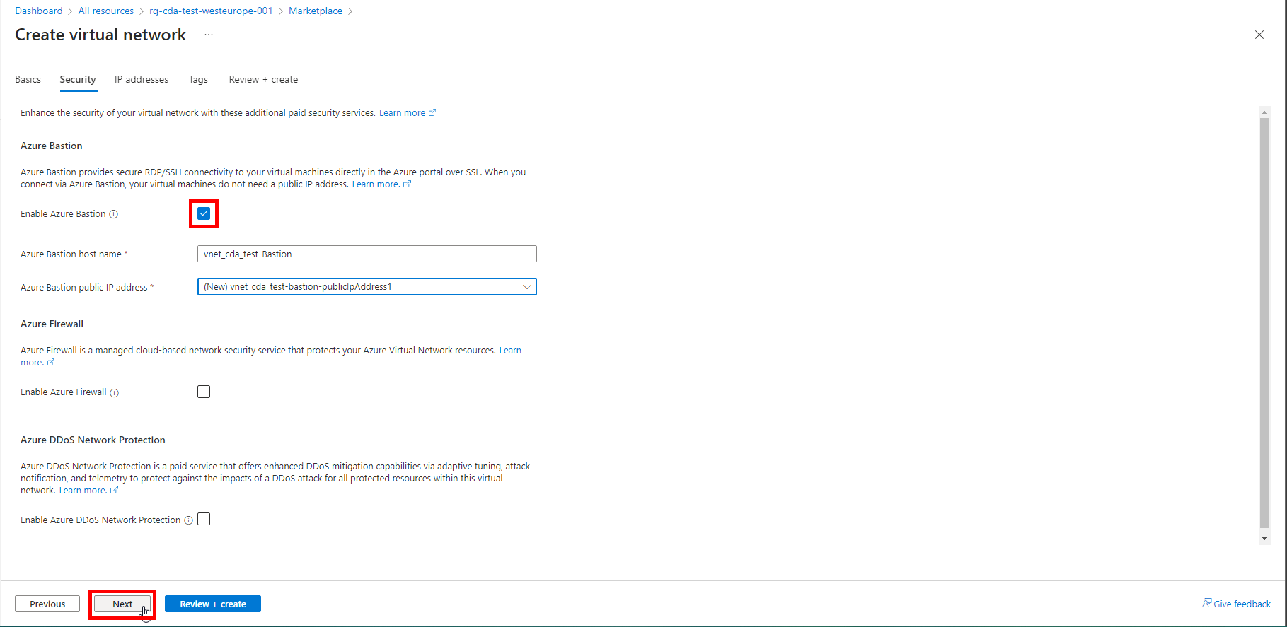

1. Make sure the IP addresses added are as below.

Click on *Next*

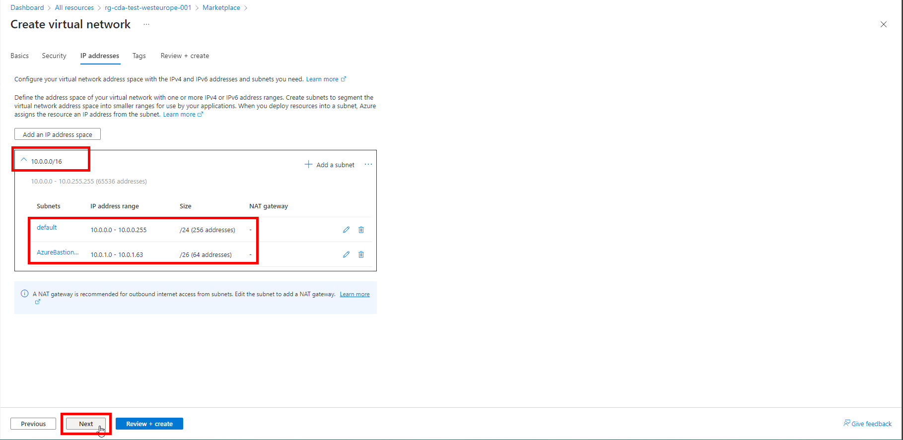

1. Add the tags as shown below:

application à *cda*

owner à *KGH BI Team*

environment à *test*

Click on *Next*

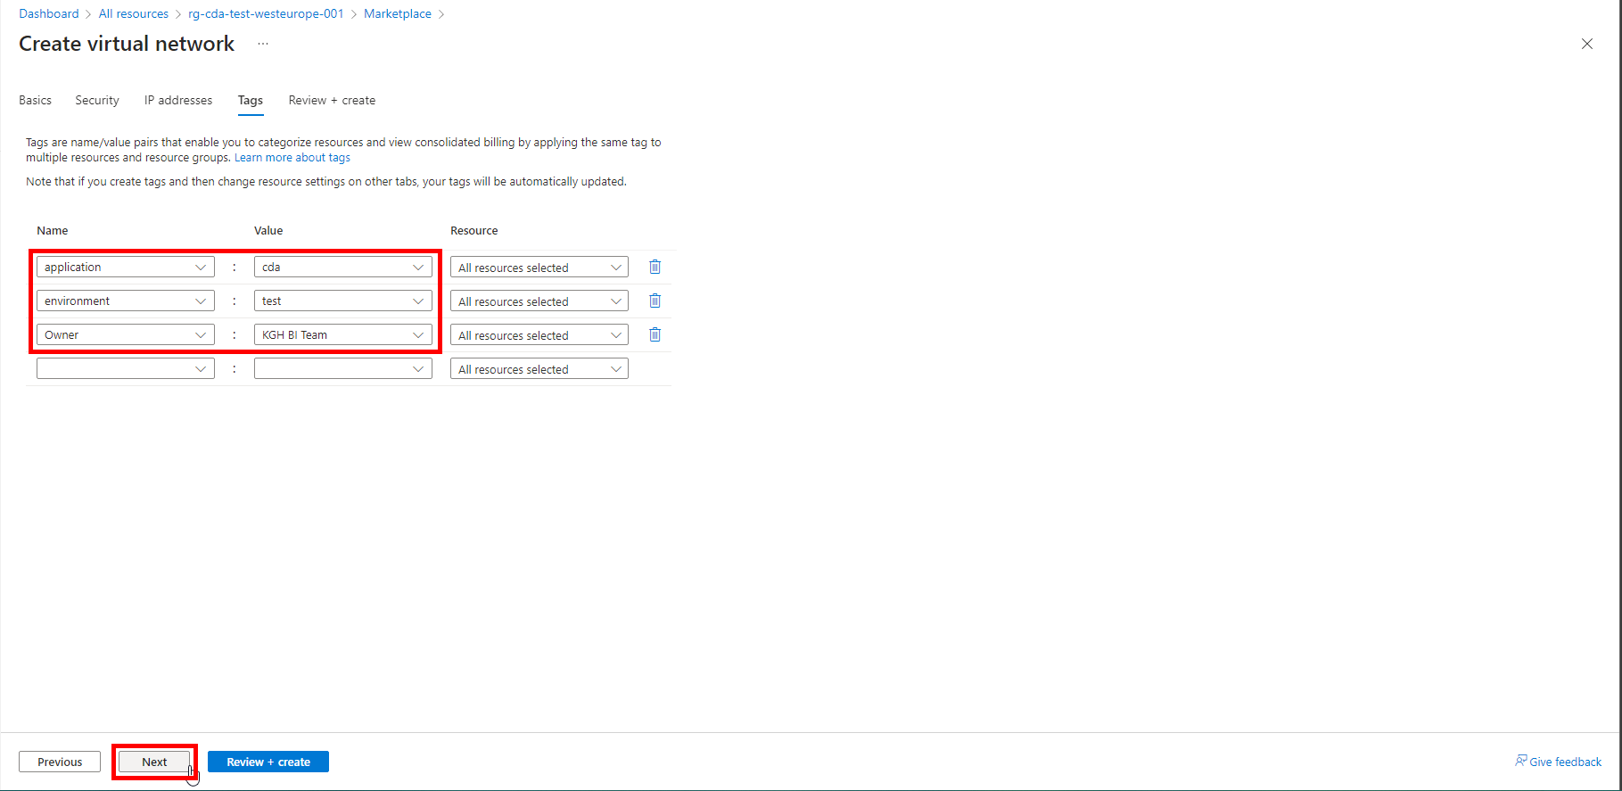

1. Wait for the *Validation* to complete and *Create* button to be enabled.
2. Click on *Create*

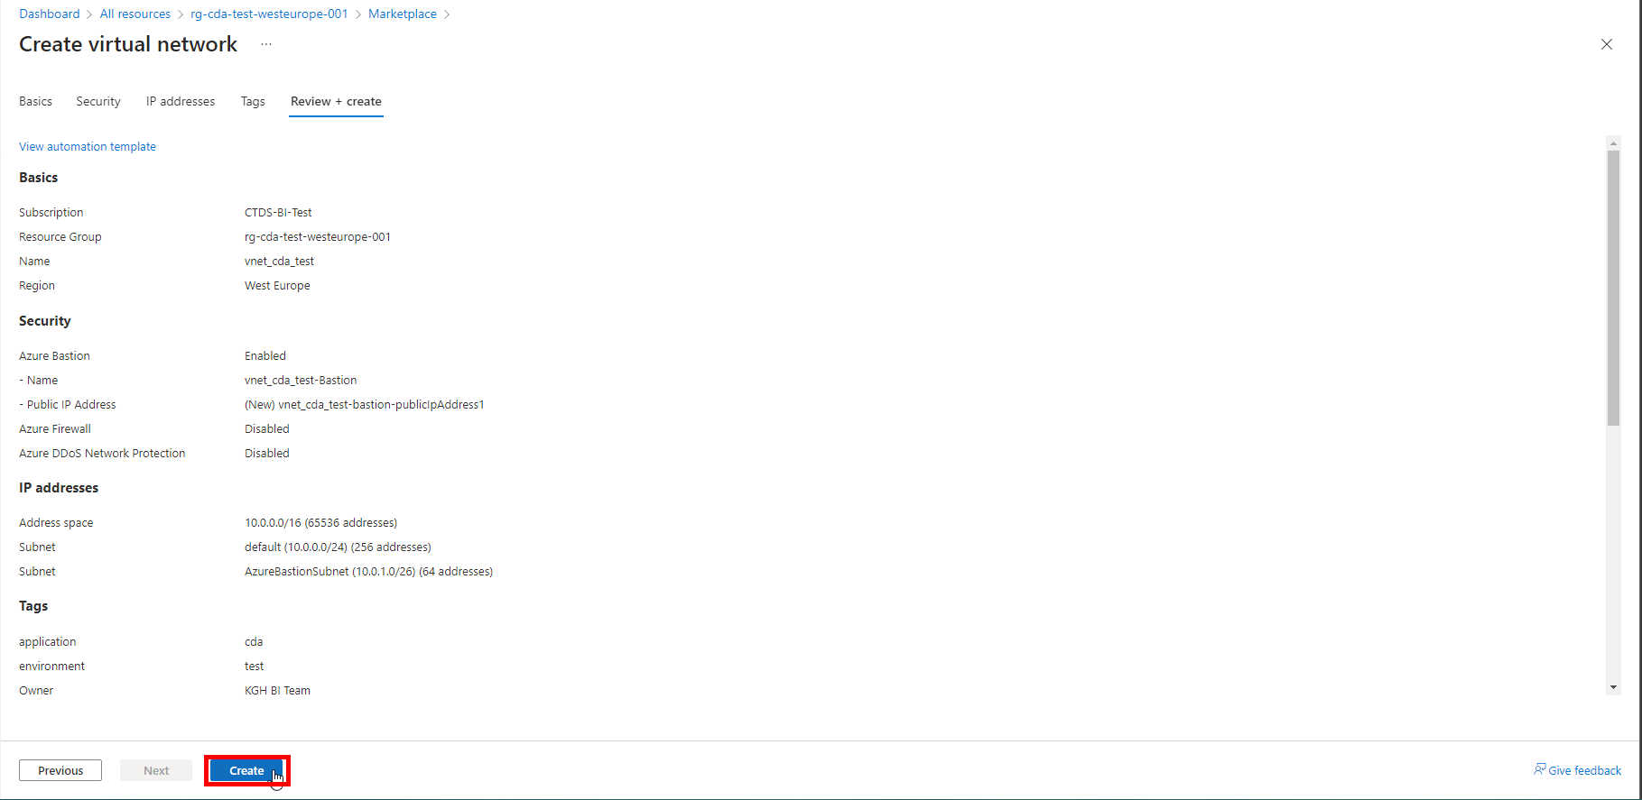

1. It will initialize the deployment of resource.

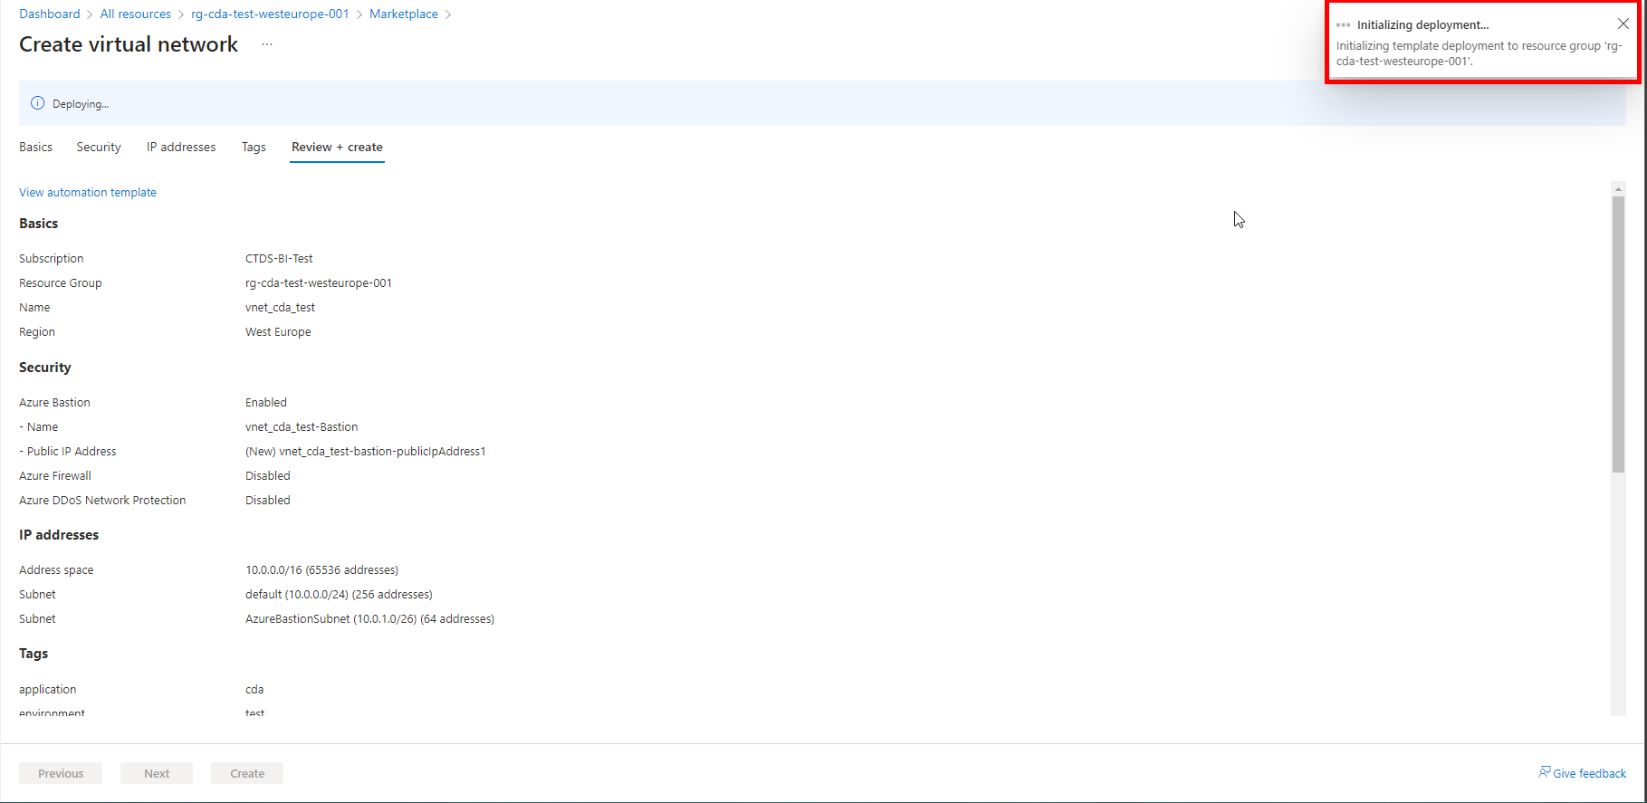

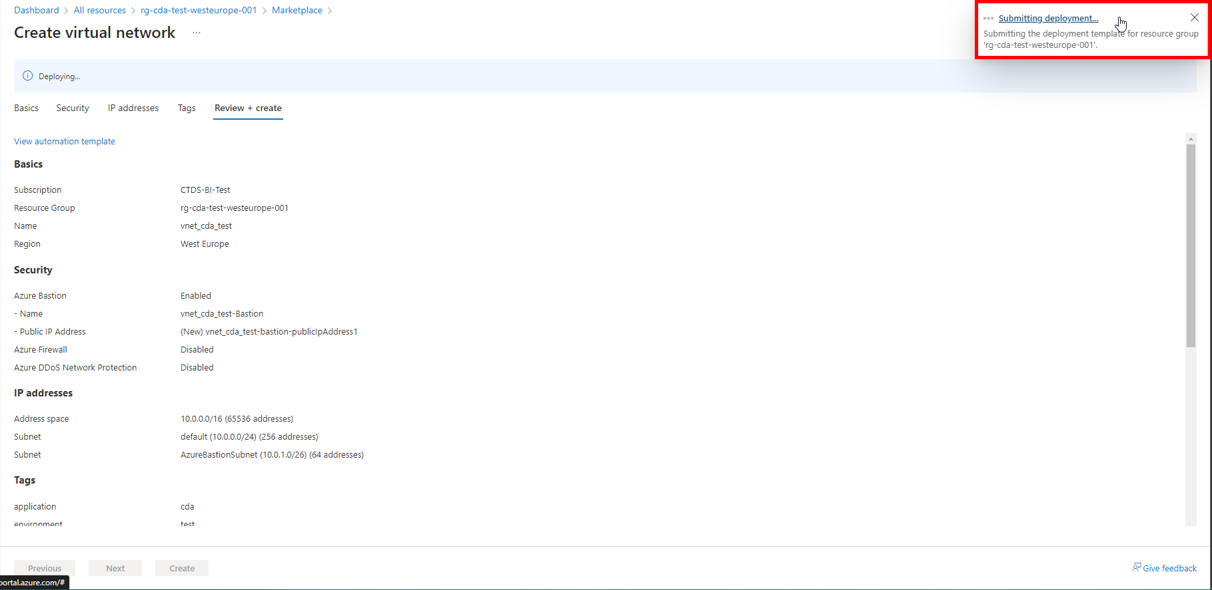

1. It will auto-redirect to deployment screen

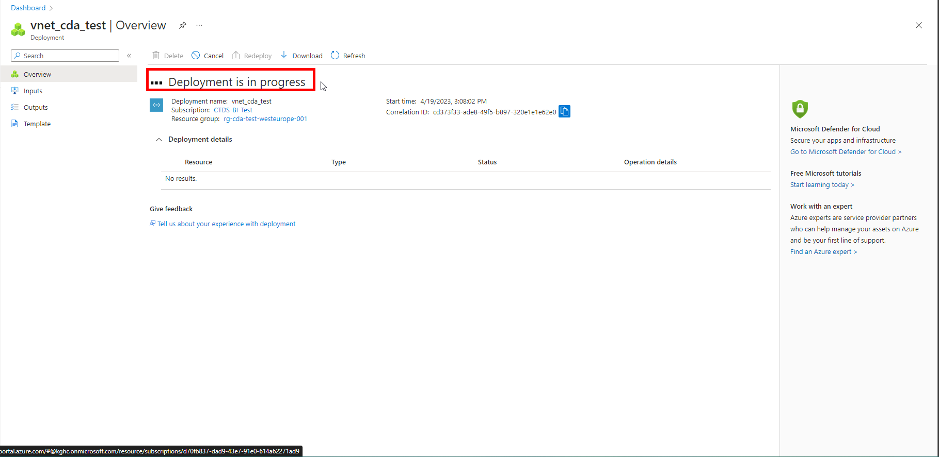

1. When the message changes to *Your deployment is complete*, click on *Go to resource*

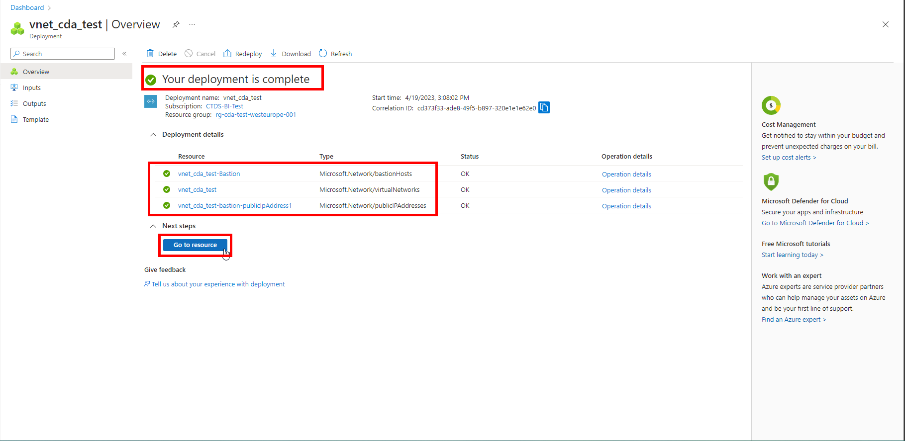

1. It will take to *Overview* page of created resource.

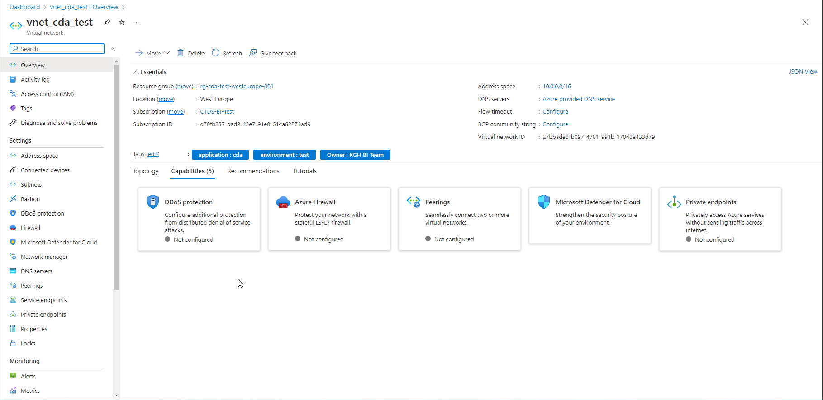

### **Network Configuration: Virtual network to on-premises network**

[Tutorial: Link a VNet to an ExpressRoute circuit - Azure portal | Microsoft Learn](https://learn.microsoft.com/en-us/azure/expressroute/expressroute-howto-linkvnet-portal-resource-manager?toc=%2Fazure%2Fvirtual-network%2Ftoc.json)

# **Resource Creation: Databricks**

1. Open *Resource Groups* and search for *rg-cda-test-westeurope-001*



1. Click on *Create*

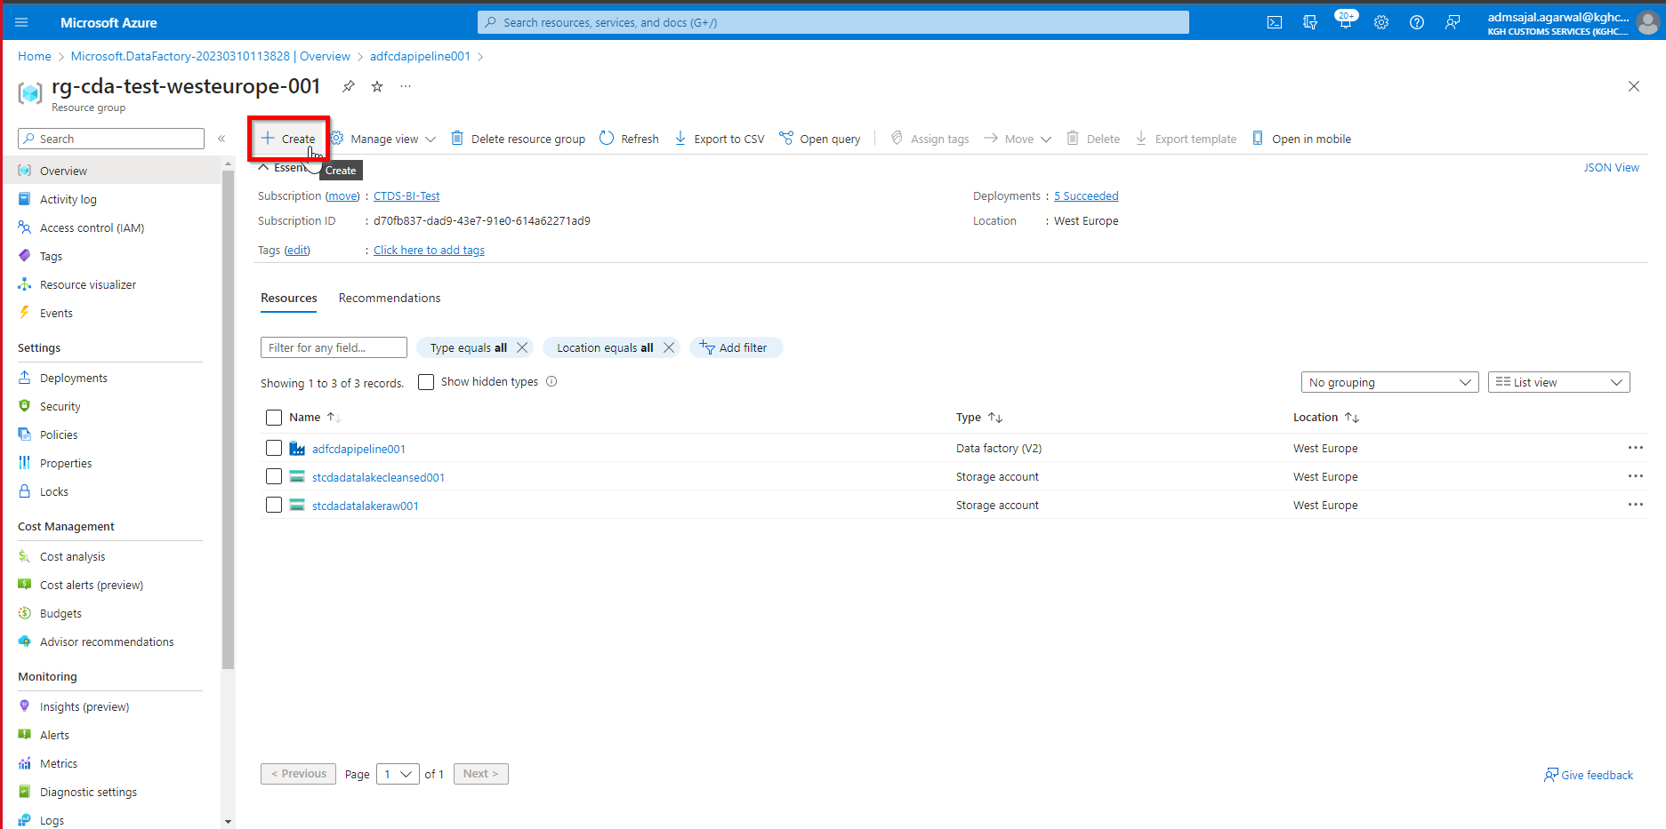

1. Below screen will appear:



1. Search for *databricks*

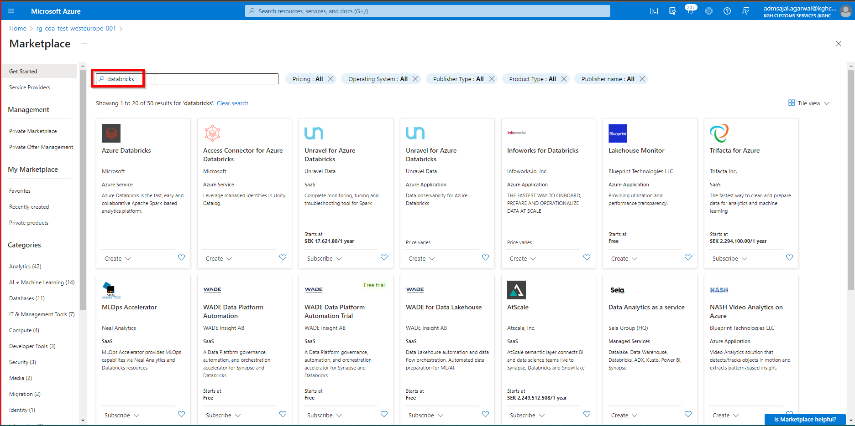

1. Click on *Create* 🡪 *Azure Databricks* in *Azure Databricks* tile

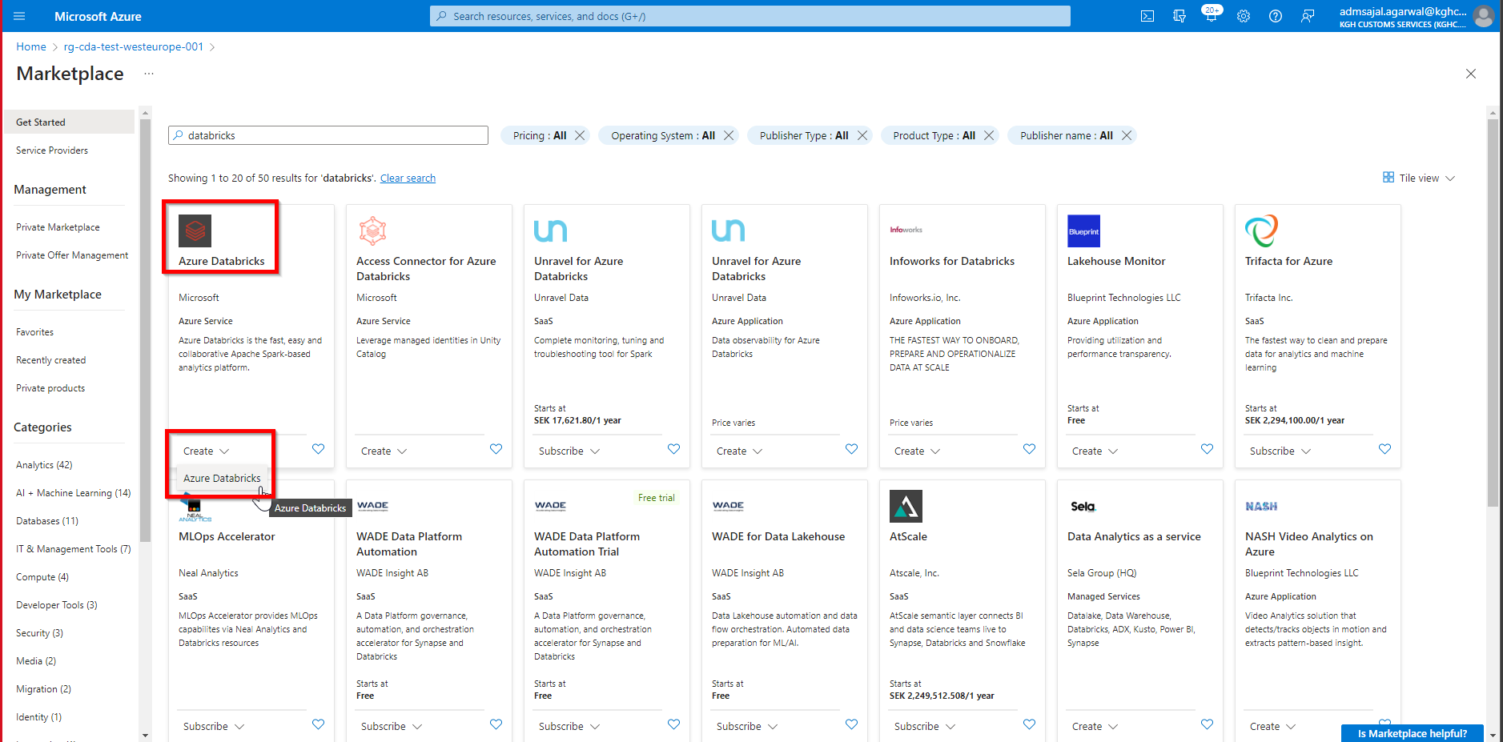

1. Fill the details as below:

Subscription: *CTDS-BI-Test*

Resource Group: *rg-cda-test-westeurope-001*

Workspace name: *dbwcdadatalake001*

Region: *West Europe*

Pricing Tier: *Standard*

Click on *Next : Networking*

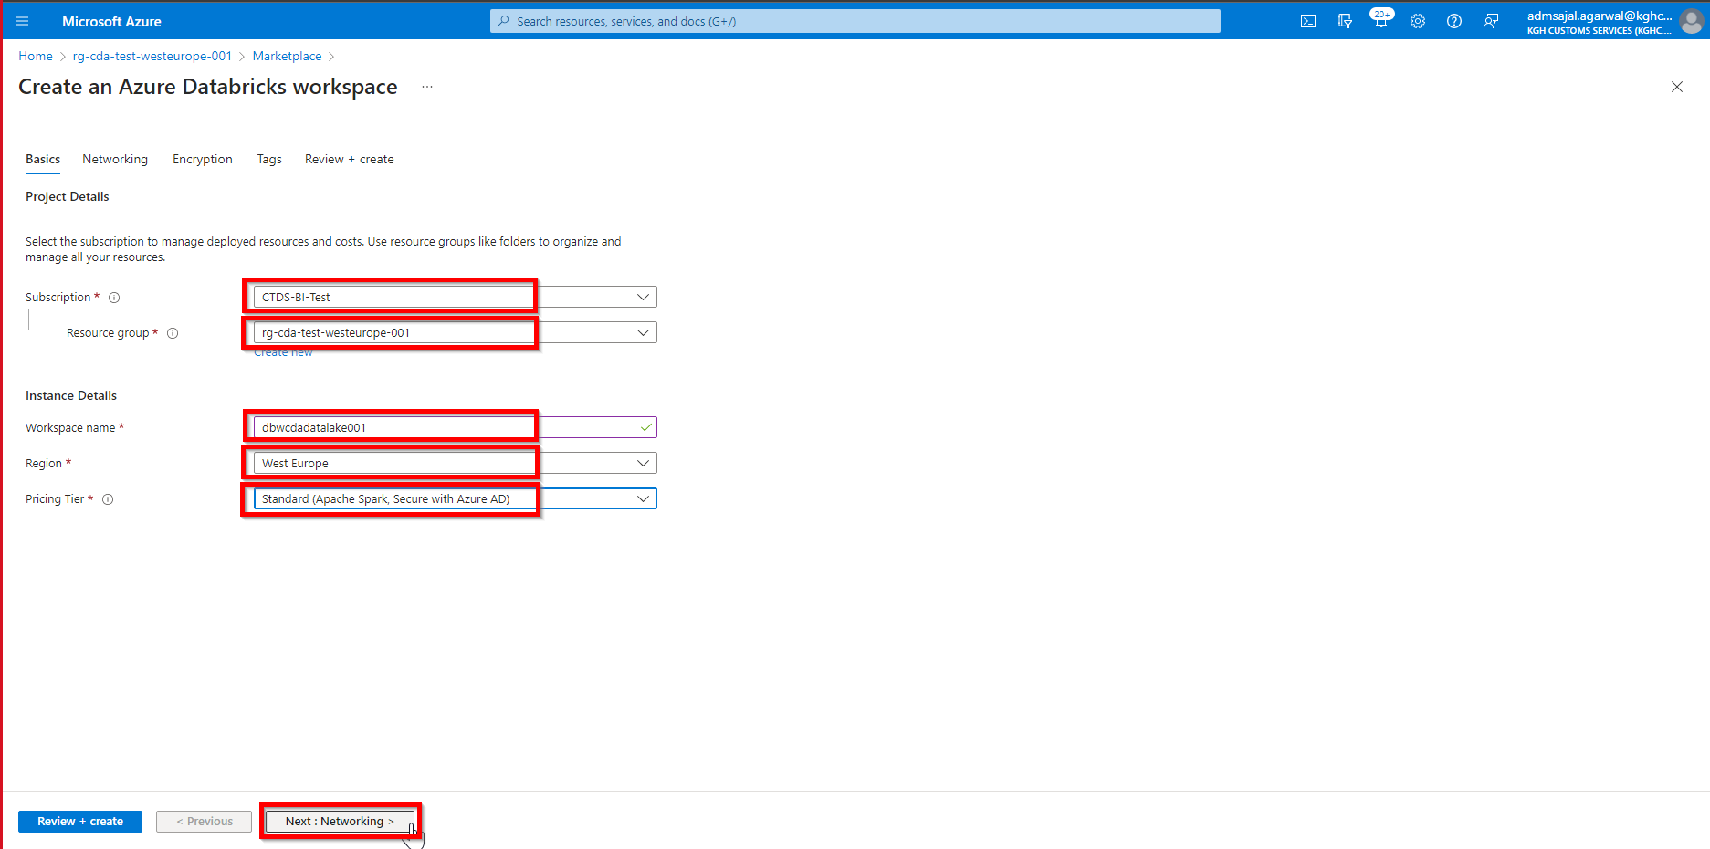

1. Keeping all options as default, click on *Next : Encryption*

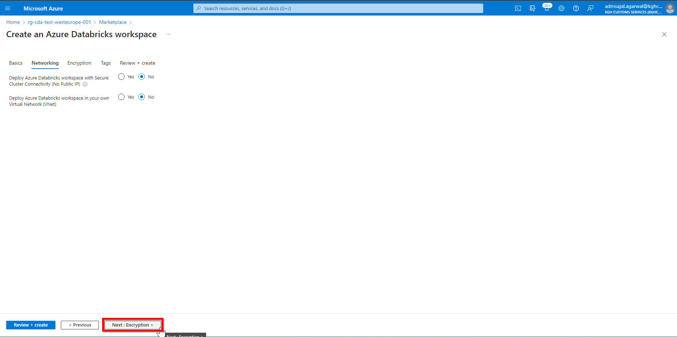

1. Keeping all options as default, click on *Next : Tags*

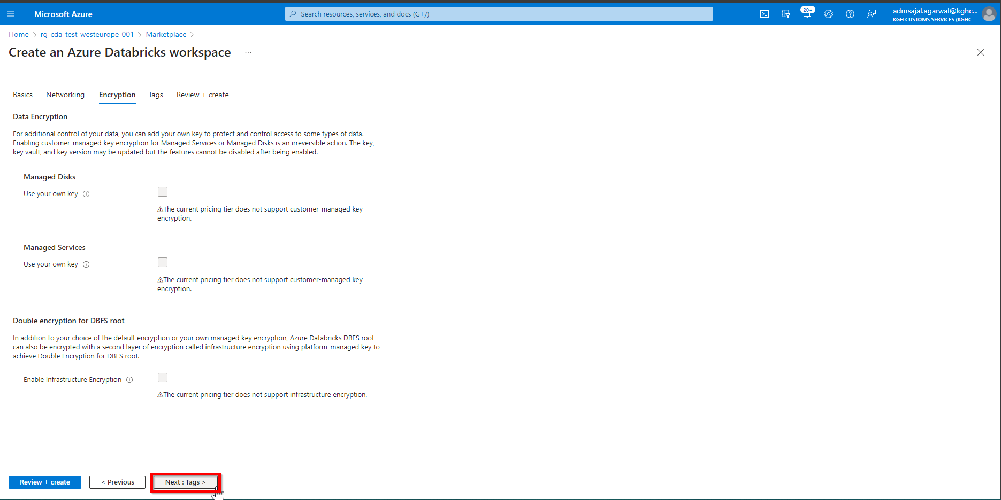

1. Add the tags as shown below:

application 🡪 *cda*

owner 🡪 *KGH BI Team*

environment 🡪 *test*

Click on *Review + create*

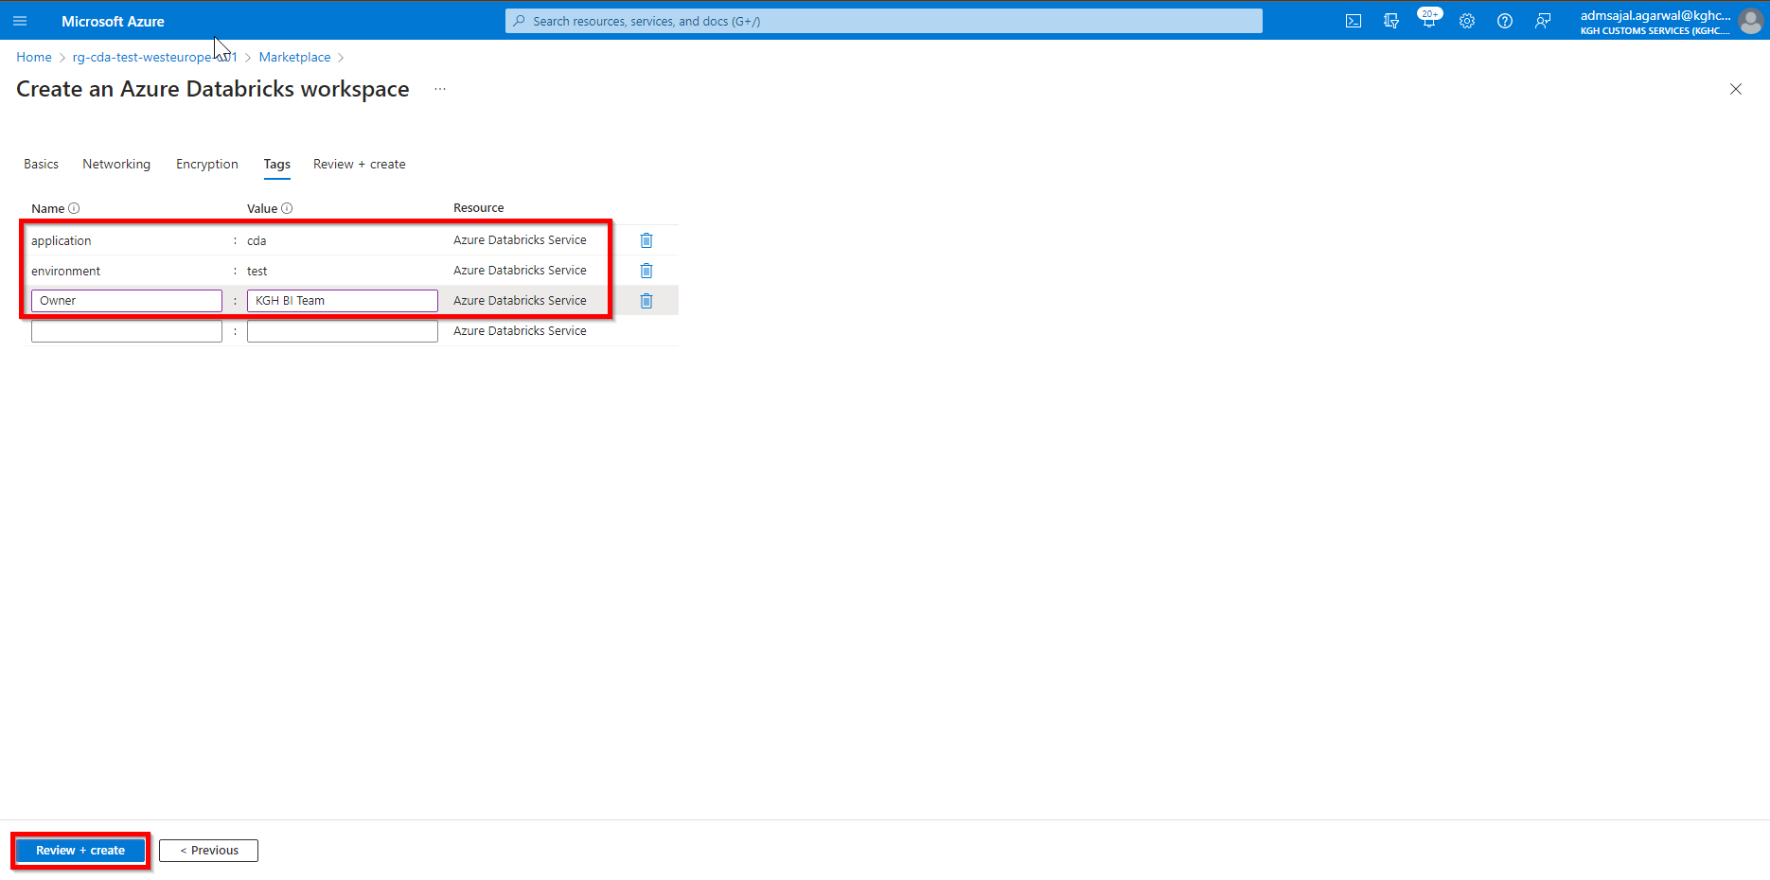

1. Wait for the *Validation* to complete and *Create* button to be enabled

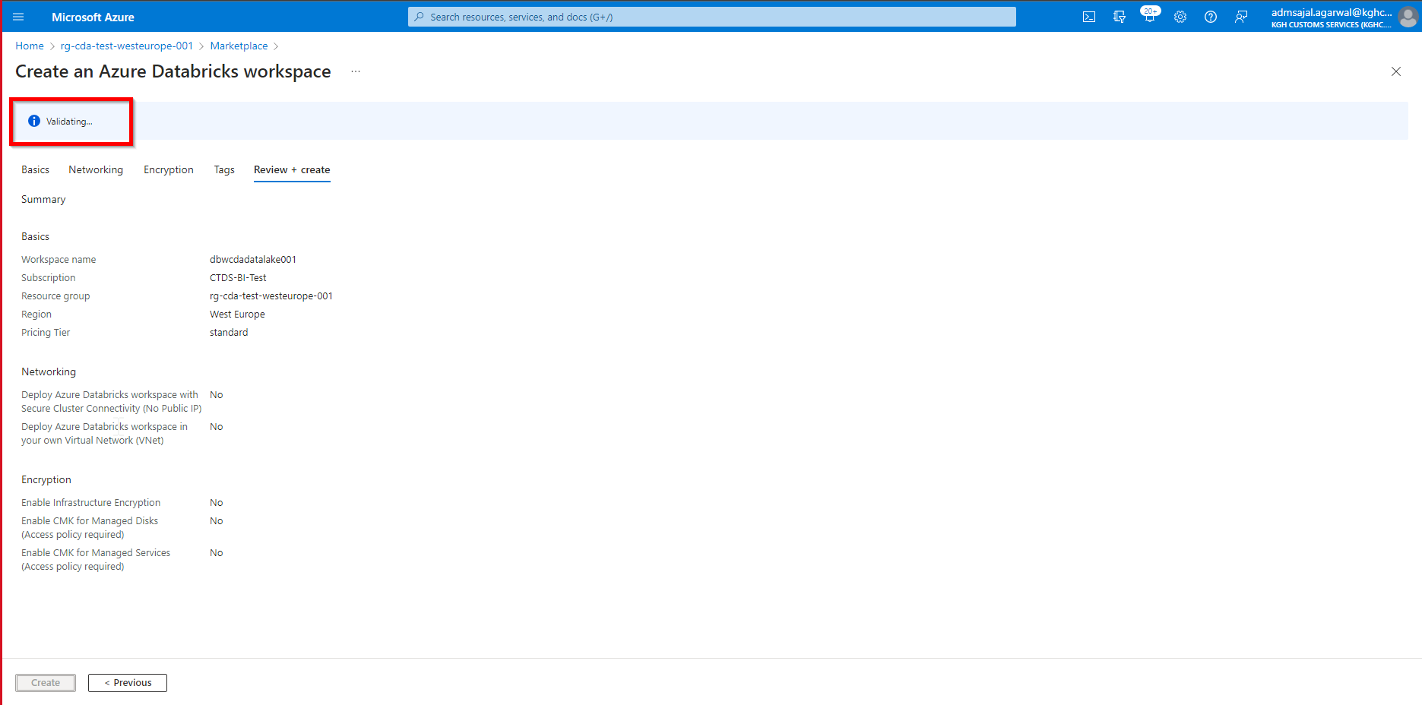

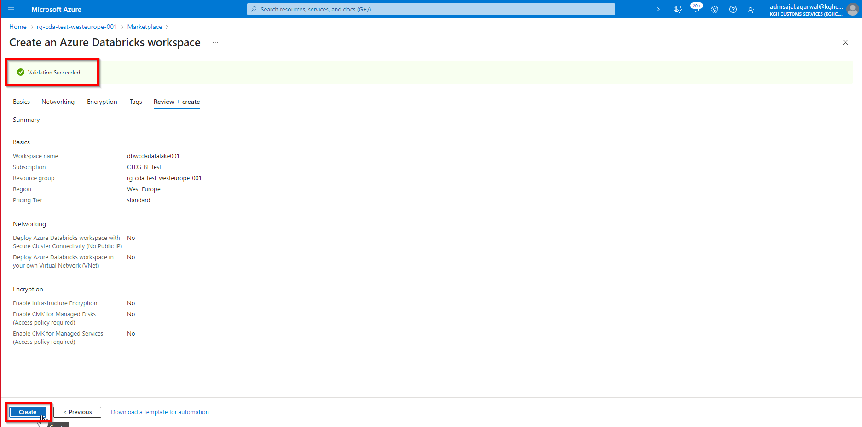

1. Click on *Create*. It will initialize the deployment of resource.

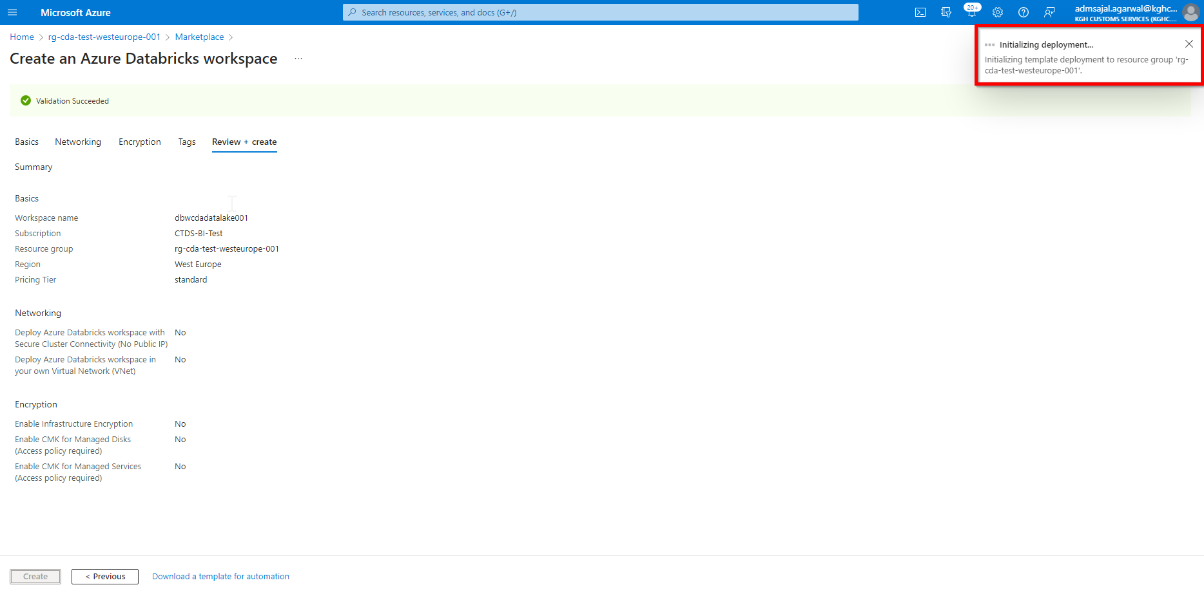

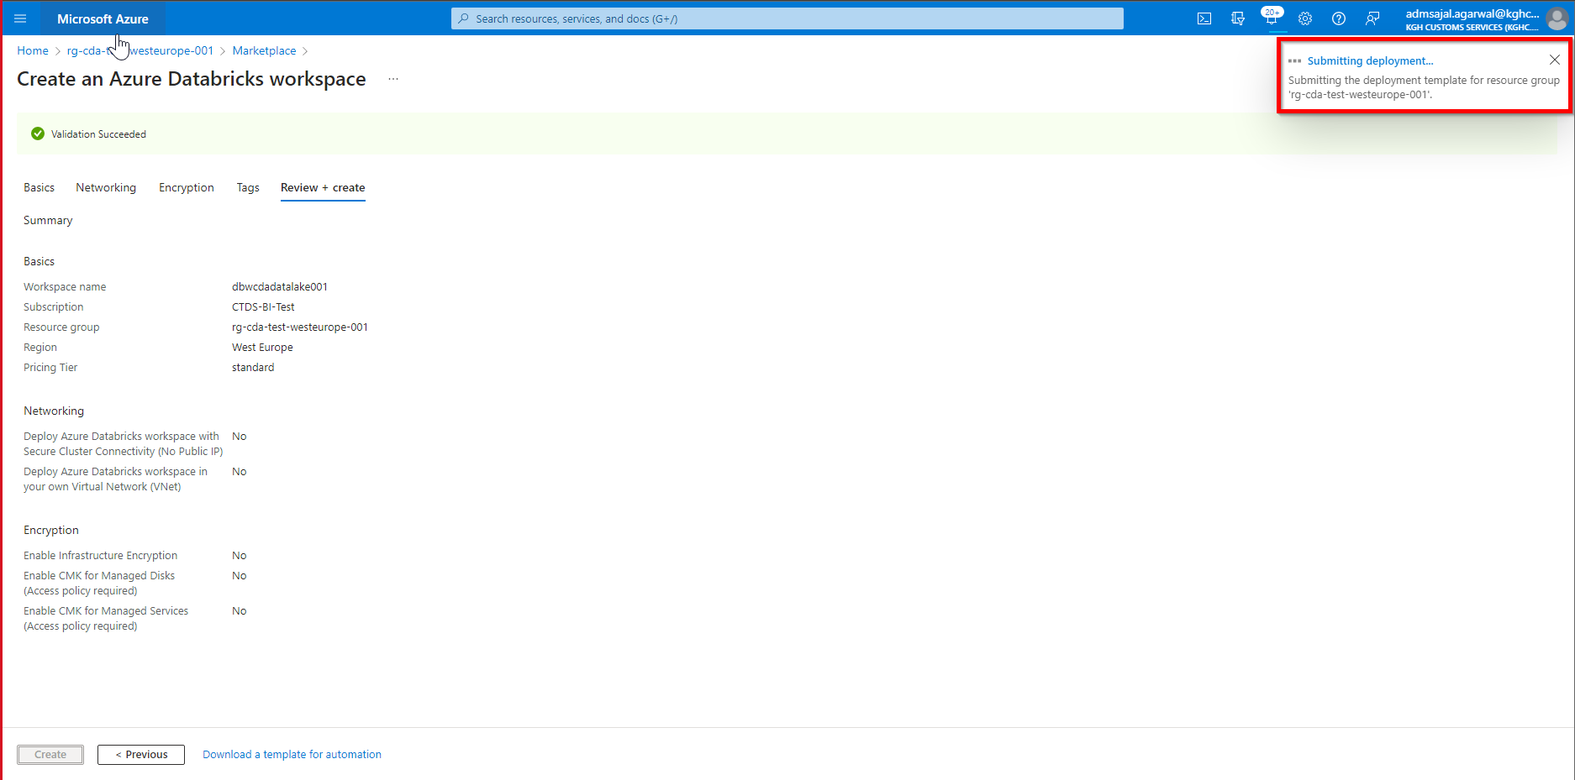

1. It will auto-redirect to deployment screen

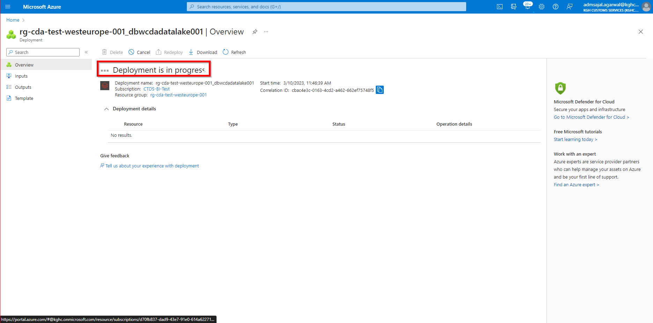

1. When the message changes to *Your deployment is complete*, click on *Go to resource*

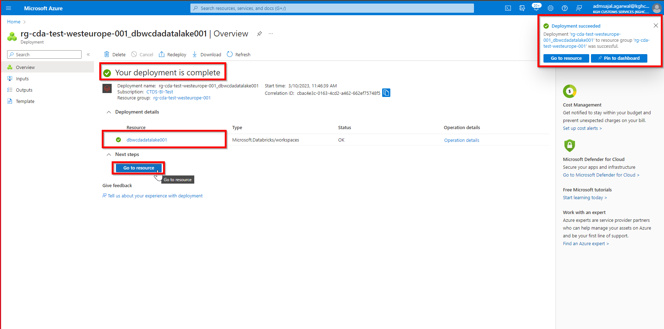

1. Click on *Launch workspace* from resource *Overview* page

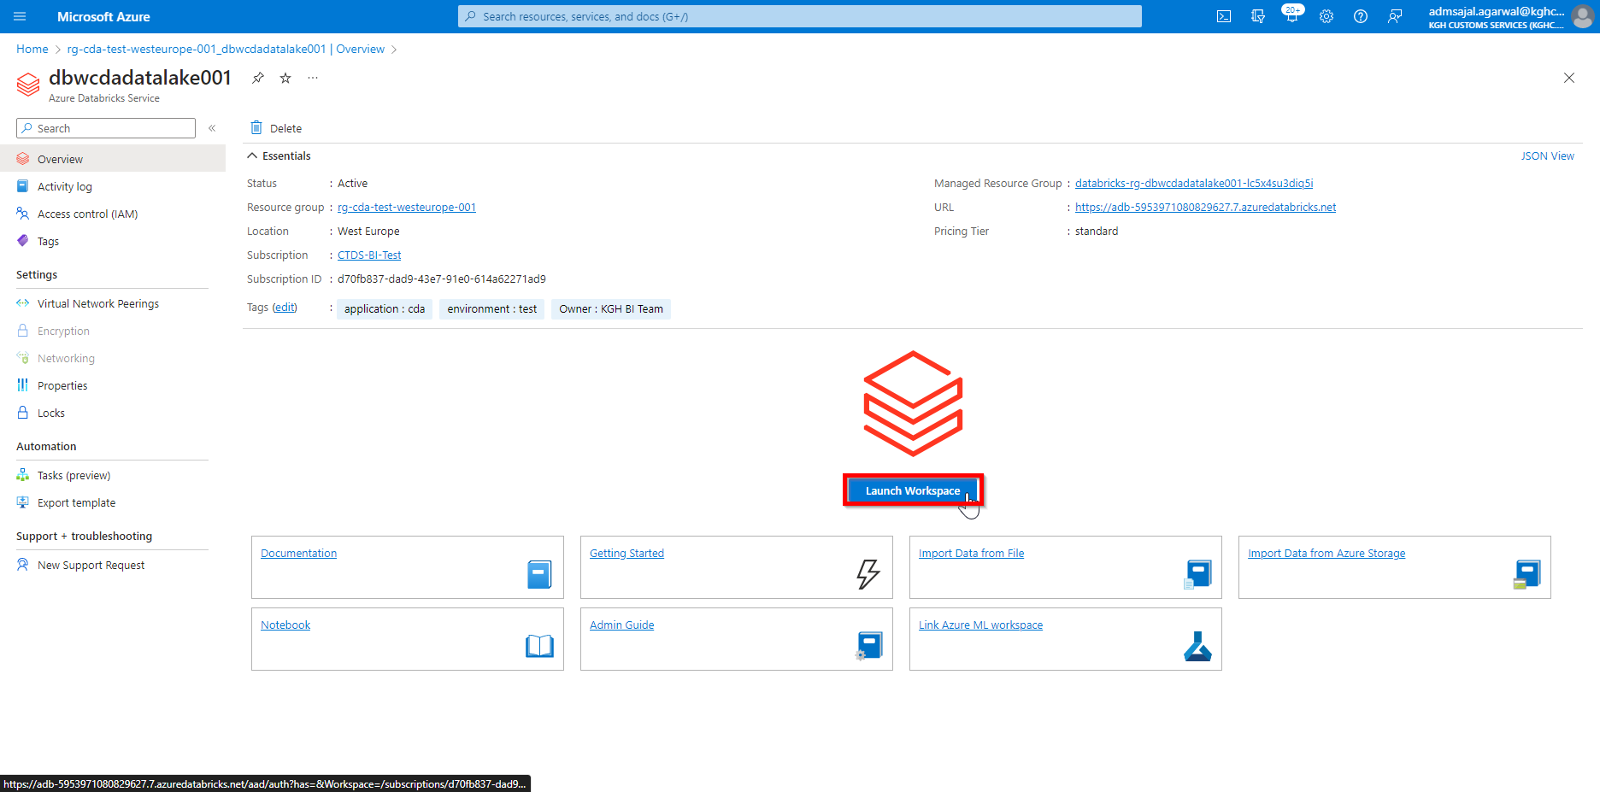

1. Sign-in with appropriate credentials

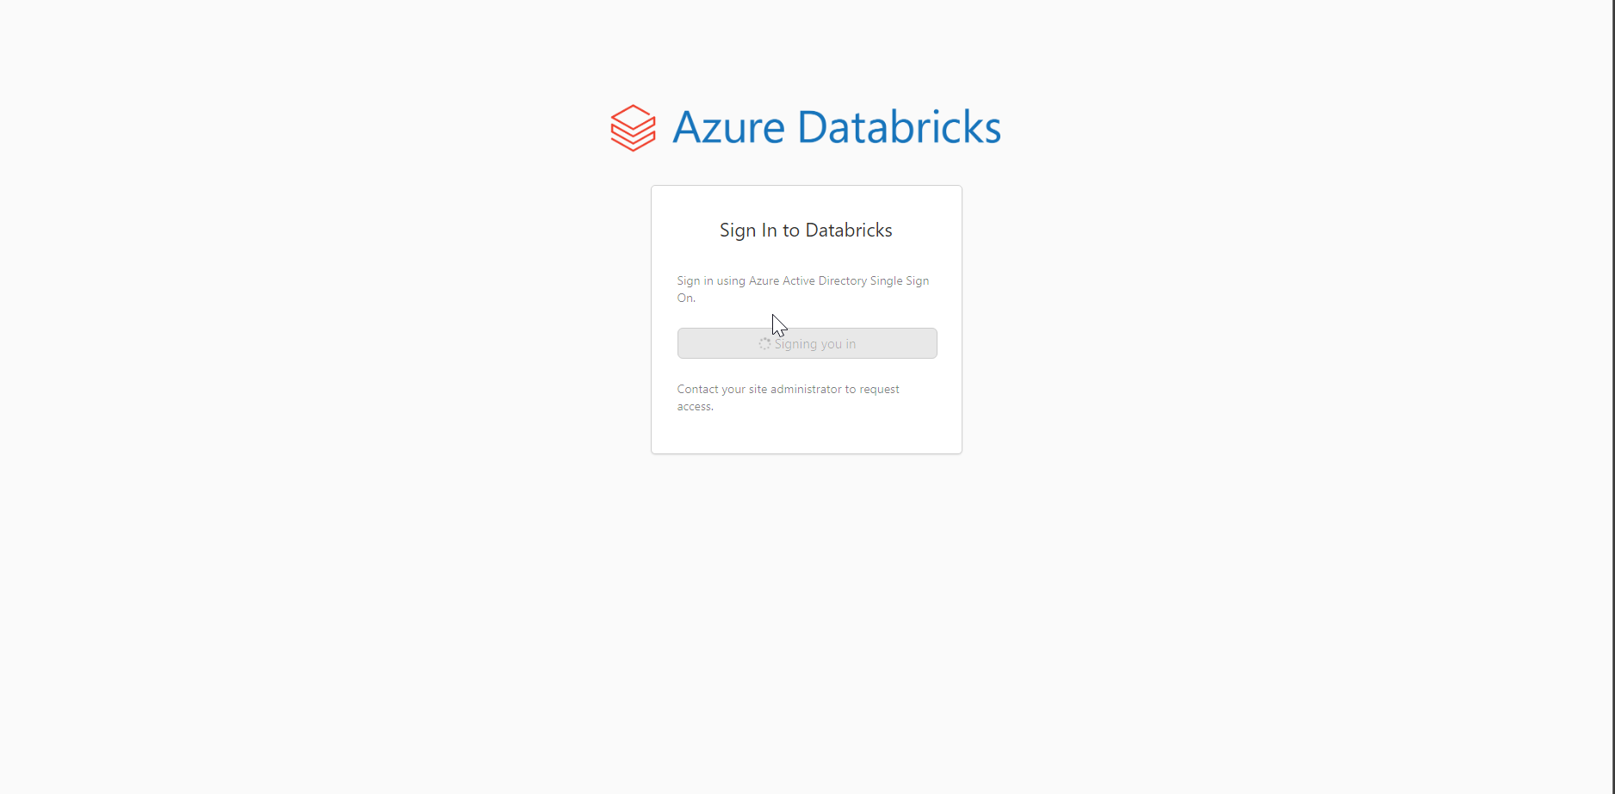

1. Databricks workspace is launched

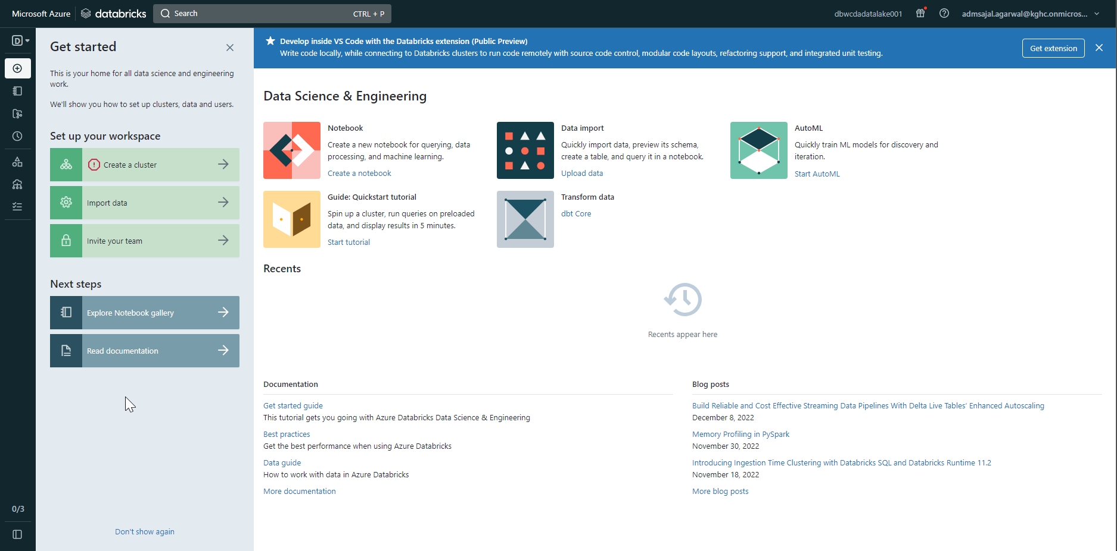

# **Resource Creation: KeyVault**

1. Open *Resource Groups* and search for *rg-cda-test-westeurope-001*



1. Click on *Create*

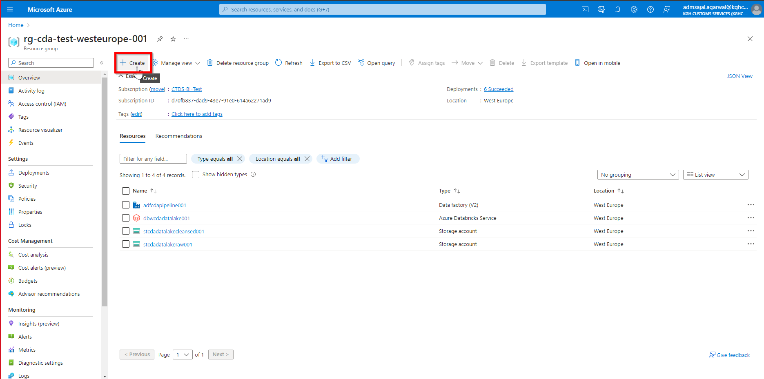

1. Below screen will appear:



1. Search for *key vault*

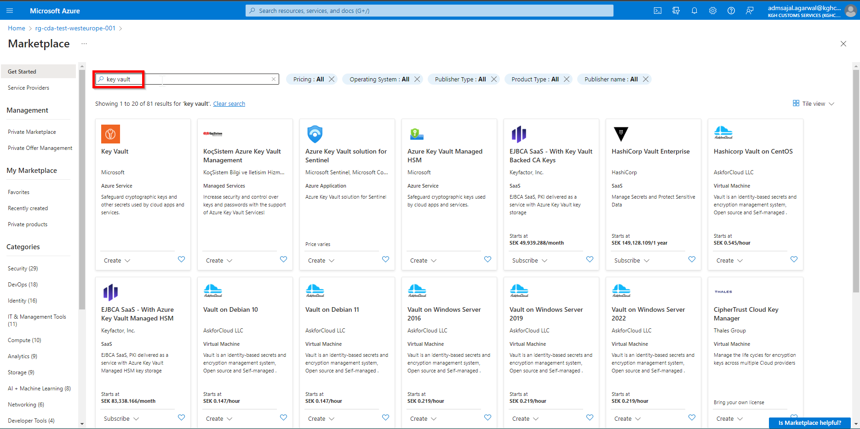

1. Click on *Create* 🡪 *Key Vault* in *Key Vault* tile

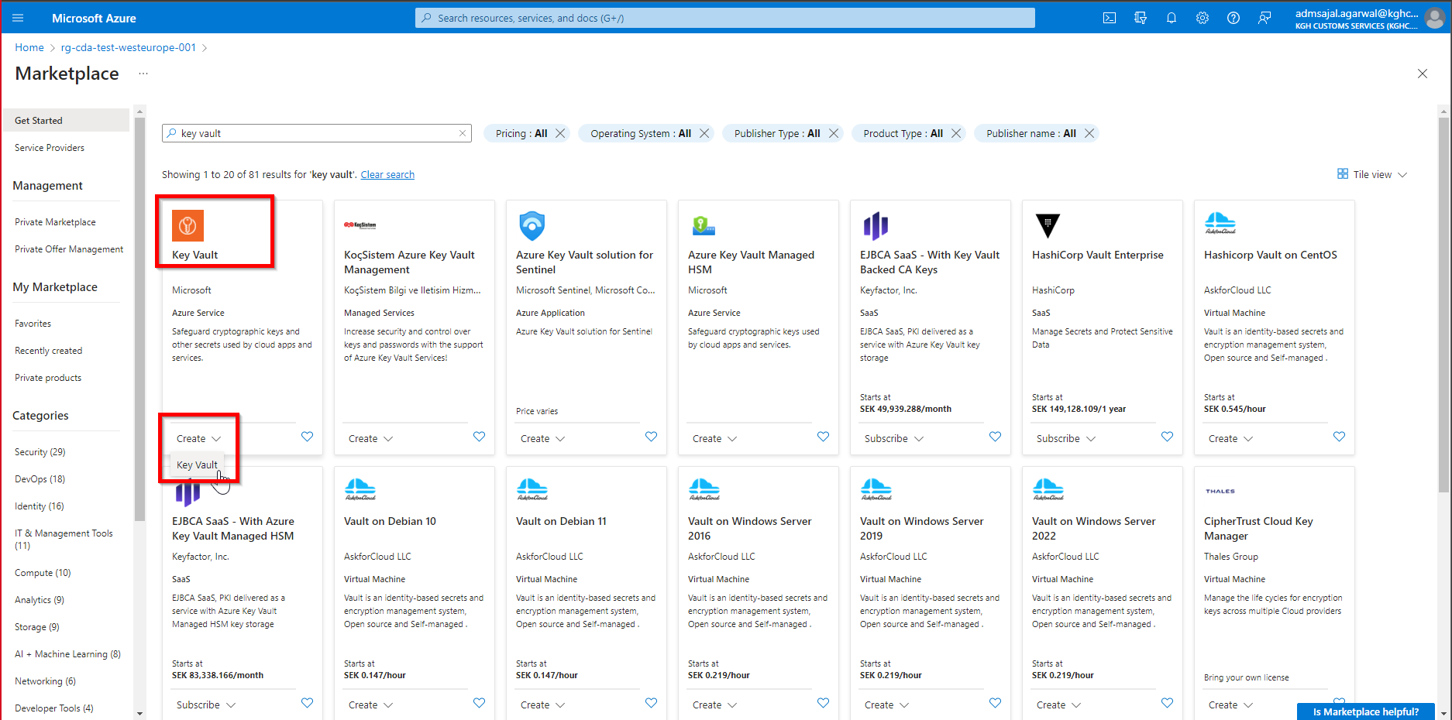

1. Fill the details as below:

Subscription: *CTDS-BI-Test*

Resource Group: *rg-cda-test-westeurope-001*

Key vault name: *kvcdacredentials001*

Region: *West Europe*

Pricing Tier: *Standard*

Click on *Next*

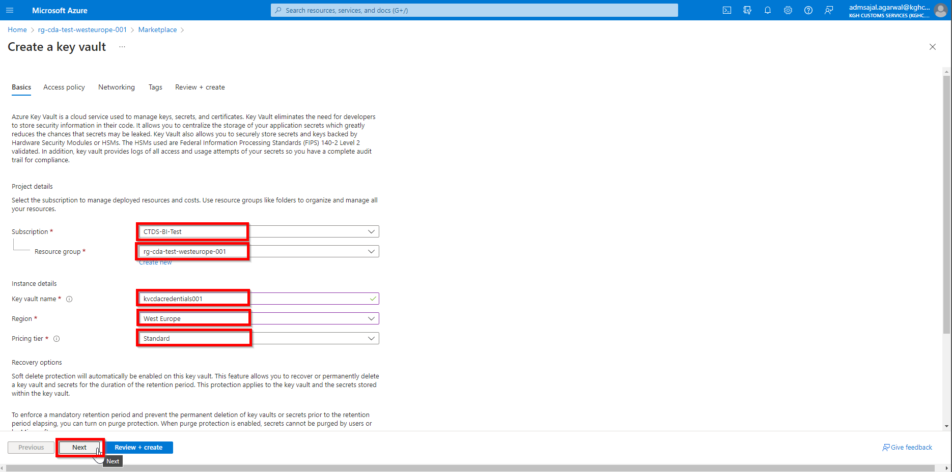

1. Keeping all options as default, click on *Next*

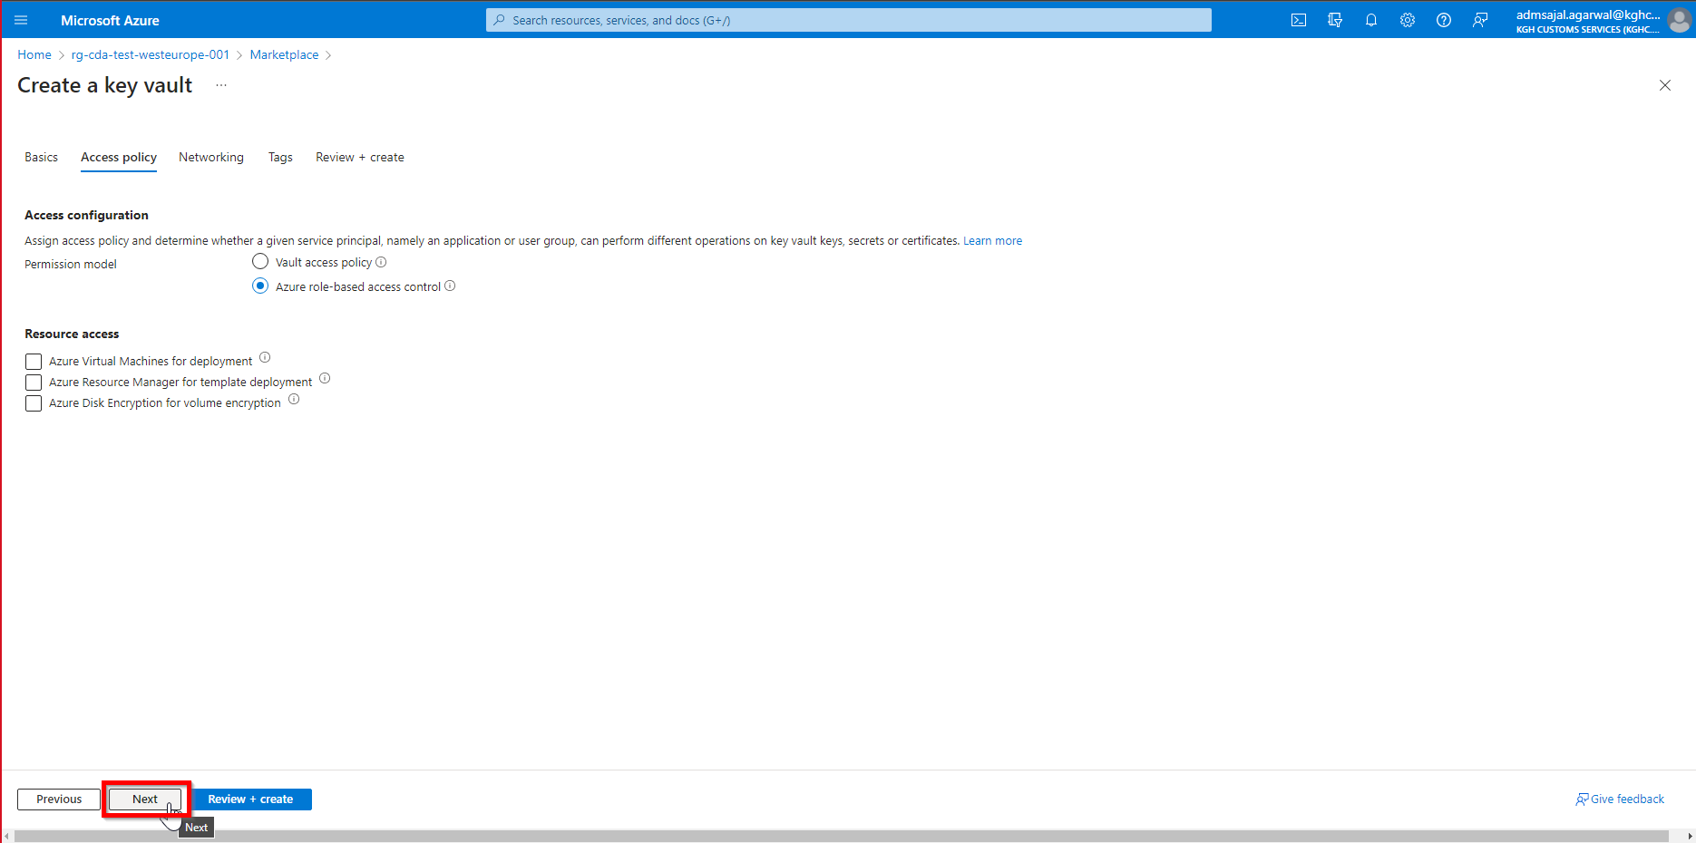

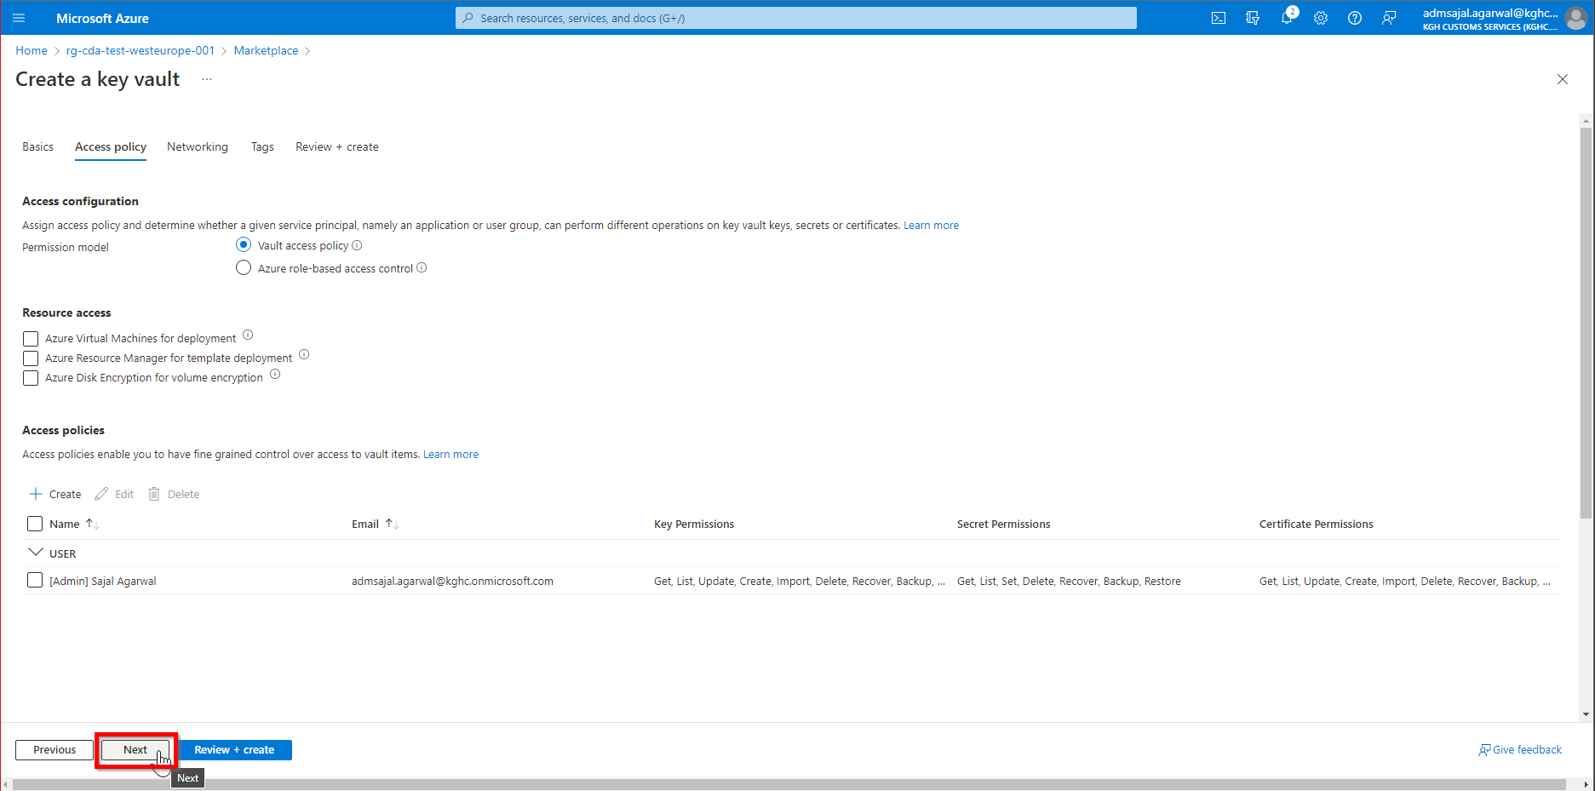

1. Add the tags as shown below:

application 🡪 *cda*

owner 🡪 *KGH BI Team*

environment 🡪 *test*

Click on *Next*

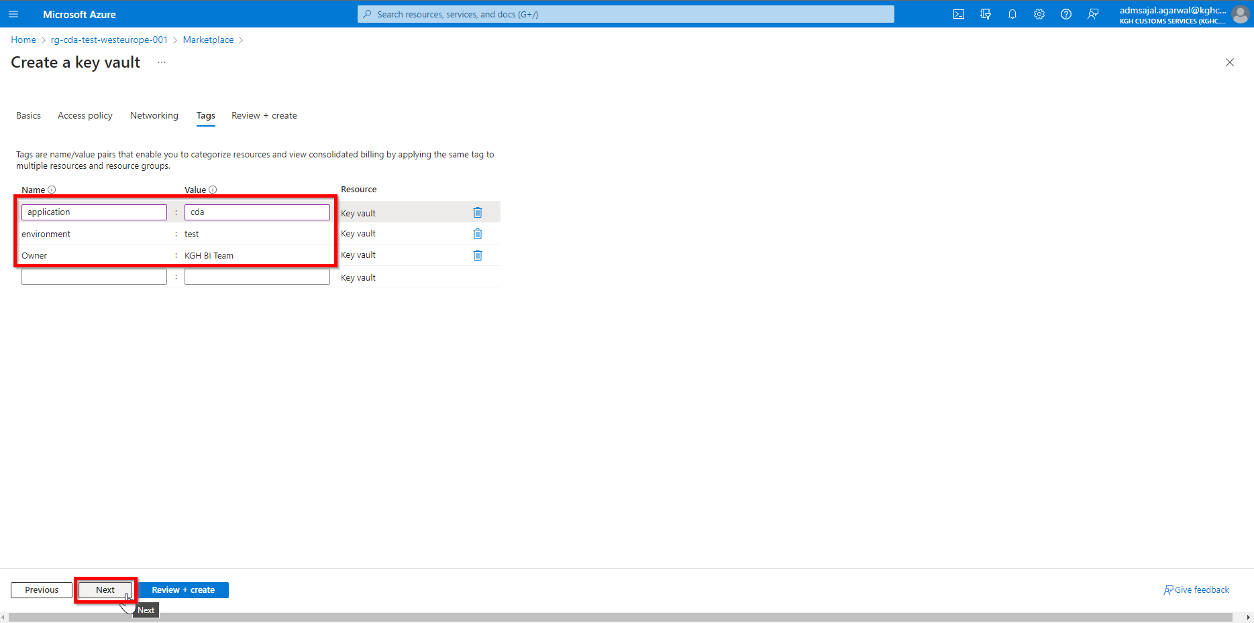

1. Wait for the *Validation* to complete and *Create* button to be enabled

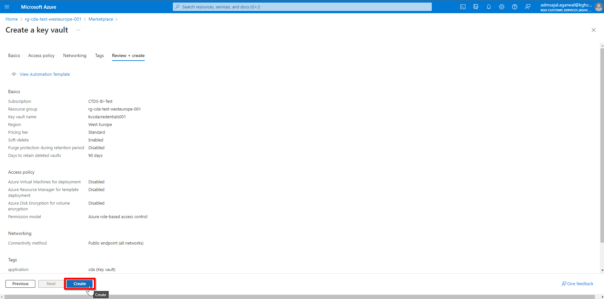

1. Click on *Create*. It will initialize the deployment of resource.

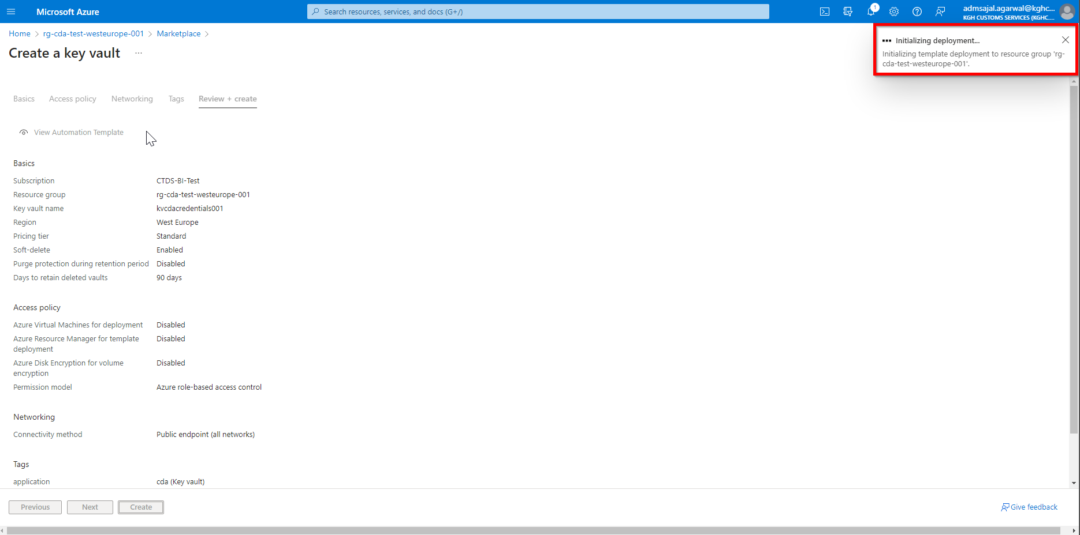

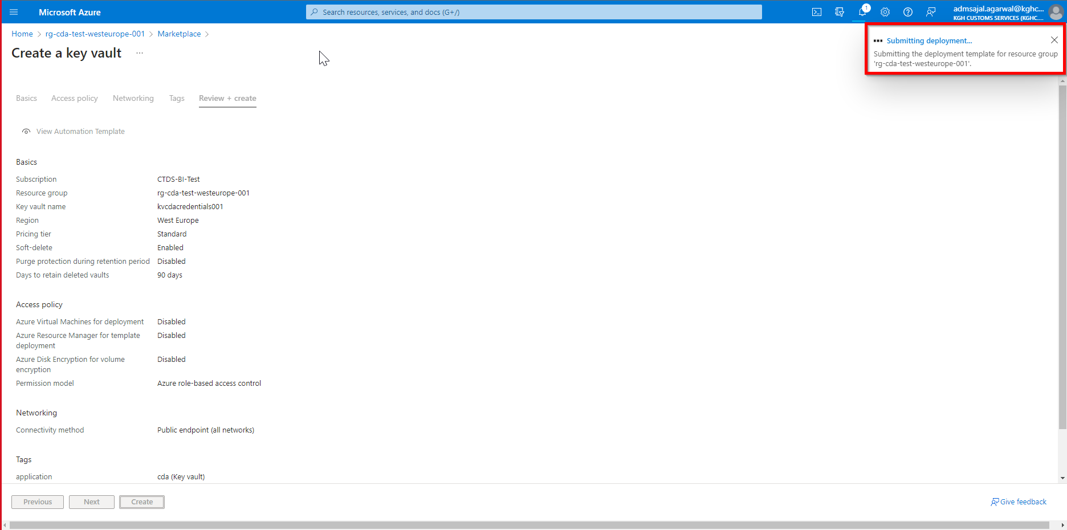

1. It will auto-redirect to deployment screen

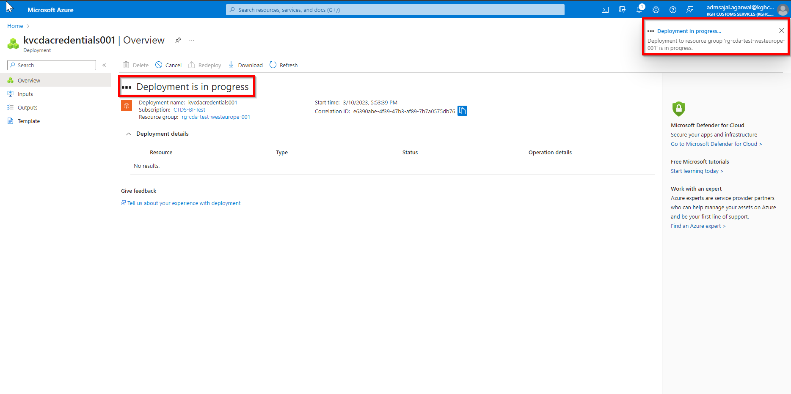

1. When the message changes to *Your deployment is complete*, click on *Go to resource*

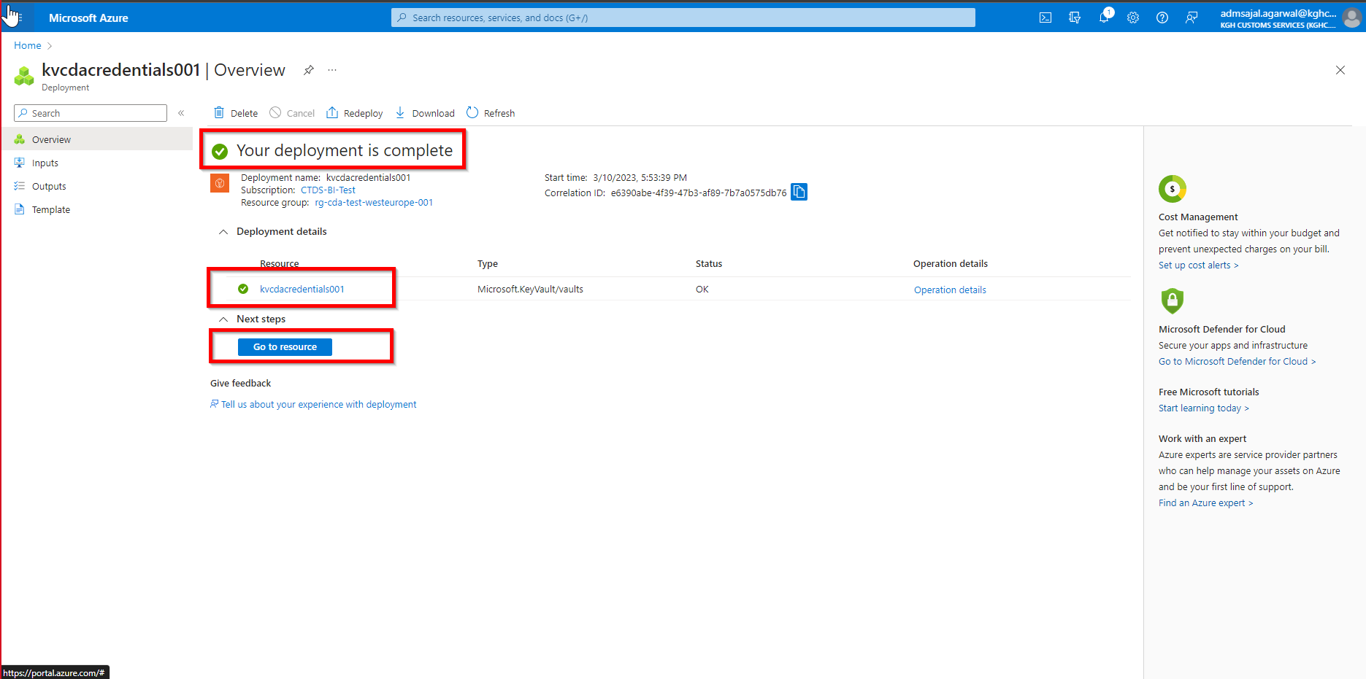

1. It will take to *Overview* page of created resource.

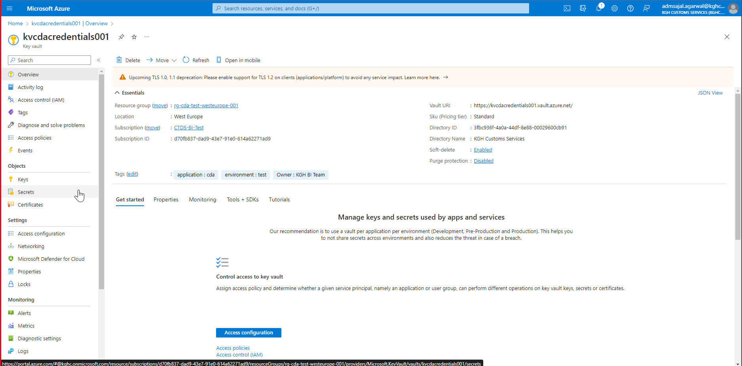

## **Objects Creation: Secrets**

1. Click on *Secrets*  from resource *Overview* page

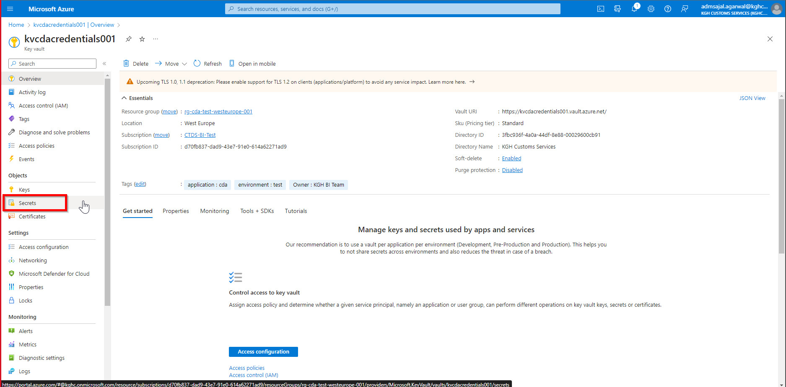

1. Click on *Generate/Import*

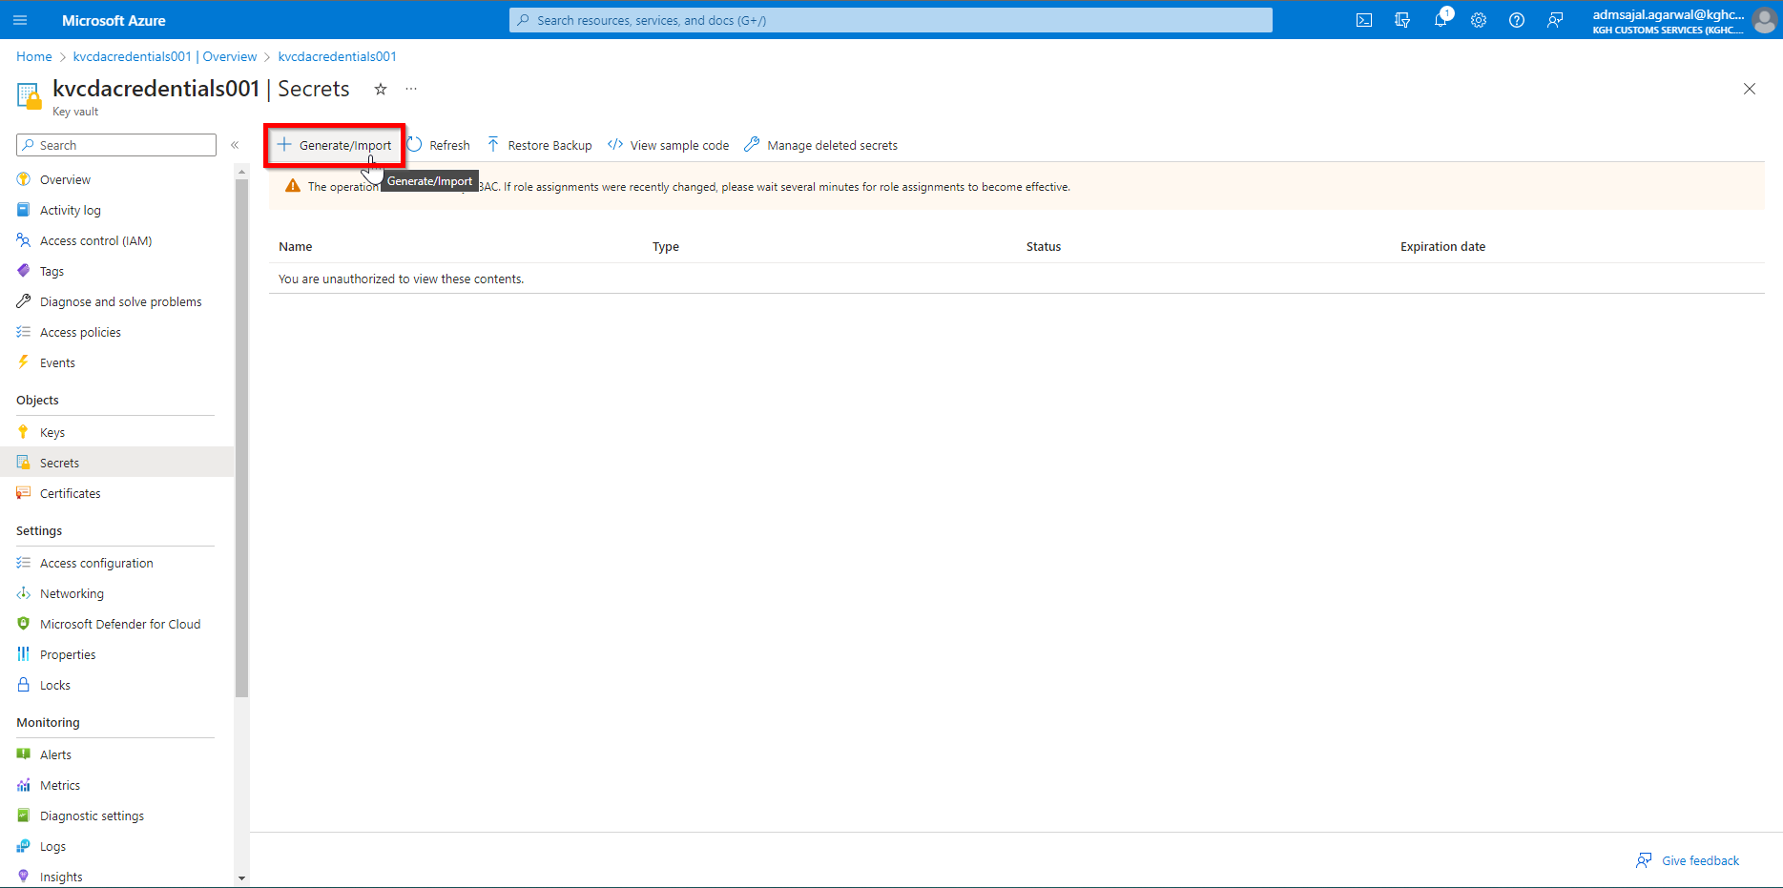

1. Get the Access key for Storage Account
   1. Open *Resource Groups* and search for *rg-cda-test-westeurope-001*



* 1. Click on resource *stcdadatalakeraw001*

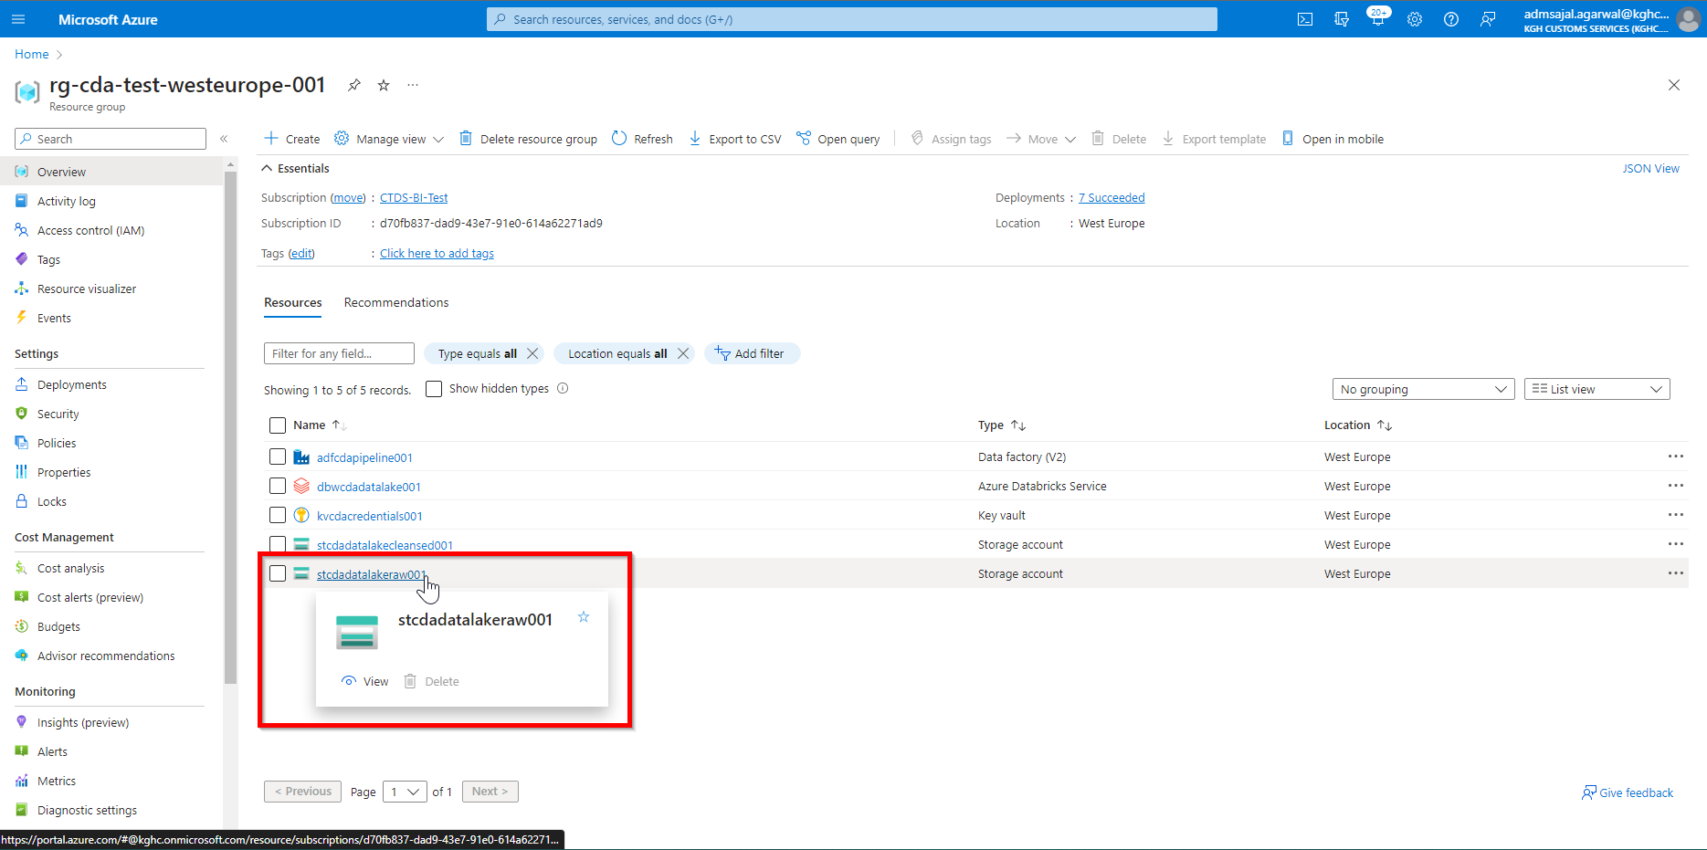

* 1. Click on *Access keys* from resource *Overview* page

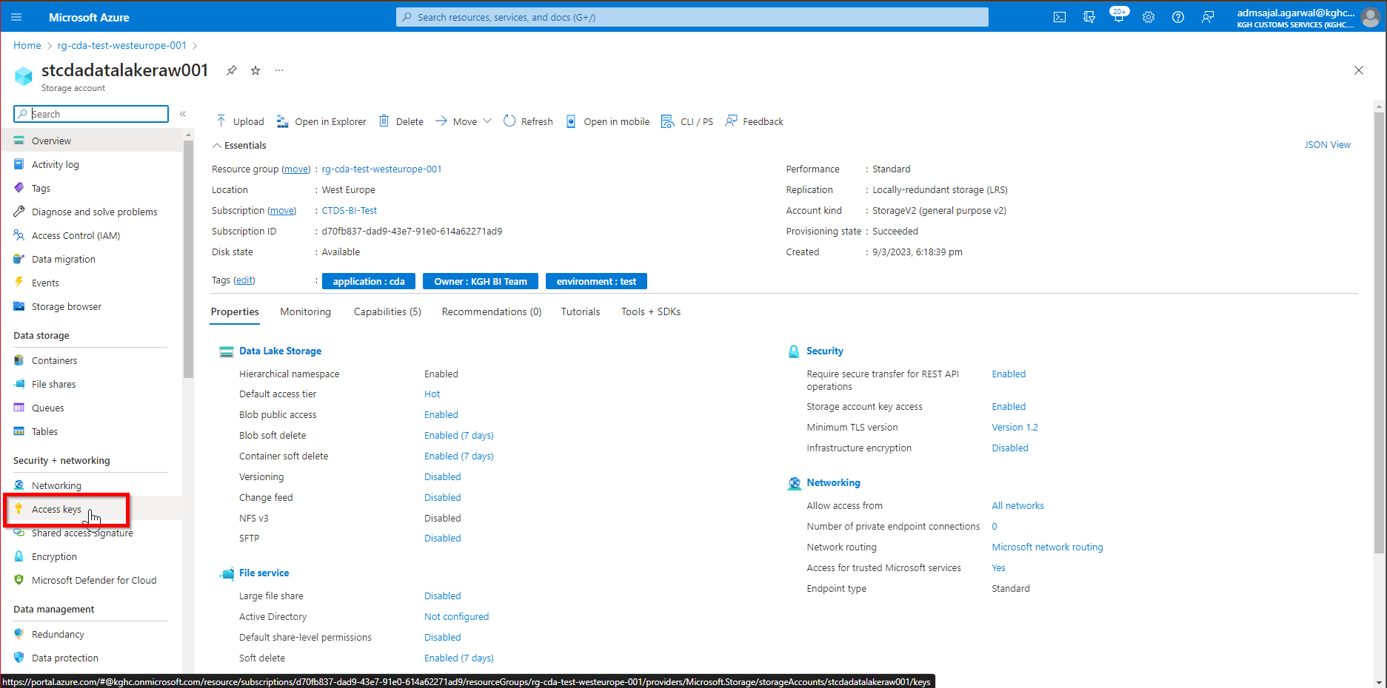

* 1. Under *key1*, click on *Show* in front of *Key* to display the access key

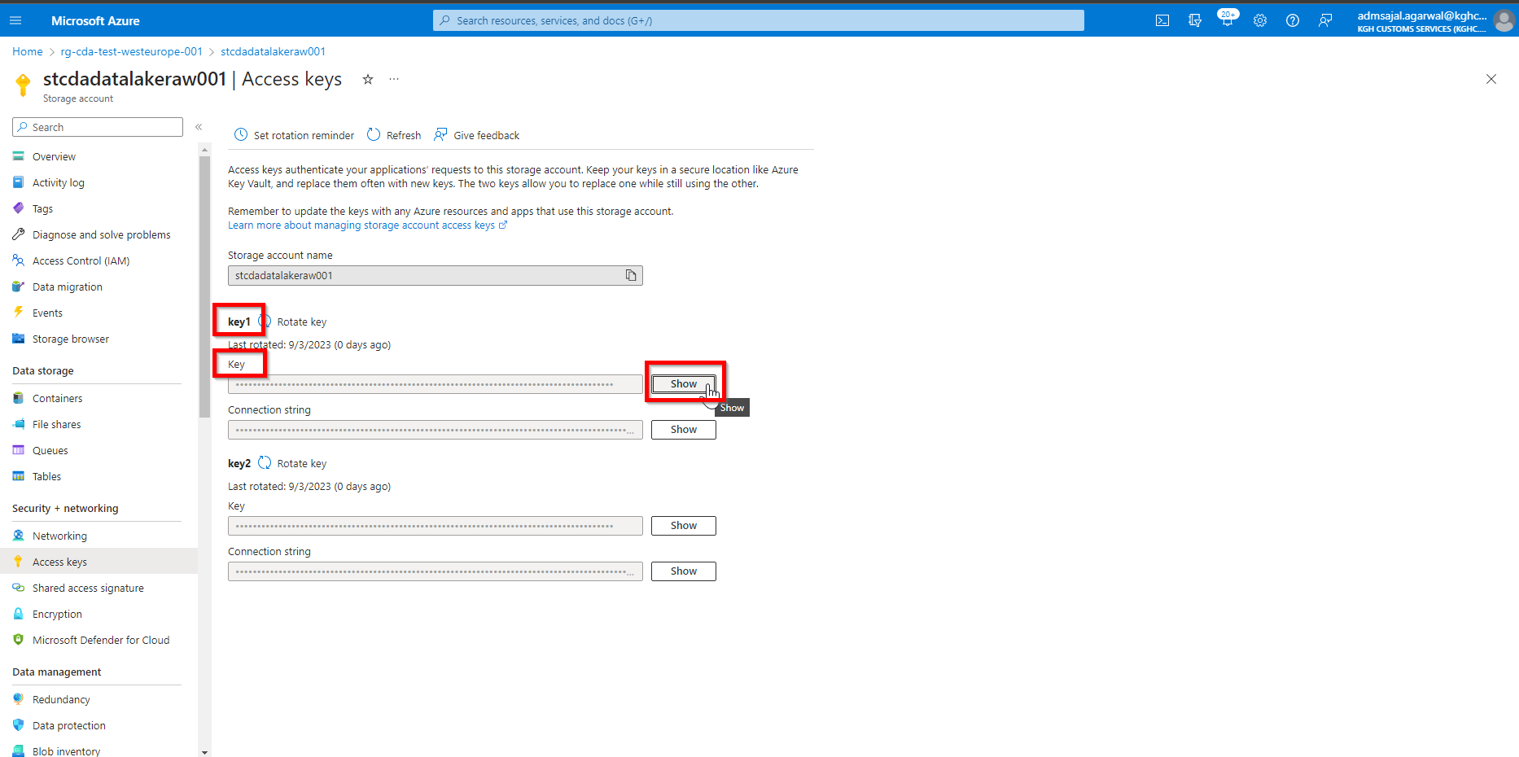

* 1. Click on *Copy to clipboard* icon

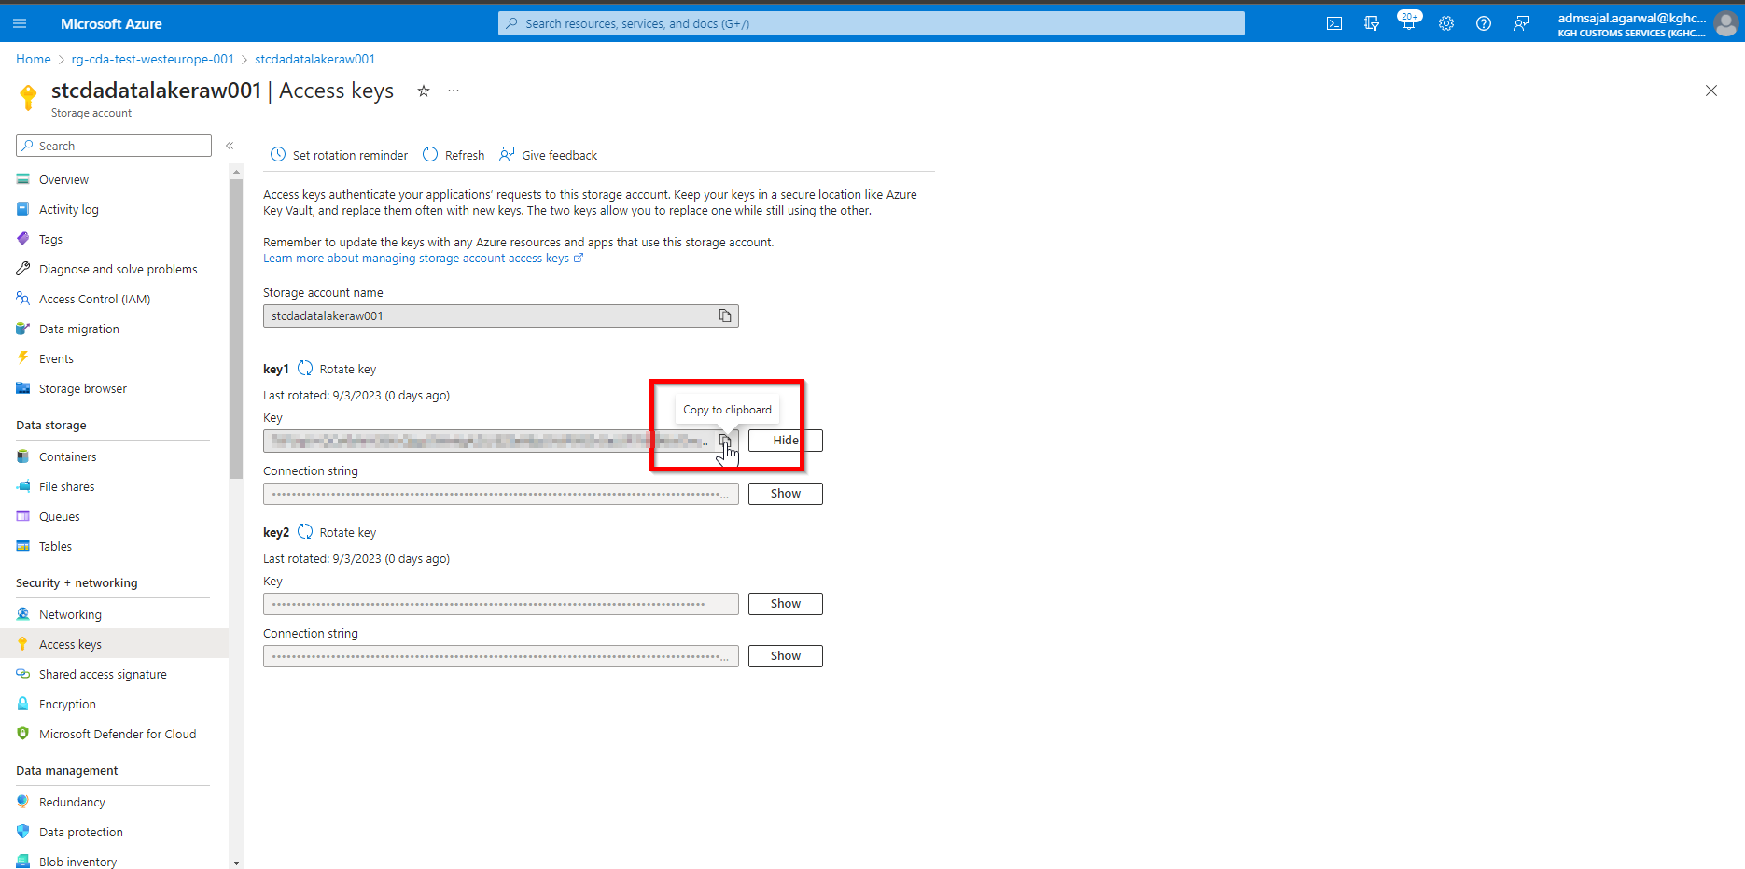

1. Fill the details as below:

Upload options: *Manual*

Name: *stcdadatalakeraw001-key1*

Secret value: *<paste the key copied in Step 29.e>*

Content type (optional): *Access keys <mention appropriate content type here>*

Click on *0 tags*

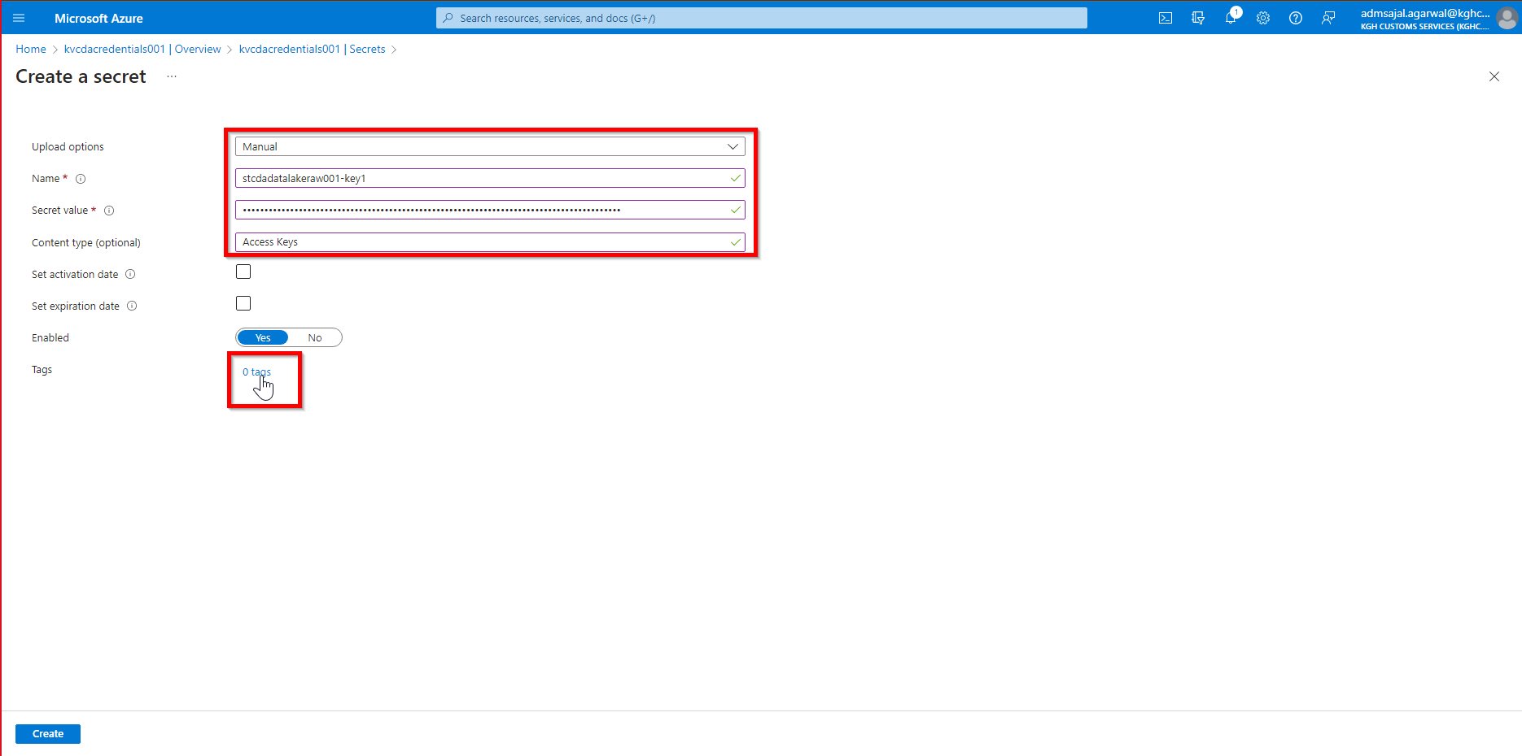

1. Add the tags as shown below:

application 🡪 *cda*

owner 🡪 *KGH BI Team*

environment 🡪 *test*

Click on *Ok*

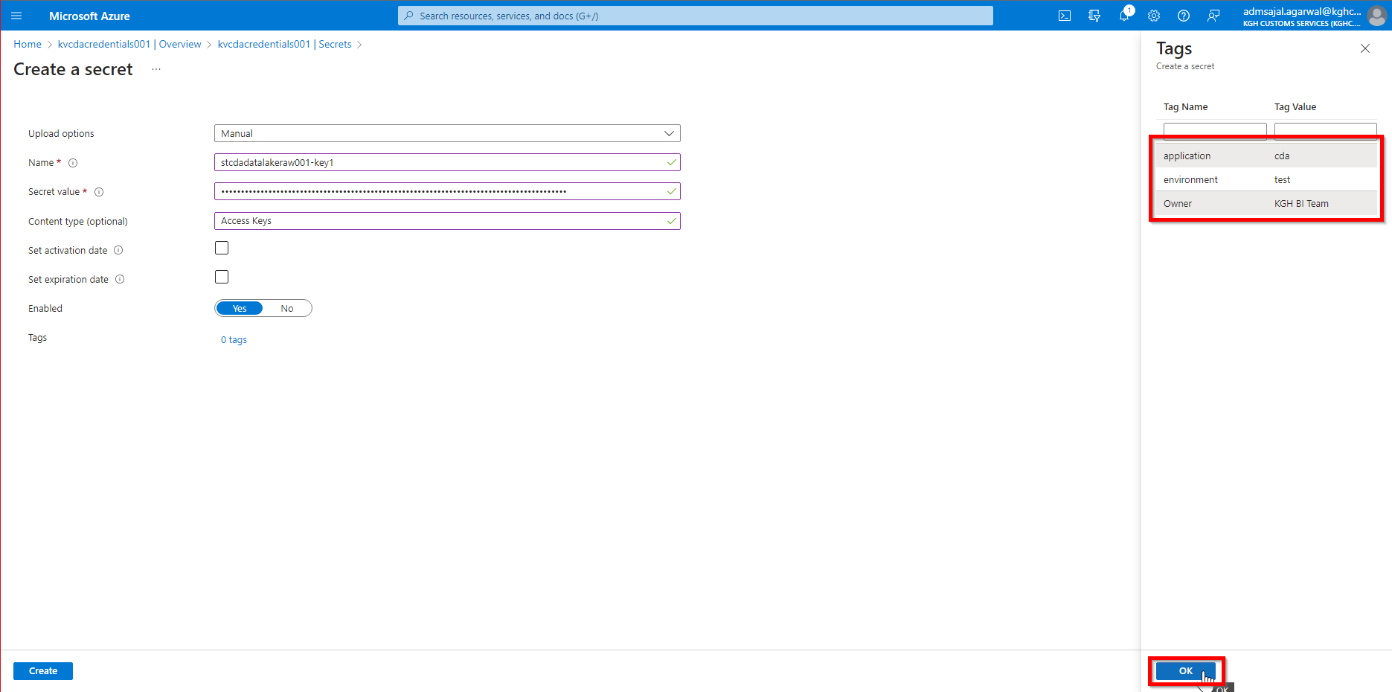

1. Click on *Create.* It will initialize the creation of the secret.

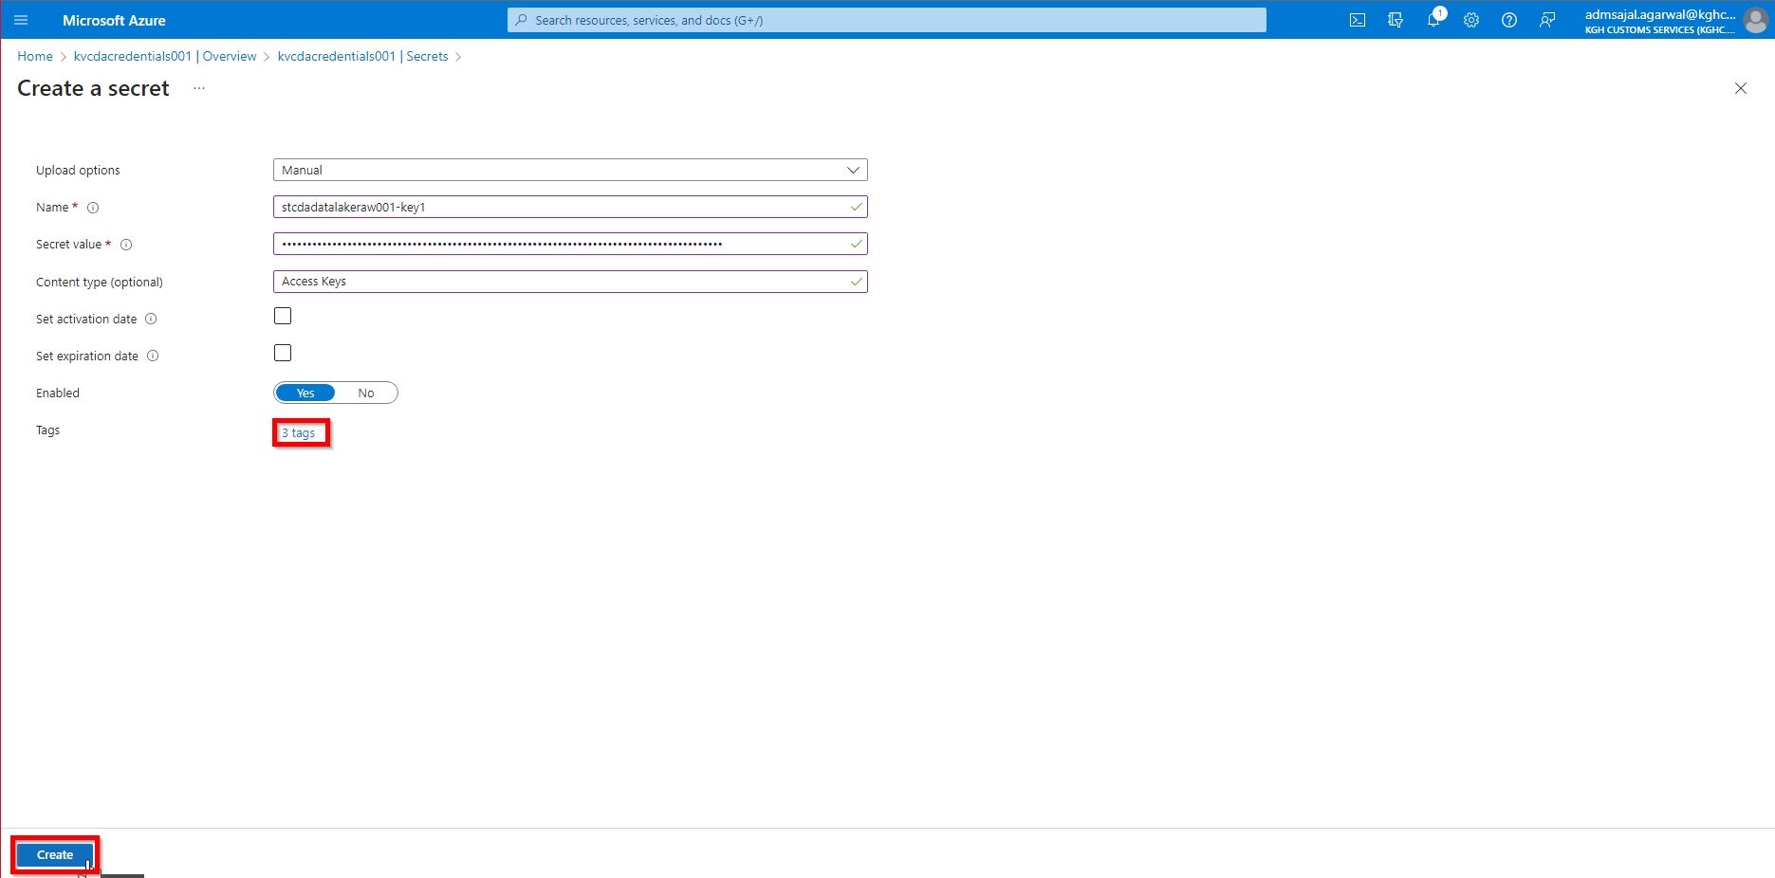

1. Once the secret is created, it will show the successful message.

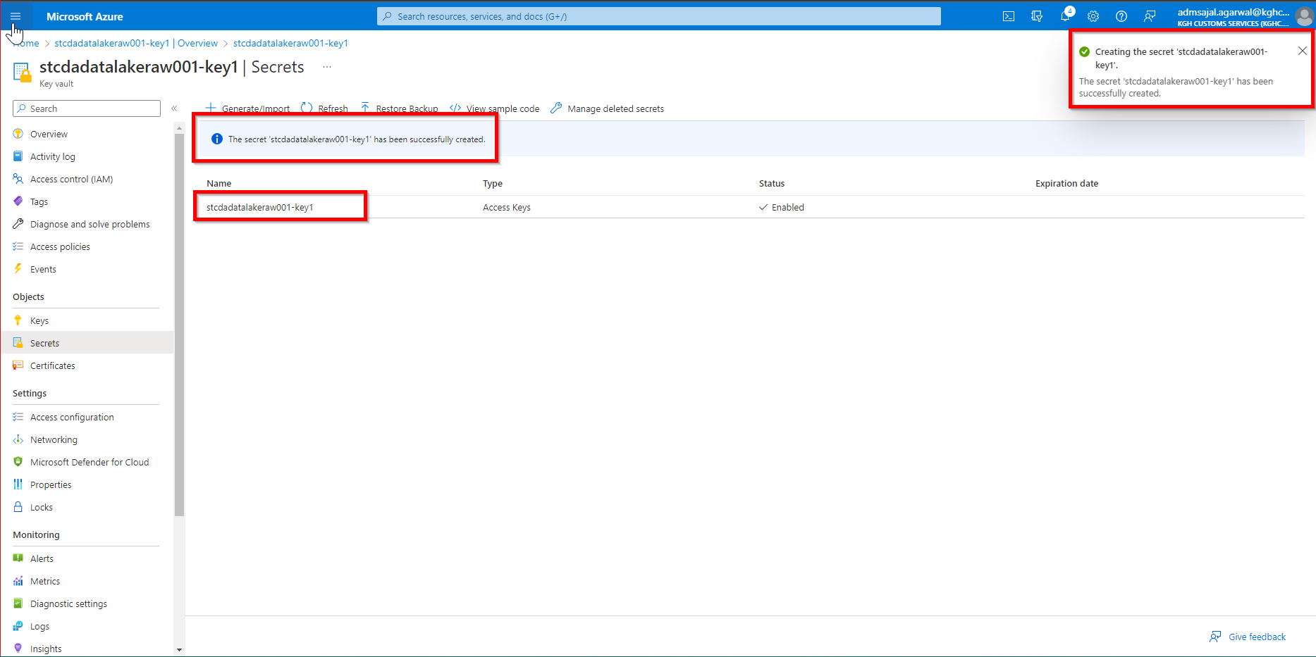

# **Resource Creation: SQL Database**

1. Open *Resource Groups* and search for *rg-cda-test-westeurope-001*



1. Click on *Create*

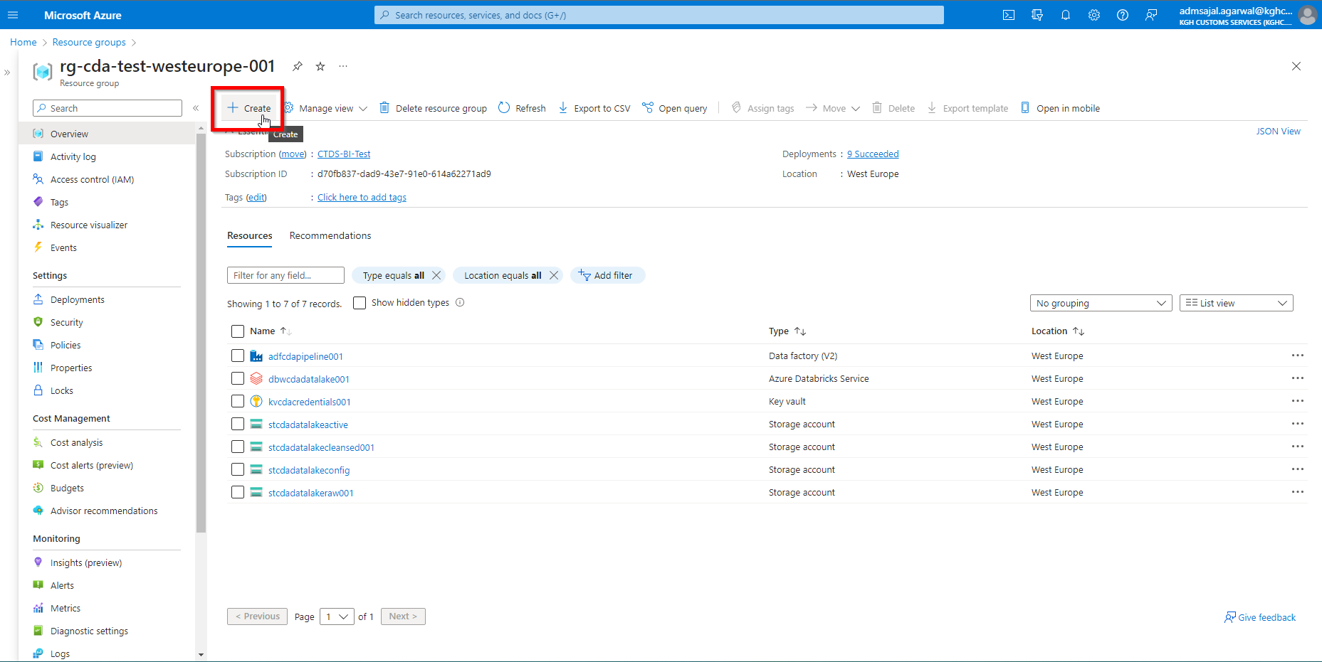

1. Below screen will appear:

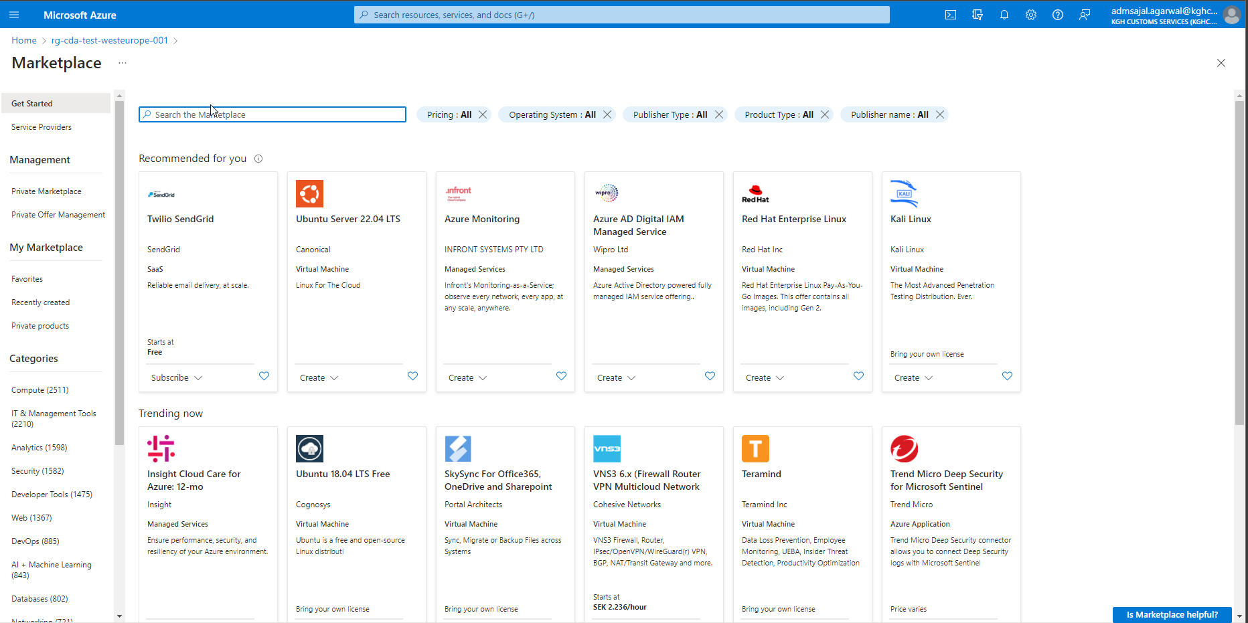

1. Search for *Azure SQL*

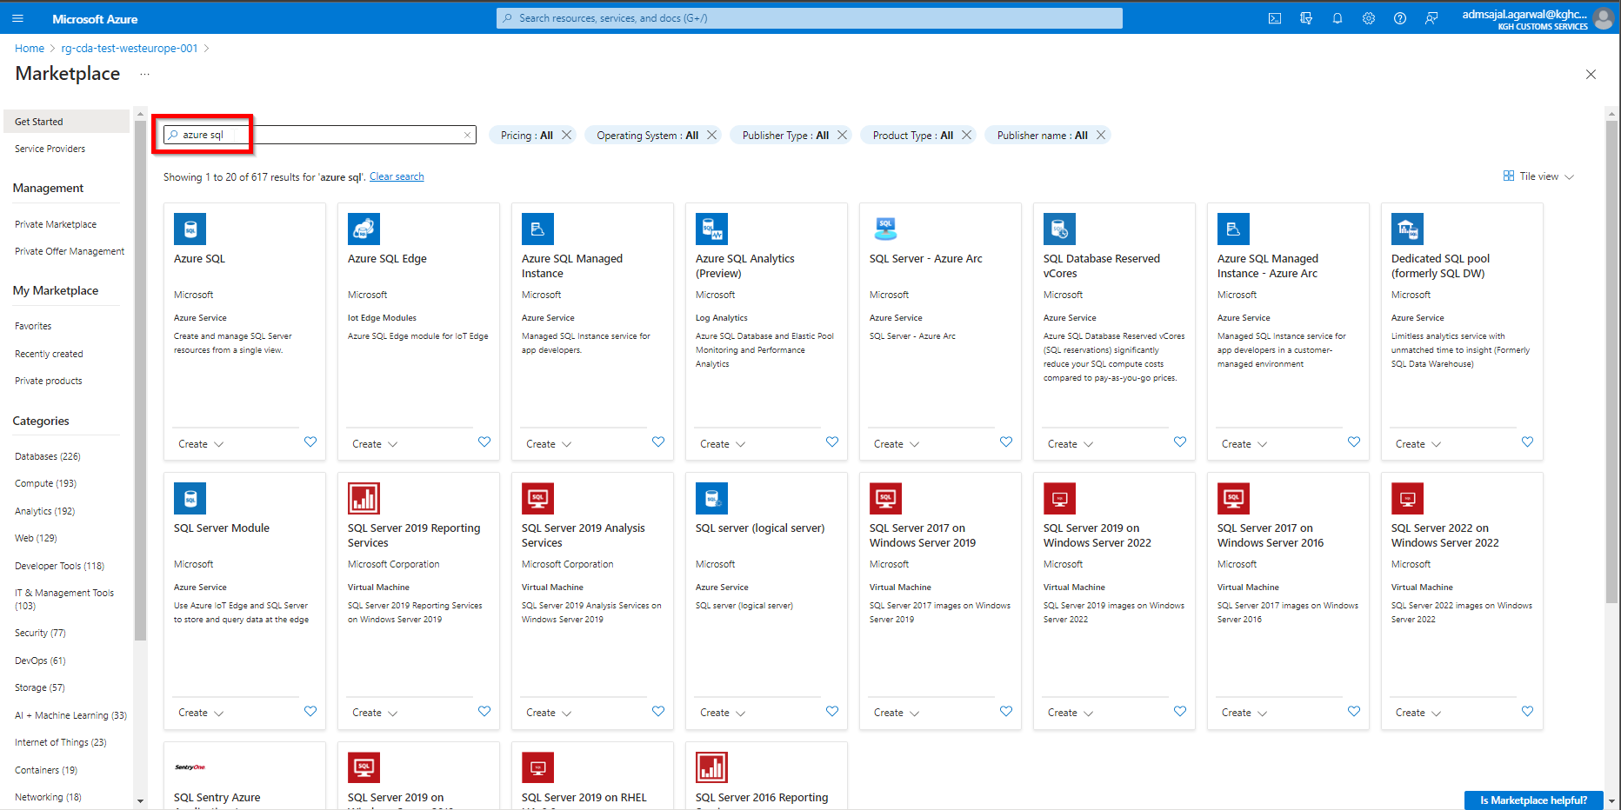

1. Click on *Create 🡪 Azure SQL* in *Azure SQL* tile

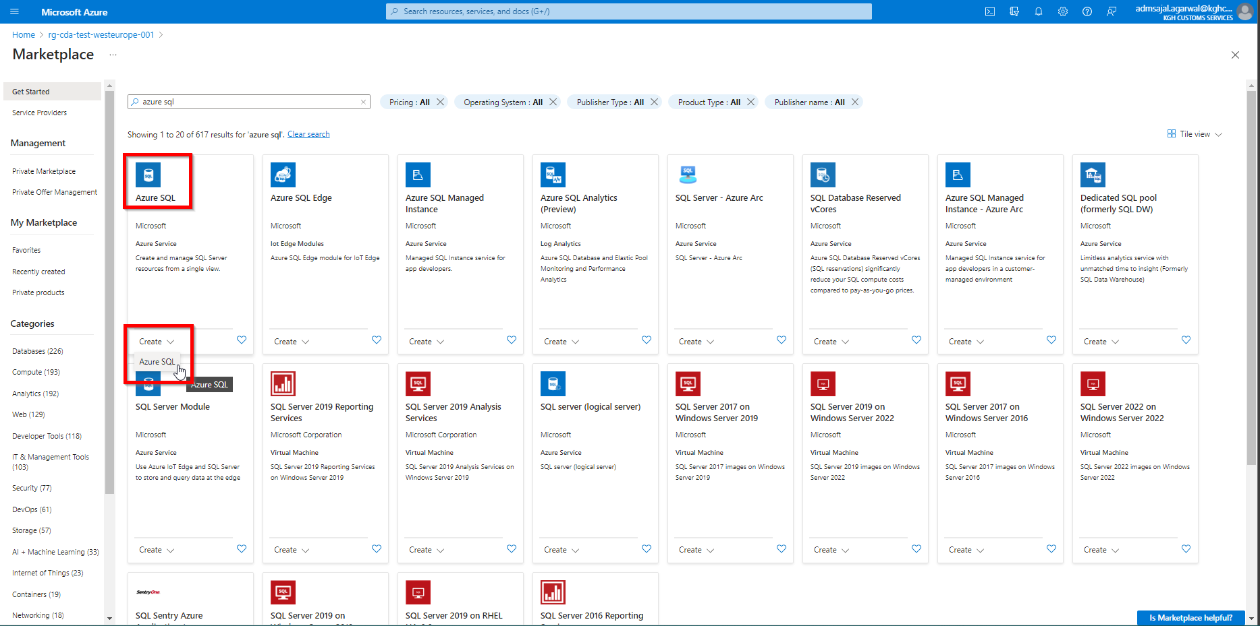

1. Click on *Create* under *SQL database*

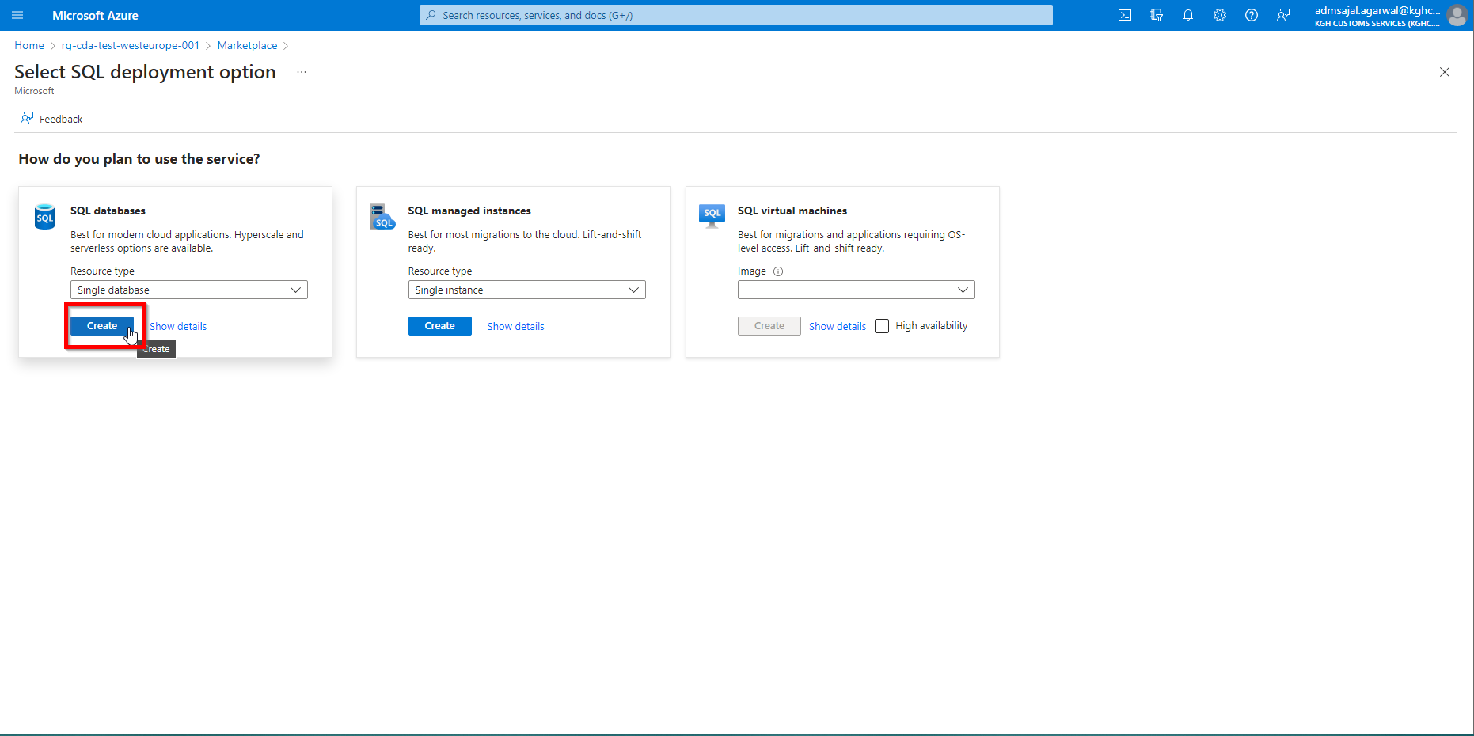

1. Fill the details as below:

Subscription: *CTDS-BI-Test*

Resource Group: *rg-cda-test-westeurope-001*

Database name: *sqldb_cda_mds_test*

Click on *Create new* under *Server*

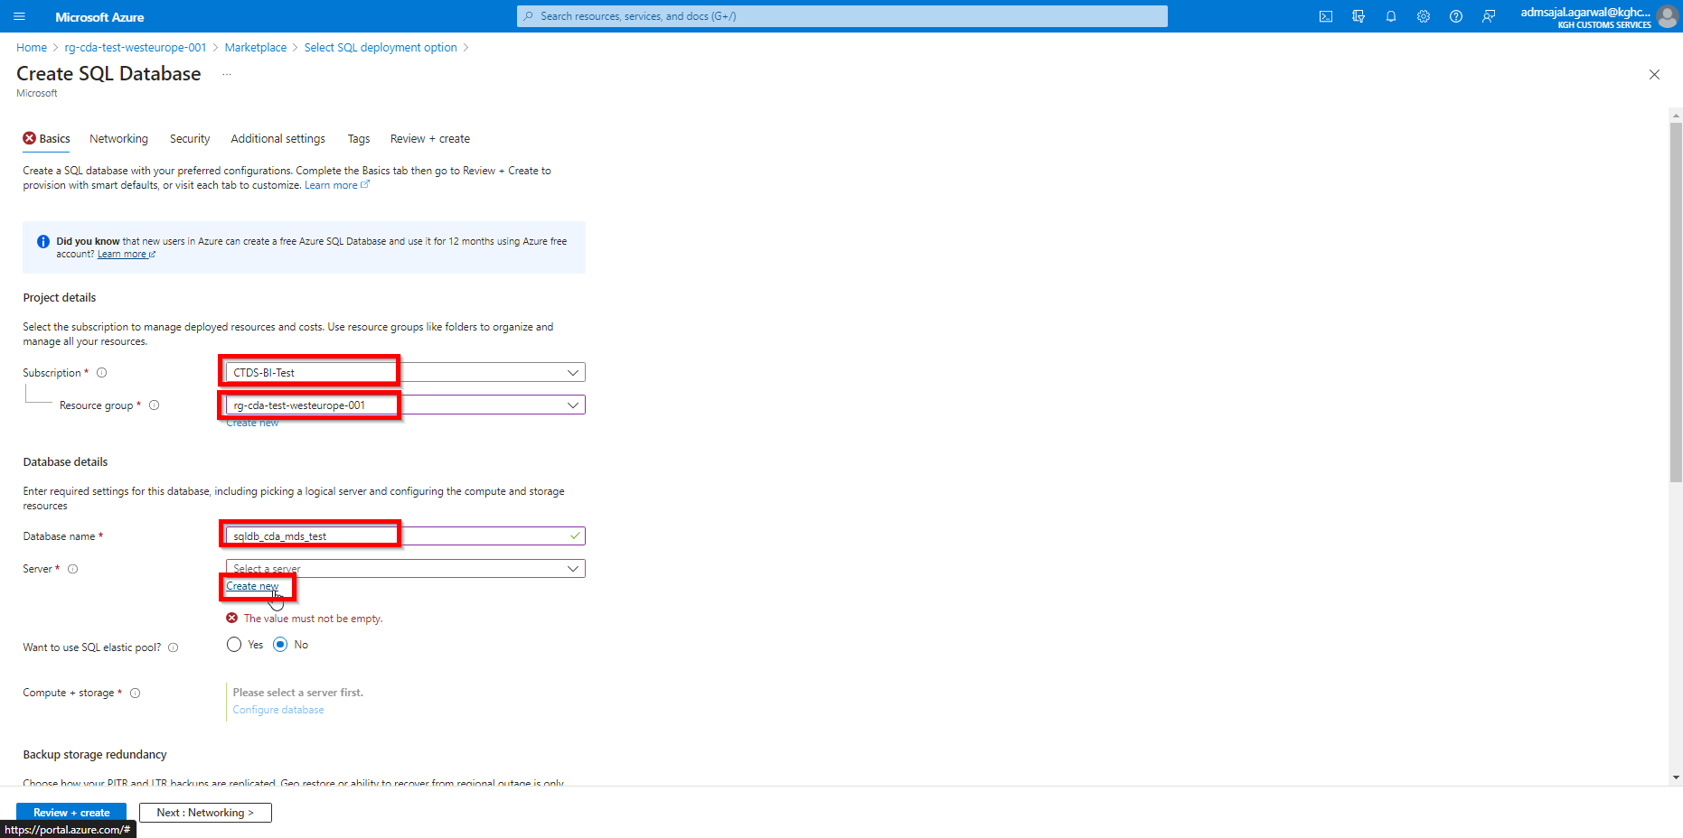

1. Fill the details as below:

Server name: *sql-vm-cda-mds-test-01*

Location: *(Europe) West Europe*

Authentication Method: *Use both SQL and Azure AD authentication*

Set Azure AD admin: Click on *Set admin* and select the admin account

Server admin login: *svr-adm-mds*

Password: *@dmmd$2023*

Confirm password: *@dmmd$2023*

Click on *Ok*

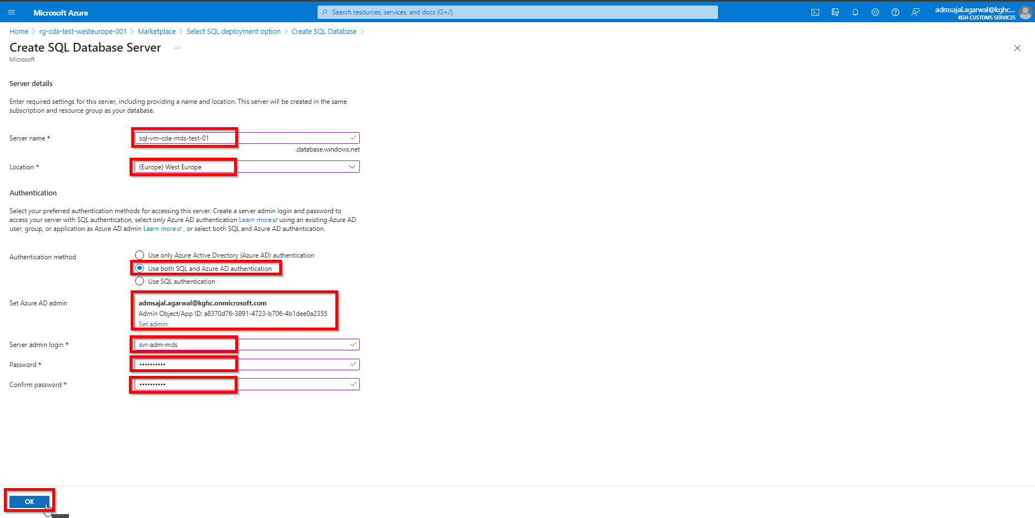

1. Click on *Configure database* under *Compute + storage*

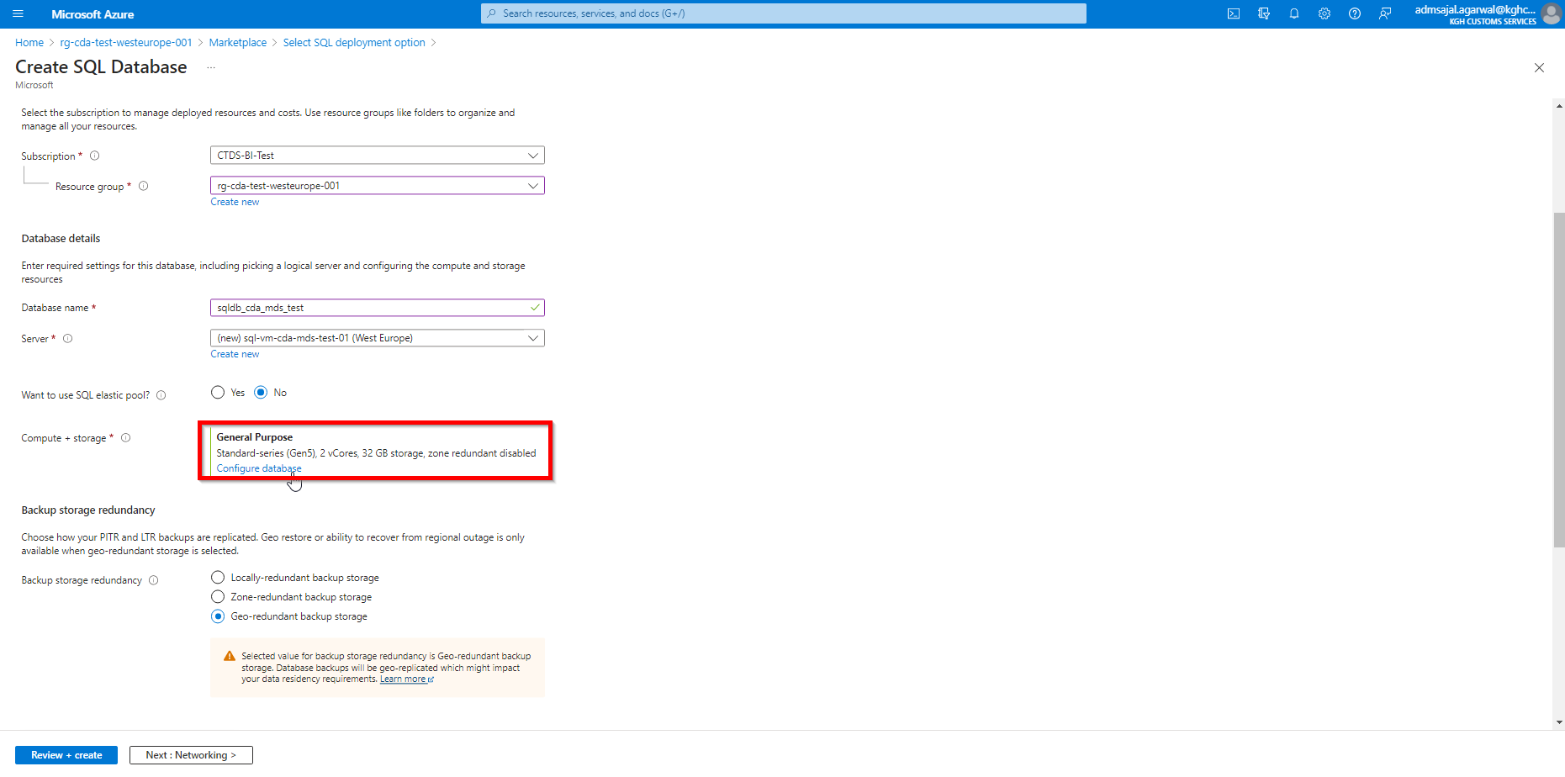

1. Select options as below:

Service tier: *General Purpose*

Compute tier: *Serverless*

Hardware Configuration: *Standard-series (Gen5)*

Max vCores: *8*

Auto-pause delay: *1 Hour*

Data max size (GB): *32*

Zone redundant: *No*

 :

Click on *Apply*

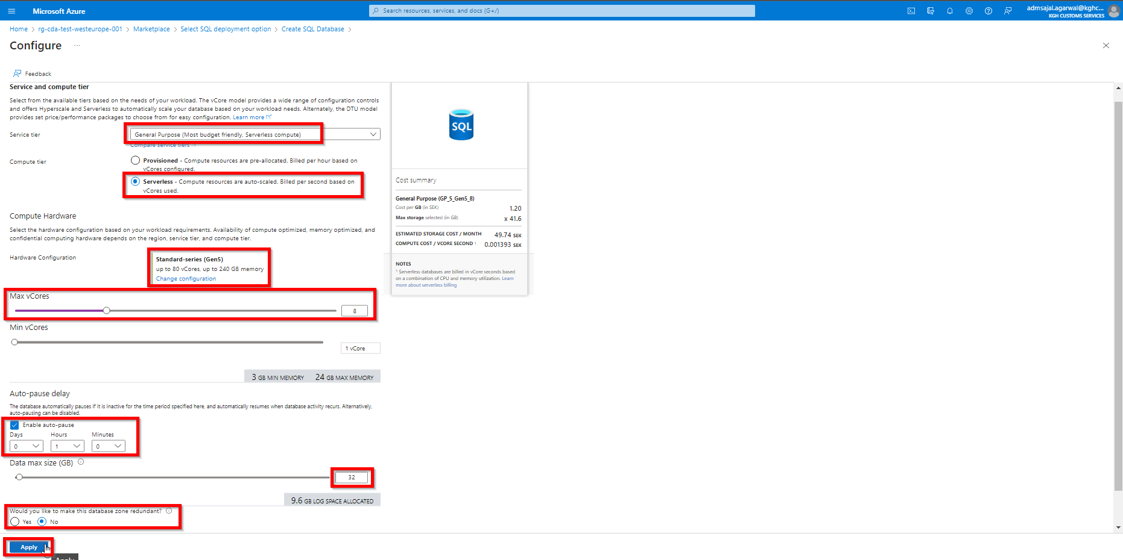

1. Select options as below:

Backup storage redundancy: *Locally-redundant backup storage*

Click on *Next : Networking*

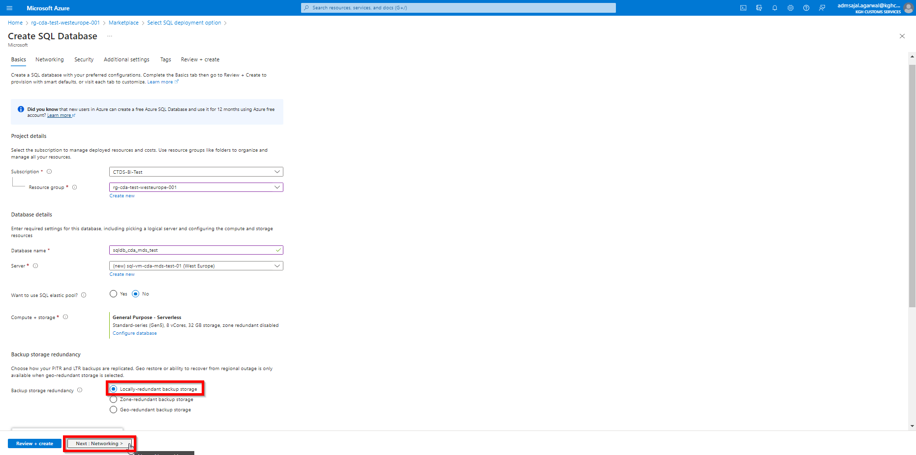

1. Keeping all options as default, click on *Next : Security*

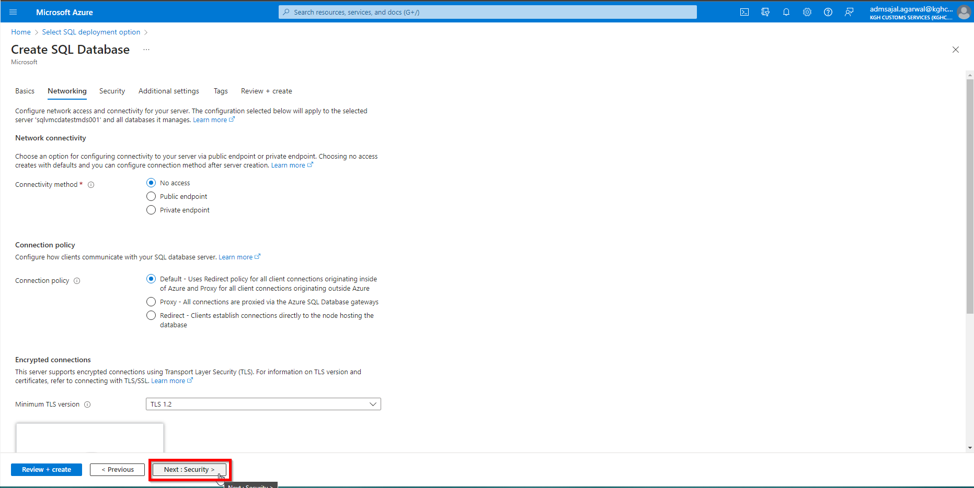

1. Keeping all options as default, click on *Next : Additional settings*

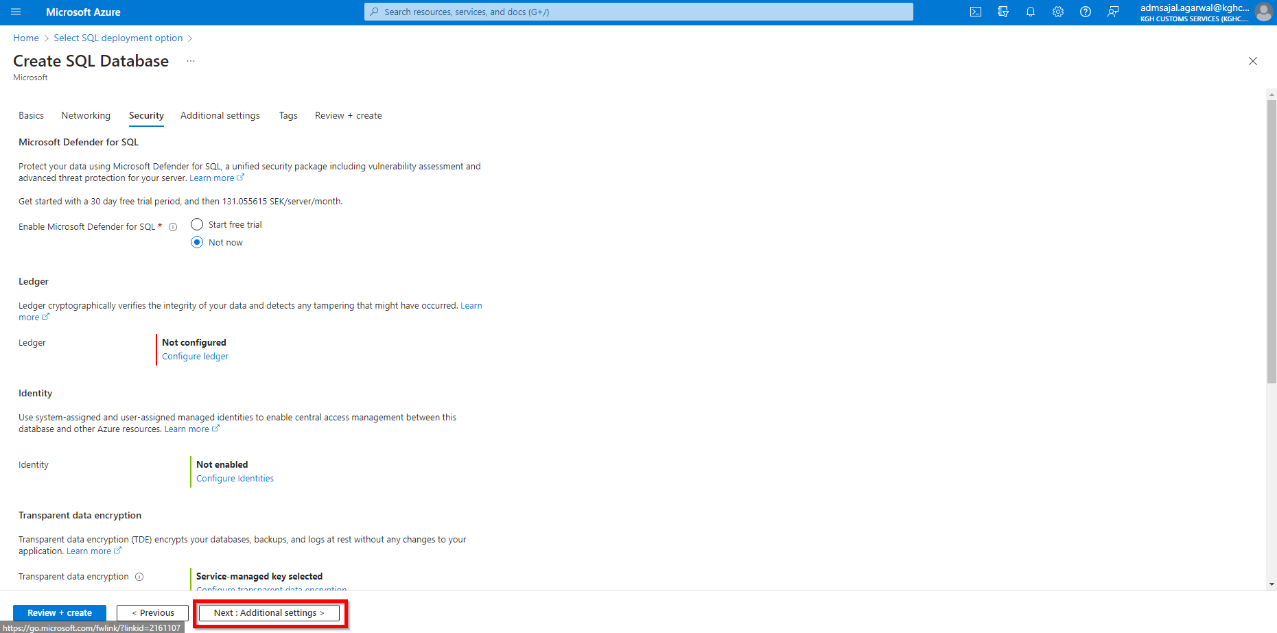

1. Change the details as shown below:

Collation 🡪 *Finnish_Swedish_CI_AS*

Click on *Next : Tags*

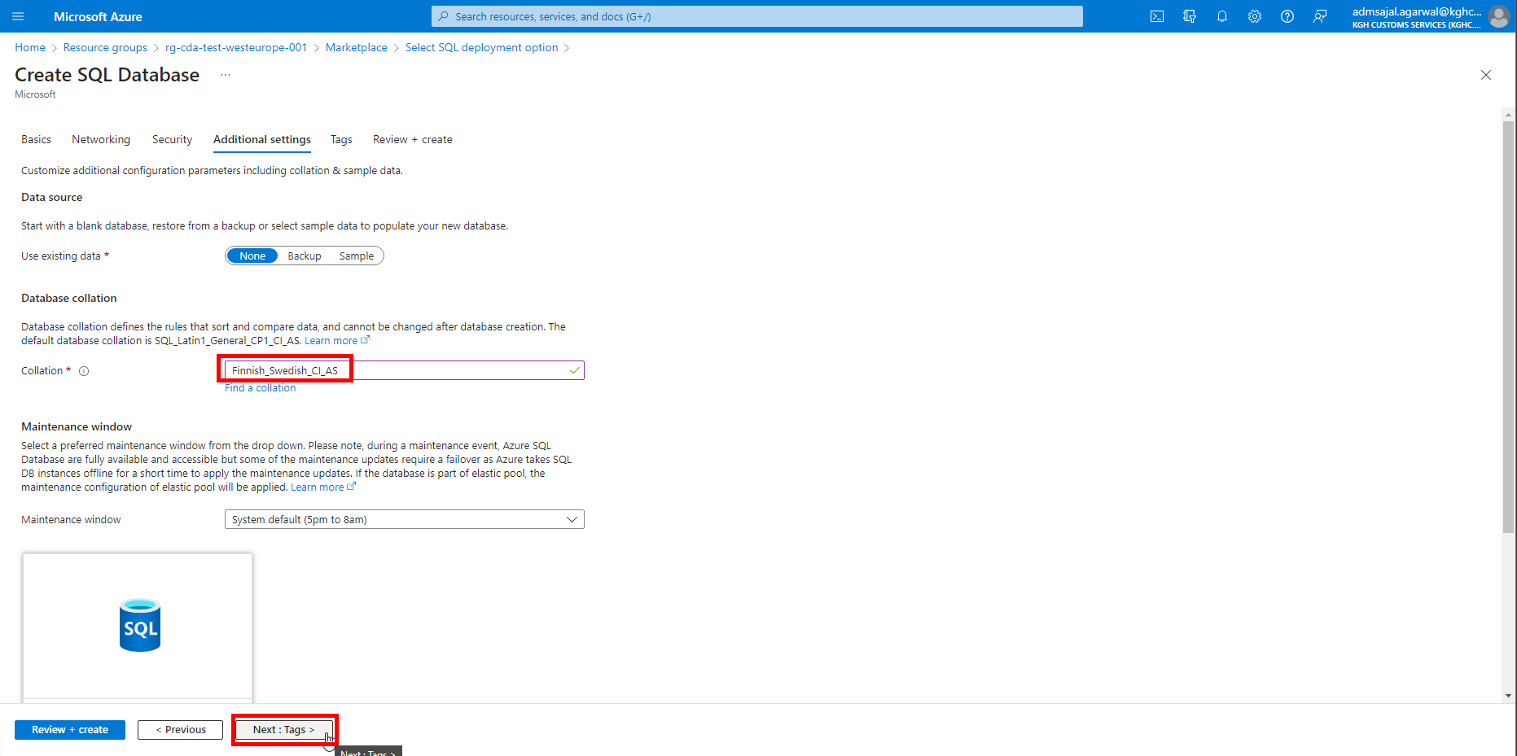

1. Add the tags as shown below:

application 🡪 *cda*

owner 🡪 *KGH BI Team*

environment 🡪 *test*

Click on *Next: Review + create*

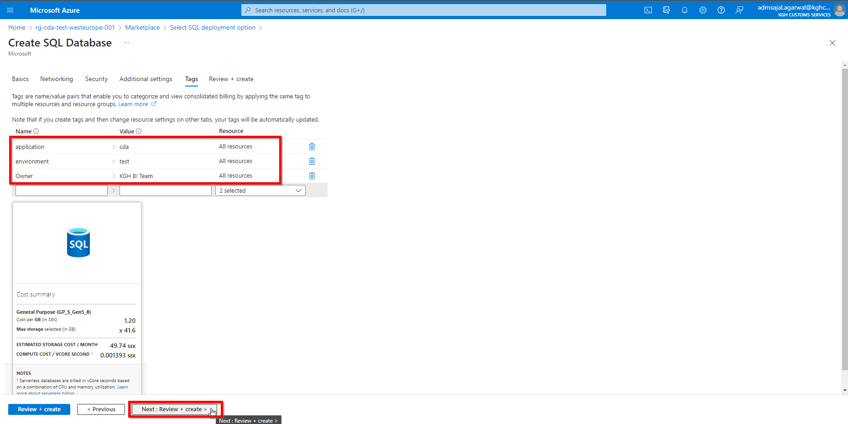

1. Wait for the *Validation* to complete and *Create* button to be enabled

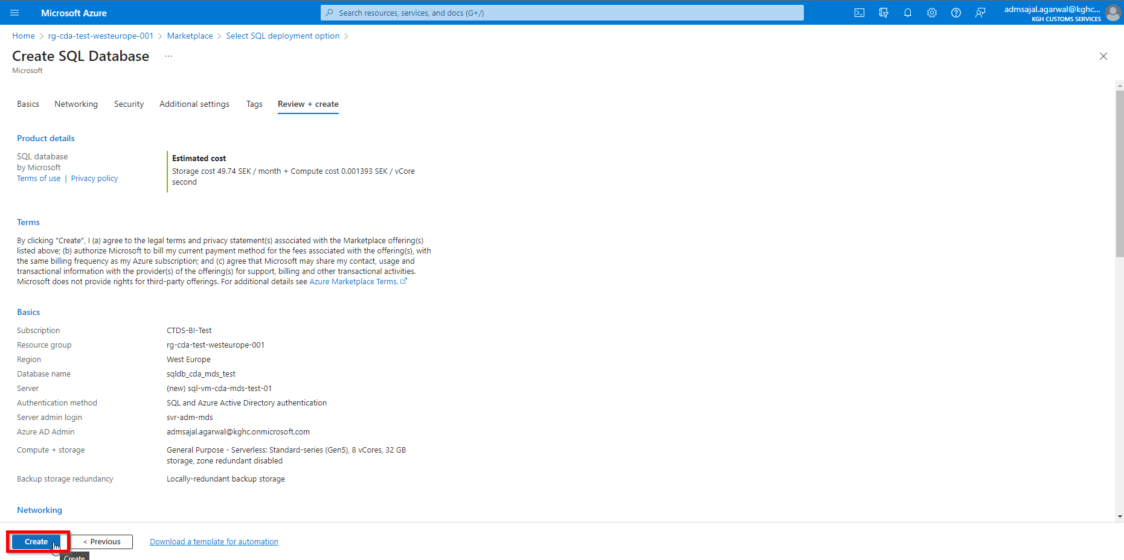

1. Click on *Create*. It will initialize the deployment of resource.

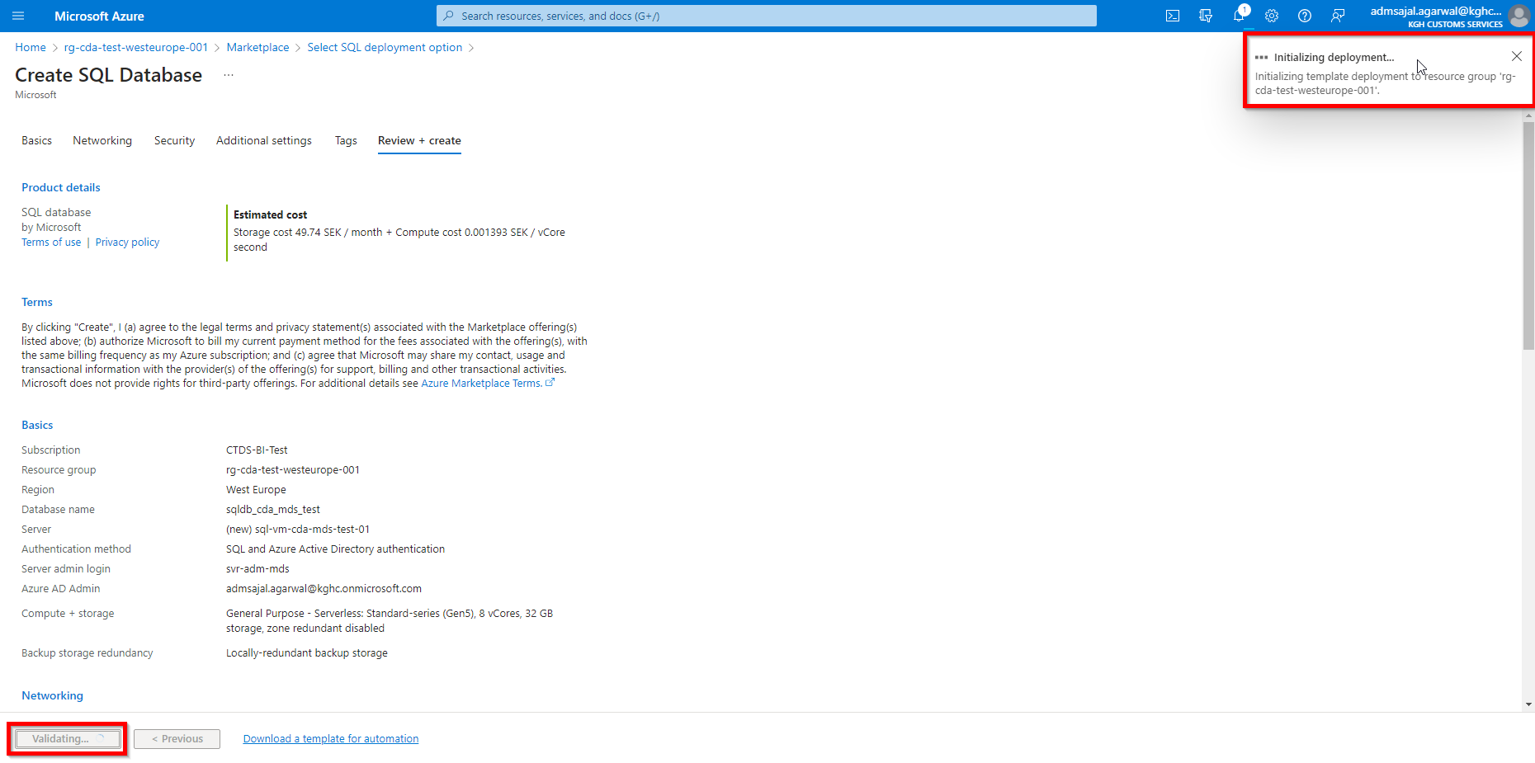

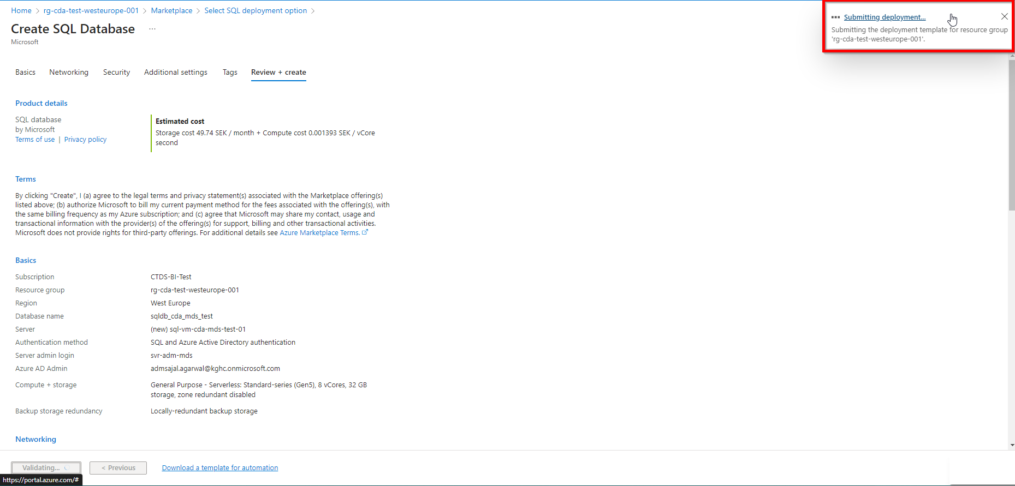

1. It will auto-redirect to deployment screen

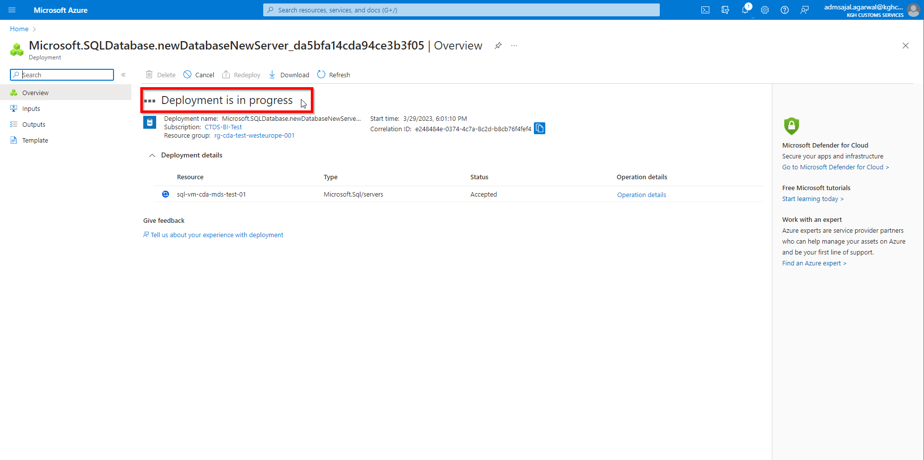

1. When the message changes to *Your deployment is complete*, click on *Go to resource*

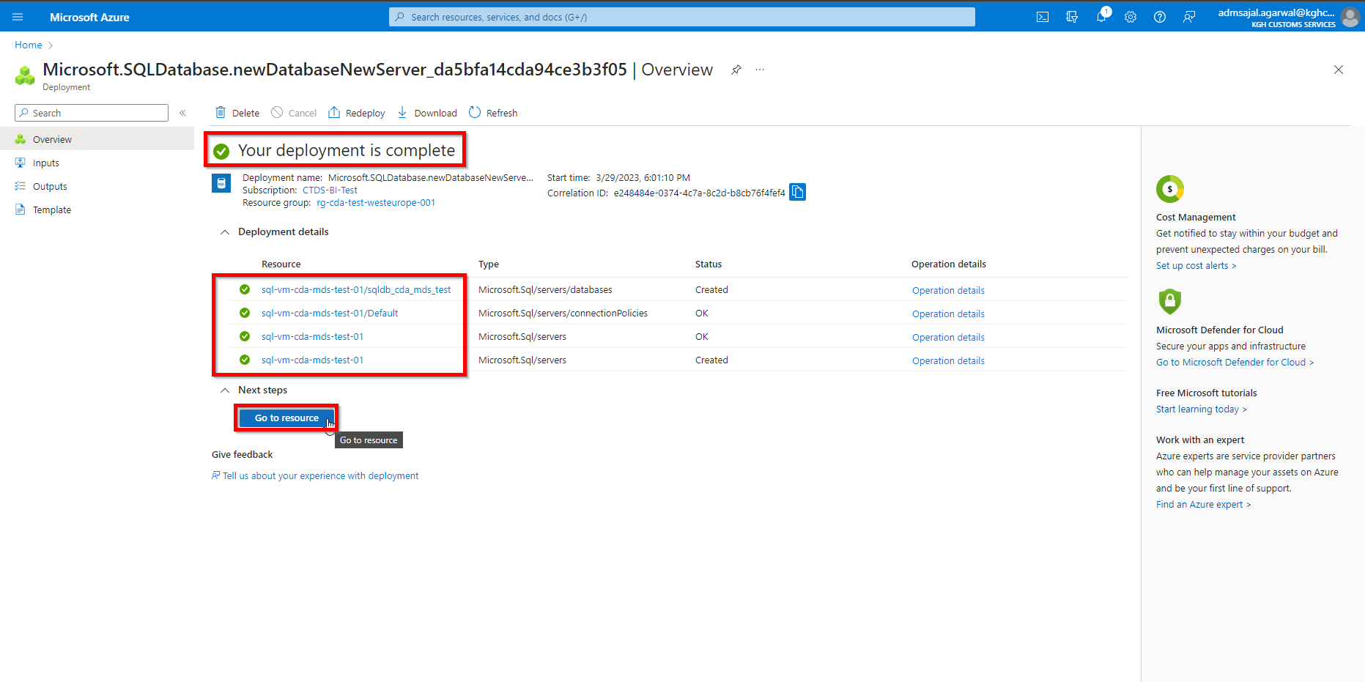

1. It will take to *Overview* page of created resource.

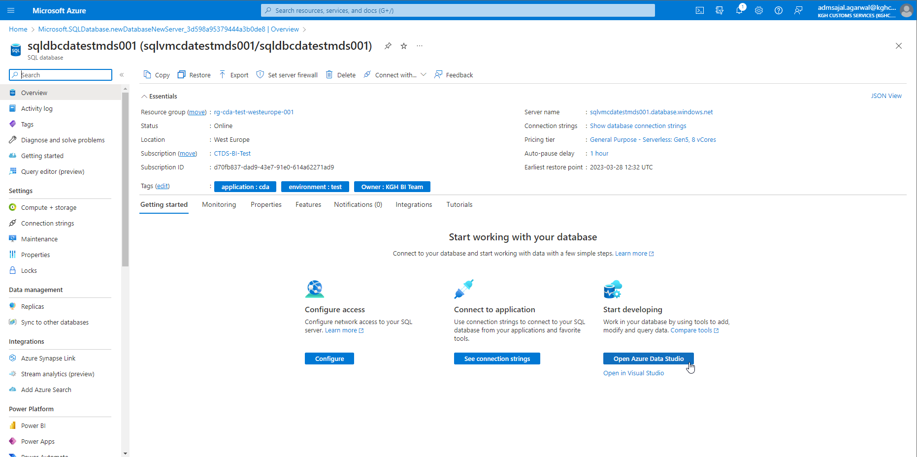

## **Installation: Azure Data Studio**

1. Click on *Open Azure Data Studio* from resource *Overview* page

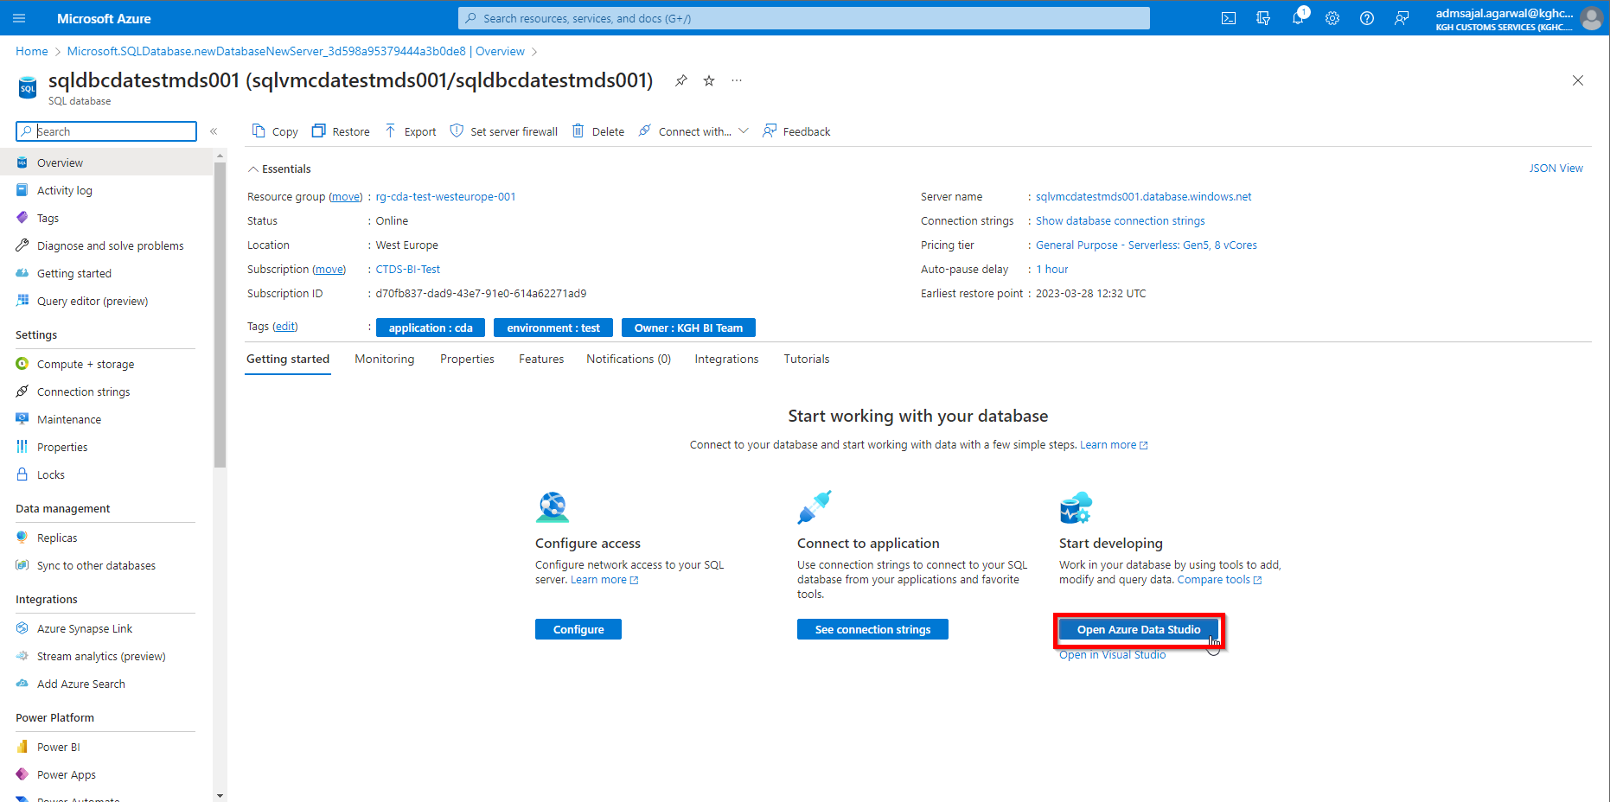

1. Click on *Download* *Azure Data Studio*

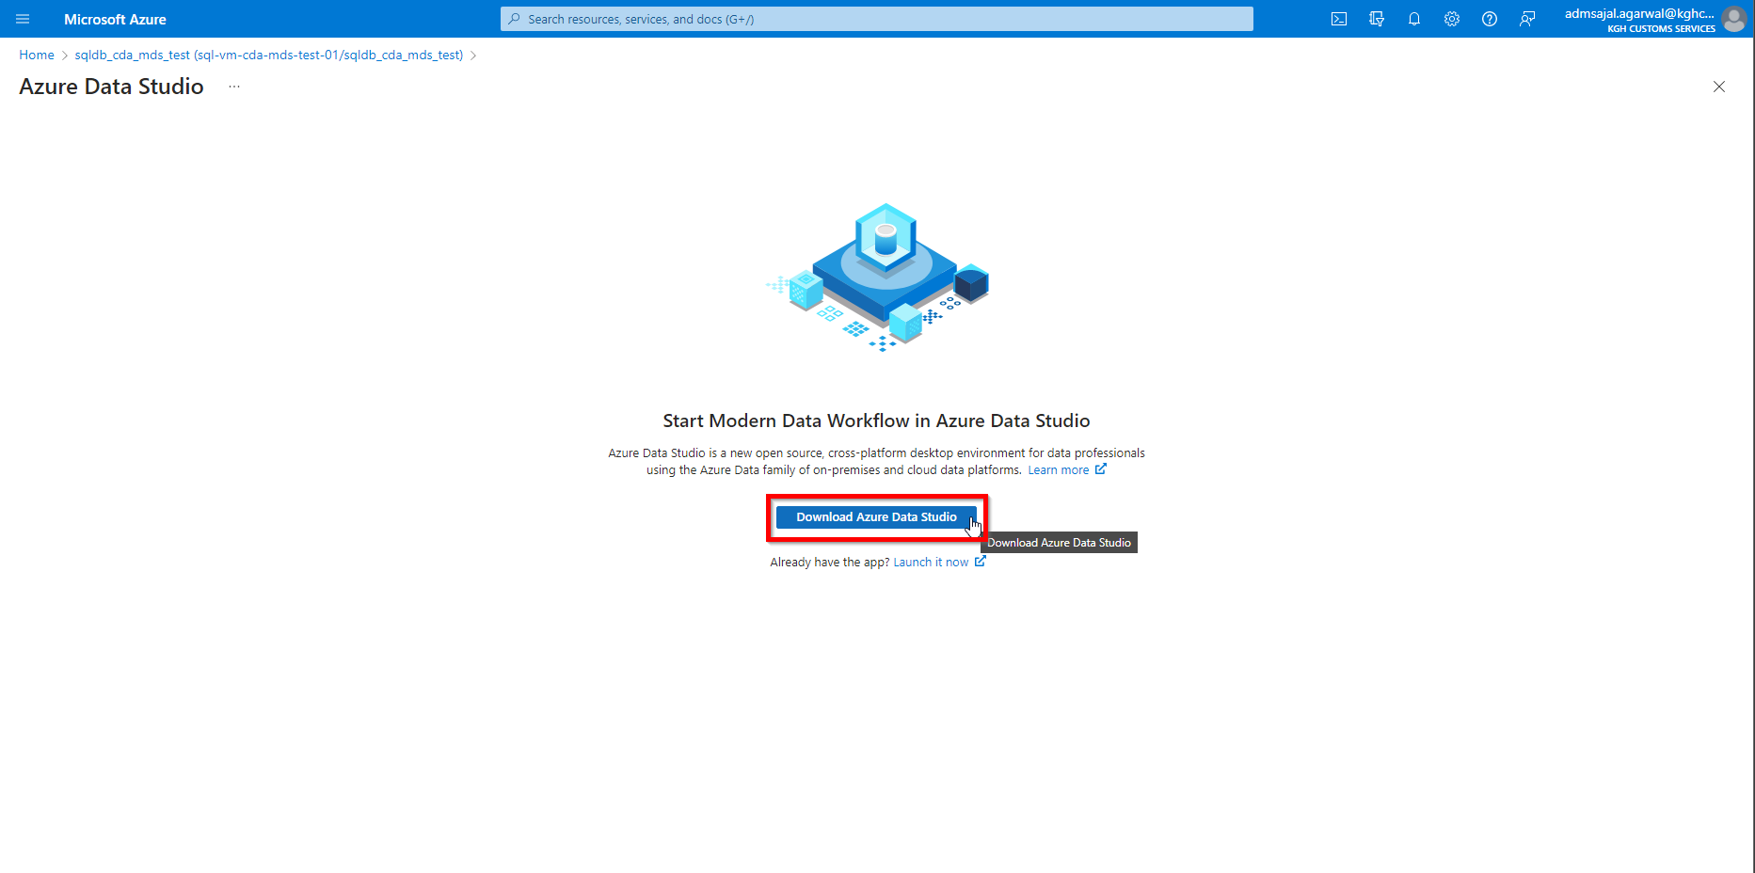

1. Click on *Azure Data Studio user installed for Windows*

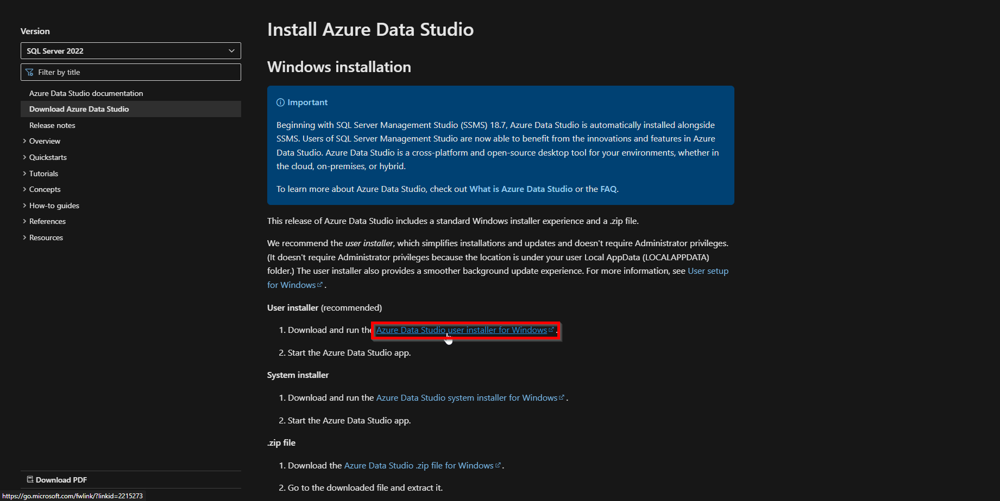

1. Click on *I accept the Agreement*

Click on *Next*

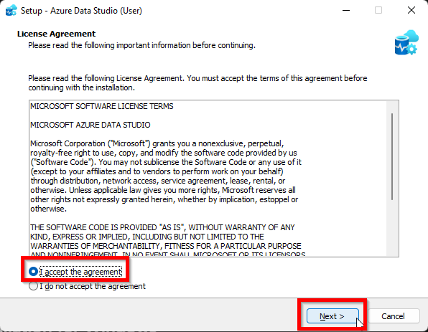

1. Provide a local path for installation. Click on *Next*.

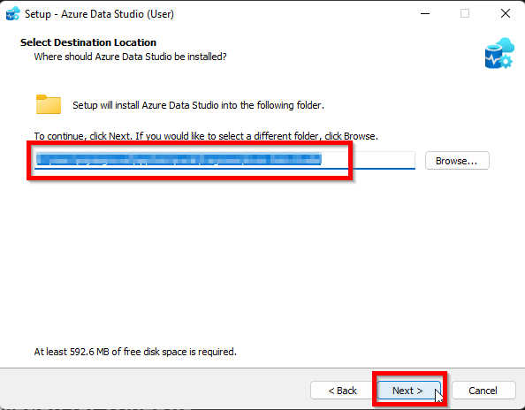

1. Click on *Next*

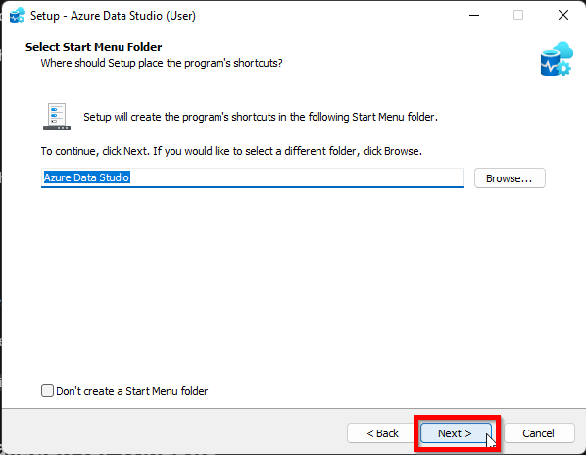

1. Click on *Next*

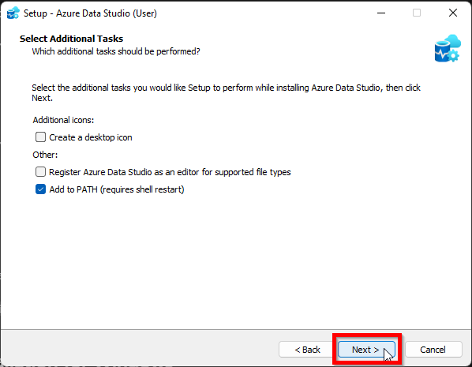

1. Click on *Install*

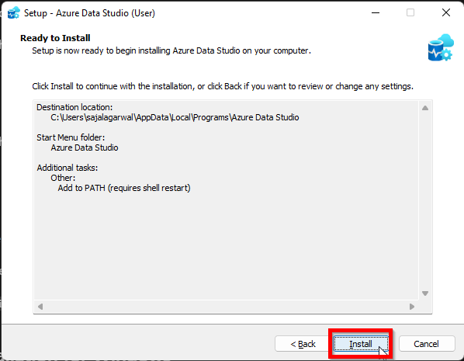

1. Wait for installation to complete.

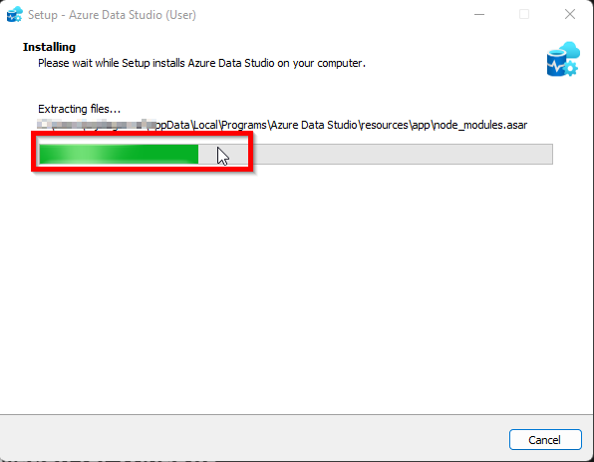

1. Tick-mark the *Launch Azure Data Studio*. Click on *Finish.*

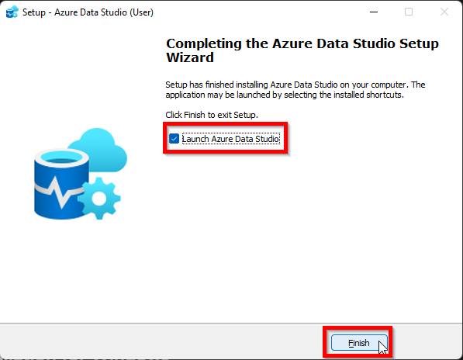

1. It will open the *Azure Data Studio.*

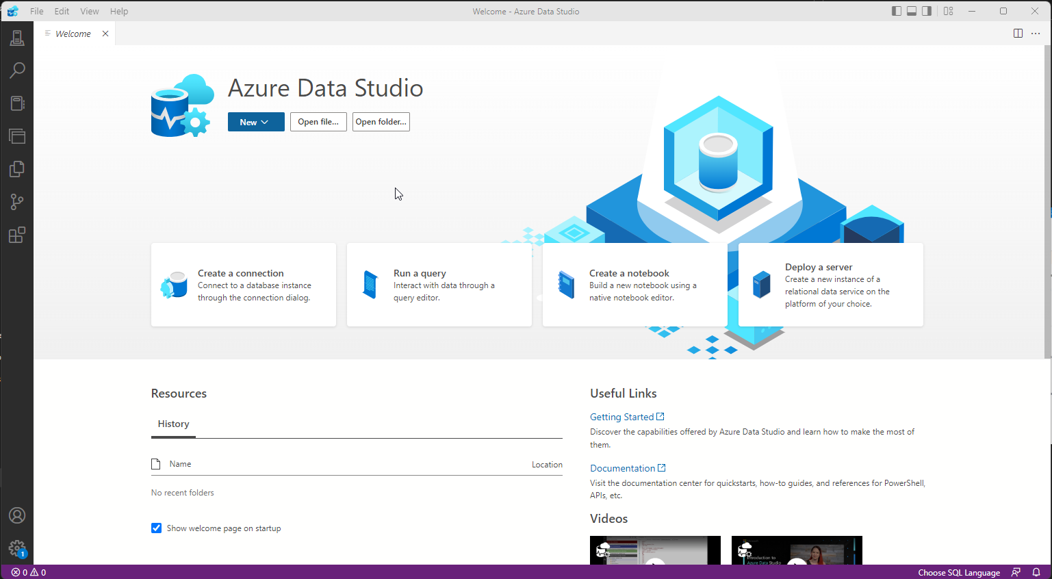

## **Connection: Azure Data Studio to Azure SQL Database**

1. Open the *Azure Data Studio*
2. Click on *New* 🡪 *New connection*

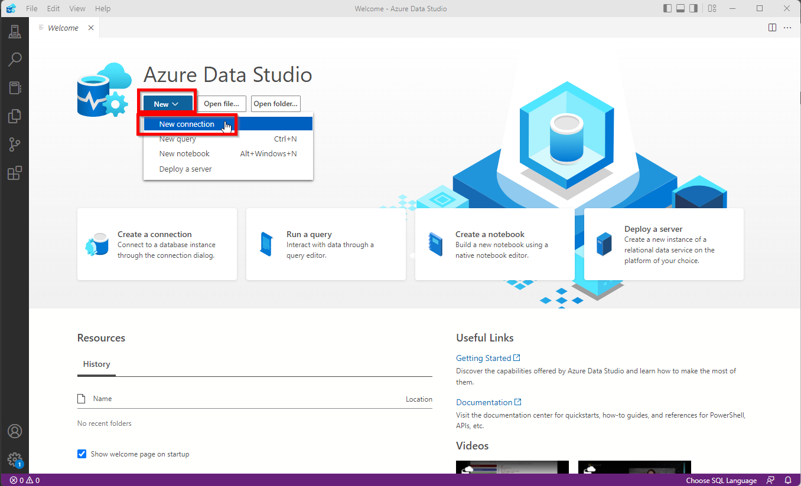

1. Get the Server name for Azure SQL database:
   1. Go back to Azure screen. Click on <database name>.

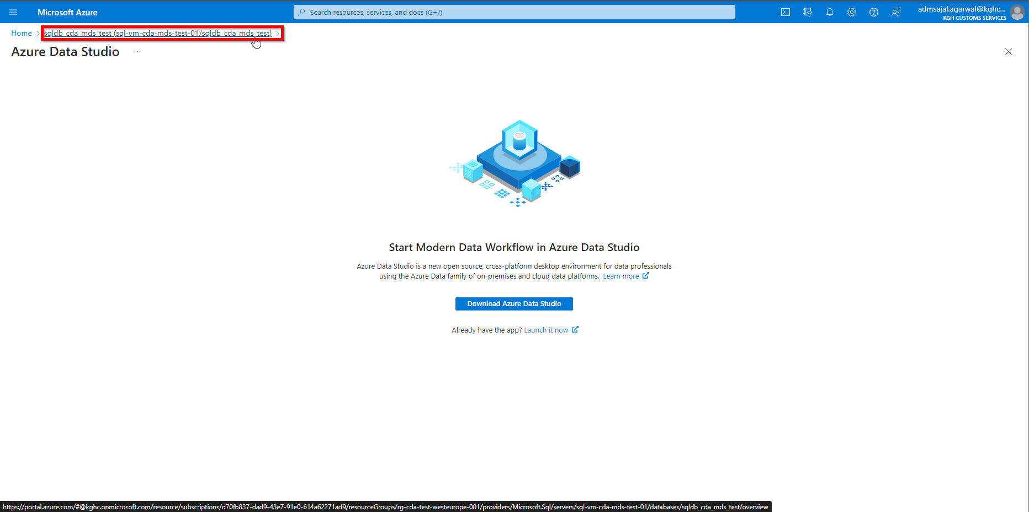

* 1. Note the *Server name*

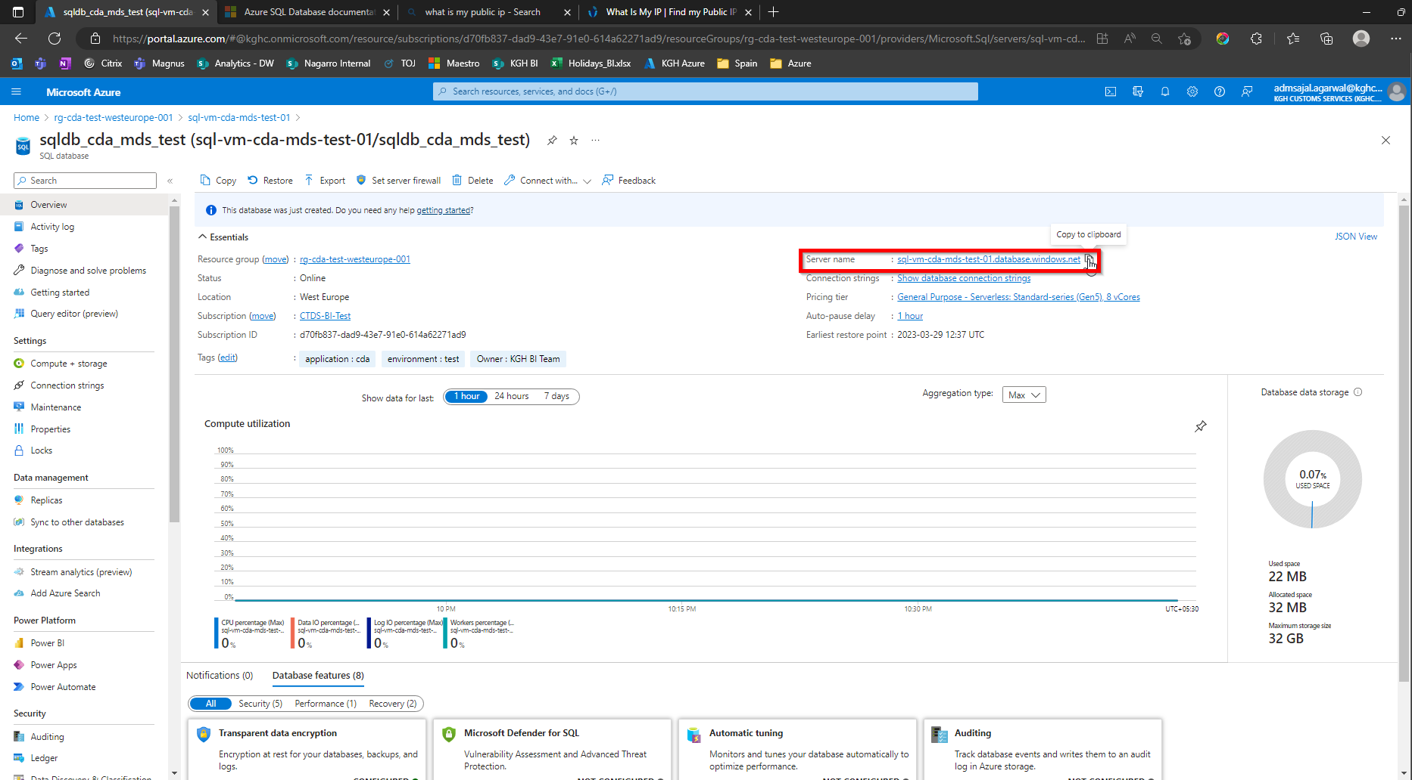

1. Allow access from local machine to Azure SQL VM:
   1. Click on *Overview*

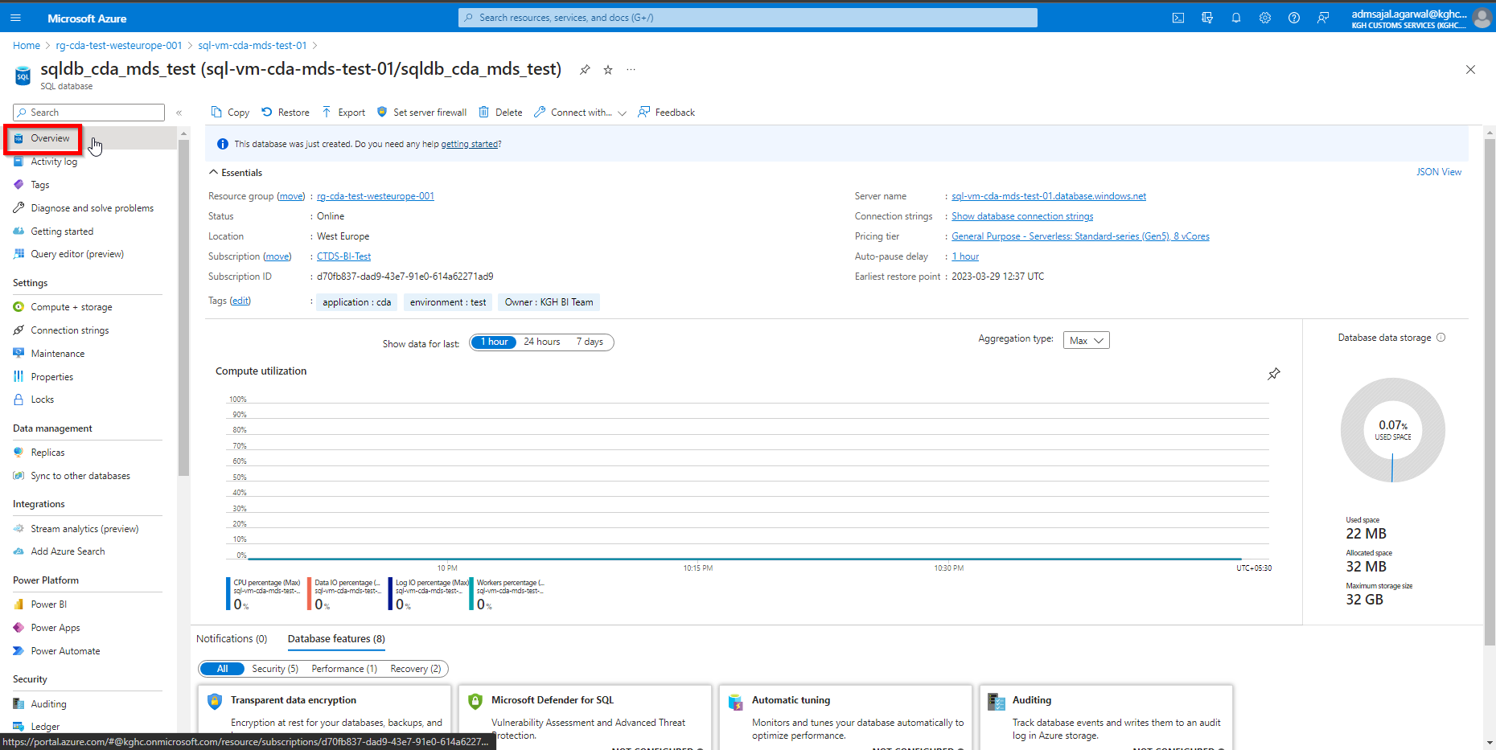

* 1. Click on *Configure* under *Configure access*

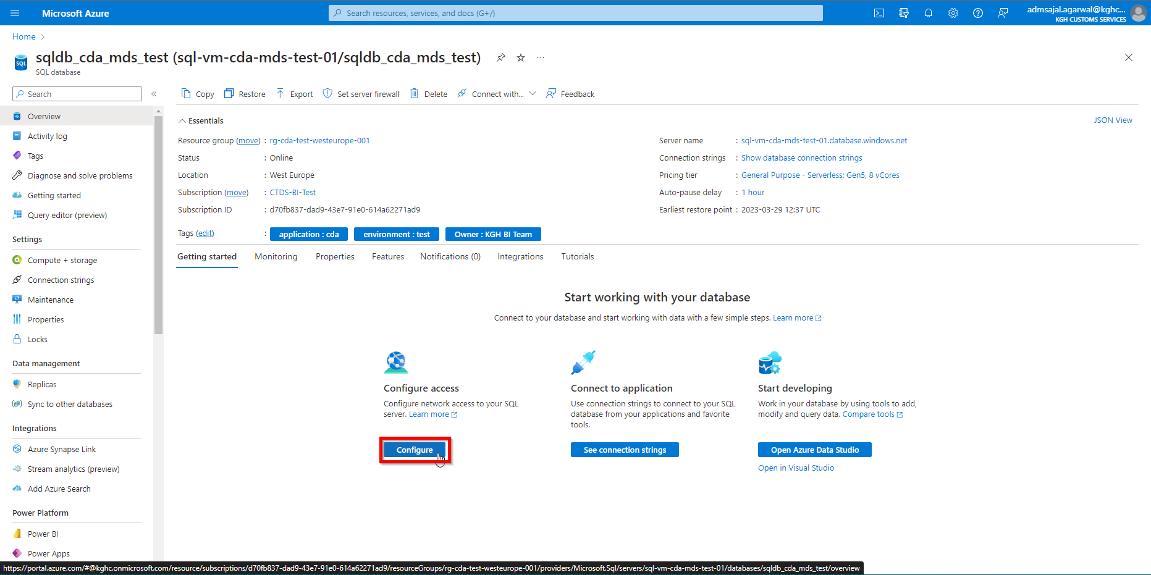

* 1. Select *Selected networks*

*Add your client IPv4 address* 🡪 Enter the Public IPv4 of machine

Tick-mark the *Allow Azure services and resources to access this server*

Click on *Save*

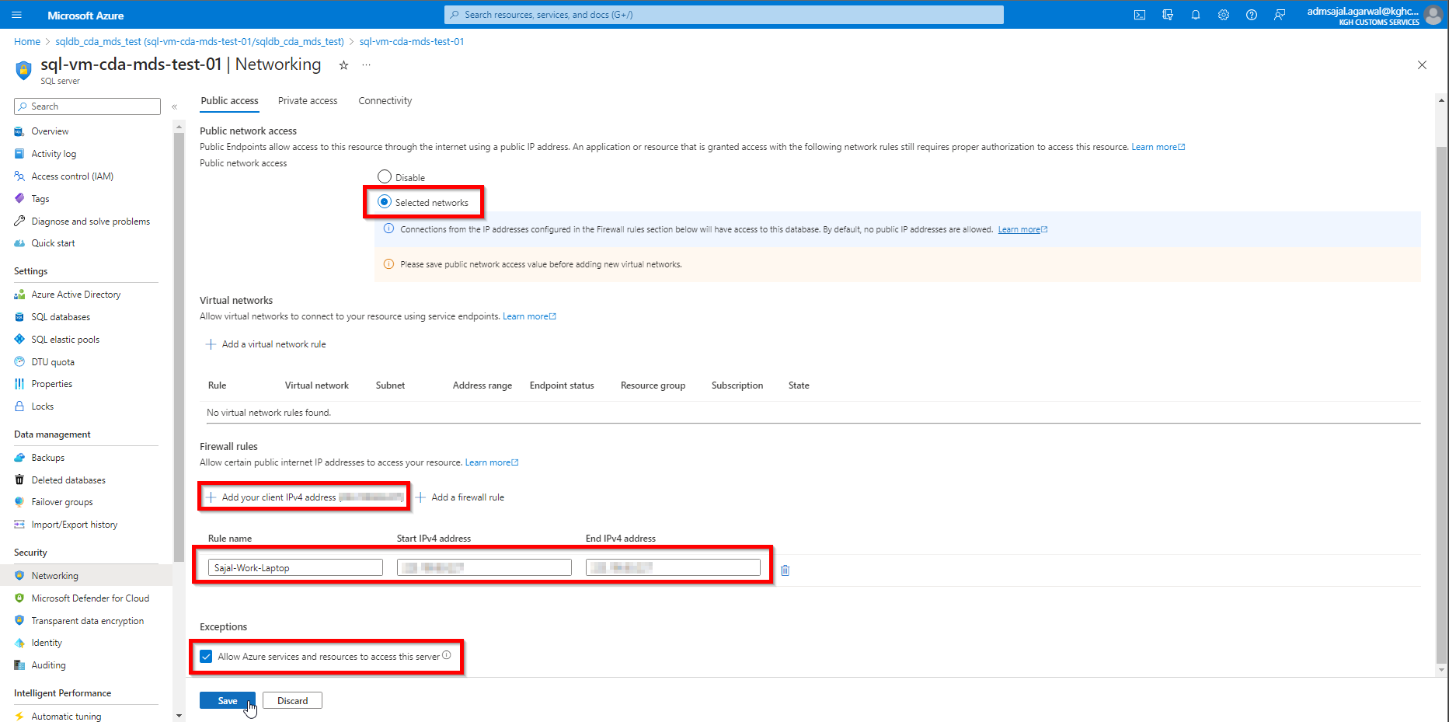

* 1. Public IPv4 entered be added to Firewall rules of Azure SQL server now

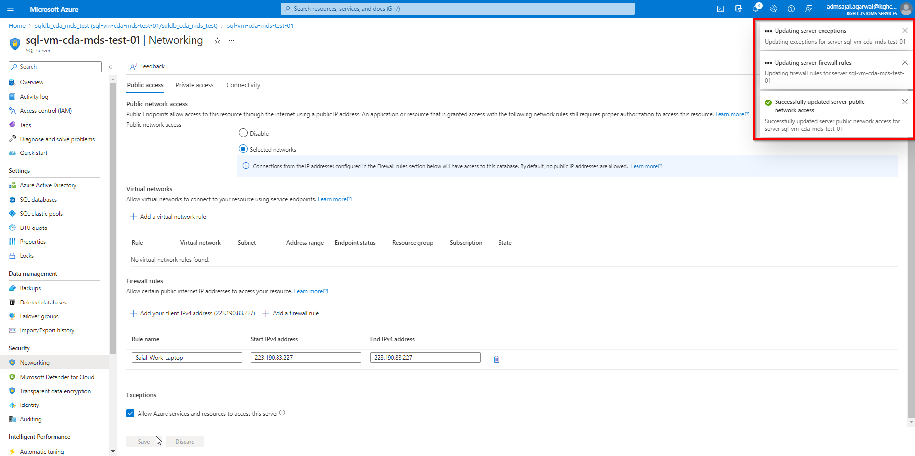

1. In *Azure Data Studio*, enter the details as below:

Connection type: *Microsoft SQL Server*

Connection method: *Parameters*

Server: *<enter it from Step 32.b>*

*Authentication type: SQL Login*

*User name: <enter the username entered in Step 8>*

*Password: <enter the username entered in Step 8>*

*Database: <Default>*

Name (optional): *AZ-MDS-Test-01*

Click on *Connect*

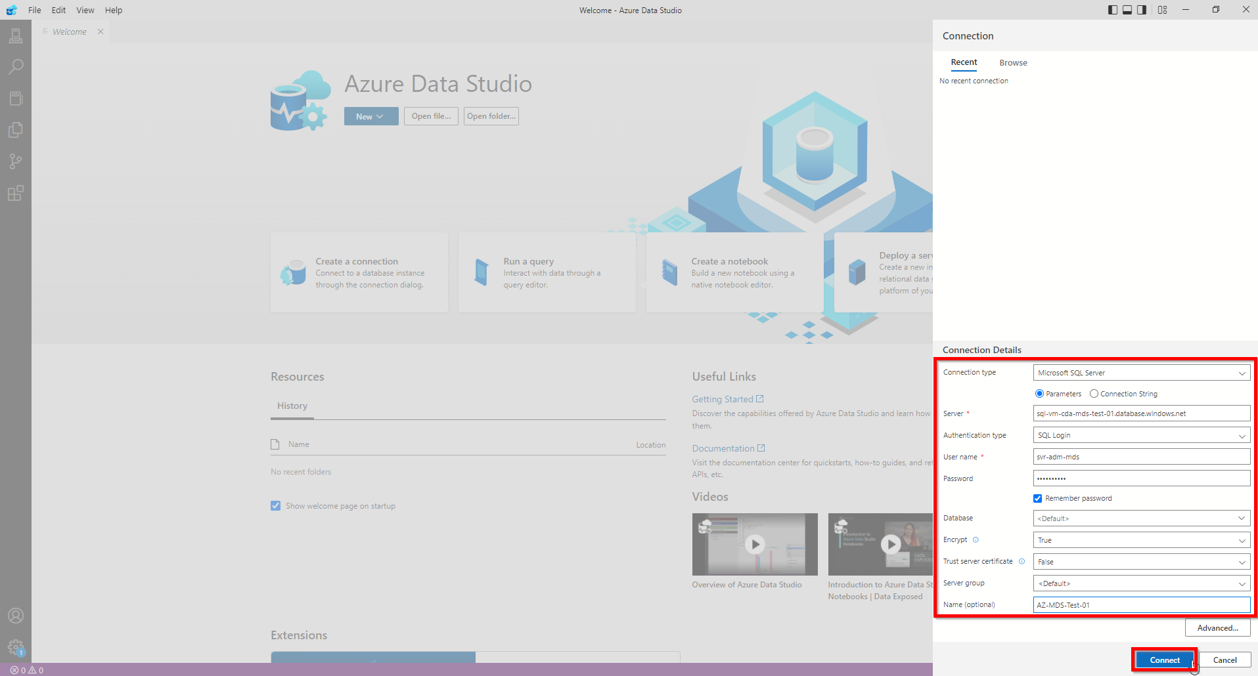

1. Once successfully connected, it will open a tab with connection name given in above step as title

Click on database name entered in Step 7 🡪 *…* 🡪 *New Query*

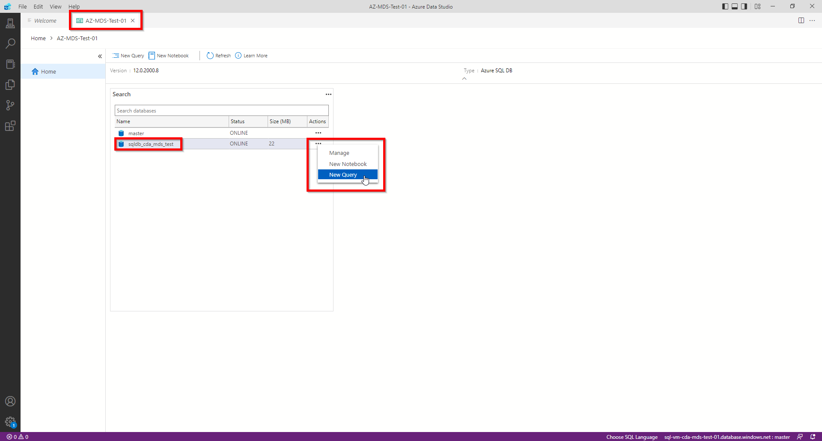

1. It will open a tab with name *SQLQuery_1.*

Enter the below query to test connection:

SELECT *

FROM sys.all_objects

GO

Click on *Run* 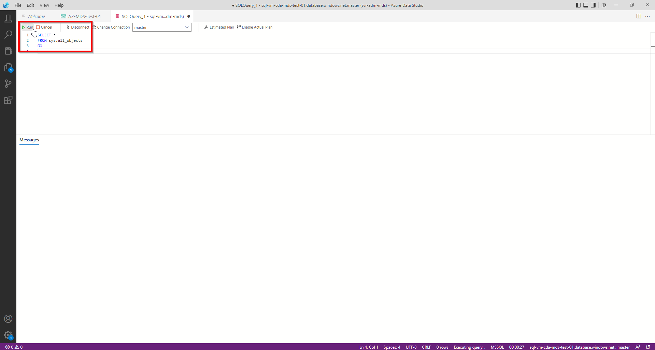

1. If the result is returned (even with 0 rows), connection to Azure SQL is working.

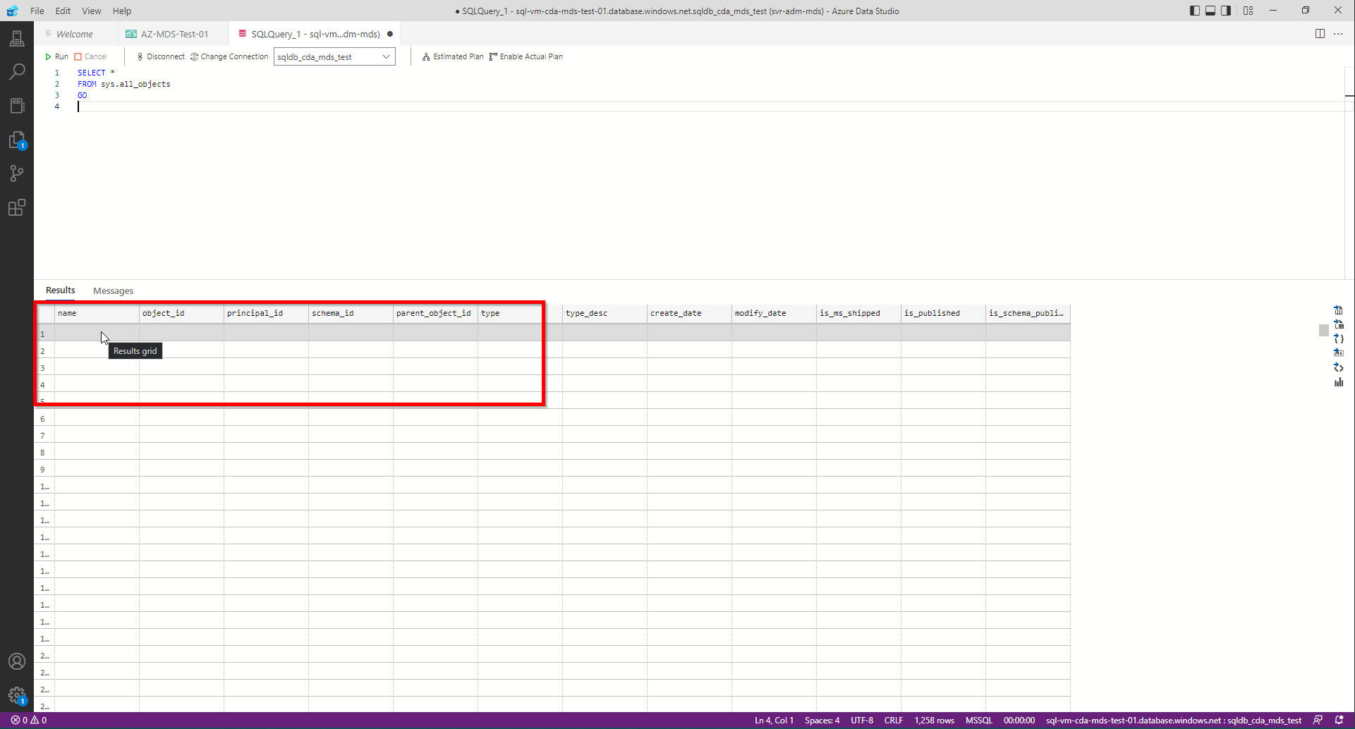

## **Connection: Azure Data Studio to On-Premises SQL Database**

1. Login to on-premises server *SQLDWTEST2*
2. Open *Azure Data Studio*
3. Click on *New Connection* as show below

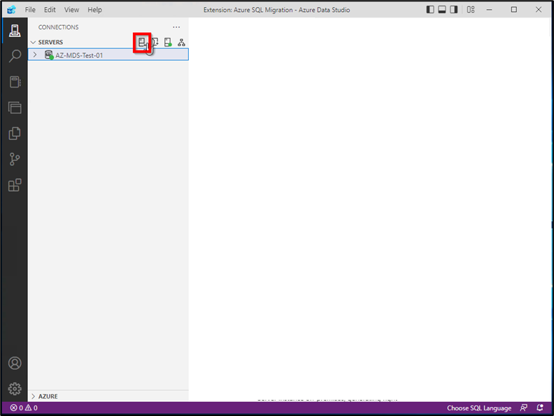

1. Fill the details as below:

Connection type: *Microsoft SQL Server*

*Parameters*

Server:  *sqldwtest2*

Authentication type: *Windows Authentication*

Encrypt: *Optional (False)*

Name (optional): *ON-PREM-SQLDWTEST2*

Click on *Connect*

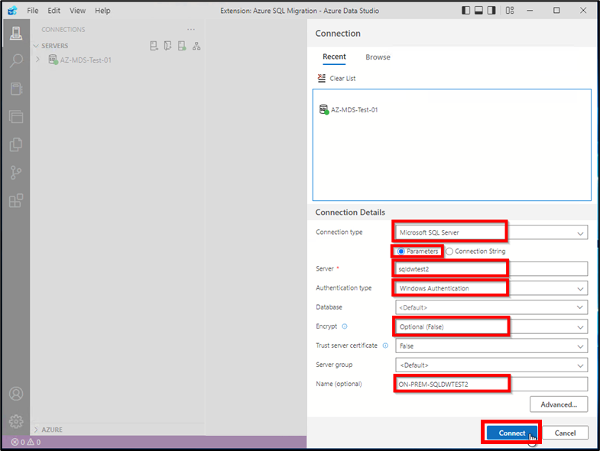

## **Database Migration: SQL Data Sync for Azure**

### **Database Creation: Metadata database**

1. Open *Resource Groups* and search for *rg-cda-test-westeurope-001*



1. Click on resource with *Type* as *SQL Server*

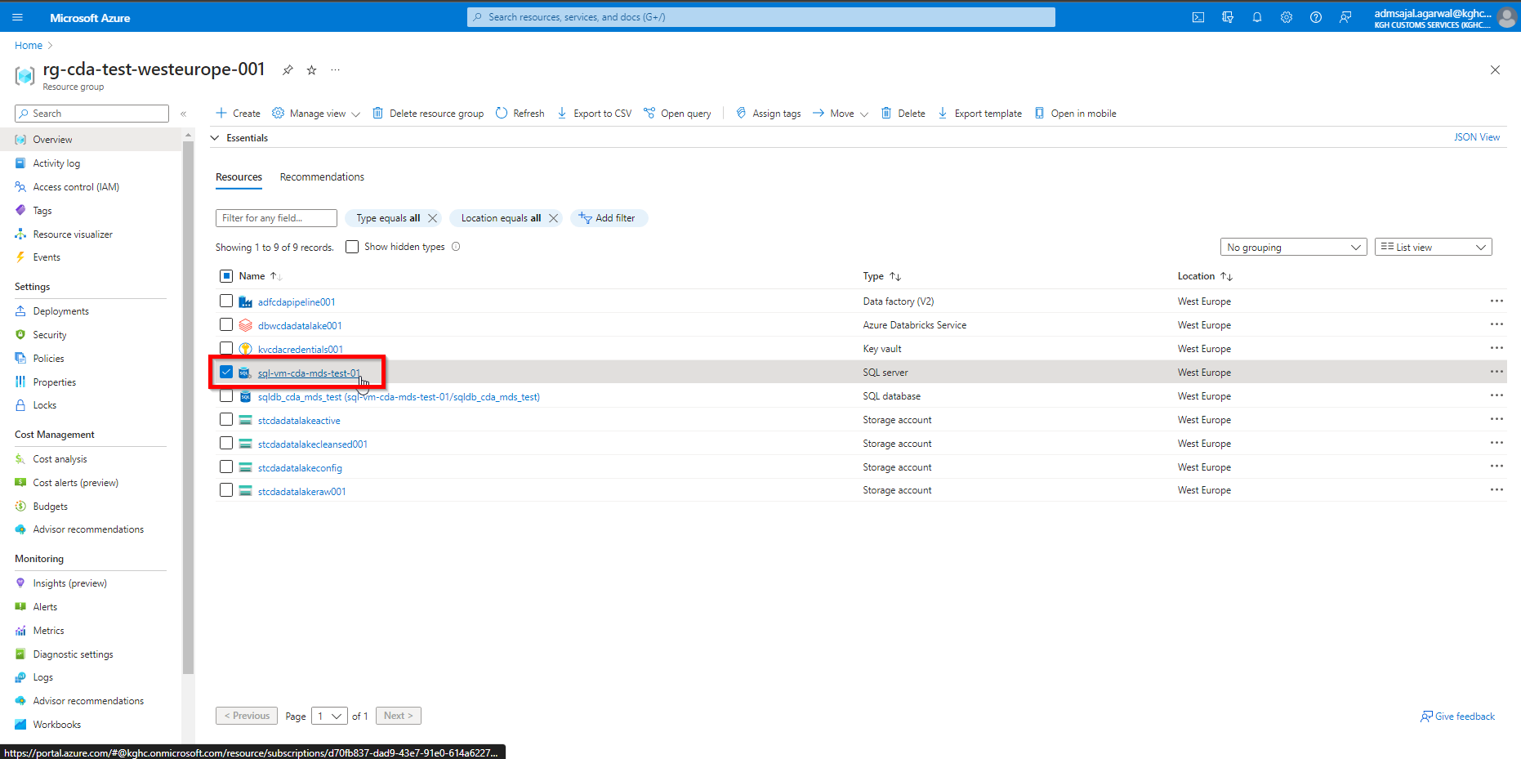

1. Click on *Create database*

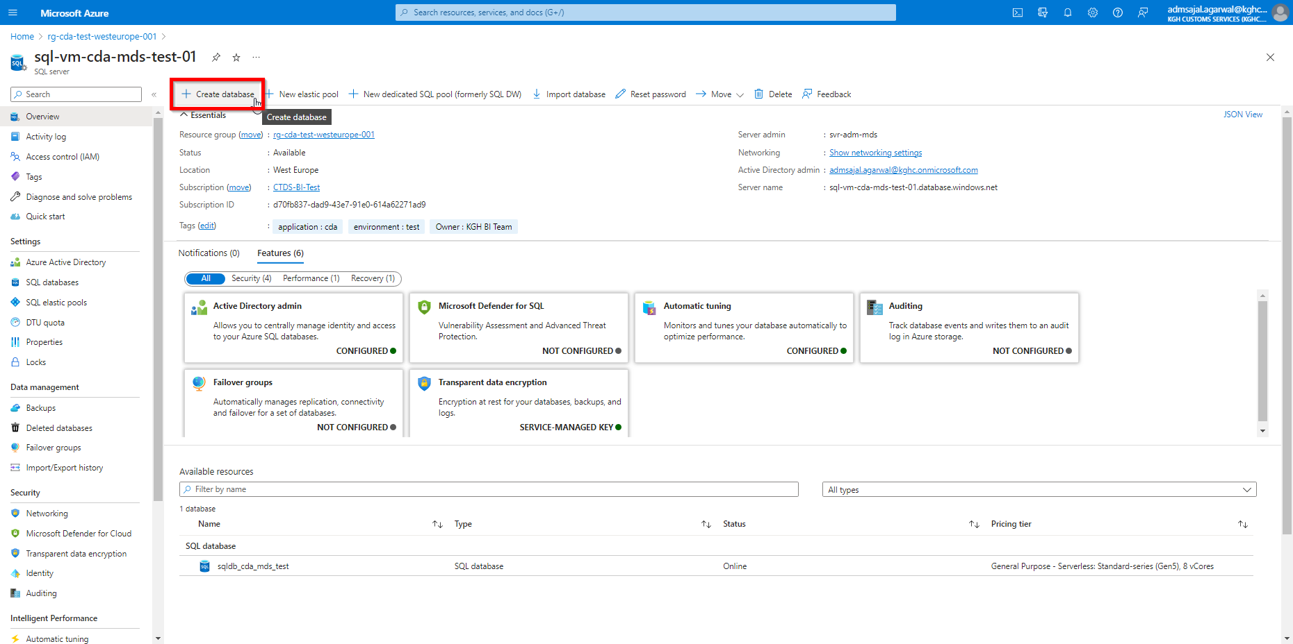

1. Fill the details as below:

Database name: *sqldb_syncgroup_mds_metadata*

Click on *Configure database* under *Compute + storage*

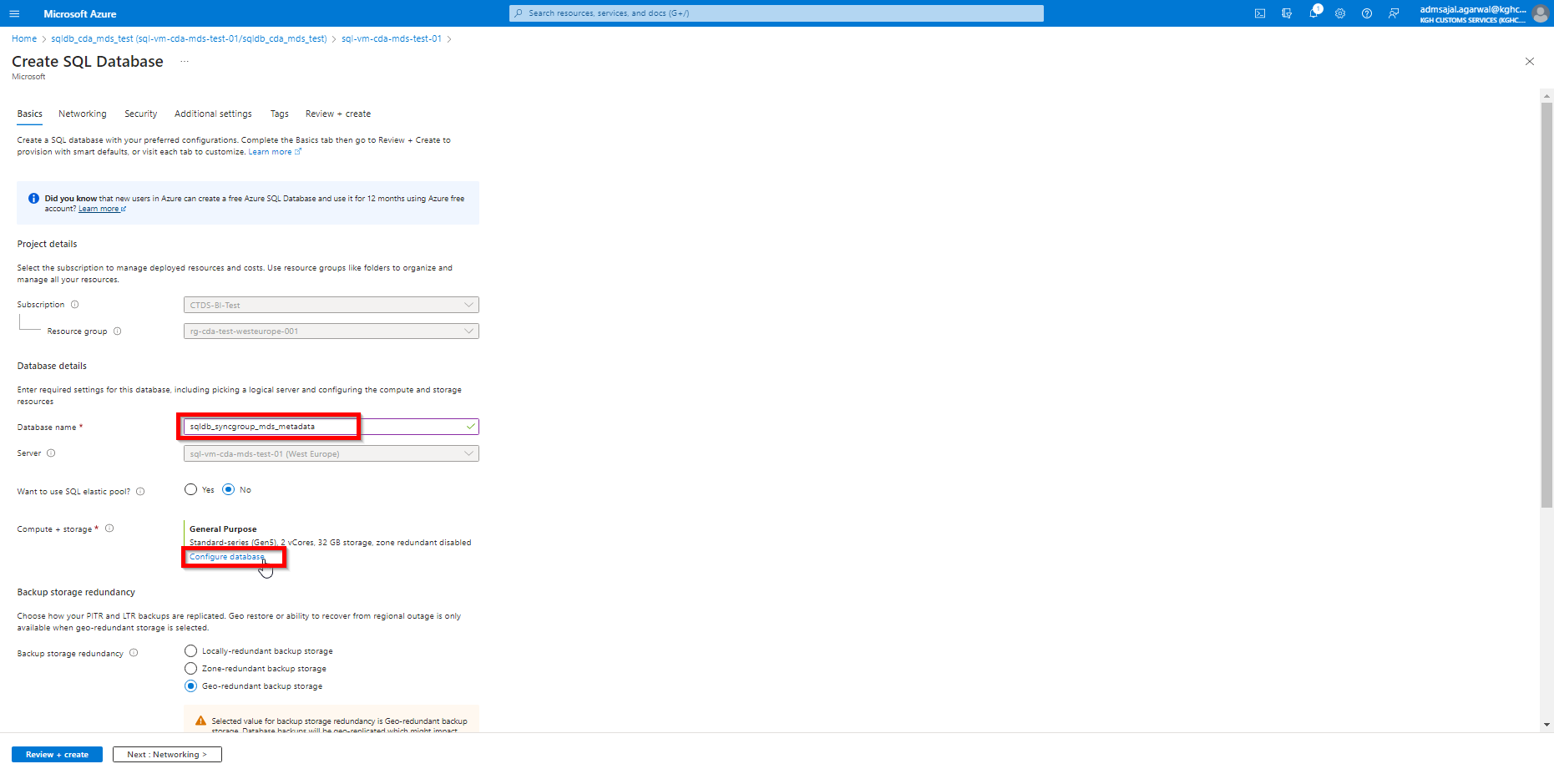

1. Select options as below:

Service tier: *General Purpose*

Compute tier: *Serverless*

Hardware Configuration: *Standard-series (Gen5)*

Max vCores: *4*

Auto-pause delay: *1 Hour*

Data max size (GB): *32*

Zone redundant: *No*

 :

Click on *Apply*

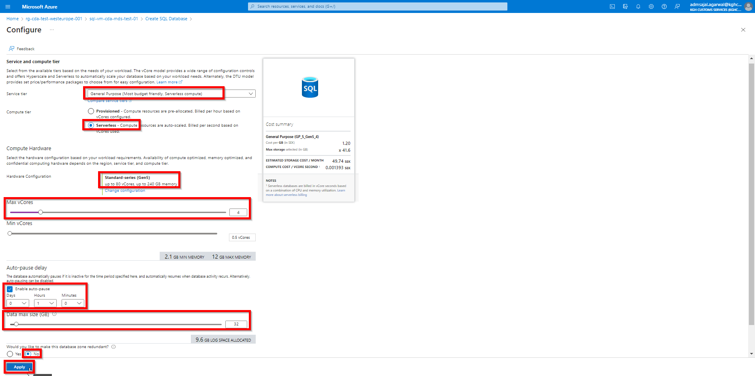

1. Select options as below:

Backup storage redundancy: *Locally-redundant backup storage*

Click on *Next : Networking*

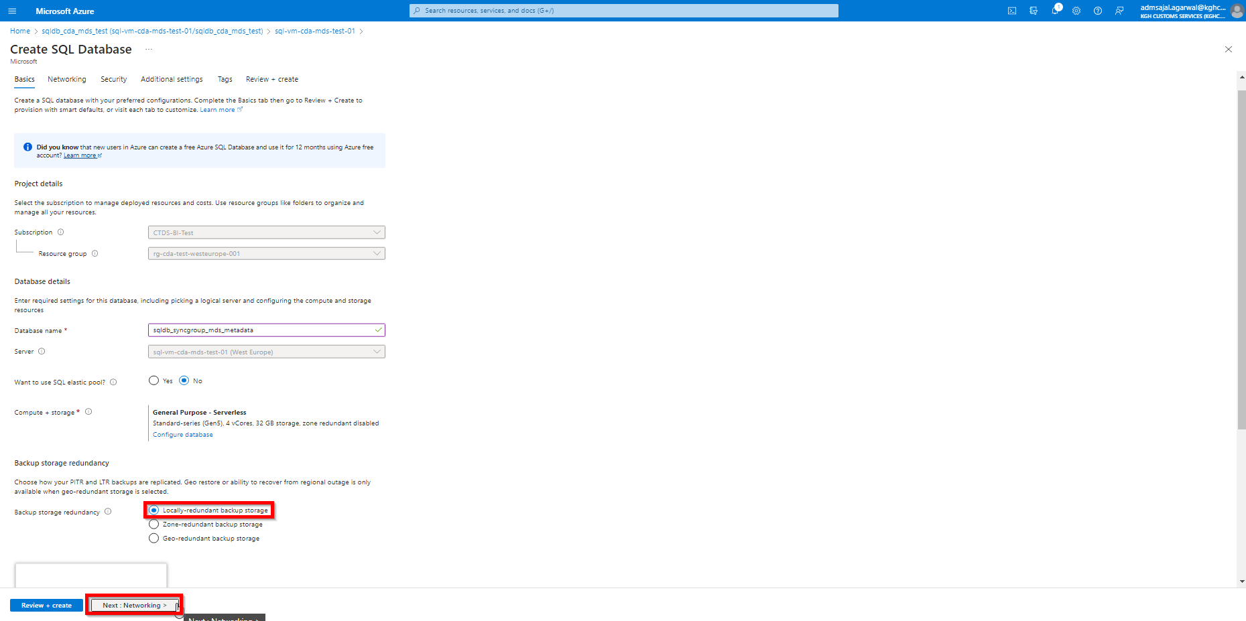

1. Keeping all options as default, click on *Next : Security*

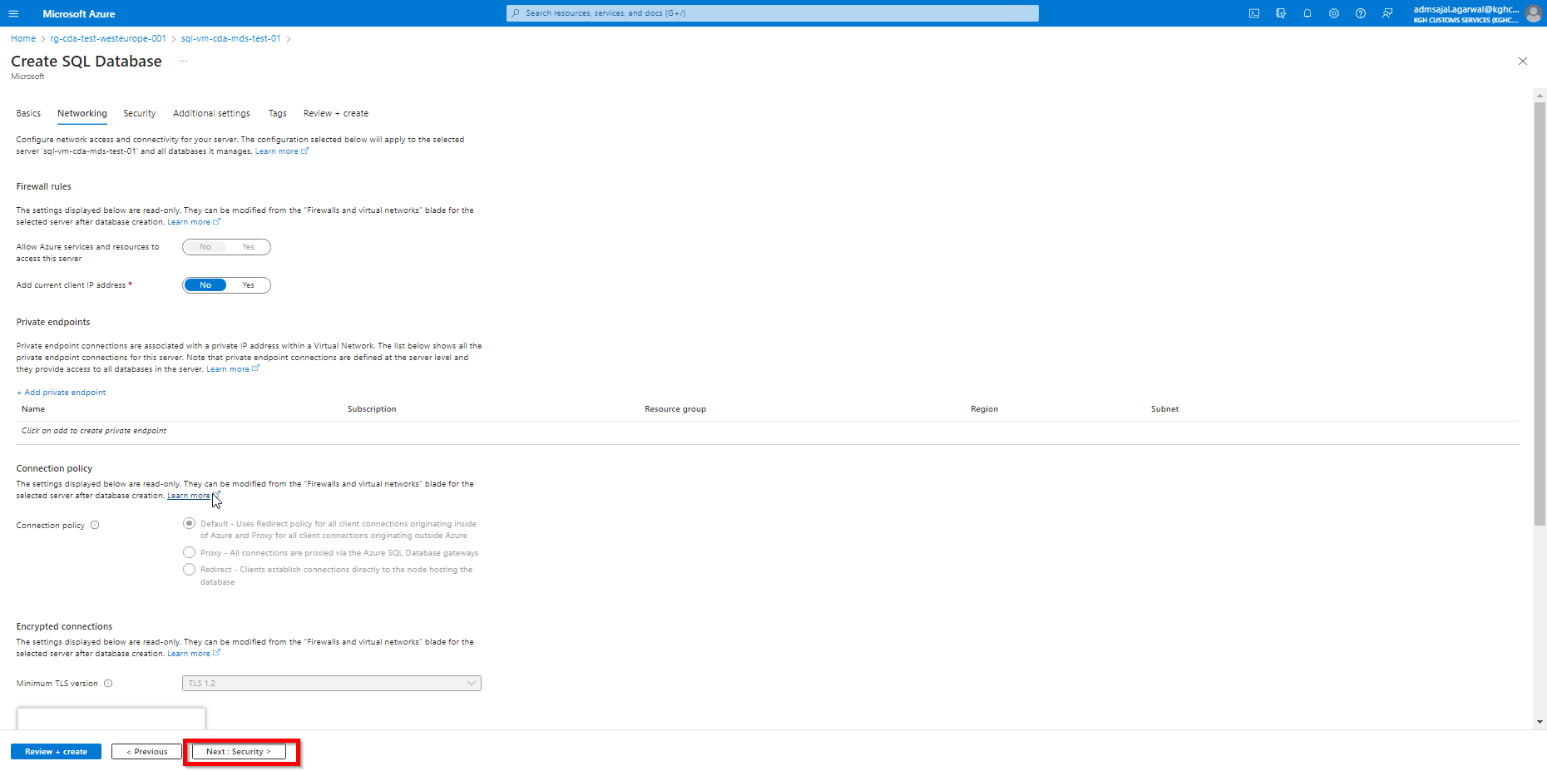

1. Keeping all options as default, click on *Next : Additional settings*

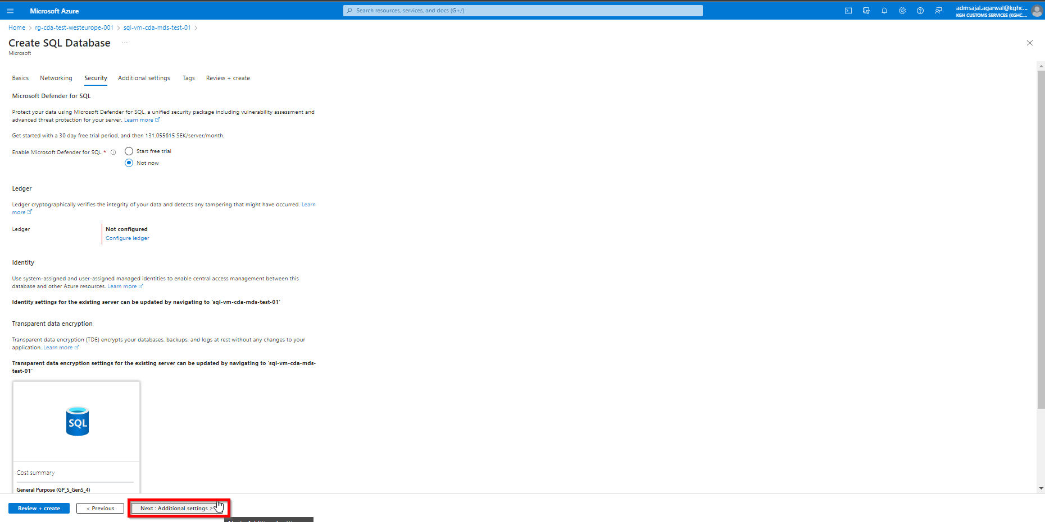

1. Change the details:

Collation 🡪 *Finnish_Swedish_CI_AS*

Click on *Next : Tags*

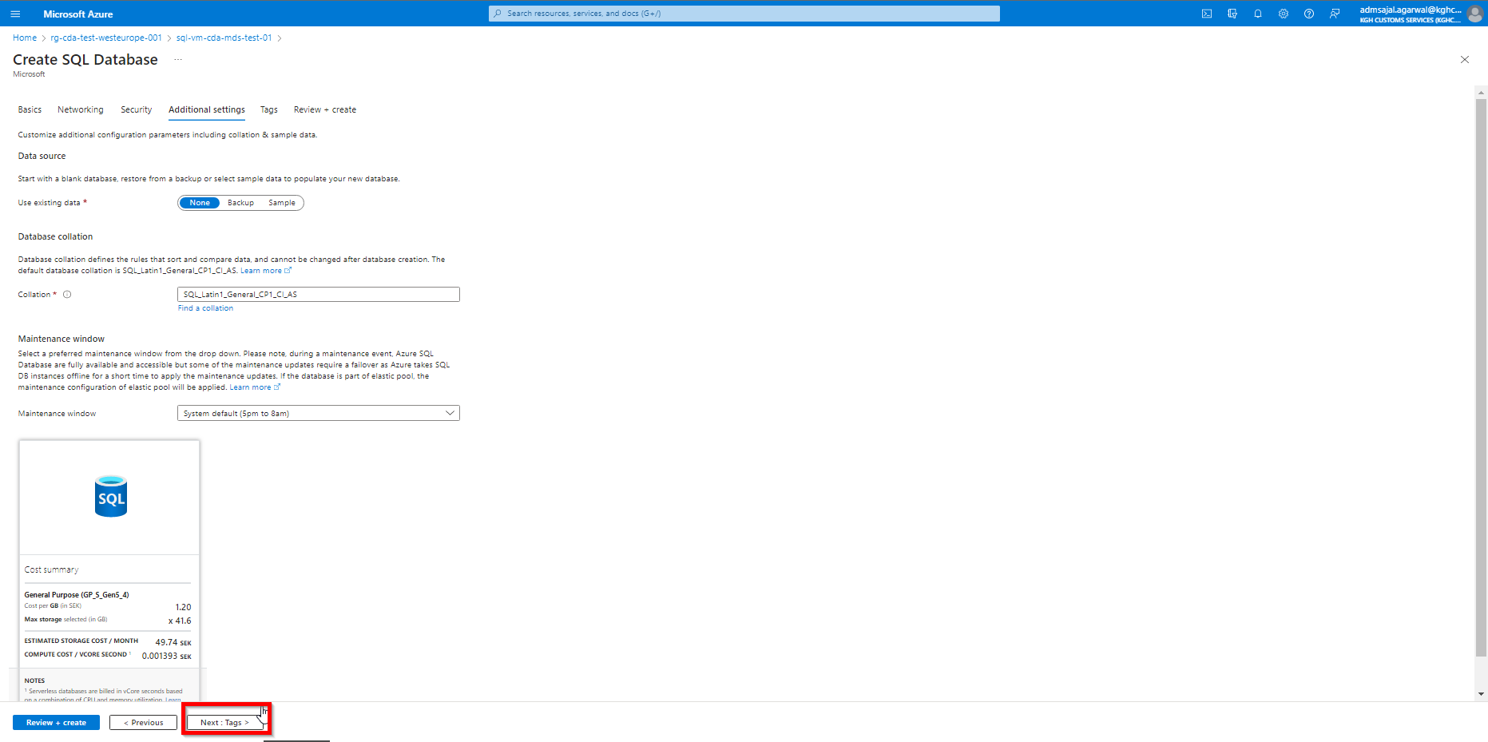

1. Add the tags as shown below:

application 🡪 *cda*

owner 🡪 *KGH BI Team*

environment 🡪 *test*

Click on *Next: Review + create*

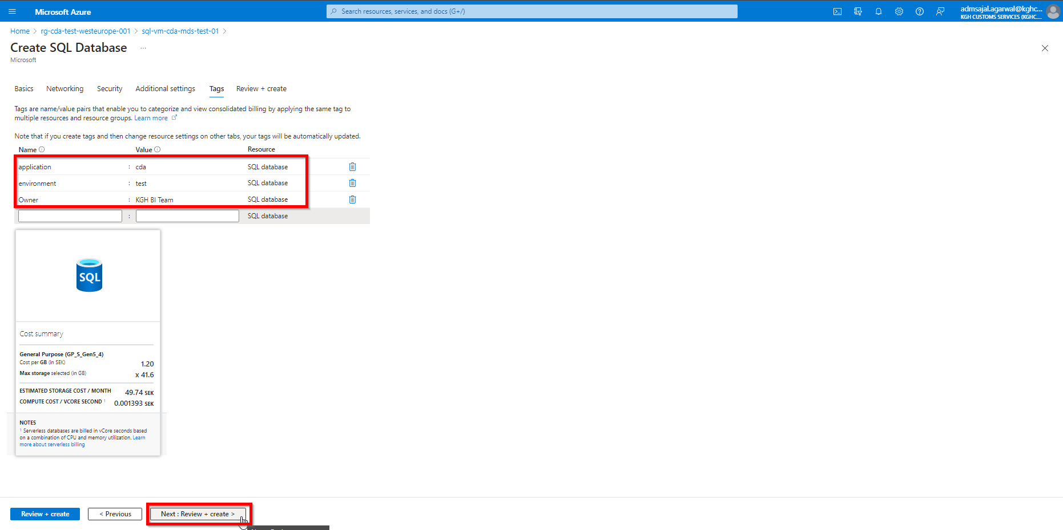

1. Wait for the *Validation* to complete and *Create* button to be enabled

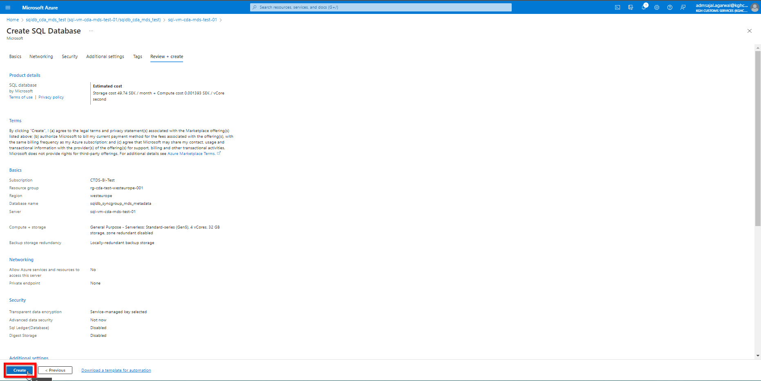

1. Click on *Create*. It will initialize the deployment of resource.

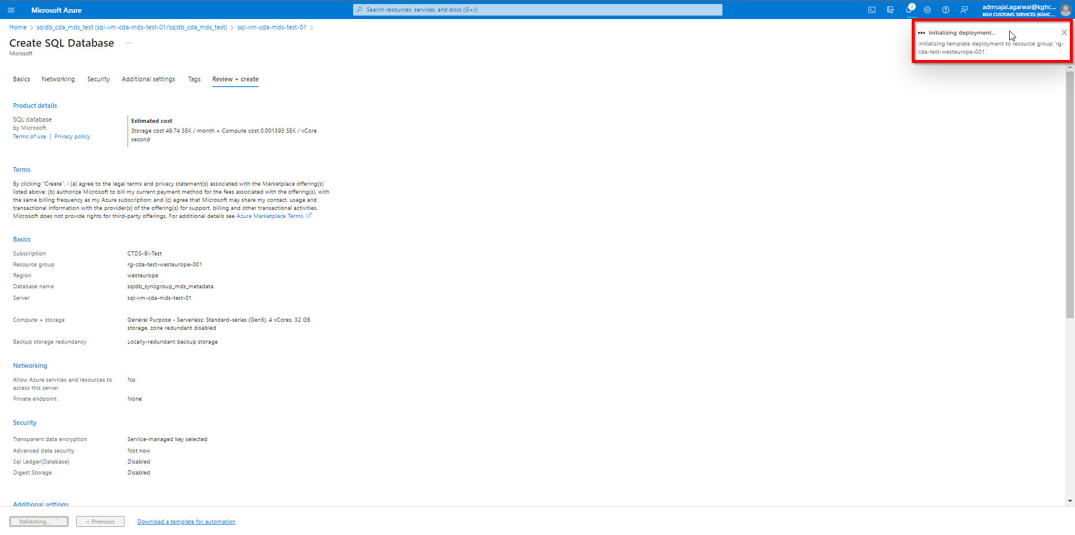

1. It will auto-redirect to deployment screen

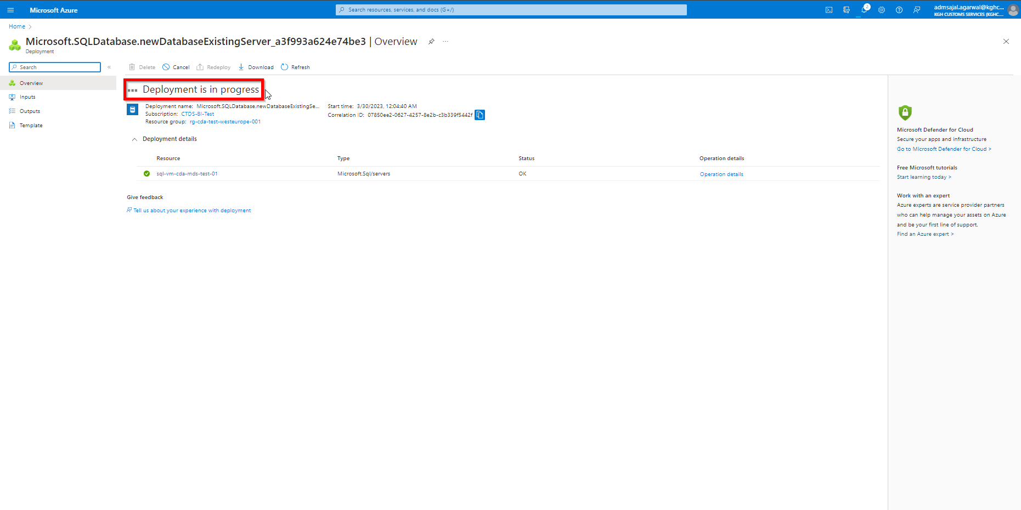

1. When the message changes to *Your deployment is complete*, SQL database is successfully created

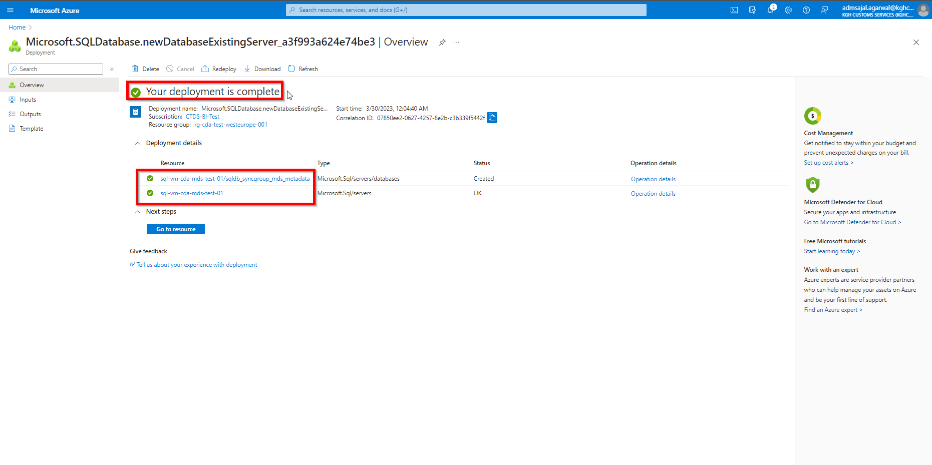

### **SQL Data Sync Creation**

#### **Creation: Sync Group**

1. Search for *sql database* in the search bar at top

Click on *SQL databases* from results

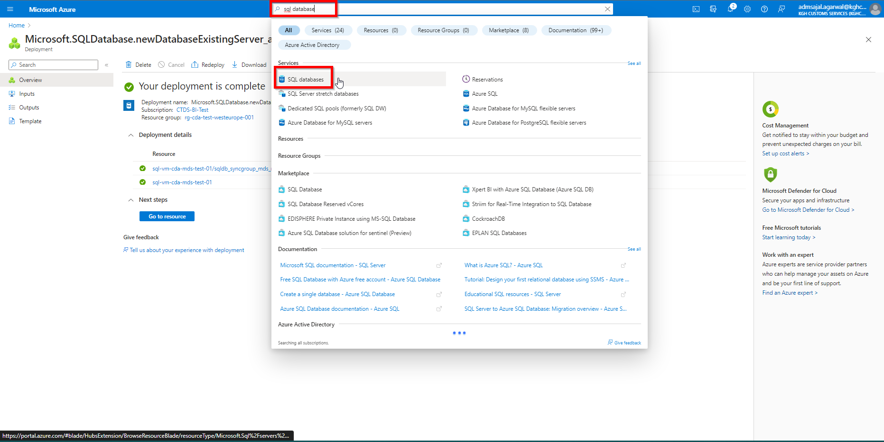

1. Click on Azure SQL database created

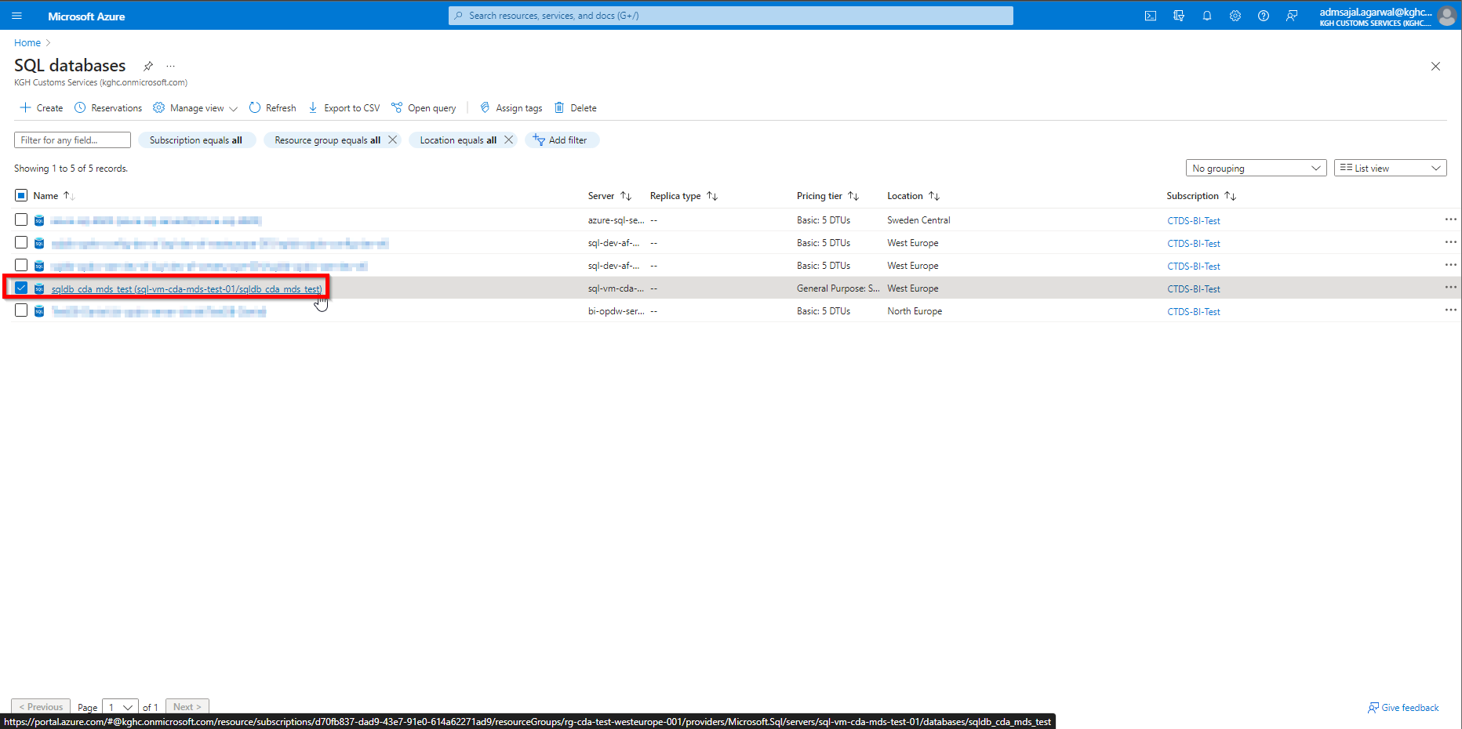

1. Click on *Sync to other databases*

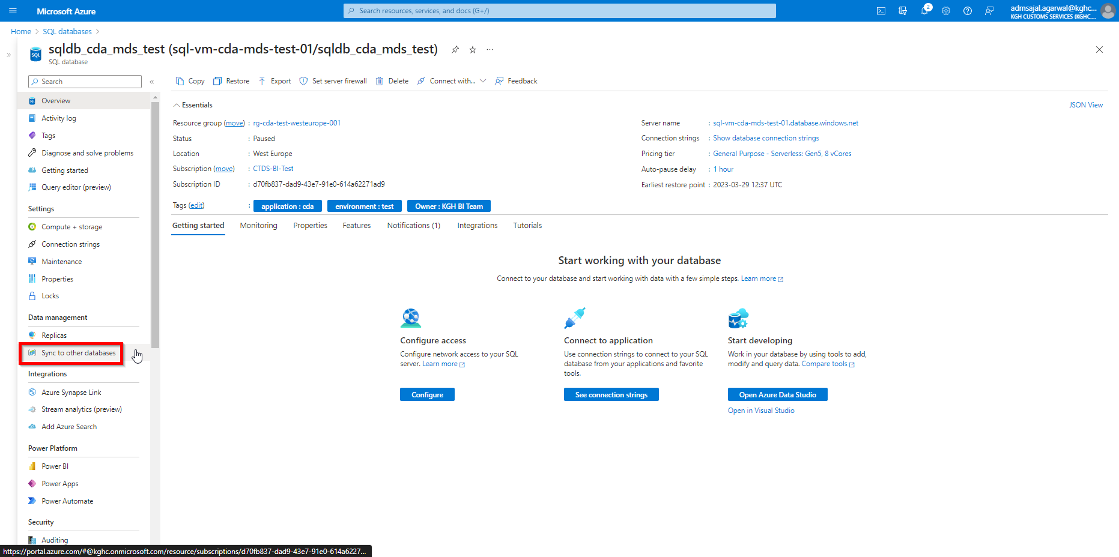

1. Click on *New Sync Group*

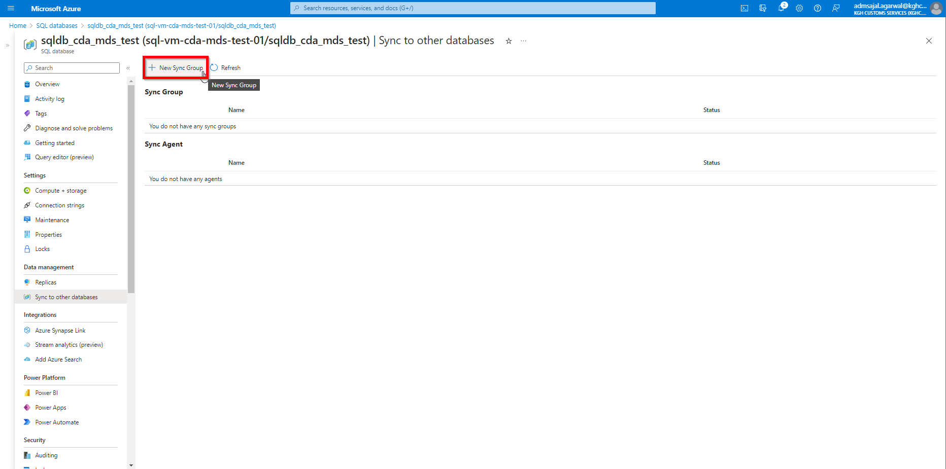

1. Fill the details as below:

Sync Group Name: *sync-group-mds-on-prem-to-azure*

*Use existing database*

Sync Metadata Database: *sqldb_syncgroup_mds_metadata (Server: sql-vm-cda-mds-test-01)*

Conflict Resolution: *Member win*

Username: *svr-adm-syncgrp-mds*

Password: *@dmsyncmd$2023*

*Use private link*

Click on *OK*

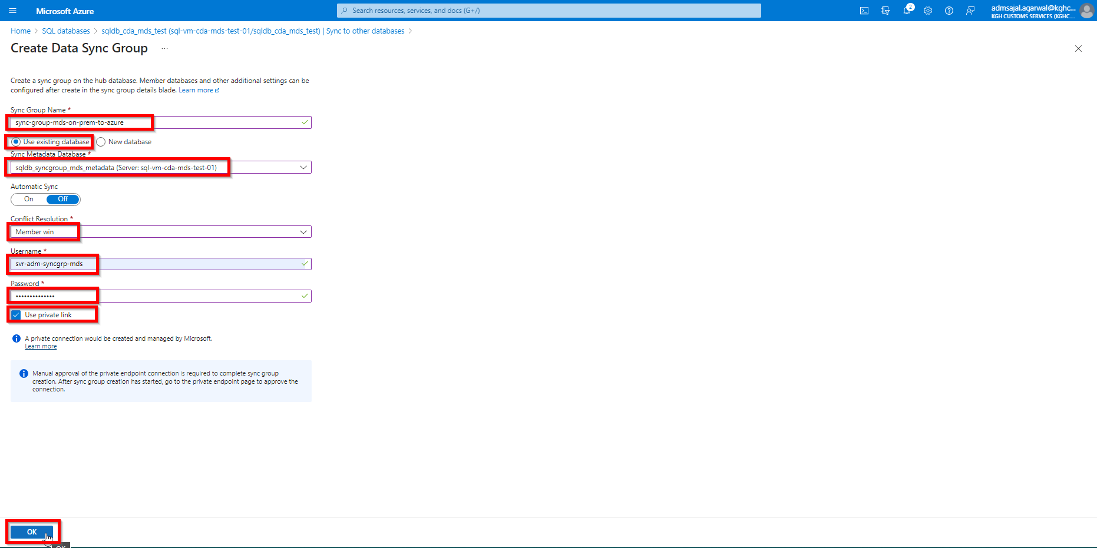

1. It will start creating the sync group.

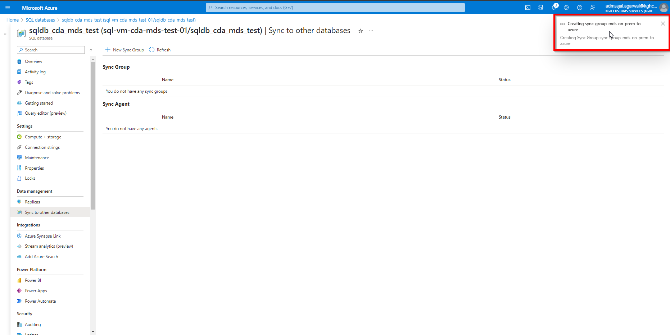

1. Click on *Refresh*

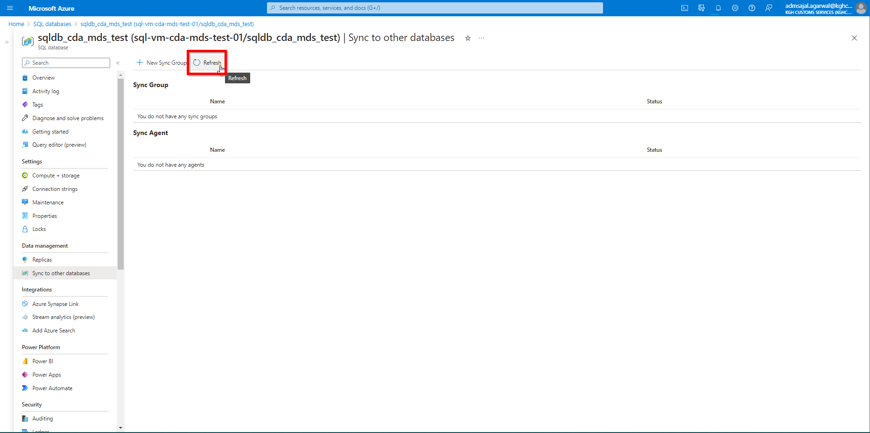

1. Click on *click here to approve endpoint connection*

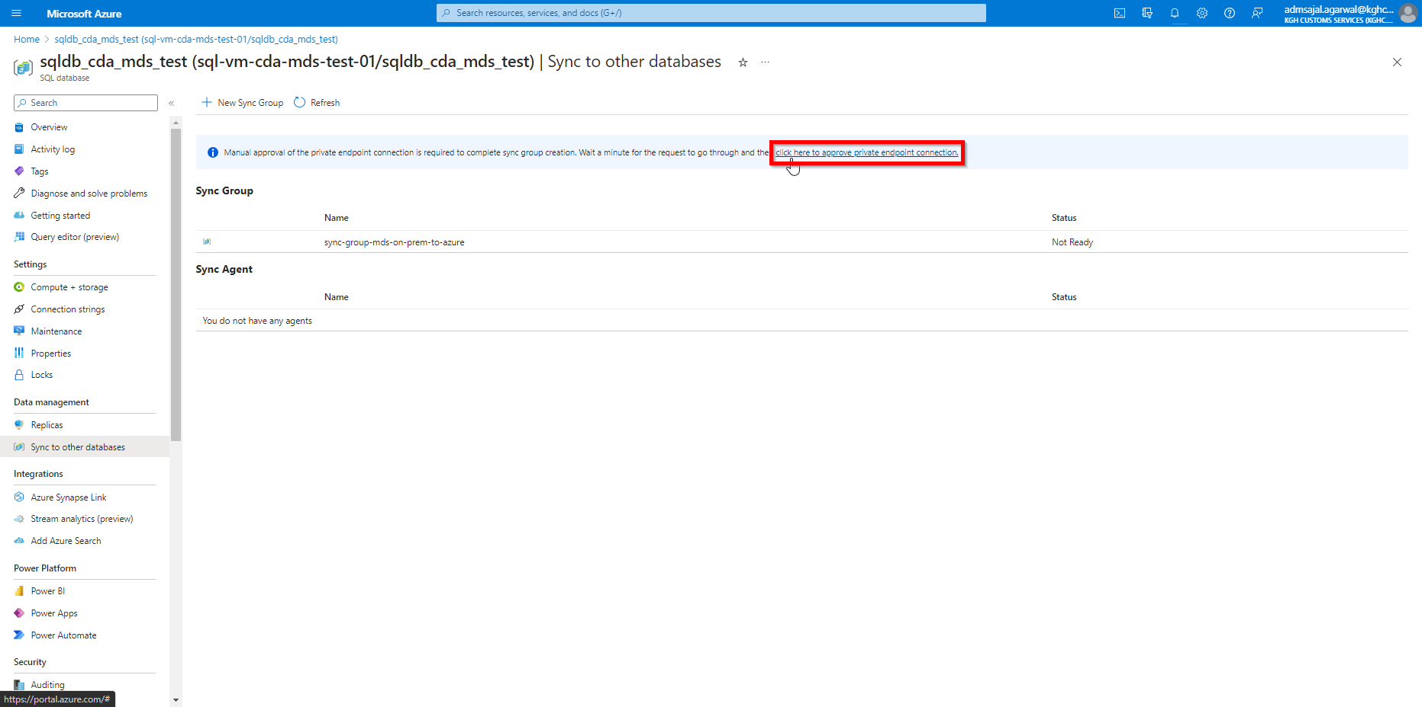

1. Fill the details as below:

Public Network Access: *Selected networks*

Under *Firewall Rules*, provide the *Rule name*, *Start IPv4 address* and *End IPv4 address.*

Under *Exception*, tick mark the *Allow Azure services and resources to access this server*.

Click on *Save*

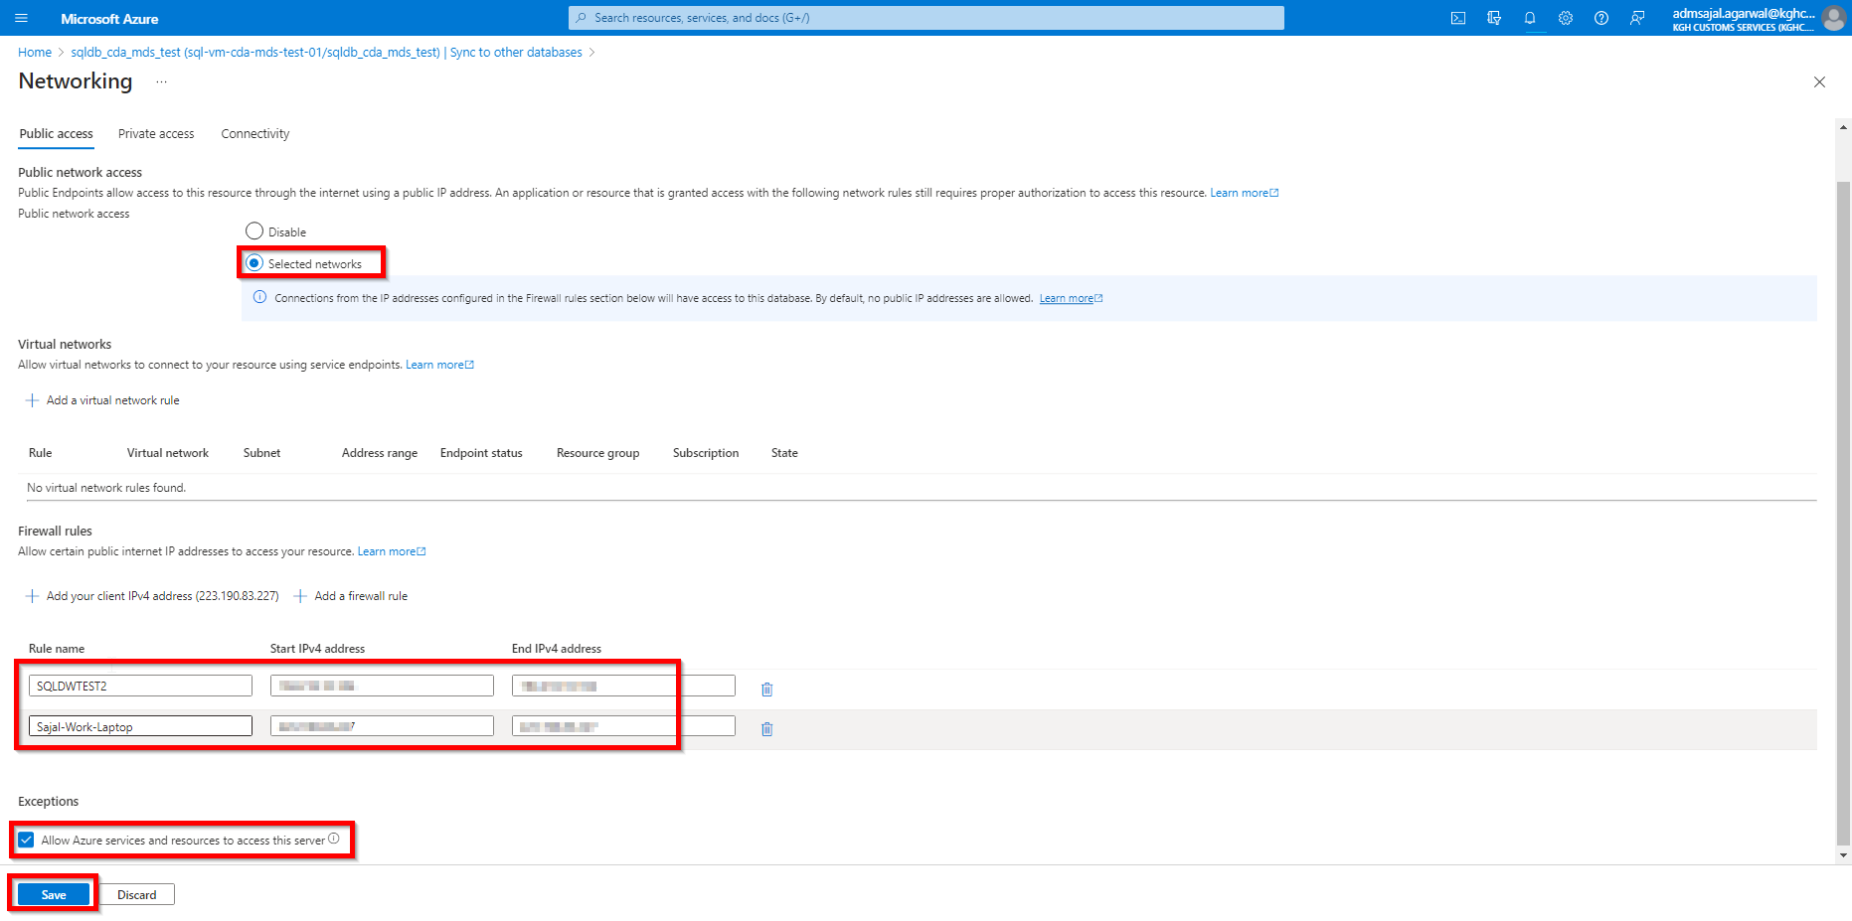

1. Firewall rules will be successfully updated.

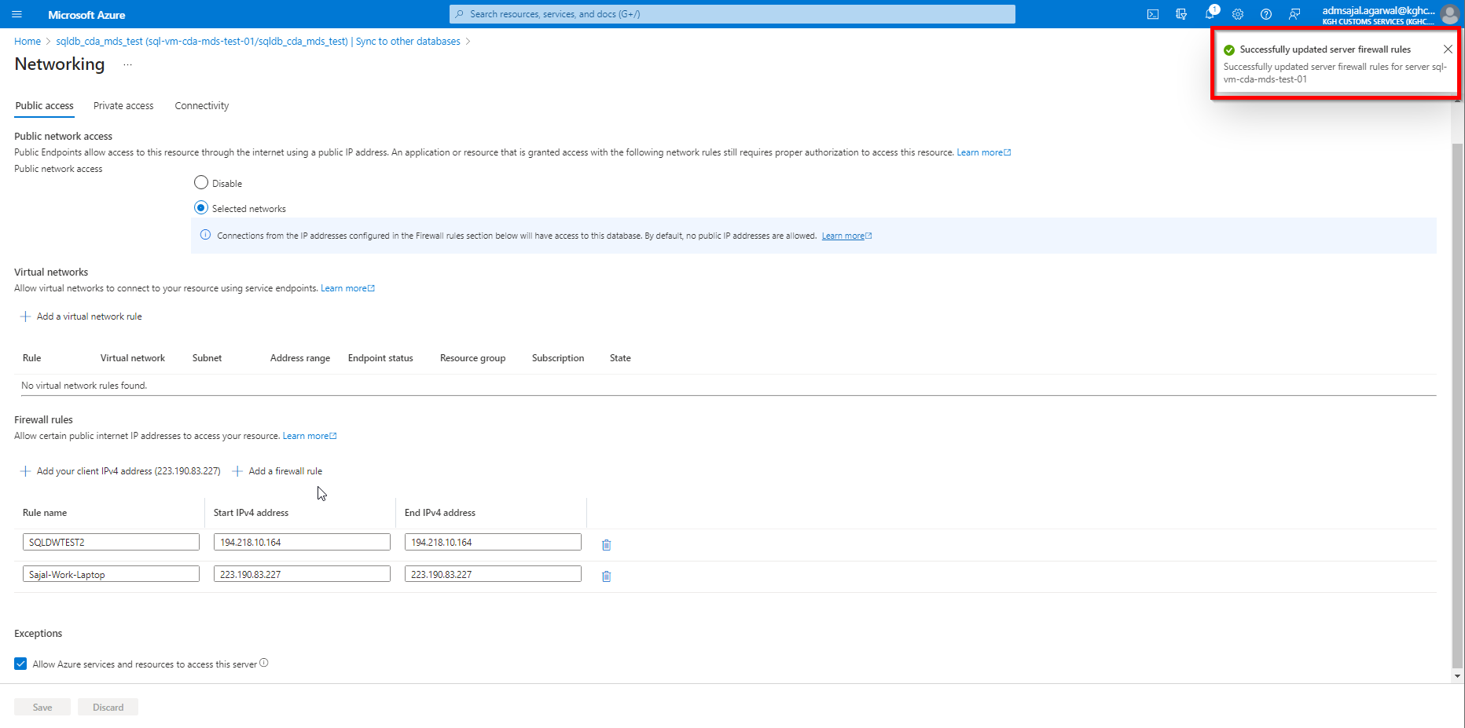

1. Click on *Private access*

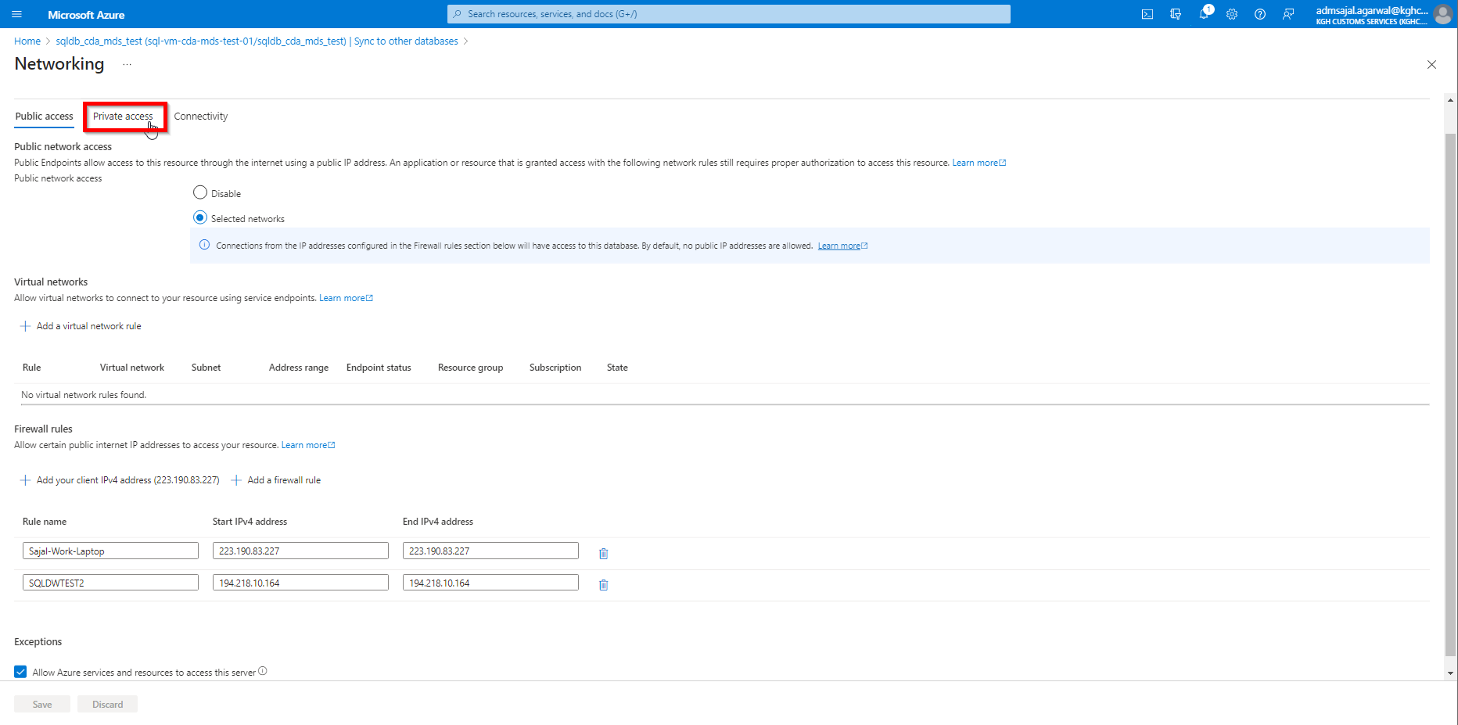

1. Select the *Private endpoint* and click on *Approve*

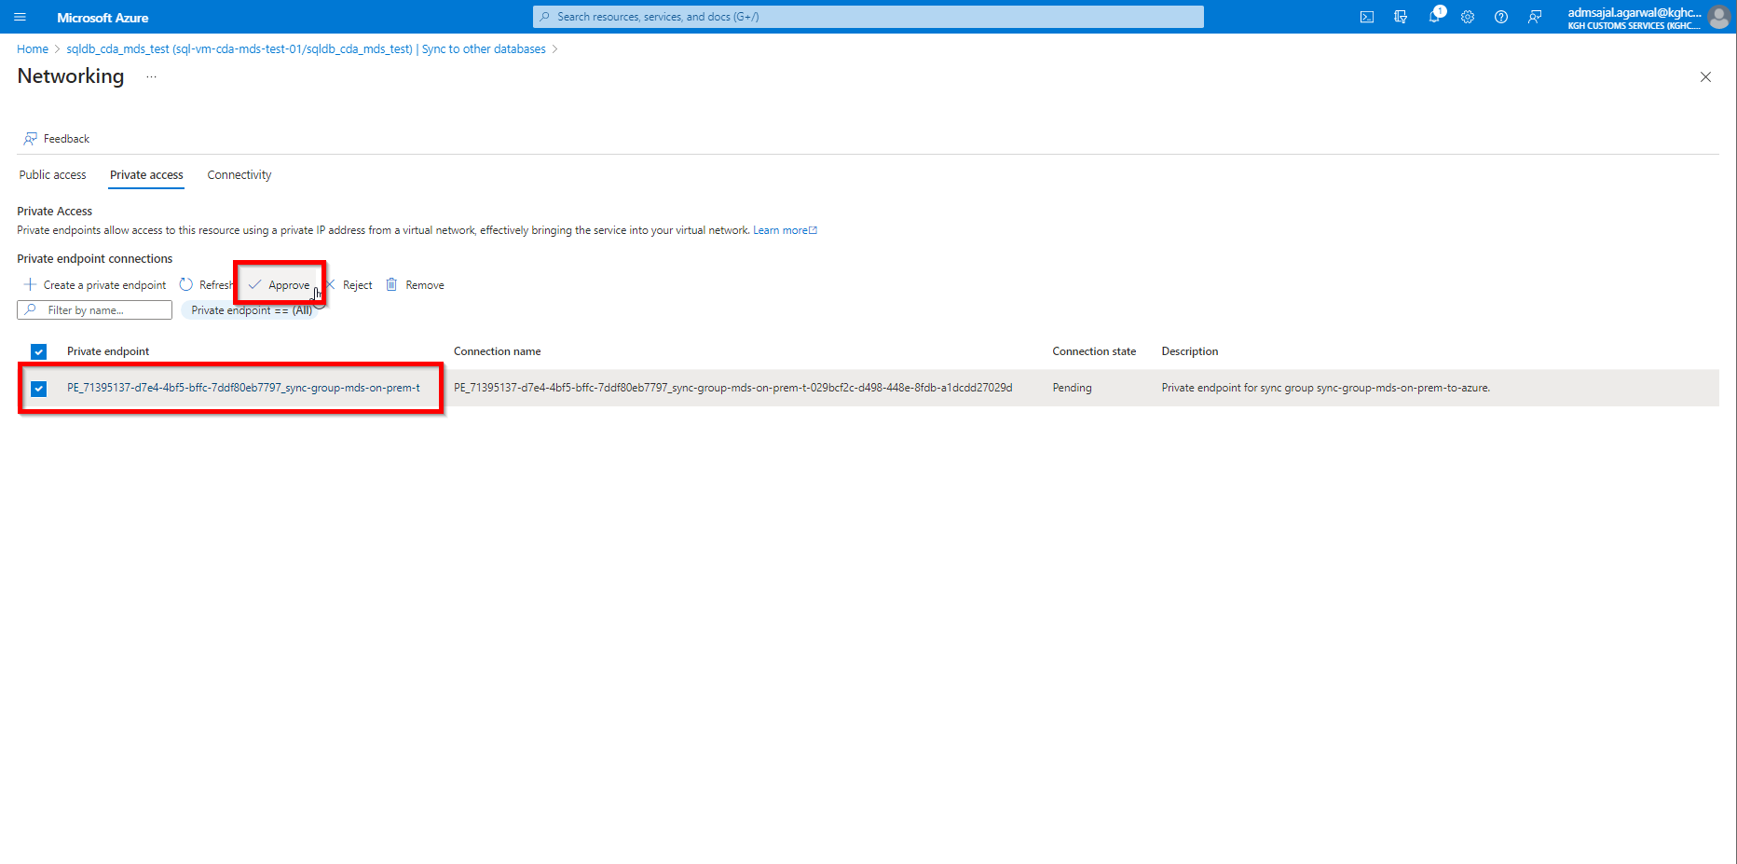

1. Provide a *Response message*.

Click on *Yes*.

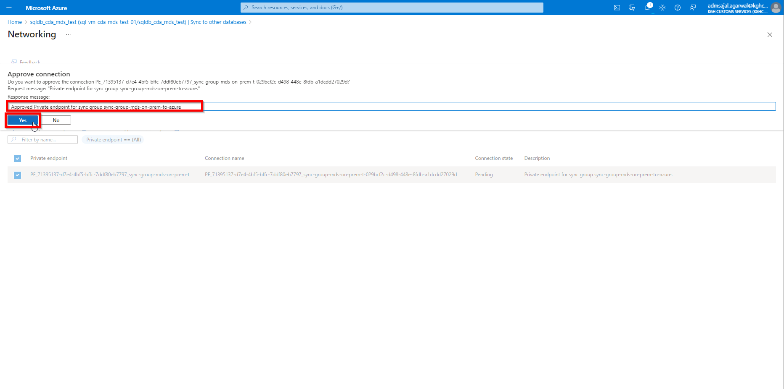

1. Wait for some time for approval to go through.

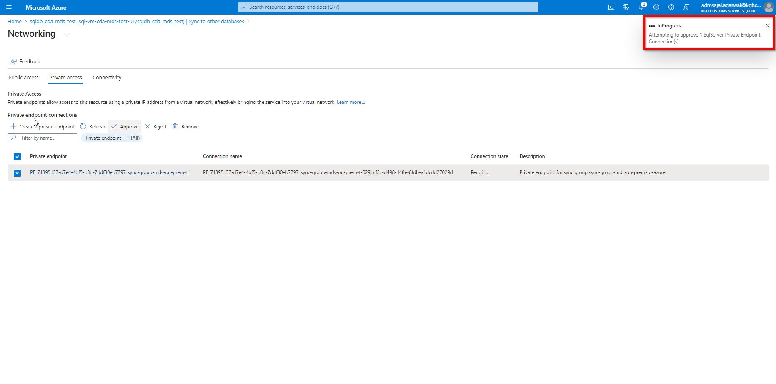

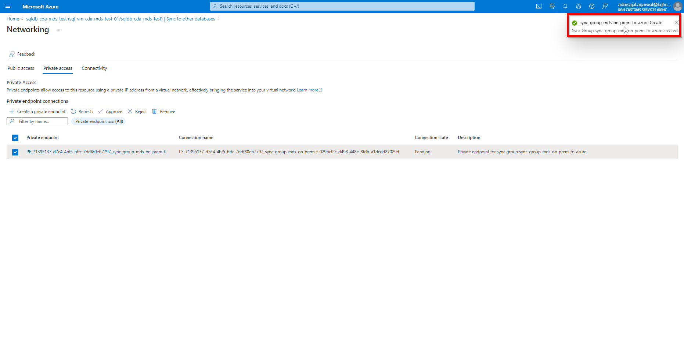

1. Click on *X* (close)

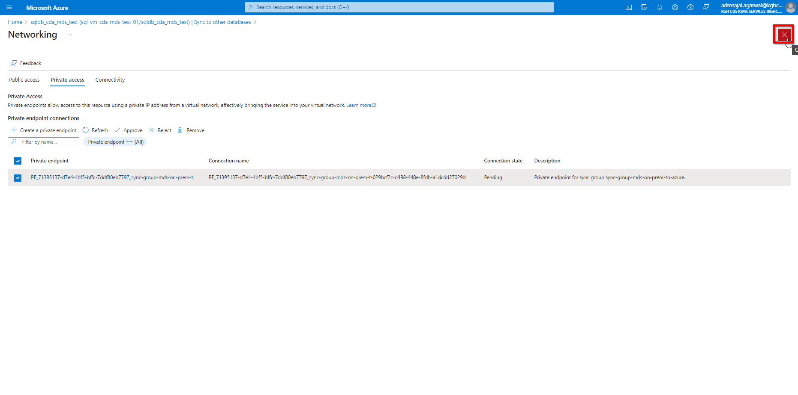

1. Click on *Refresh.*

It will show the newly created Sync Group.

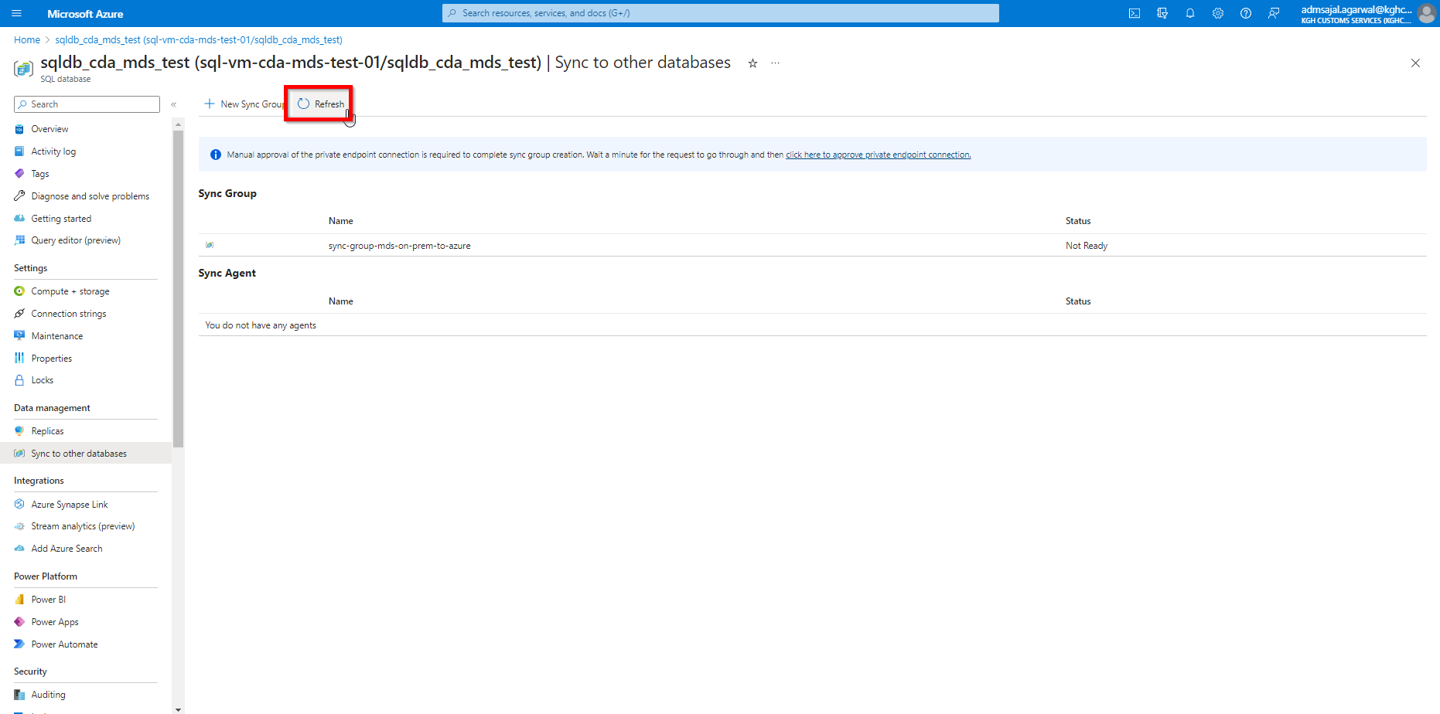

#### **Configuration: Sync Group**

1. Click on <sync group>

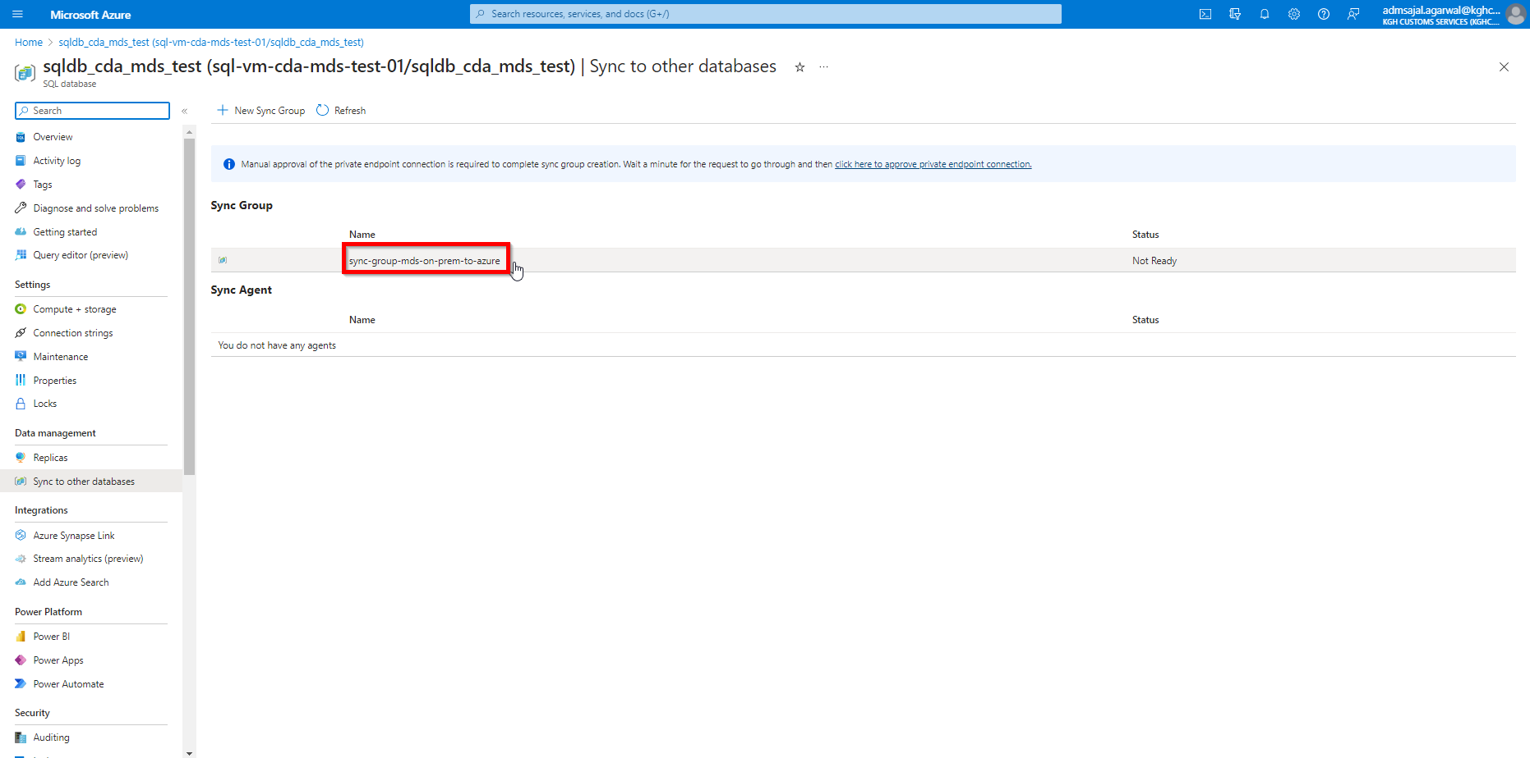

1. Click on *Databases*

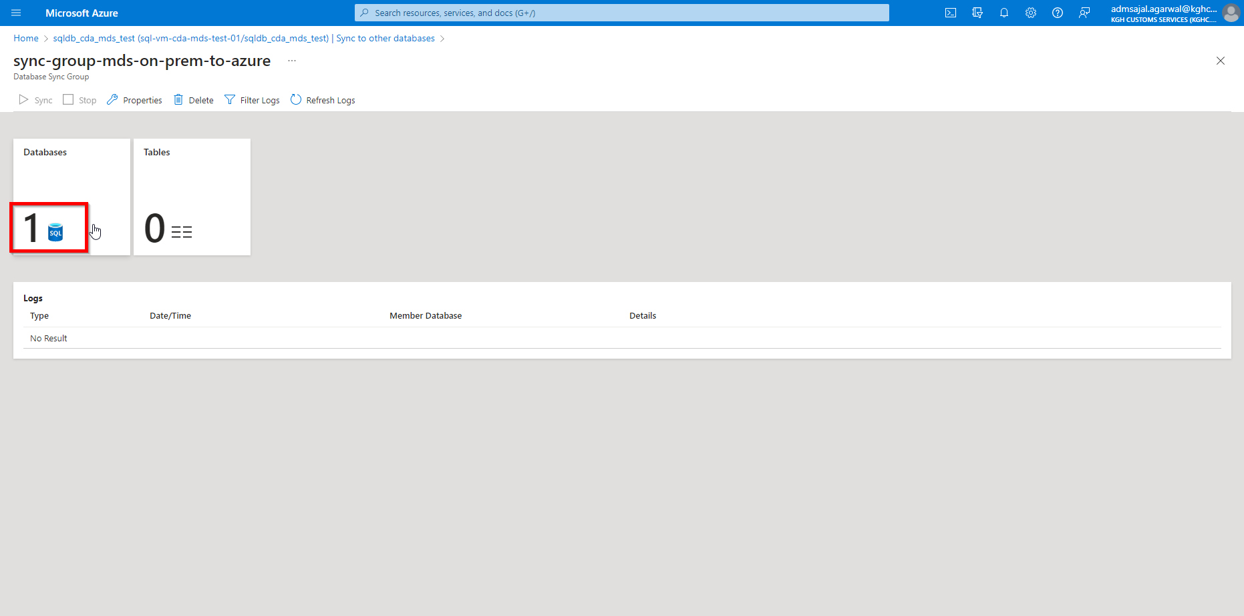

1. Click on *Add an On-Premises Database*

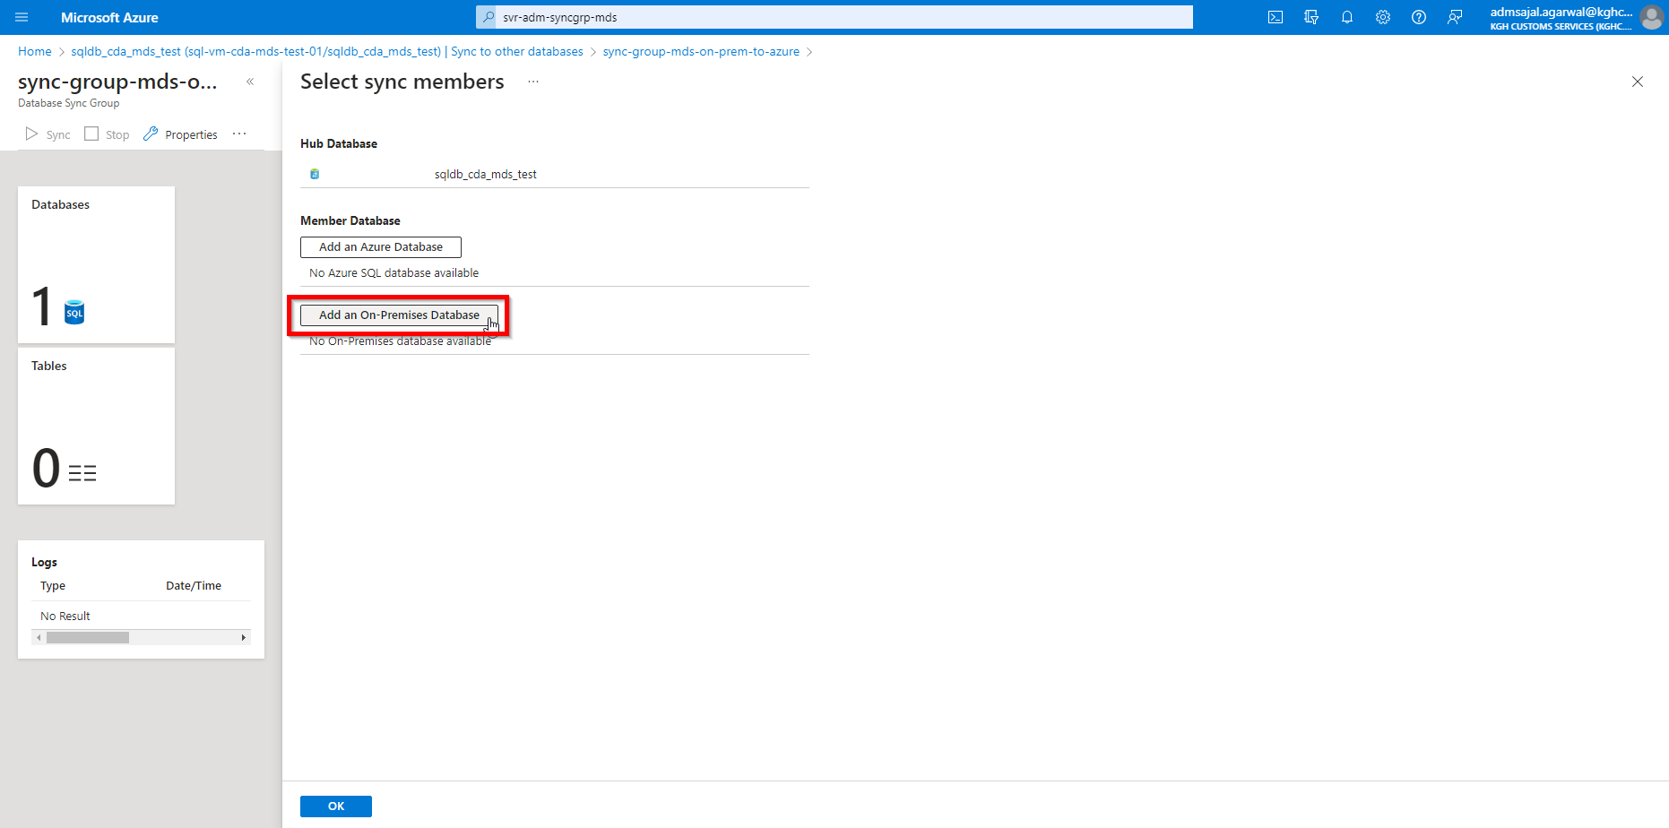

1. Click on *Choose the Sync Agent Gateway*

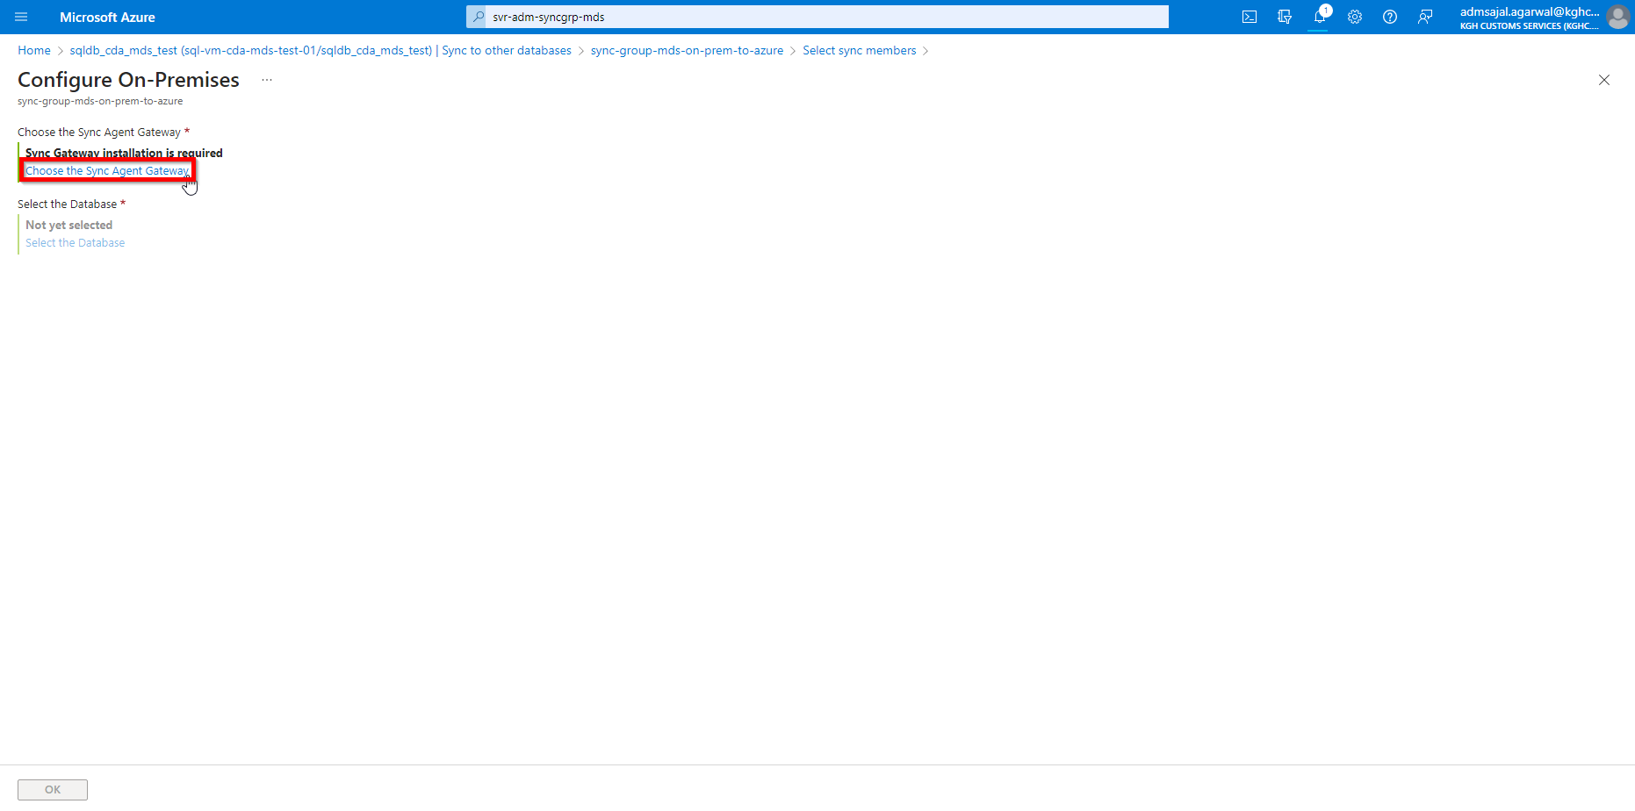

1. Click on *Create a new agent*.

Click on *Download*.

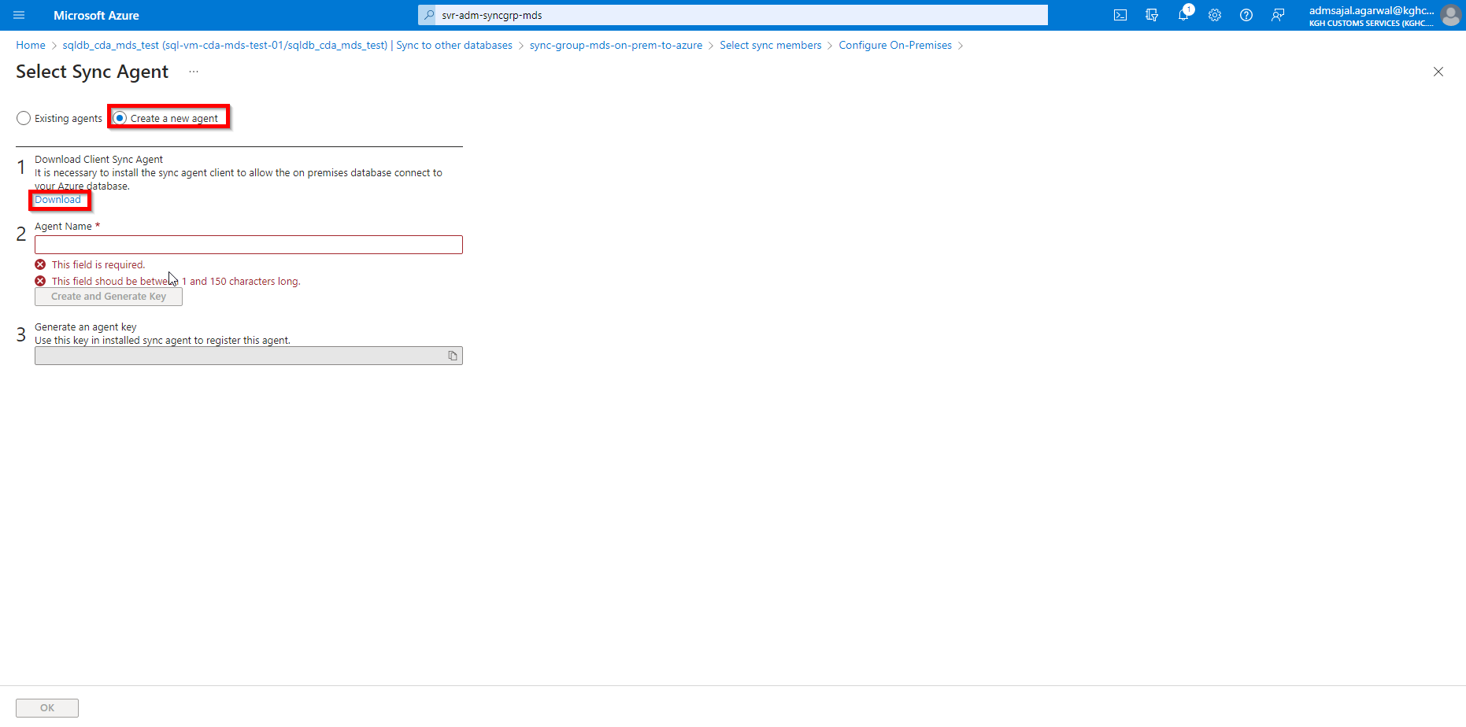

1. Click on *Download*

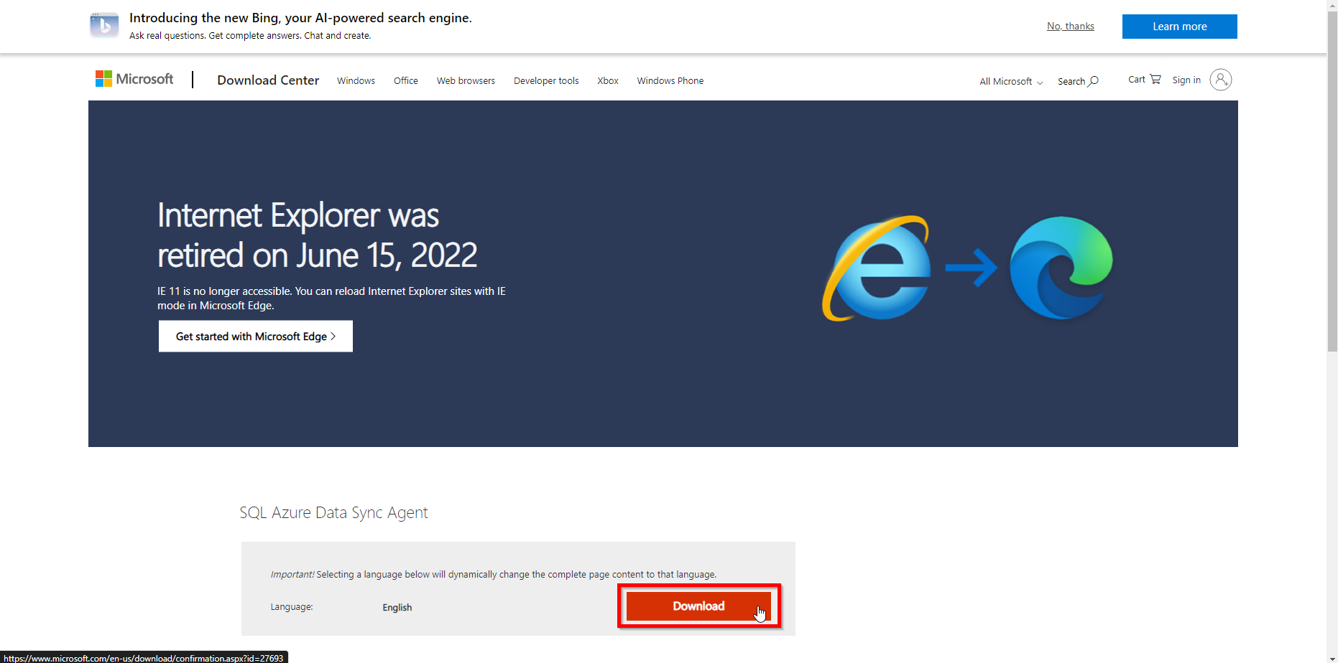

1. Select *SQLDataSyncAgent-2.0-x64-ENU.msi* for 64-bit server.

Click on *Next*

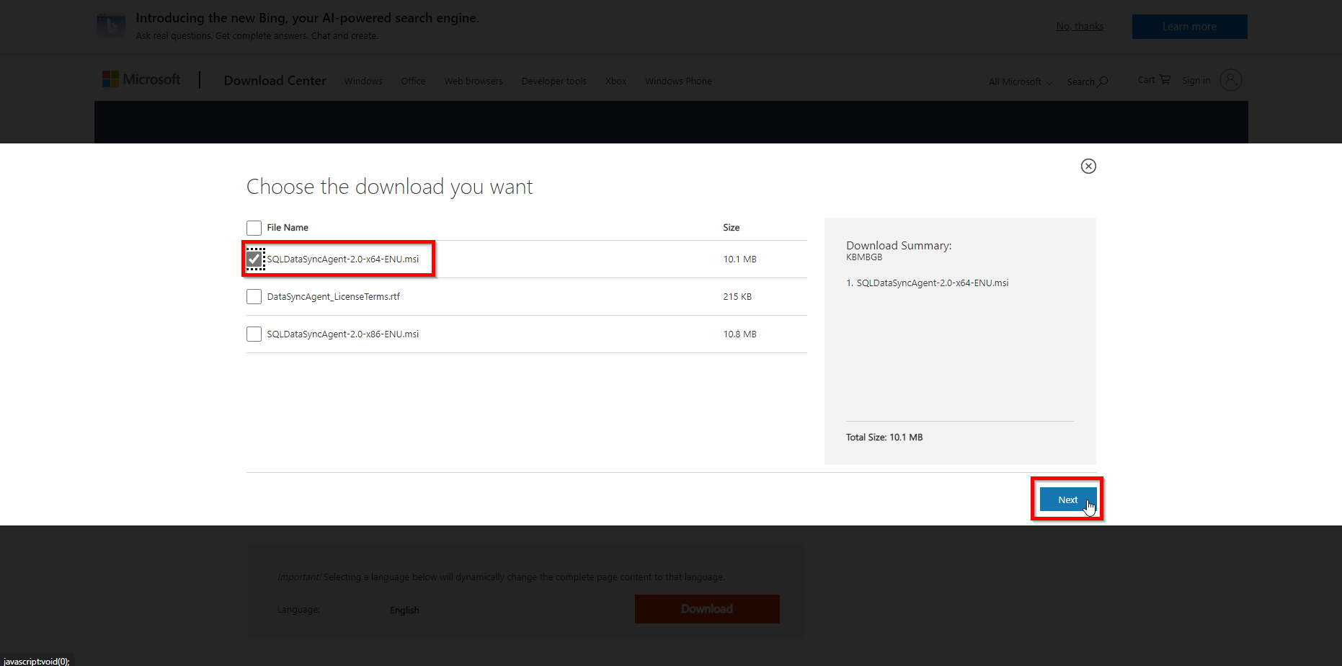

1. It will download the Client Sync Agent. Install it on the on-prem server *SQLDWTEST2*.
2. Fill the details as below:

Agent name: *sync-group-agent-mds-test2*

Click on *Create and Generate Key*

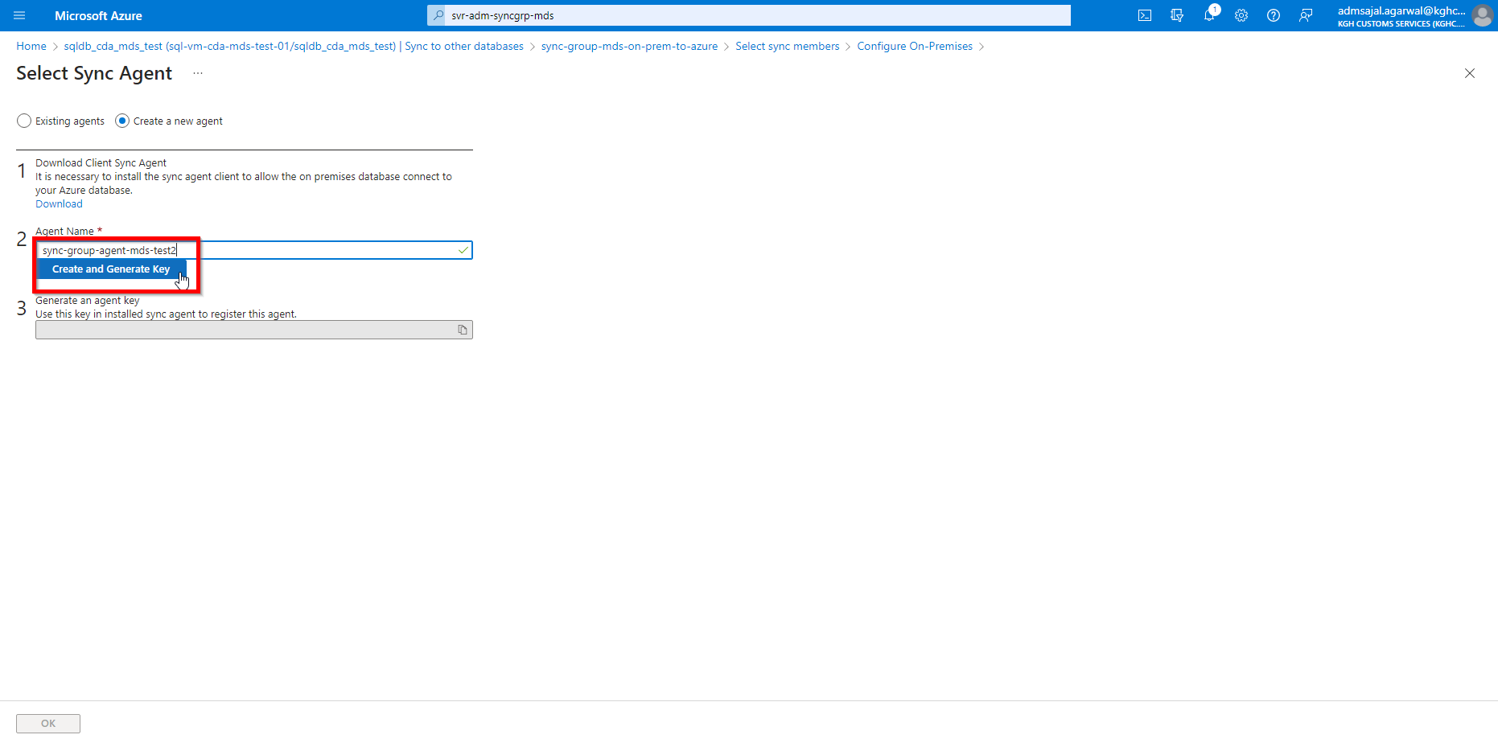

1. Wait for a few secs for the key to be generated.
2. After key is generated, click on *Copy to clipboard*

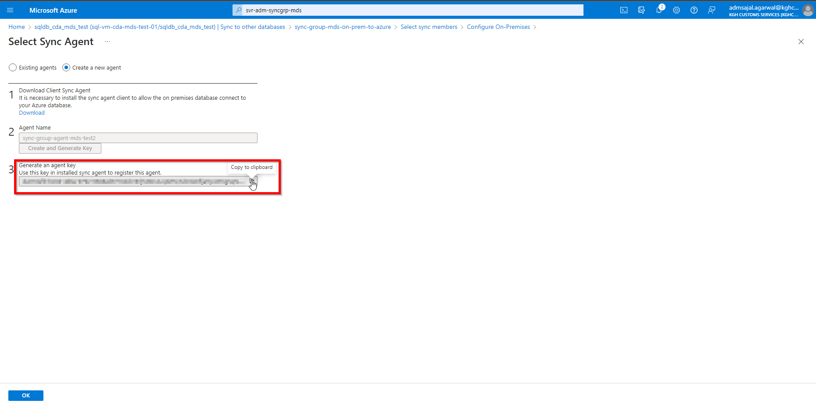

#### **Configuration: Client Sync Agent**

1. In the on-premises server *SQLDWTEST2*, open the *Client Sync Agent.*

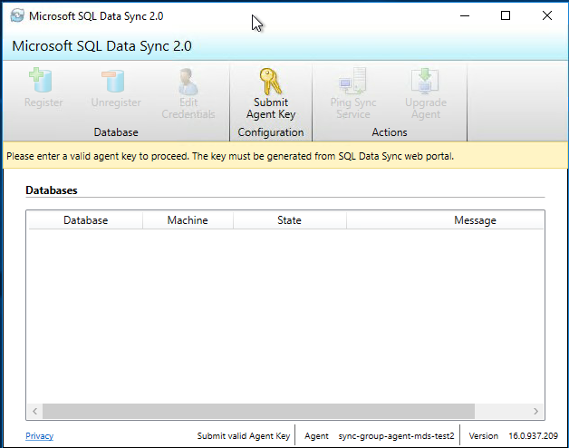

1. Click on *Submit Agent Key*

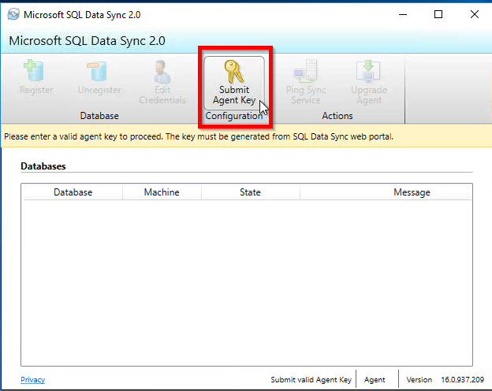

1. Fill the details as below:

Agent Key: *<paste the key copied in Step 27>*

Login: *<provide the username entered while creating SQL database>*

Password: *<provide the username entered while creating SQL database>*

Click on *Test Connection*

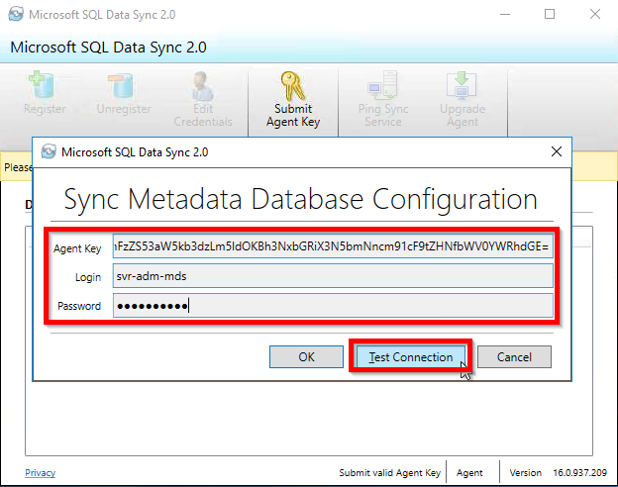

1. If it shows *Connection succeeded!*, click on *OK*

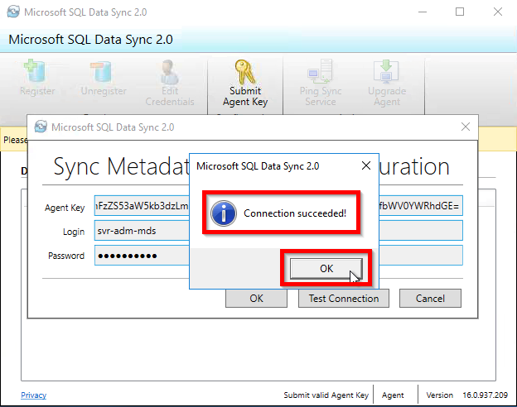

1. Click on *OK*

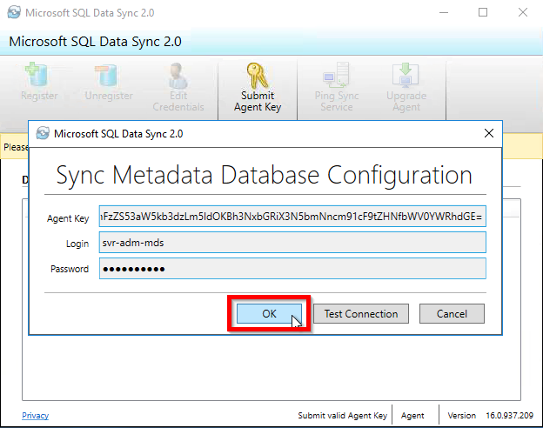

1. Click on Register

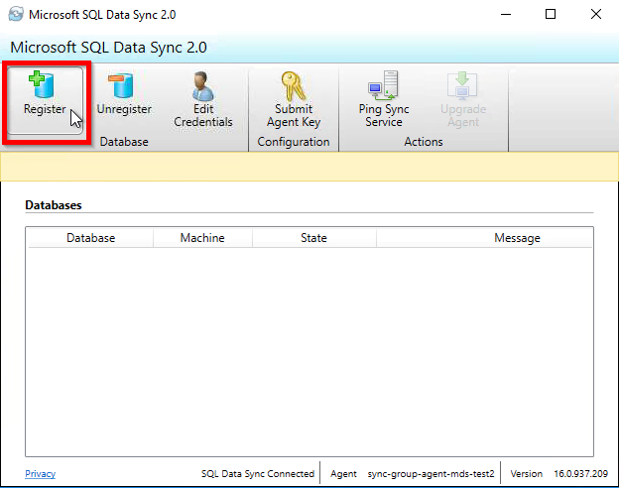

1. Fill the details as below:

Authentication: *Windows*

Server: *SQLDWTEST2*

Database: *KGH_MDS_Cloud*

Click on *Test Connection*

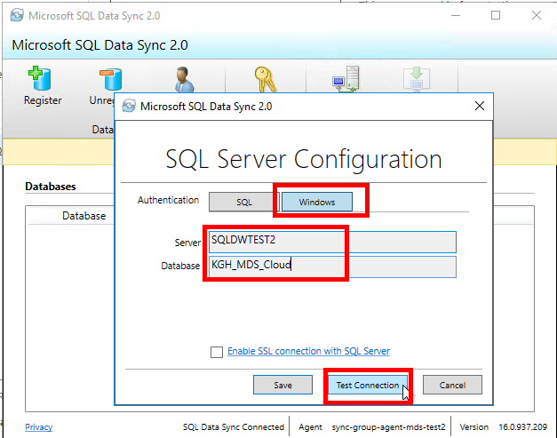

1. If it shows *Connection succeeded!*, click on *OK*

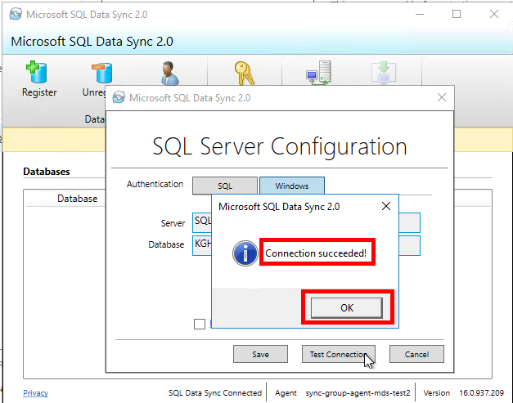

1. Click on *OK*

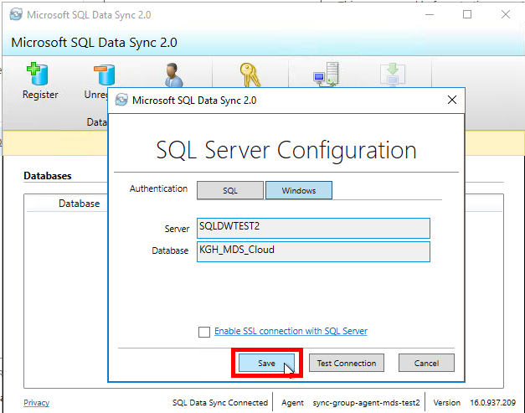

1. On-Premises Database should now be visible in list of Databases.

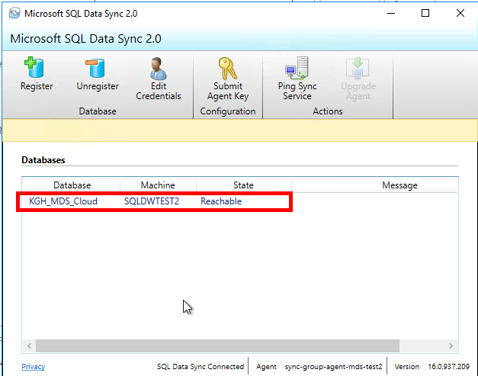

#### **Configuration: Sync Group (contd…)**

1. Click on *OK*

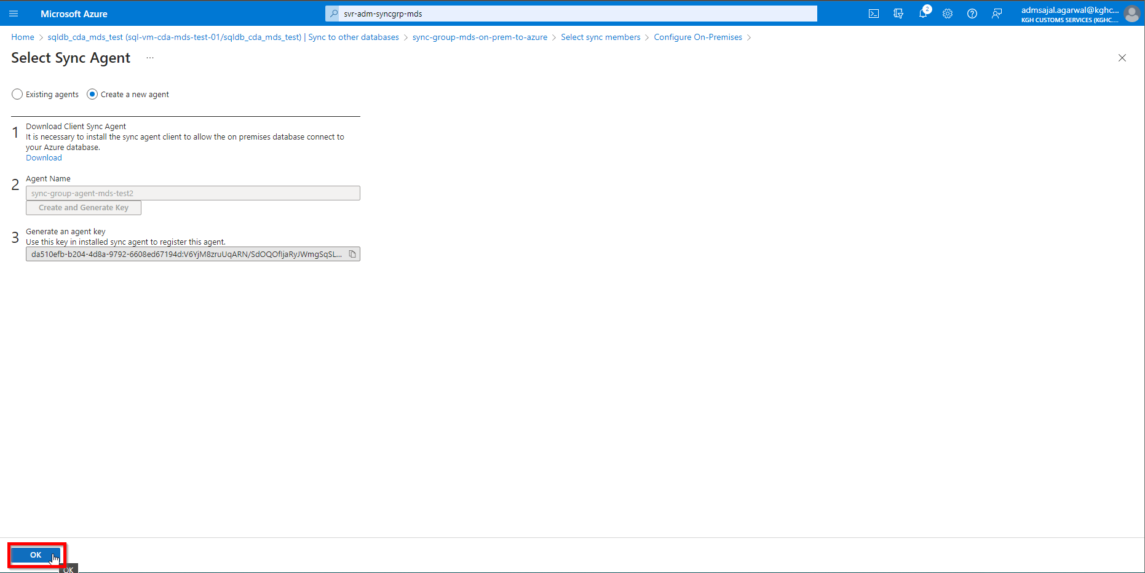

1. Click on *Select the Database*

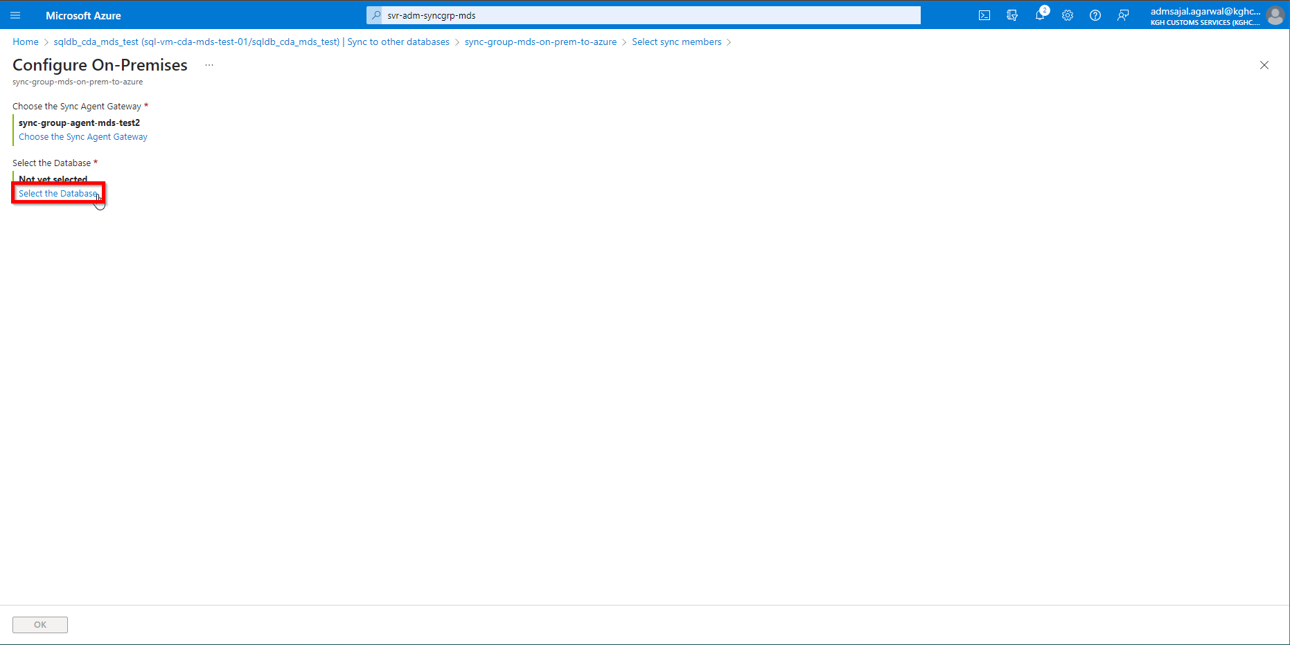

1. Fill the details as below:

Sync Member Name: *on-prem-KGH_MDS_Cloud*

On-premises database connected to this agent: *<select from drop down>*

Sync directions: *To the Hub*

Click on *OK*

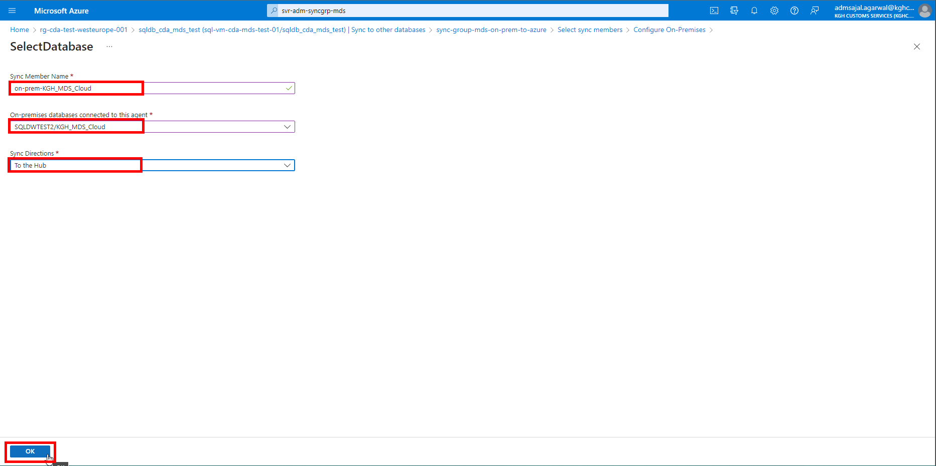

1. On-premises server *SQLDWTEST2* and database name *KGH_MDS_Cloud* should now be displayed under *Select the Database.*

Click on *OK.*

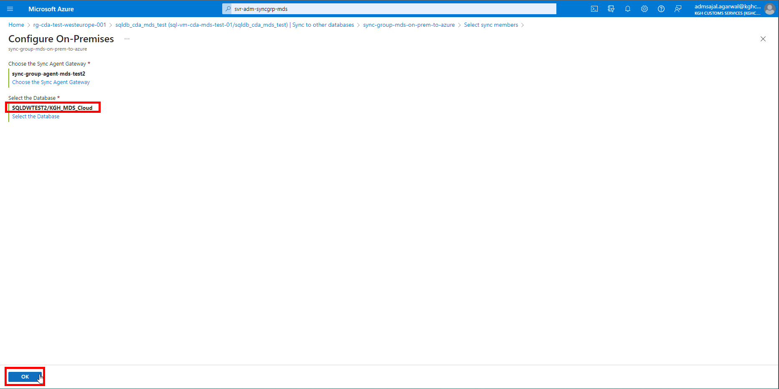

1. It will start adding the on-premises database *KGH_MDS_Cloud* as a member database.

Once added, it will be displayed under *Member Database.*

Click on *OK.*

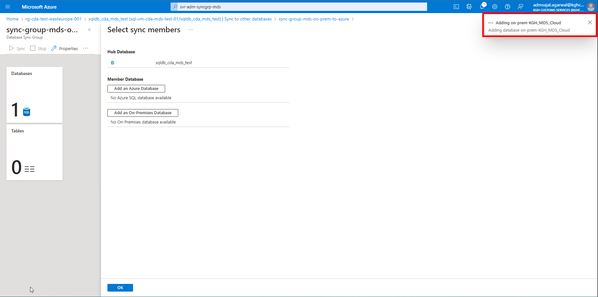

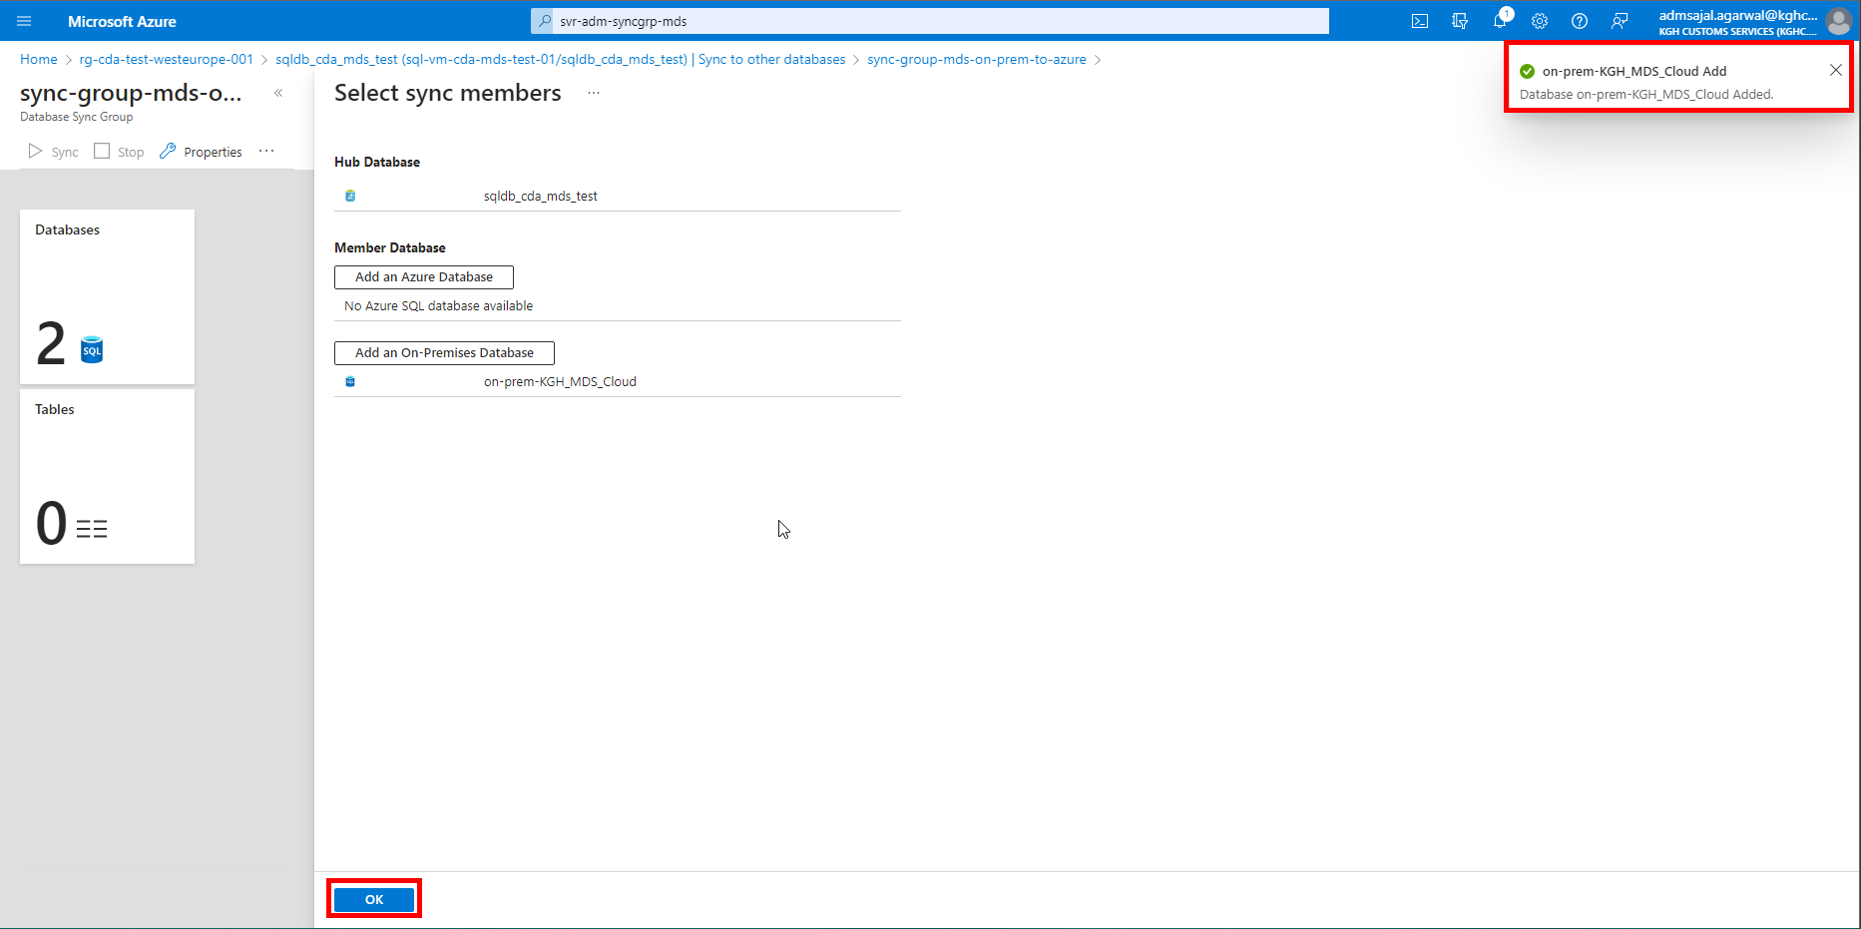

1. Click on *Tables*

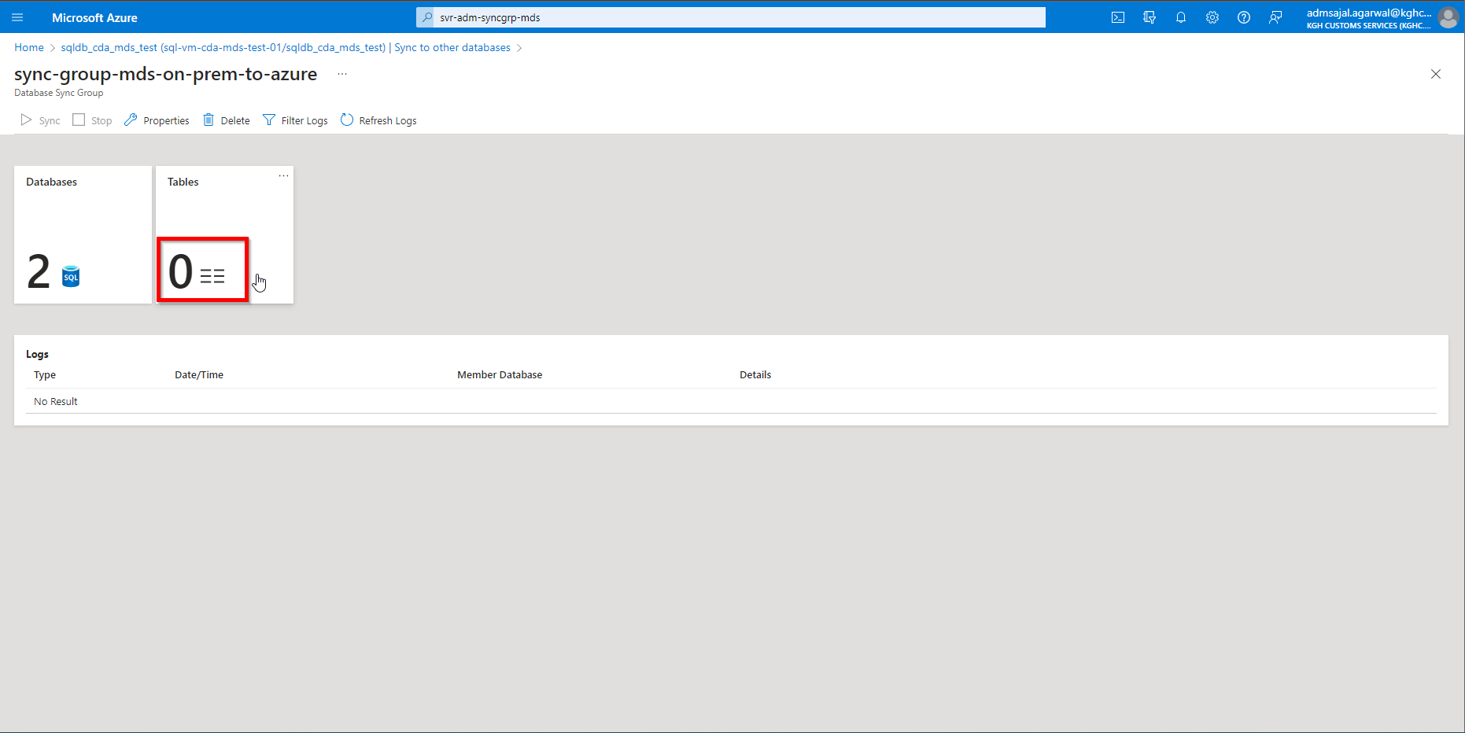

1. Under *Select a database*, select the on-prem database.

Click on *Refresh Schema*.

Select all the tables by ticking the mark against *Name*.

Click on *Save*.

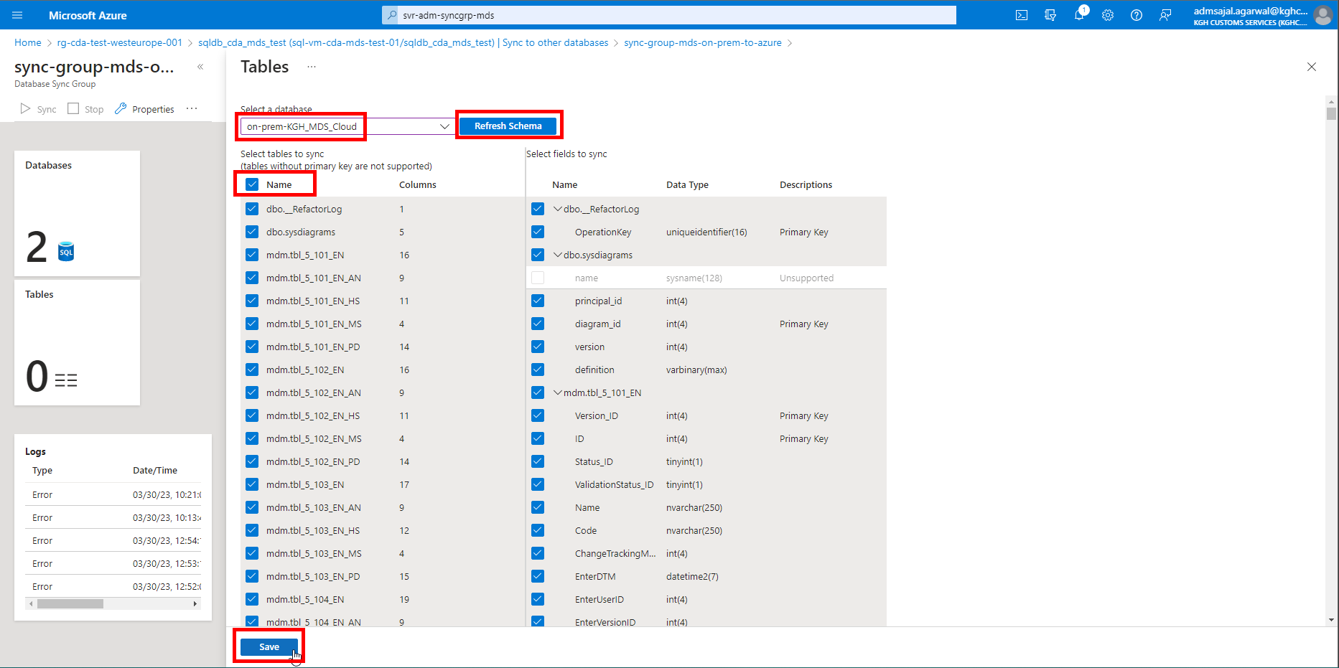

1. It will update the *Sync Group* and will show the count of tables to sync under *Tables*

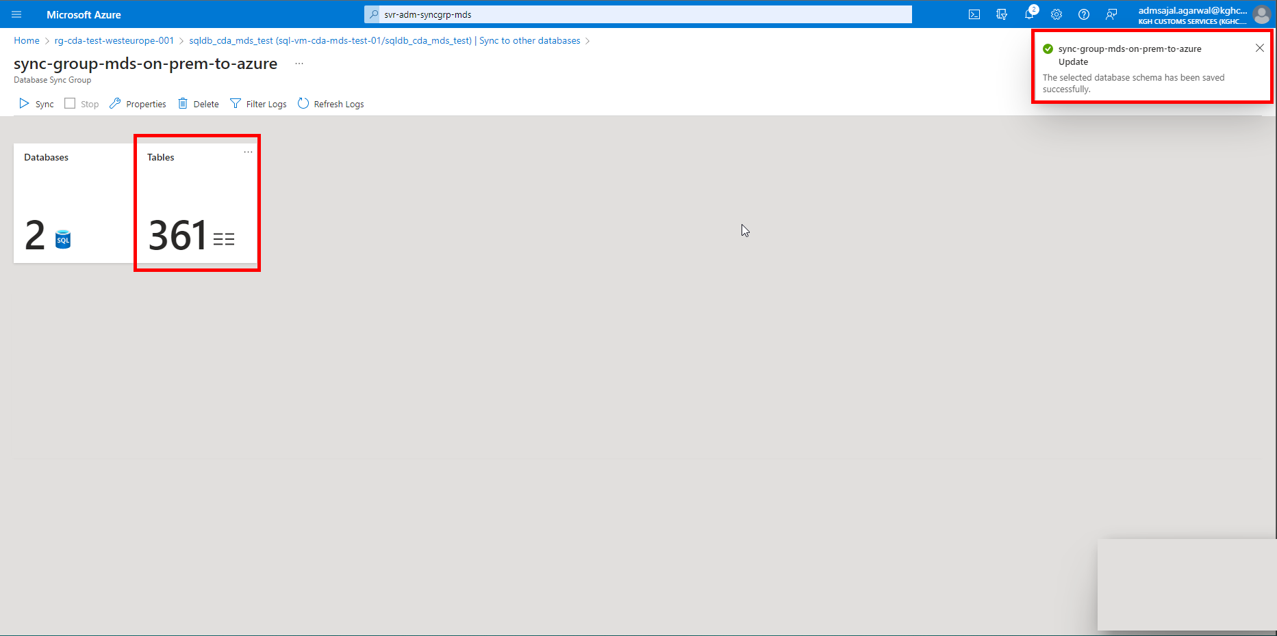

1. Click on *Sync* to start syncing the databases.

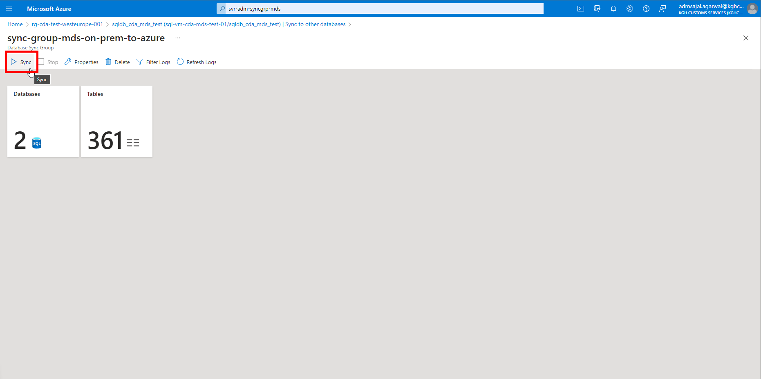

## **Database Migration: Azure SQL Migration extension for Azure Data Studio**

1. Login to on-premises server *SQLDWTEST2*
2. Open *Azure Data Studio*

Click on *Manage*

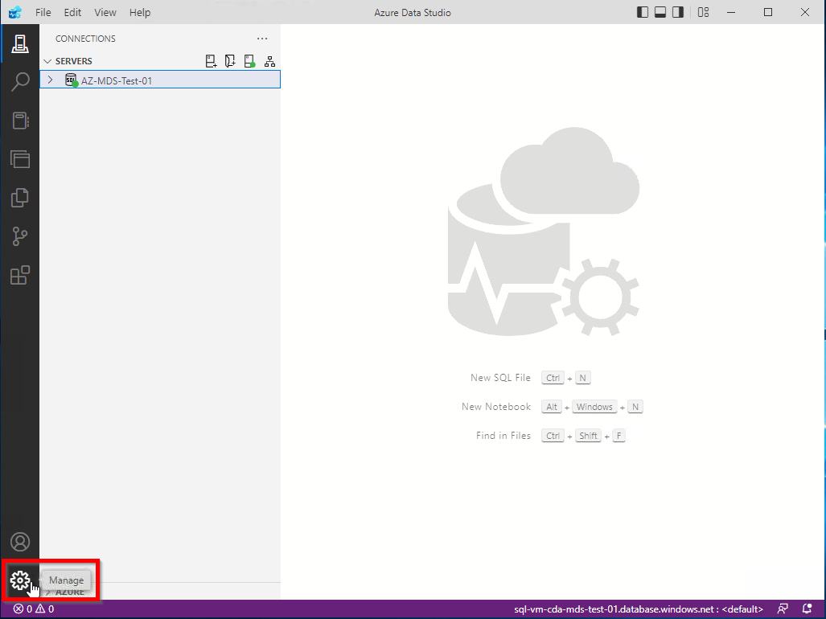

1. Click on *Extensions*

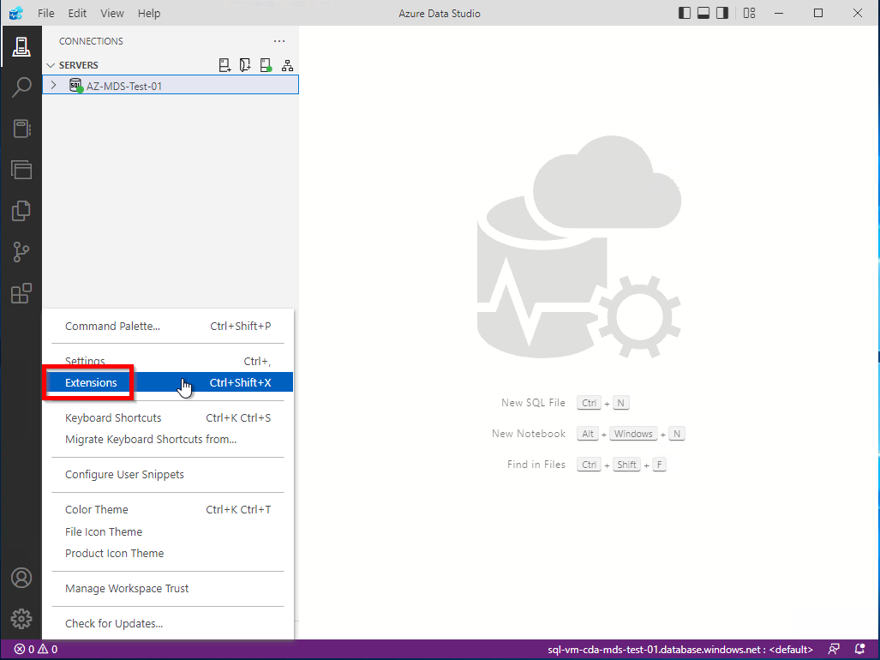

1. Search for *Azure SQL Migration*

Click on result named *Azure SQL Migration*

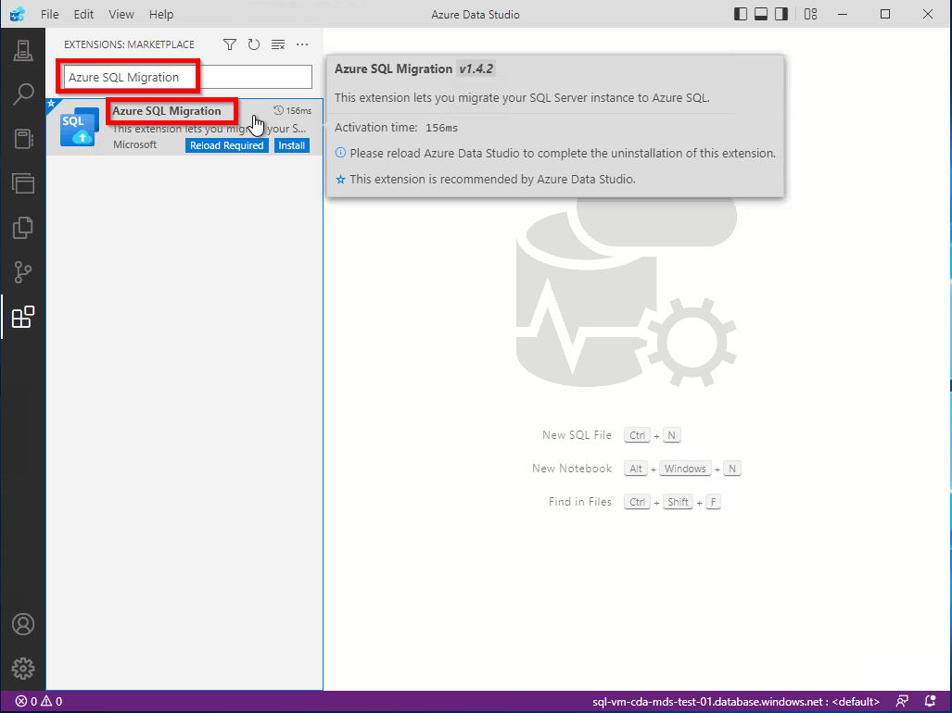

1. Click on *Install*

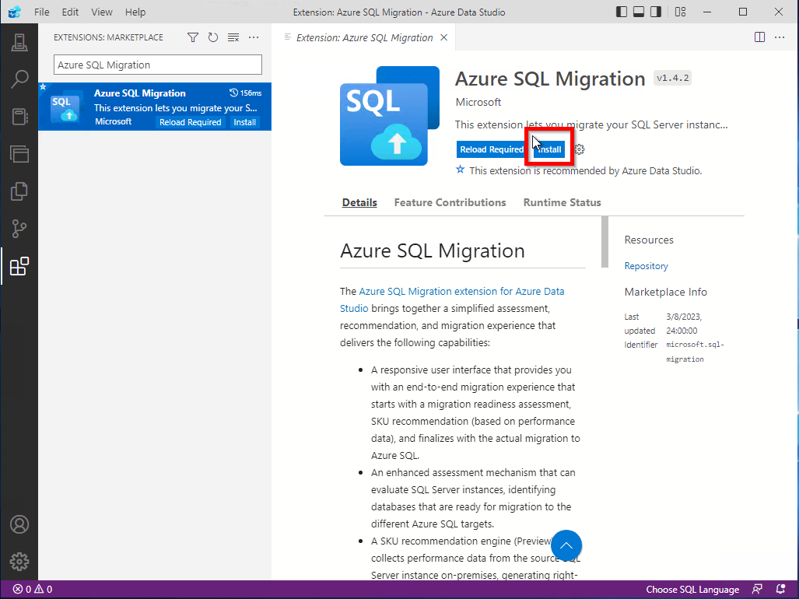

1. After installation is complete, it will show *Installed* as show below

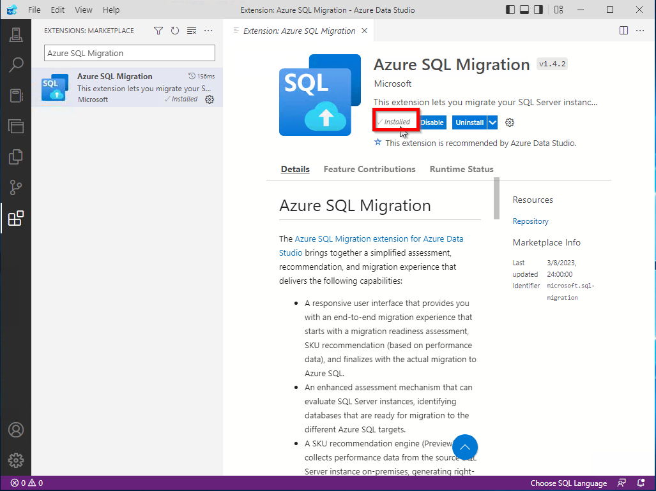

1. Click on *Connections* (first option in left side menu bar)

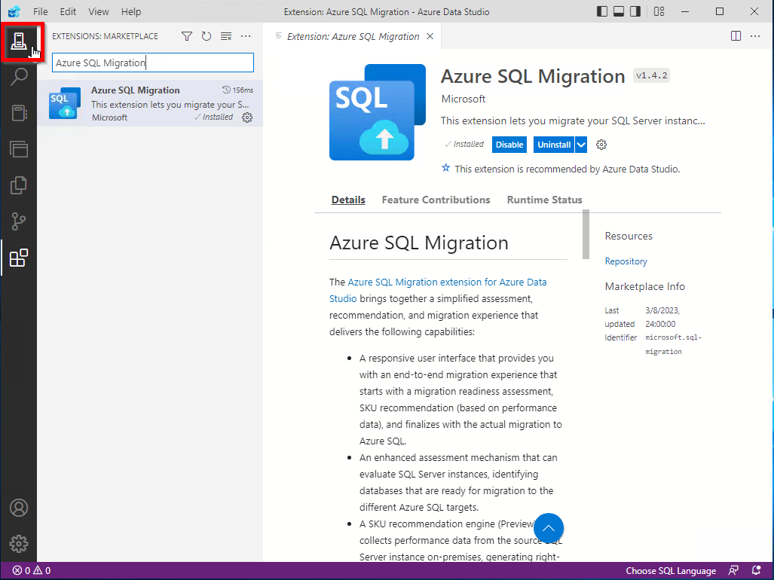

1. Click on *ON-PREM-SQLDWTEST2*

Click on *Azure SQL Migration* under *General*

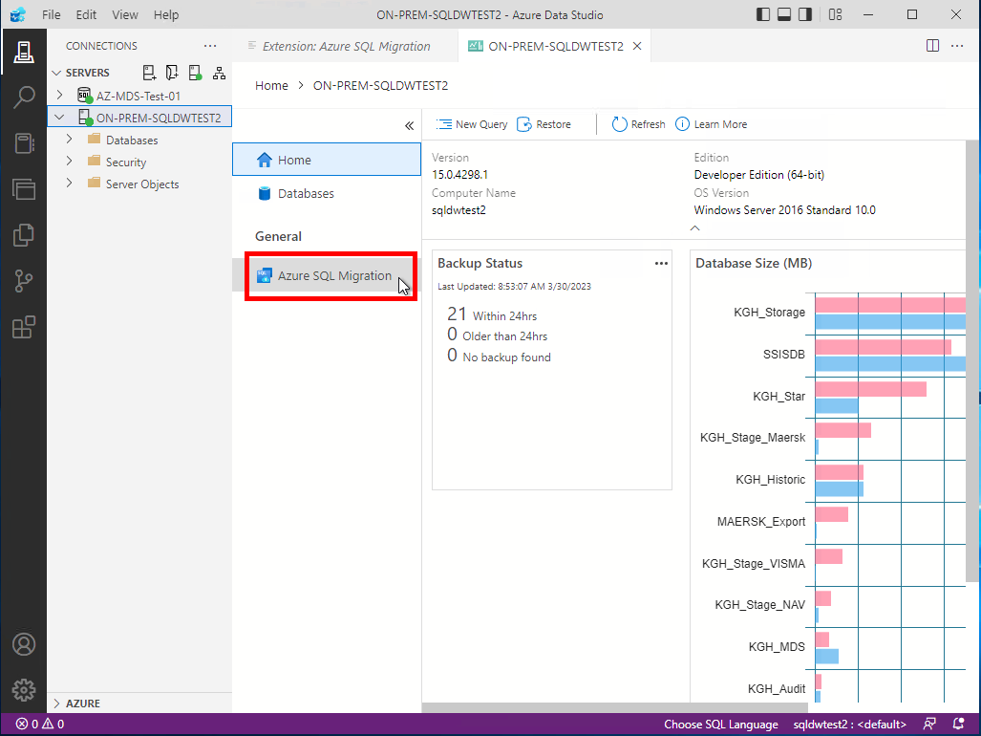

1. Click on *Migrate to Azure SQL*

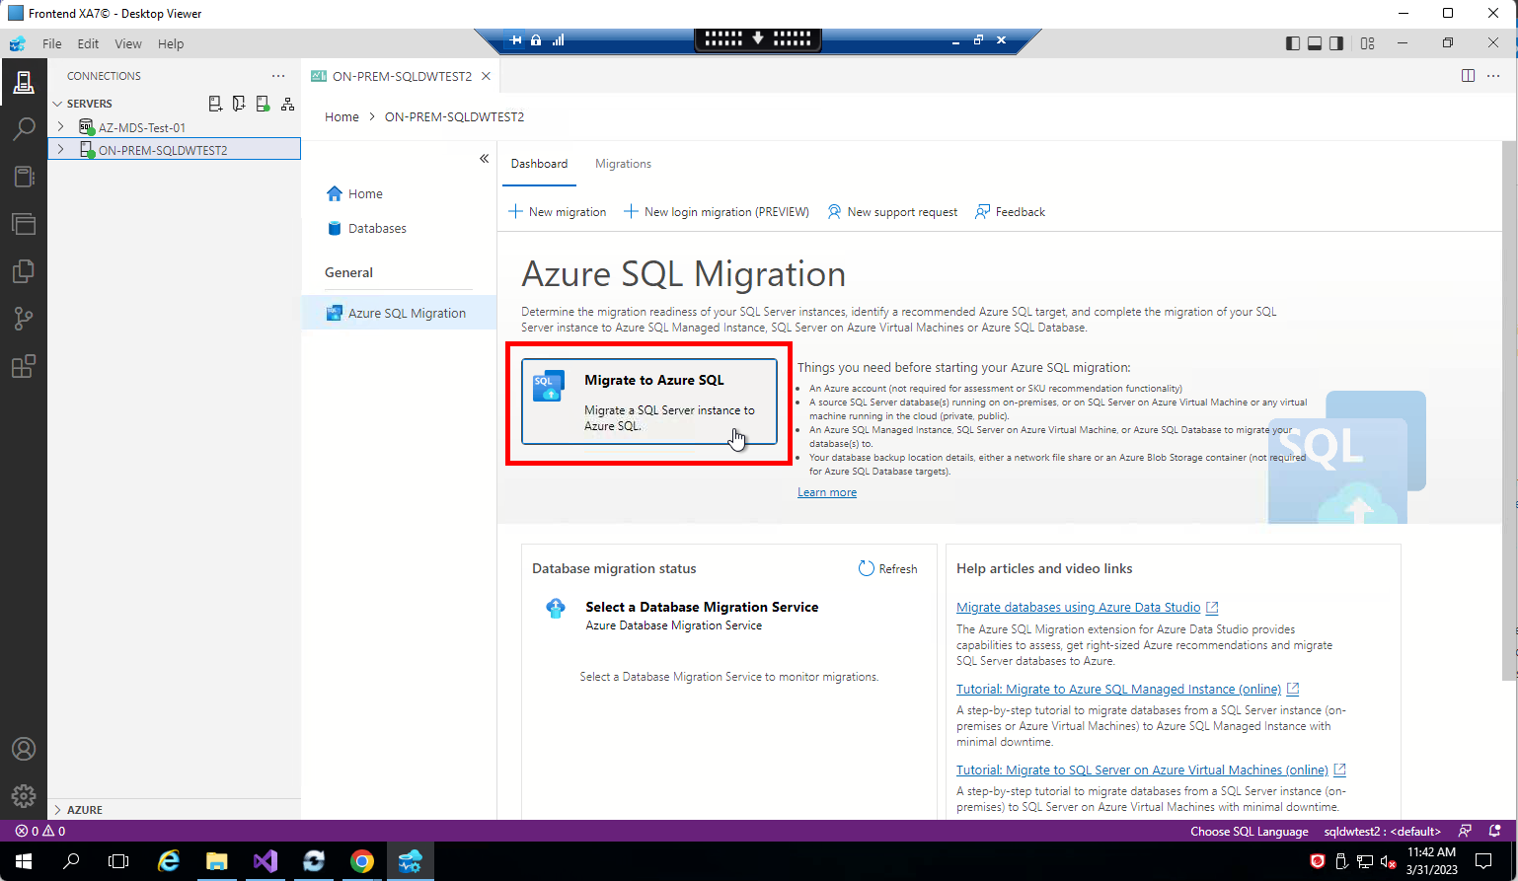

1. Select the *KGH_MDS_Cloud* database

Click on *Next*

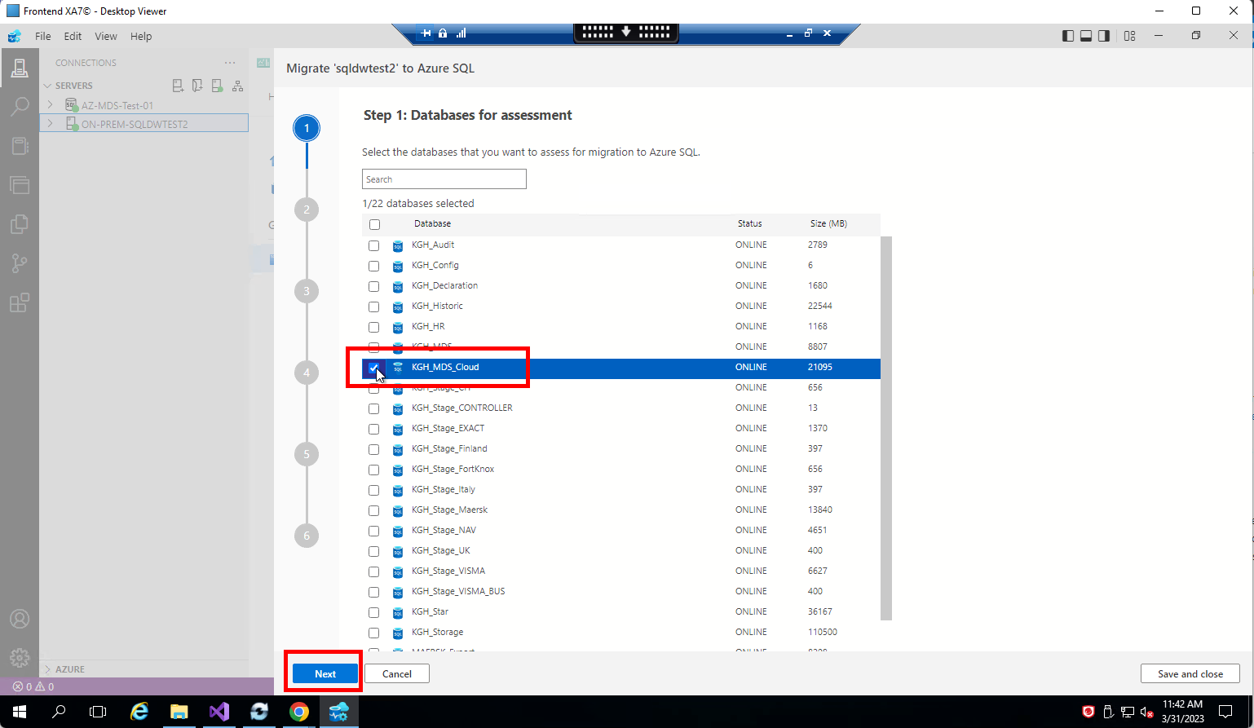

1. It will provide the assessment report of whether the database can be migrated to Azure SQL Database or not.

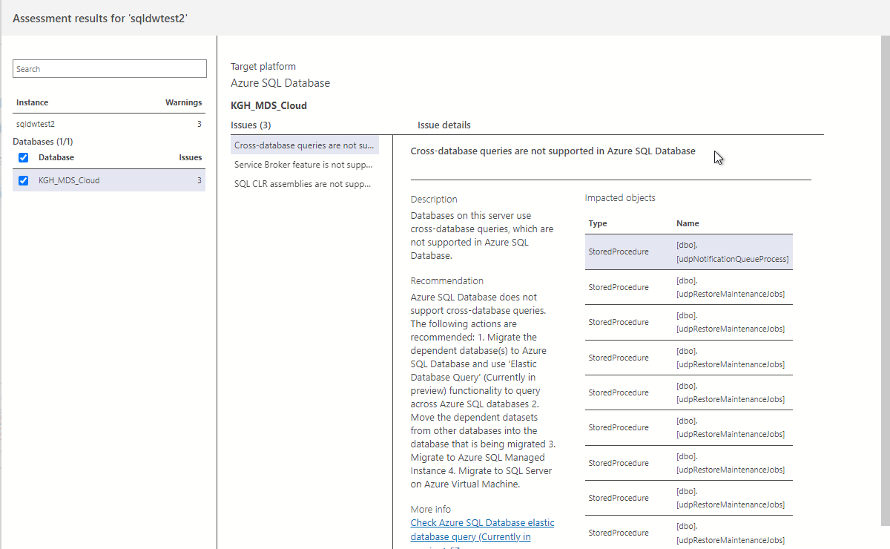

## **Database Migration: SQL Server dacpac extension for Azure Data Studio**

1. Login to on-premises *SQLDWTEST2*
2. Open *Azure Data Studio*

Click on *Manage*

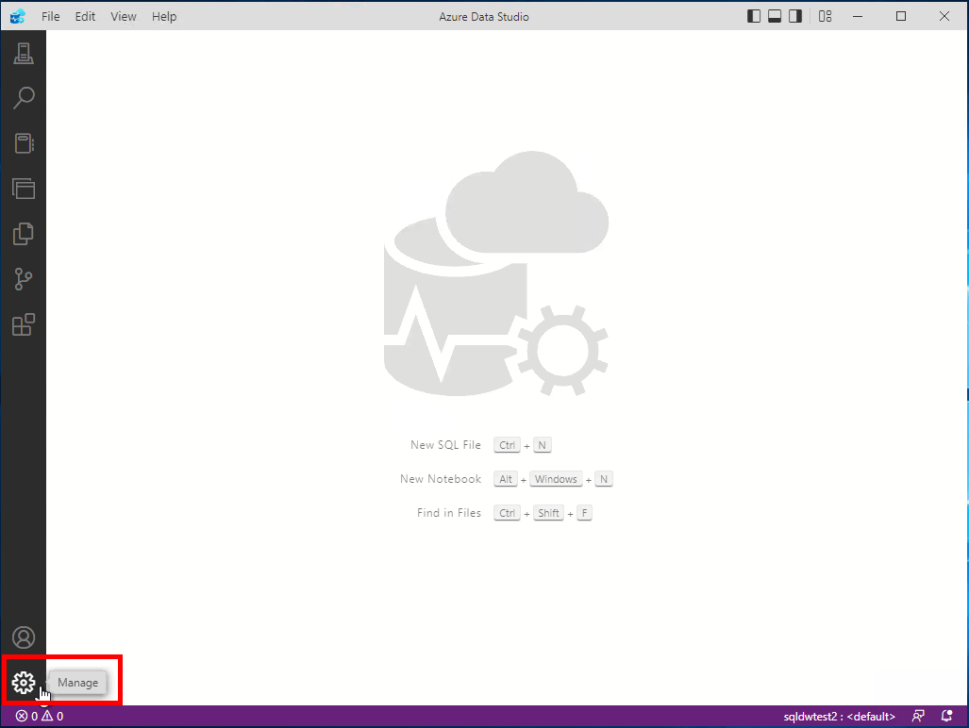

1. Click on *Extensions*

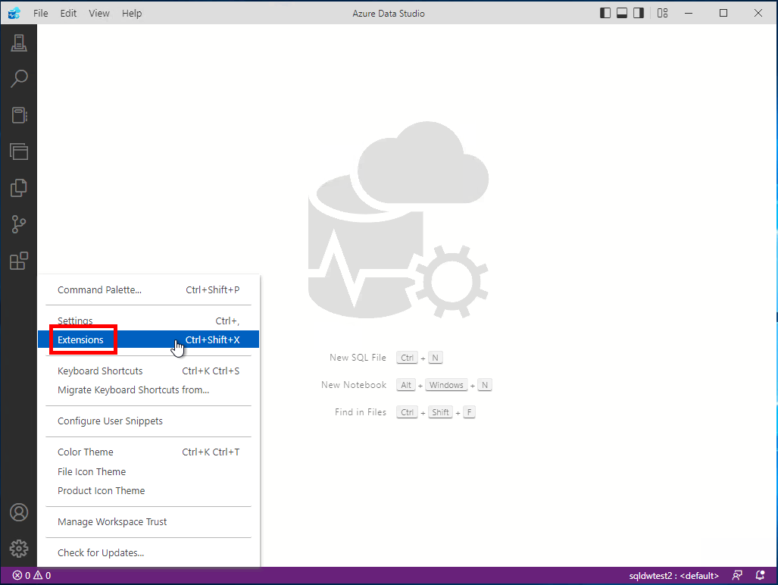

1. Search for *SQL Server dacpac*

Click on result named *SQL Server Dacpac*

Click on *Install*

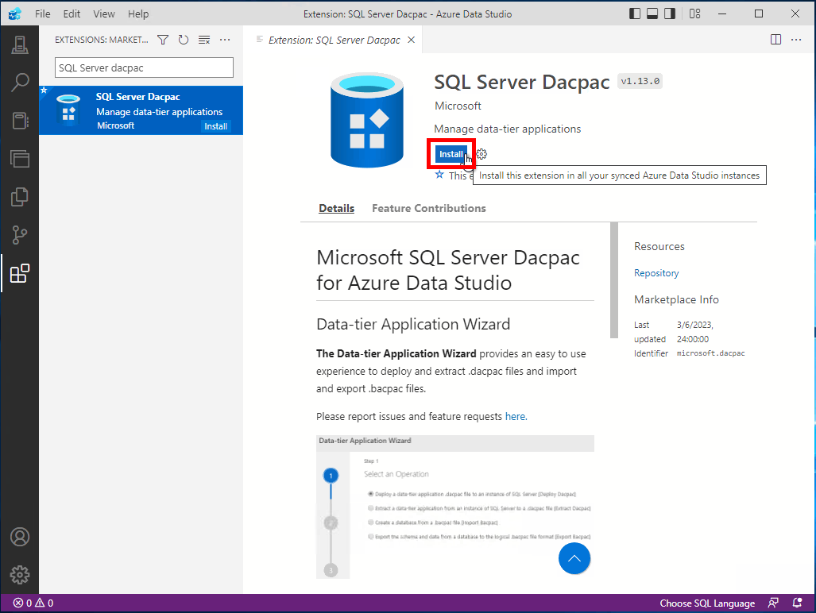

1. After installation is complete, it will show *Installed* as show below

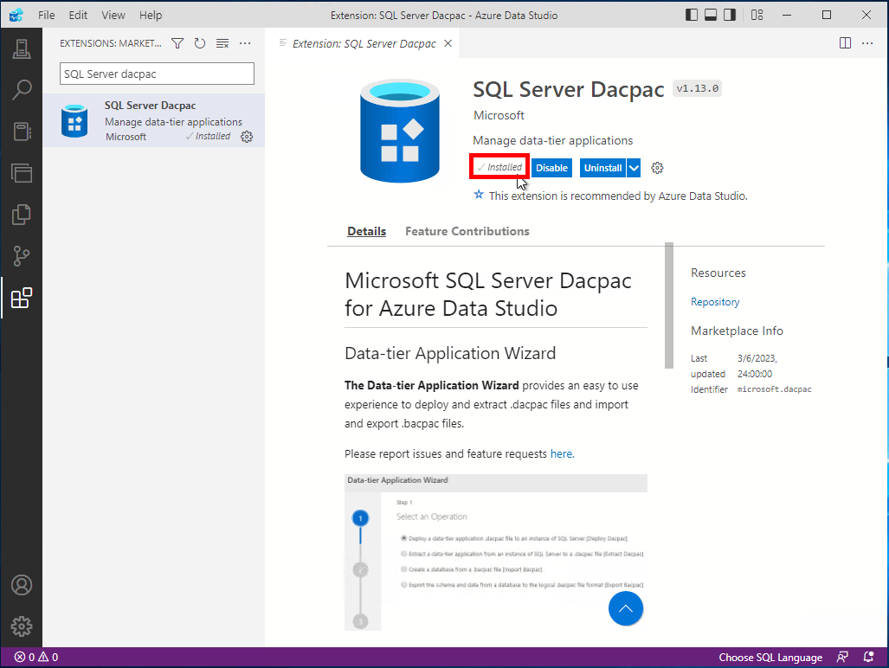

1. Right click on connection *ON-PREM-SQLDWTEST2* and click on *Data tier Application Wizard*

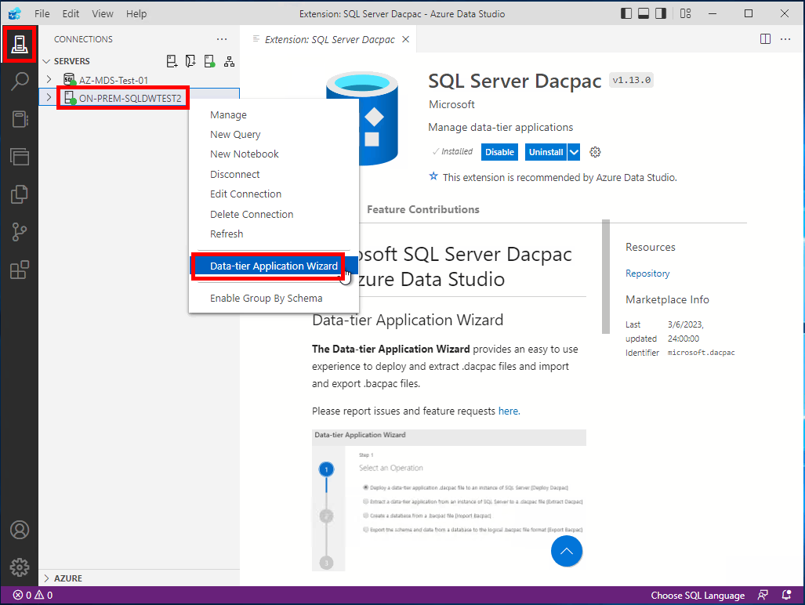

### **Option 1: dacpac file**

1. Select *Extract a data-tier application from an instance of SQL Server to a .dacpac file [Extract Dacpac]*

Click on *Next*

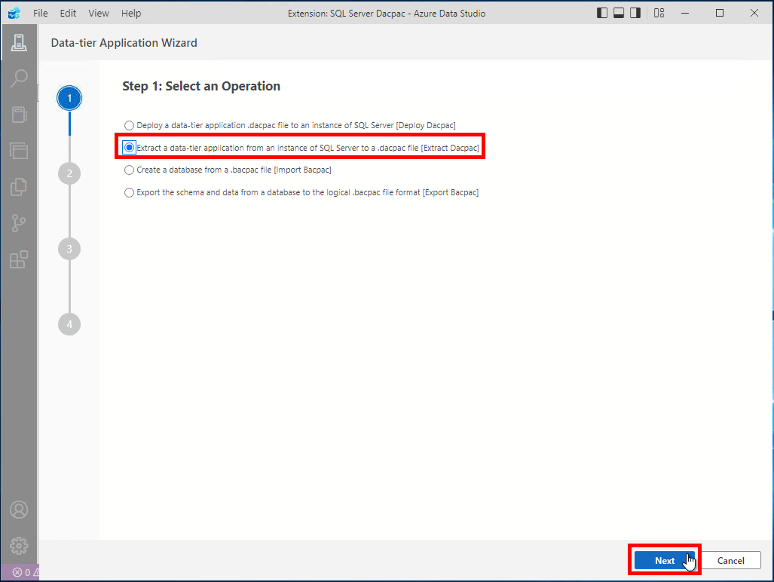

1. Fill the details as below:

Source Server: *ON-PREM-SQLDWTEST2*

Source Database: *KGH_MDS*

Version: *1.0.0.0*

File Location: <provide a location>

Click on *Next*

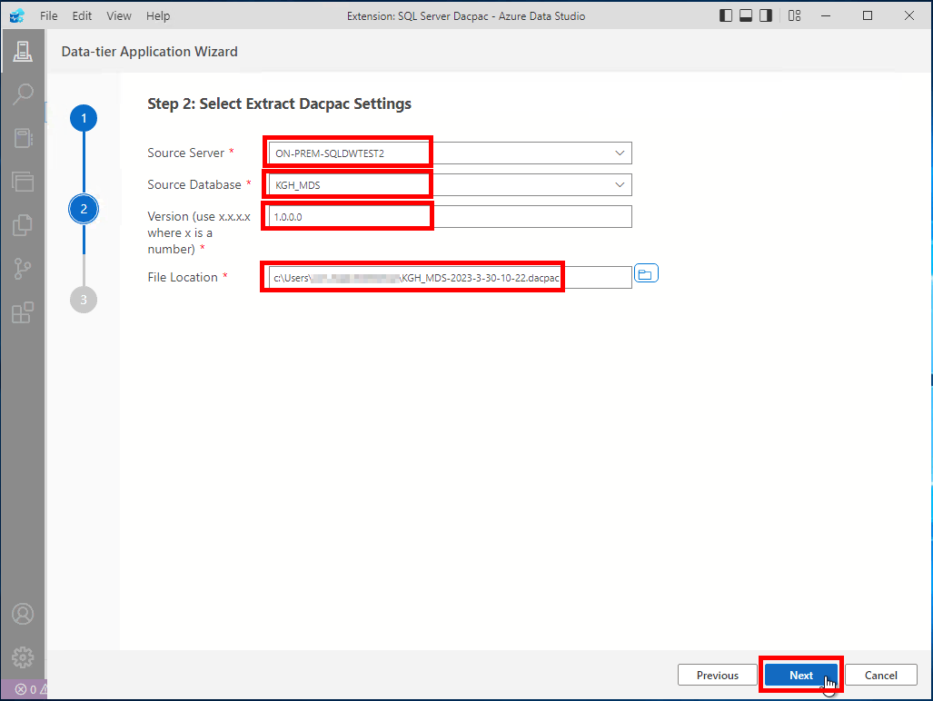

1. Click on *Extract*

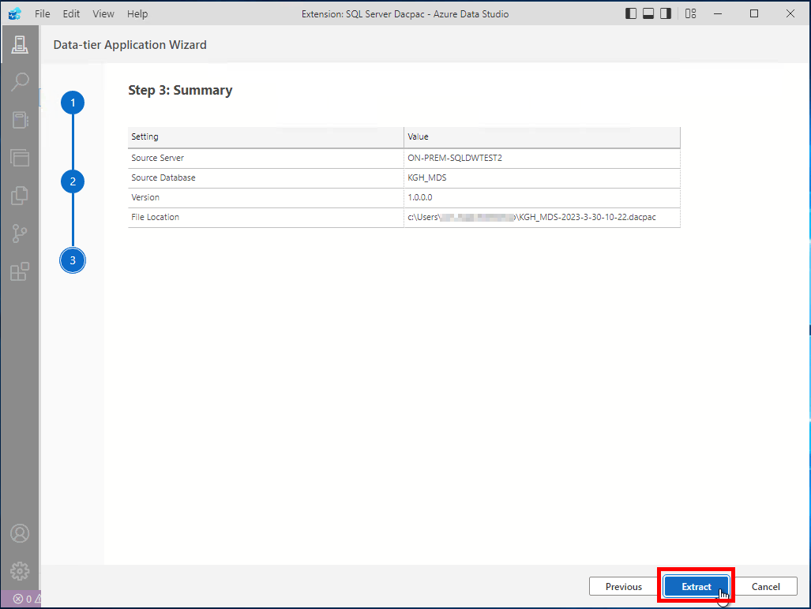

1. Extraction will start

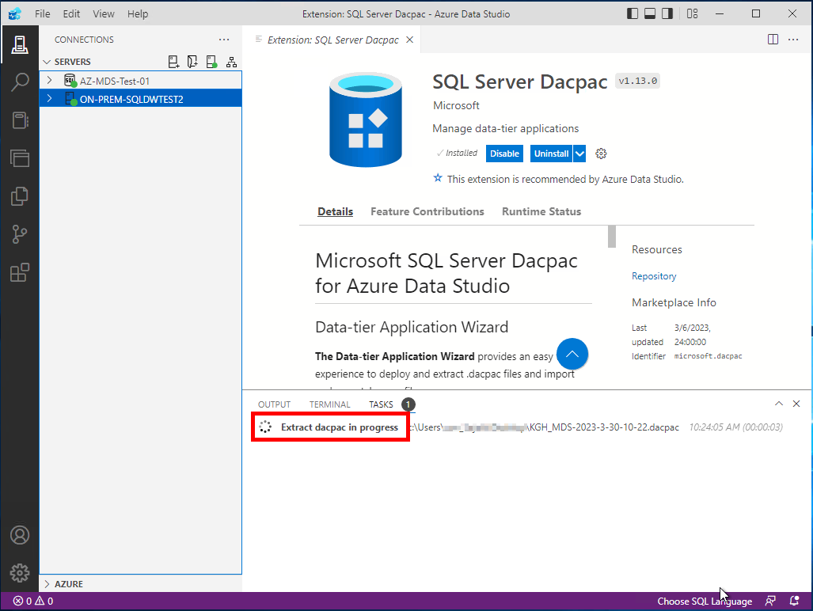

1. Wait for a few minutes for the extraction to complete

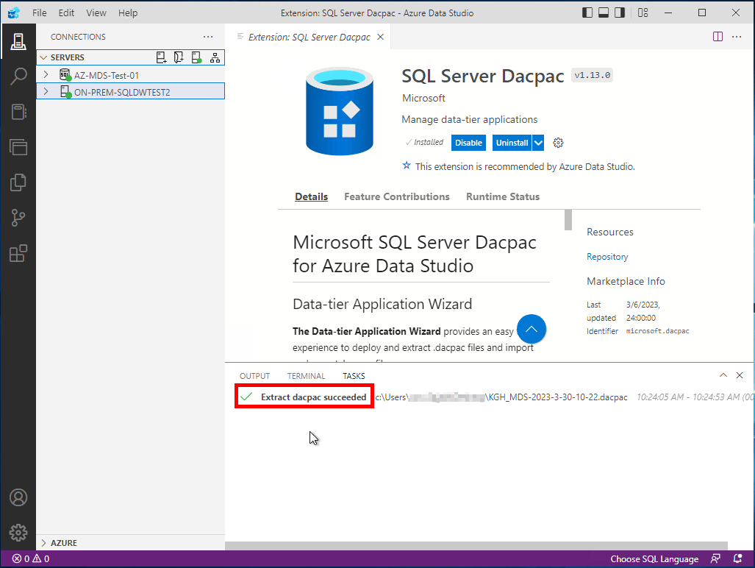

1. Right click on connection *AZ-MDS-Test-01* and click on *Data tier Application Wizard*

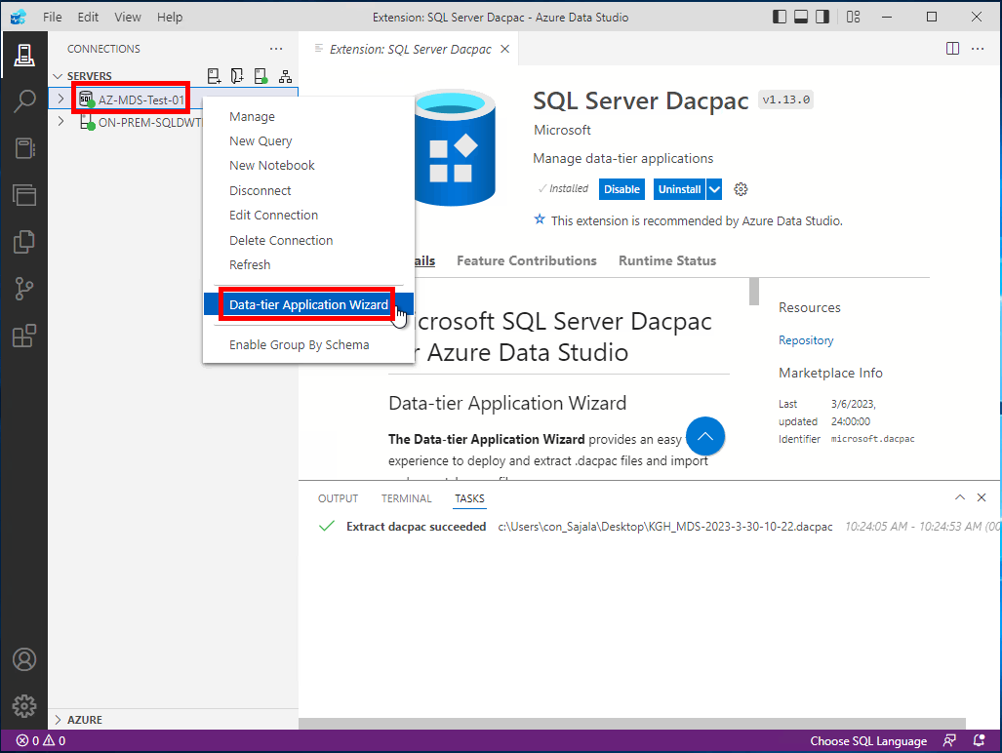

1. Select *Deploy a data-tier application .dacpac file to an instance of SQL Server [Deploy Dacpac]*

Click on *Next*

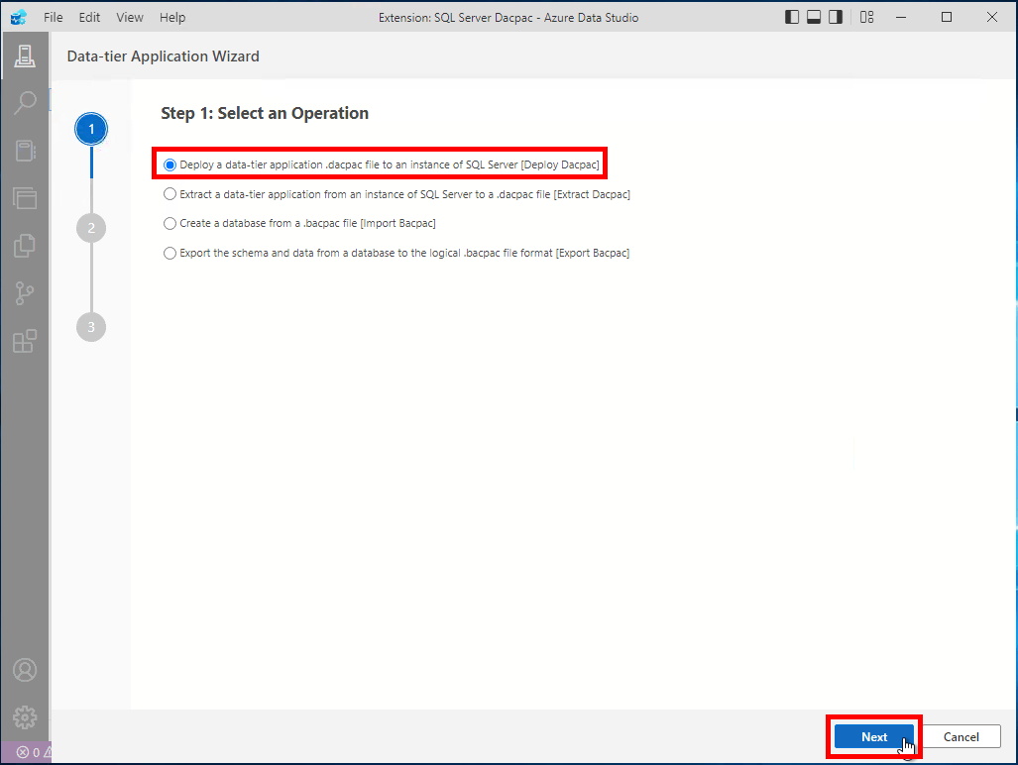

1. Fill the details as below:

File Location: <provide a location of file created above>

Target Server: *AZ-MDS-Test01*

Target Database: *Upgrade Exiting Database*

Database Name: *sqldb_cda_mds_test*

Click on *Next*

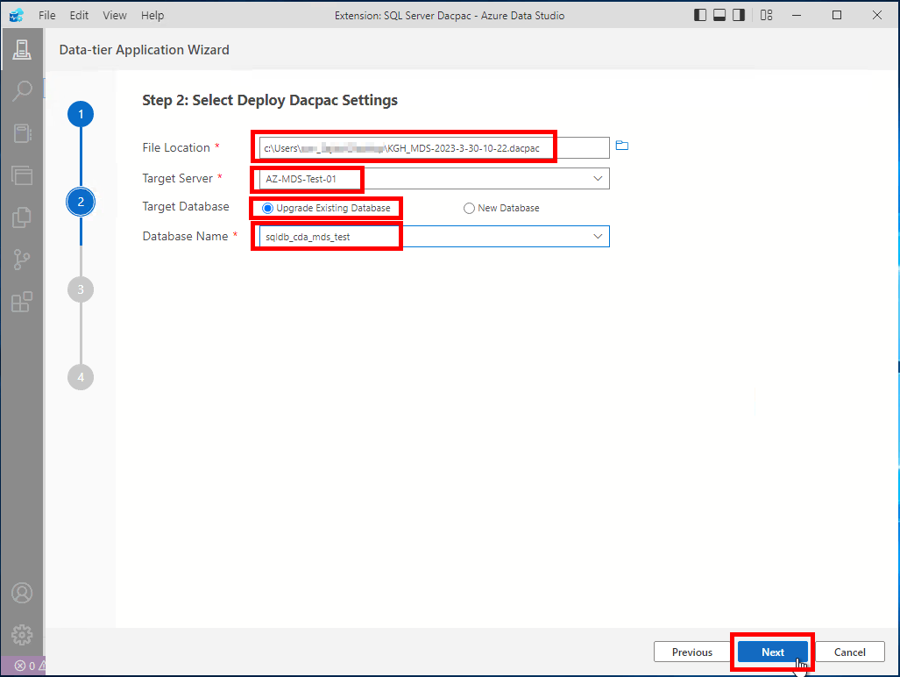

1. It will review the deploy plan.

Wait for *Next* button to be enabled.

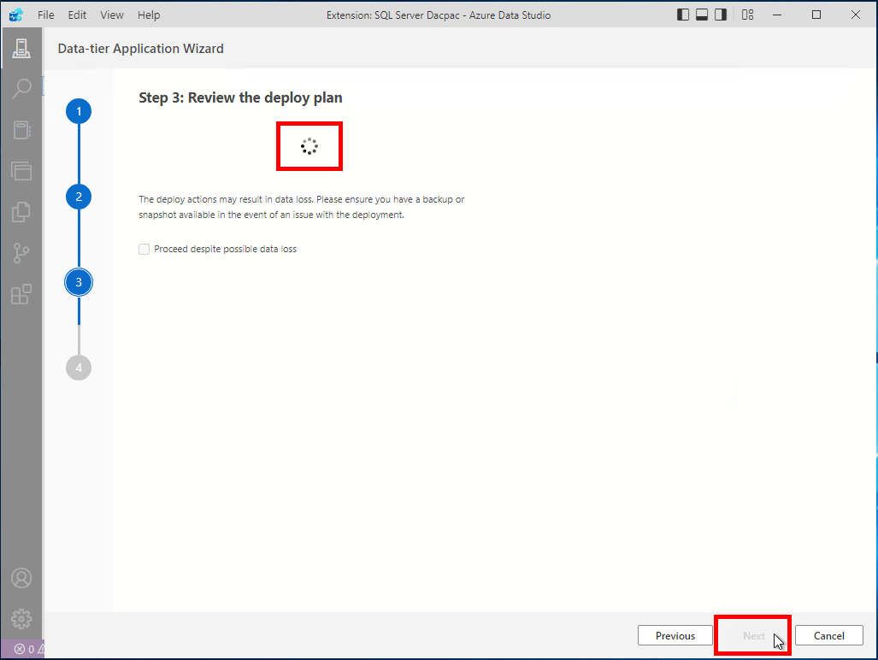

1. Click on *Next*

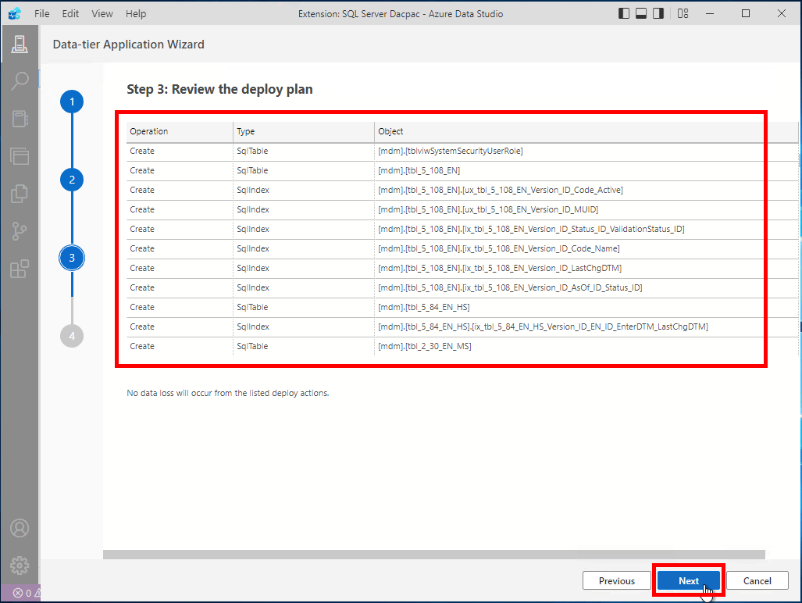

1. Click on *Deploy*

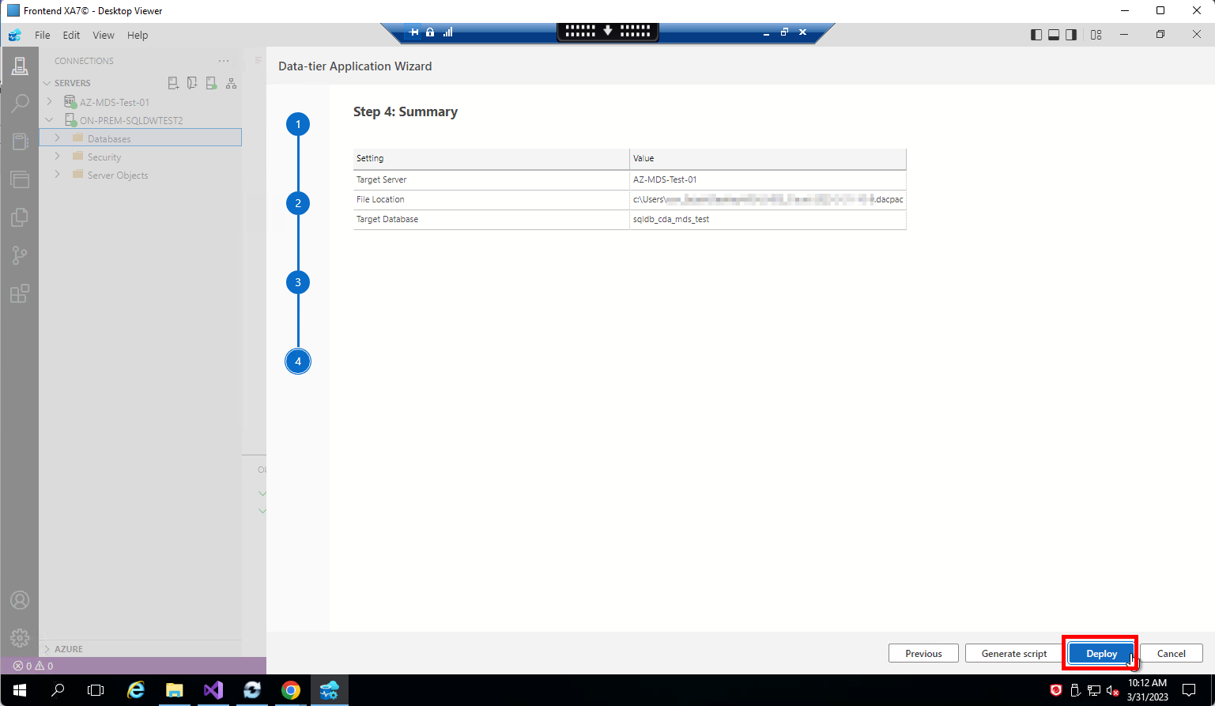

1. Deployment will start

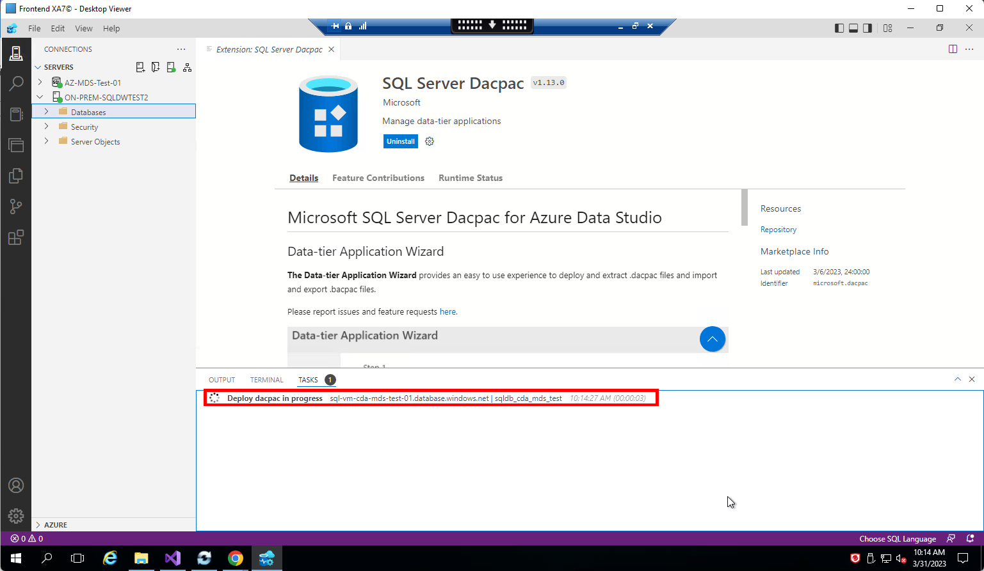

1. Wait for a few minutes for deployment to complete

### **Option 2: bacpac file**

1. Select *Extract the schema and data from a database to the logical .bacpac file [Extract Bacpac]*

Click on *Next*

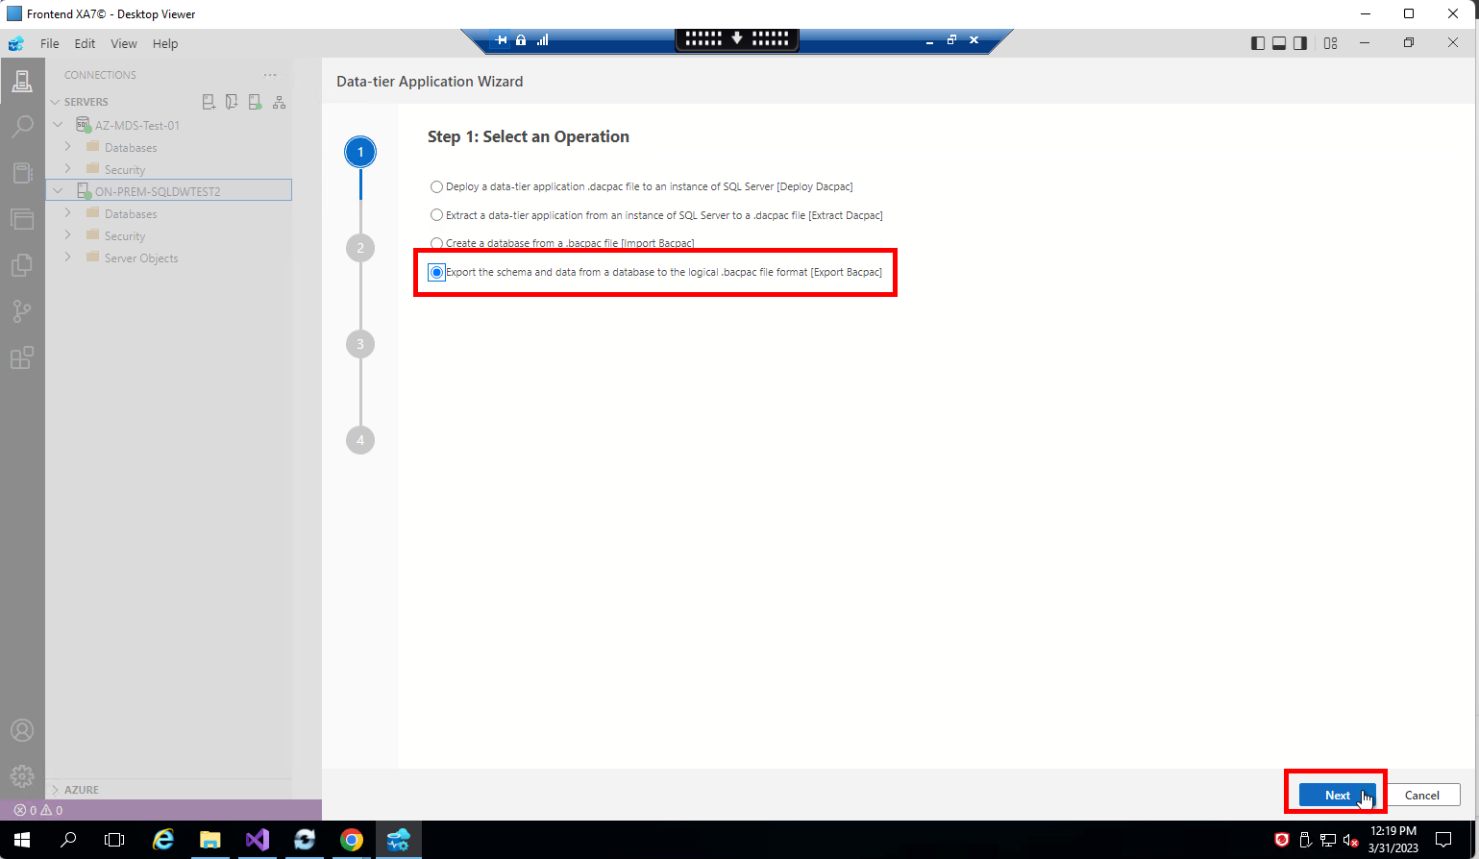

1. Fill the details as below:

Source Server: *ON-PREM-SQLDWTEST2*

Source Database: *KGH_MDS_Cloud*

File Location: <provide a location>

Click on *Next*

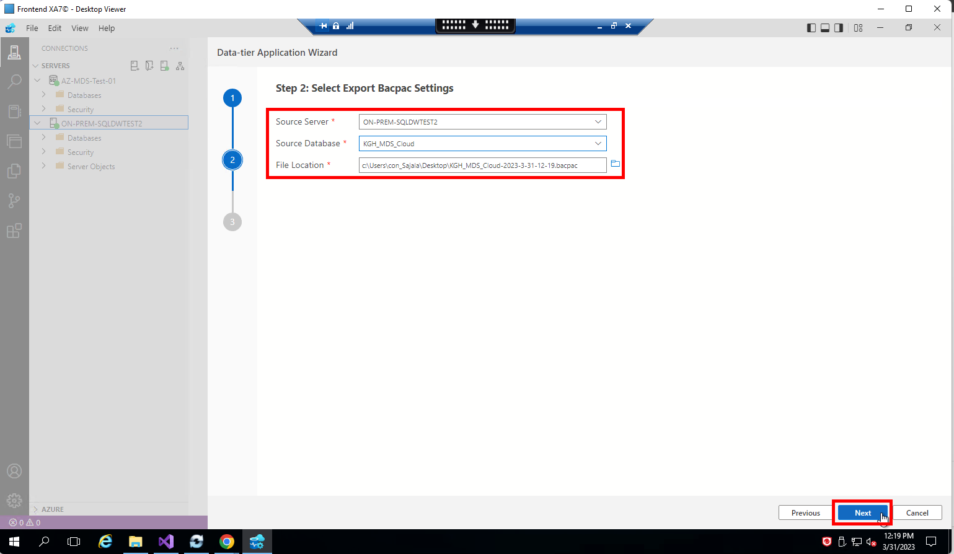

1. Extraction will start
2. Wait for a few minutes for the extraction to complete
3. Right click on connection *AZ-MDS-Test-01* and click on *Data tier Application Wizard*
4. Select *Create a database from a .bacpac [Import Bacpac]*

Click on *Next*

1. Click on *Deploy*
2. Deployment will start
3. Wait for a few minutes for deployment to complete

# **Resource Creation: SQL Managed Instance**

1. Open *Resource Groups* and search for *rg-cda-test-westeurope-001*



1. Click on *Create*

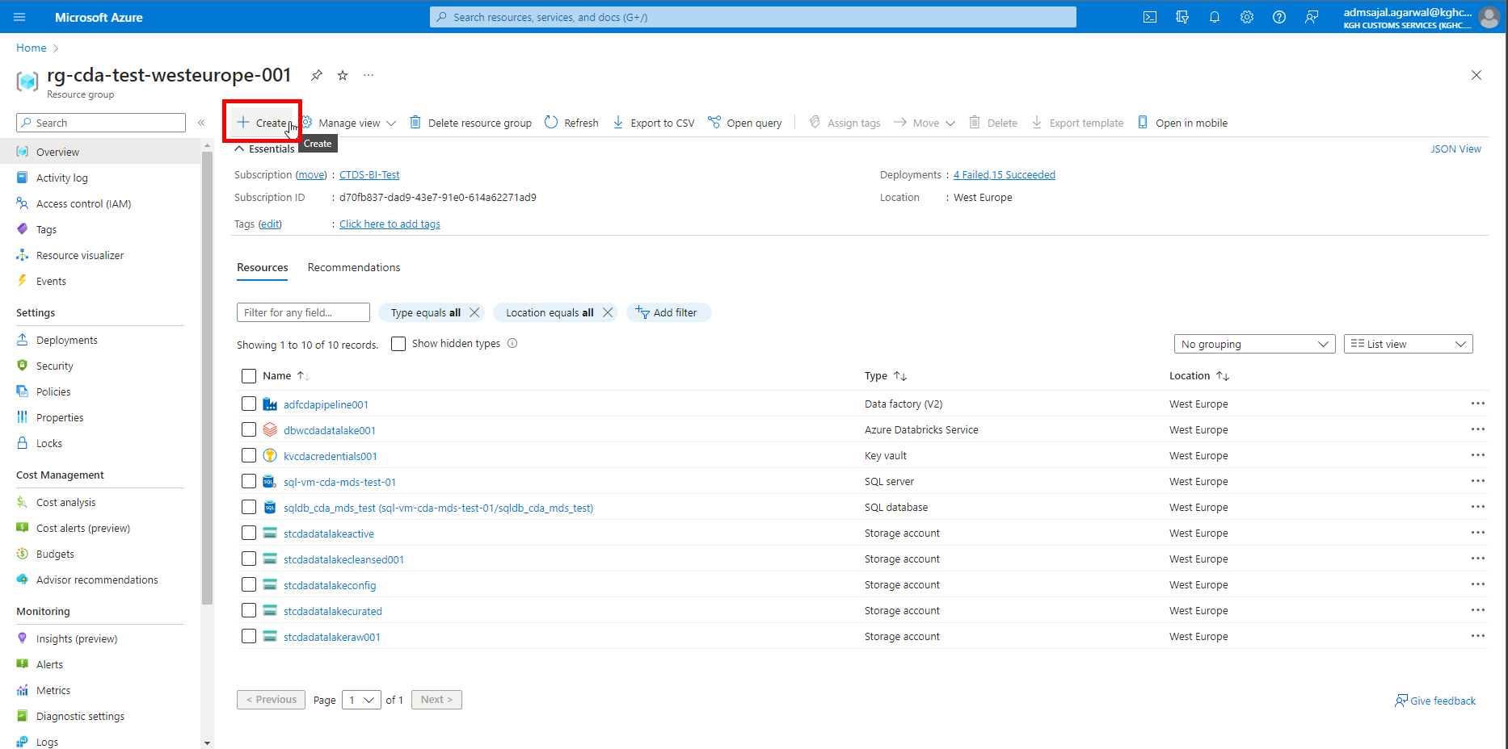

1. Below screen will appear:



1. Search for *Azure SQL*



1. Click on *Create 🡪 Azure SQL Managed Instance* in *Azure SQL Managed Instance* tile

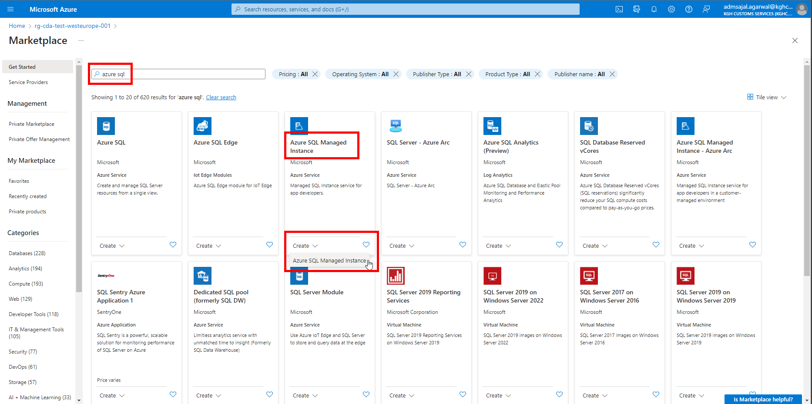

1. Fill the details as below:

Subscription: *CTDS-BI-Test*

Resource Group: *rg-cda-test-westeurope-001*

Managed instance name: *sql-mi-cda-mds-test-01*

Region: *(Europe) West Europe*

Click on *Configure Managed Instance* under *Compute + Storage*

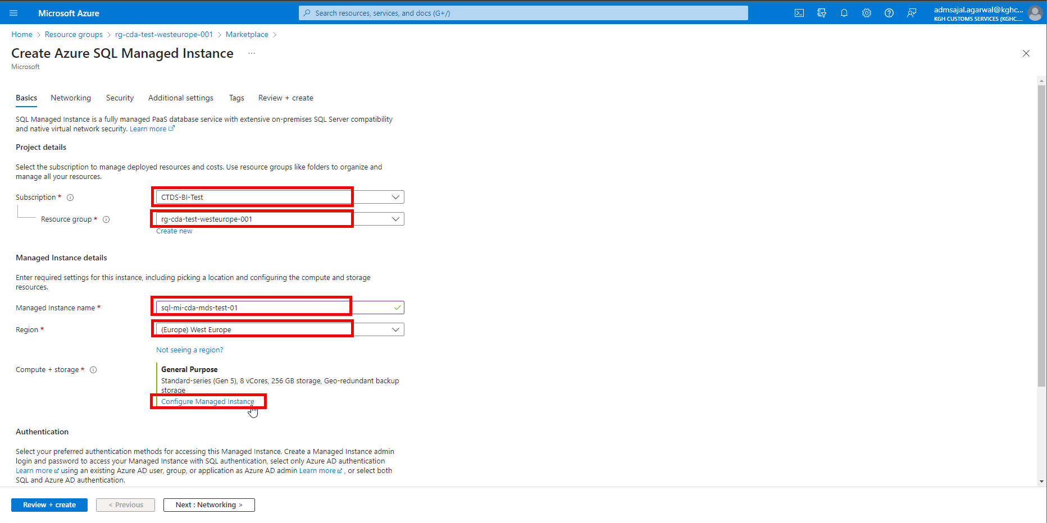

1. Select options as below:

Service tier: *General Purpose*

Hardware generation: *Standard-series (Gen5)*

vCores: *4*

Storage in GB: *128*

SQL Server License: *Azure Hybrid Benefit*

Tick-mark on the confirmation

 :

Backup storage redundancy: *Locally-redundant backup storage*

Click on *Apply*

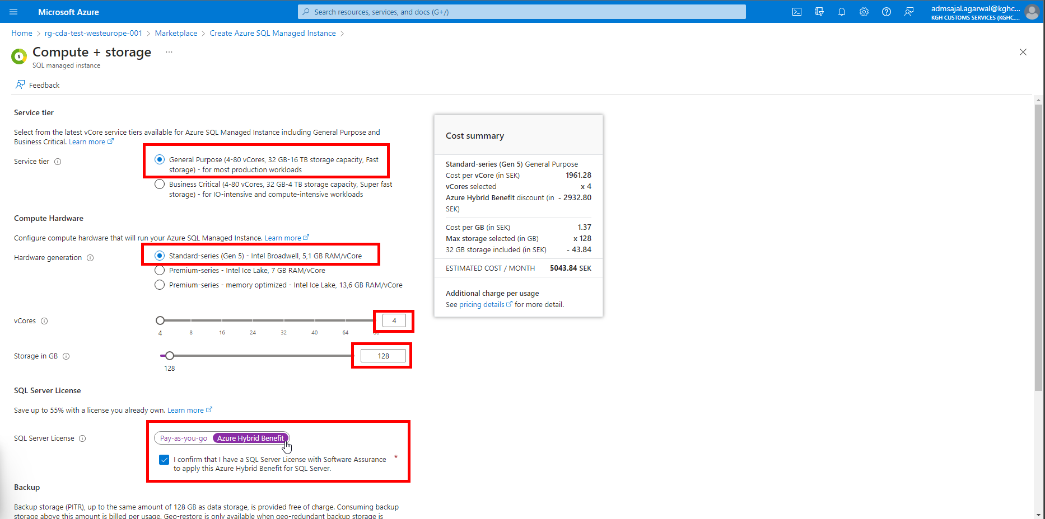

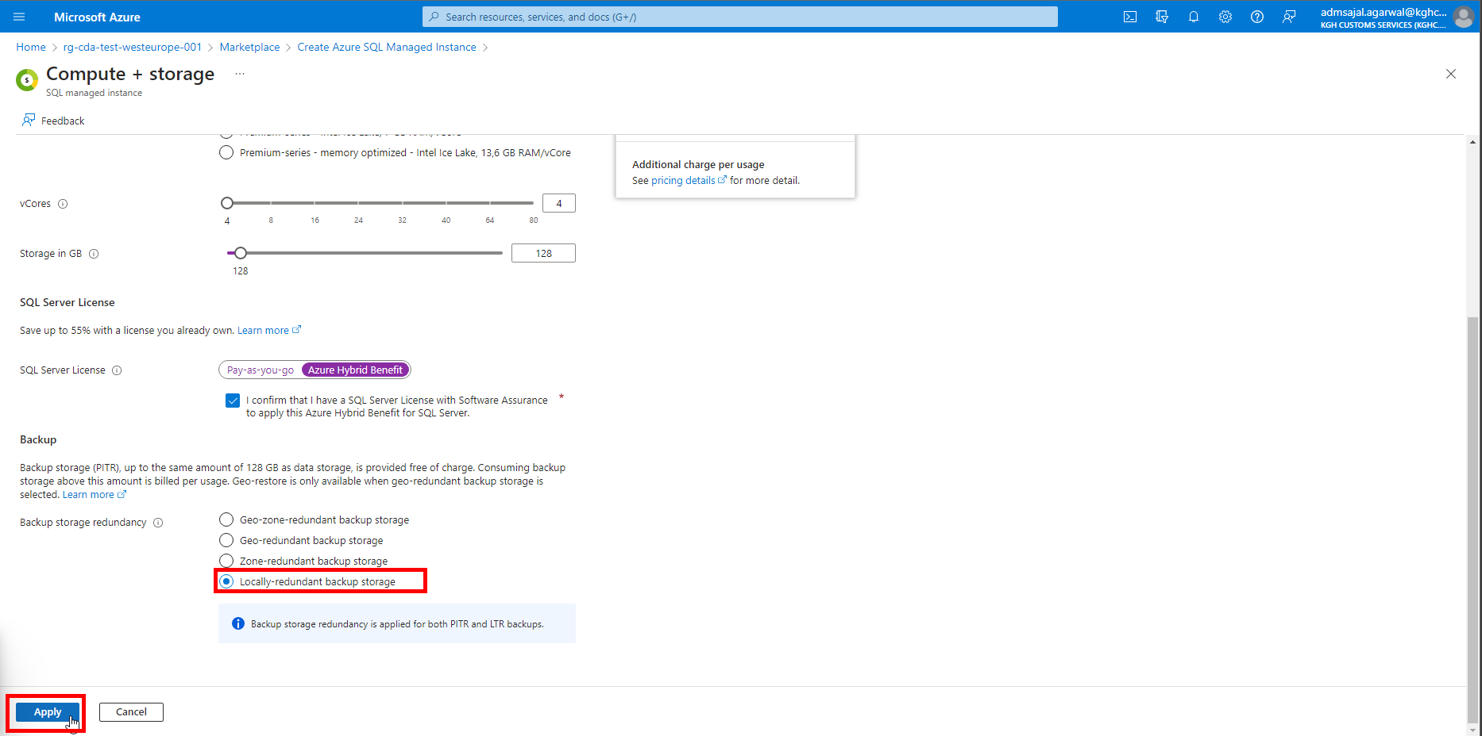

1. Fill the details as below:

Authentication Method: *Use both SQL and Azure AD authentication*

Set Azure AD admin: Click on *Set admin* and select the admin account

Managed instance admin login: *svr-adm-mds*

Password: *@dminmdm$erver2023*

Confirm password: *@dminmdm$erver2023*

Click on *Next : Networking*

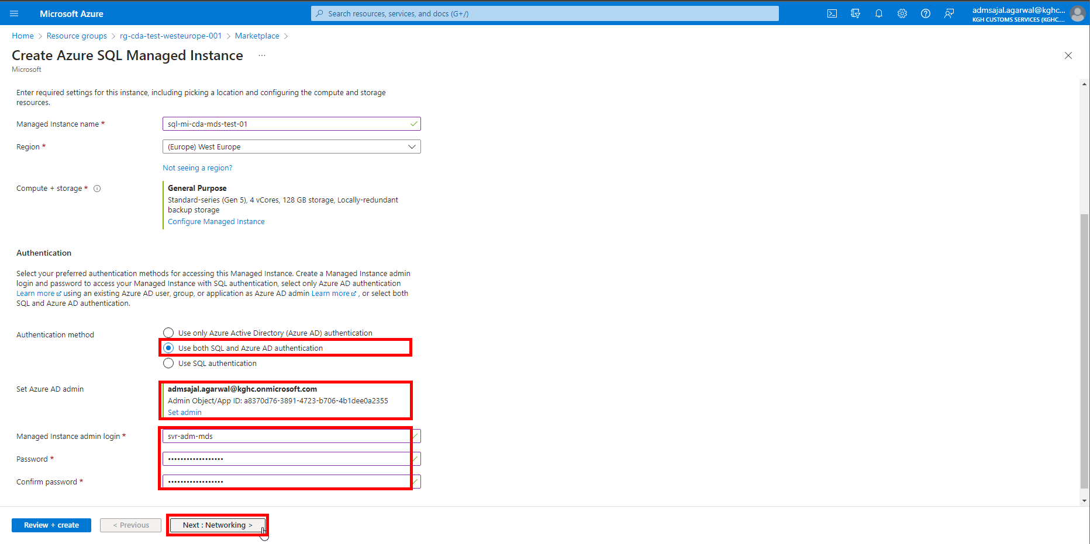

1. Keeping all options as default, click on *Next : Security*

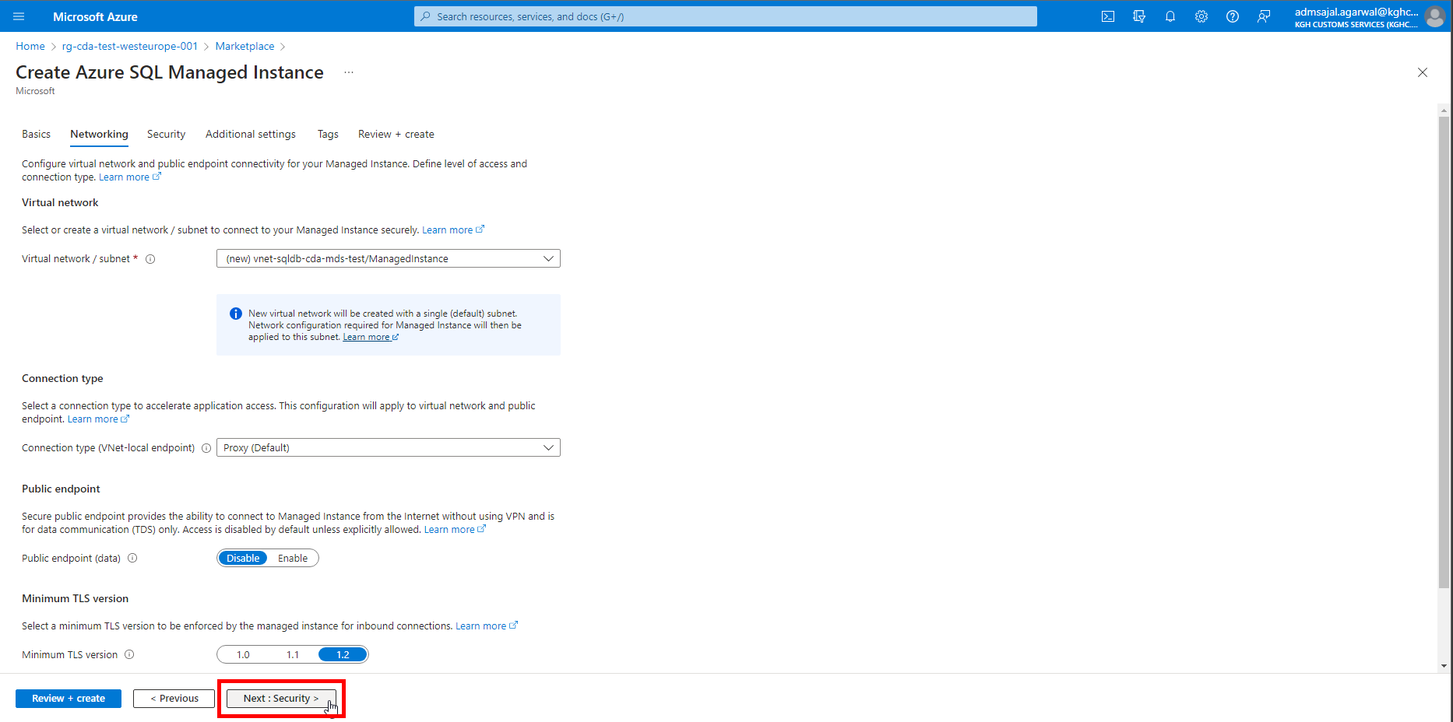

1. Keeping all options as default, click on *Next : Additional settings*

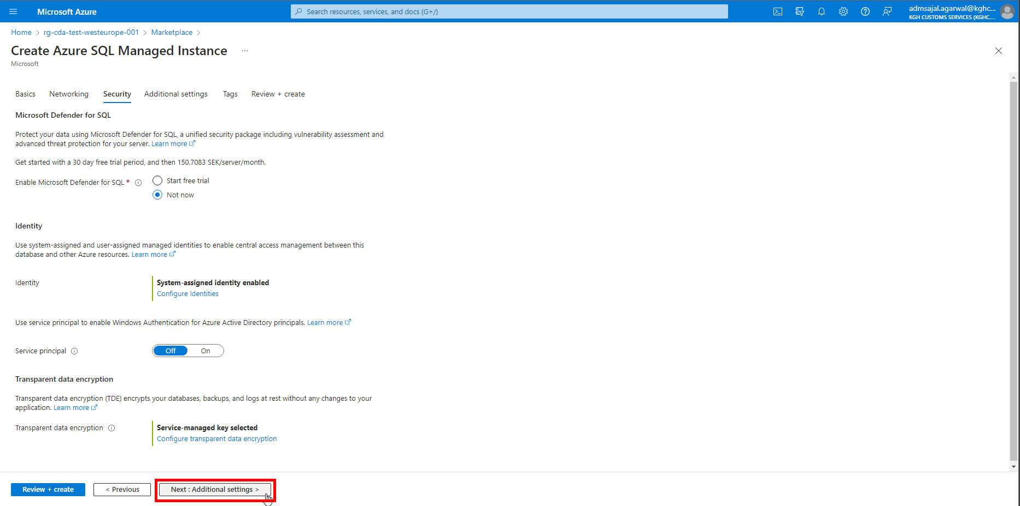

1. Change the details as shown below:

Collation 🡪 *Finnish_Swedish_CI_AS*

Click on *Next : Tags*

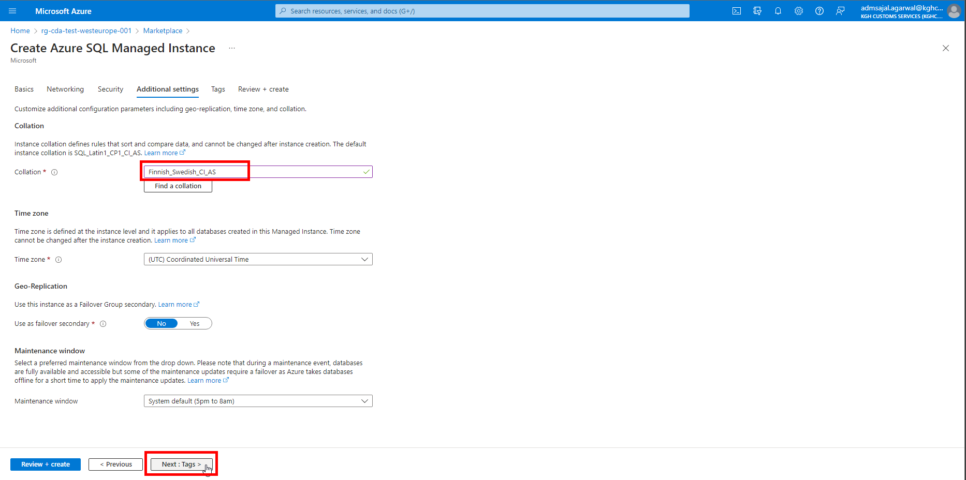

1. Add the tags as shown below:

application 🡪 *cda*

owner 🡪 *KGH BI Team*

environment 🡪 *test*

Click on *Next: Review + create*

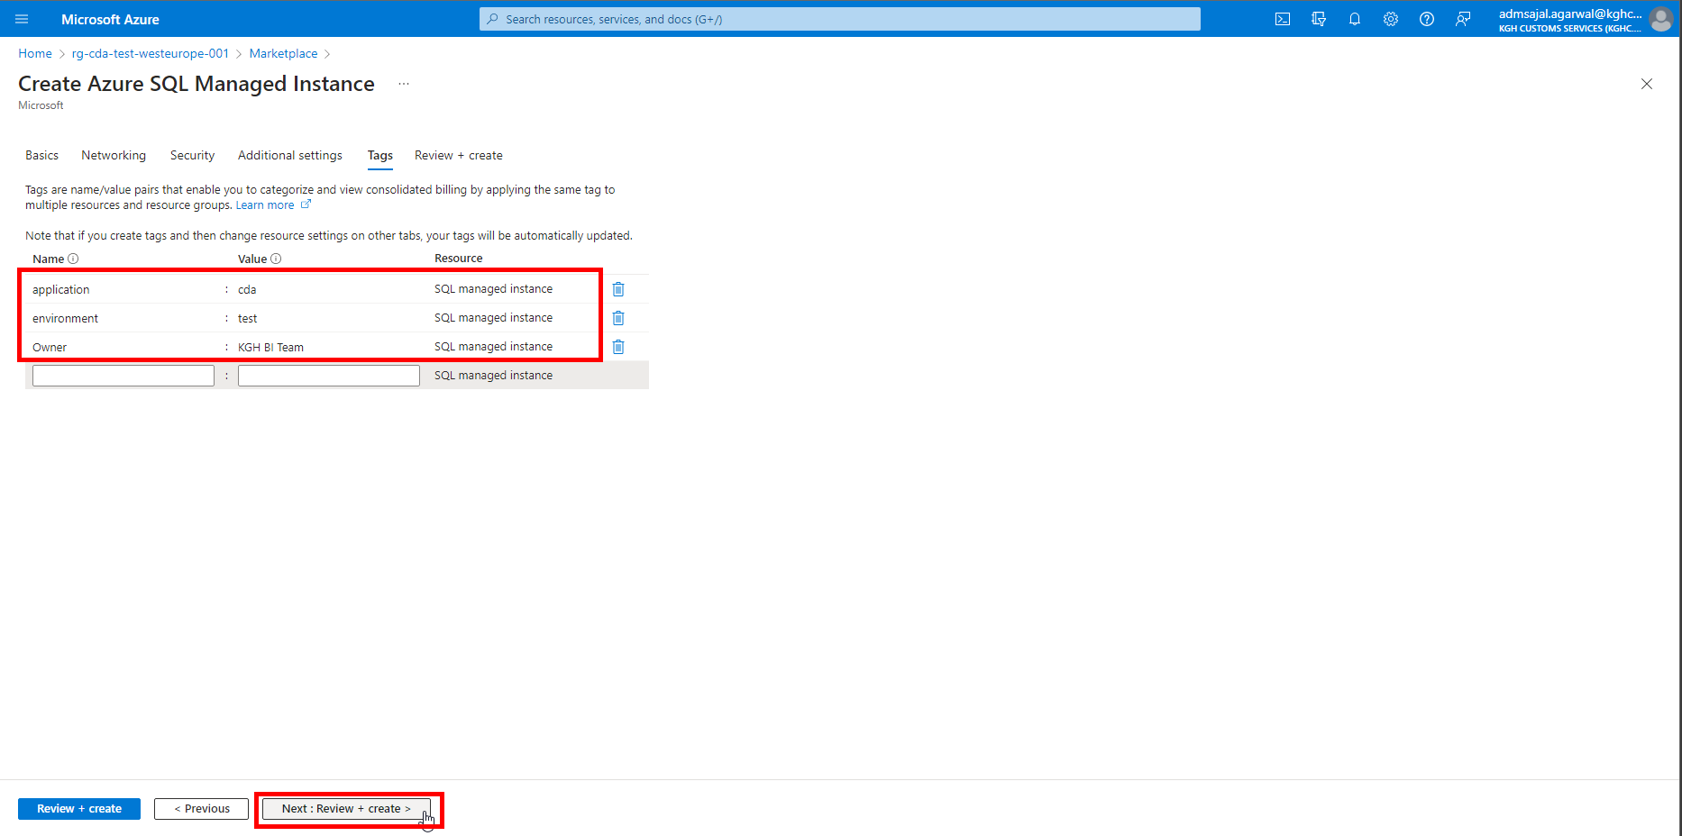

1. Wait for the *Validation* to complete and *Create* button to be enabled

Click on *Create*

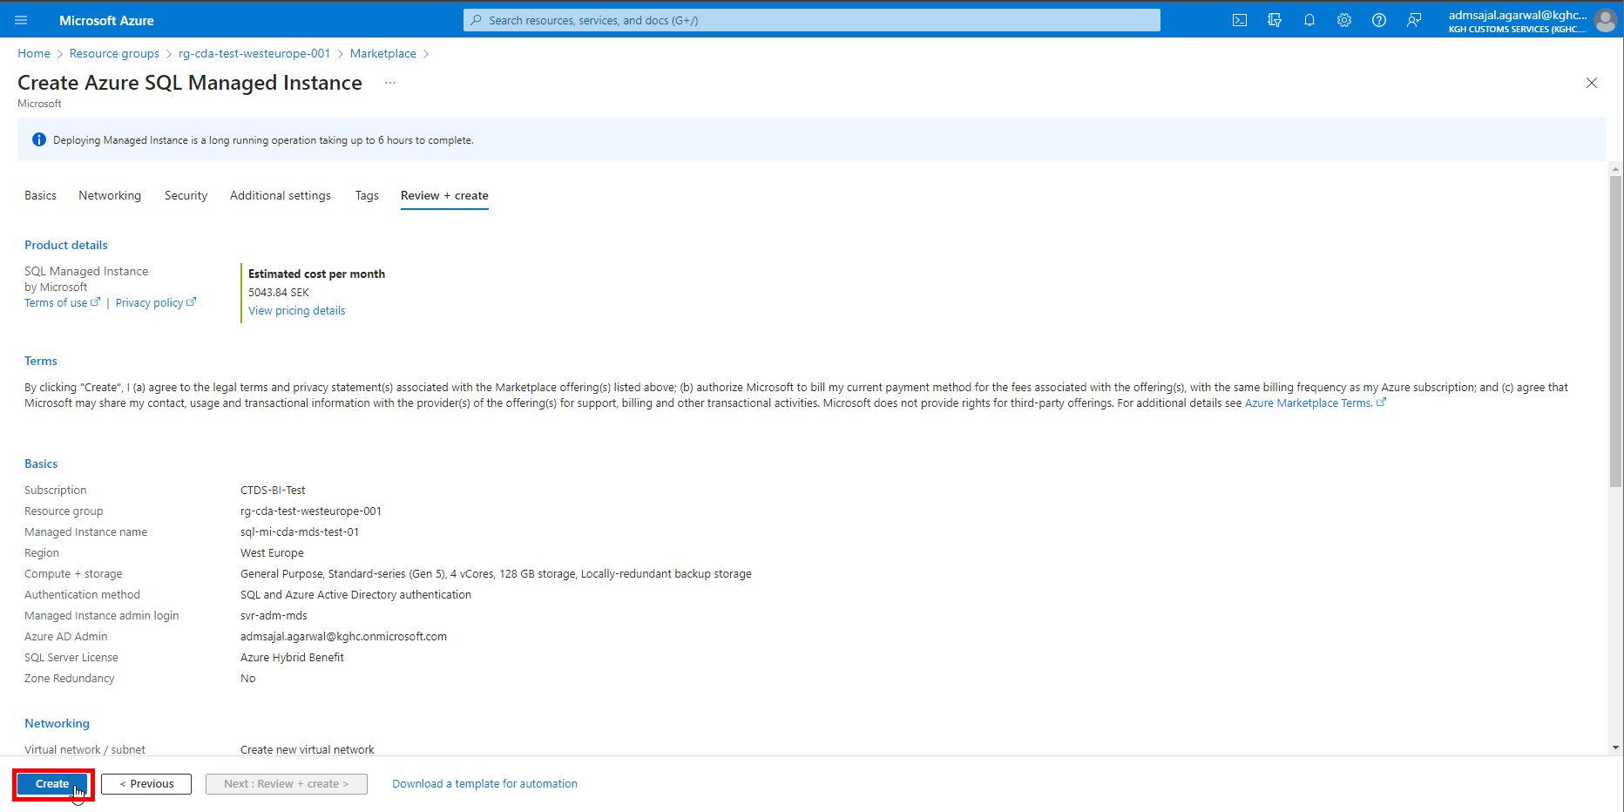

1. It will initialize the deployment of resource.

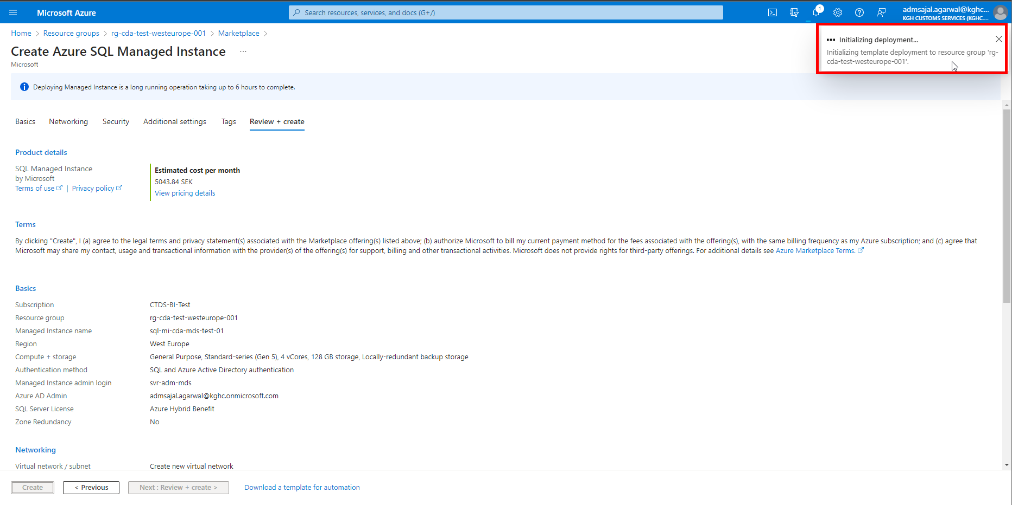

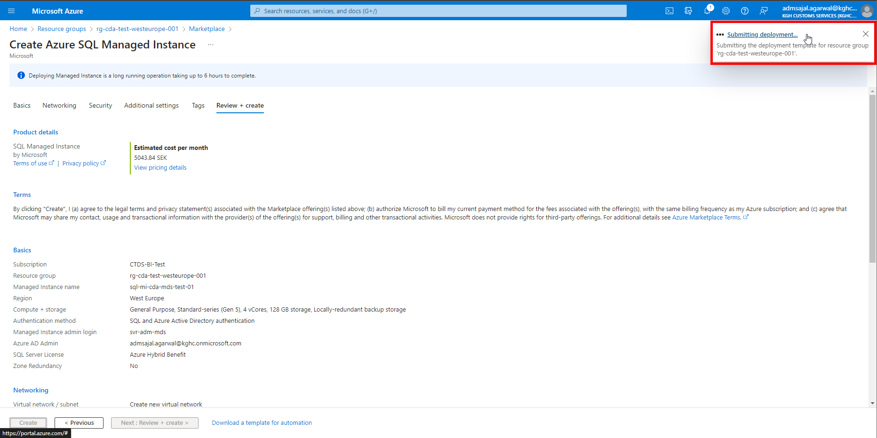

1. It will auto-redirect to deployment screen

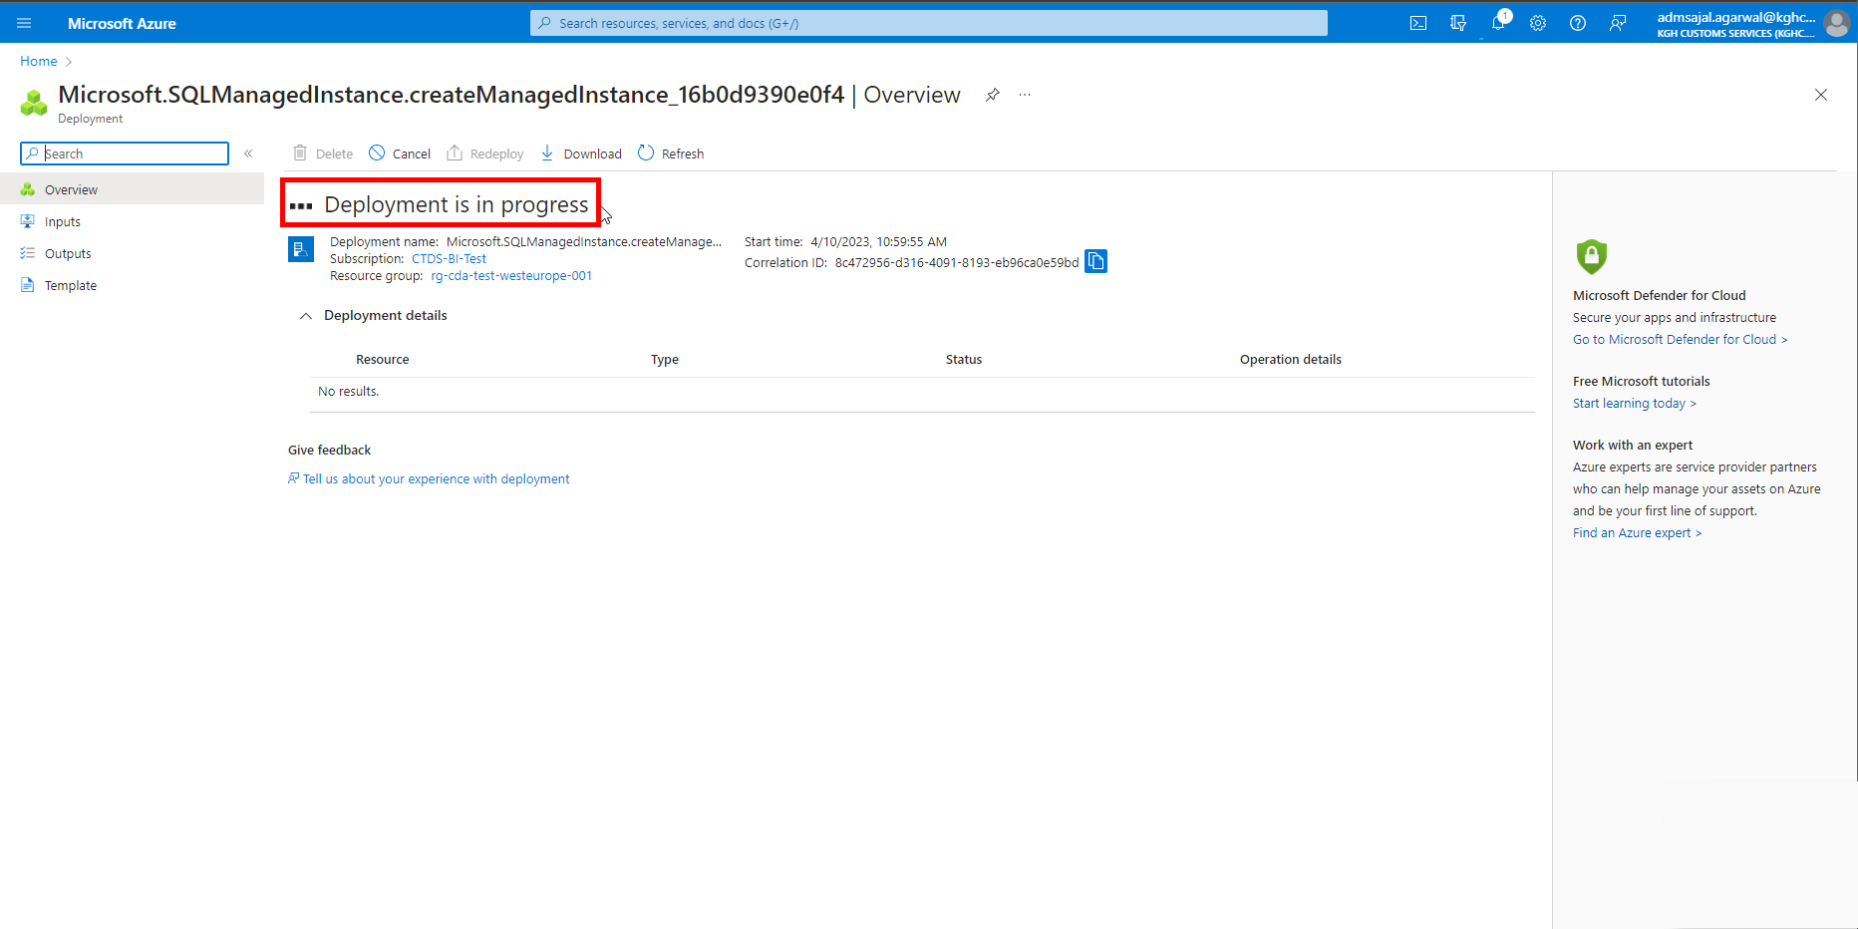

1. When the message changes to *Your deployment is complete*, click on *Go to resource*

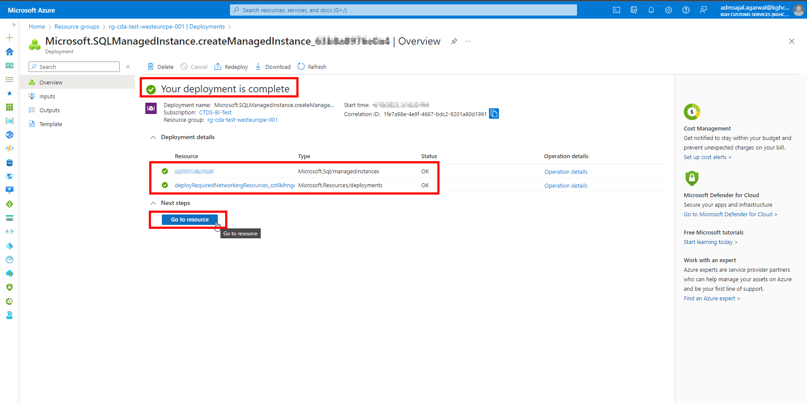

1. It will take to *Overview* page of created resource.

## **Connection: On-Premises to SQL Managed Instance**

### **Network Configuration: Public Endpoint**

1. Click on *Networking* from resource *Overview* page

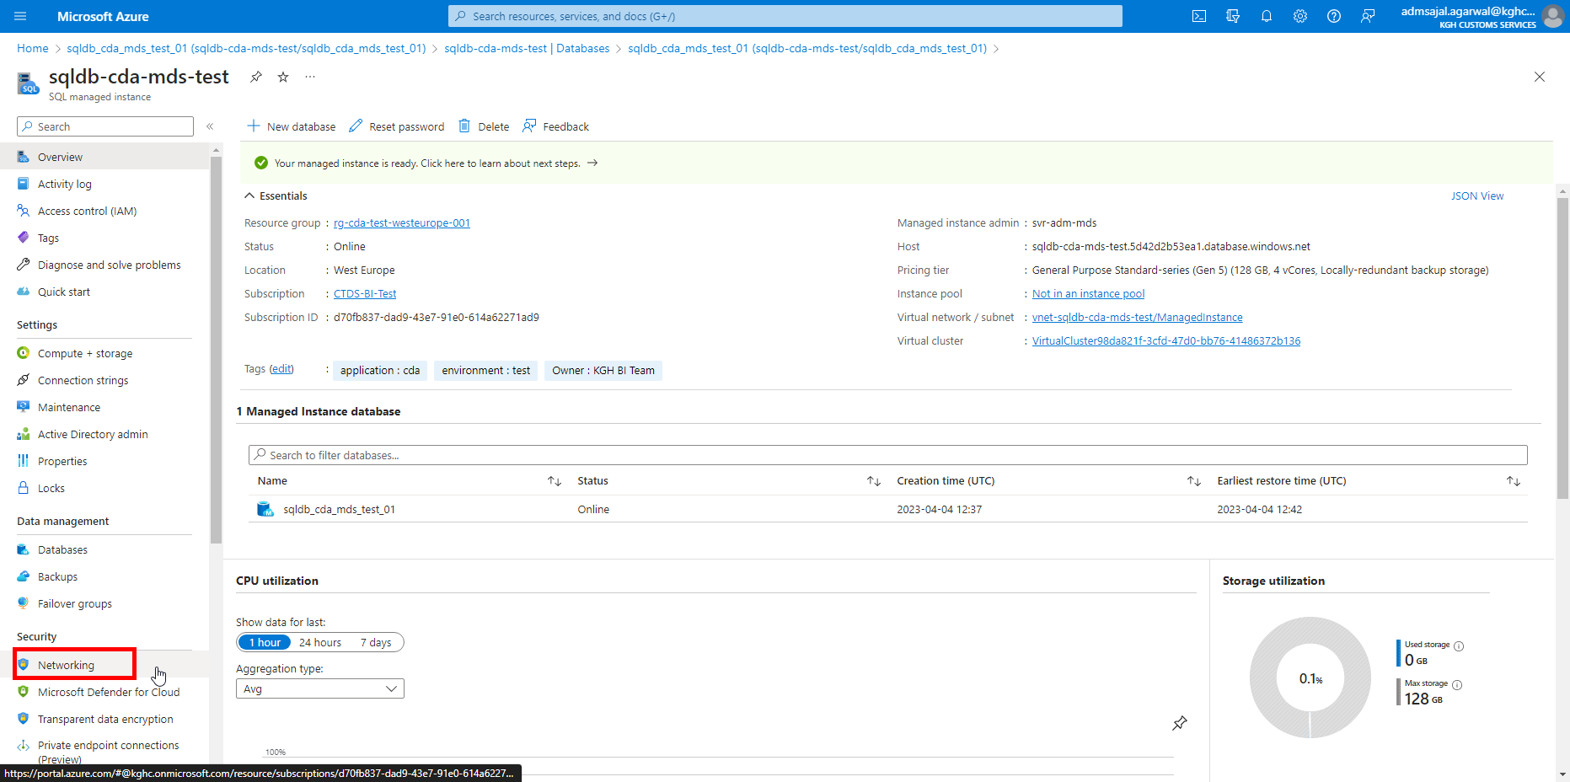

1. Click on *Enable* under *Public endpoint (data)*

Click on *Save*

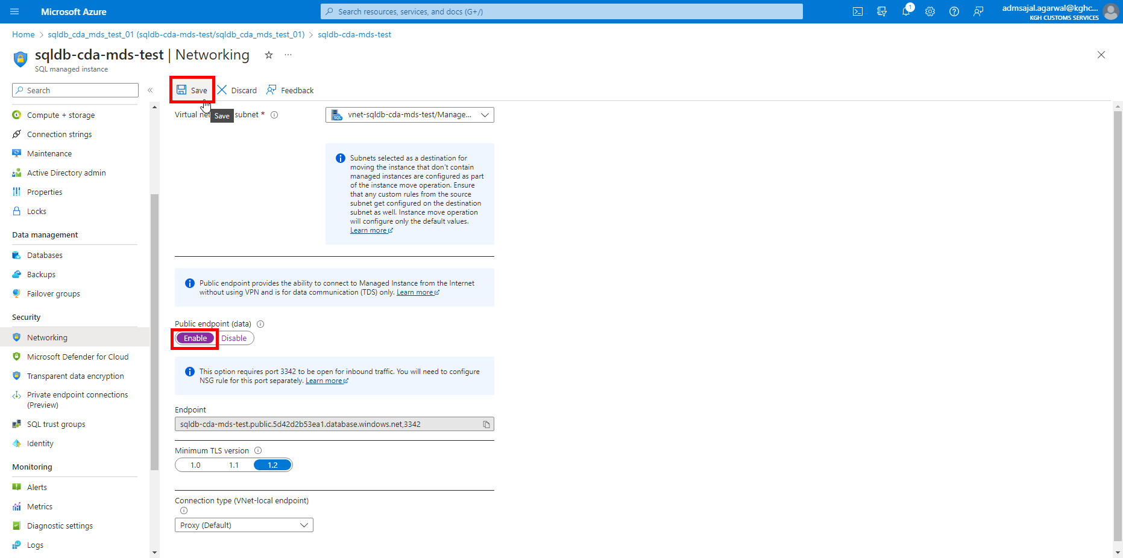

1. It will start saving the change.

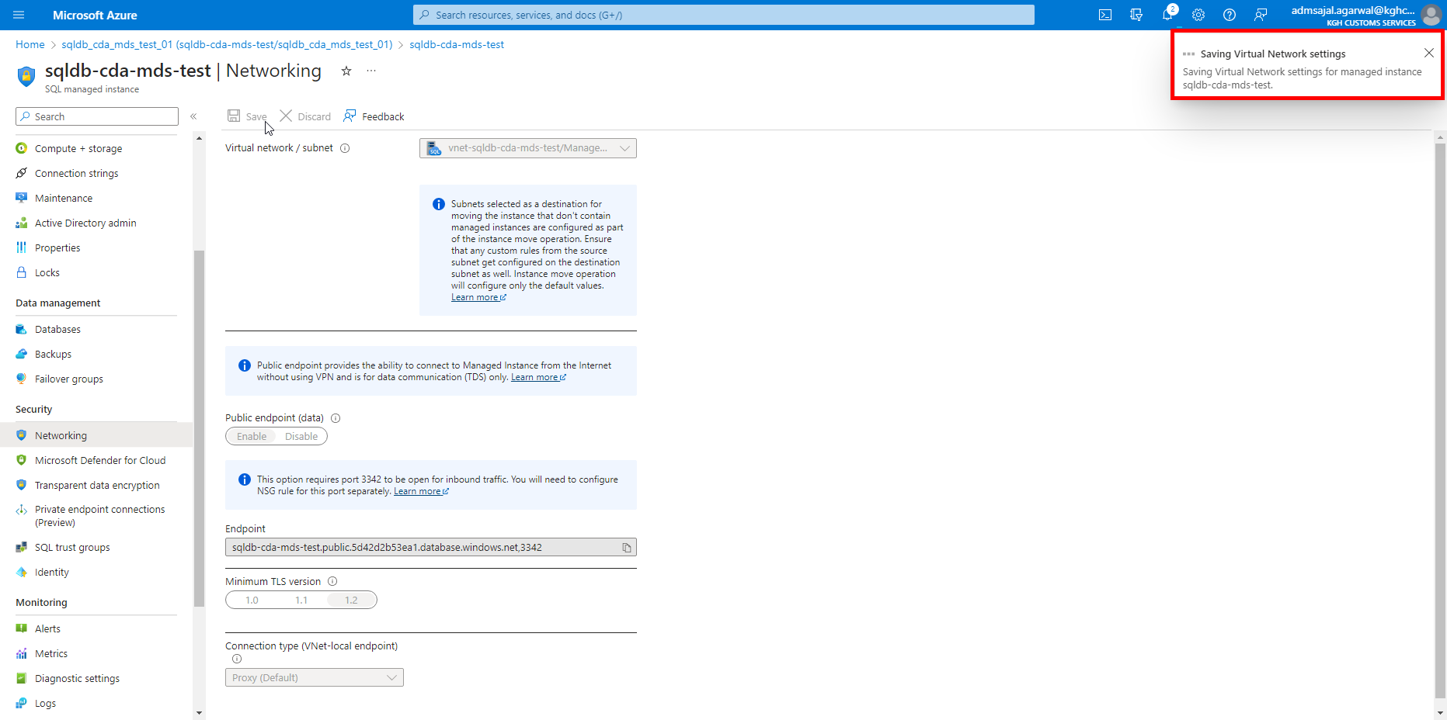

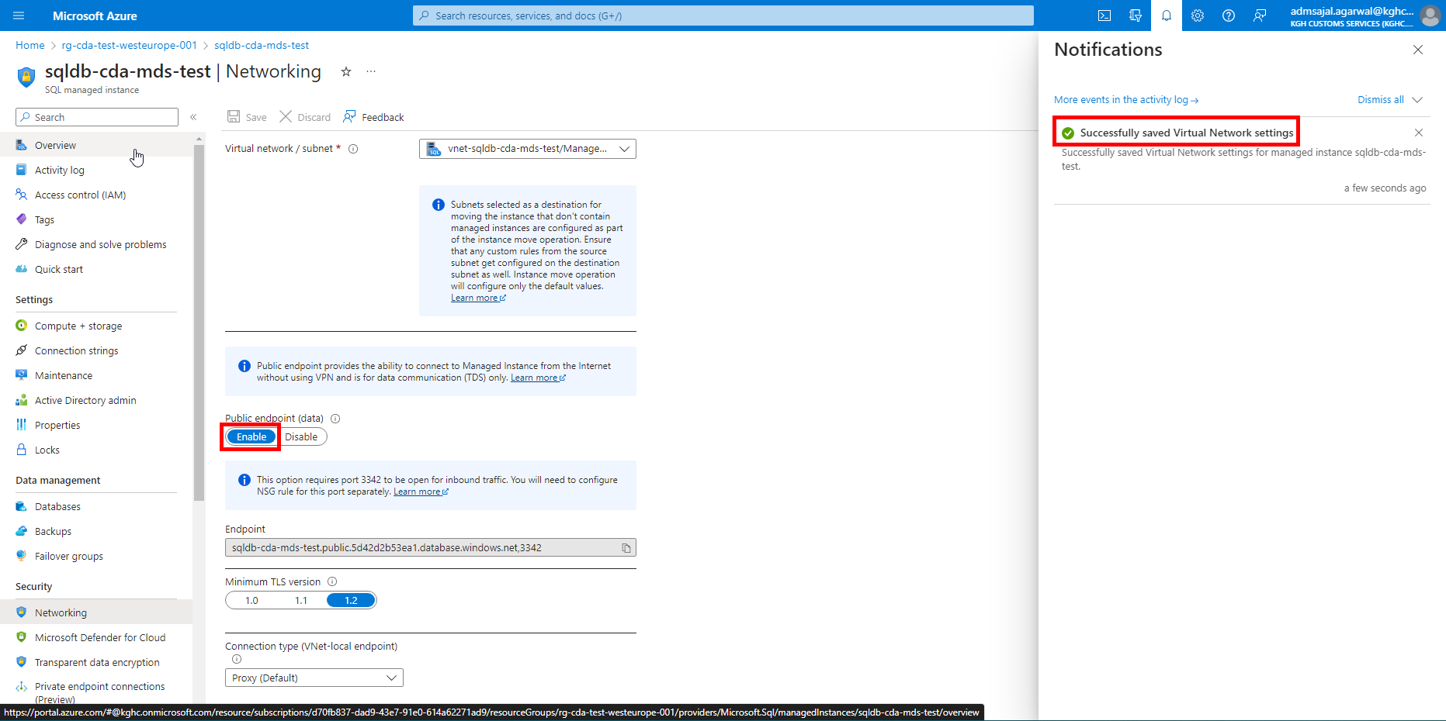

### **Network Configuration: Inbound Security Rules**

1. Click on *Virtual network / subnet vnet-sql-mi-cda-test/ManagedInstance* from resource *Overview* page

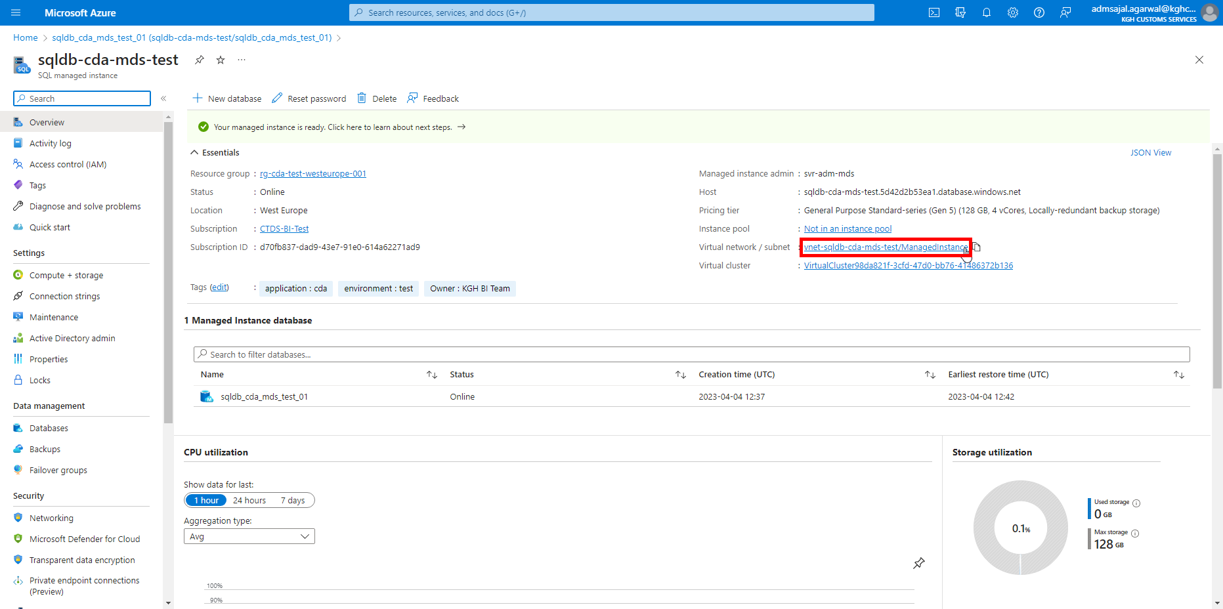

1. Click on *Subnets*

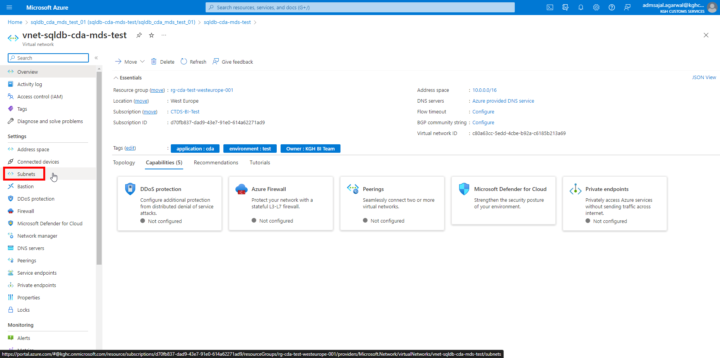

1. Click on *Security group* [*nsg-sql-mi-cda-test*](https://portal.azure.com/)

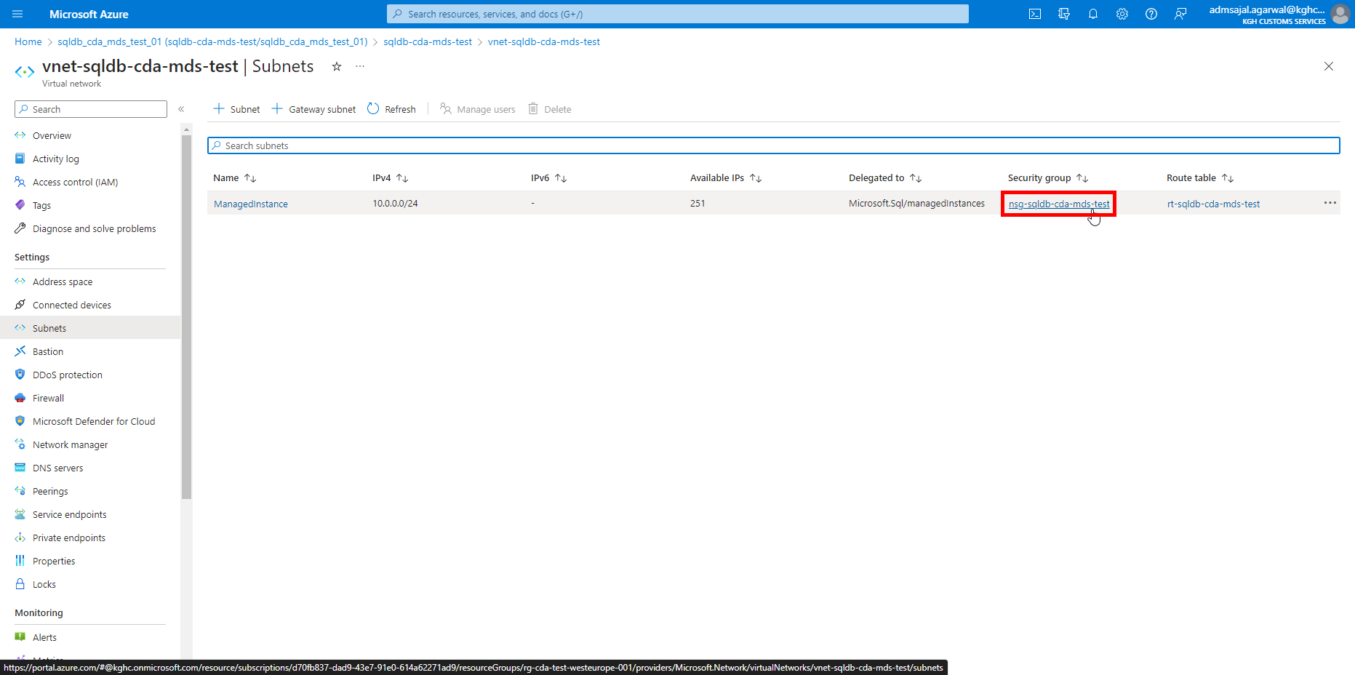

1. Click on *Inbound Security rules*

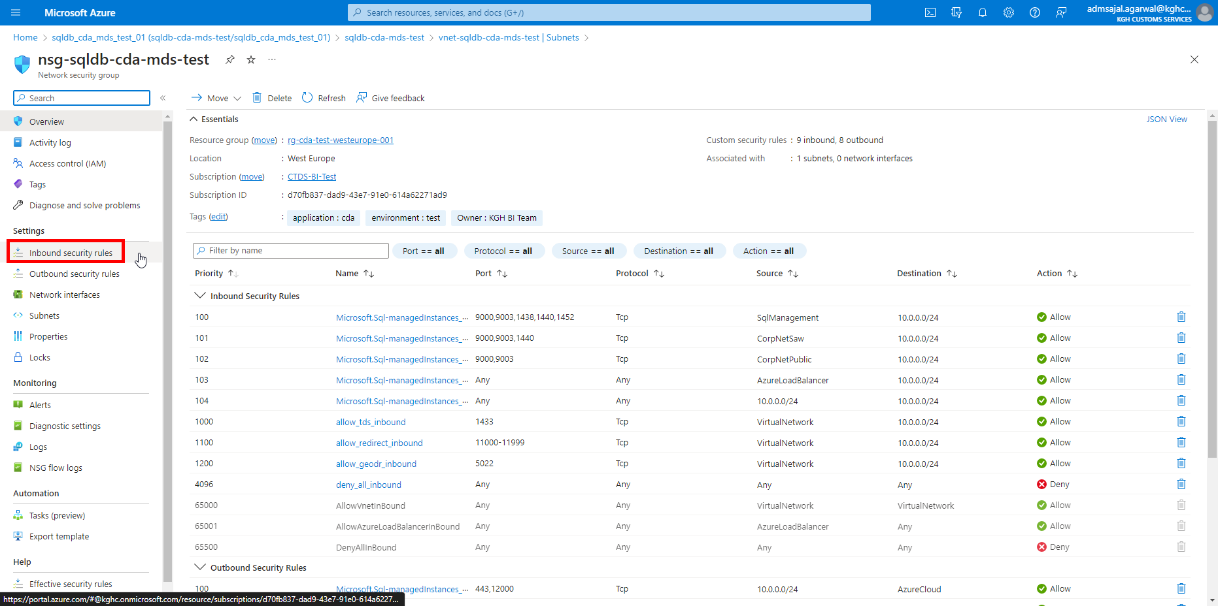

1. Click on *Add*

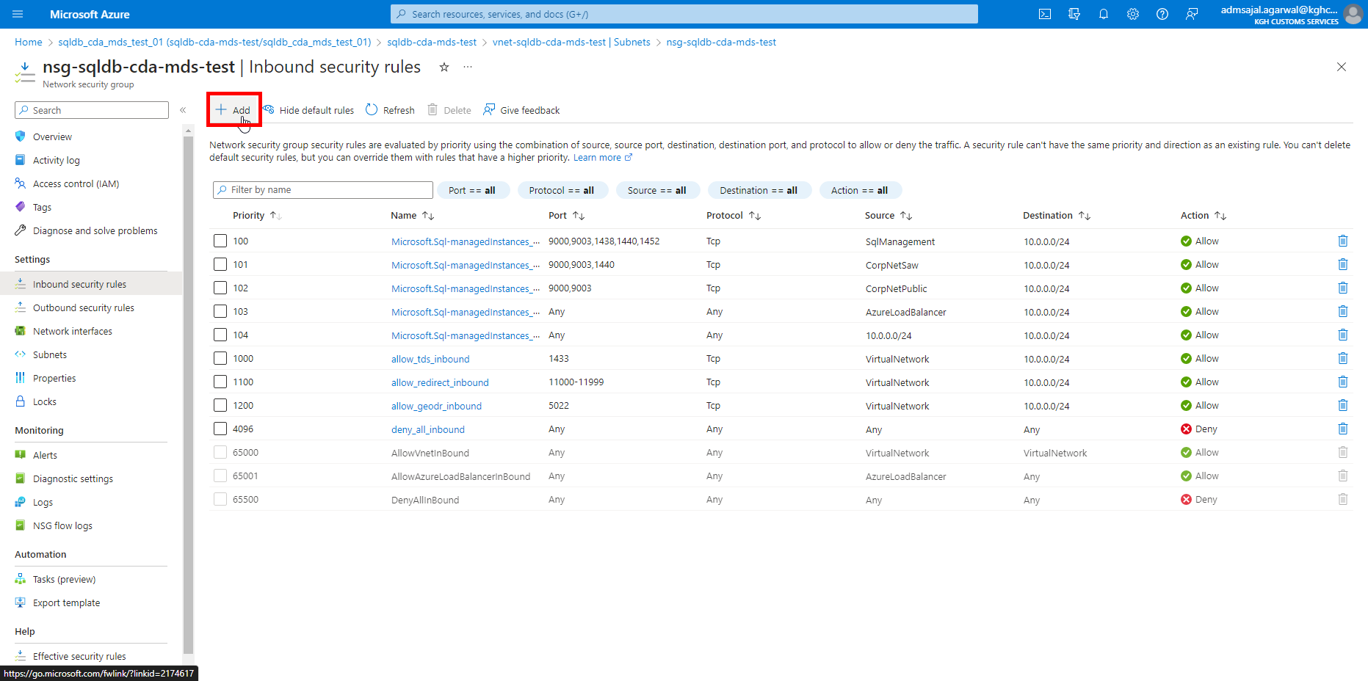

1. Fill the details as below:

Source: *IP Addresses*

Source IP addresses/CIDR ranges: *<add public IP of SQLDWTEST2>*

Source port ranges: *\**

Destination: *IP Addresses*

Destination IP addresses/CIDR ranges: *10.0.0.0/24*

Service: *Custom*

Destination port ranges: *3342*

Protocol: *Any*

Action:  *Allow*

Priority: *1300*

Name: *allow_on_prem_SQLDWTEST2_inbound*

Click on *Add*

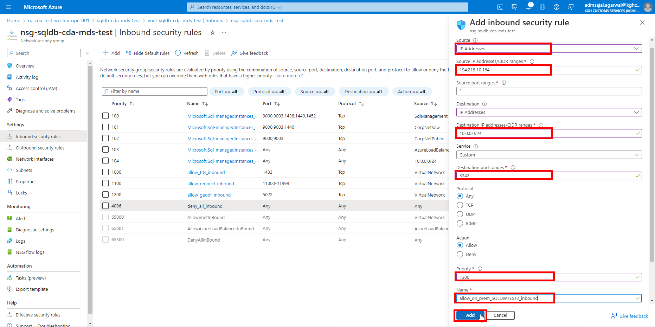

1. It will start creating the security rule.

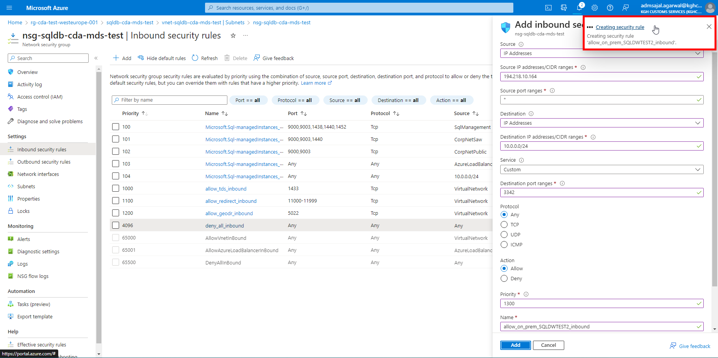

1. Once created, the new security rule will be displayed in the table.

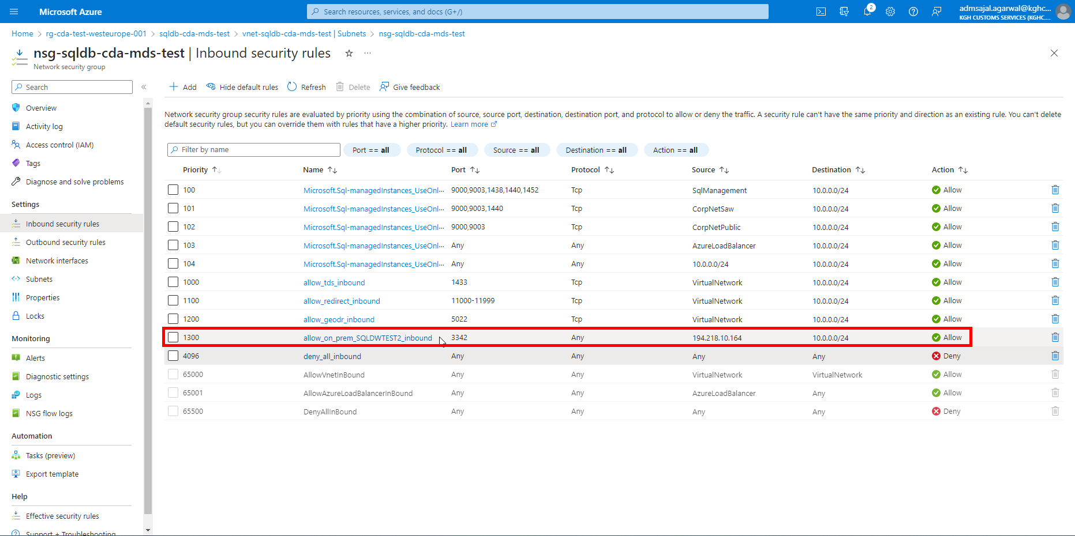

### **Connection: On-Premises SSMS to SQL Managed Instance**

1. Click on *Connection strings* from resource *Overview* page

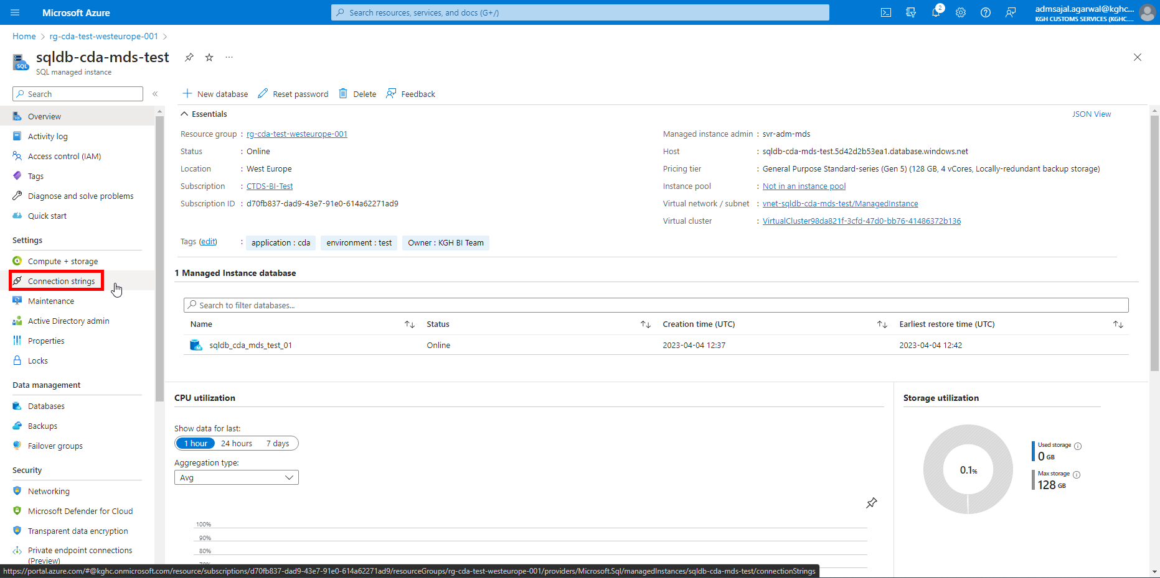

1. Copy the connection stringunder *ADO.NET (SQL authentication) - public endpoint*

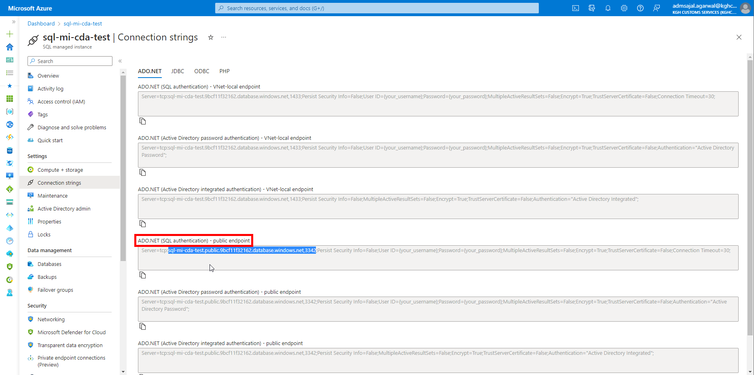

1. Login to on-premises server *SQLDWTEST2*
2. Open SQL Server Management Studio
3. Fill the details as below:

Server name: *<provide the connection string copied from Step 13>*

Authentication: *SQL Server Authentication*

Login: *svr-adm-mds*

Password: *@dminmdm$erver2023*

Click on *Connect*

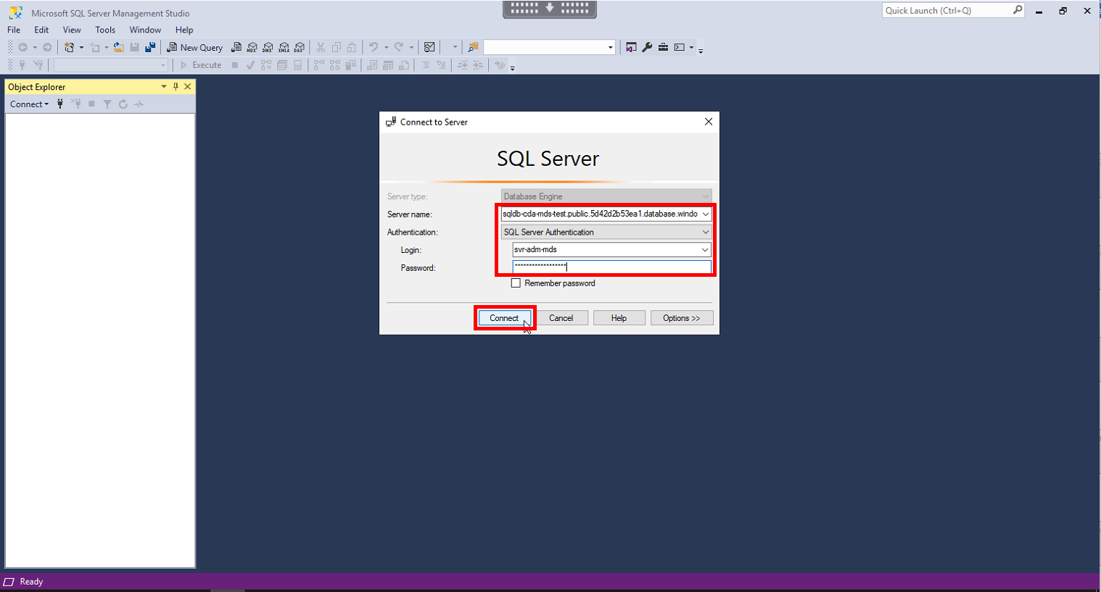

1. SQL Managed Instance should be connected now.

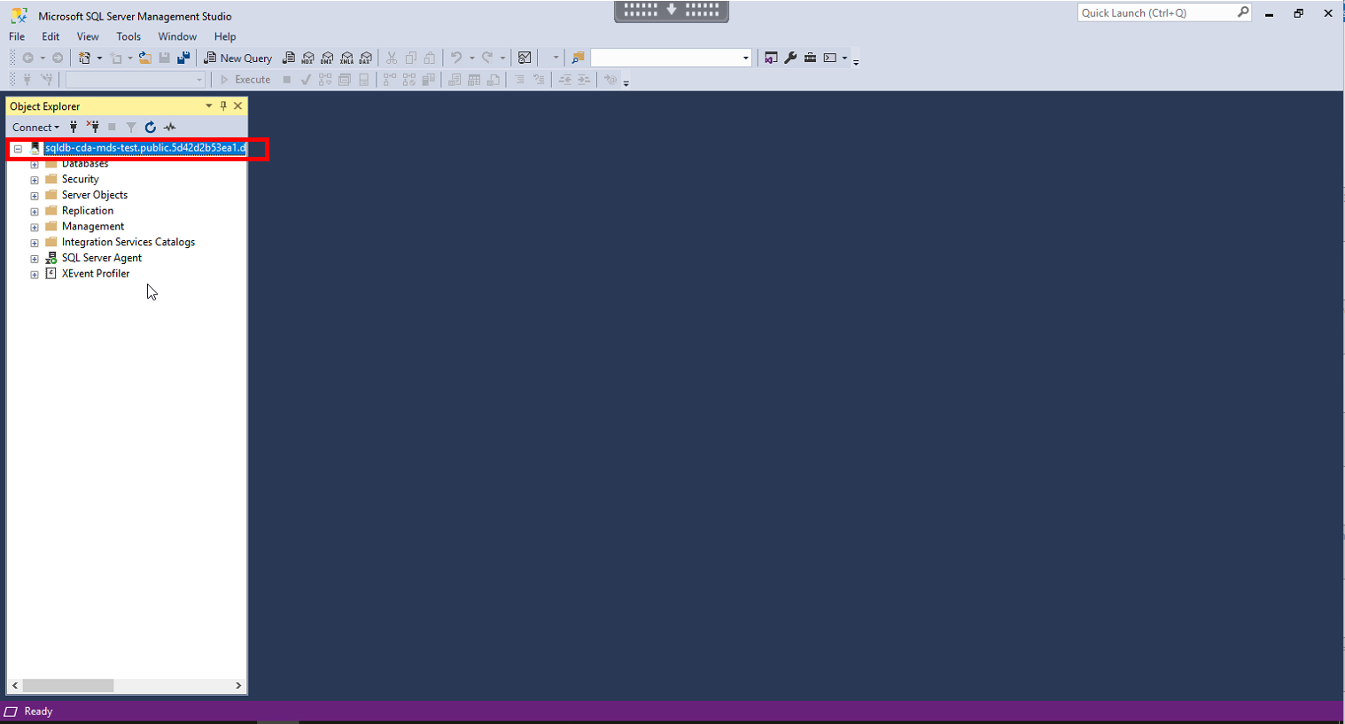

## **Connection: Databricks to SQL Managed Instance**

### **Network Configuration: Inbound Security Rules**

1. Click on *Virtual network / subnet vnet-sql-mi-cda-test/ManagedInstance* from resource *Overview* page



1. Click on *Subnets*



1. Click on *Security group* [*nsg-sql-mi-cda-test*](https://portal.azure.com/)



1. Click on *Inbound Security rules*

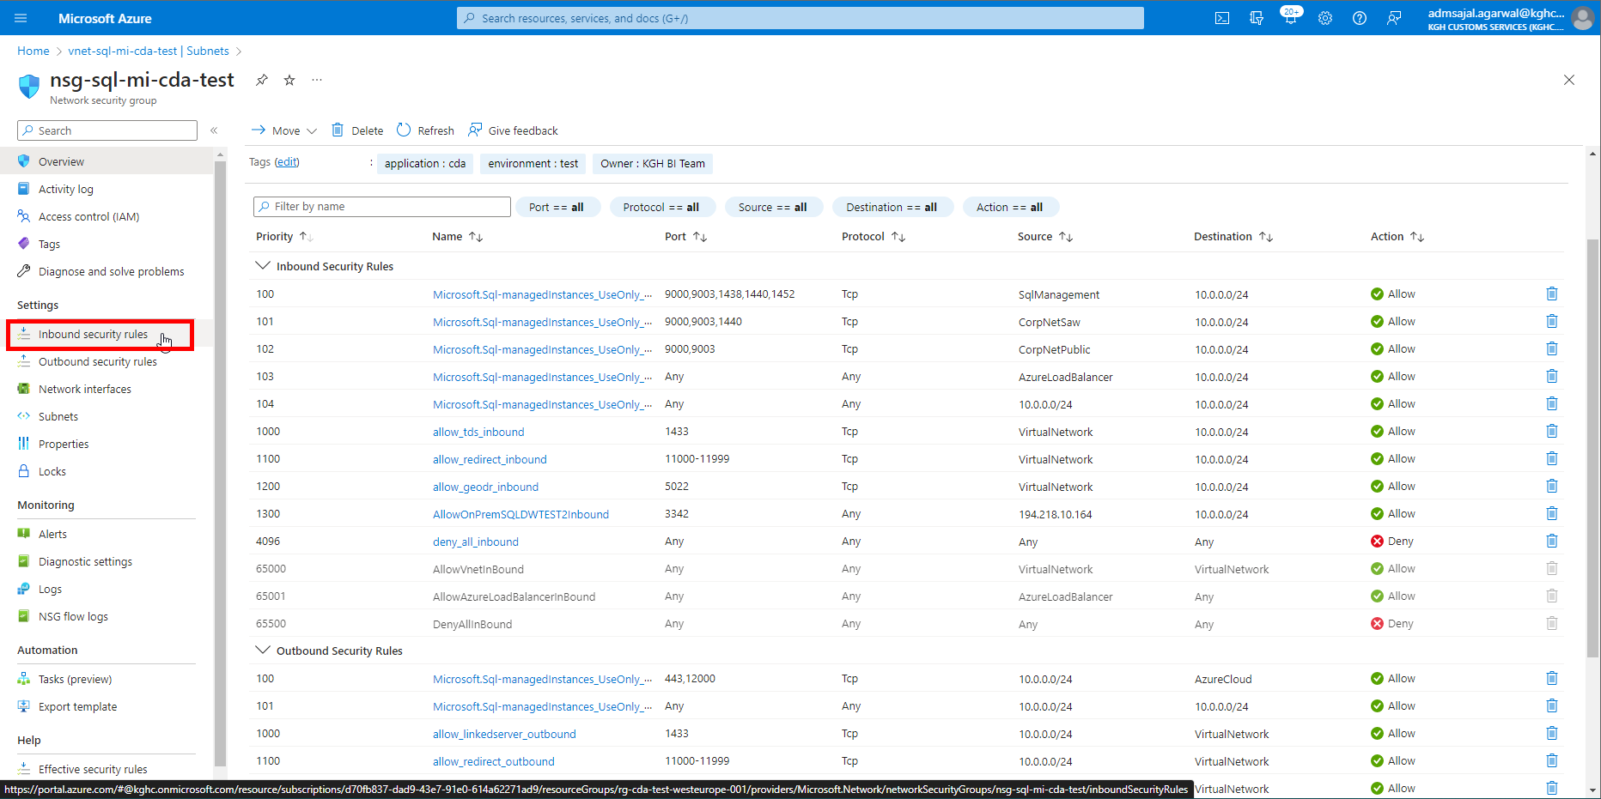

1. Click on *Add*

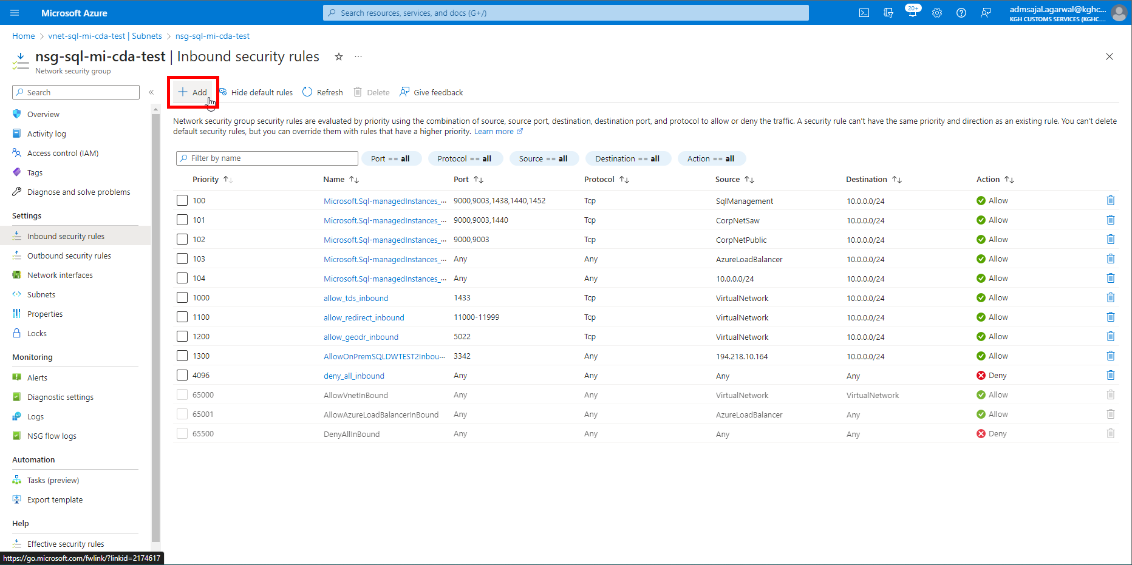

1. Fill the details as below:

Source: *Any*

Source port ranges: *\**

Destination: *IP Addresses*

Destination IP addresses/CIDR ranges: *10.0.0.0/24*

Service: *Custom*

Destination port ranges: *3342*

Protocol: *Any*

Action:  *Allow*

Priority: *1400*

Name: *AllowCDATestDatabricks3342Inbound*

Click on *Add*

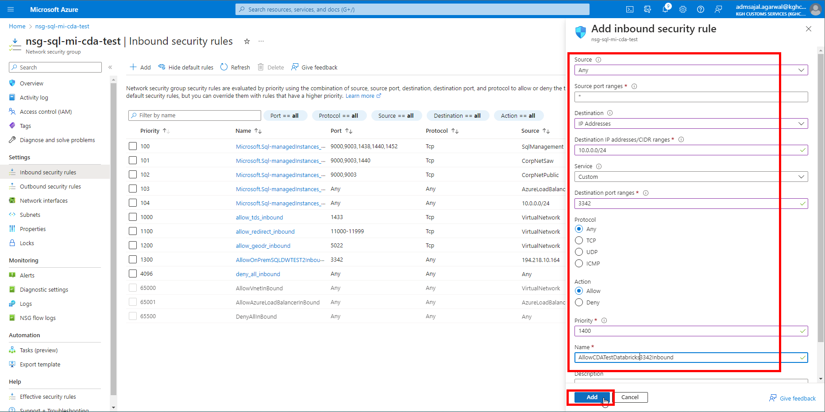

1. It will start creating the security rule.

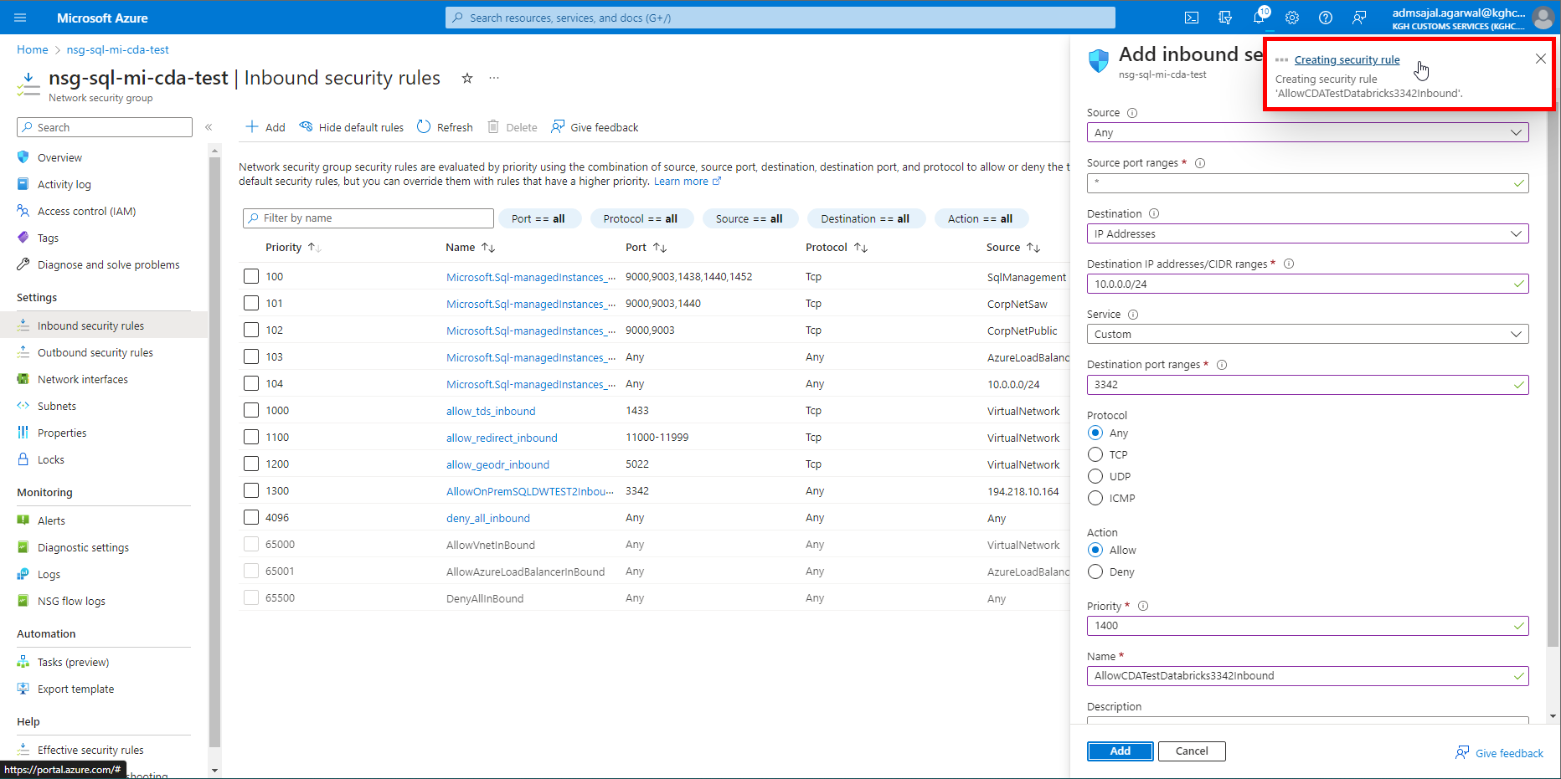

1. Once created, the new security rule will be displayed on the table.

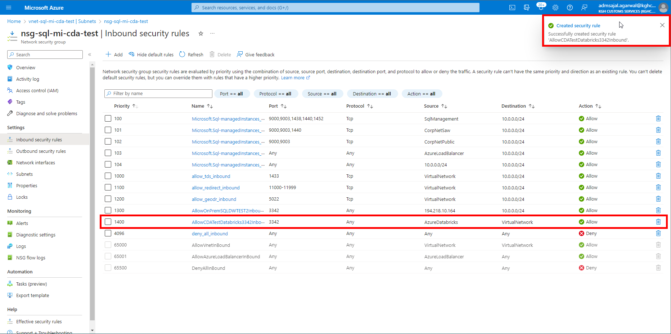

### **Network Configuration: Outbound Security Rules**

1. Click on *Outbound Security rules*

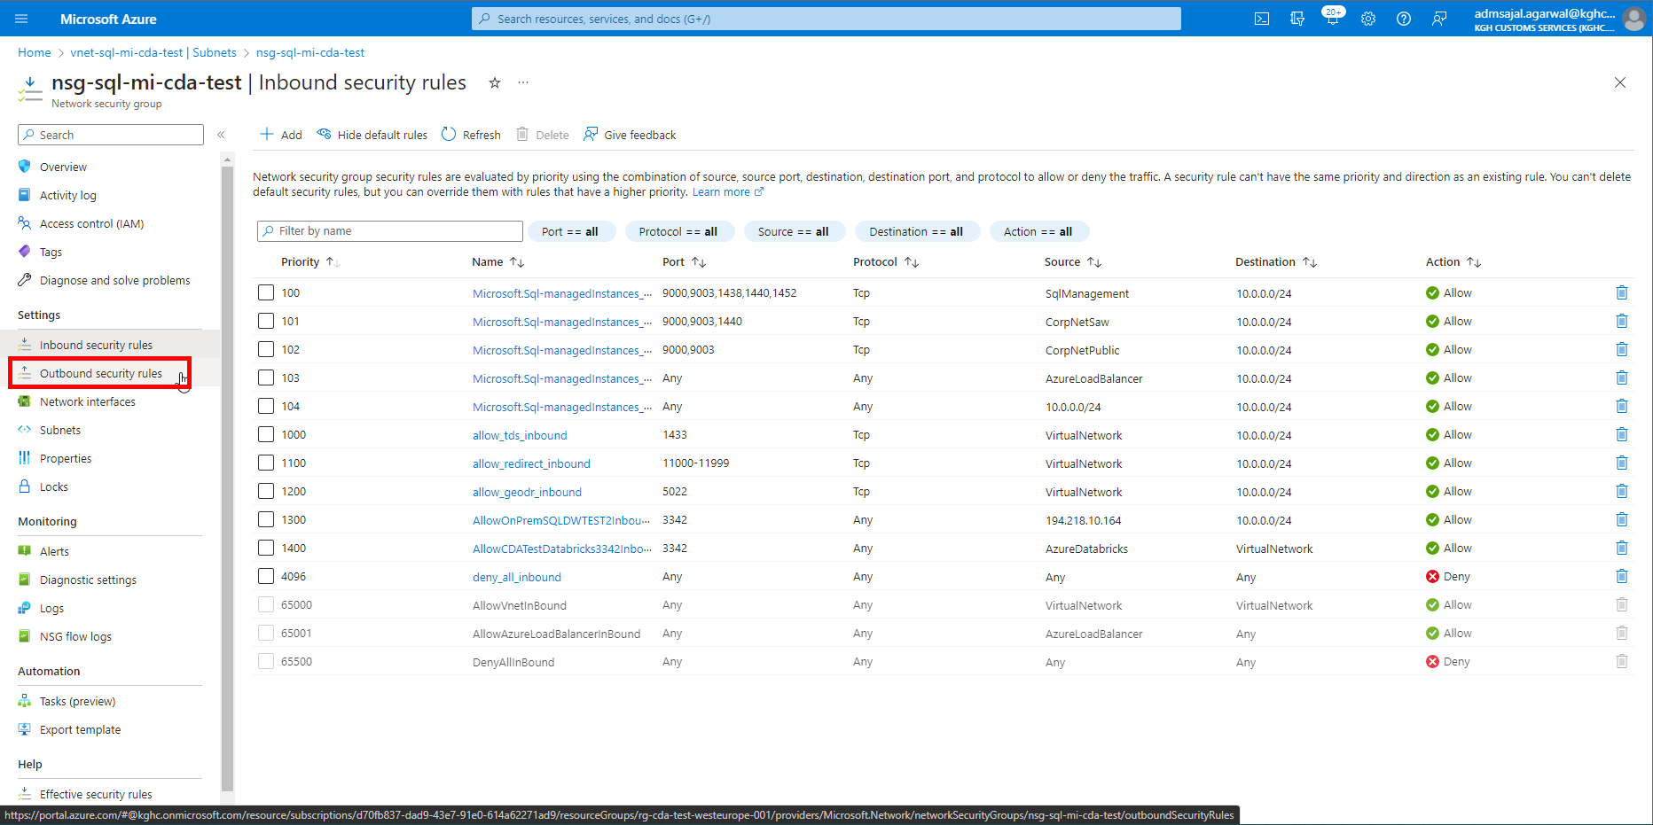

1. Click on *Add*

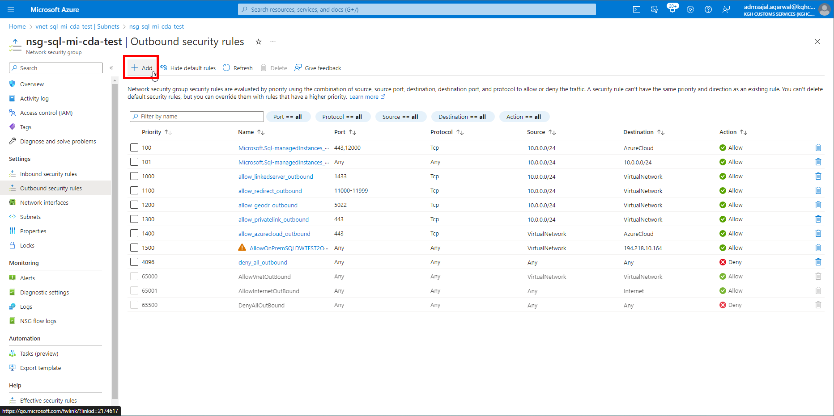

1. Fill the details as below:

Source: *IP Addresses*

Source IP addresses/CIDR ranges: *10.0.0.0/24*

Source port ranges: *3342*

Destination: *Any*

Service: *Custom*

Destination port ranges: *\**

Protocol:*Any*

Action:  *Allow*

Priority: *1600*

Name: *AllowCDATestDatabricks3342Outbound*

Click on *Add*

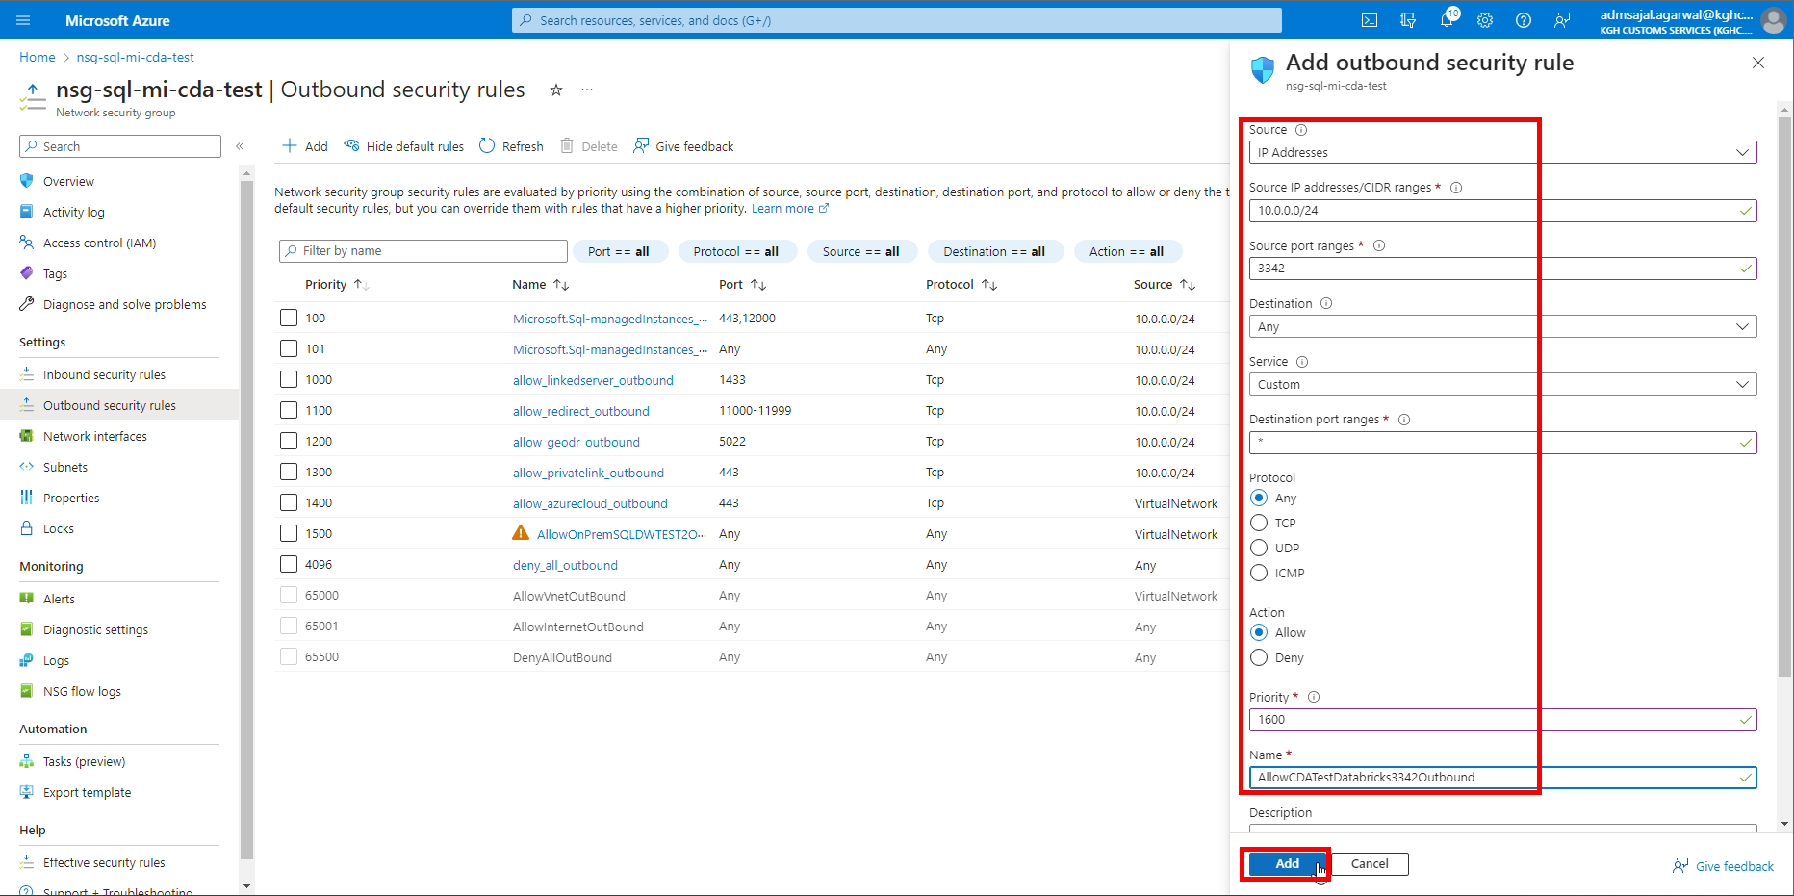

1. It will start creating the security rule.

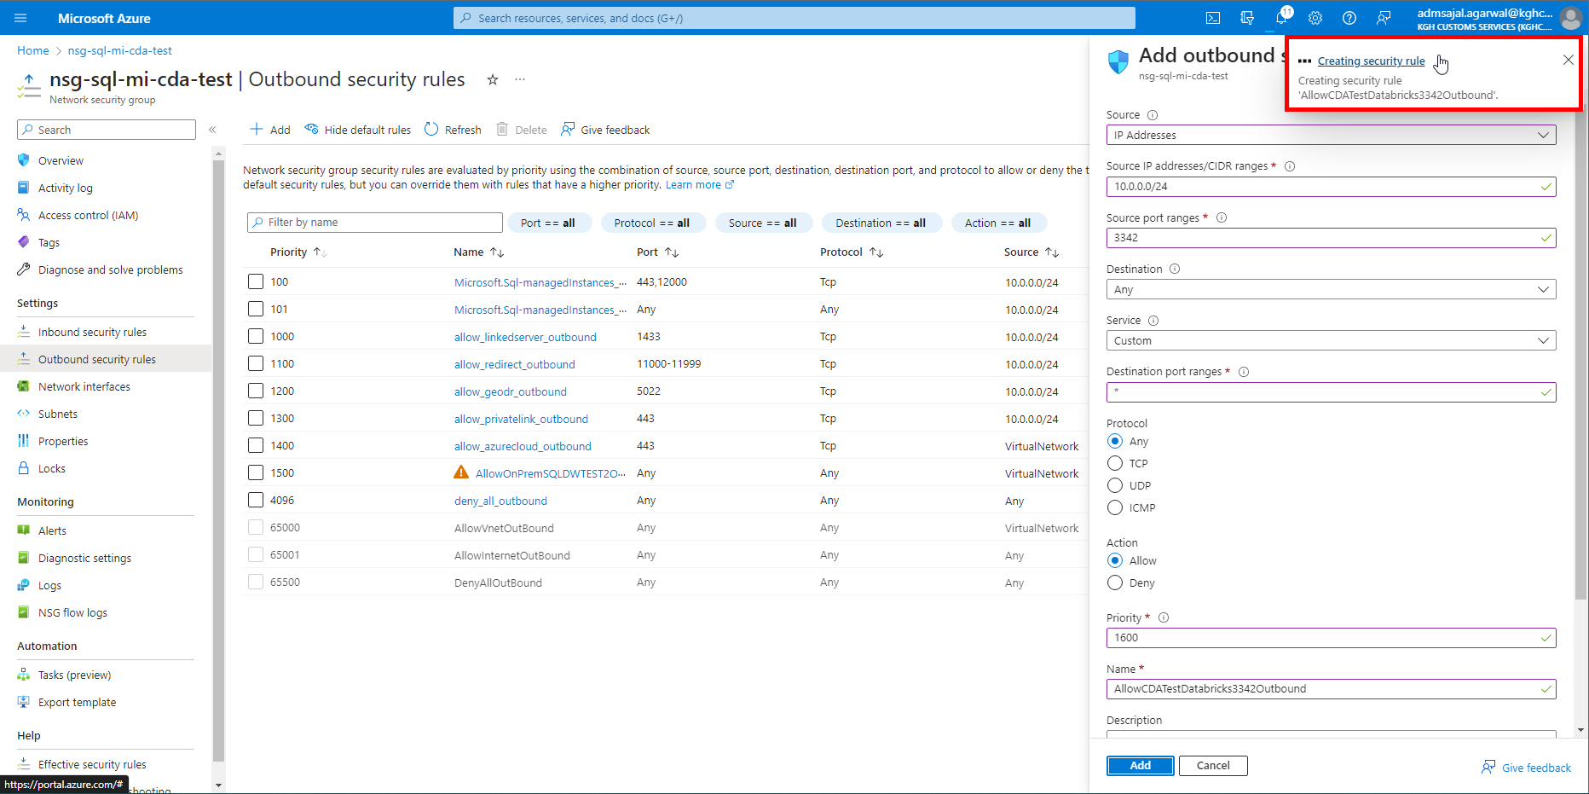

1. Once created, the new security rule will be displayed on the table.

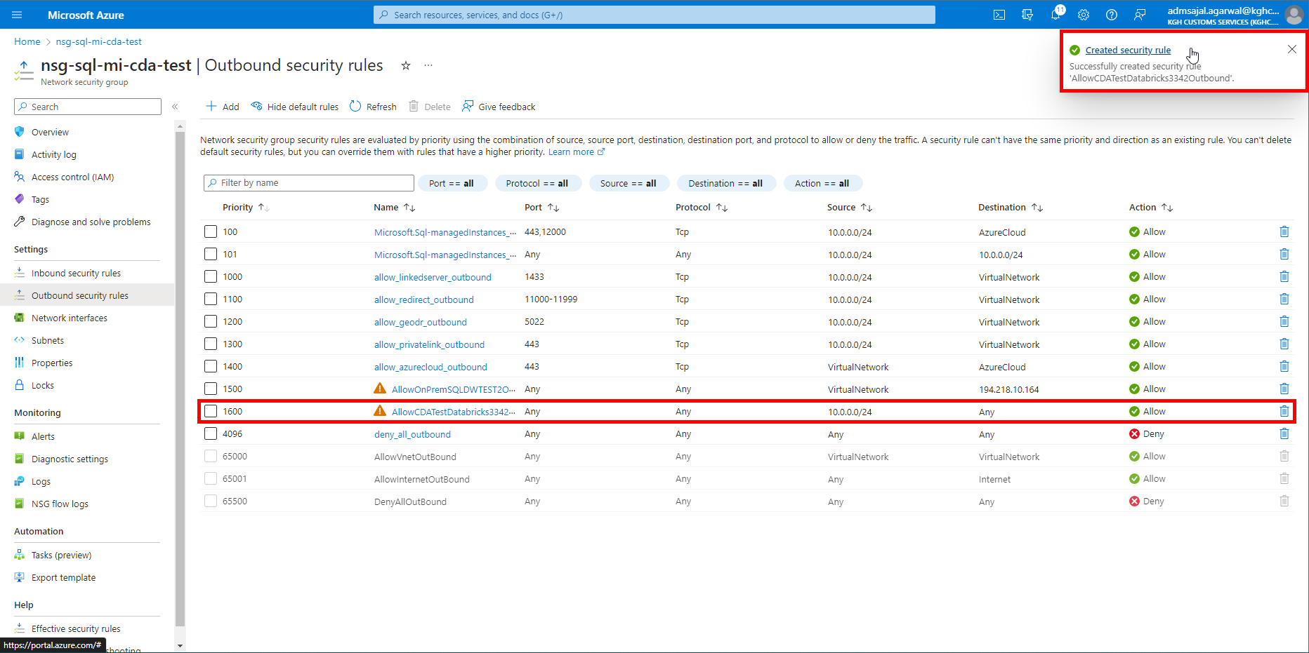

### **Connection: Databricks Notebook to SQL Managed Instance**

1. Click on *Connection strings* from resource *Overview* page



1. Click on *JDBC*

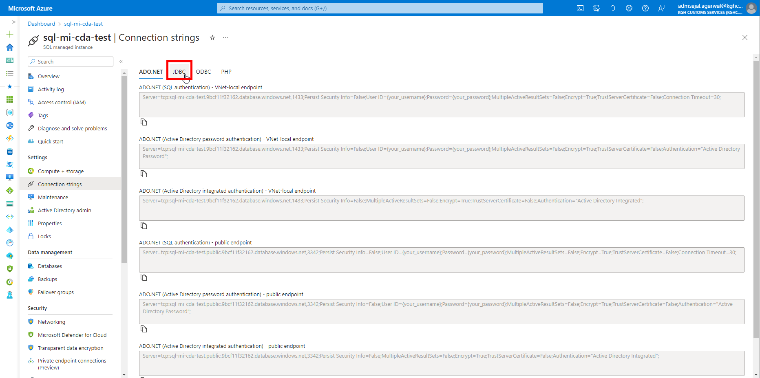

1. Copy the connection stringunder *JDBC (SQL authentication) – public endpoint*

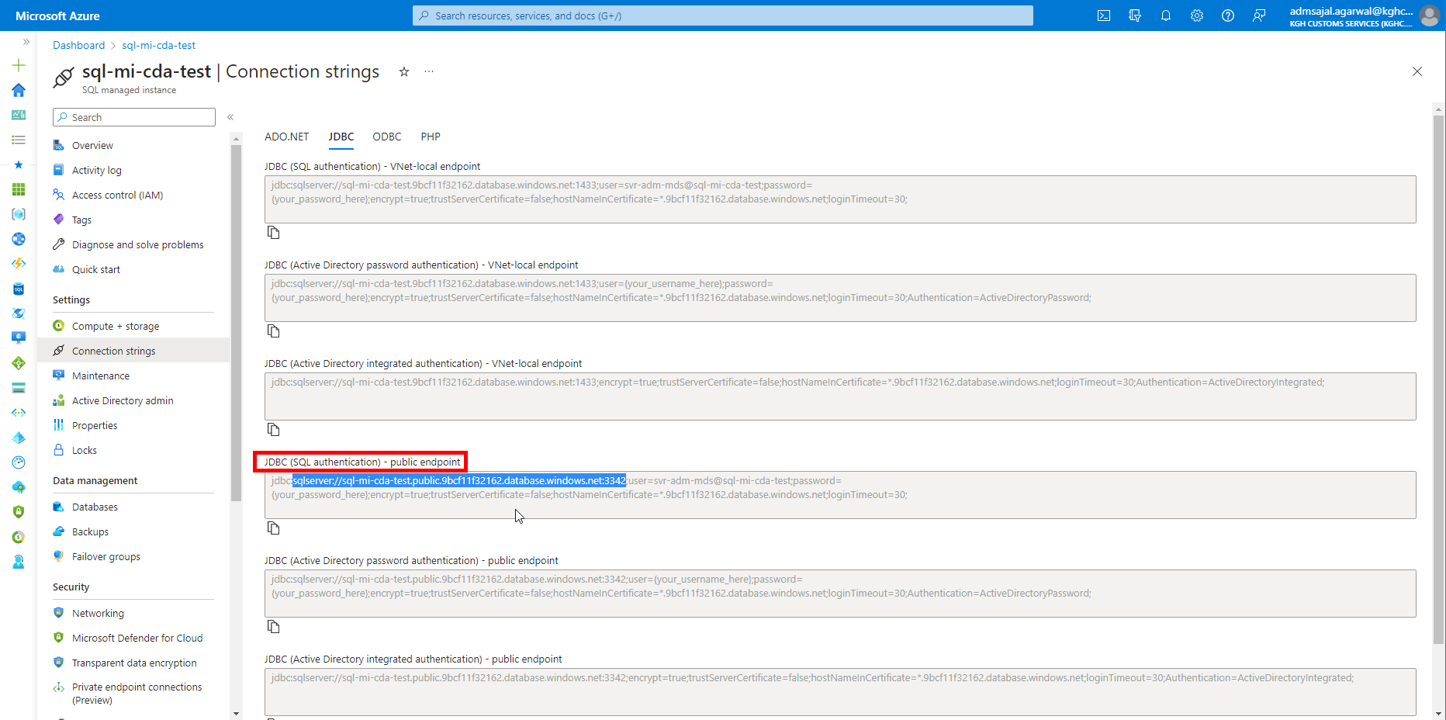

1. Use below code to connect to SQL Managed Instance from Databricks Notebook

sql_server_df = (spark.read

  .format("sqlserver")

  .option("host", "sql-mi-cda-test.public.9bcf11f32162.database.windows.net") # provide the JDBC public endpoint

  .option("port", "3342") # provide the JDBC public endpoint port

  .option("user", "svr-adm-mds") # provide the server user name

  .option("password", "@dminmdm$erver2023") # provide the server password

  .option("database", "KGH_MDS") # provide the database name

  .option("dbtable", "mdm.OPDW_Global_TaxType") # provide the schema and table name

  .load()

)

sql_server_df.show()

## **Database Creation**

1. Click on *Databases* from resource *Overview* page

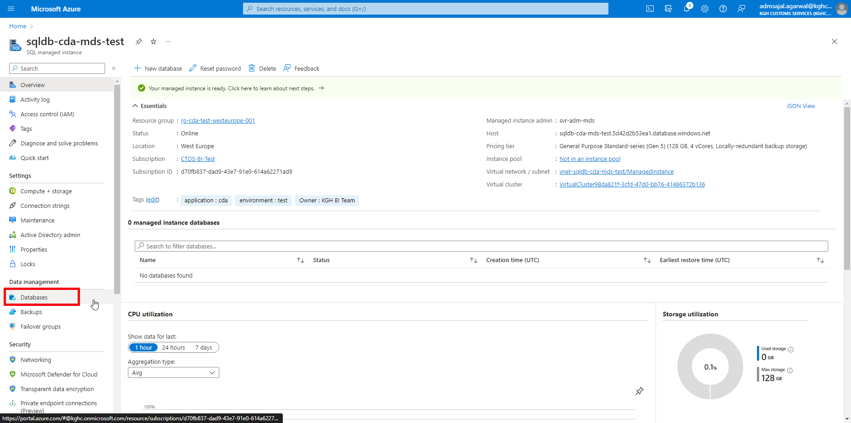

1. Click on *New database*

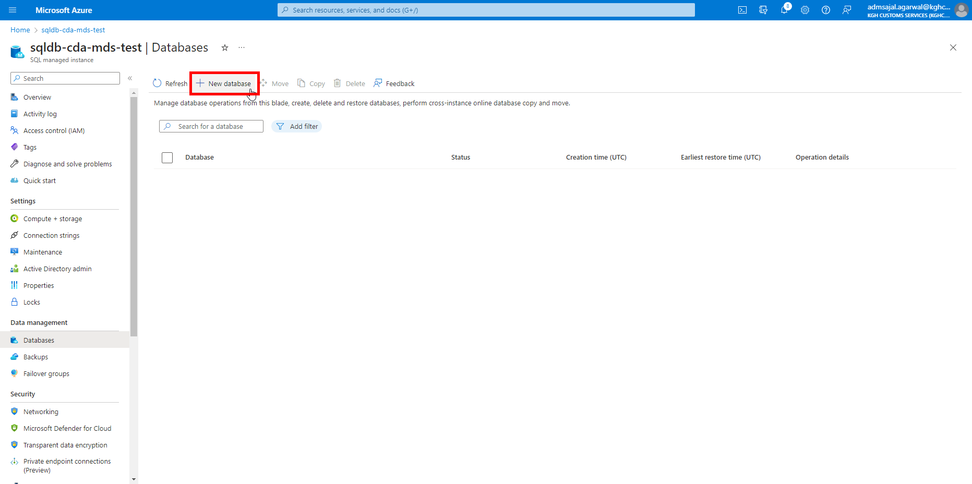

1. Fill the details as below:

Subscription: *CTDS-BI-Test*

Resource Group: *rg-cda-test-westeurope-001*

Database name: *sqldb_cda_mds_test_01*

Managed instance: *sqldb-cda-mds-test (westeurope)*

Click on *Next : Data source*

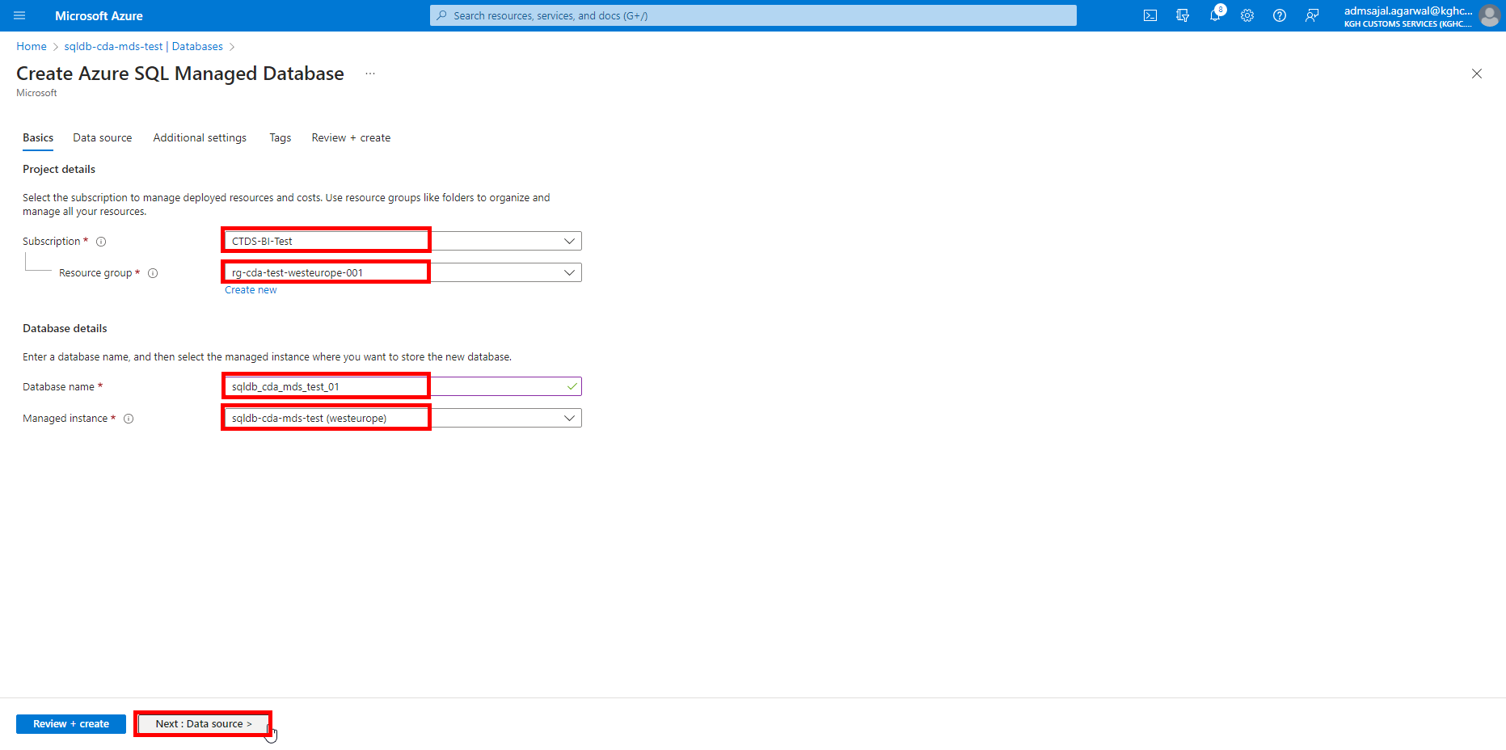

1. Keeping all options as default, click on *Next : Additional settings*

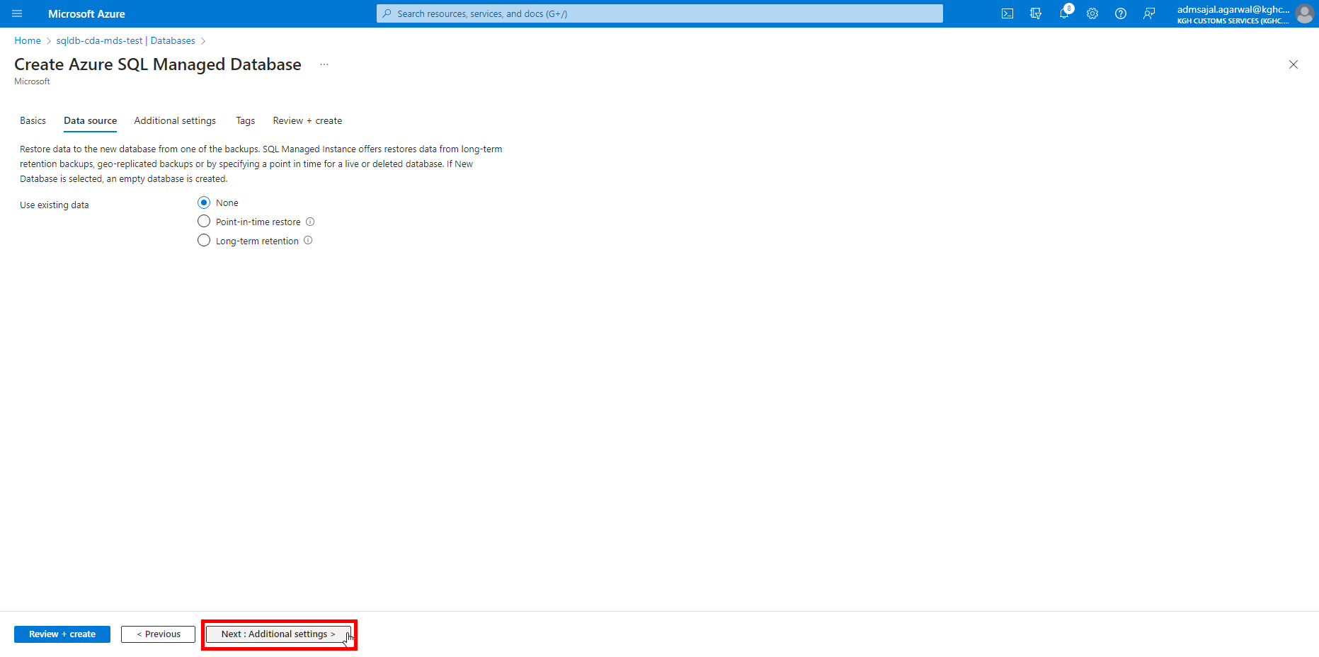

1. Keeping all options as default, click on *Next : Tags*

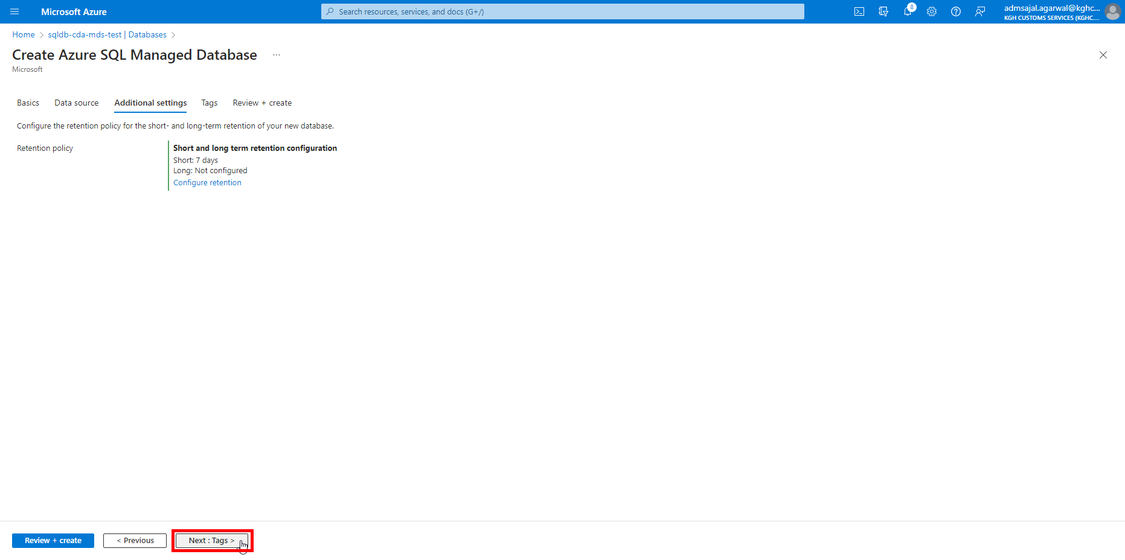

1. Add the tags as shown below:

application 🡪 *cda*

owner 🡪 *KGH BI Team*

environment 🡪 *test*

Click on *Next: Review + create*

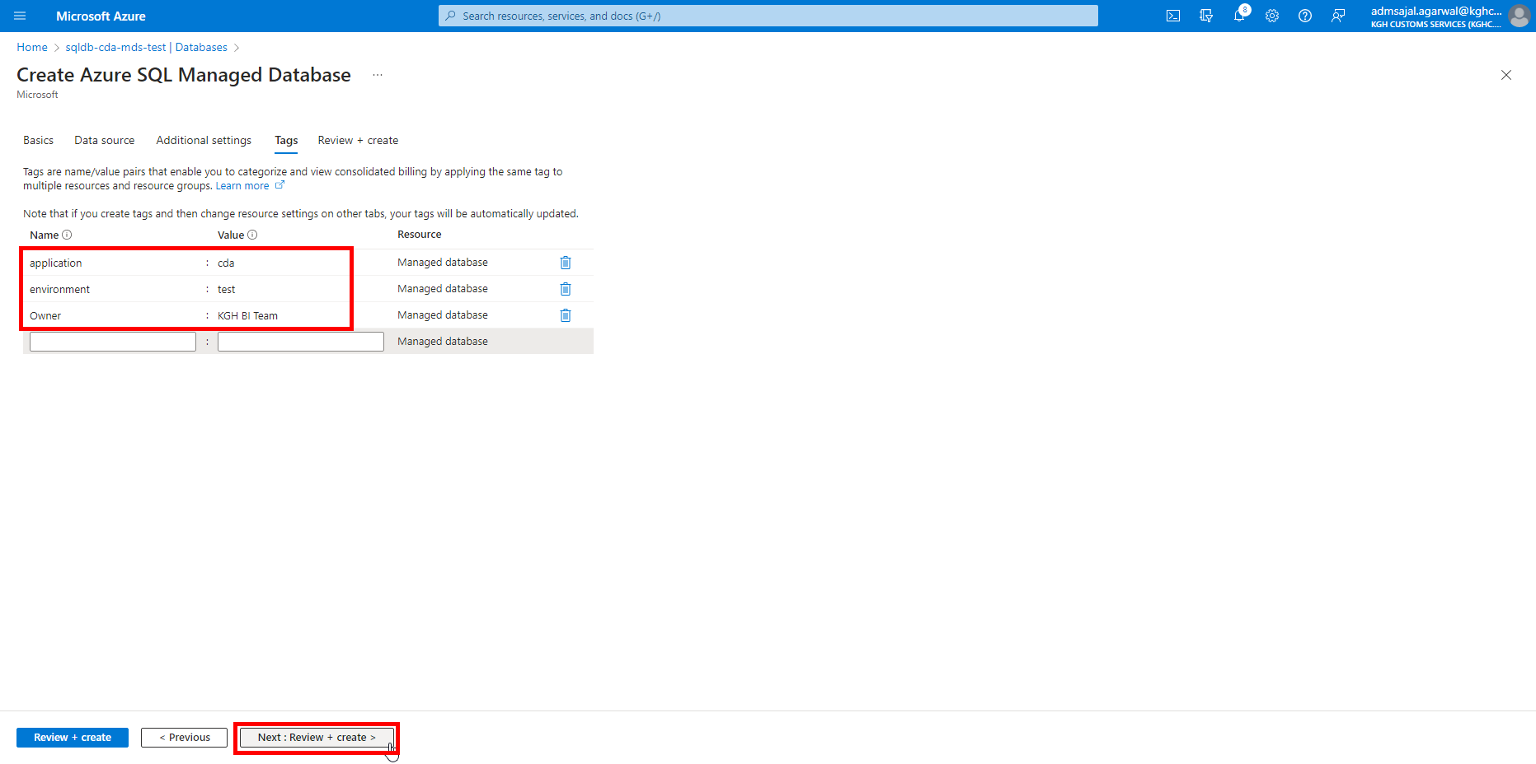

1. Wait for the *Validation* to complete and *Create* button to be enabled

Click on *Create*

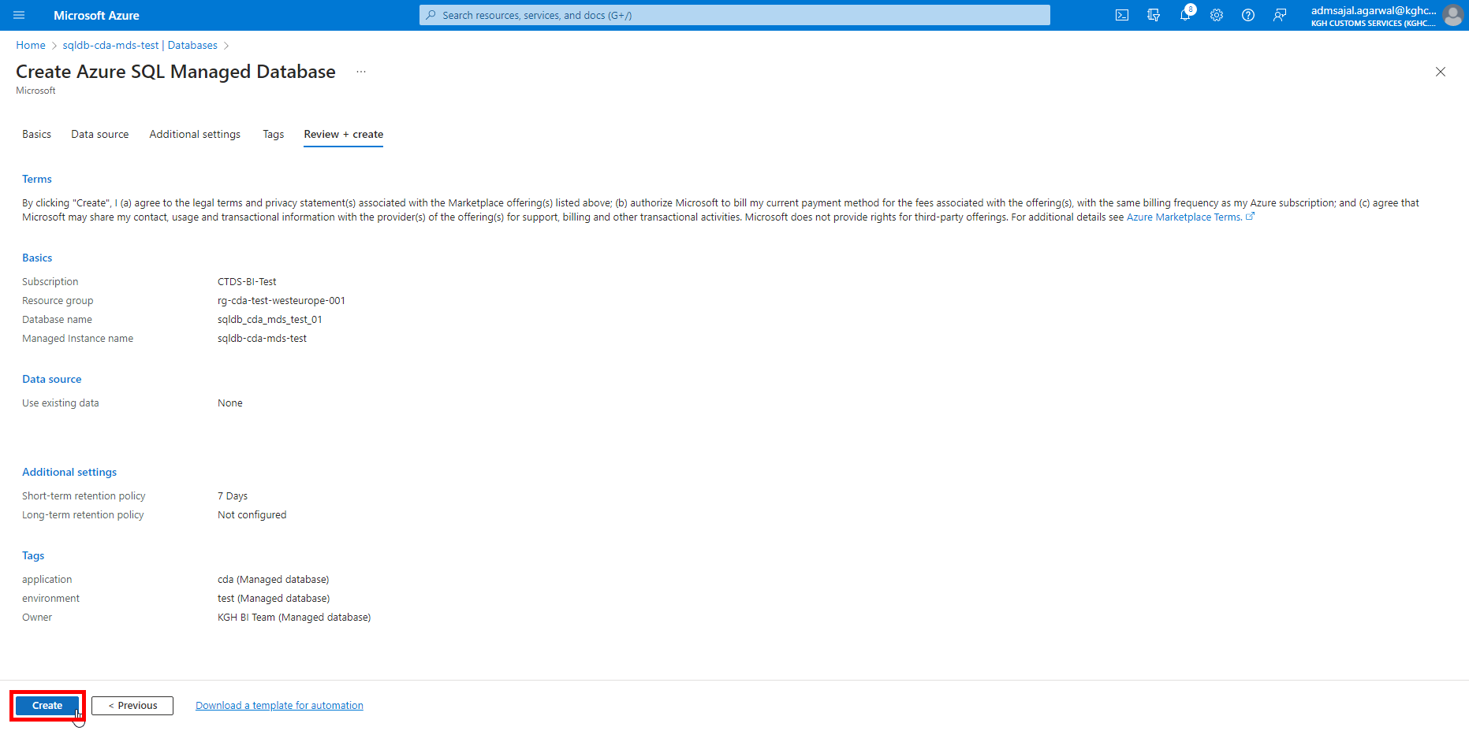

1. It will initialize the deployment of resource.

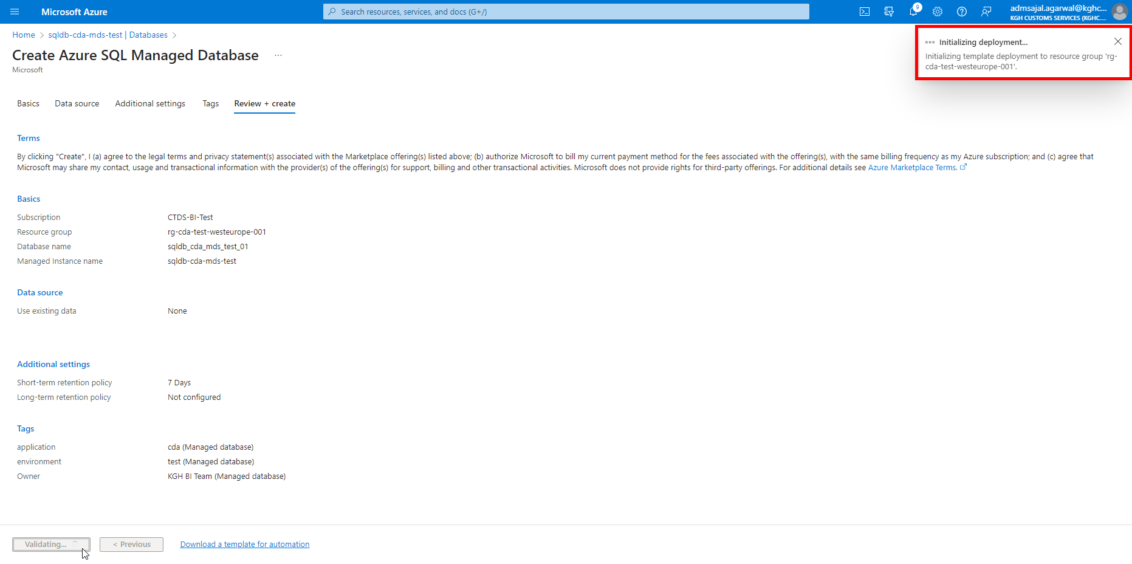

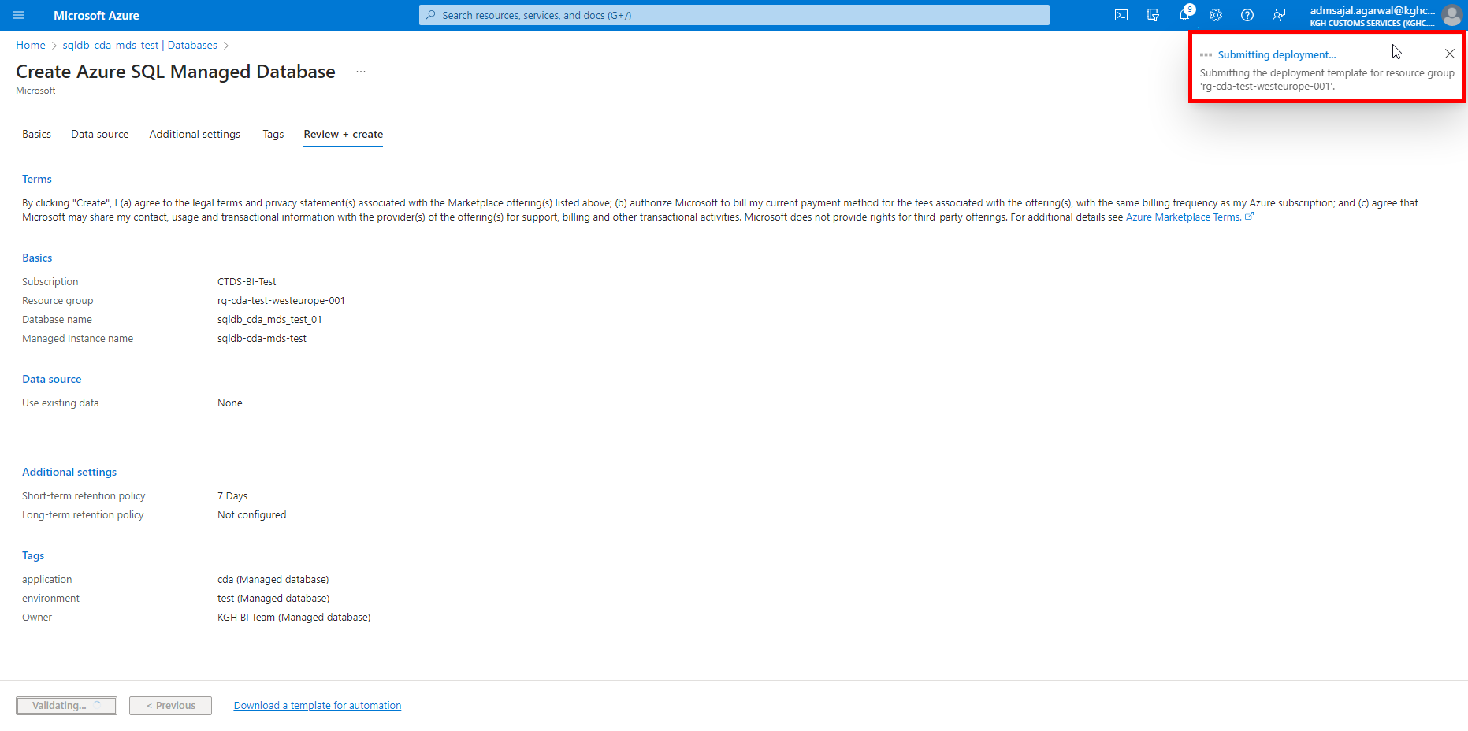

1. It will auto-redirect to deployment screen

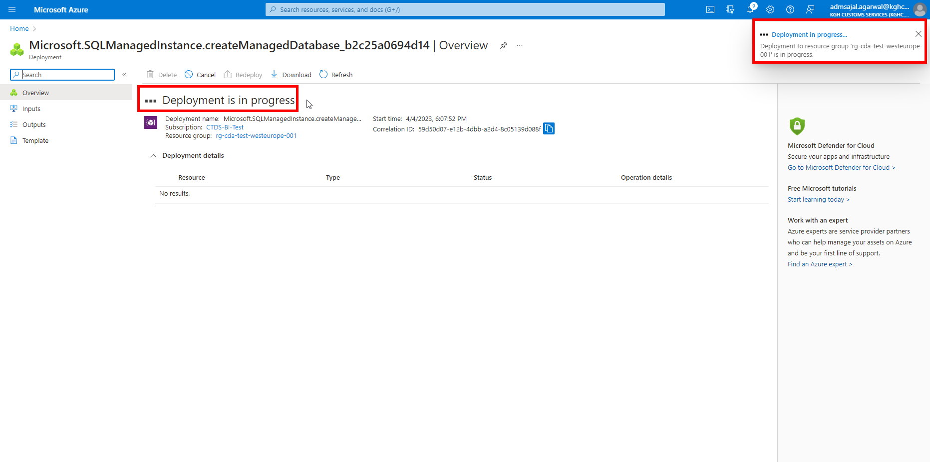

1. When the message changes to *Your deployment is complete*, click on *Go to resource*

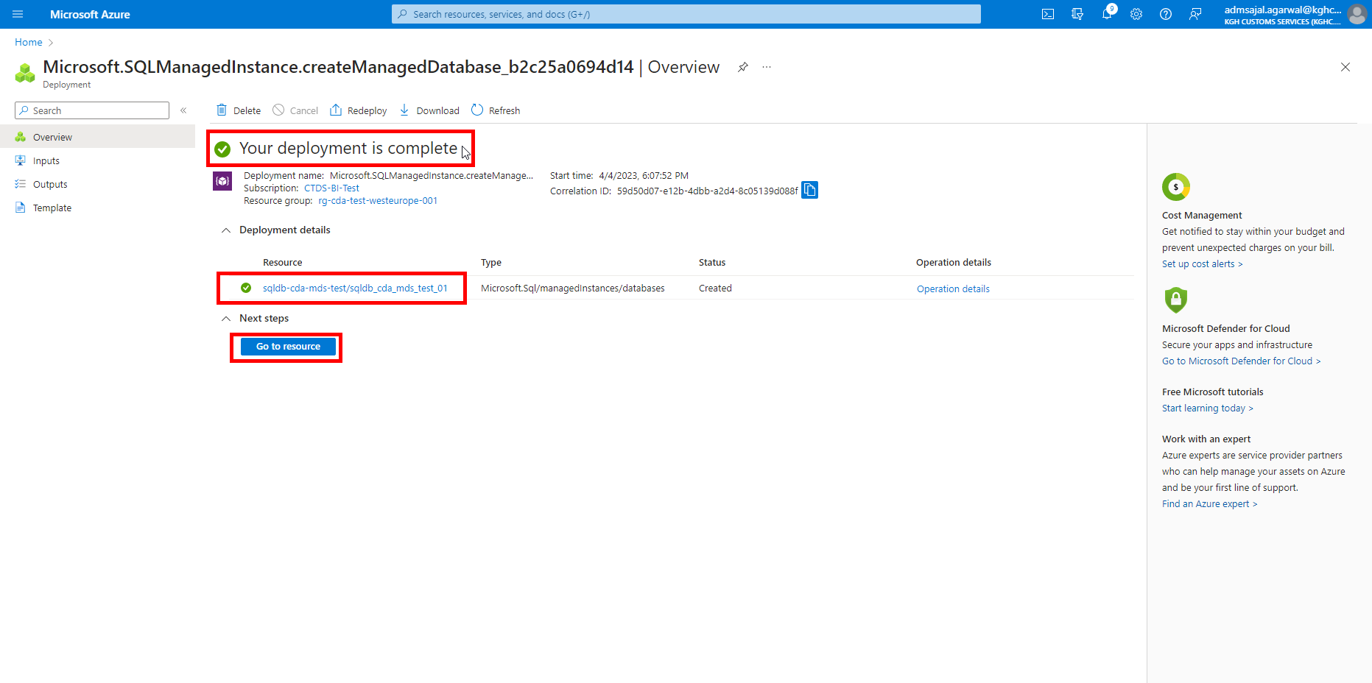

1. It will take to *Overview* page of created resource.

## **Installation: Azure CLI**

1. Go to [How to install the Azure CLI | Microsoft Learn](https://learn.microsoft.com/en-us/cli/azure/install-azure-cli)
2. Click on *Install on Windows*

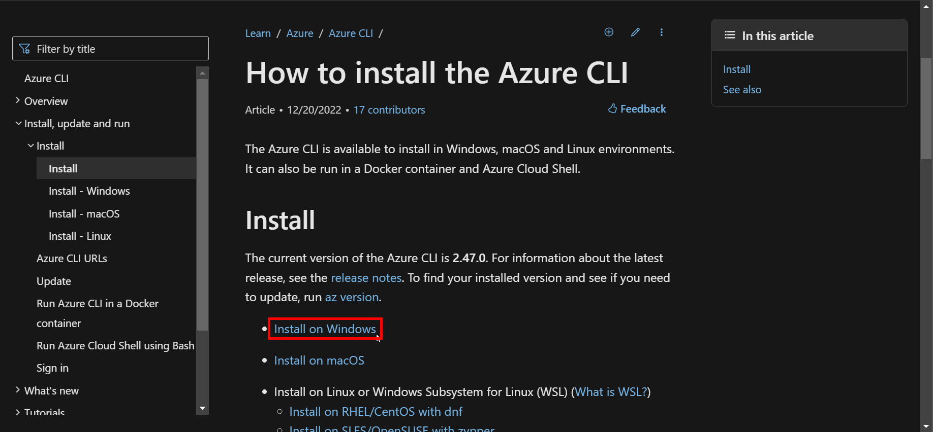

1. Click on Latest release of the Azure CLI

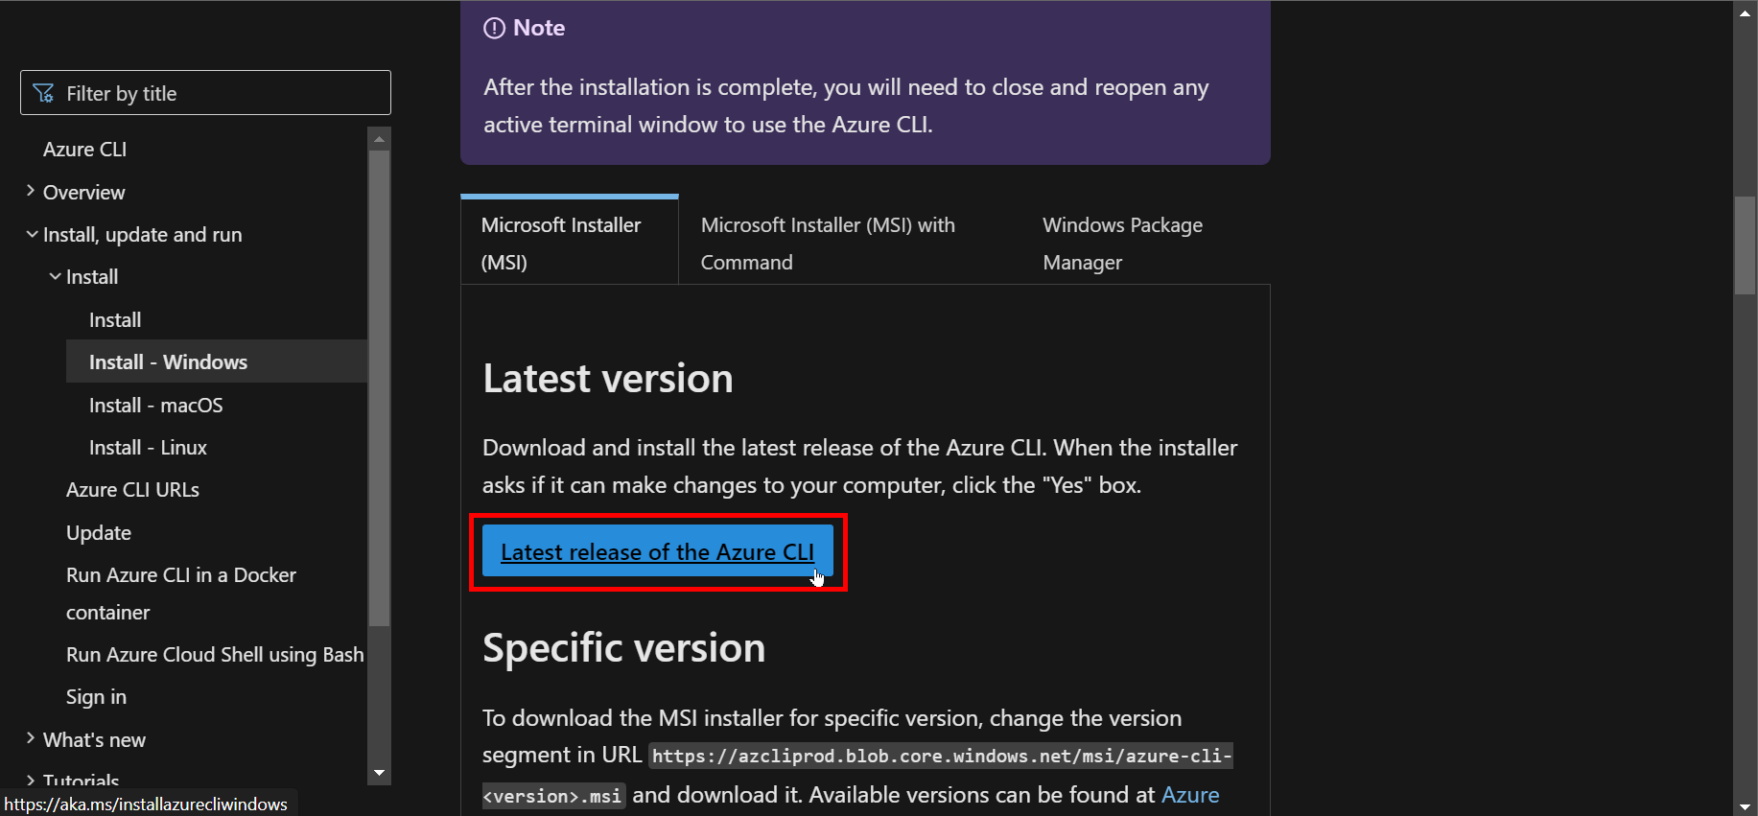

1. Downloading of installation file will start. Once downloaded, open the file.

Click on *Run*

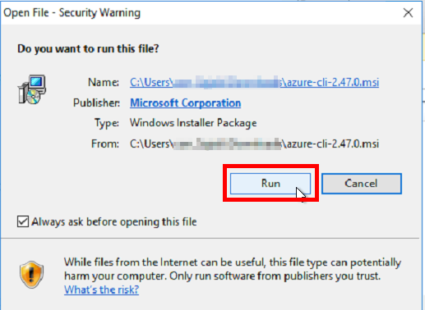

1. Tick-mark the *I accept the terms in the License Agreement*

Click on *Install*

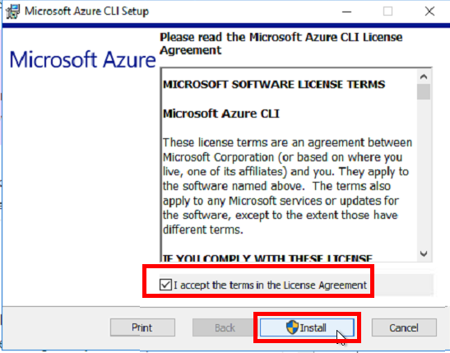

1. Click on *Yes*

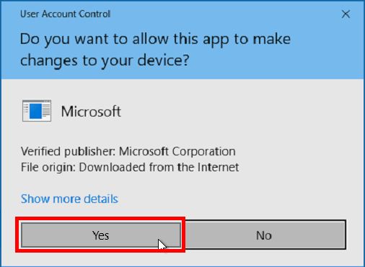

1. Installation will start.

Click on *Next* when enabled.

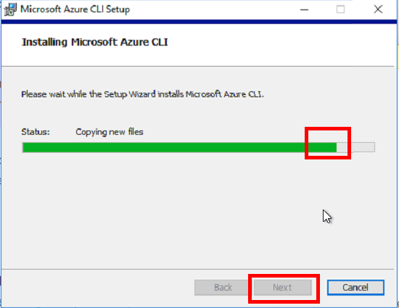

1. Click on Finish

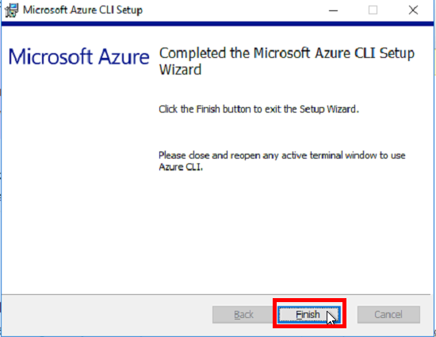

## **Installation: Azure Commands in PowerShell**

Reference: <https://azurelessons.com/no-match-was-found-for-the-specified-search-criteria-and-module-name-az/>

1. Open *Powershell* as *admin*
2. Run the below commands in specified order:

# Set Protocol to TLS 1.2

[Net.ServicePointManager]::SecurityProtocol = [Net.SecurityProtocolType]::Tls12

# Verify Protocol

[Net.ServicePointManager]::SecurityProtocol

# Set Repository to Default

Register-PSRepository -Default

# Install Azure Commands for all Users

Install-Module -Name Az -AllowClobber -Scope AllUsers

# Install Azure Commands for Current Users

Install-Module -Name Az -AllowClobber -Scope CurrentUser

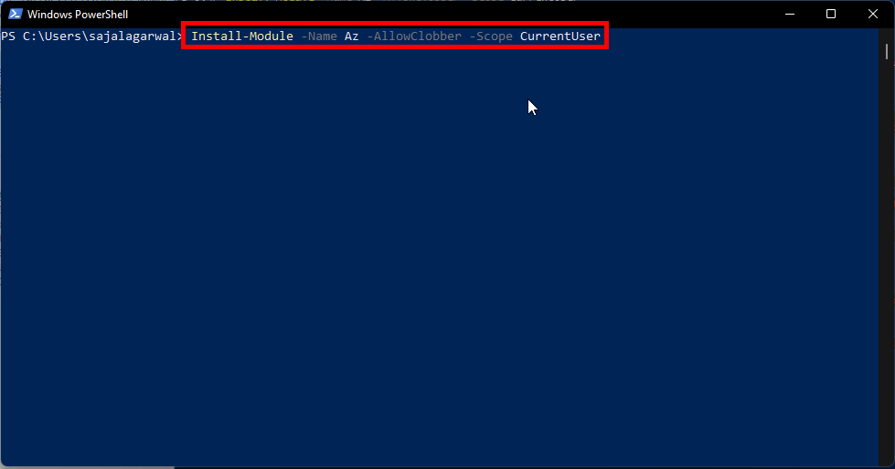

1. Enter Y if it asks for any confirmation.

Installation will start after final confirmation.

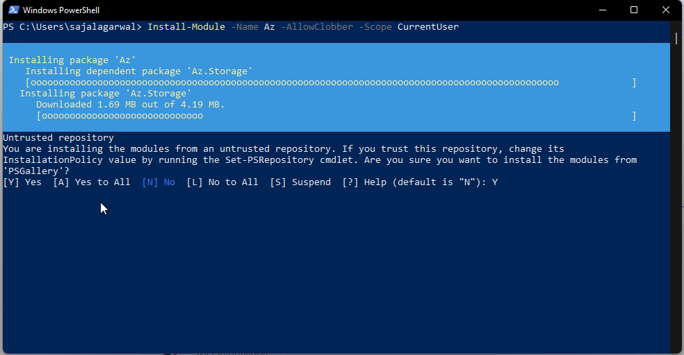

## **Installation: SQL Server in PowerShell**

1. Open *Powershell* as *admin*
2. Run the below commands in specified order:

# Set Protocol to TLS 1.2

[Net.ServicePointManager]::SecurityProtocol =

# Verify Protocol

[Net.SecurityProtocolType]::Tls12

# Install Azure Commands for all Users

Install-Module -Name SqlServer -AllowClobber -Scope AllUsers

# Install Azure Commands for Current Users

Install-Module -Name SqlServer -AllowClobber -Scope CurrentUser

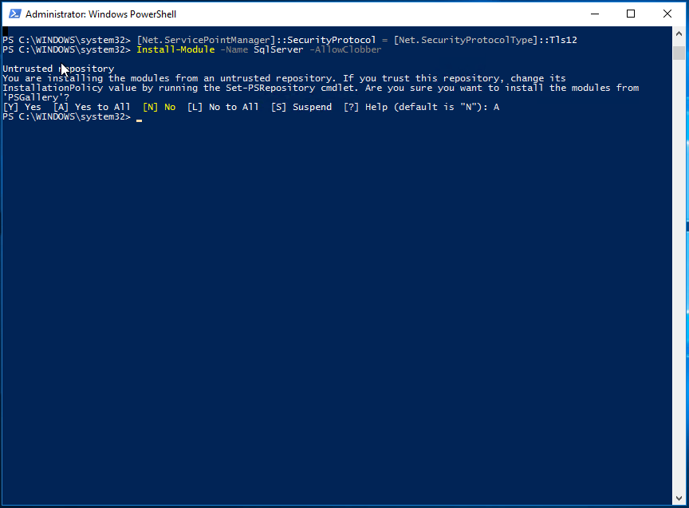

## **Database Migration: Log Replay Service**

### **Migration Assessment: Azure SQL Migration extension for Azure Data Studio**

1. Login to on-premises server *SQLDWTEST2*
2. Open *Azure Data Studio*

Click on *Manage*



1. Click on *Extensions*



1. Search for *Azure SQL Migration*

Click on result named *Azure SQL Migration*



1. Click on *Install*



1. After installation is complete, it will show *Installed* as show below



1. Click on *Connections* (first option in left side menu bar)



1. Click on *ON-PREM-SQLDWTEST2*

Click on *Azure SQL Migration* under *General*

Click on *Migrate to Azure SQL*

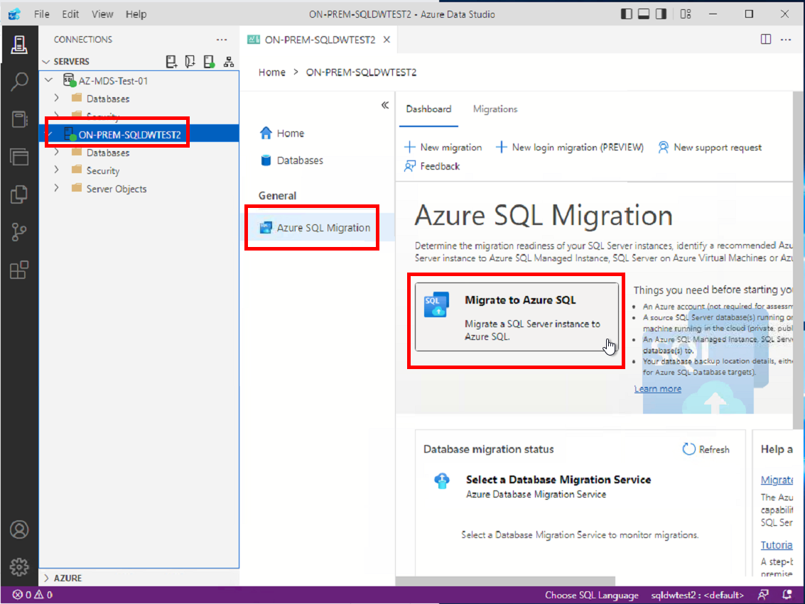

1. Select the *KGH_MDS* database

Click on *Next*

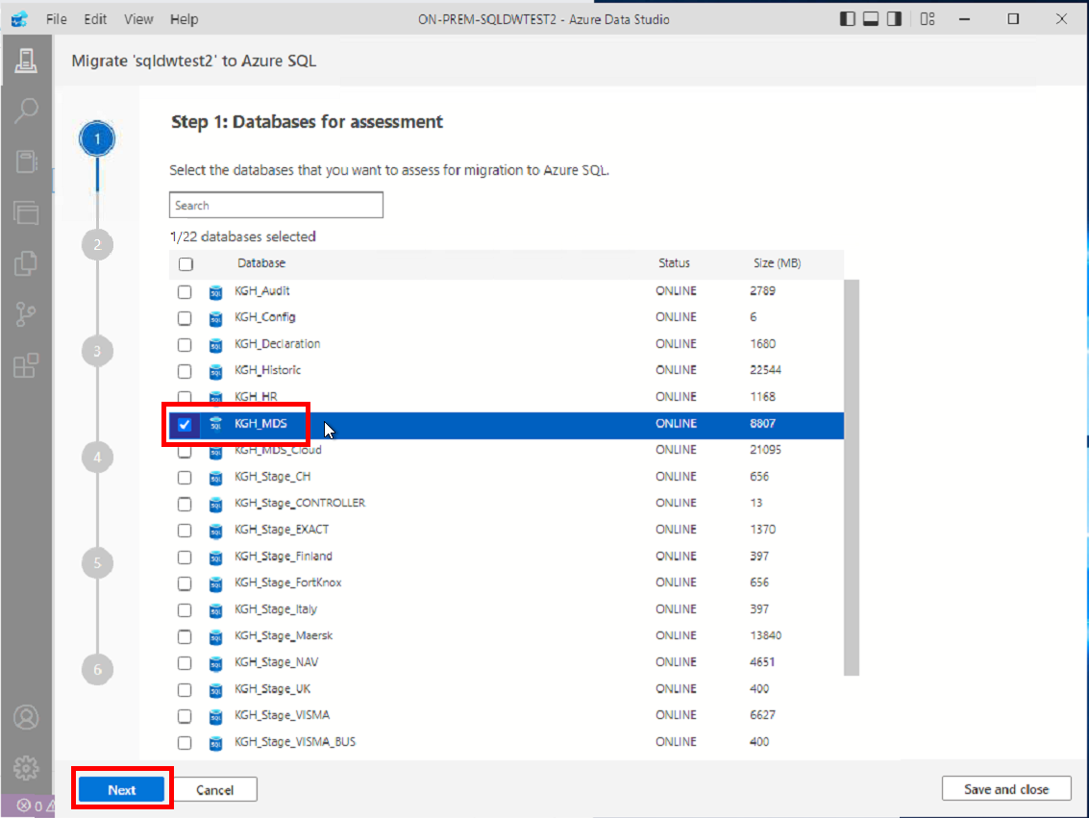

1. It will provide the assessment results of whether the database can be migrated to SQL Managed Instance Database or not

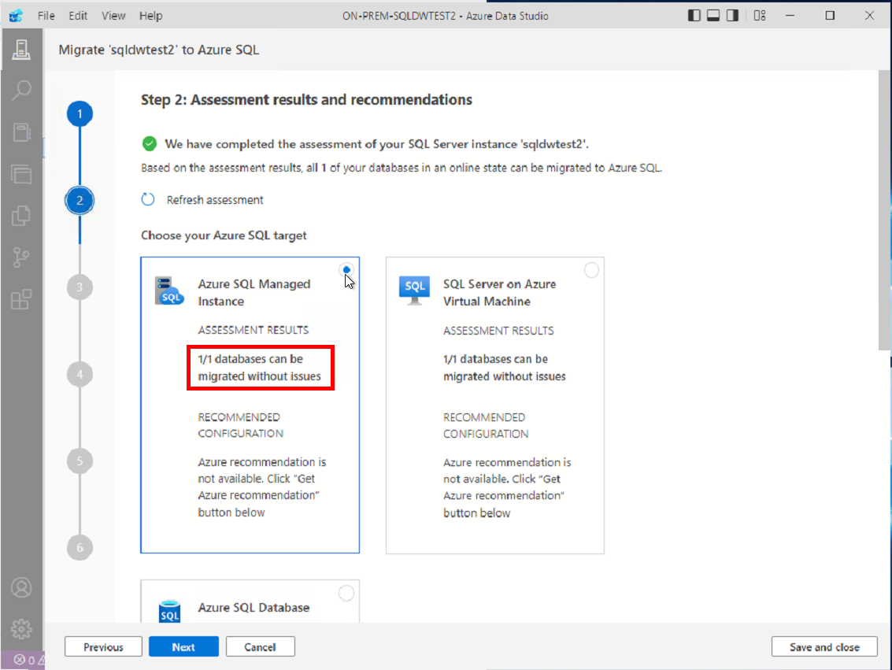

### **Authentication Tokens: Storage Account**

1. Create a Storage Account (Gen2) with name as *stcdadatalakemds*
2. Create a container in above storage account with name as *lrs-db-backup-kgh-mds*

#### **Access Policy**

1. Open the container

Click on *Access Policy*

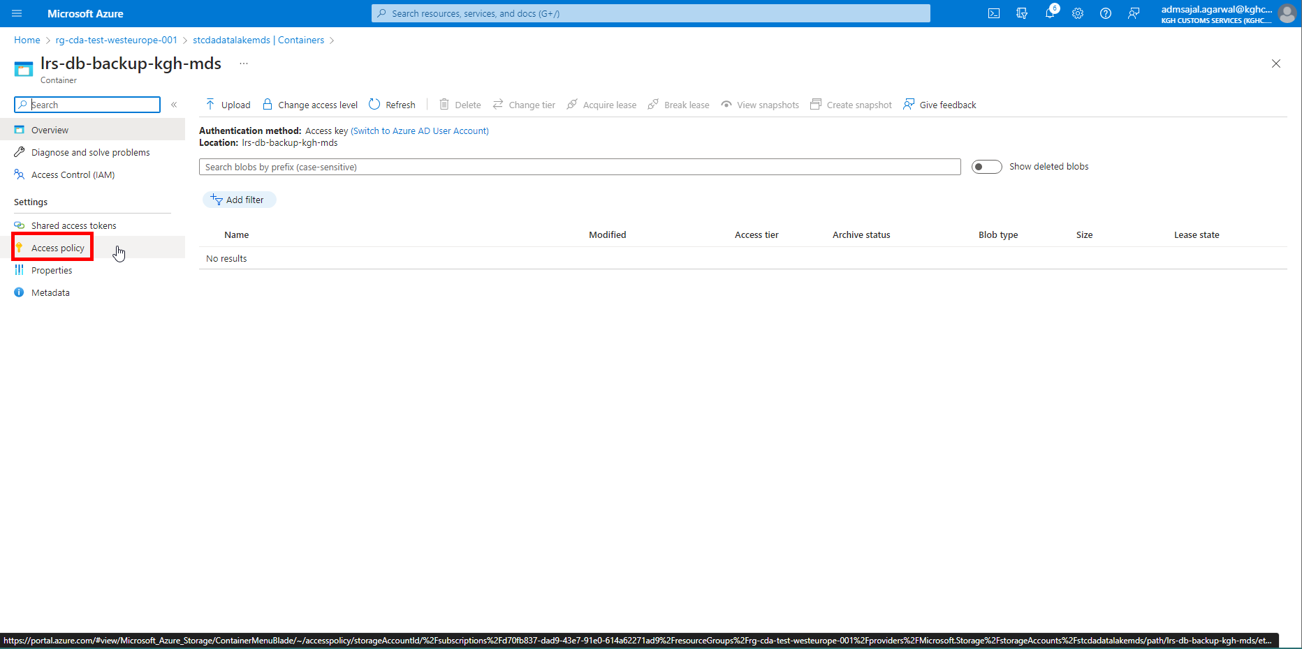

1. Click on *Add policy* under *Shared access policies*

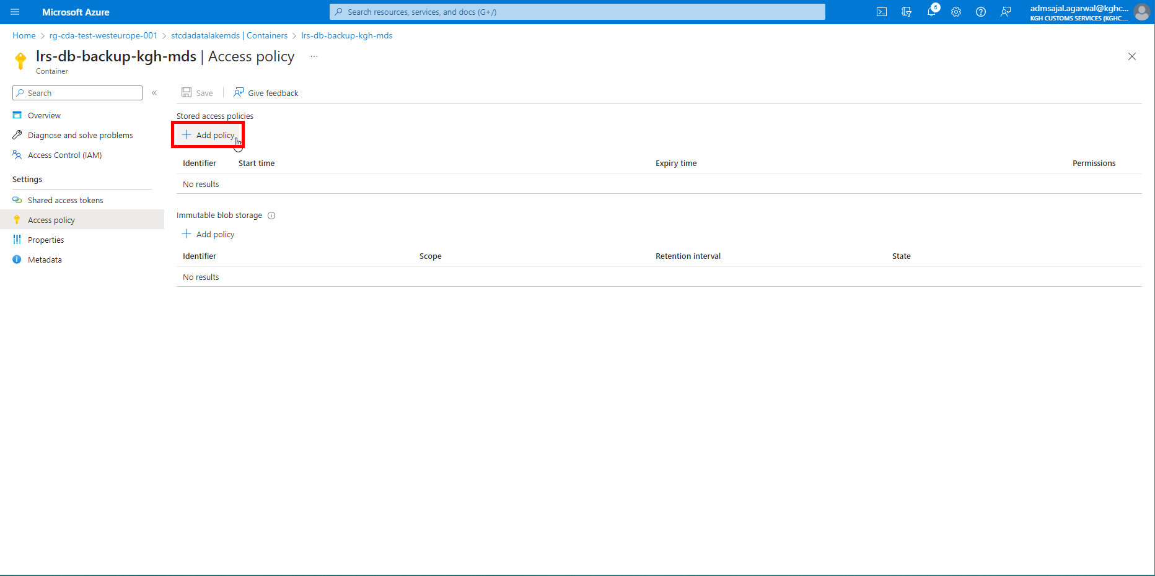

1. Provide the details as mentioned below.

Click on *OK*.

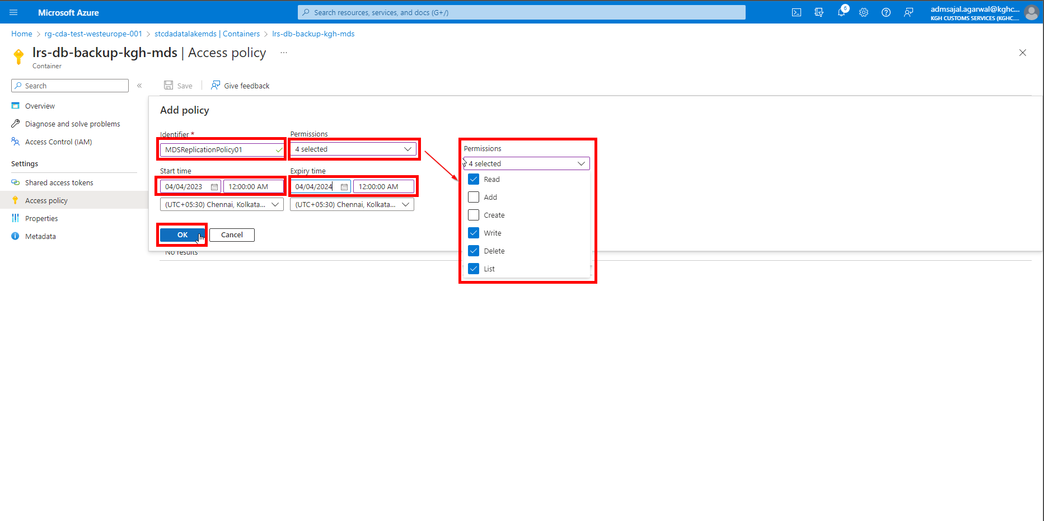

1. It will add the storage access policy.

Click on *Save*.

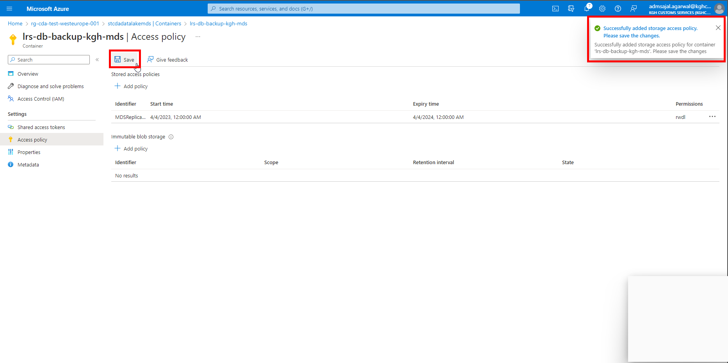

1. It will update the storage container with the newly created access policy.

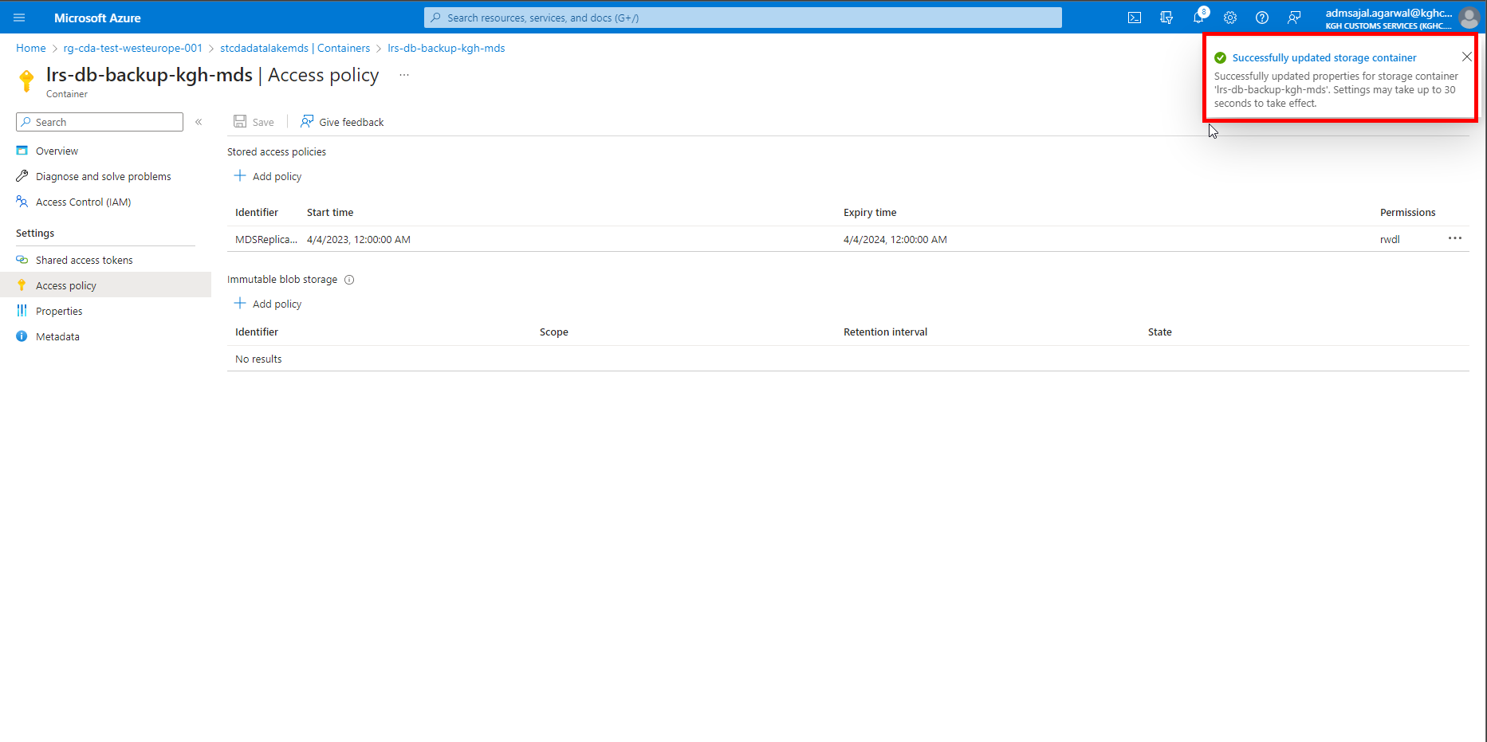

#### **Object Creation: SAS authentication token at container level**

1. Open the container
2. Click on *Shared access tokens*

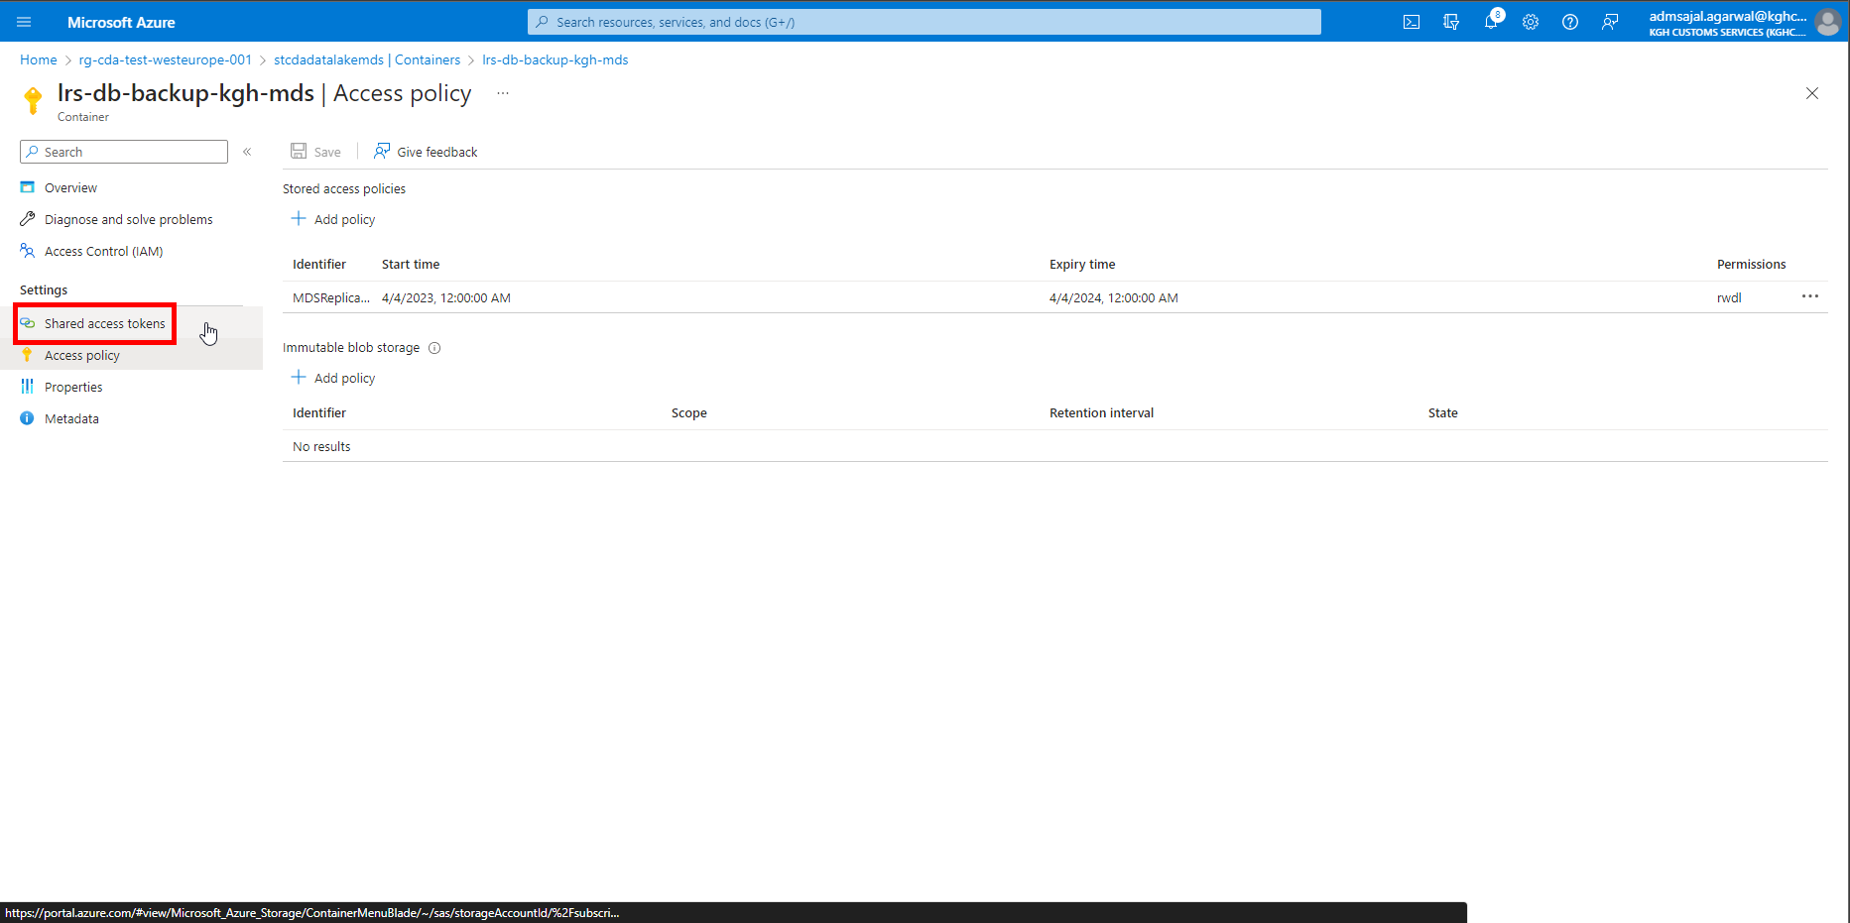

1. Select the newly created access policy in the dropdown under *Shared access policy.*

Click on *Generate SAS token and URL*

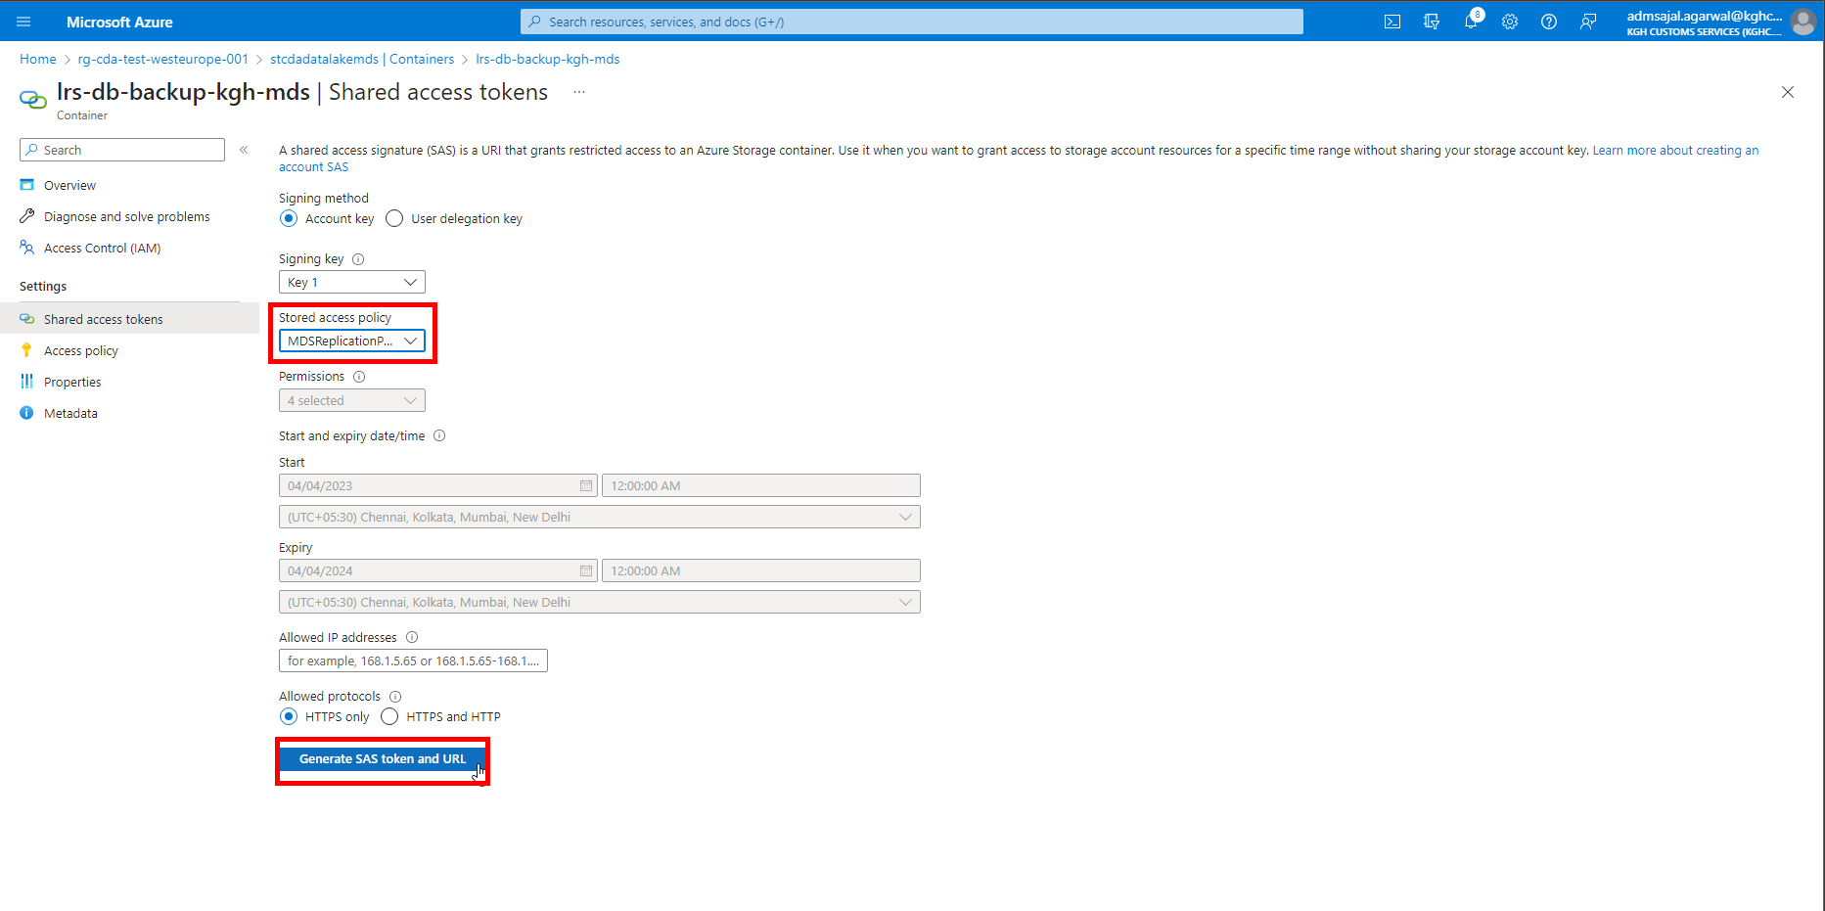

#### **Object Creation: SAS authentication token at storage level**

1. Open the Storage Account
2. Click on *Shared access signature* on *Overview* page of resource

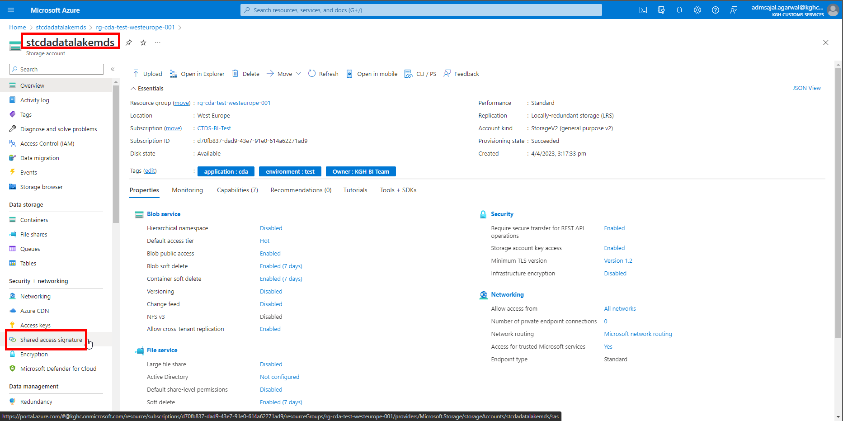

1. Provide the details as mentioned below.

Click on *Generate SAS token and URL*

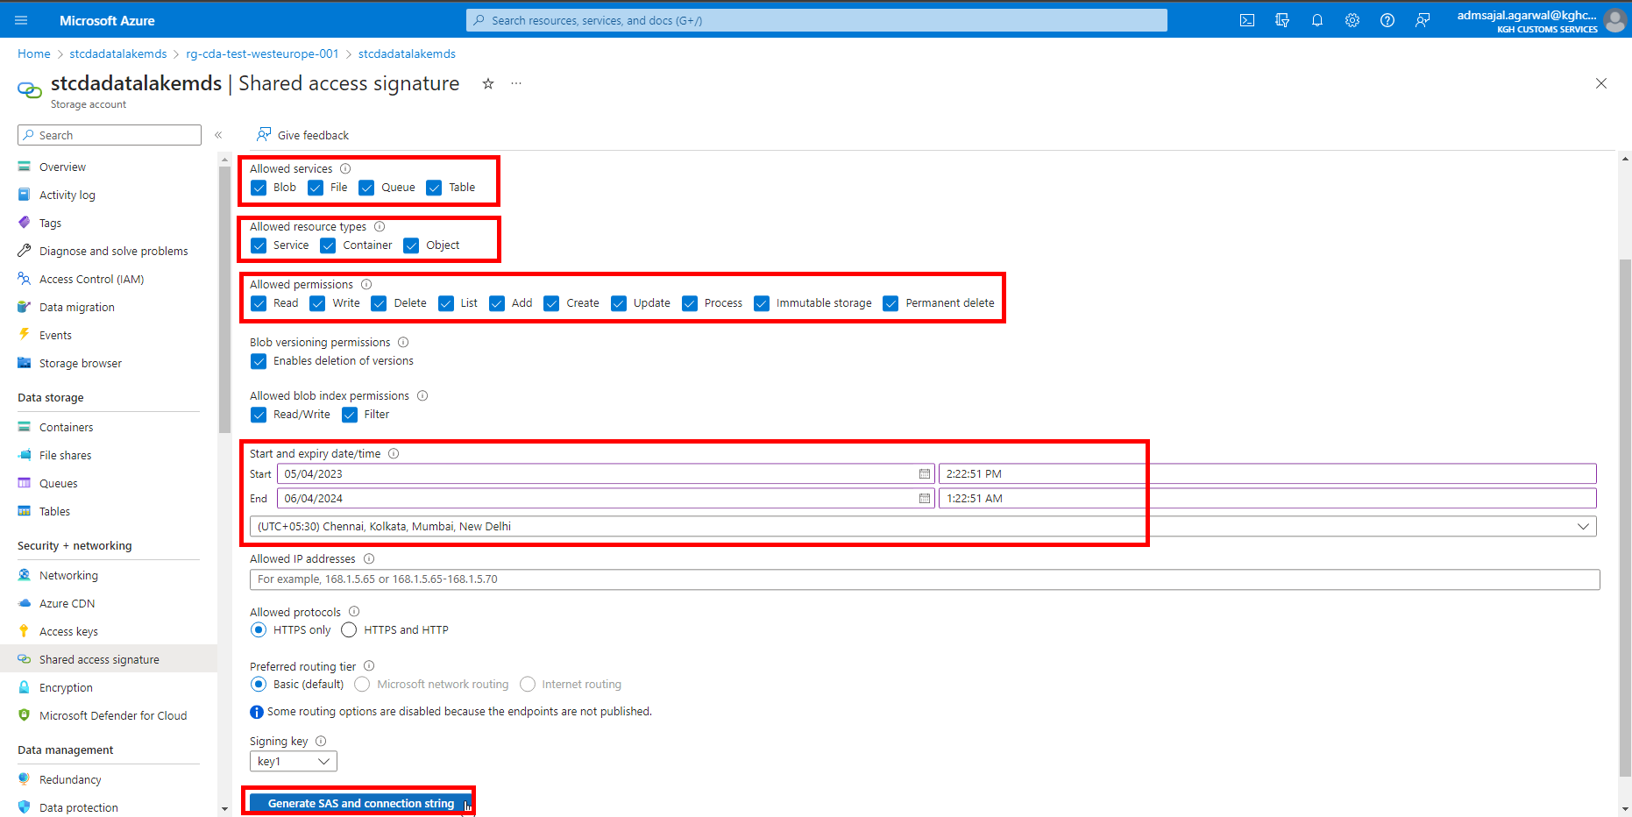

1. Copy the *SAS token*

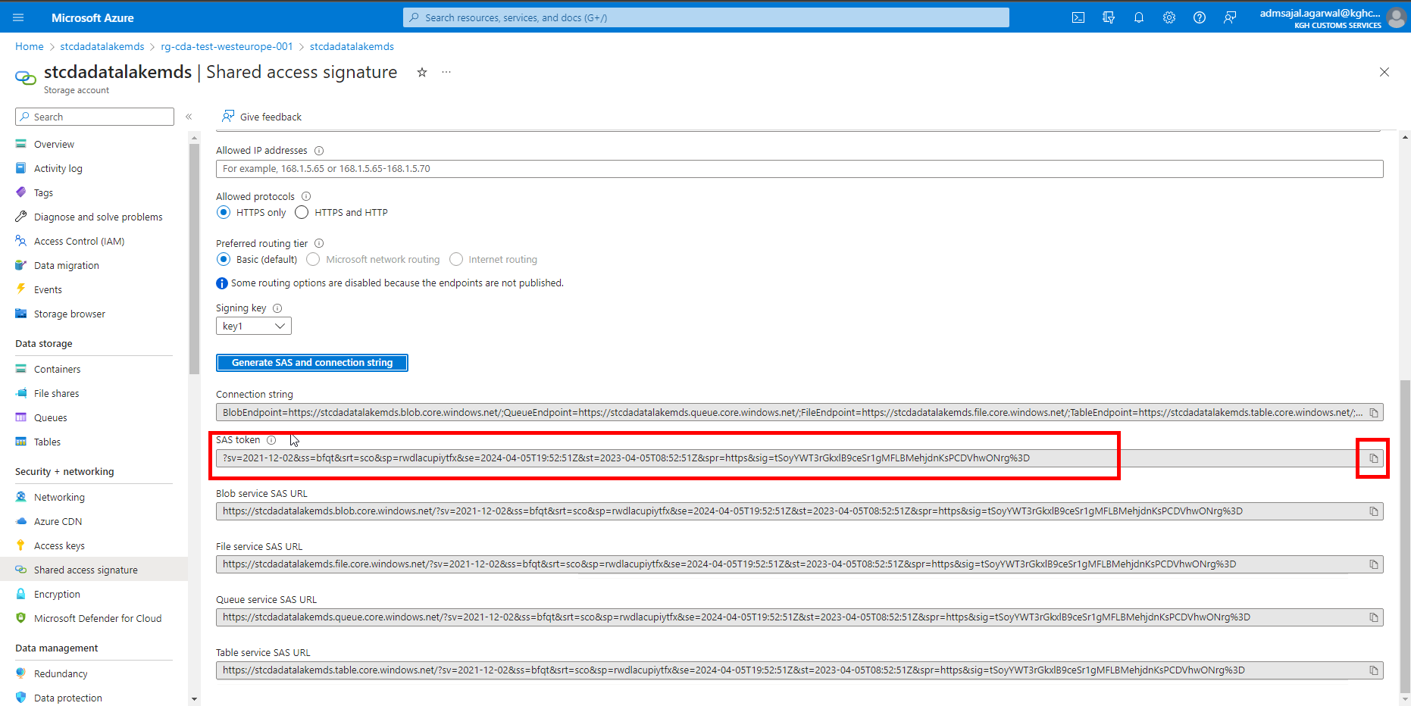

### **Backup: On-Premises SQL Server to Storage Account**

1. Login to on-premises server *SQLDWTEST2*
2. Open SQL Server Management Studio
3. Connect to *SQLDWTEST2* database
4. Run the below query with SAS token obtained in this section

-- Set the database for session

USE KGH_MDS

-- Create Credential to Blob Storage Account

CREATE CREDENTIAL [https://stcdadatalakemds.blob.core.windows.net/lrs-db-backup-kgh-mds]

WITH IDENTITY = 'SHARED ACCESS SIGNATURE',

SECRET = 'si=MDSReplicationPolicy01&spr=https&sv=2021-12-02&sr=c&sig=cld3rDkeW3opWcrvO7jMJc4MfyHwBKINWlqhUJ570YA%3D';

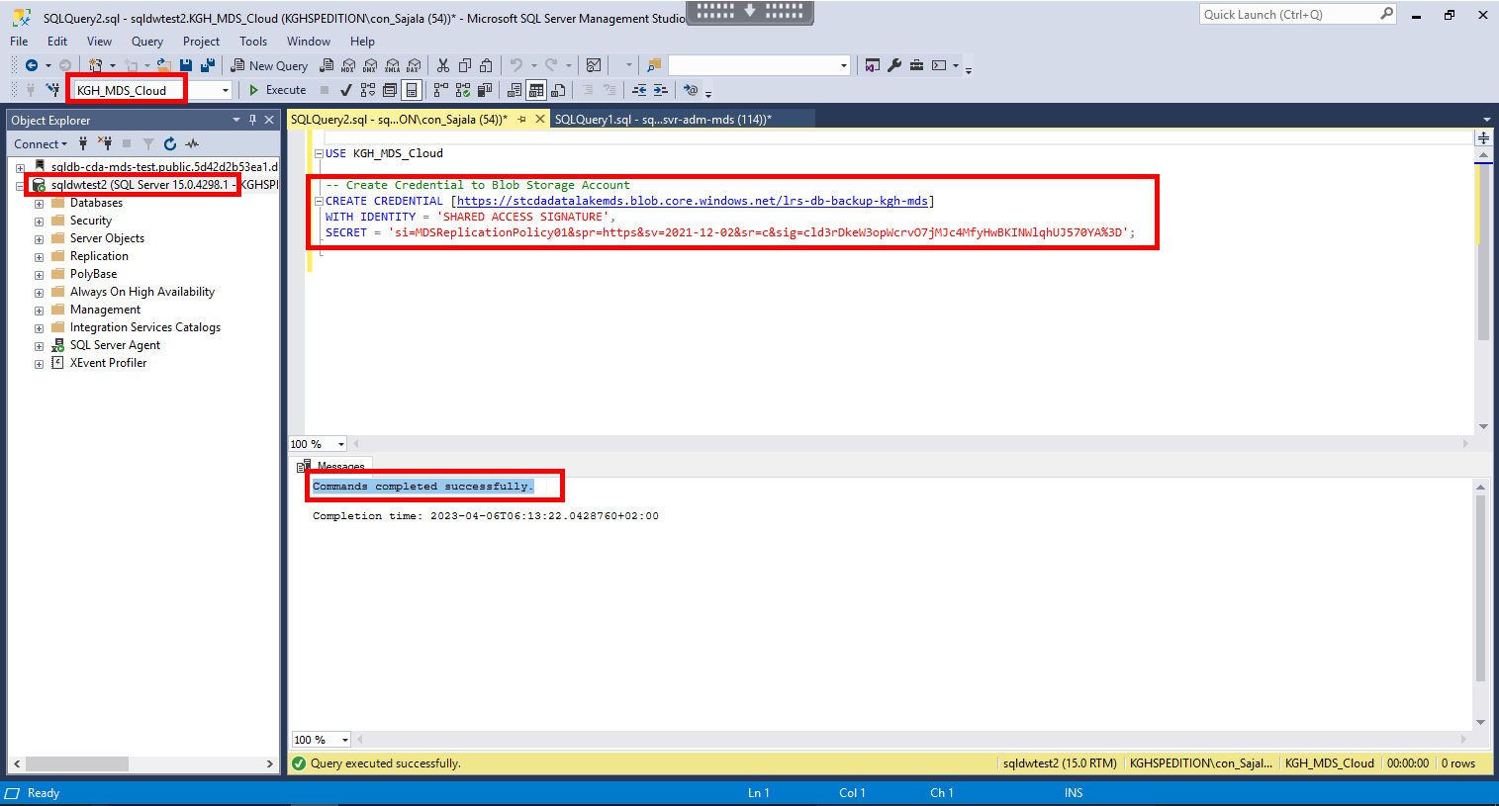

1. Run the below query:

-- Validate creation of credentials

SELECT * from sys.credentials;

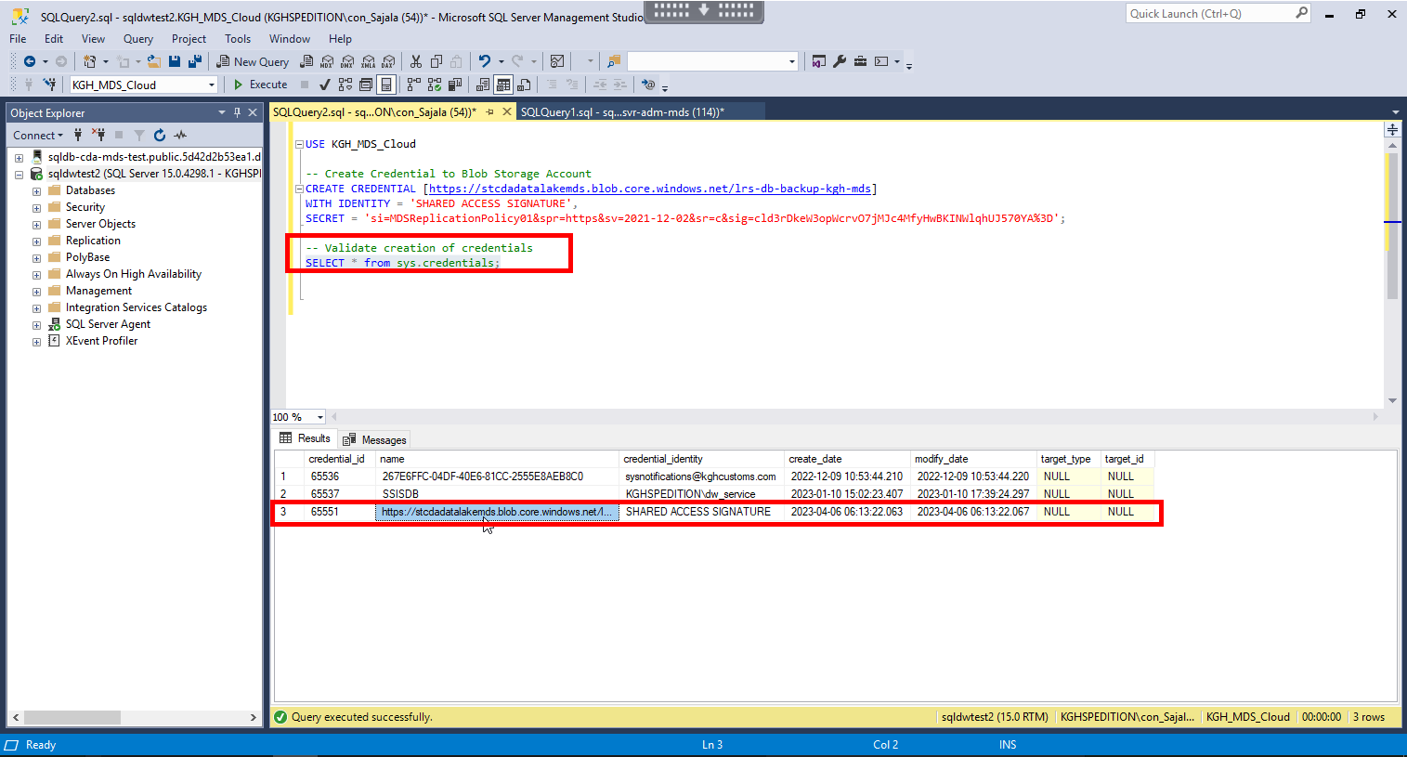

1. Run the below query:

-- Take the database backup and upload to Storage Account

BACKUP DATABASE [KGH_MDS_Cloud]

TO URL = 'https://stcdadatalakemds.blob.core.windows.net/lrs-db-backup-kgh-mds/KGH_MDS_Cloud/01_KGH_MDS_Cloud_Init_Backup_01.bak'

WITH INIT, COMPRESSION

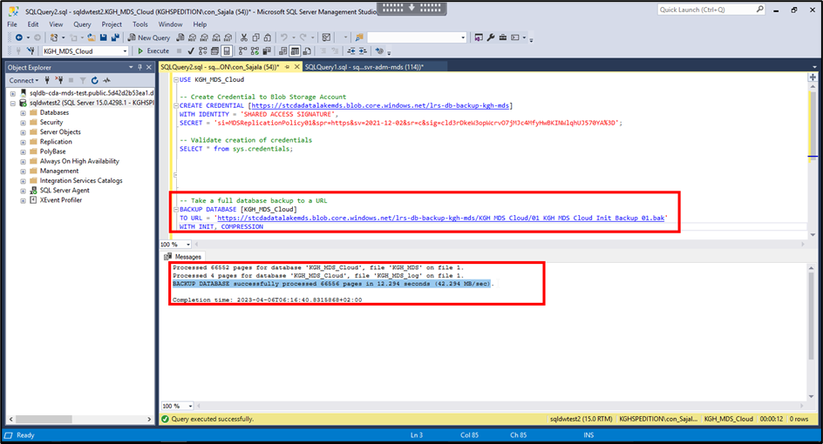

### **Restore: Storage Account to SQL Managed Instance**

#### **Option 1: SSMS**

1. Login to on-premises server *SQLDWTEST2*
2. Open SQL Server Management Studio
3. Connect to *SQL Managed Instance* database
4. Run the below query with SAS token obtained in this section

-- Set the database for session

USE master

-- Create Credential to Blob Storage Account

CREATE CREDENTIAL [https://stcdadatalakemds.blob.core.windows.net/lrs-db-backup-kgh-mds]

WITH IDENTITY = 'SHARED ACCESS SIGNATURE',

SECRET = 'si=MDSReplicationPolicy01&spr=https&sv=2021-12-02&sr=c&sig=cld3rDkeW3opWcrvO7jMJc4MfyHwBKINWlqhUJ570YA%3D';

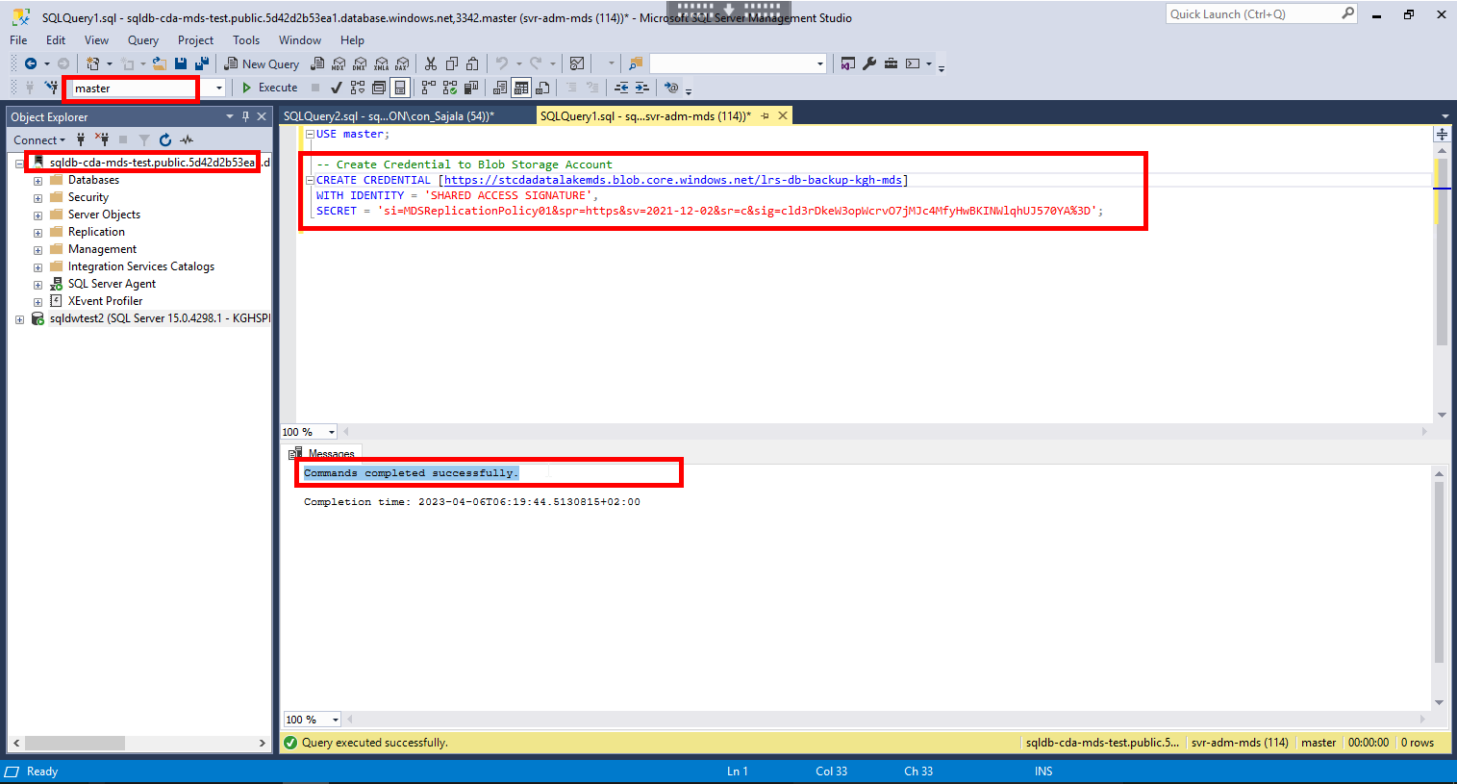

1. Run the below query:

-- Validate creation of credentials

SELECT * from sys.credentials;

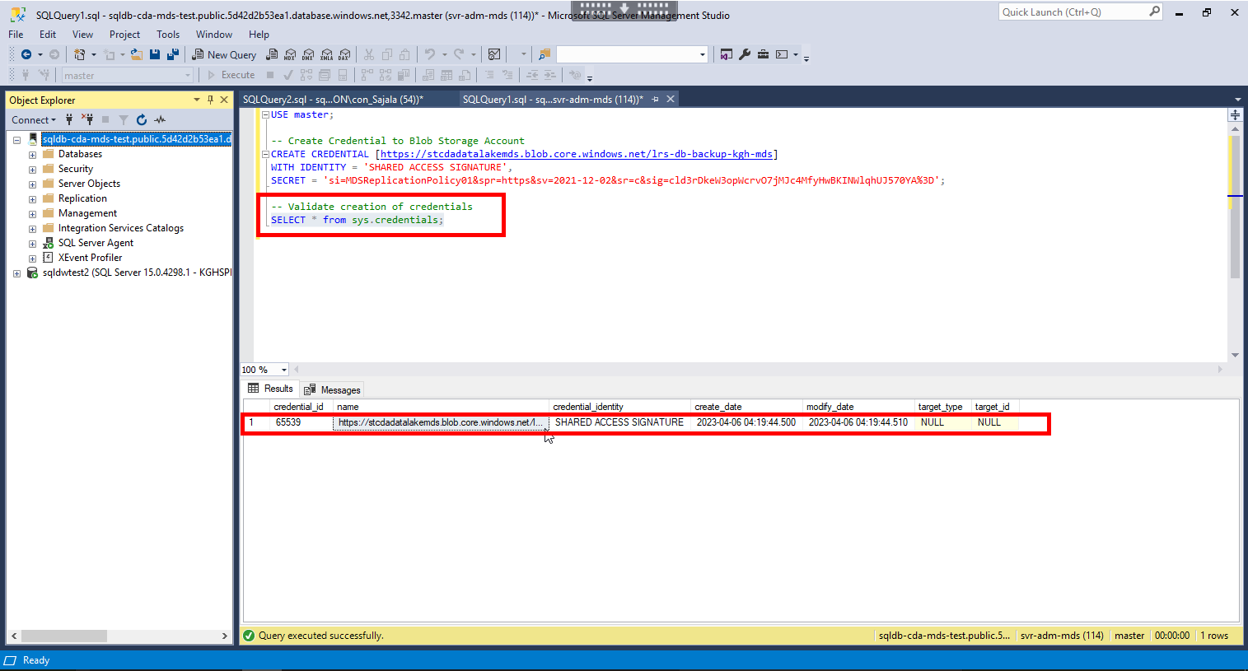

1. Run the below query:

-- Validate access to database backup file by just restoring the header

RESTORE HEADERONLY

FROM URL = 'https://stcdadatalakemds.blob.core.windows.net/lrs-db-backup-kgh-mds/01_Full_Backup.bak'

If data is returned, it means SQL Managed Instance is able to access Storage account and backup file on it.

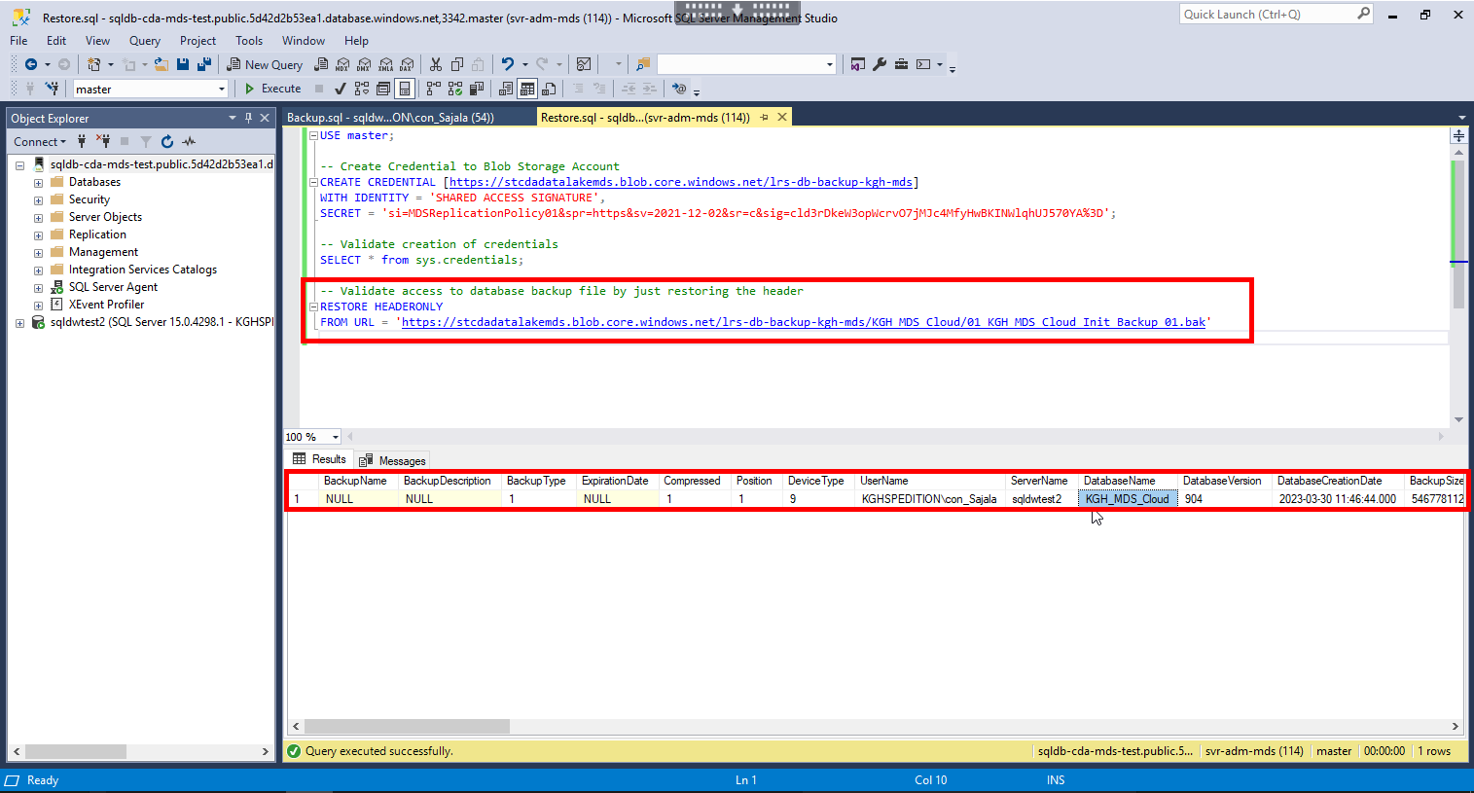

1. Run the below query:

-- Restore the database backup file

RESTORE DATABASE KGH_MDS

FROM URL = 'https://stcdadatalakemds.blob.core.windows.net/lrs-db-backup-kgh-mds/01_Full_Backup.bak'

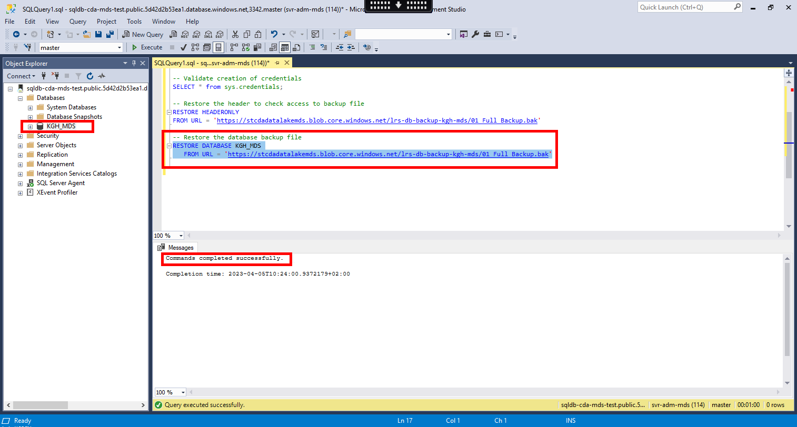

#### **Option 2: Powershell**

1. Run the below command:

# Login to Azure Account

Connect-AzAccount

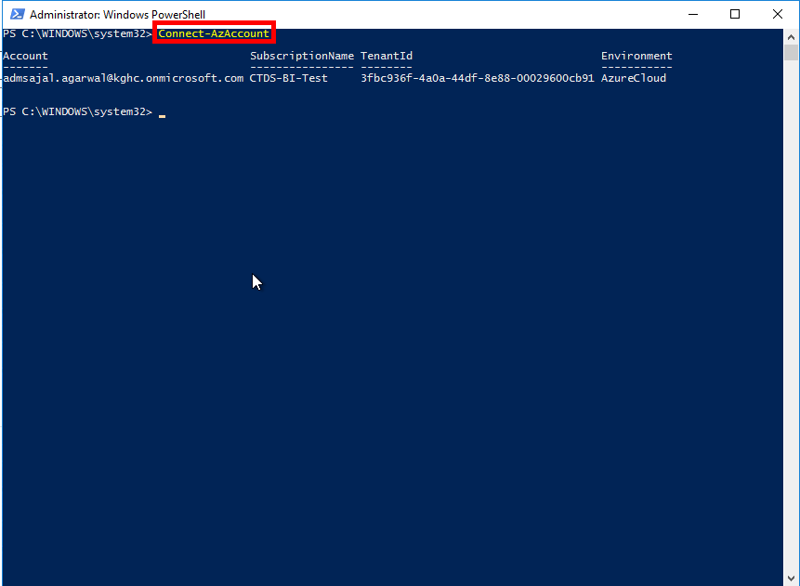

1. Run the below command:

# Select the Azure subcription

Set-AzContext -SubscriptionId d70fb837-dad9-43e7-91e0-614a62271ad9

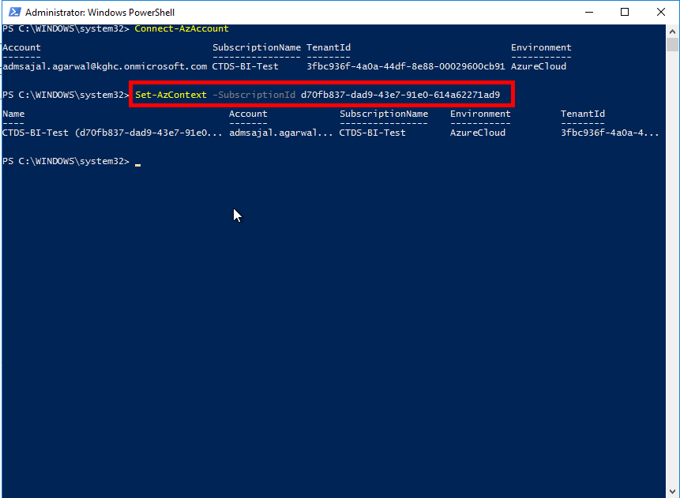

1. Run the below command:

# Start the Log Replay Server

Start-AzSqlInstanceDatabaseLogReplay -ResourceGroupName "rg-cda-test-westeurope-001" `

-InstanceName "sqldb-cda-mds-test" `

-Name "KGH_MDS" `

-Collation "Finnish_Swedish_CI_AS" -StorageContainerUri "https://stcdadatalakemds.blob.core.windows.net/lrs-db-backup-kgh-mds" `

-StorageContainerSasToken " ?sv=2021-12-02&ss=bfqt&srt=sco&sp=rwdlacupiytfx&se=2024-06-03T19:52:51Z&st=2023-04-05T08:52:51Z&spr=https&sig=GyL1jHi1wLNWh2YiM%2BZ4z5%2B2%2FXbfmaKv%2Fq9%2F5qfuAXo%3D"

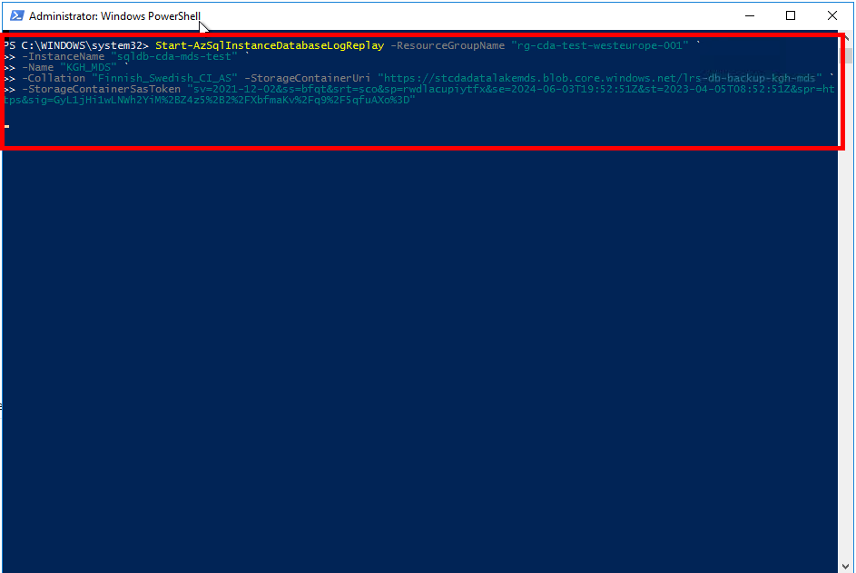

## **Database Migration: PowerShell**

Approach 1:

$sqlConn = New-Object System.Data.SqlClient.SqlConnection

$sqlConn.ConnectionString = “Server=sql-mi-cda-test.public.9bcf11f32162.database.windows.net,3342;Integrated Security=true;Initial Catalog=master”

Approach 2:

$sqlConn.ConnectionString = “Server=tcp:sql-mi-cda-test.public.9bcf11f32162.database.windows.net,3342;Persist Security Info=False;User ID= svr-adm-mds;Password=@dminmdm$erver2023;MultipleActiveResultSets=False;Encrypt=True;TrustServerCertificate=False”

$sqlConn.Open()

Approach 3:

$sqlConn.ConnectionString = “Server=SQLDWTEST2;Database=KGH_MDS;Integrated Security=True”

# Set TLS to 1.2

[Net.ServicePointManager]::SecurityProtocol = [Net.SecurityProtocolType]::Tls12

Approach 4:

$connString="Data Source=SQLDWTEST2;Database=KGH_MDS;Integrated Security=True"

#Create a SQL connection object

$conn = New-Object System.Data.SqlClient.SqlConnection $connString

#Attempt to open the connection

$conn.Open()

$Query = 'SELECT * FROM sys.sysdatabases'

Approach 5:

Invoke-Sqlcmd -ConnectionString "Data Source=$SqlServer;Initial Catalog=$Database;Integrated Security=True;TrustServerCertificate=true" -Query "$Query" | Format-Table

Approach 6:

Invoke-Sqlcmd -ConnectionString "Data Source=$SqlServer;Initial Catalog=$Database;Integrated Security=True;TrustServerCertificate=true" -InputFile "C:\Scripts\Backup.sql" | Out-File -FilePath "C:\Scripts\Backup_Ouput.rpt"

$filename = Invoke-Sqlcmd -ConnectionString "Data Source=$SqlServer;Initial Catalog=$Database;Integrated Security=True;TrustServerCertificate=true" -Query "$Query" -AS DataSet

$file = $filename.Tables[0].Rows | %{ echo "$($_['backup_filename'])" }

echo $file

$connString2="Data Source=sql-mi-cda-test.public.9bcf11f32162.database.windows.net,3342;Database=KGH_MDS;User ID= svr-adm-mds;Password=@dminmdm$erver2023;TrustServerCertificate=False"

$conn2 = New-Object System.Data.SqlClient.SqlConnection $connString2

$conn2.Open()

$Query = 'SELECT * FROM sys.sysdatabases'

Invoke-Sqlcmd -ConnectionString $connString2 -Query "$Query"

*Approach 7:

# Set TLS to 1.2

[Net.ServicePointManager]::SecurityProtocol = [Net.SecurityProtocolType]::Tls12

# Provide the source server name

$source_SqlServer = "SQLDWTEST2"

# Provide the source database name

$source_Database = "master"

# Provide the query to execute

$Query = "BEGIN

DECLARE

@return_value AS varchar(50)

EXEC @return_value = dbo.backup_db_test01

IF @return_value = 0

BEGIN

PRINT 'Return Value: ' + @return_value + '; Database backup uploaded to Azure Blob Storage successfully.'

END

ELSE IF @return_value <> 0

BEGIN

PRINT 'Return Value: ' + @return_value + '; ERROR: Database backup upload process failed.'

END

END

GO"

# Execute the query

$backup_output = Invoke-Sqlcmd -ConnectionString "Data Source=$source_SqlServer;Initial Catalog=$source_Database;Integrated Security=True;TrustServerCertificate=true" -Query "$Query" -AS DataSet

# Retrieve the name of generated backup file

$backup_filename = $backup_output.Tables[0].Rows | %{ echo "$($_['backup_filename'])" }

# Display the name of generated backup file

echo $backup_filename

pause

$dest_SqlServer = "sql-mi-cda-test.public.9bcf11f32162.database.windows.net,3342"

$dest_Database = "master"

$dest_Query = 'SELECT * FROM sys.sysdatabases'

# Invoke-Sqlcmd -ConnectionString "Data Source=$dest_SqlServer;Initial Catalog=$dest_Database;User=svr-adm-mds;Password=@dminmdm$erver2023" -Query "$Query" | Format-Table

Invoke-Sqlcmd -ConnectionString "Data Source=$dest_SqlServer;Initial Catalog=$dest_Database;User=svr-adm-mds;Password=@dminmdm$erver2023;Connection Timeout=60" -Query "$dest_Query" | Format-Table

Invoke-Sqlcmd -ServerInstance $dest_SqlServer -Database $dest_Database -Query $dest_Query -Username "svr-adm-mds" -Password "@dminmdm$erver2023" -ConnectionTimeout 60

# **Resource Creation: Log Analytics Workspace**

1. Open *Resource Groups* and search for *rg-cda-test-westeurope-001*

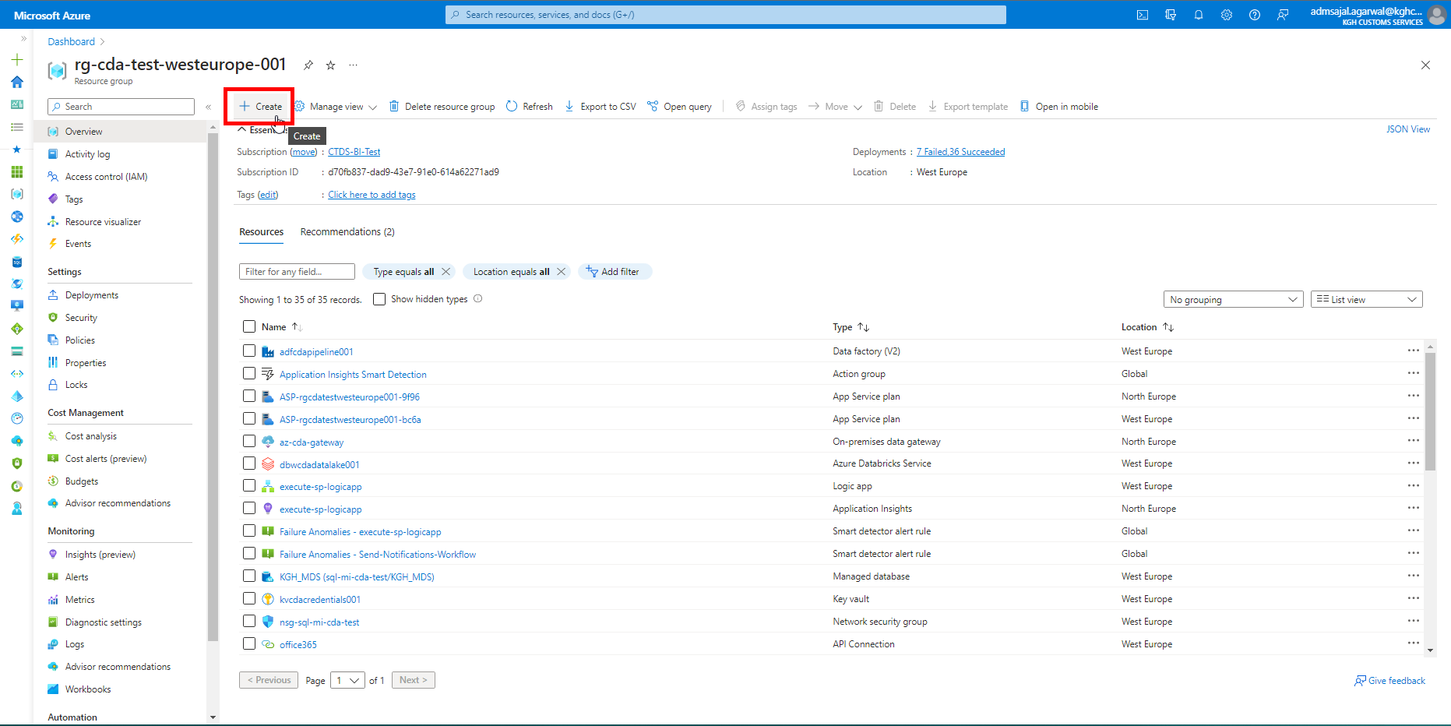

1. Below screen will appear:

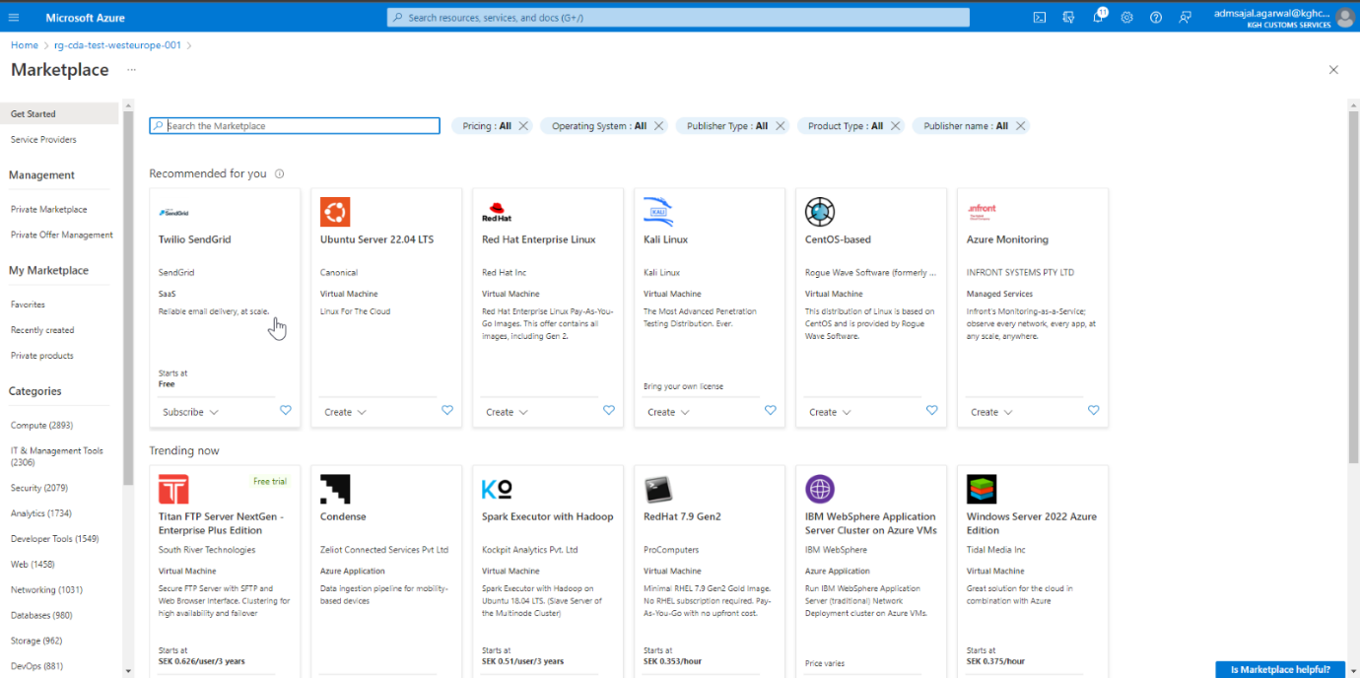

1. Search for *log analytics workspace*

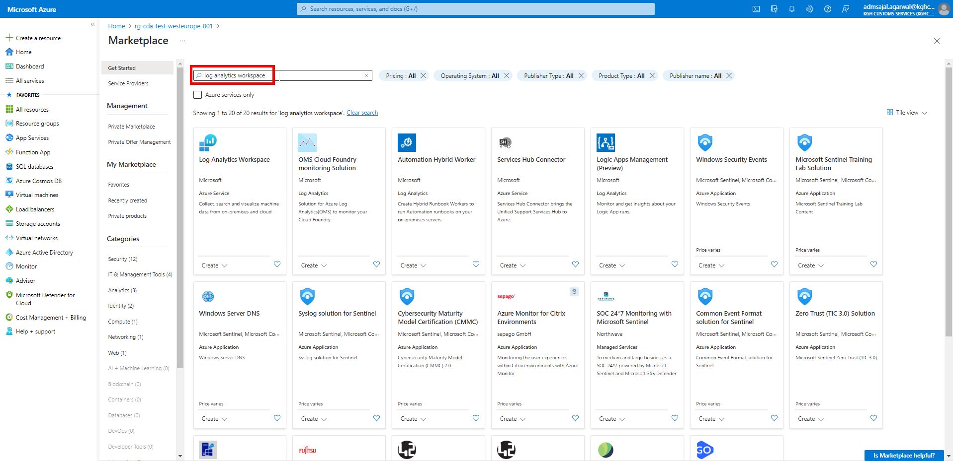

1. Click on *Create* 🡪 *Log Analytics Workspace* in *Log Analytics Workspace* tile

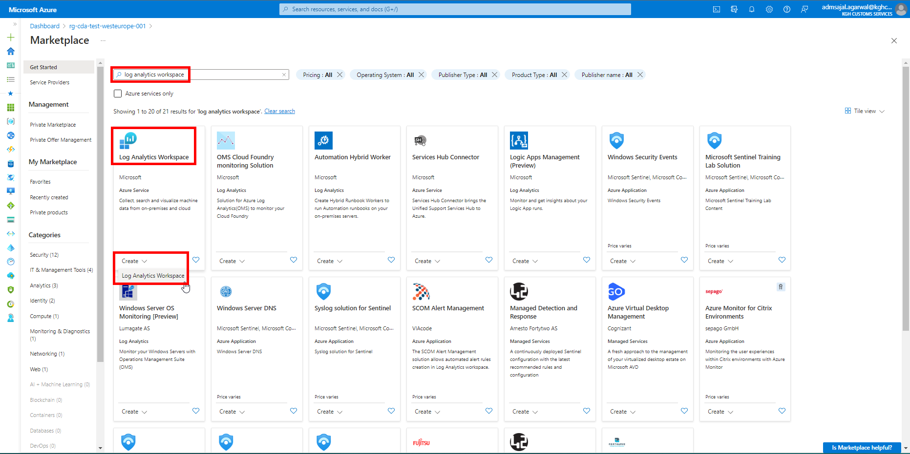

1. Fill the details as below:

Subscription: *CTDS-BI-Test*

Resource Group: *rg-cda-test-westeurope-001*

Name: *log-cda-test-wkspc*

Region: *West Europe*

Click on *Next: Tags*

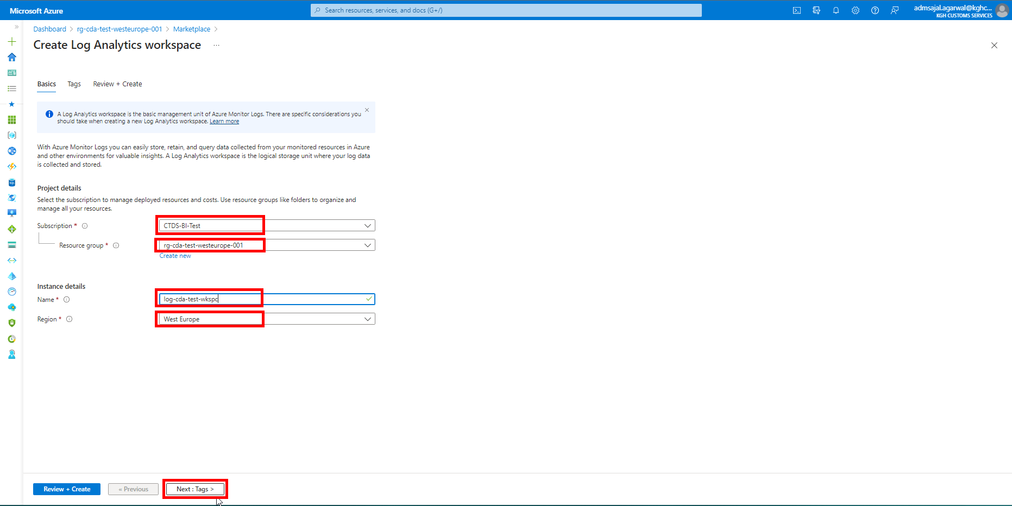

1. Add the tags as shown below:

application à *cda*

owner à *KGH BI Team*

environment à *test*

Click on *Review + Create*

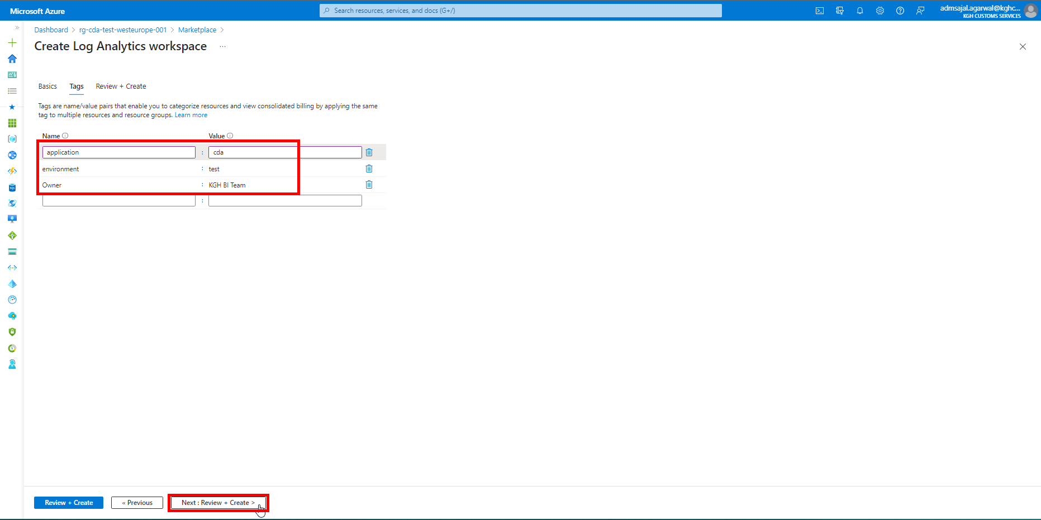

1. Wait for the *Validation* to complete and *Create* button to be enabled.

Click on *Create*.

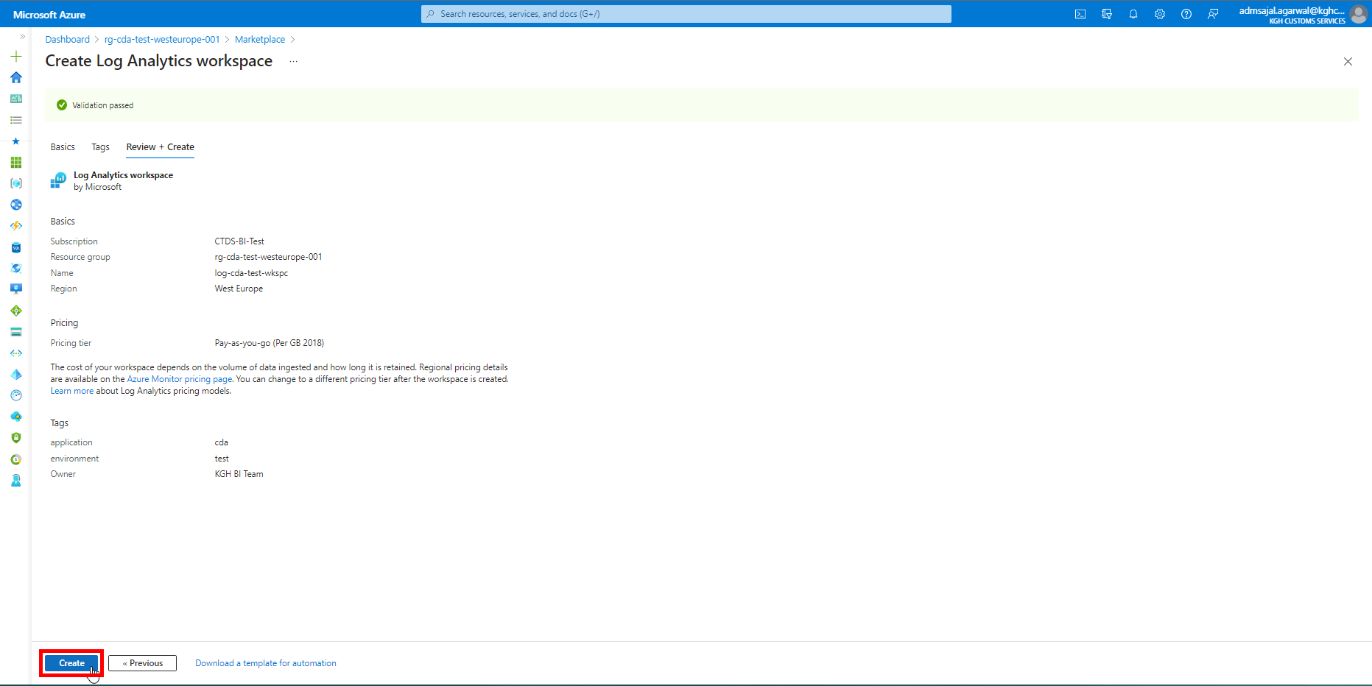

1. It will initialize the deployment of the resource.

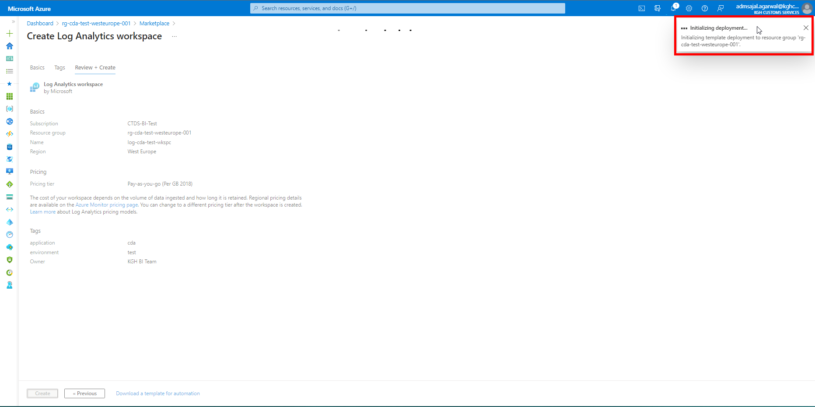

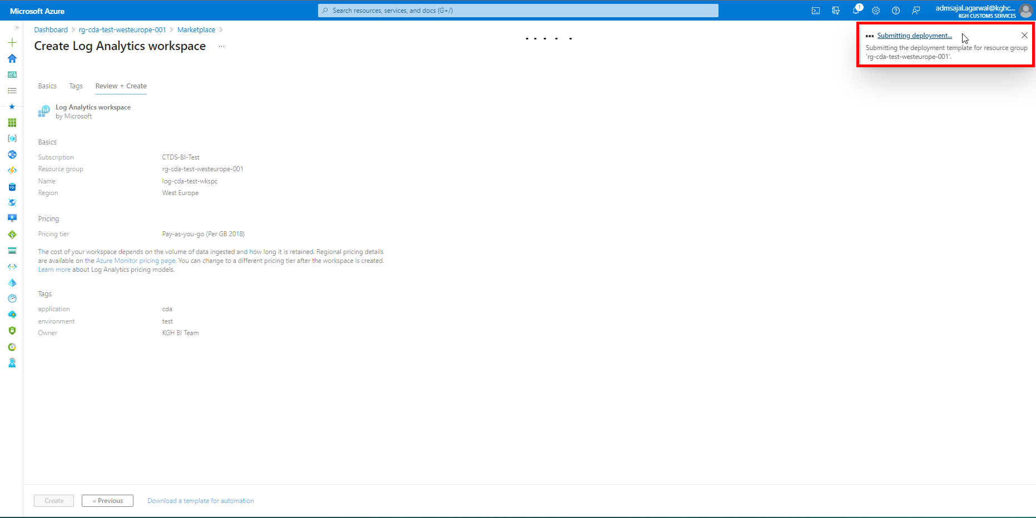

1. It will auto-redirect to deployment screen.

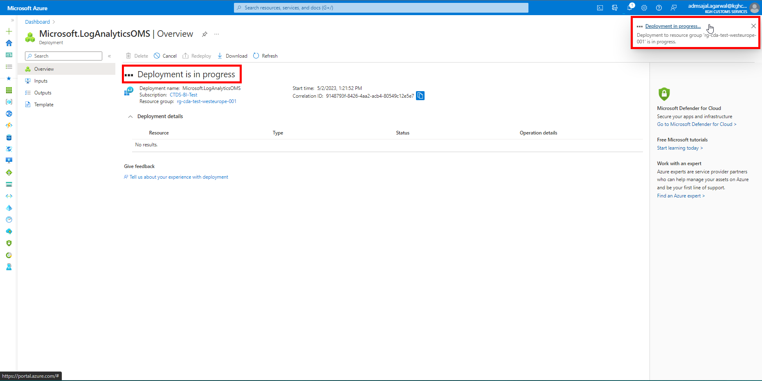

1. When the message changes to *Your deployment is complete*, click on *Go to resource*.

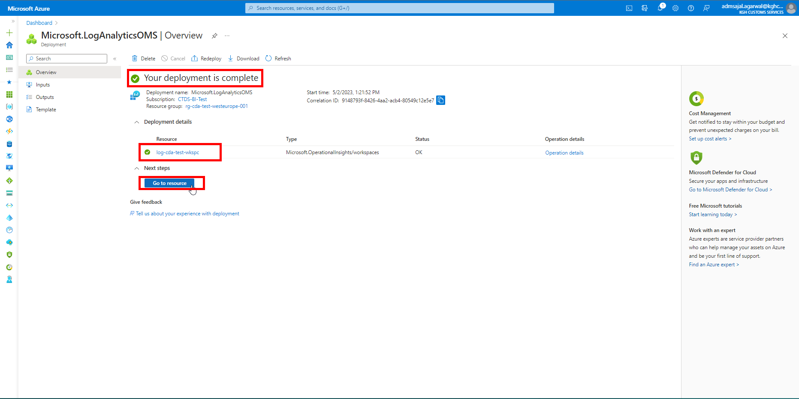

1. It will take to *Overview* page of created resource.

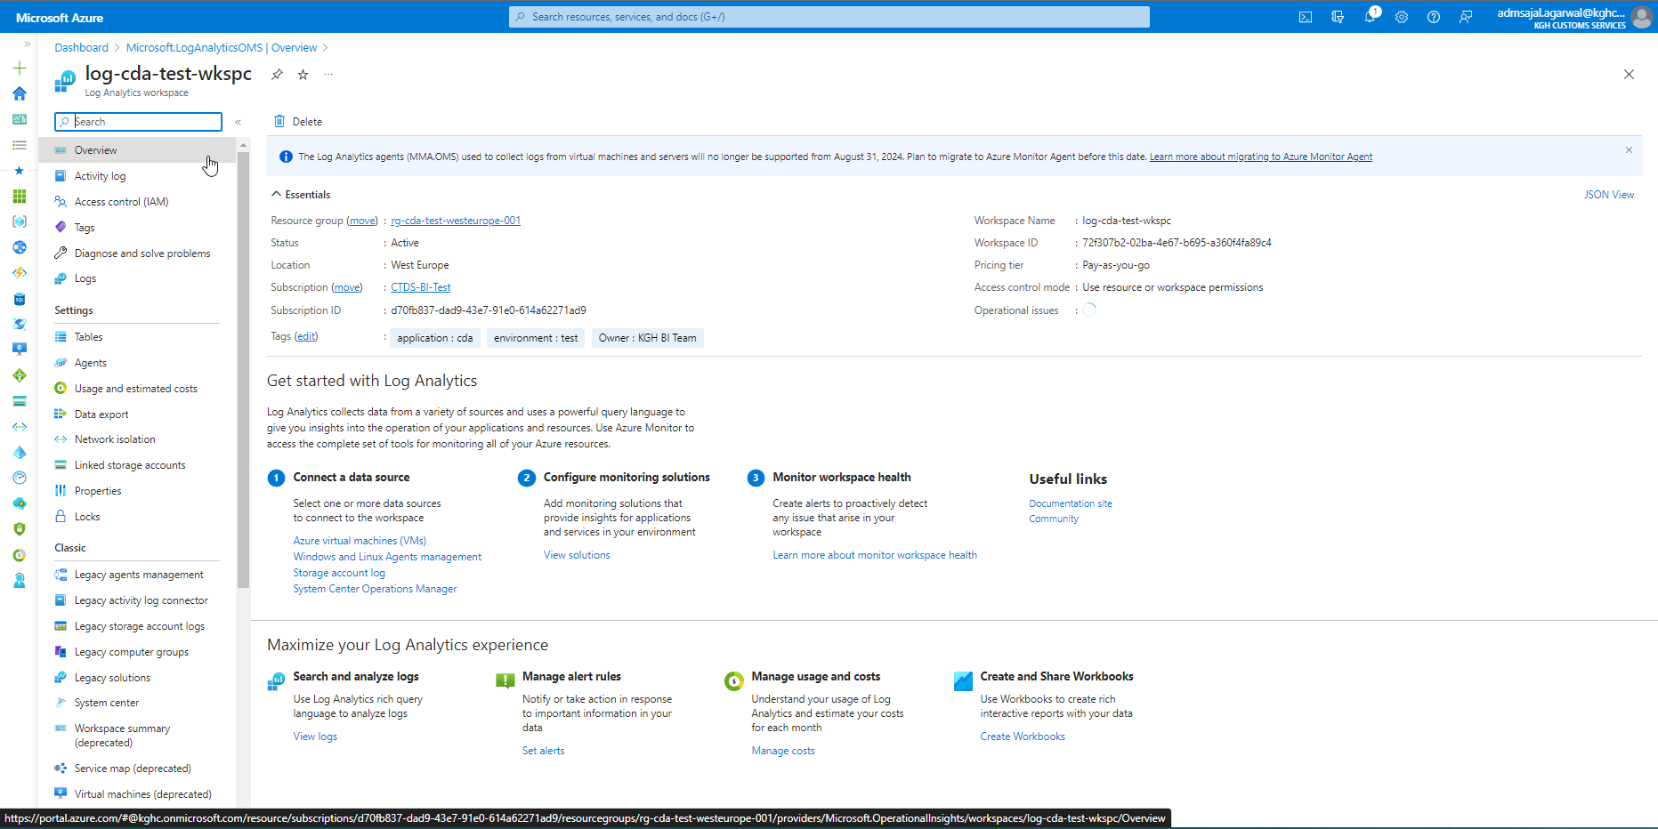

# **CI/CD Configuration – GitHub**

GitHub Link: <https://github.com/>

Owner/Organization Name: Maersk-Global

Owner/Organization Link: [Maersk-Global (github.com)](https://github.com/Maersk-Global)

Repository Name: [cda](https://github.com/Maersk-Global/cda)

Repository Link: [Maersk-Global/cda (github.com)](https://github.com/Maersk-Global/cda)

Master Branch: main

Review Branch: dev

Working Branch: <feature>

Git Branch Hierarchy Structure:

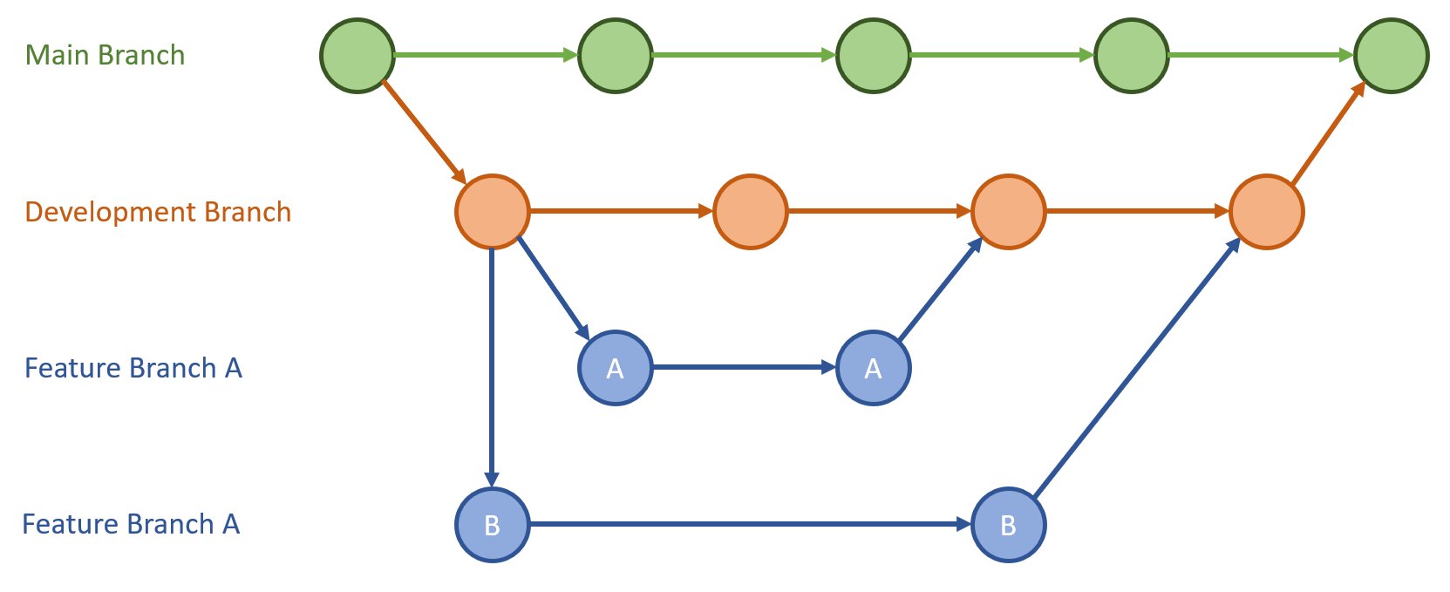

Reference Links:

* [Continuous integration and delivery - Azure Data Factory | Microsoft Learn](https://learn.microsoft.com/en-us/azure/data-factory/continuous-integration-delivery)
* [Source control - Azure Data Factory | Microsoft Learn](https://learn.microsoft.com/en-us/azure/data-factory/source-control)
* [What is CI/CD on Azure Databricks? - Azure Databricks | Microsoft Learn](https://learn.microsoft.com/en-us/azure/databricks/dev-tools/index-ci-cd)
* [CI/CD techniques with Git and Databricks Repos - Azure Databricks | Microsoft Learn](https://learn.microsoft.com/en-us/azure/databricks/repos/ci-cd-techniques-with-repos)
* [What is Azure Pipelines? - Azure Pipelines | Microsoft Learn](https://learn.microsoft.com/en-us/azure/devops/pipelines/get-started/what-is-azure-pipelines?view=azure-devops)

## **Data Factory: Git Configuration**

1. Open Azure Data Factory resource.

Click on *Manage*.

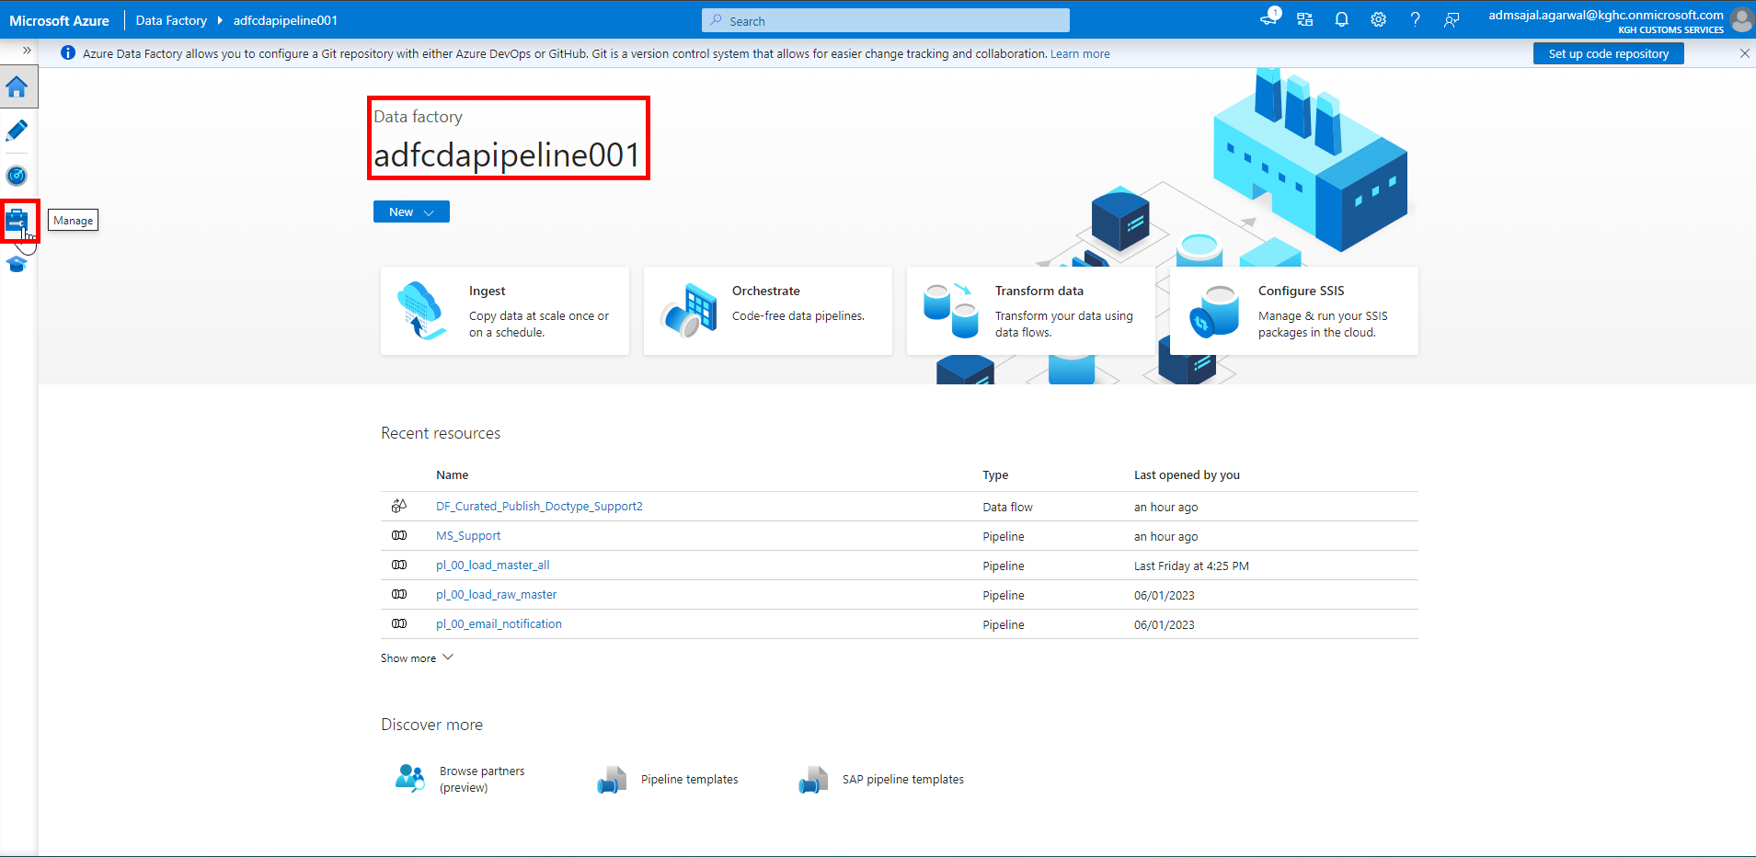

1. Click on *Git configuration* under *Source control*.

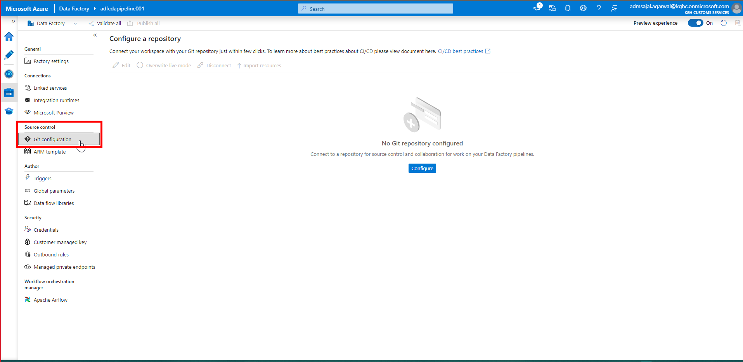

1. Click on *Configure*.

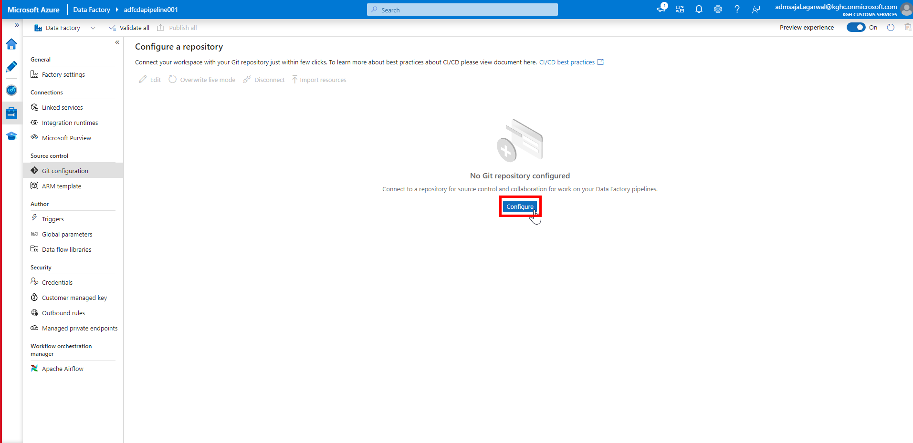

1. Fill the details as below:

Repository type à *GitHub*

GitHub repository owner à *Maersk-Global (Enter repository owner name)*

Click on *Continue*.

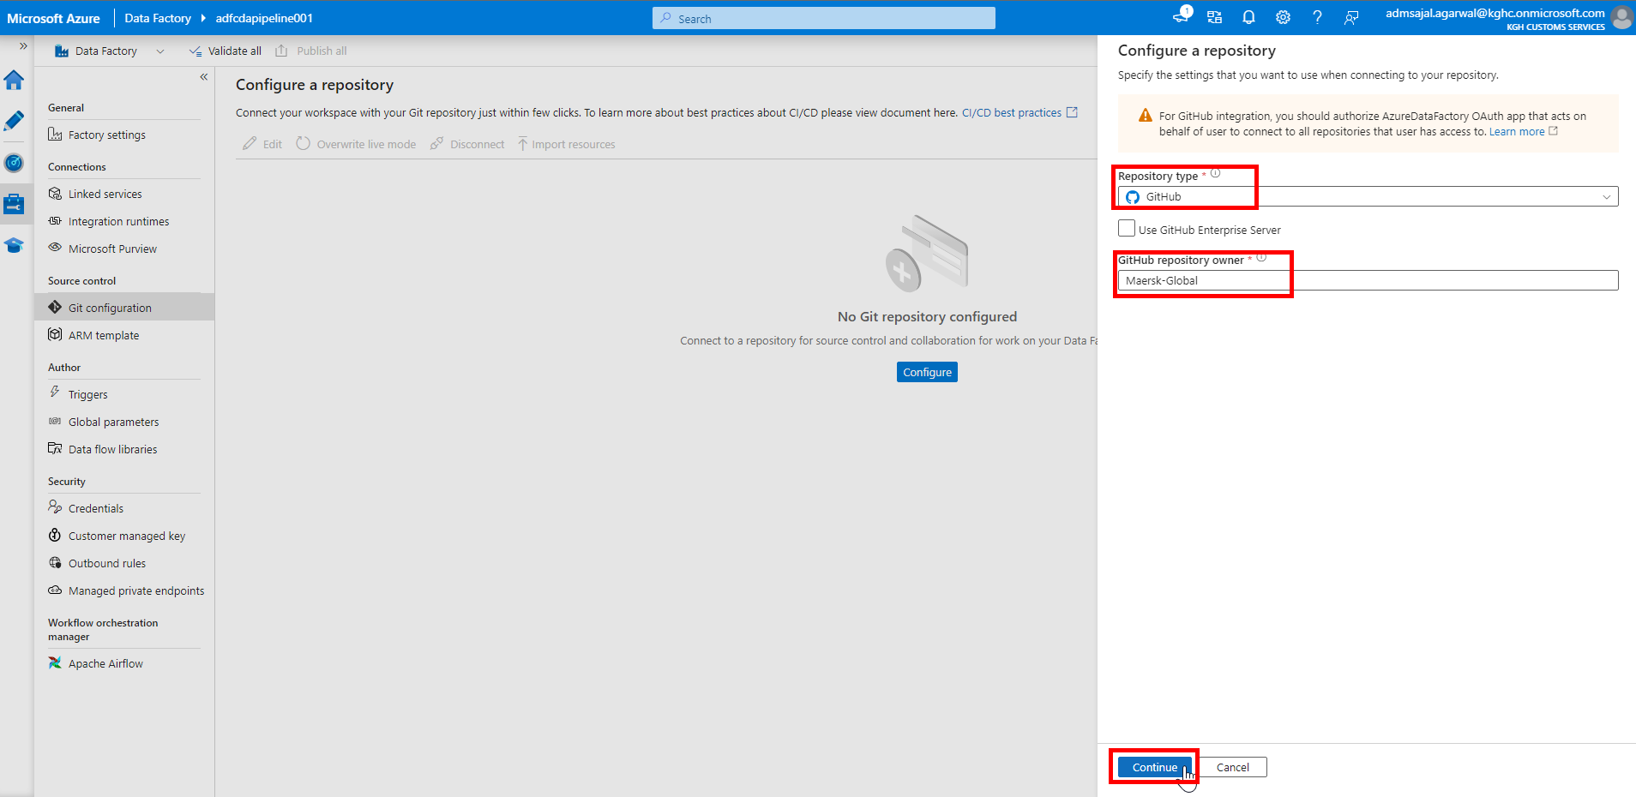

1. Authorize Azure Data Factory to access Git repository.

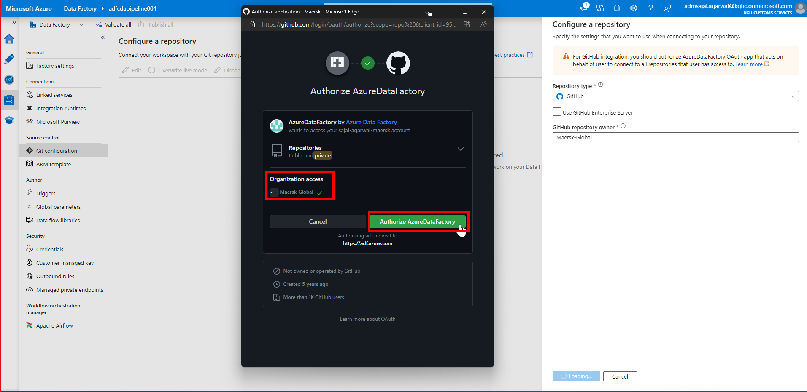

Enter Git credentials if asked for.

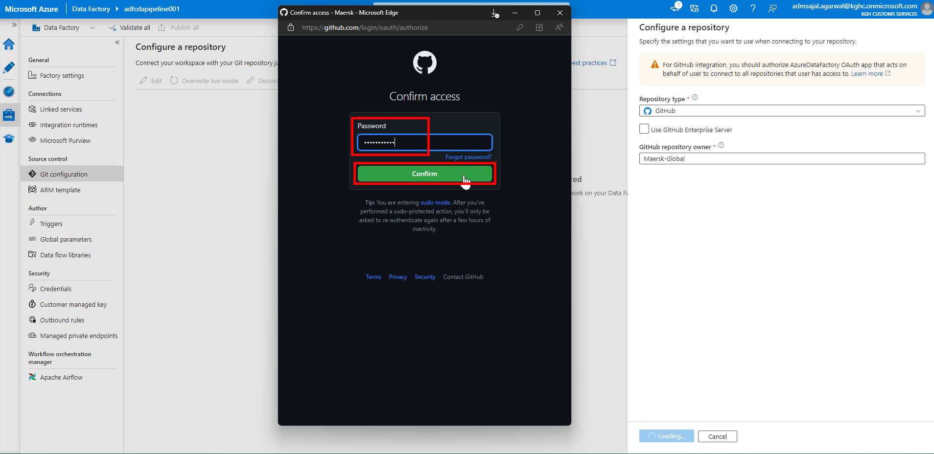

1. An email will be triggered as below:

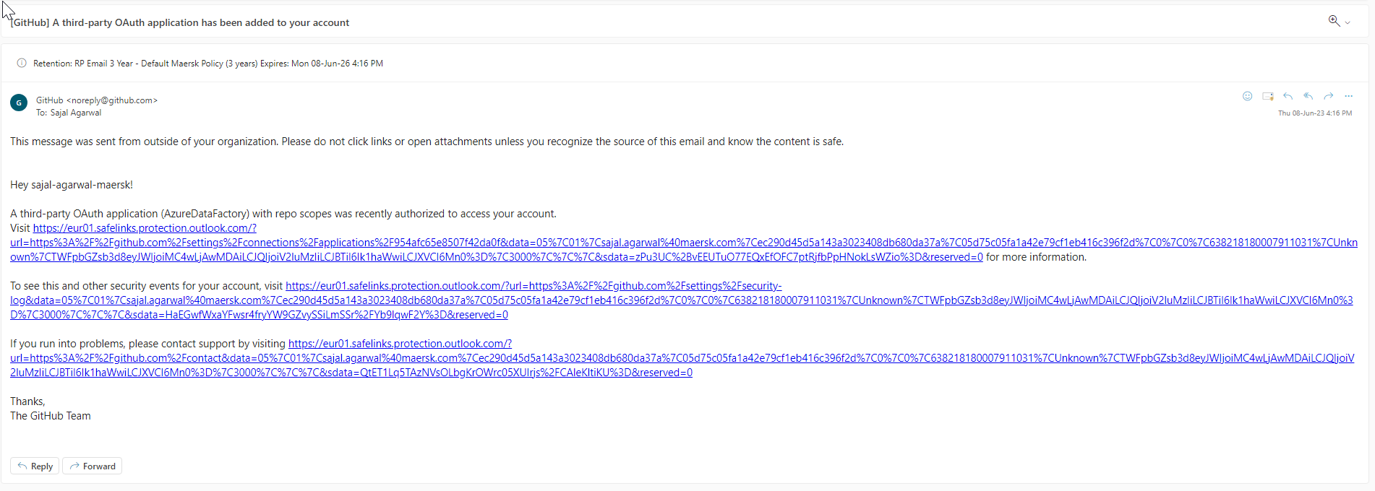

1. Fill the details as below:

Select *Select Repository*

Repository name: *cda*

Collaboration branch: *main*

Publish branch: *adf_publish*

Root folder: */solution/DataFactory/ADF/adfcdapipeline001/*

Custom comment:Tick-mark on *Use custom comment*

Import existing resources*:* Tick-mark on *Import existing resources to repository*

Import resource into this branch: *main*

Click on *Apply*.

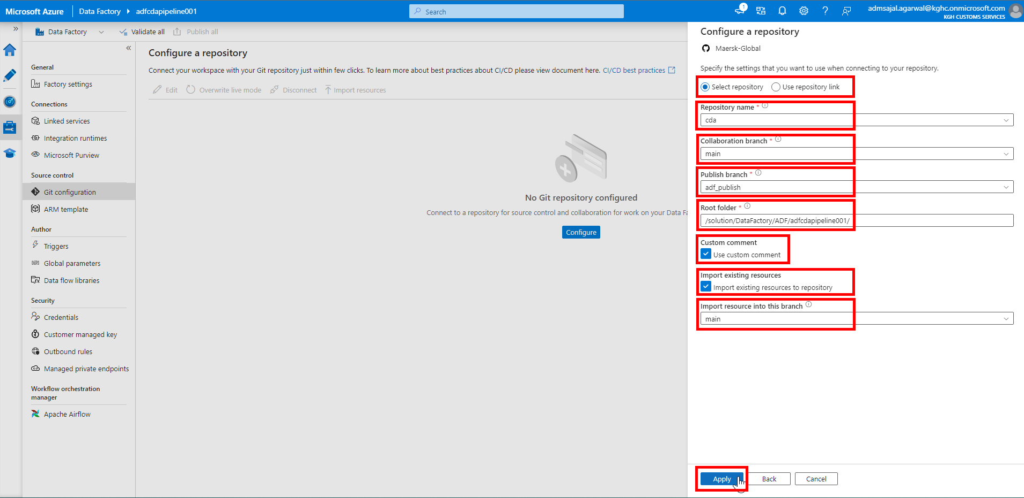

1. It will start applying the changes.

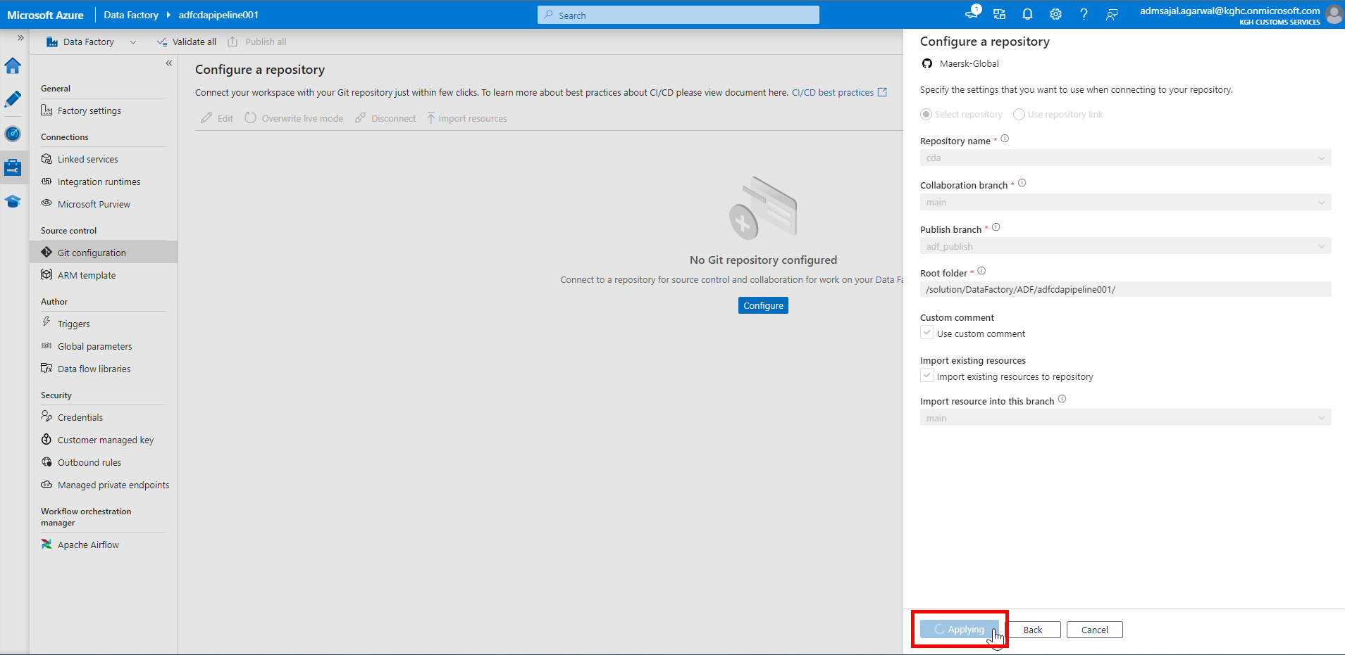

1. It will show notification as *Repo Connected* after the Git repository is connected to Azure Data Factory.

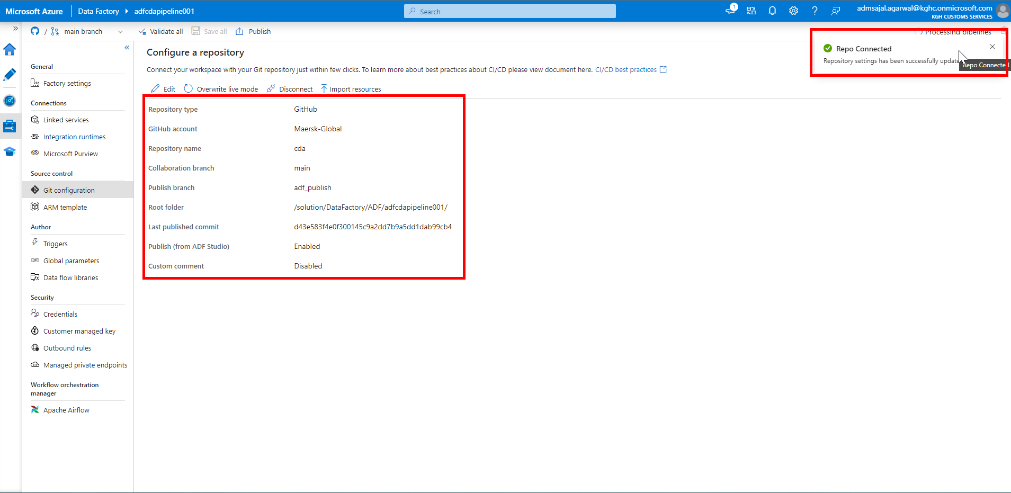

1. Login to Git Repository.

Navigate to *cda 🡪 solution 🡪 DataFactory 🡪 ADF 🡪 adfcdapipeline001*

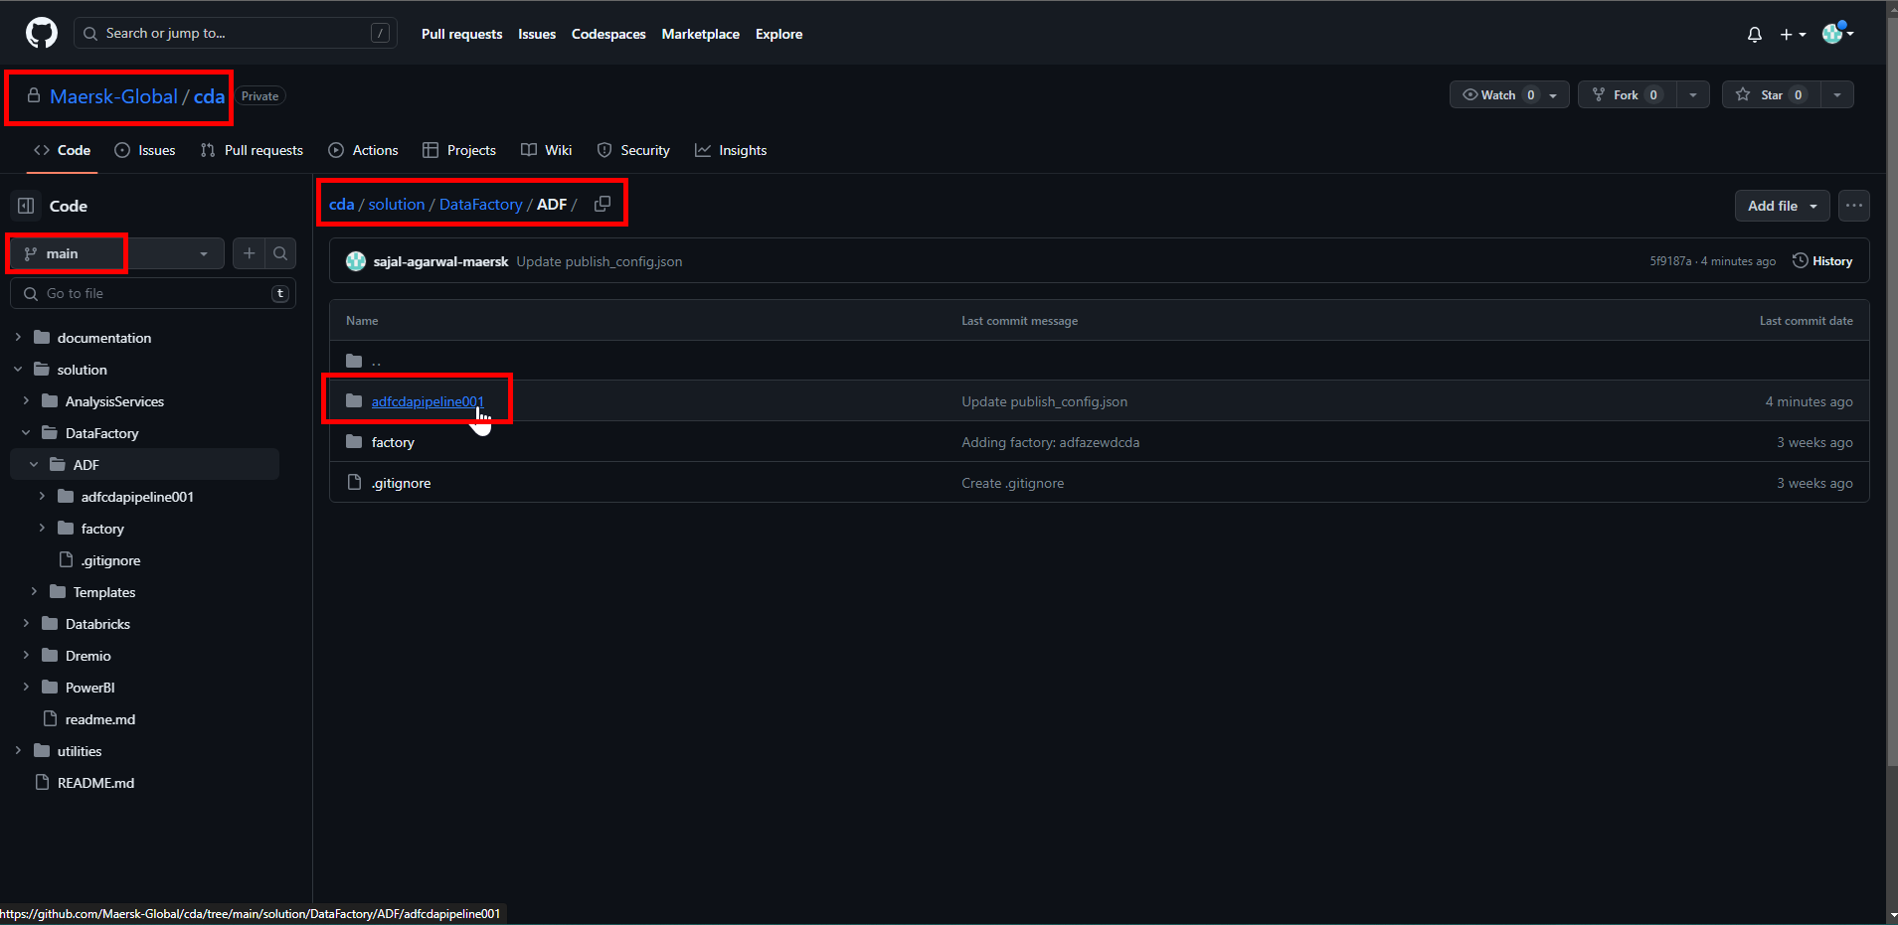

1. Verify that all ADF objects are uploaded and available in Git.

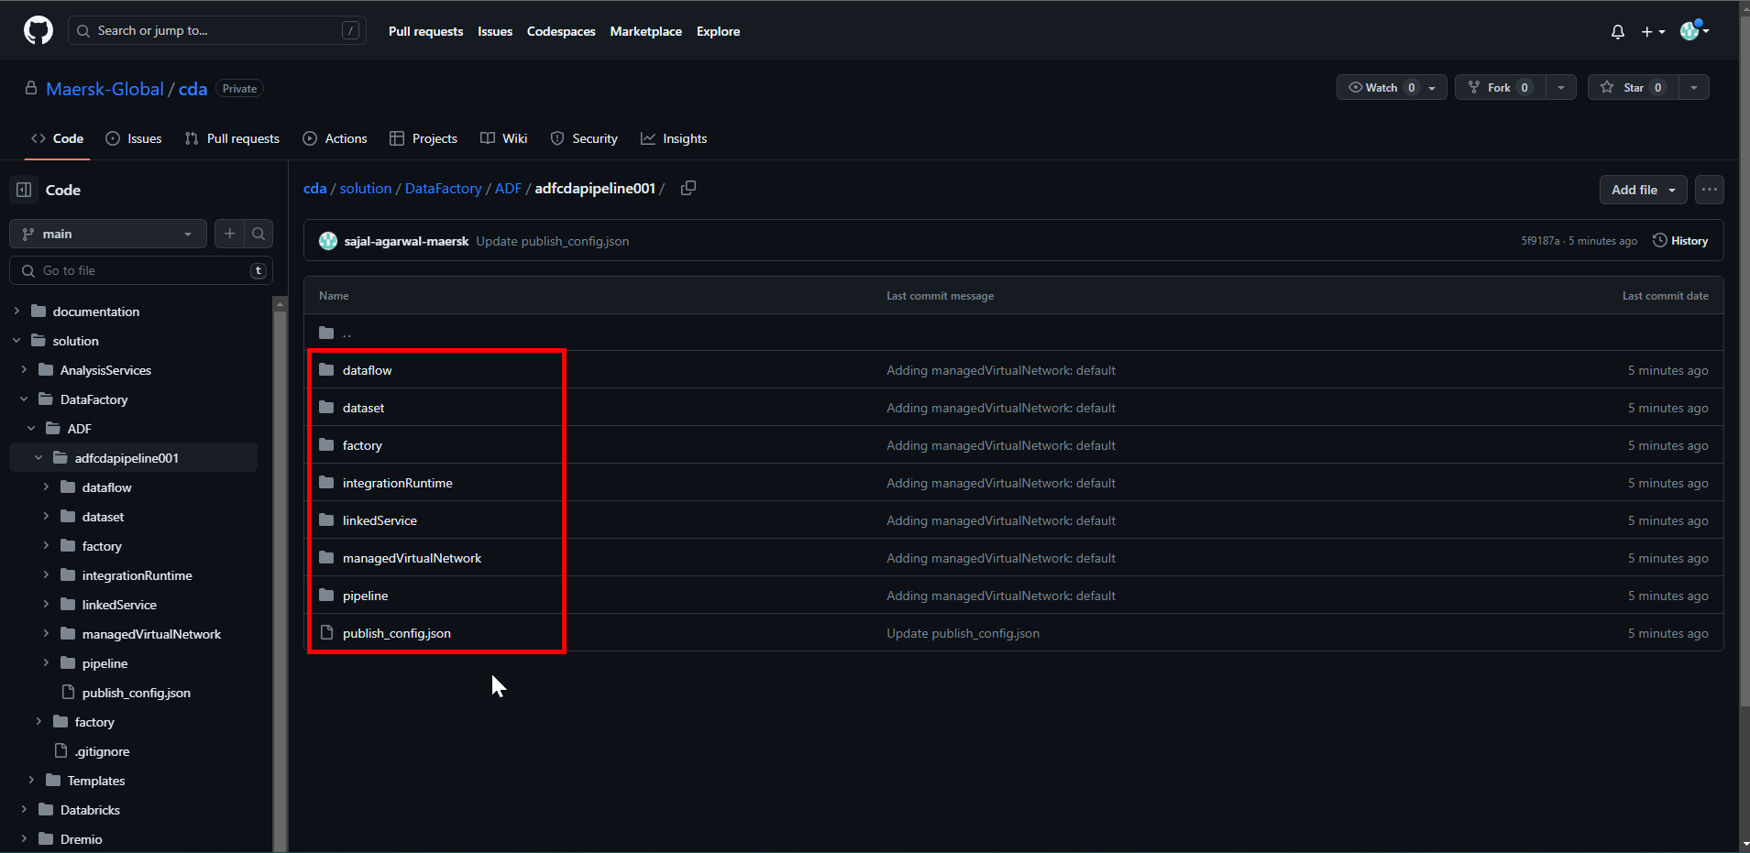

1. In ADF, it should start showing Git menu at top right corner.

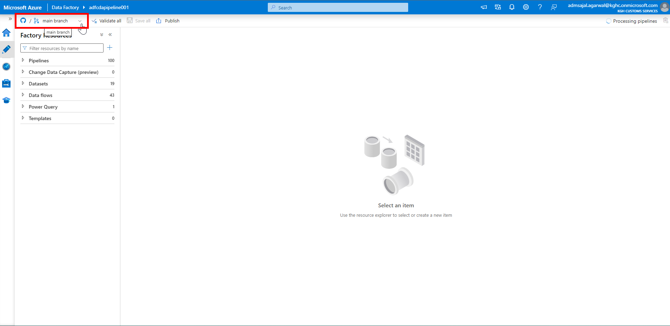

1. If it asks to *Set working branch*, then fill the details as below:

Working branch: *Use existing*

Name: *main*

Click on *Save*.

1. [This is only needed 1-time during first-time setup]

Create a *Pull Request* from *dev* branch to *main* branch and merge the branch.

1. Click on drop down in front of *main branch:*

Click on *New branch*.

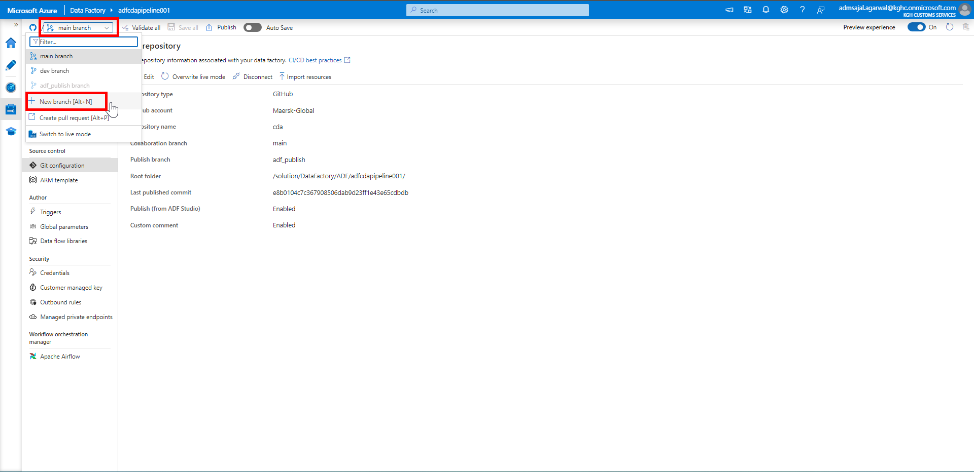

Fill the details as below:

Branch name: *feature_test01* (give any meaningful name as per feature/user/etc)

Base on: *dev branch*

Click on *Create*.

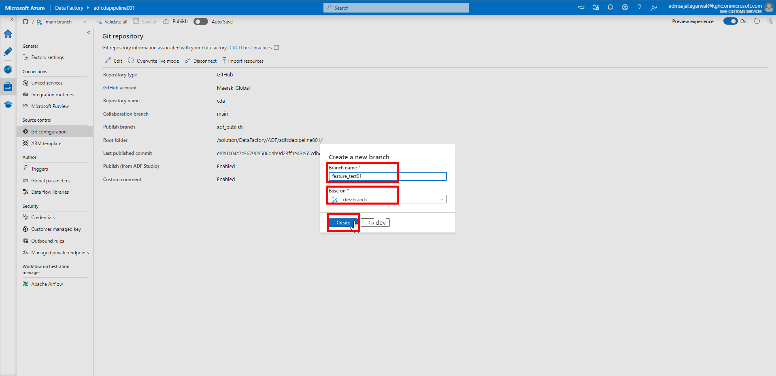

1. Login to Git Repository. Open below link:

[Branches · Maersk-Global/cda (github.com)](https://github.com/Maersk-Global/cda/branches)

Verify that newly created branch is displayed.

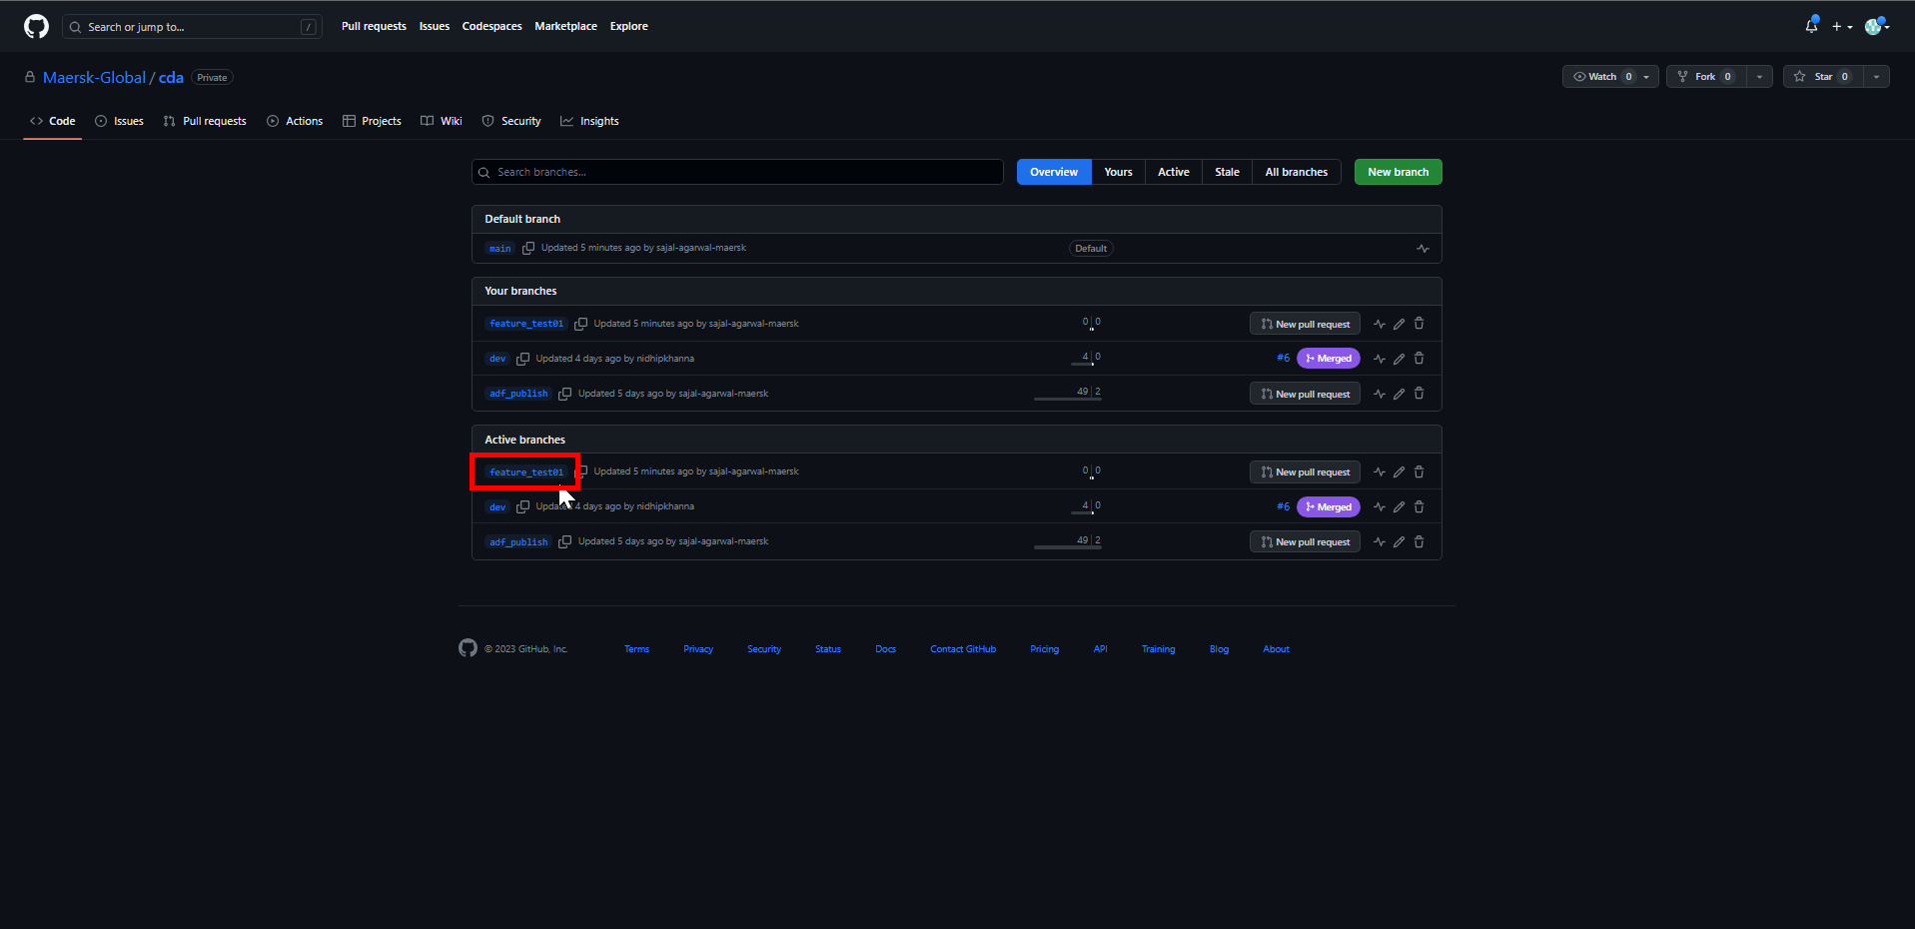

## **Data Factory: Continuous Integration (CI)**

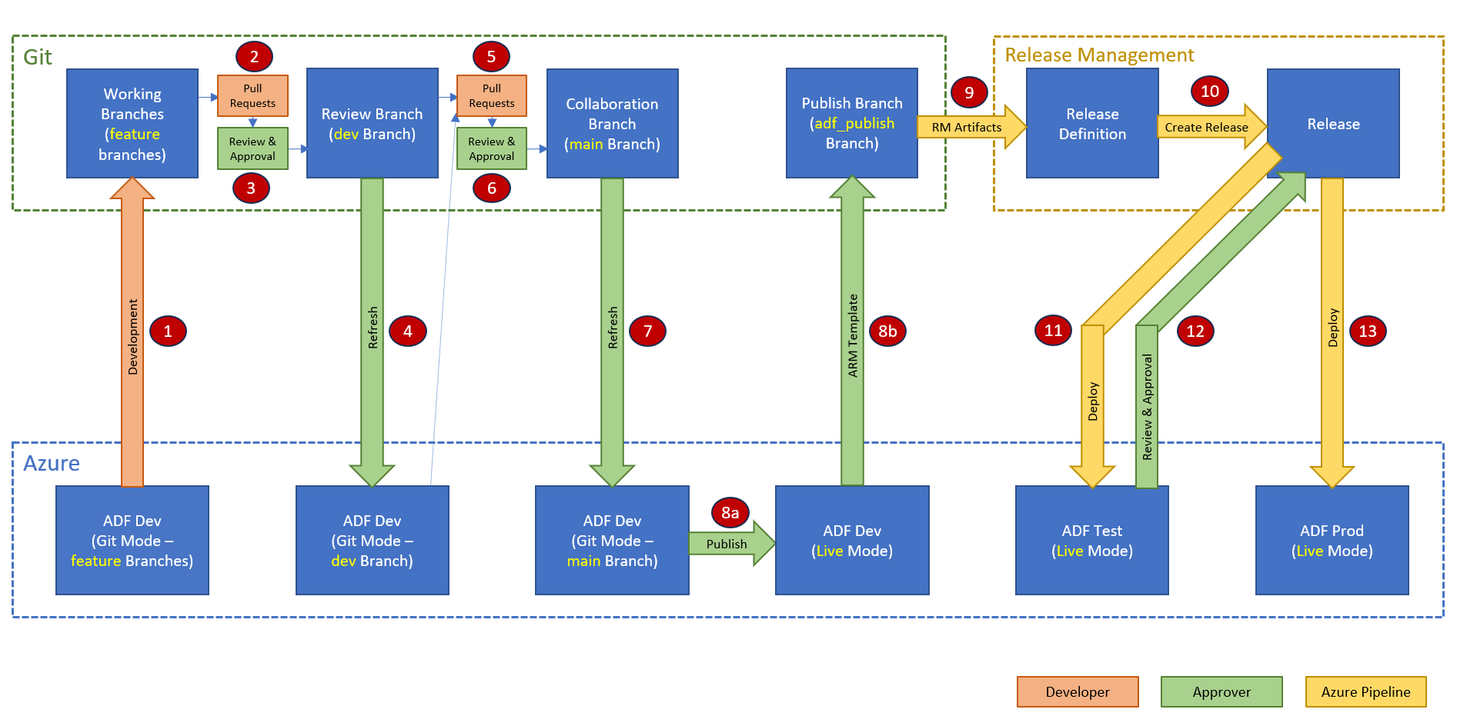

### **Code Development in Working Branch (Responsible: Developer)**

1. [Informational] Select Data Factory from top right corner of ADF UI.

Make any dummy changes to existing pipeline or create a new dummy pipeline.

Click on *Publish all*.

Publishing will fail. In Data Factory mode, publishing is not allowed.

Publishing is only allowed from feature branch when Git is configured.

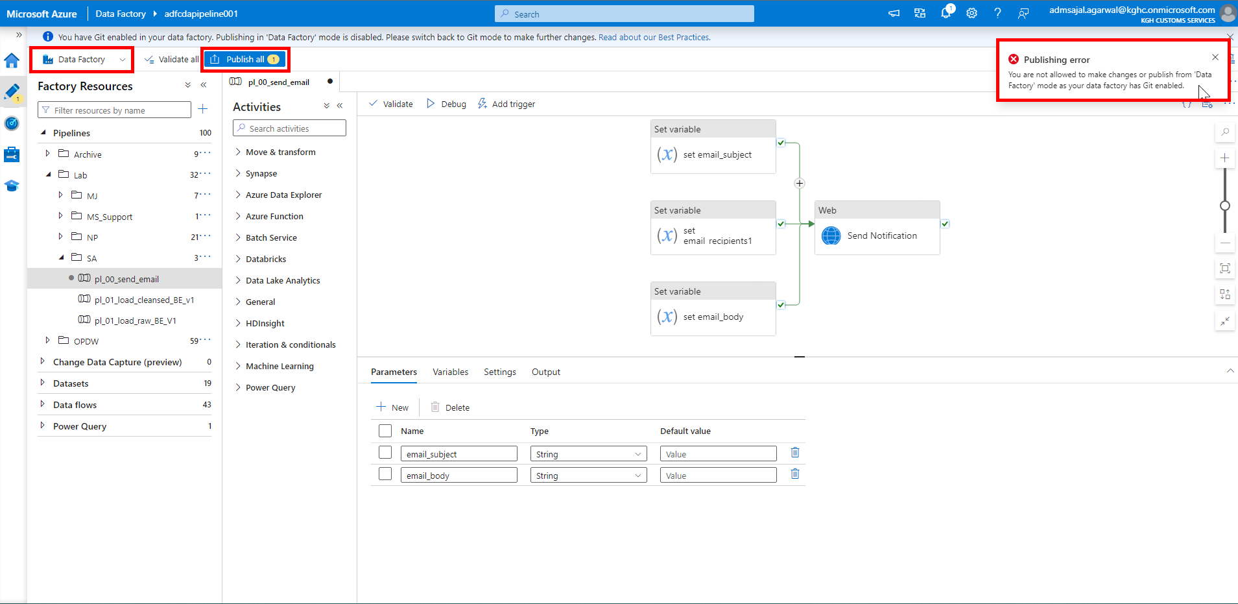

1. Select *feature_test01* branch from top right corner of ADF UI.

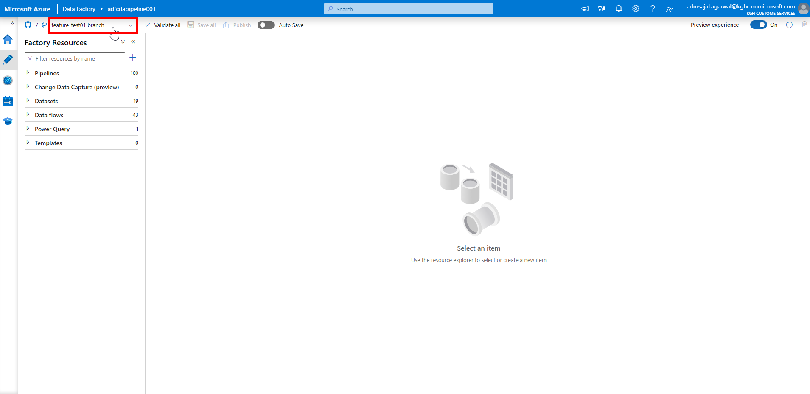

1. Create a new dummy pipeline as *pl_feature_test01*.

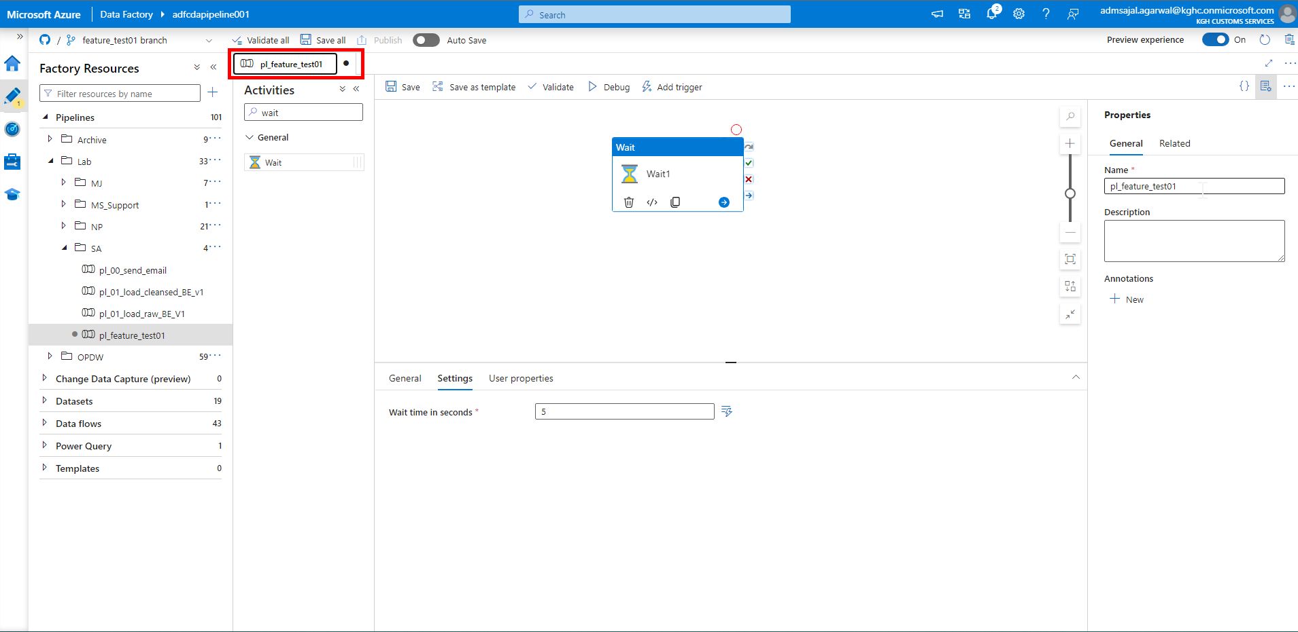

1. Click on *Save all*.

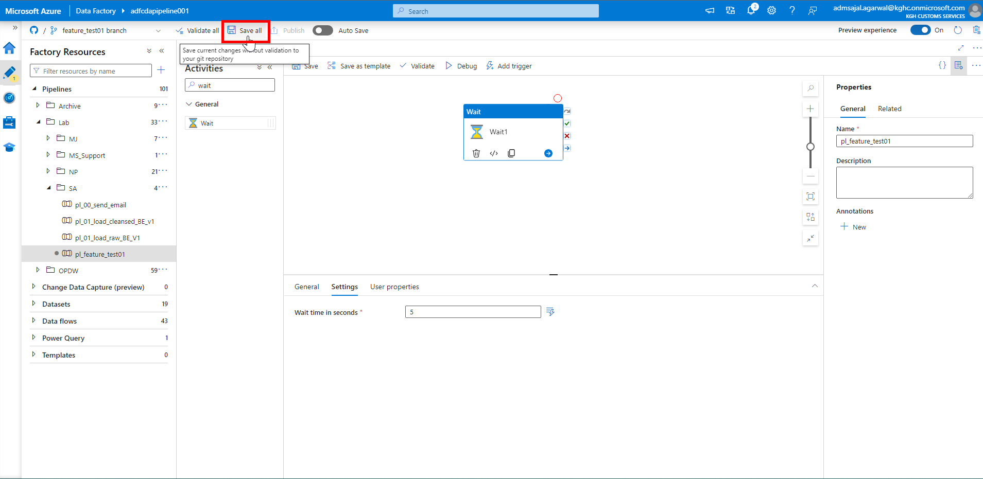

1. Enter a comment describing the changes made.

Click on *OK*.

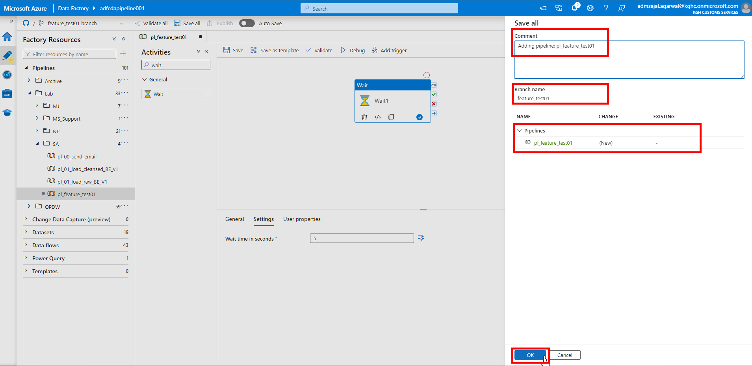

1. It will start *Saving the Git repository*.

Once completed, changes are pushed and committed to *feature_test01* branch in Git.

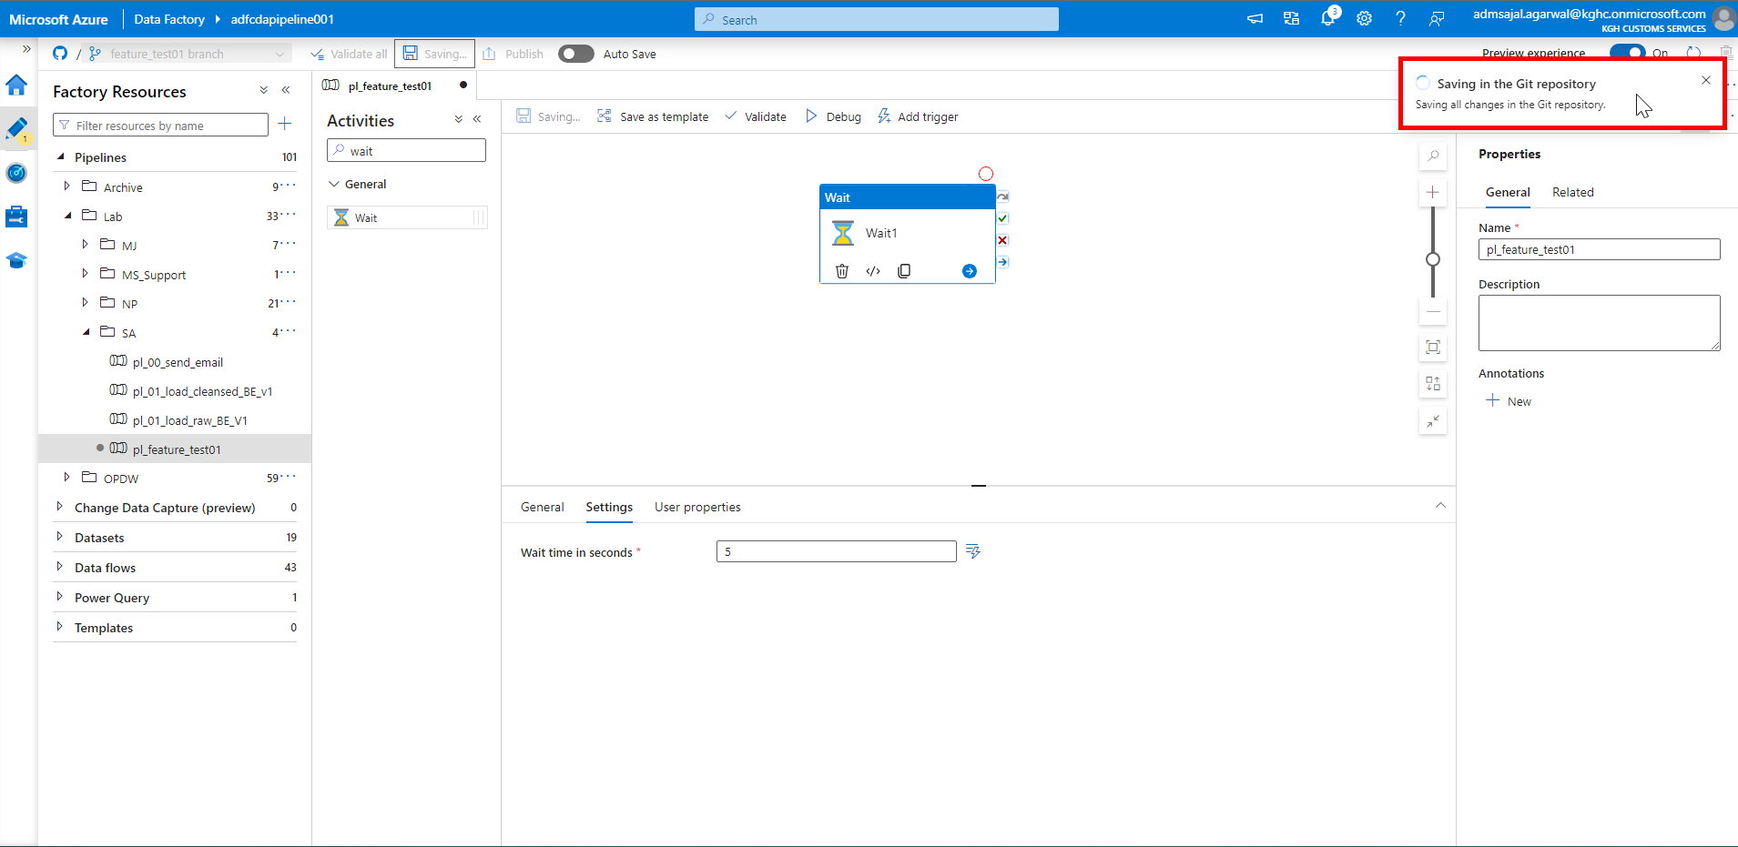

### **Code Pull Request from Working Branch (Responsible: Developer)**

Reference Link: [About pull requests - GitHub Docs](https://docs.github.com/en/pull-requests/collaborating-with-pull-requests/proposing-changes-to-your-work-with-pull-requests/about-pull-requests)

1. Click on drop down in front of *feature_test01* branch.

Click on *Create pull request*.

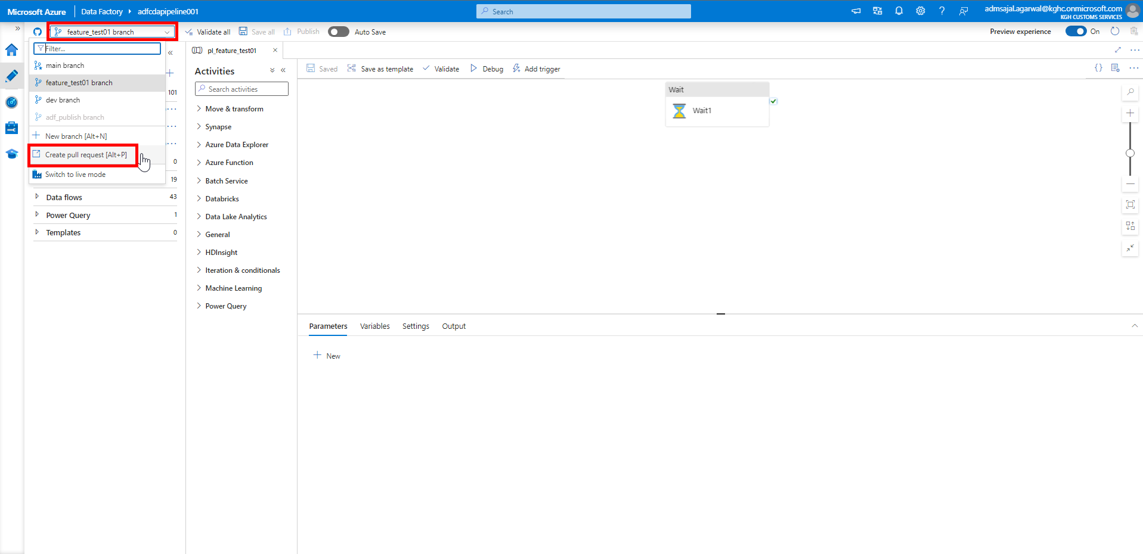

1. It will navigate to Git UI.

Make sure changes are merged from *feature_test01* to *dev*.

Verify the changes and click on *Create pull request*.

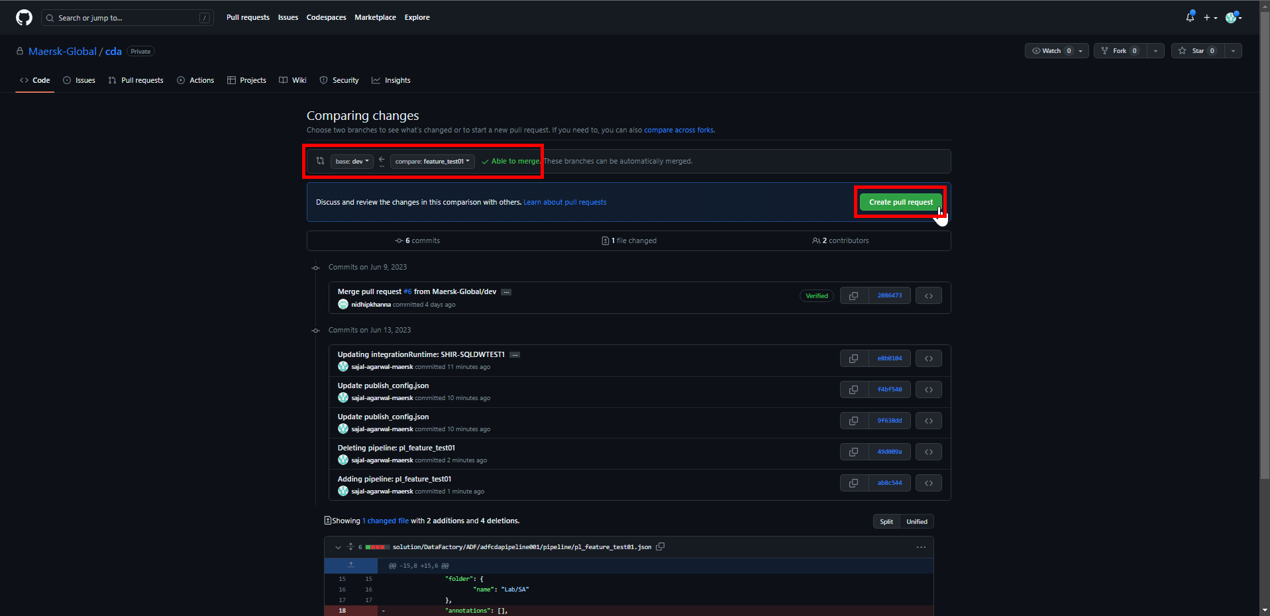

1. Enter a *comment* describing the changes.

Add *Reviewers* and *Assignees* as needed.

Click on *Create pull request*.

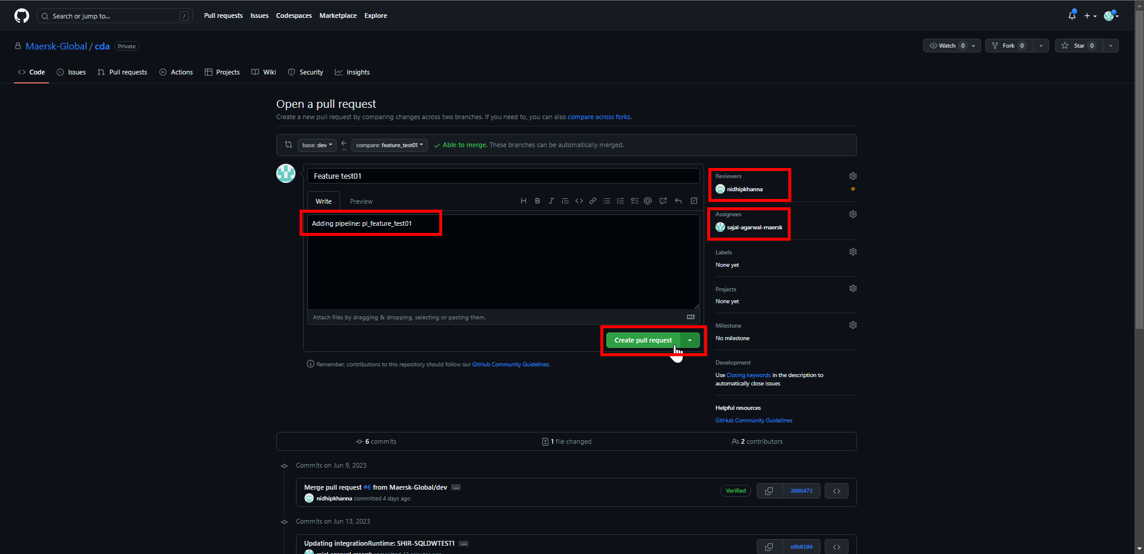

### **Code Review in Review Branch (Responsible: Reviewer)**

1. *Reviewer* will get an email as below:

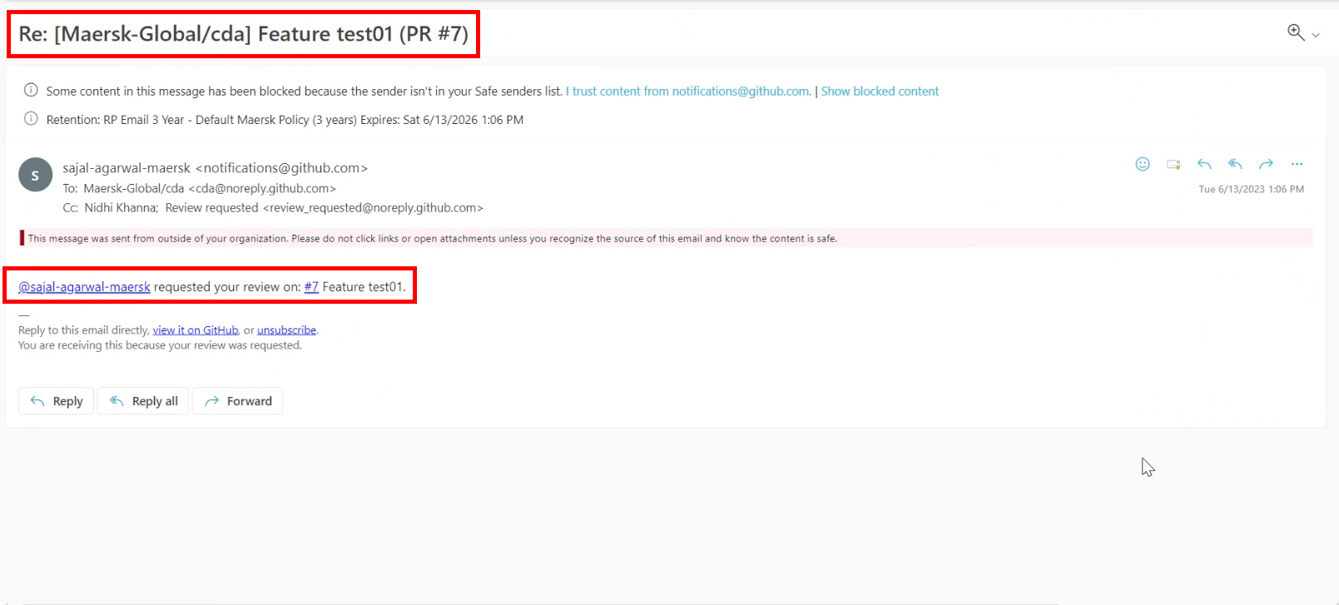

1. Login to Git Repository. Open below link:

[Maersk-Global/cda (github.com)](https://github.com/Maersk-Global/cda)

Click on *Pull requests*.

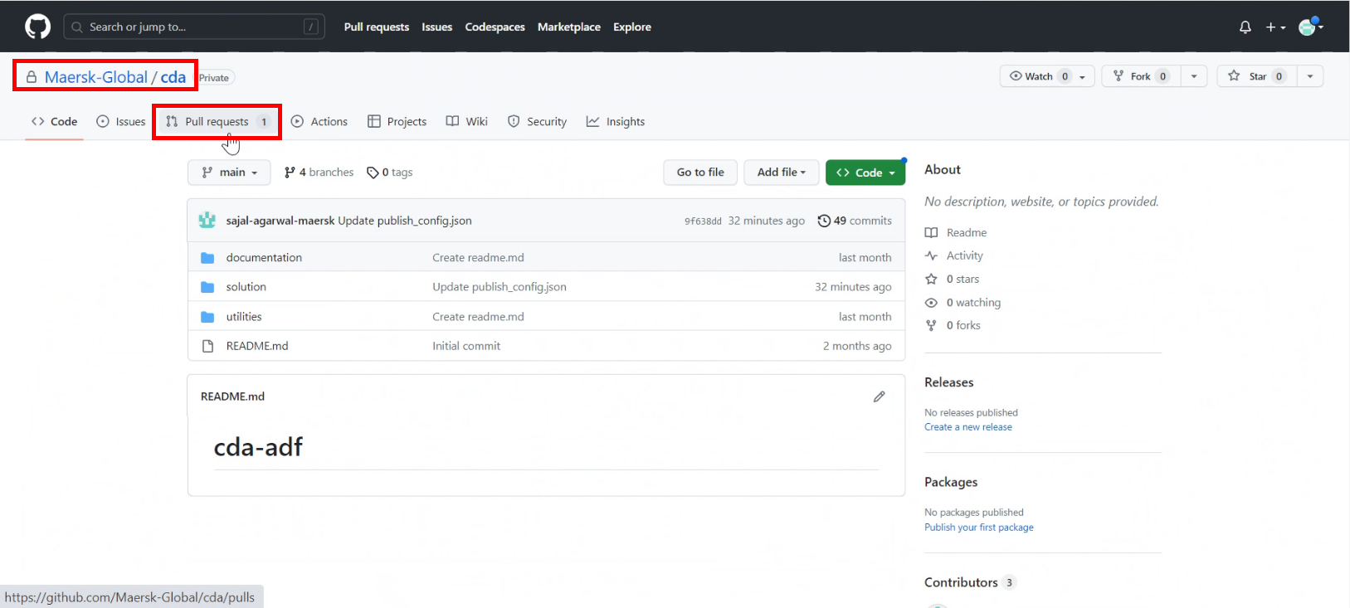

1. Click on pull request.

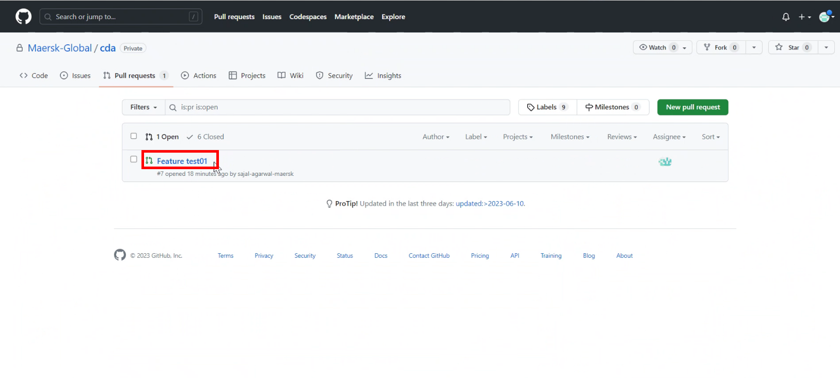

1. Click on *Add your review*.

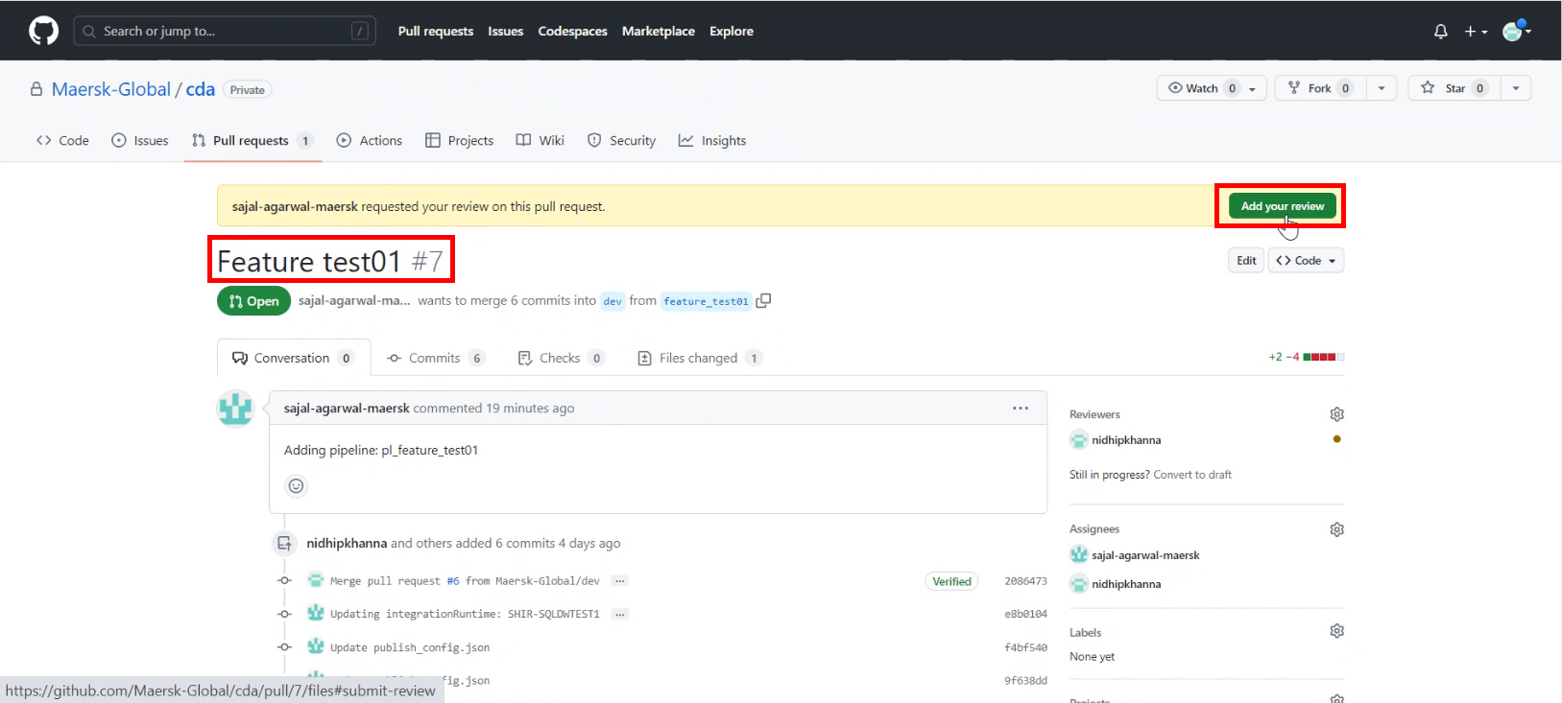

1. Review the changes.

Click on *Review changes*.

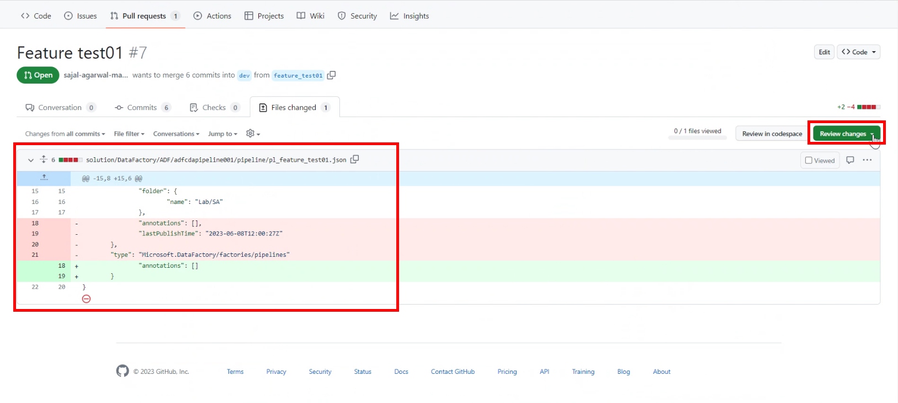

1. Write review comments.

Click on *Comment/Approve/Request changes* as per the case.

Click on *Submit review*.

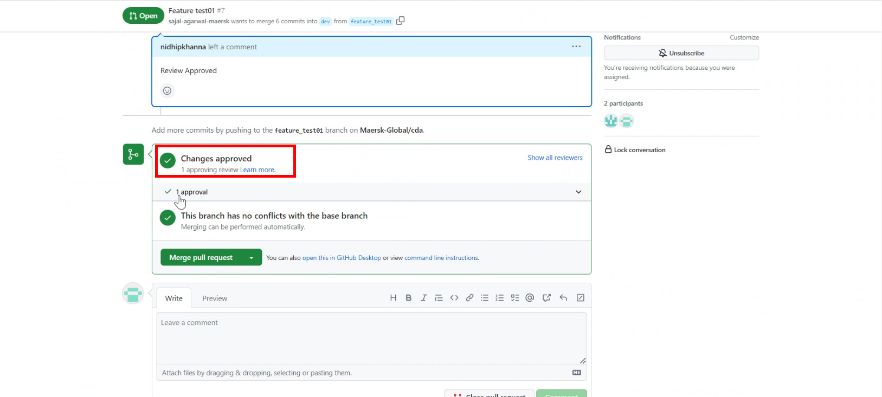

### **Code Merge with Review Branch (Responsible: Approver)**

1. *Approver* will get an email as below:

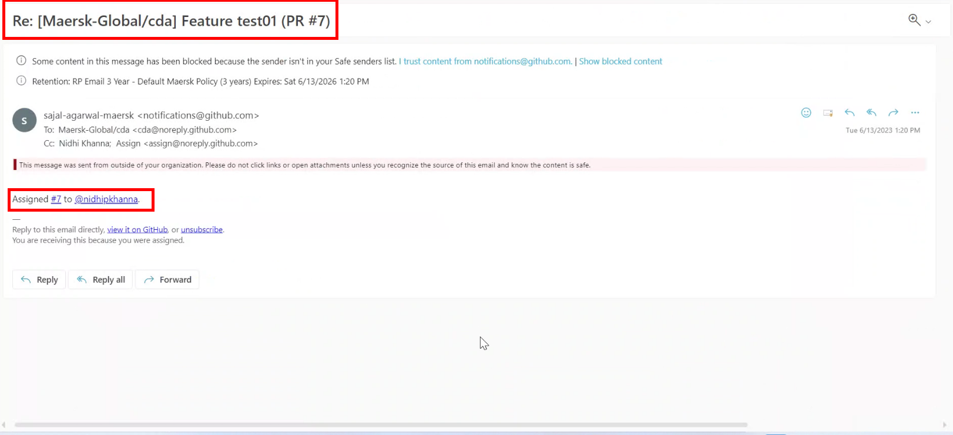

1. Login to Git Repository. Open below link:

[Maersk-Global/cda (github.com)](https://github.com/Maersk-Global/cda)

Click on *Pull requests*.

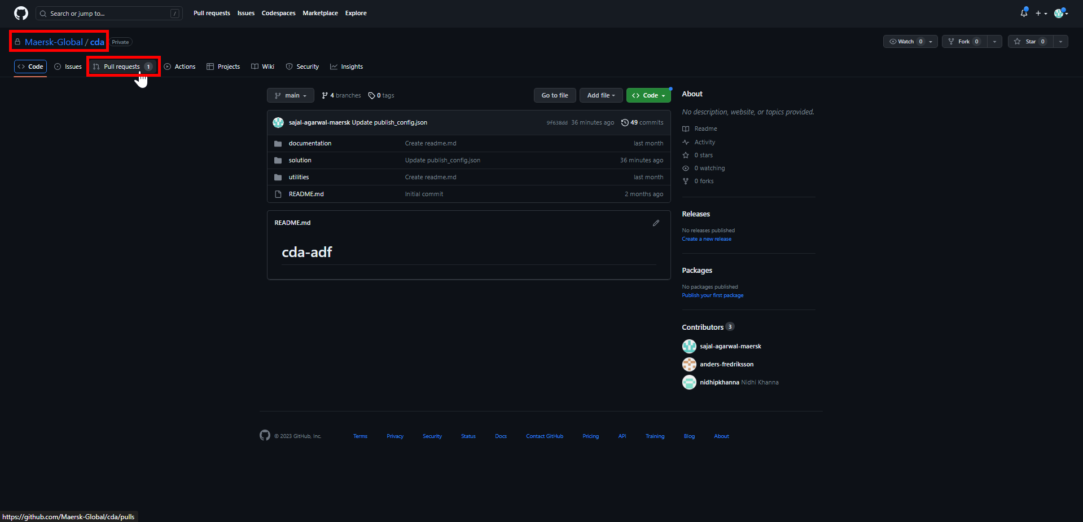

1. Click on pull request.

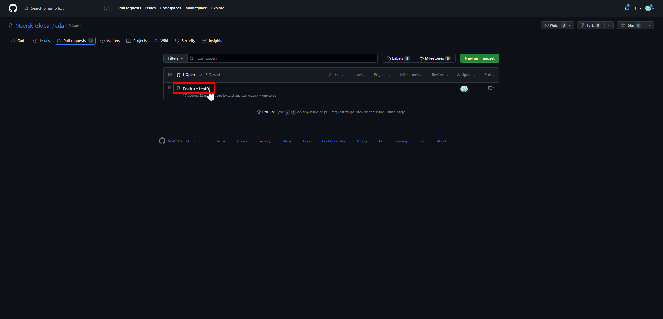

1. It will open the below page. Scroll down the page.

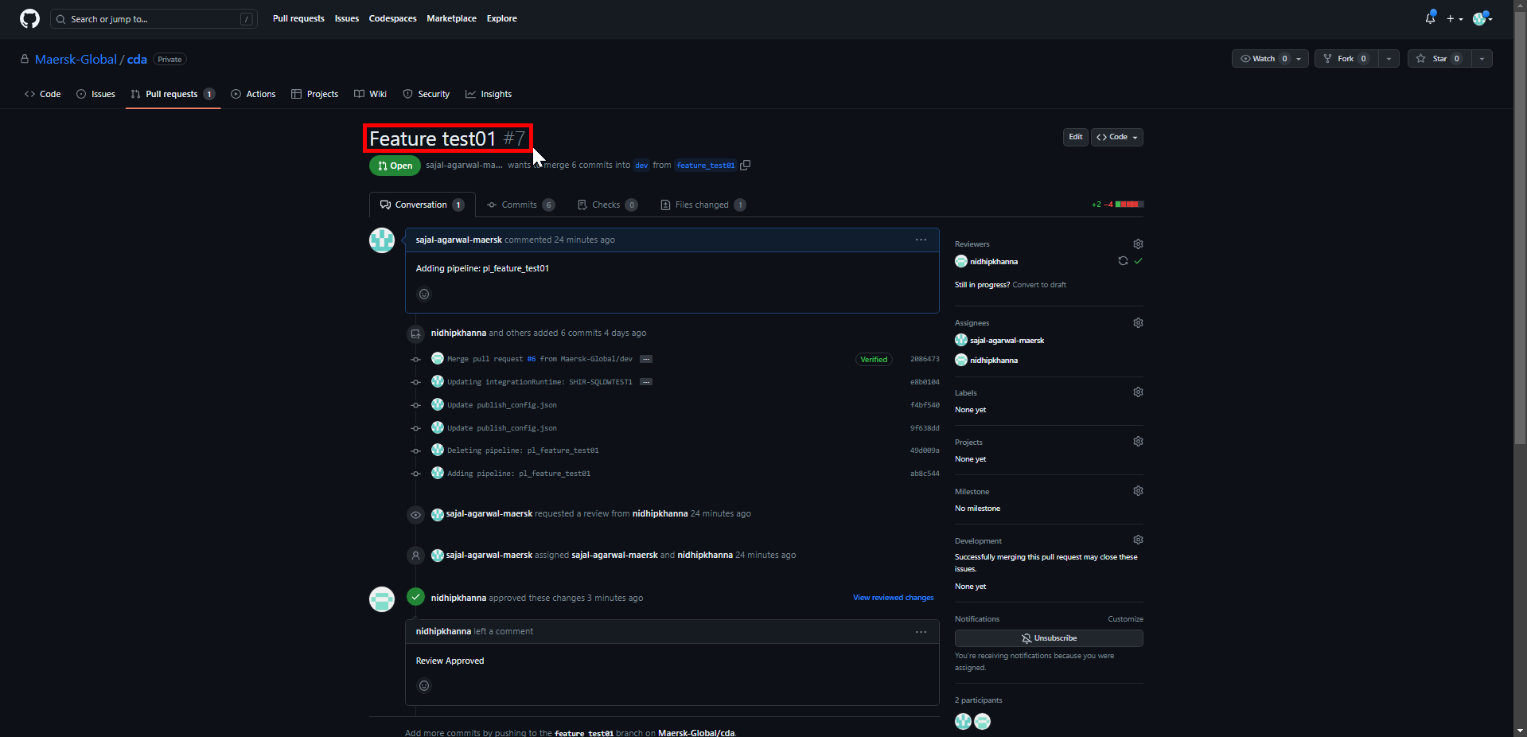

1. Click on *Merge pull request*

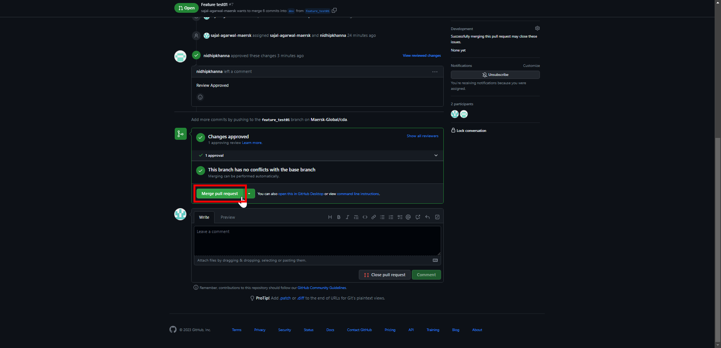

1. Enter a *comment* describing the merge request and click on *Confirm merge*.

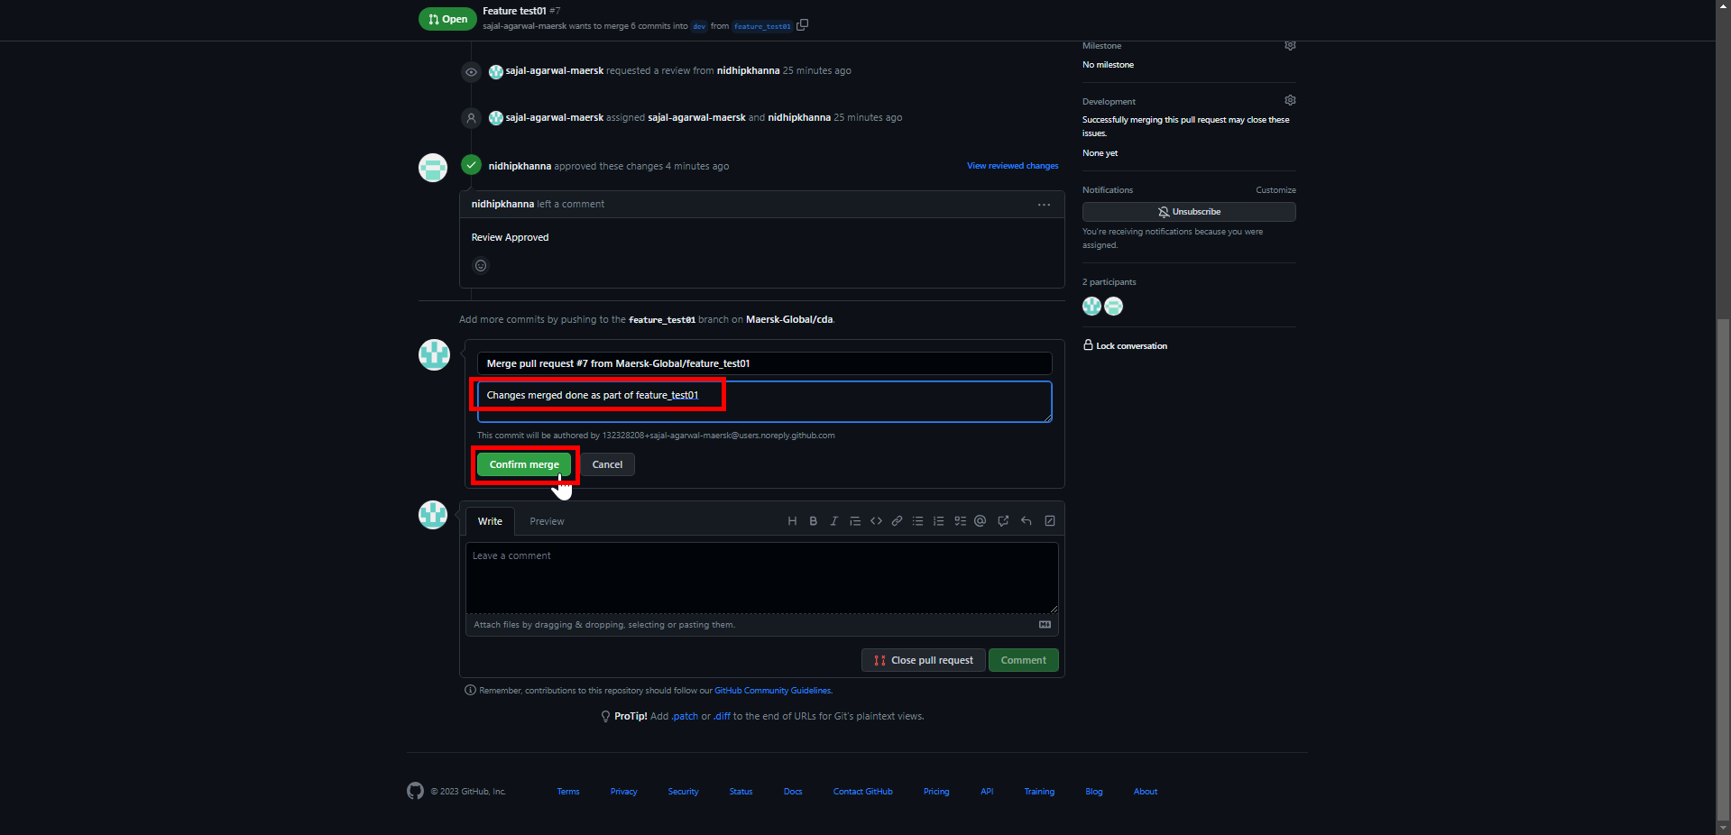

1. Enter a closing *comment* and click on *Comment*.

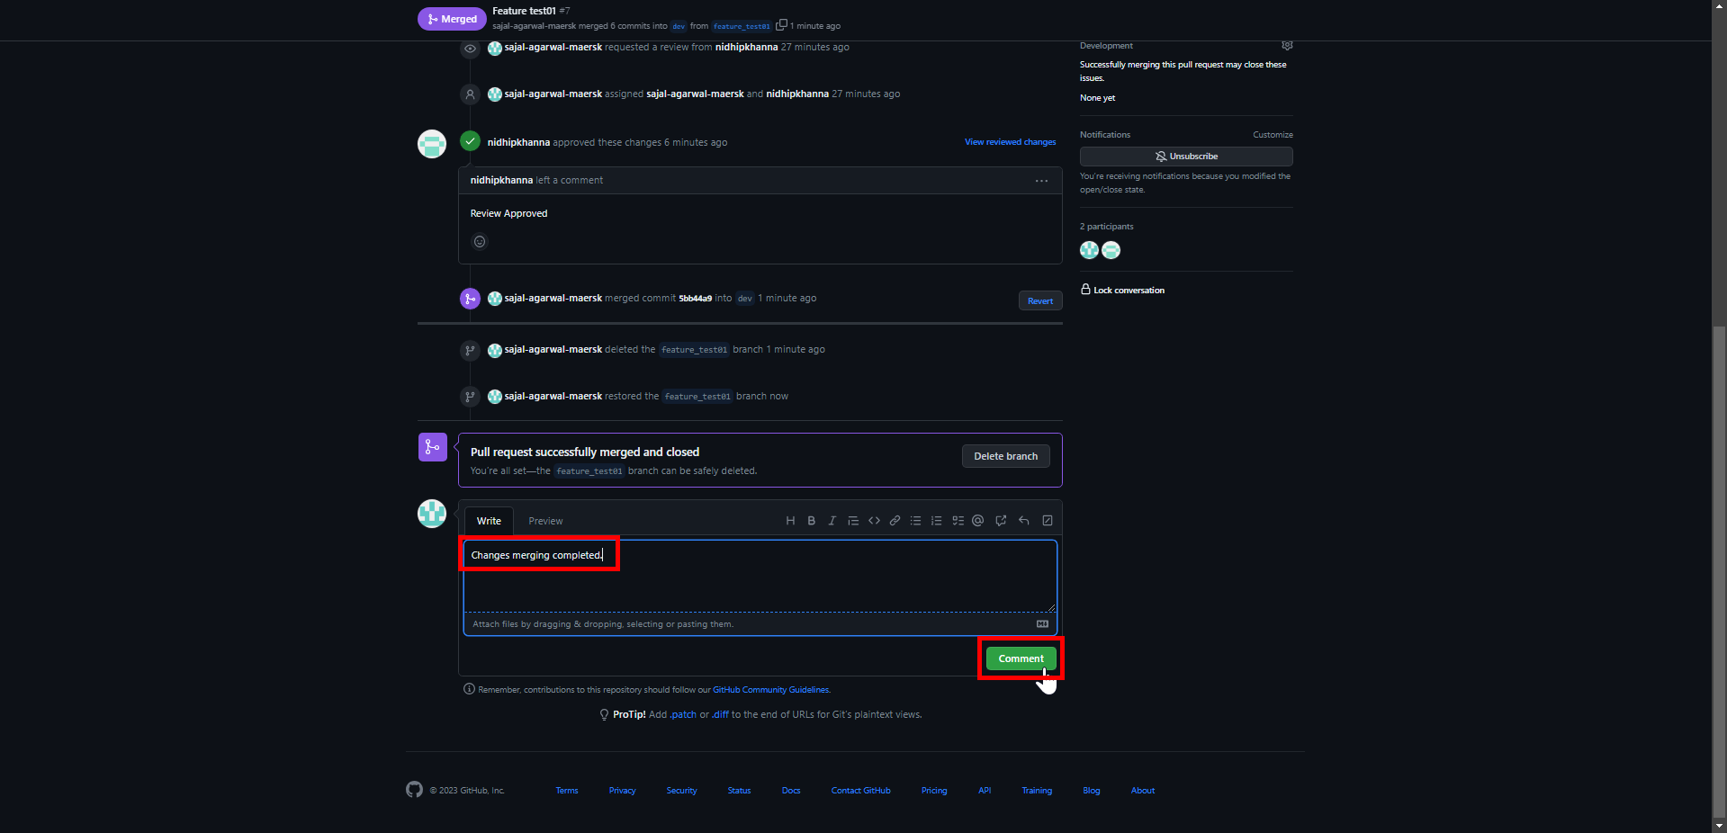

1. In ADF, click on drop down in front of *feature_test01* branch*.*

Click on *dev* branch*.*

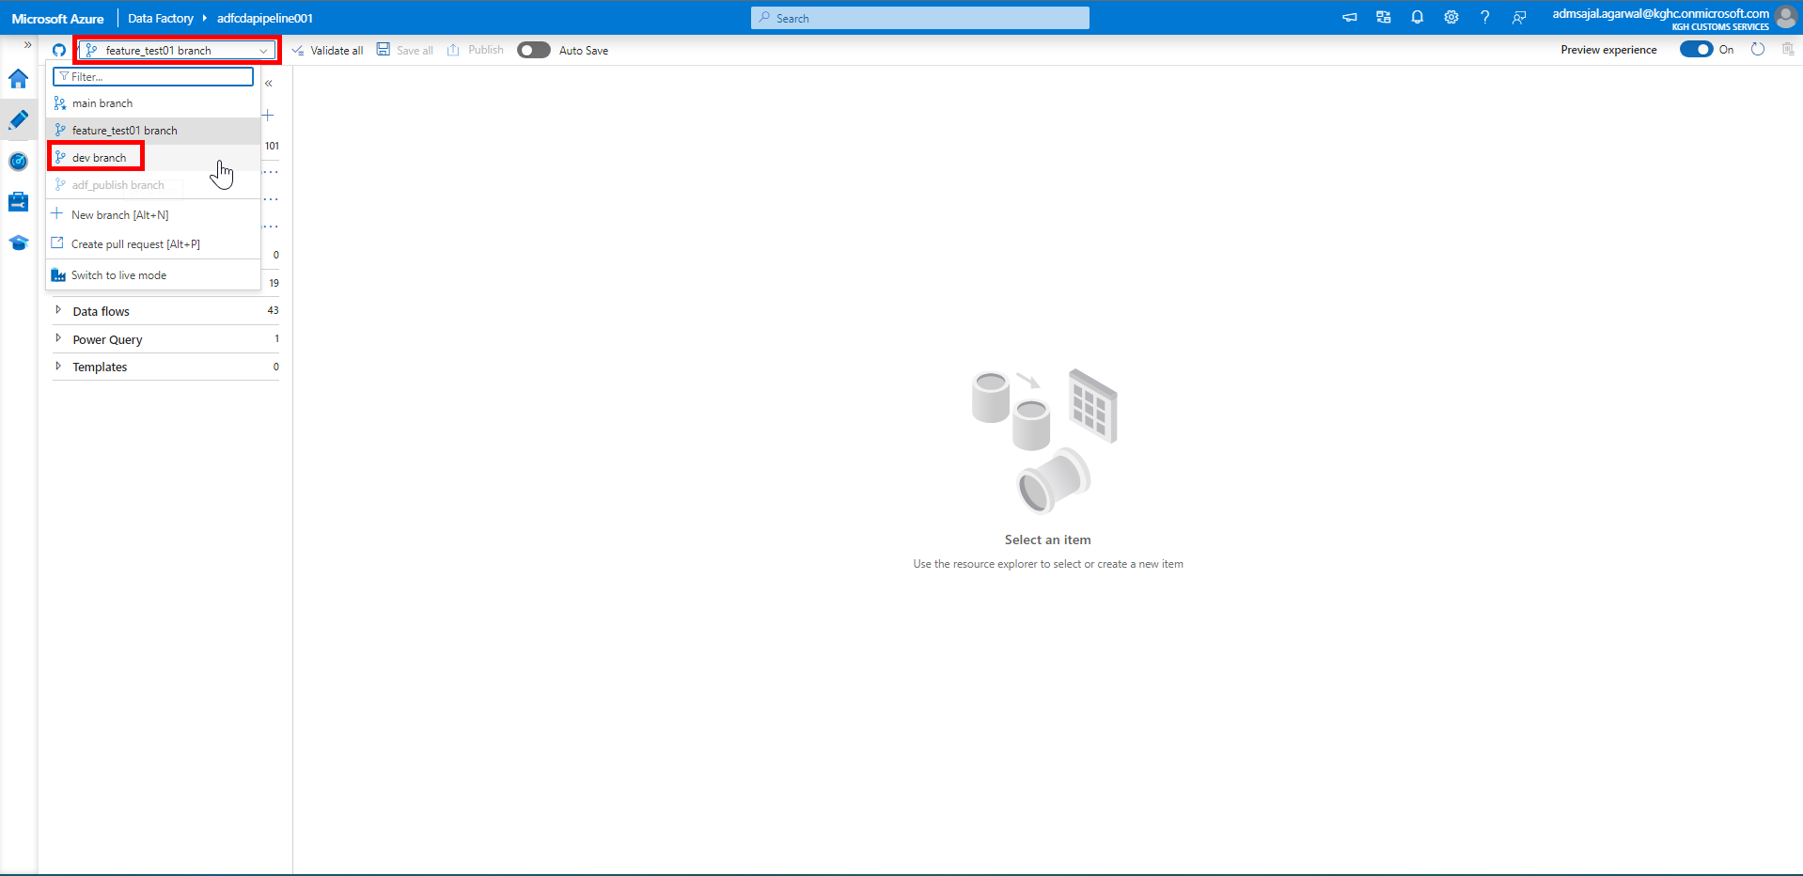

1. Click on *Refresh*.

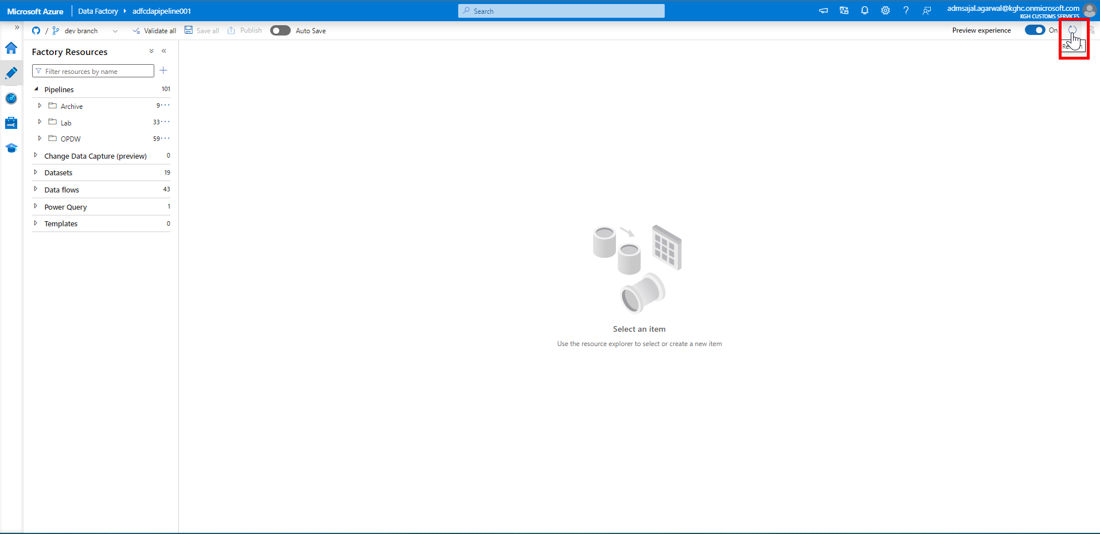

1. Verify that the recently made changes are available in *develop* branch now.

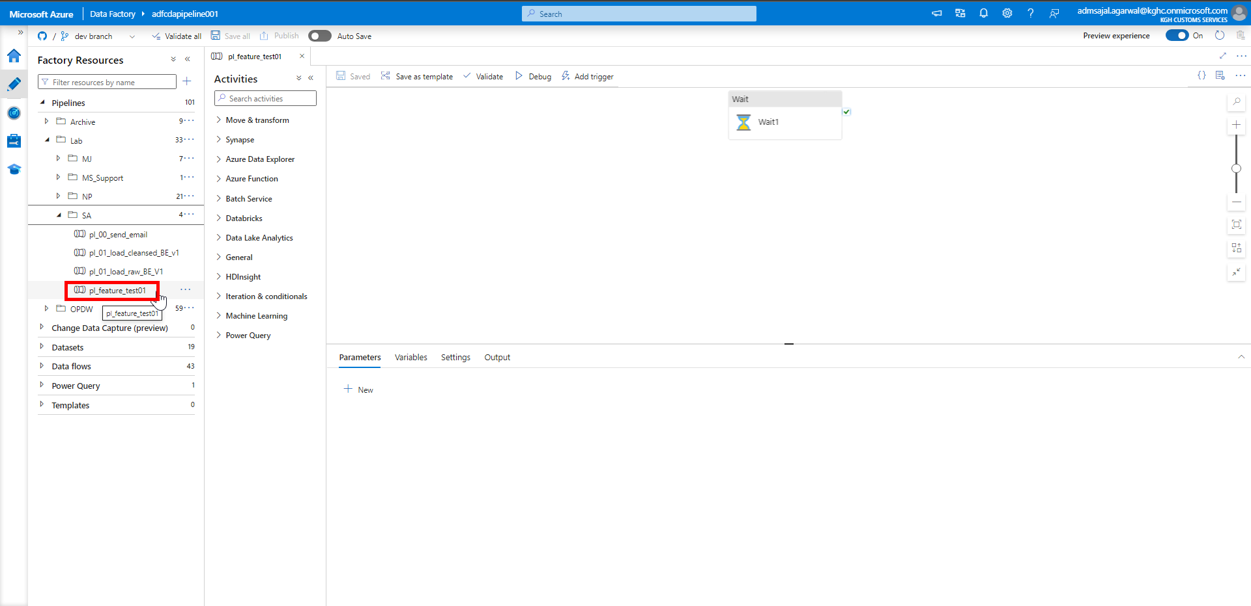

### **Code Pull Request from Collaboration Branch (Responsible: Approver)**

1. Click on drop down in front of *dev* branch*.*

Click on *Create pull request.*

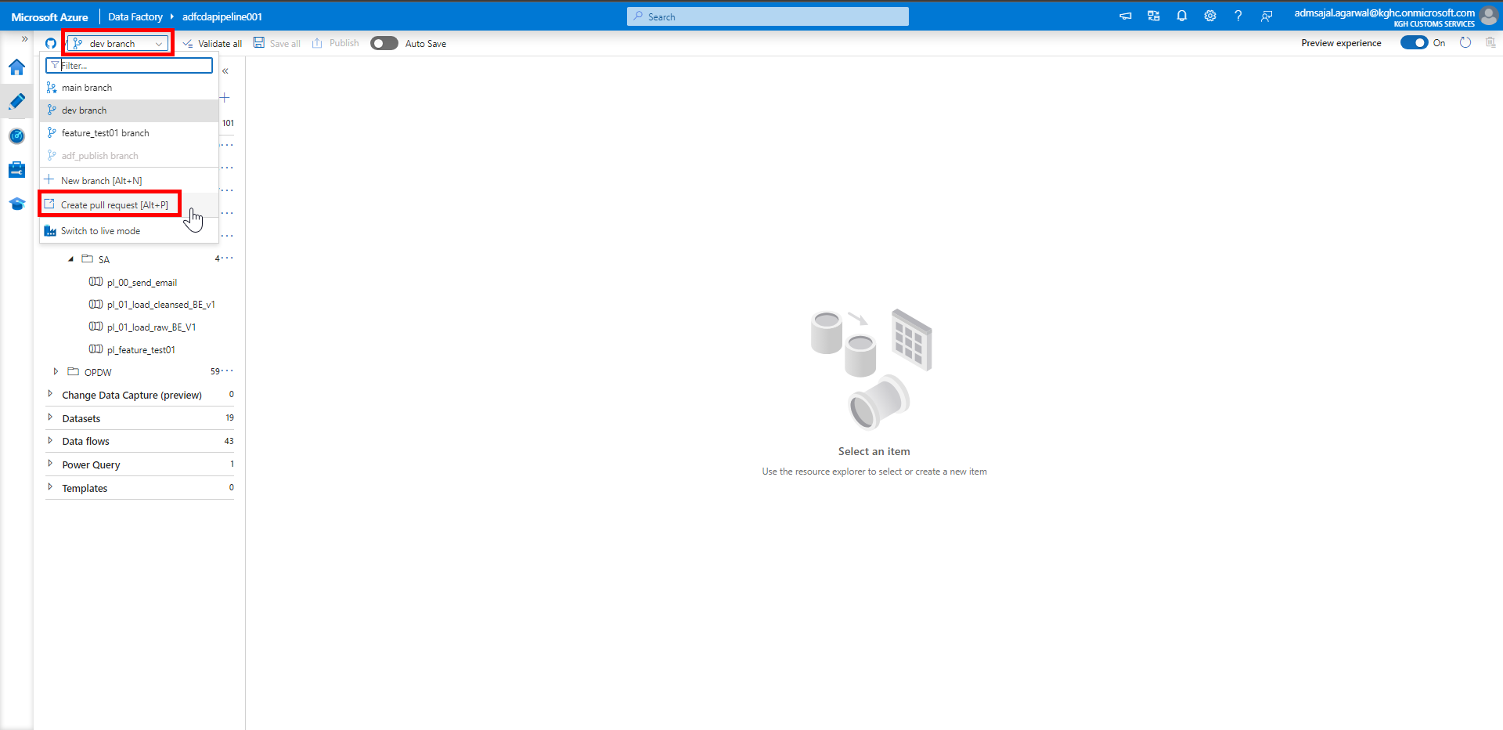

1. It will navigate to Git UI.

Make sure changes are merged from *dev* to *main*.

Verify the changes and click on *Create pull request*.

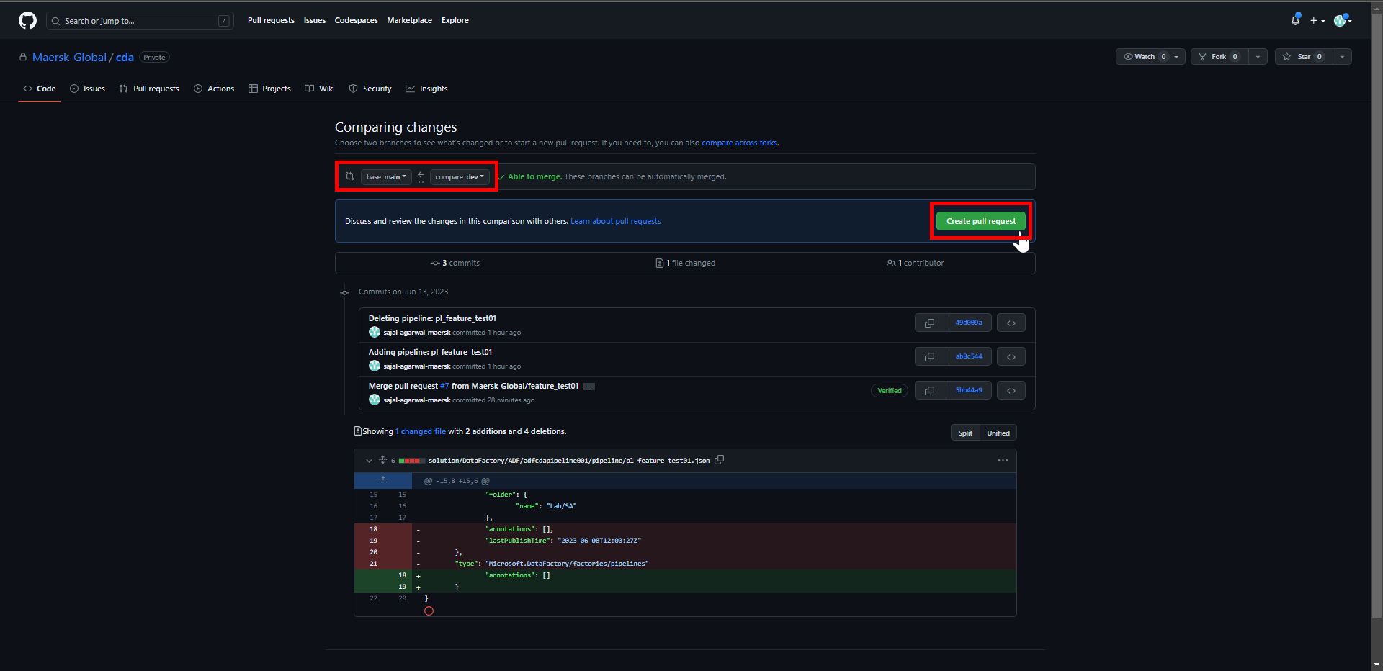

1. Enter a *comment* describing the merge request.
2. *Reviewers* and *Assignees* can be added as needed.
3. Click on *Create pull request*.

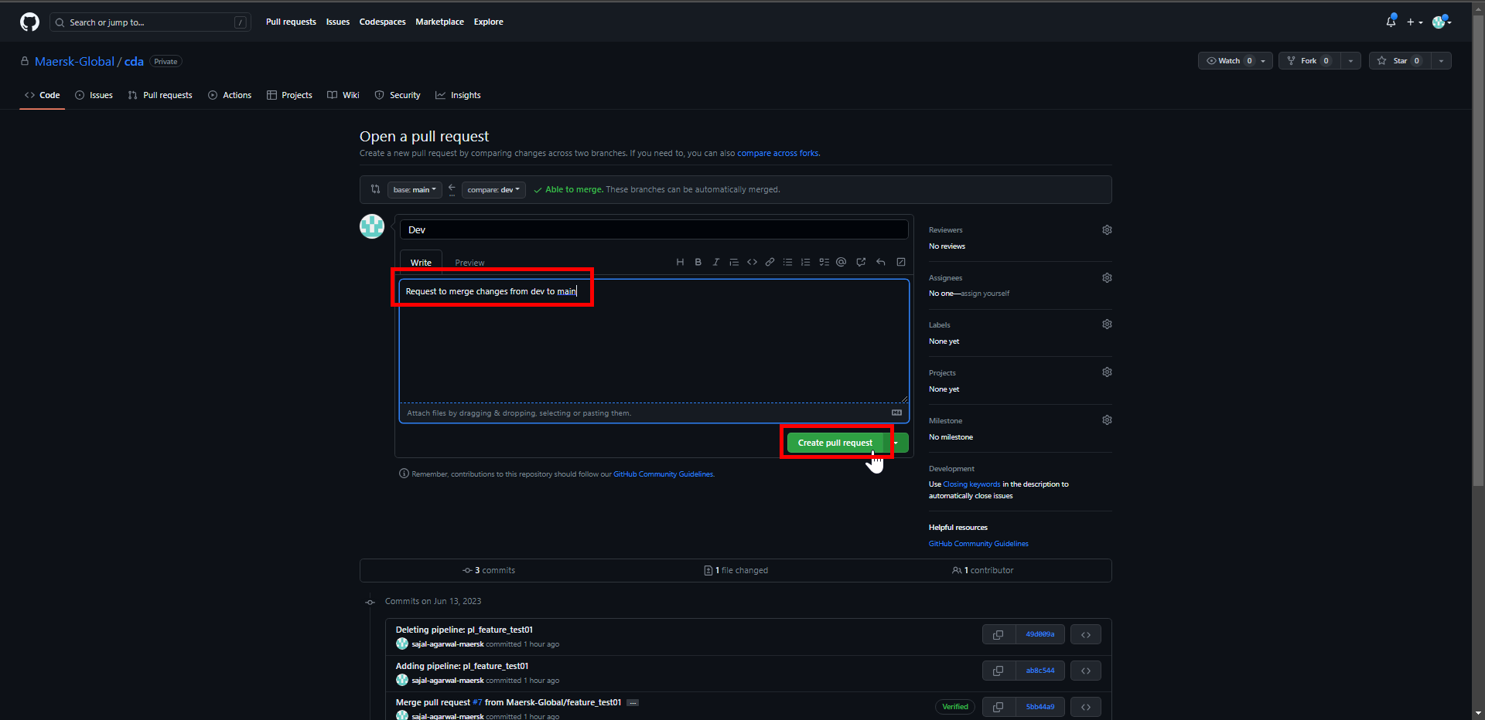

### **Code Review in Collaboration Branch (Responsible: Approver)**

1. Login to Git Repository. Open below link:

[Maersk-Global/cda (github.com)](https://github.com/Maersk-Global/cda)

Click on *Pull requests*.

1. Click on pull request.
2. Click on *Add your review*.
3. Review the changes.

Click on *Review changes*.

1. Write review comments.

Click on *Comment/Approve/Request changes* as per the case.

Click on *Submit review*.

### **Code Merge with Collaboration Branch (Responsible: Approver)**

1. Login to Git Repository. Open below link:

[Maersk-Global/cda (github.com)](https://github.com/Maersk-Global/cda)

Click on *Pull requests*.



1. Click on pull request.
2. Click on *Merge pull request*.

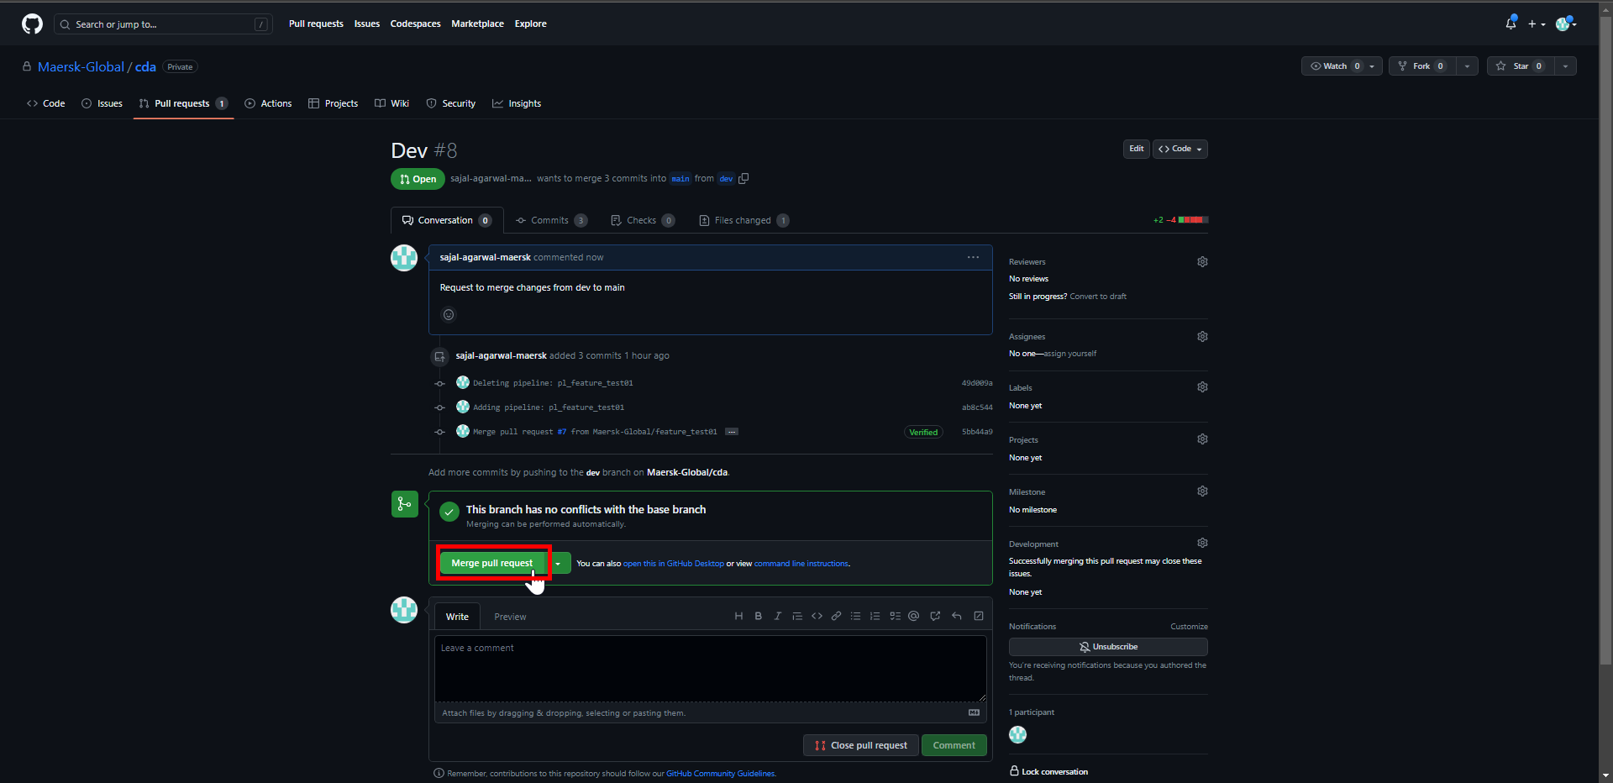

1. Enter a *comment* describing the merge request and click on *Confirm merge*.

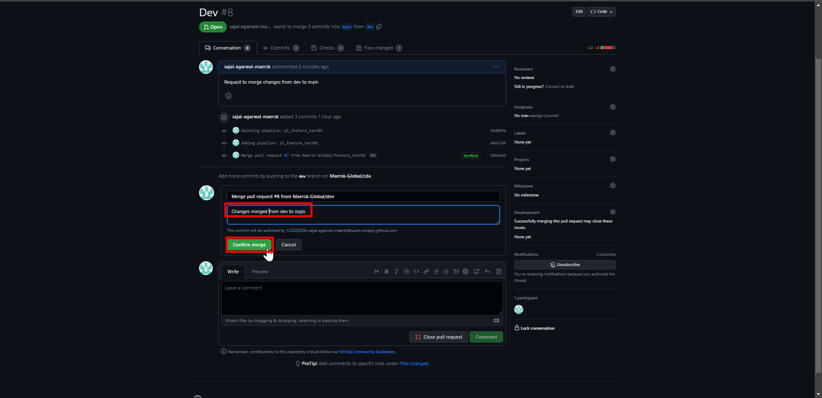

1. Enter a closing *comment* and click on *Comment*.

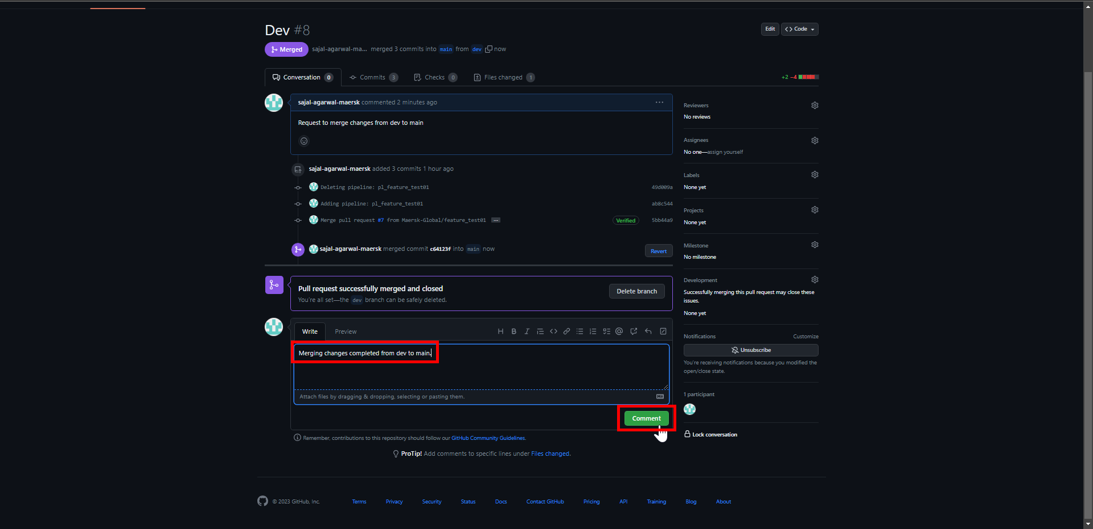

1. In ADF, click on drop down in front of *dev* branch*.*

Click on *main* branch*.*

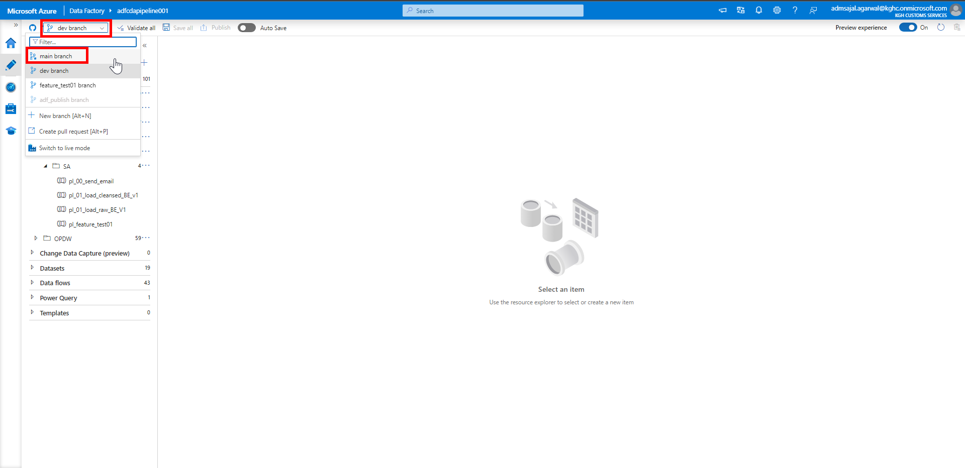

1. Click on *Refresh*.

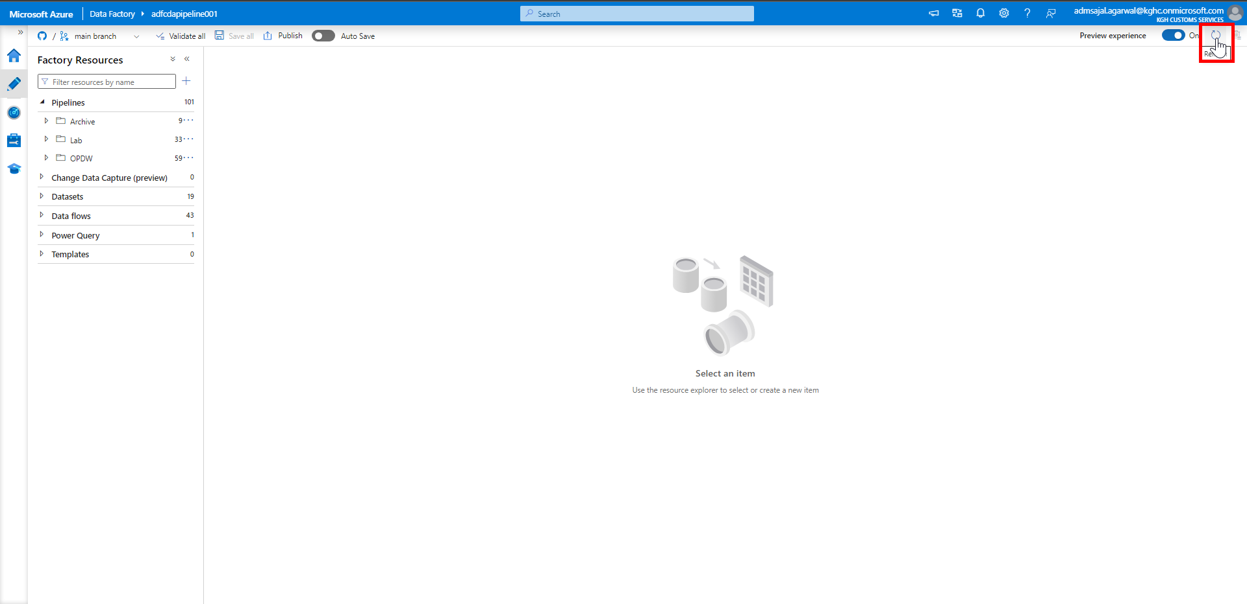

1. Verify that the recently made changes are available in *main* branch now.

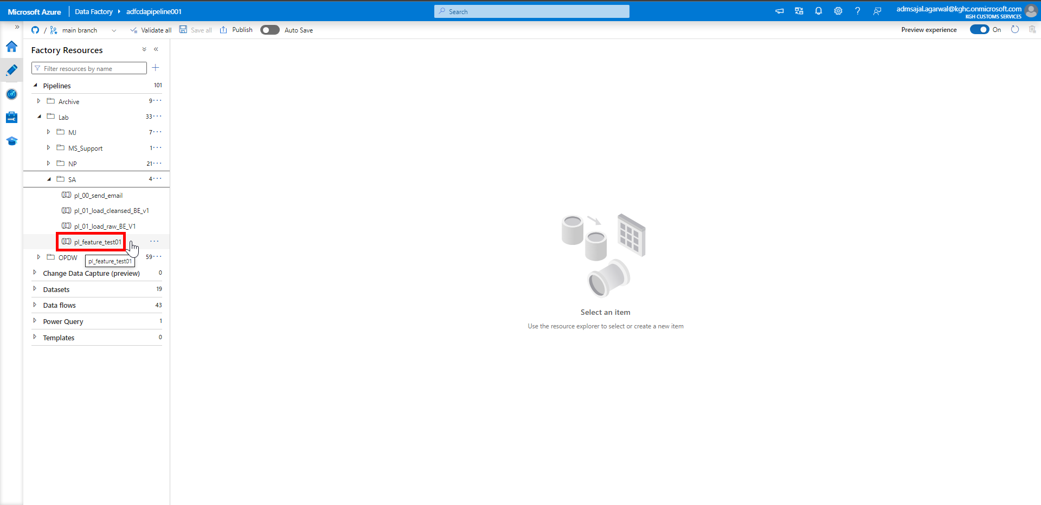

### **Code Push to ADF (Responsible: Approver)**

1. With *main* branch selected, click on *Publish*.

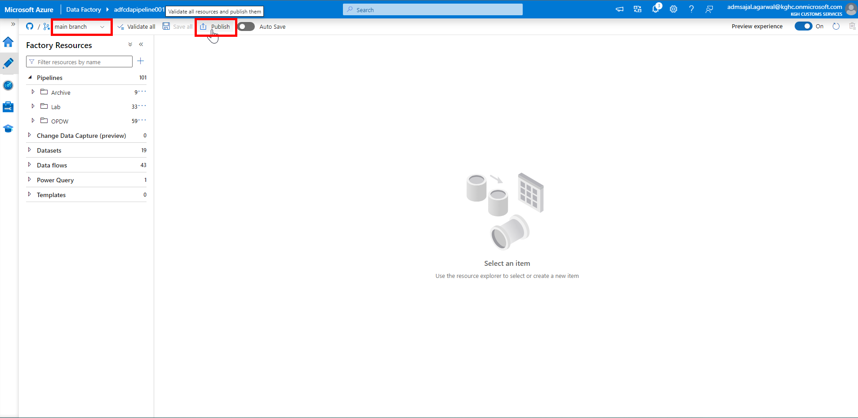

1. It will start *Publishing*.

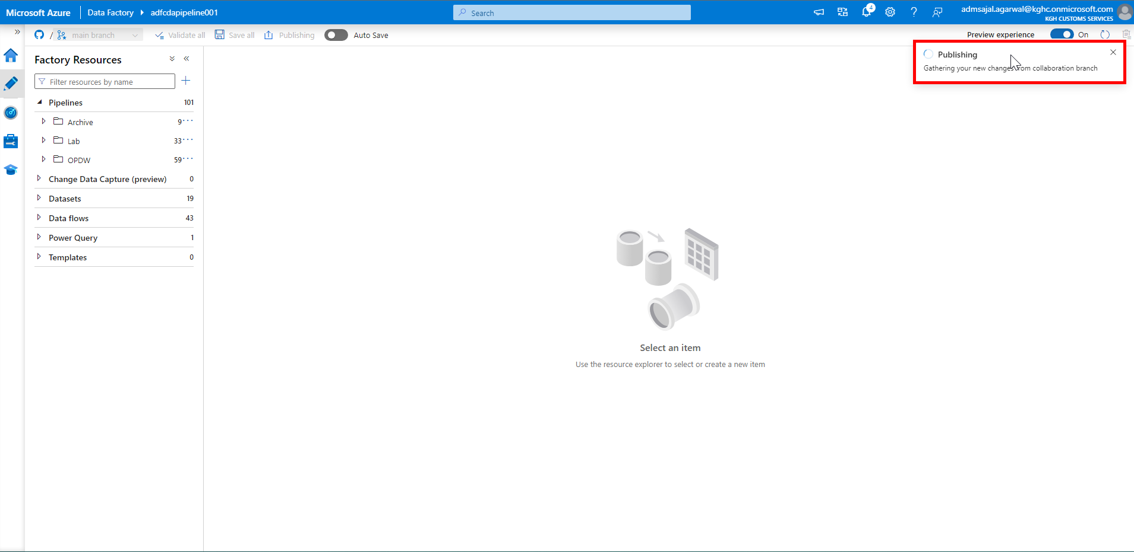

1. Verify the changes and click on *OK*.

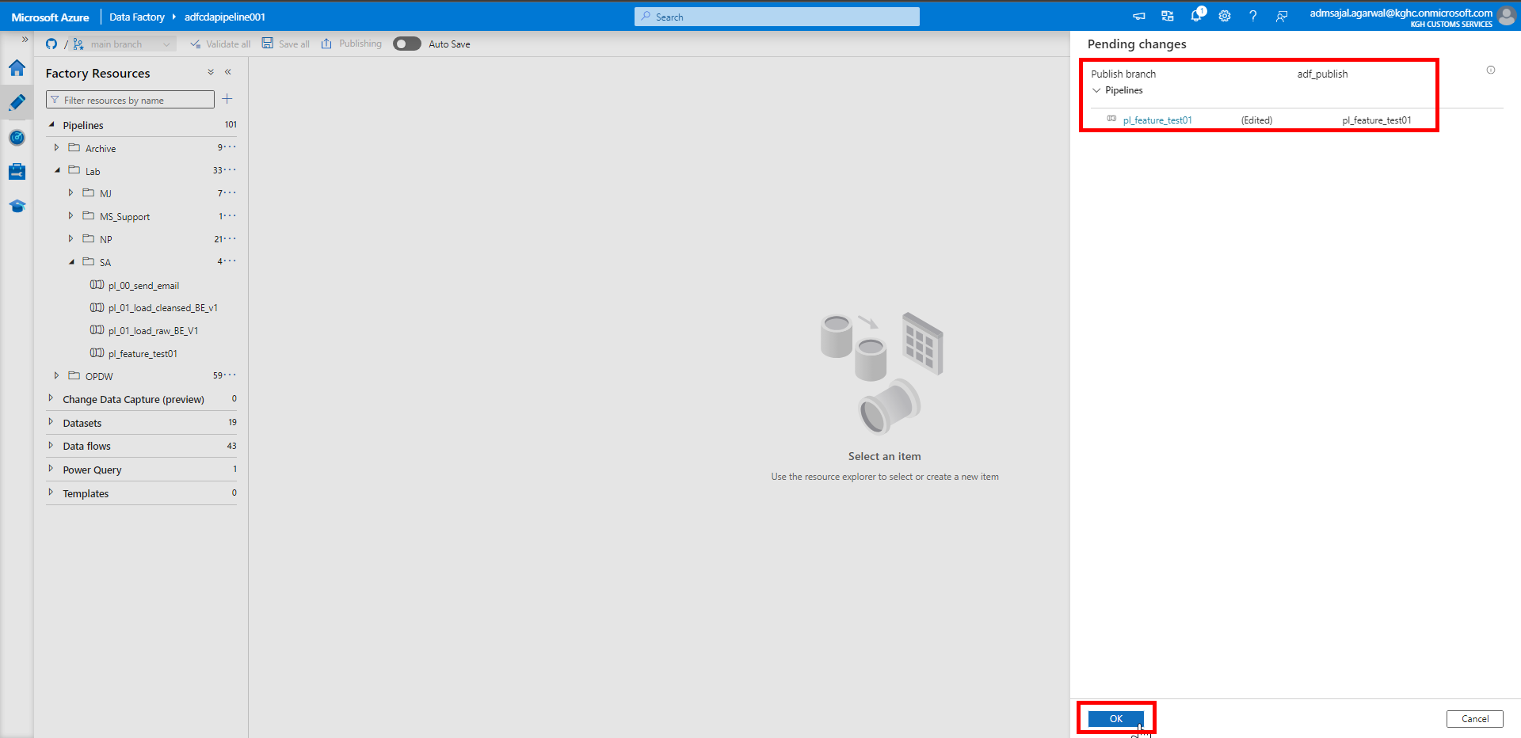

1. It will start *Deploying changes* to the Azure Data Factory.

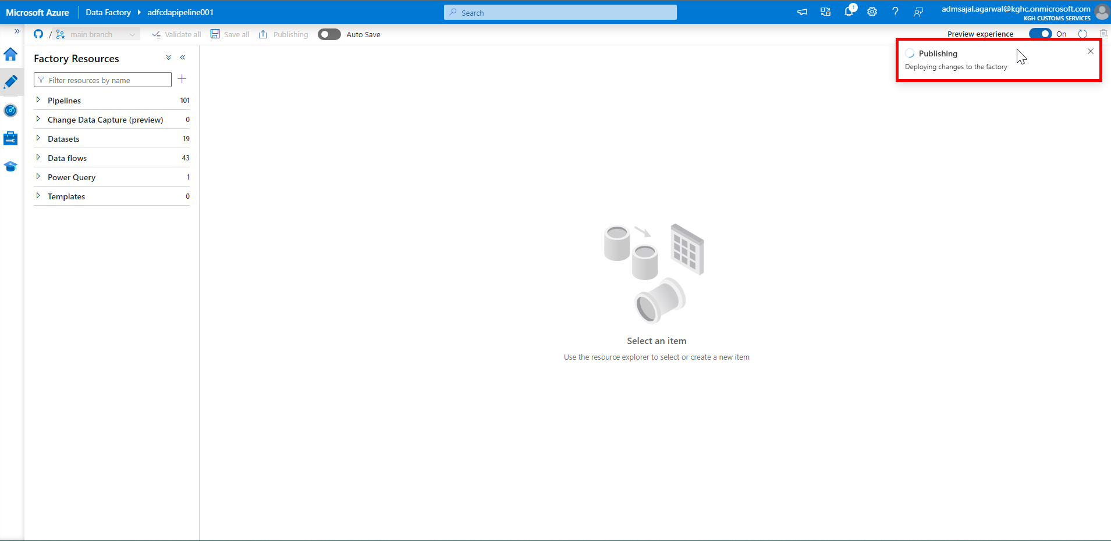

1. When the *Publishing completed* notification is shown, all new changes are pushed to *Data Factory* from *main* branch.

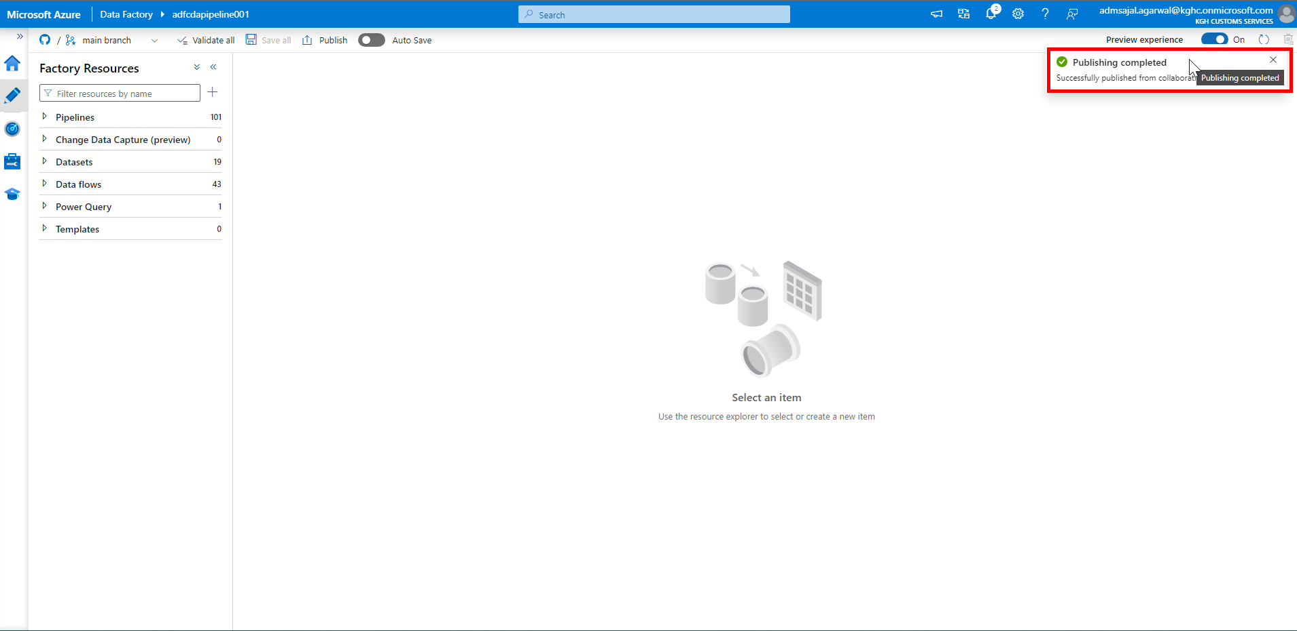

1. It will now start *Generating ARM templates*.

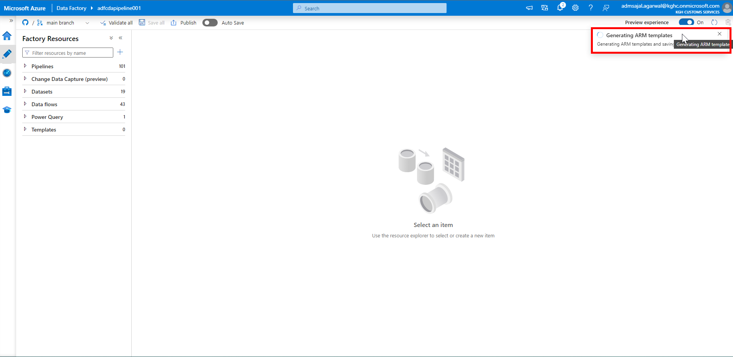

1. When the *Generating ARM templates Succeeded* notification is shown, current state of ADF is pulled and merged into a branch called as *adf_publish* in Git.

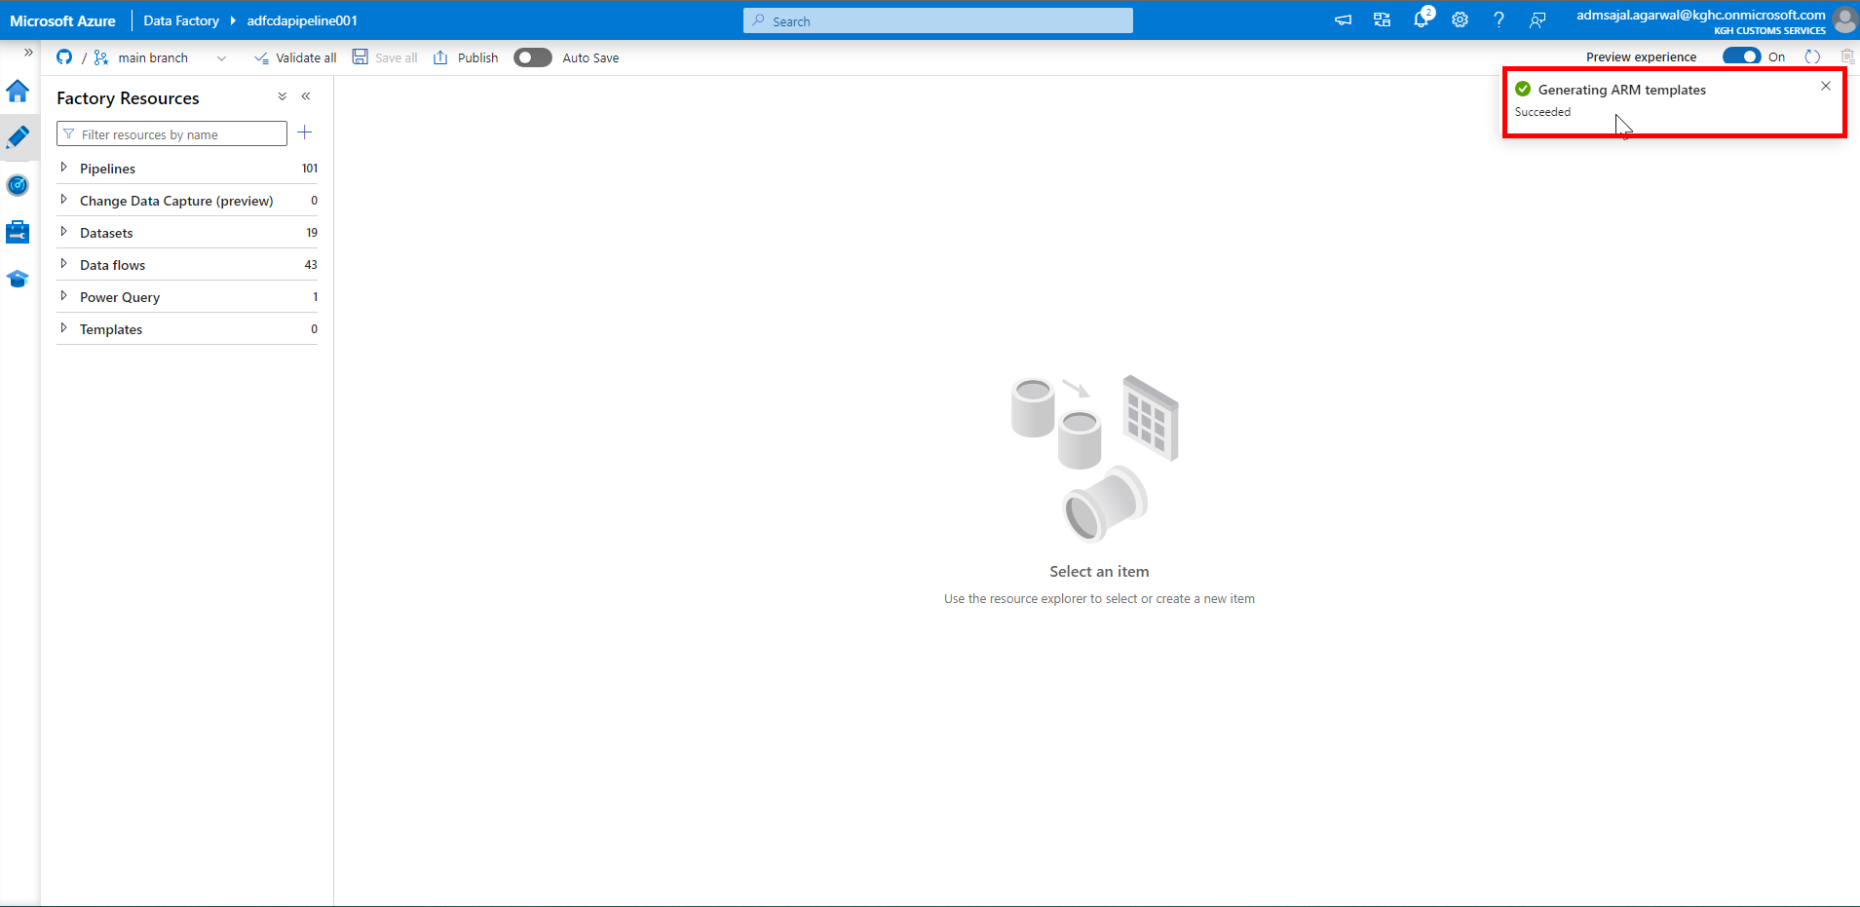

1. In ADF, click on drop down in front of *main* branch*.*

Click on *Switch to live mode.*

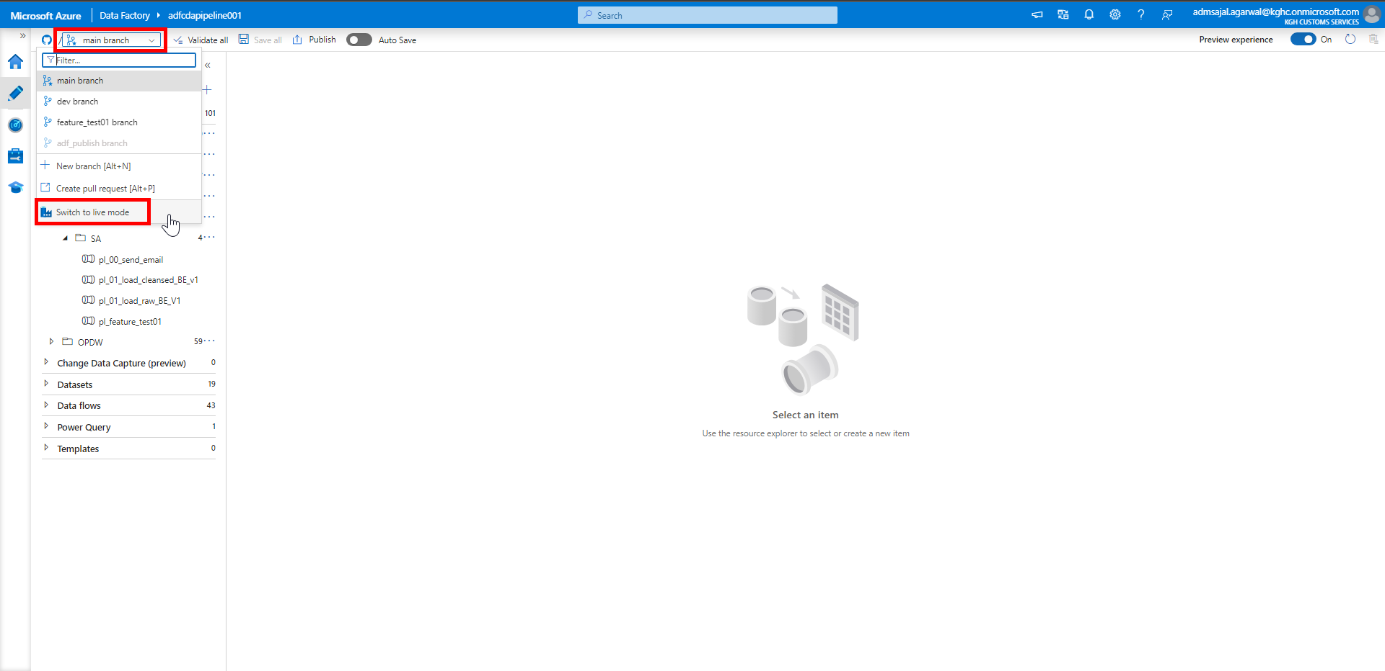

1. Click on *Refresh*.

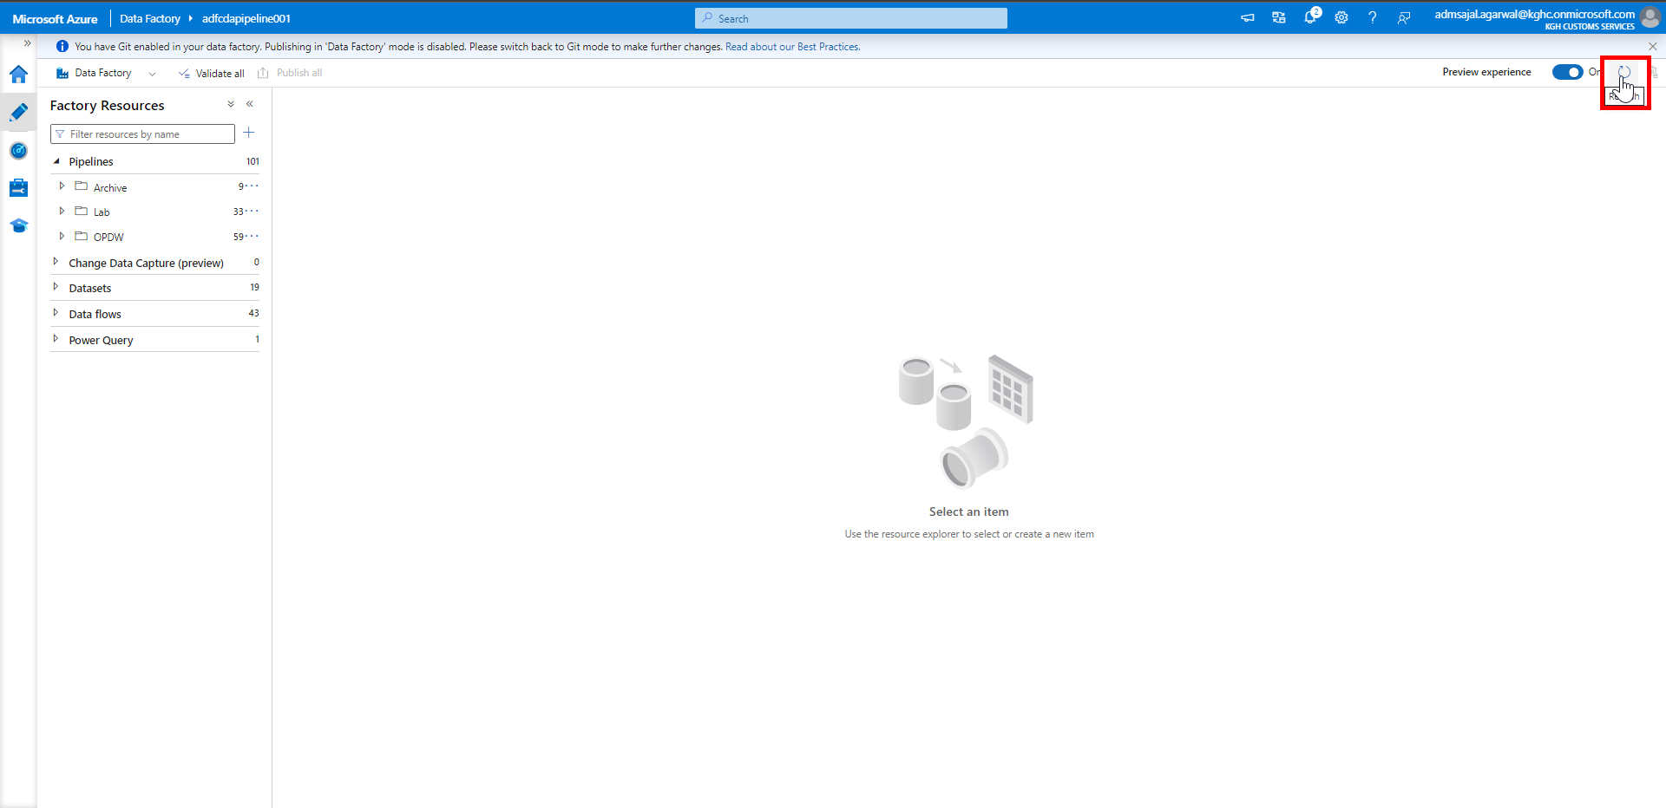

1. Verify that the recently made changes are available in *Data Factory* now.
2. Login to Git Repository. Open below link:

[**Branches · Maersk-Global/cda (github.com)**](https://github.com/Maersk-Global/cda/branches)

Verify that newly created branch *adf_publish* is displayed.

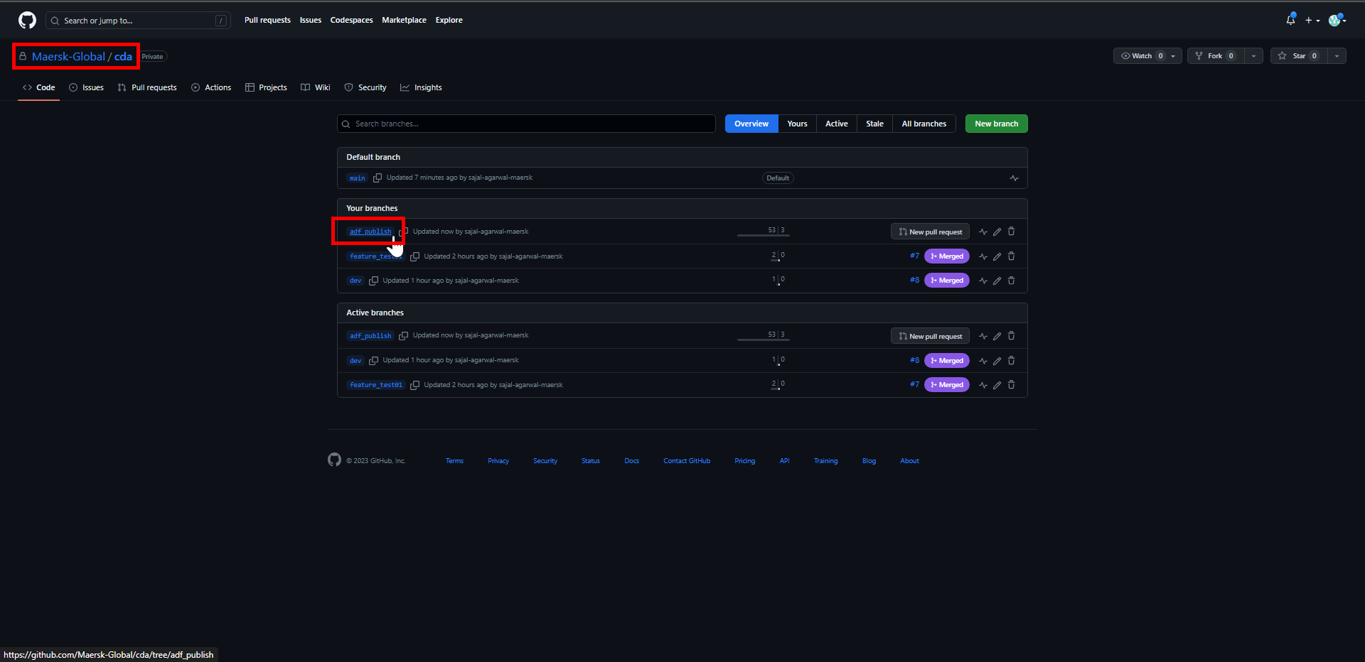

1. Open the folder *adfcdapipeline001* in *adf_publish* branch.

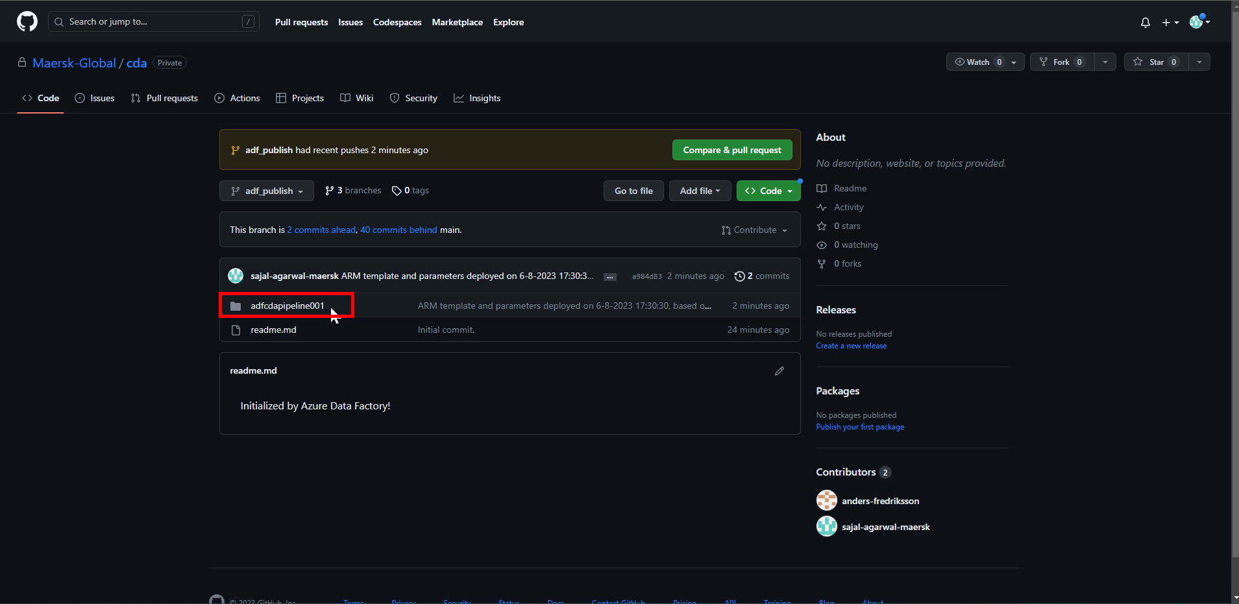

1. Verify that the *ARM template* is uploaded.

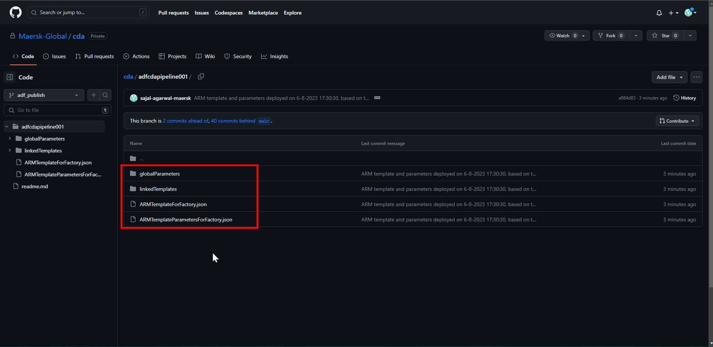

## **Databricks: Git Configuration**

1. Login to Git Repository. Open below link:

[Maersk-Global/cda (github.com)](https://github.com/Maersk-Global/cda)

1. Click on *user* icon on top left corner of screen.

Click on *Settings*.

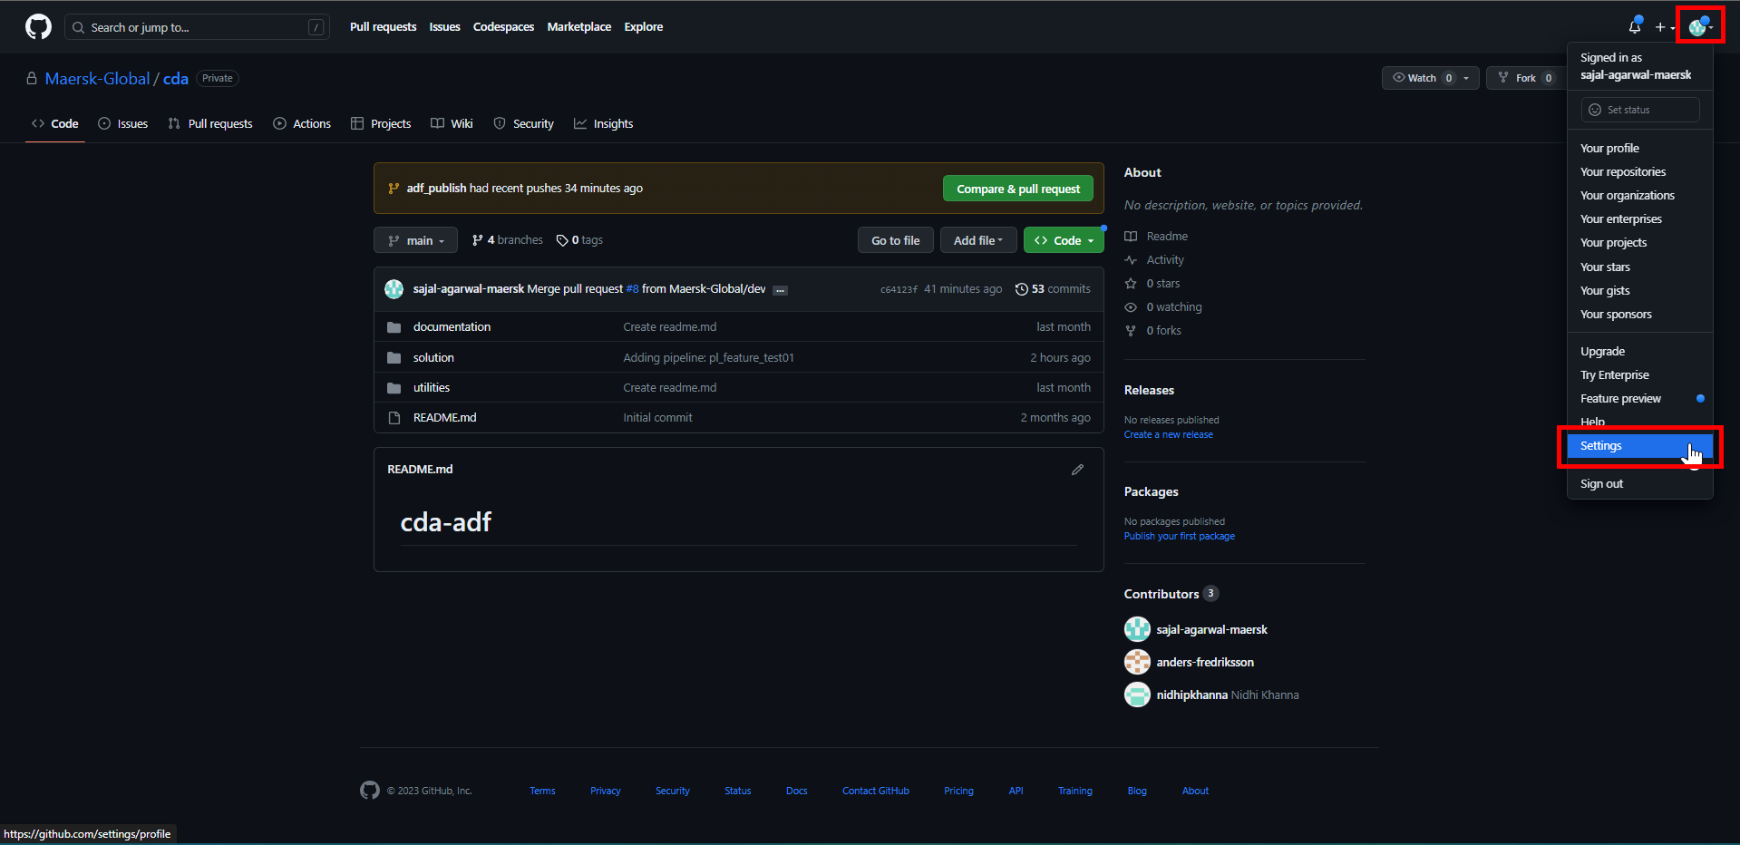

1. Below page will open.

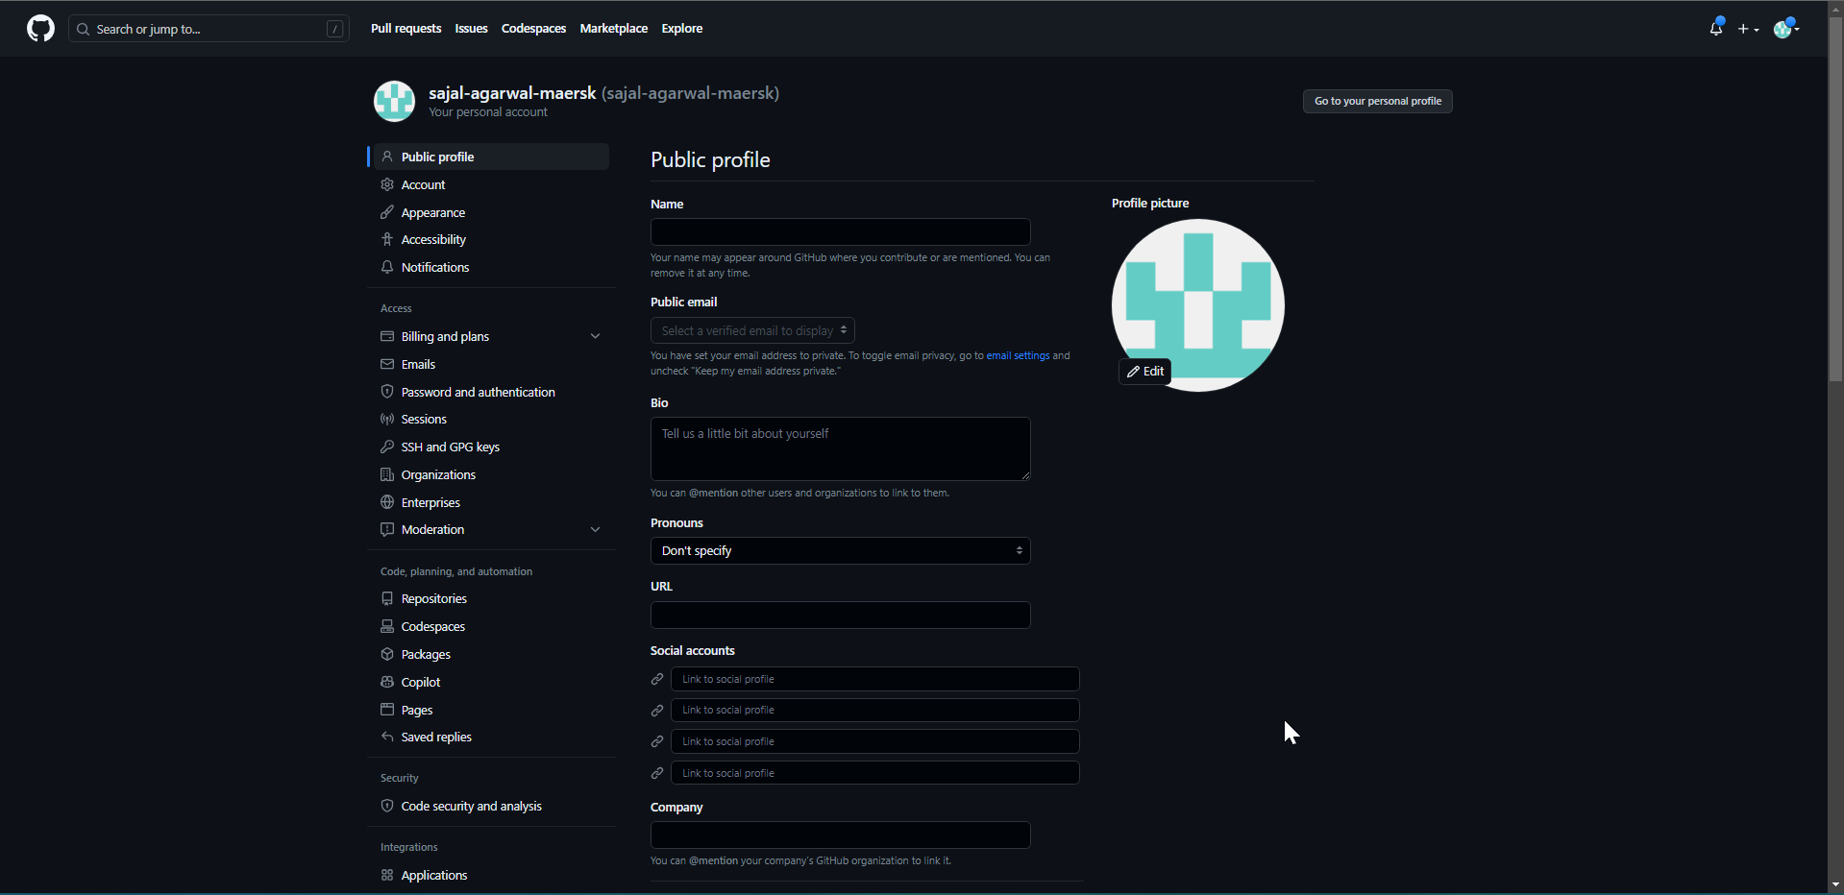

Scroll down and click on *Developer settings*

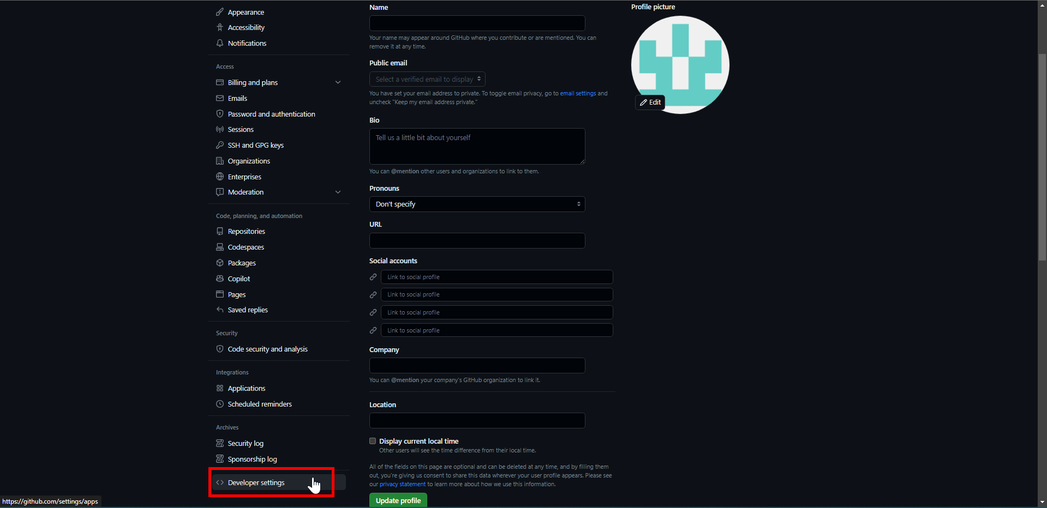

1. Click on *Personal access tokens* 🡪 *Tokens (classic)*

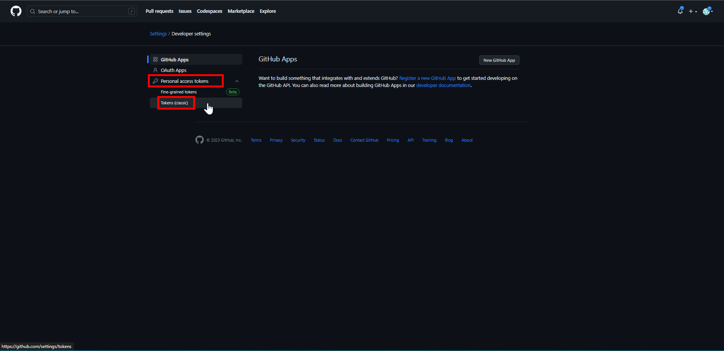

1. Click on *Generate new token* 🡪 *Generate new token (classic)*

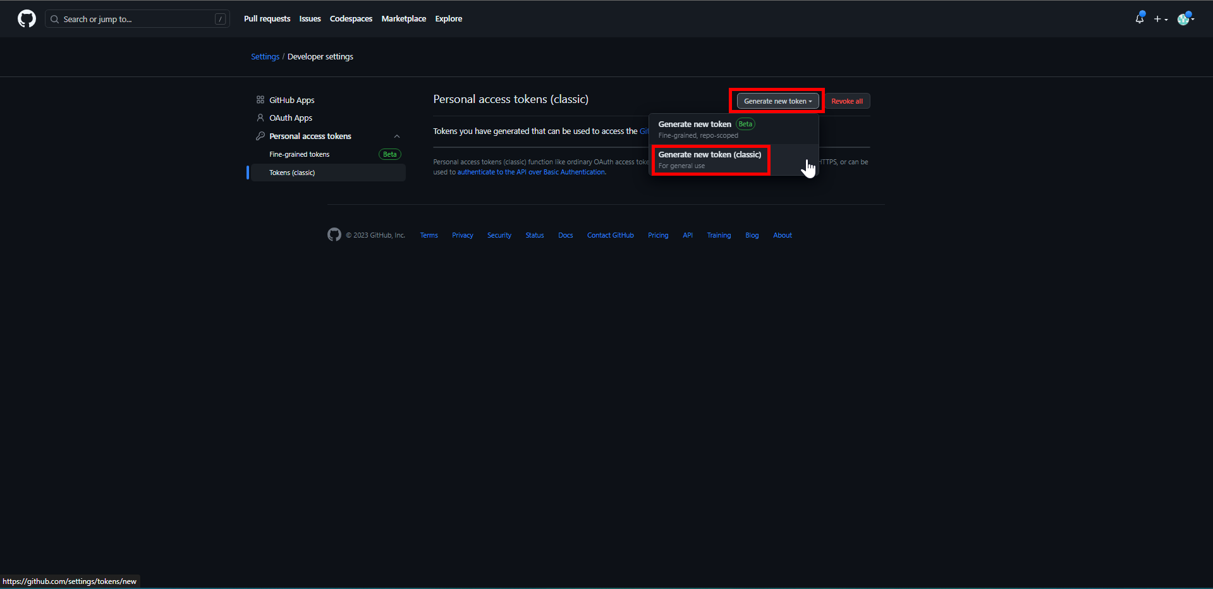

1. Authorize Azure Databricks to access Git repository.

Enter Git credentials if asked for.

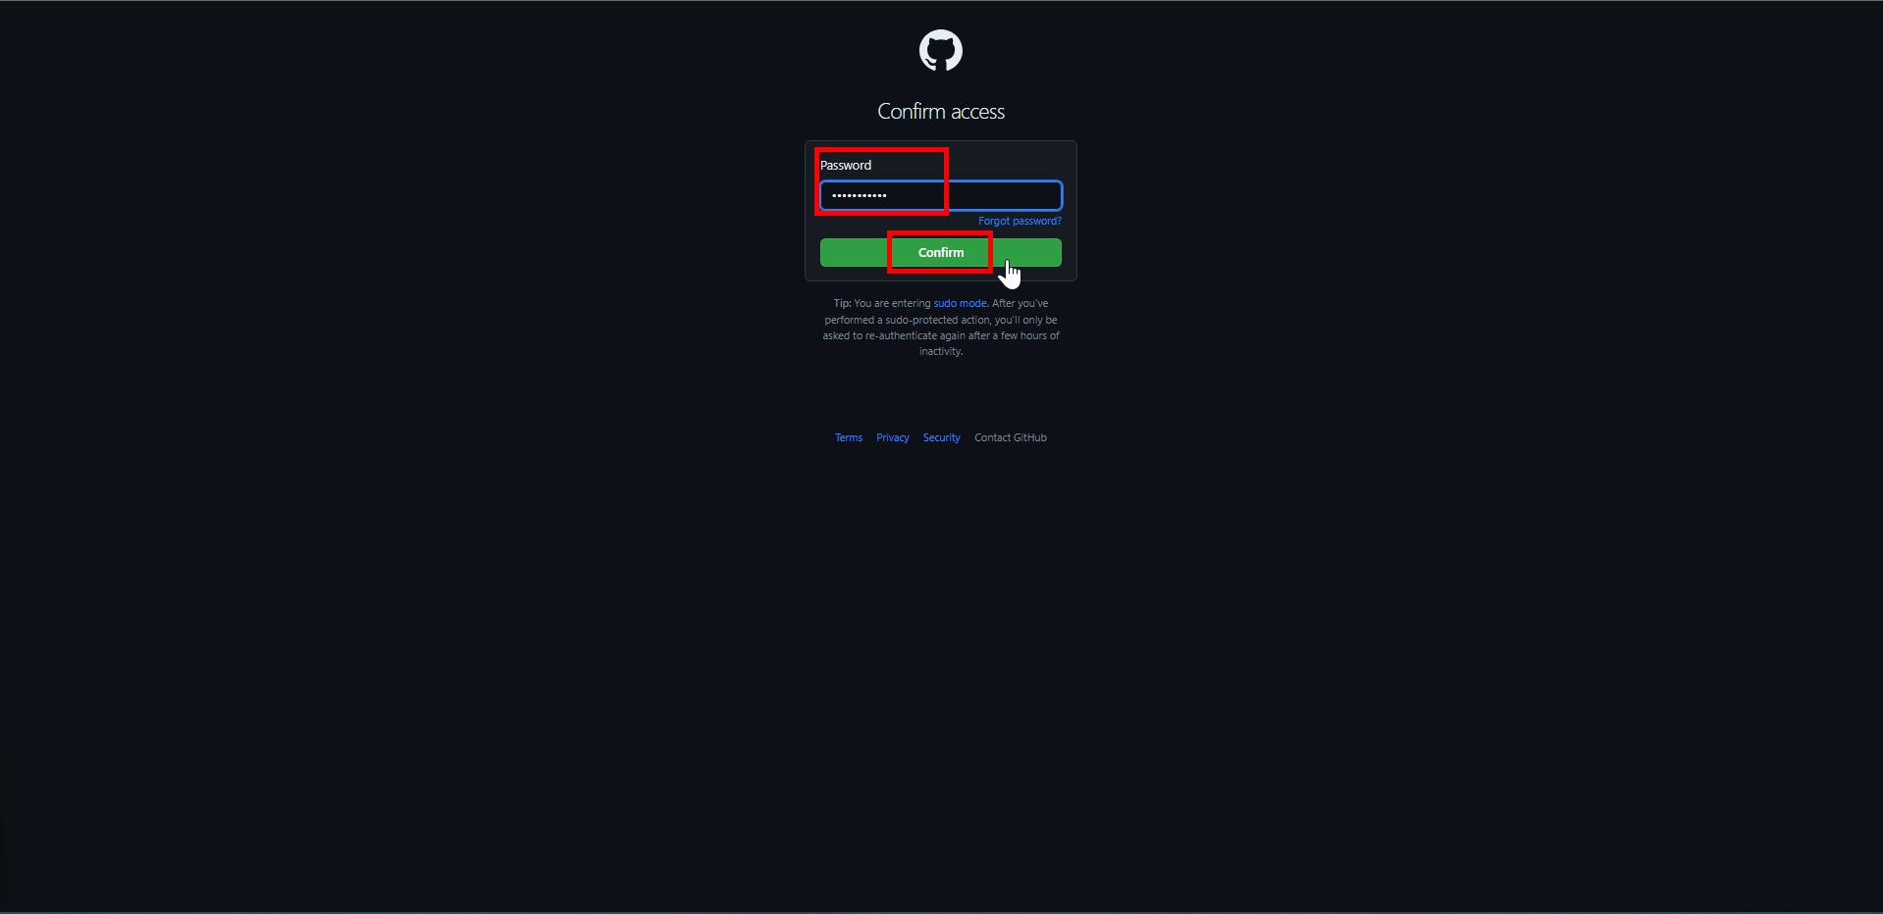

1. Add a *Note* specifying the purpose of token.

Set the *Expiration*.

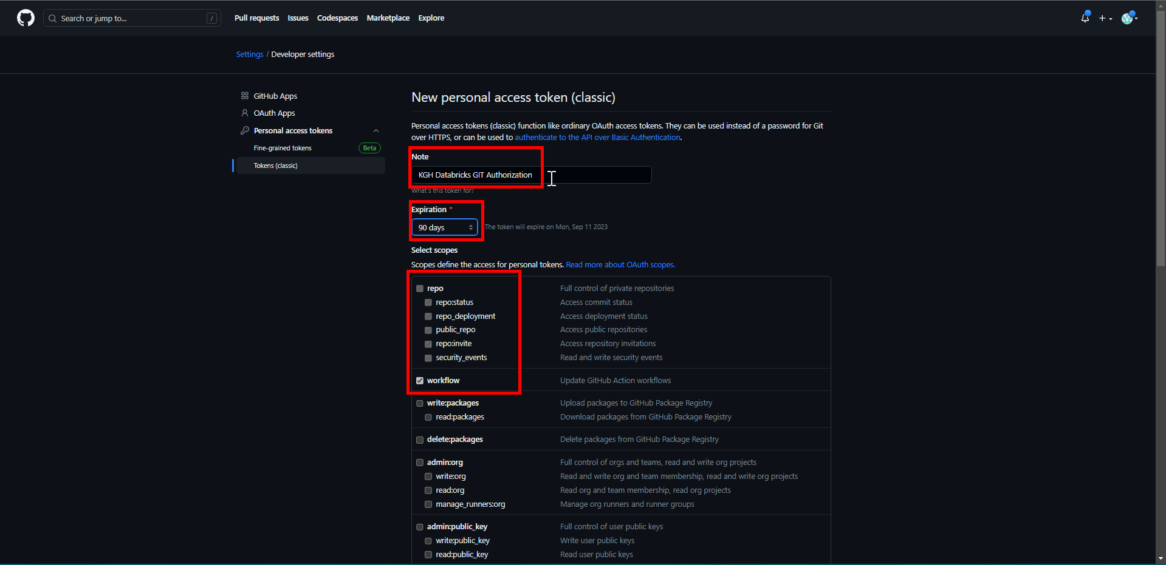

Scroll down.

Click on *Generate token*.

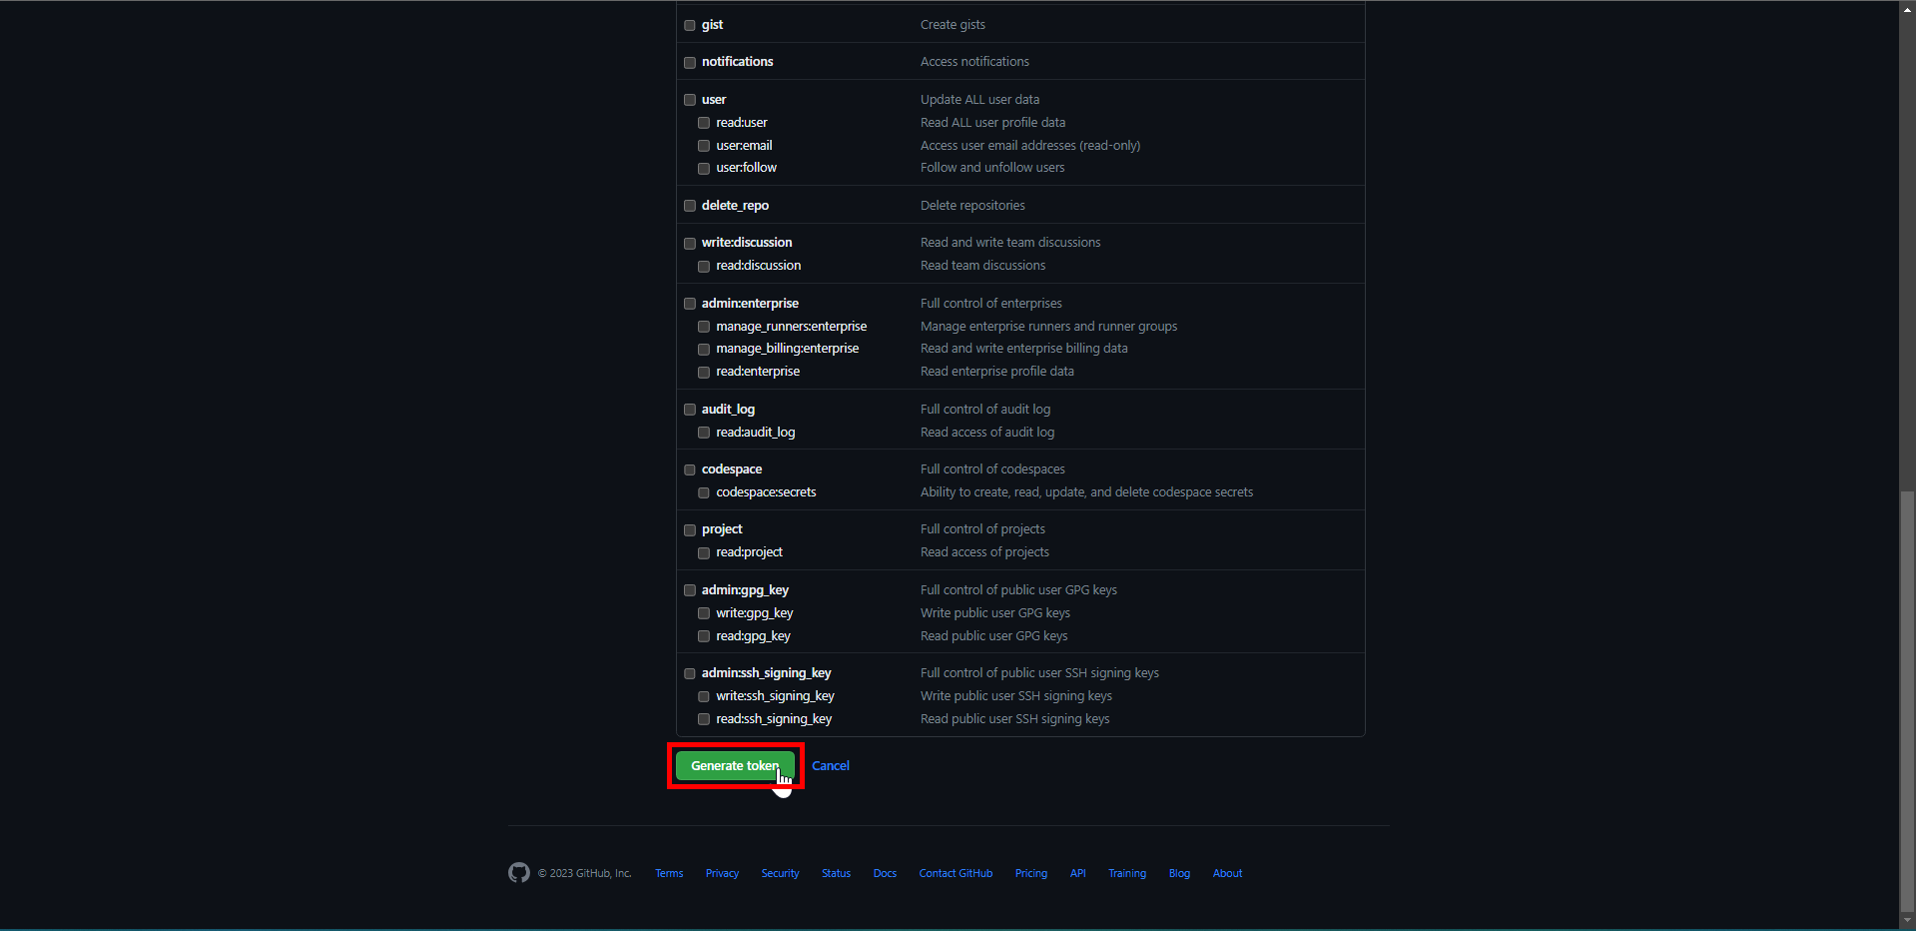

1. An email will be triggered as below:

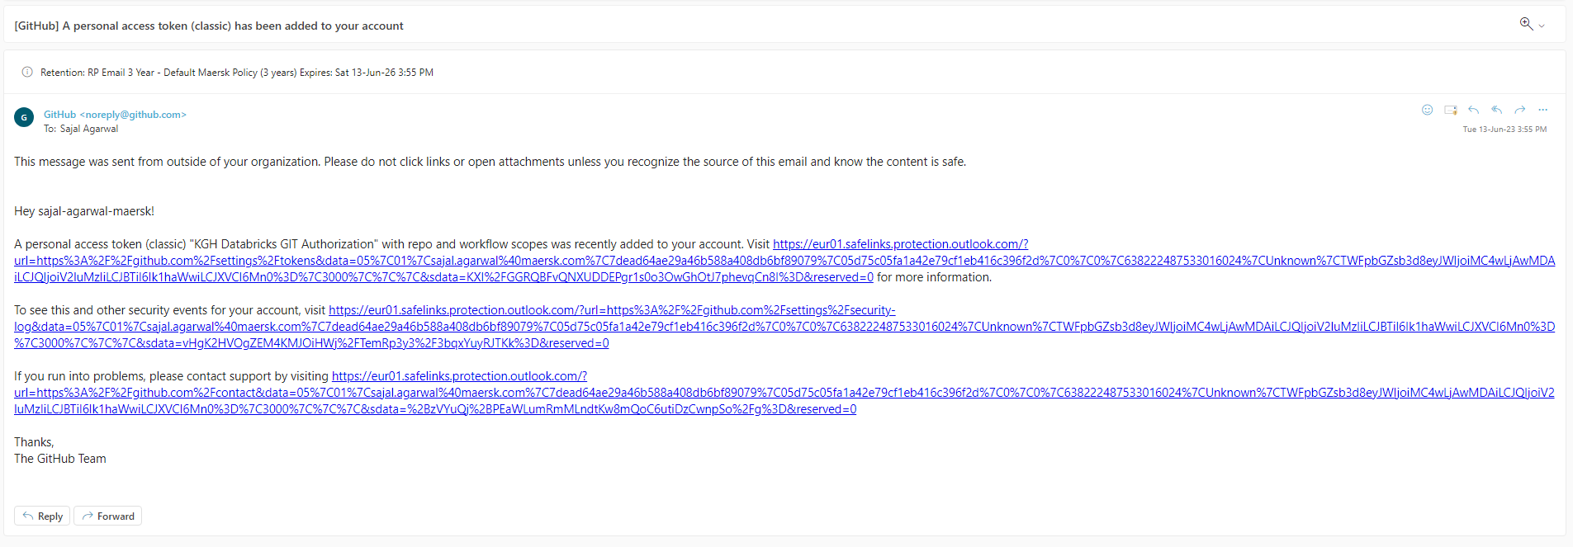

1. Copy the generated token and keep it in a safe place.

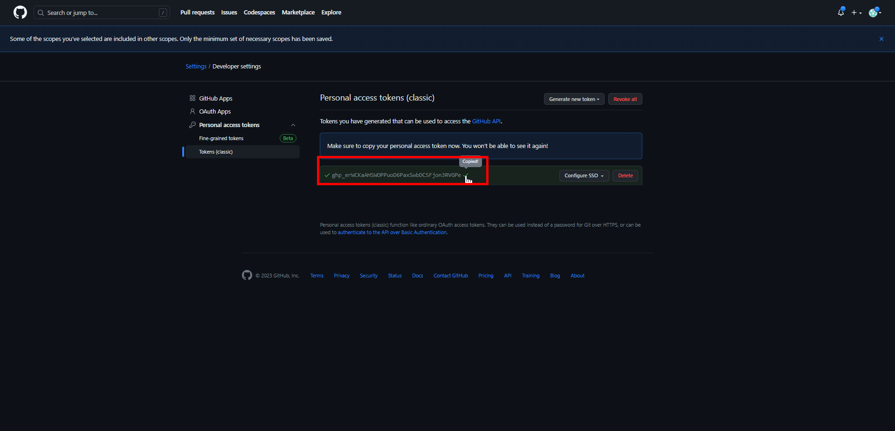

1. In Git, click on *Configure SSO* 🡪 *Authorize*

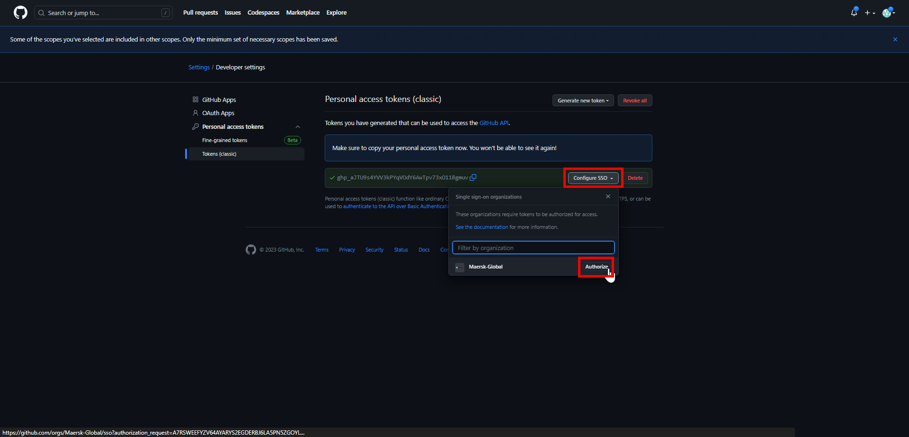

1. Click on *Continue*

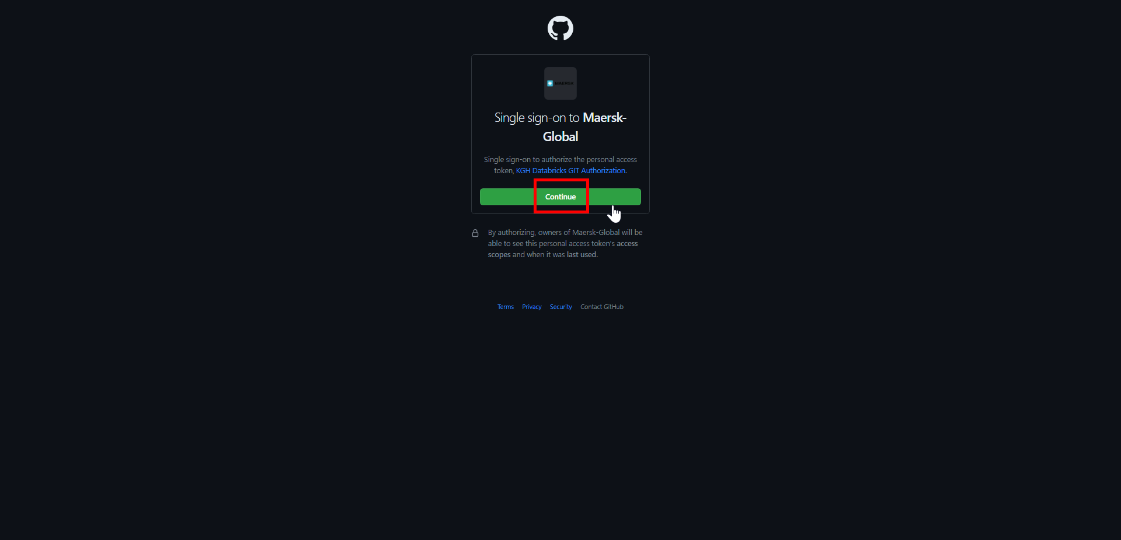

1. Click on *Continue*.

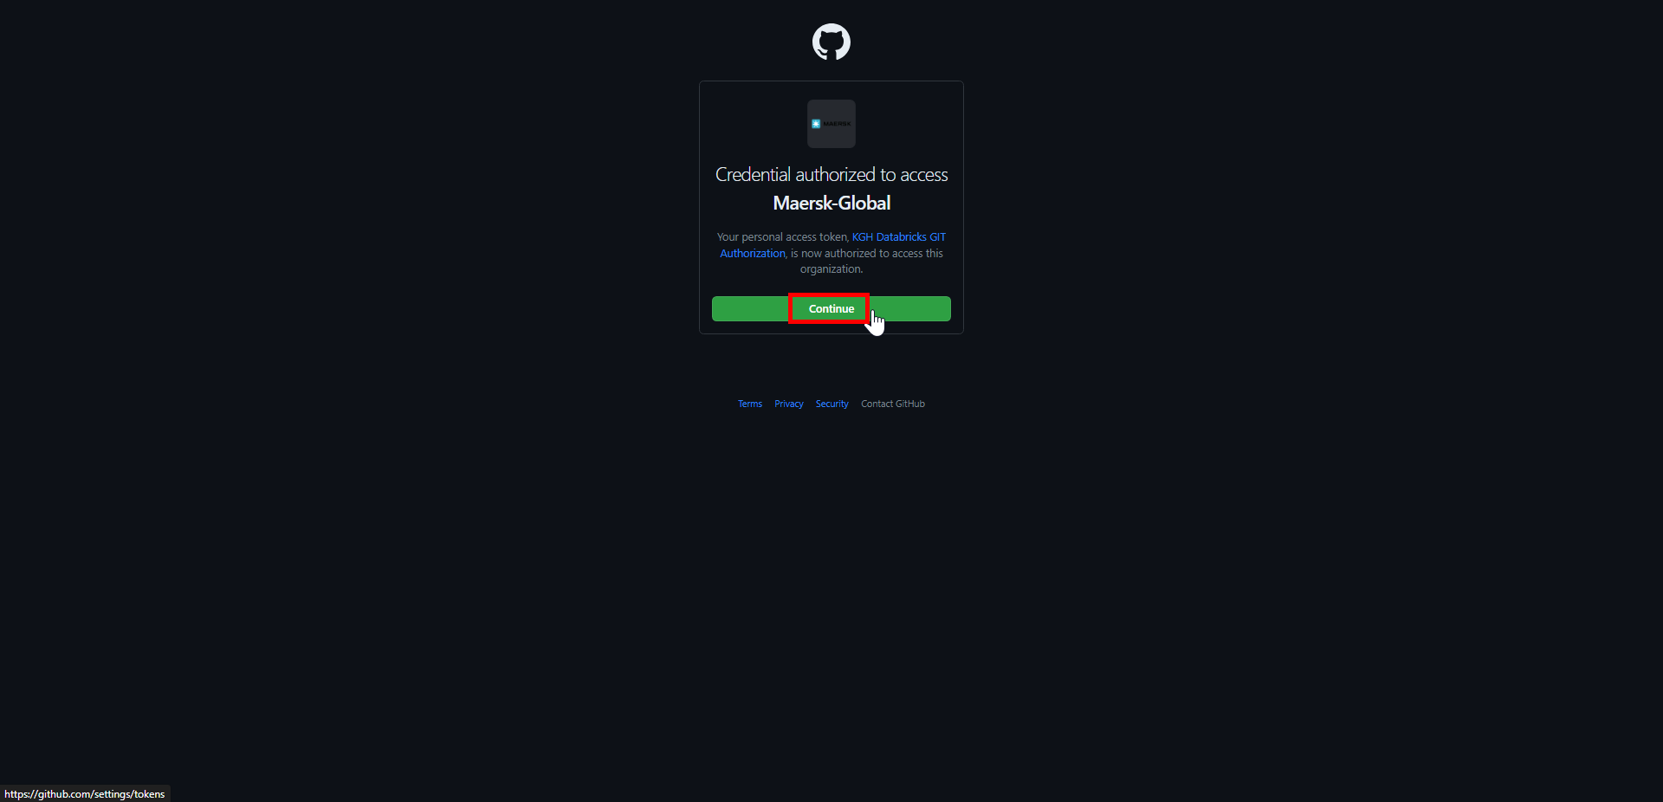

1. It will show the below screen.

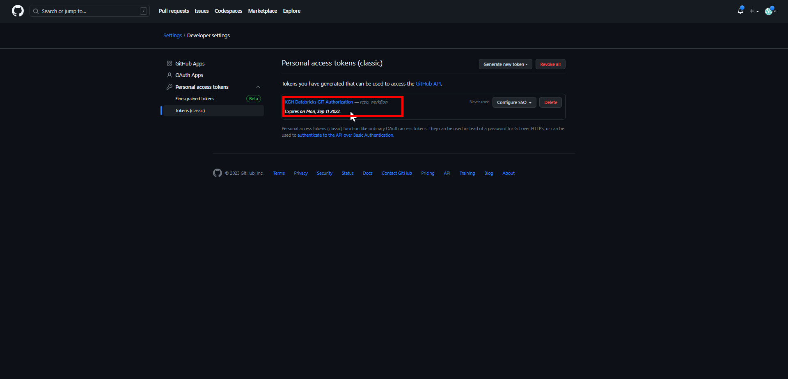

1. Login to *Databricks*.

Click on *username* 🡪 *User Settings*

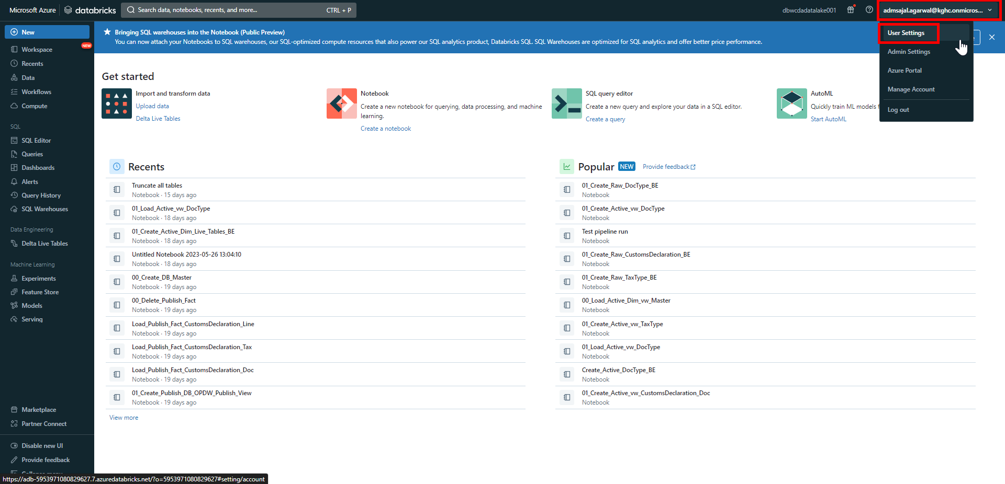

1. Click on *Git integration*

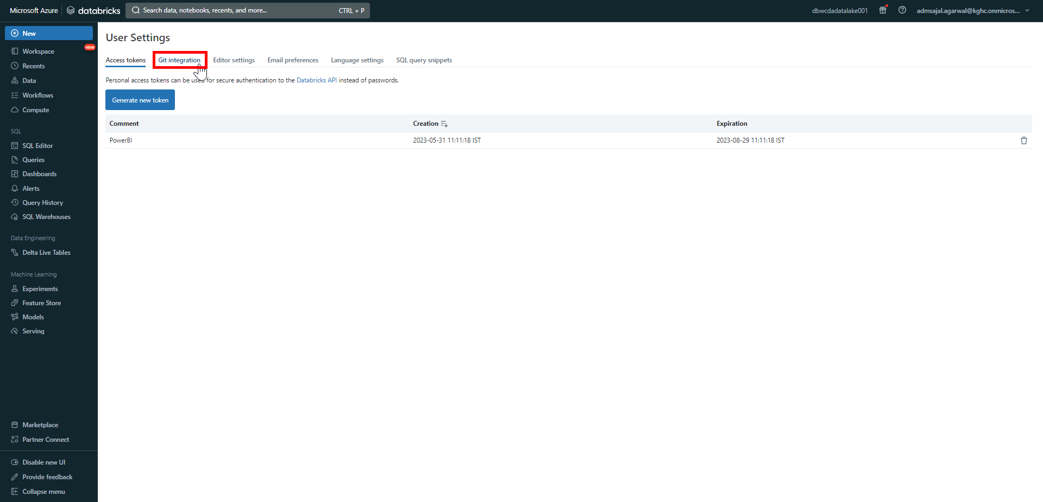

1. Fill the details as below:

Git provider *GitHub*

Git provider username or email: *<Git username>*

Token: *<copied from Git>*

Click on *Save*.

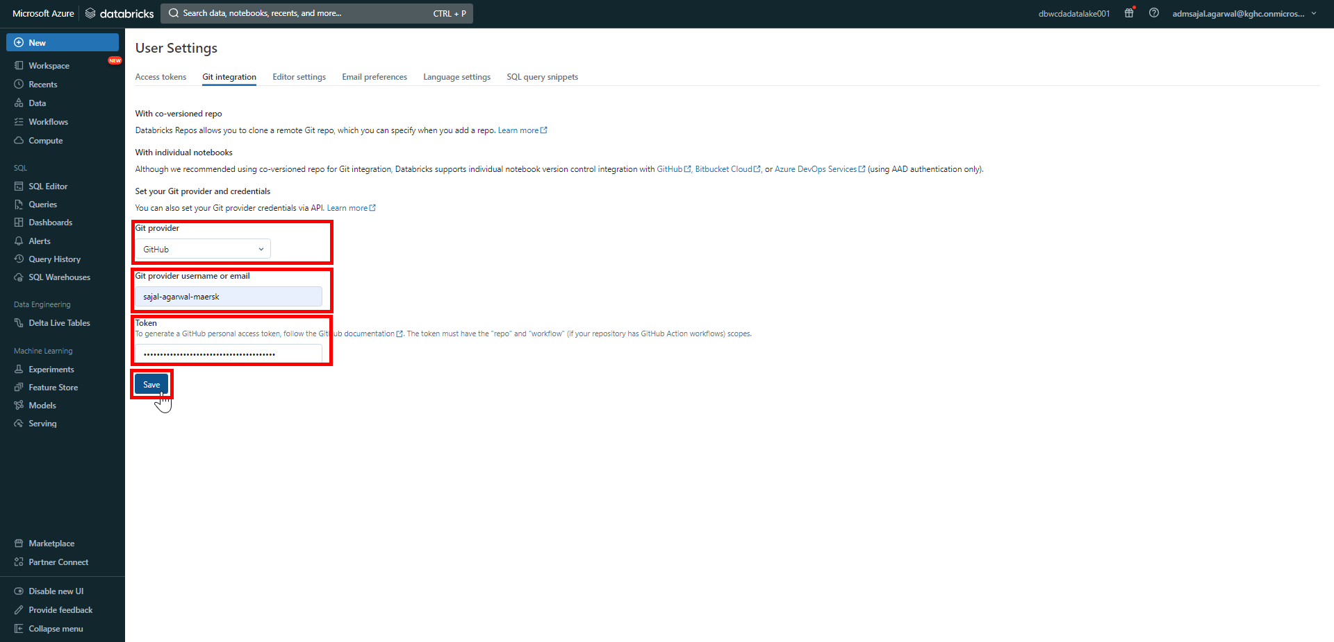

1. On successful save, it will show the notification as *Credentials update* 🡪 *Successfully saved.*

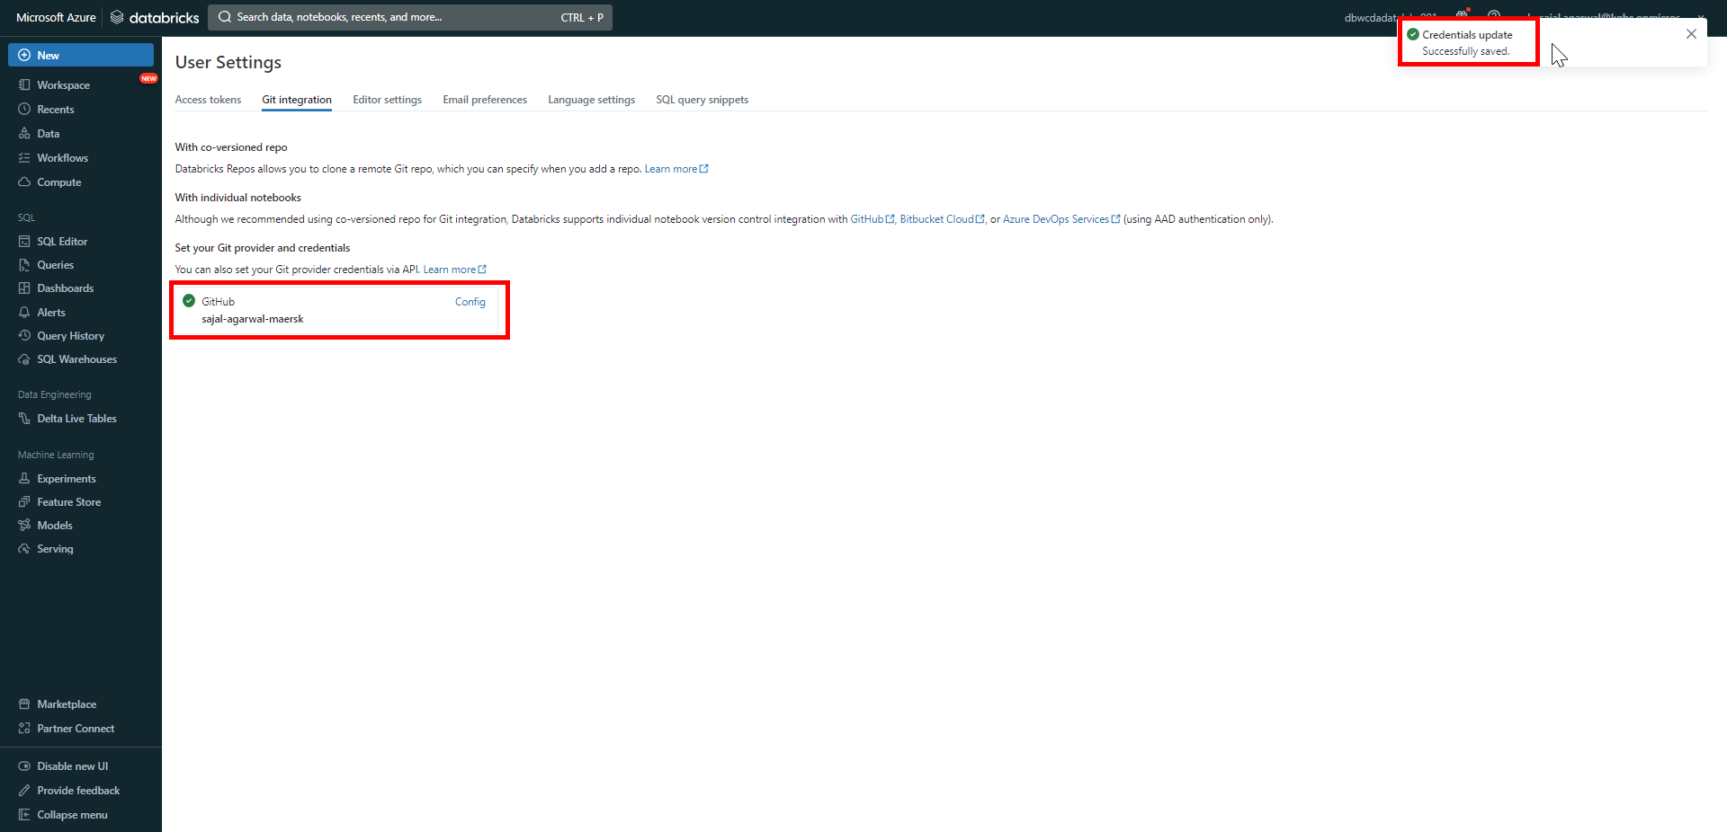

1. Click on *Workspace* 🡪 *Repos*

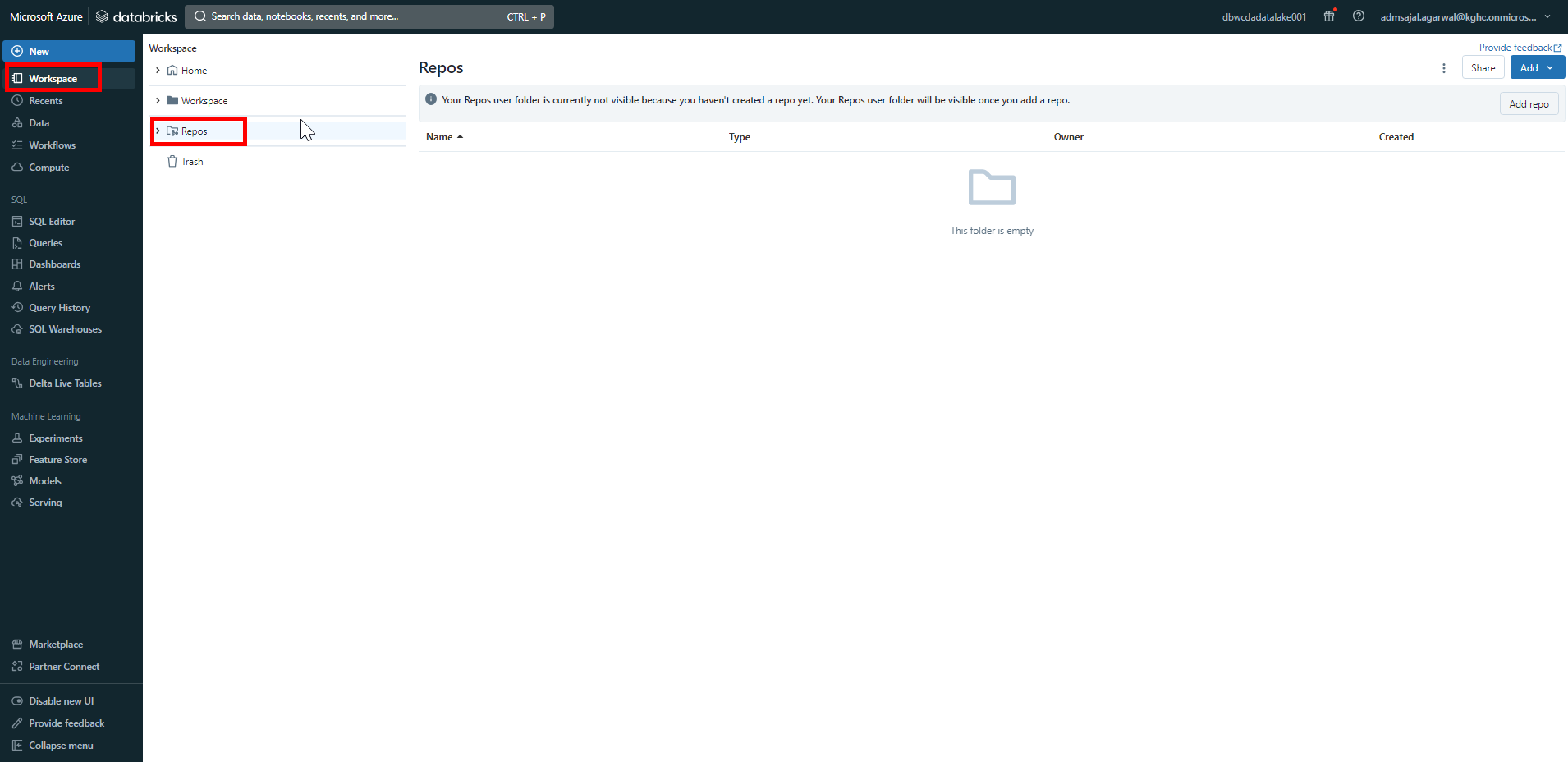

1. Click on *Add* 🡪 *Folder*

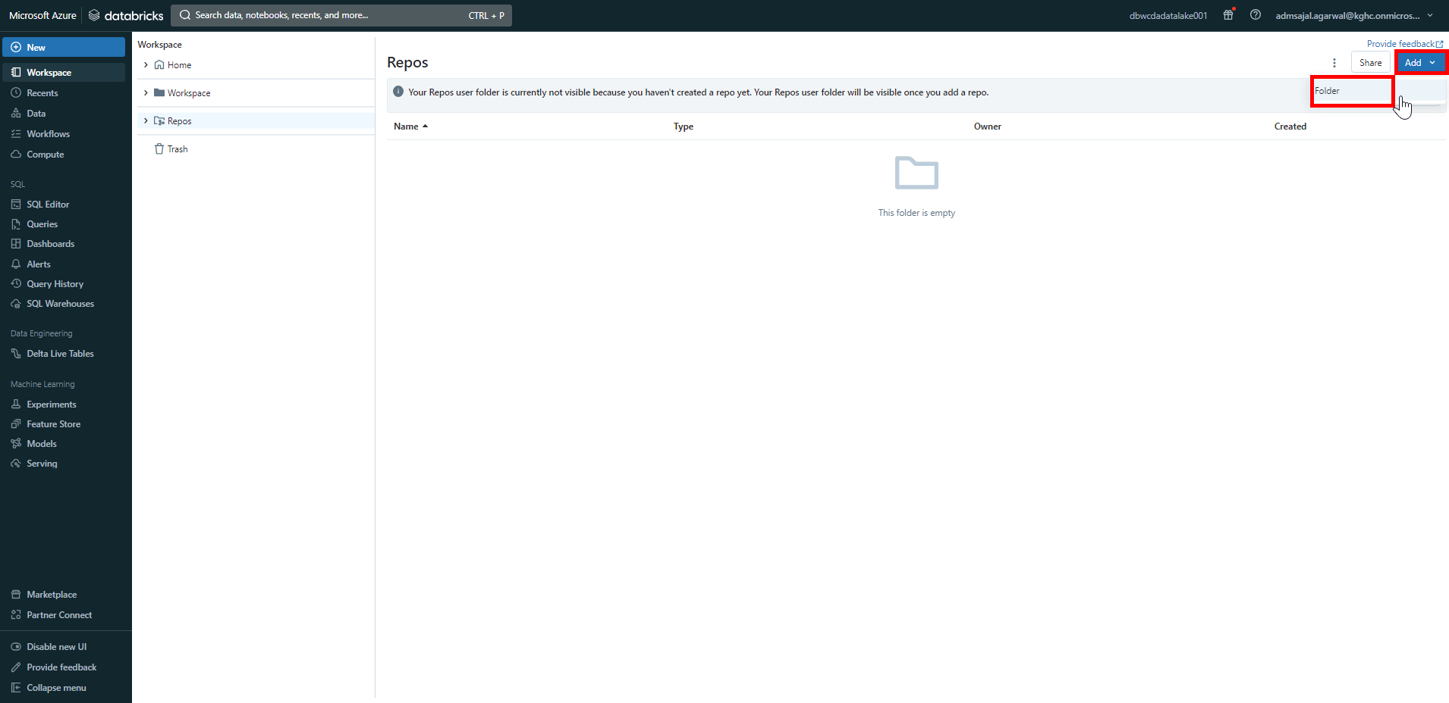

1. Set the folder name as *feature*.

Click on *Create*.

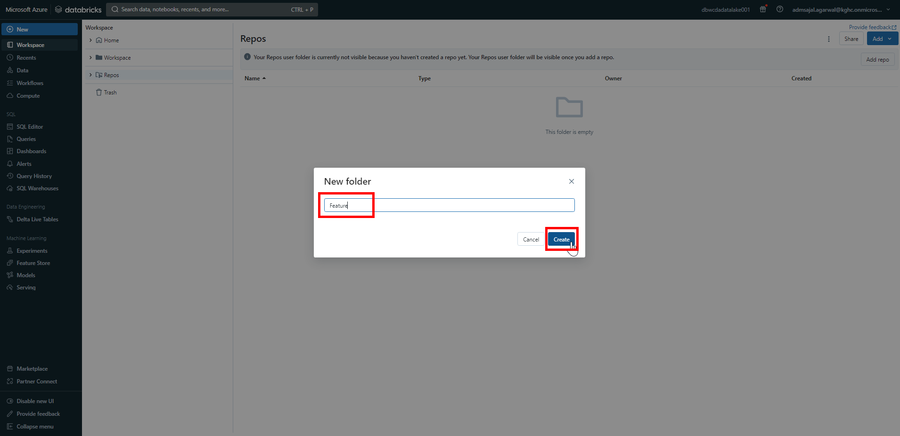

1. Click on *Add* 🡪 *Repo*.

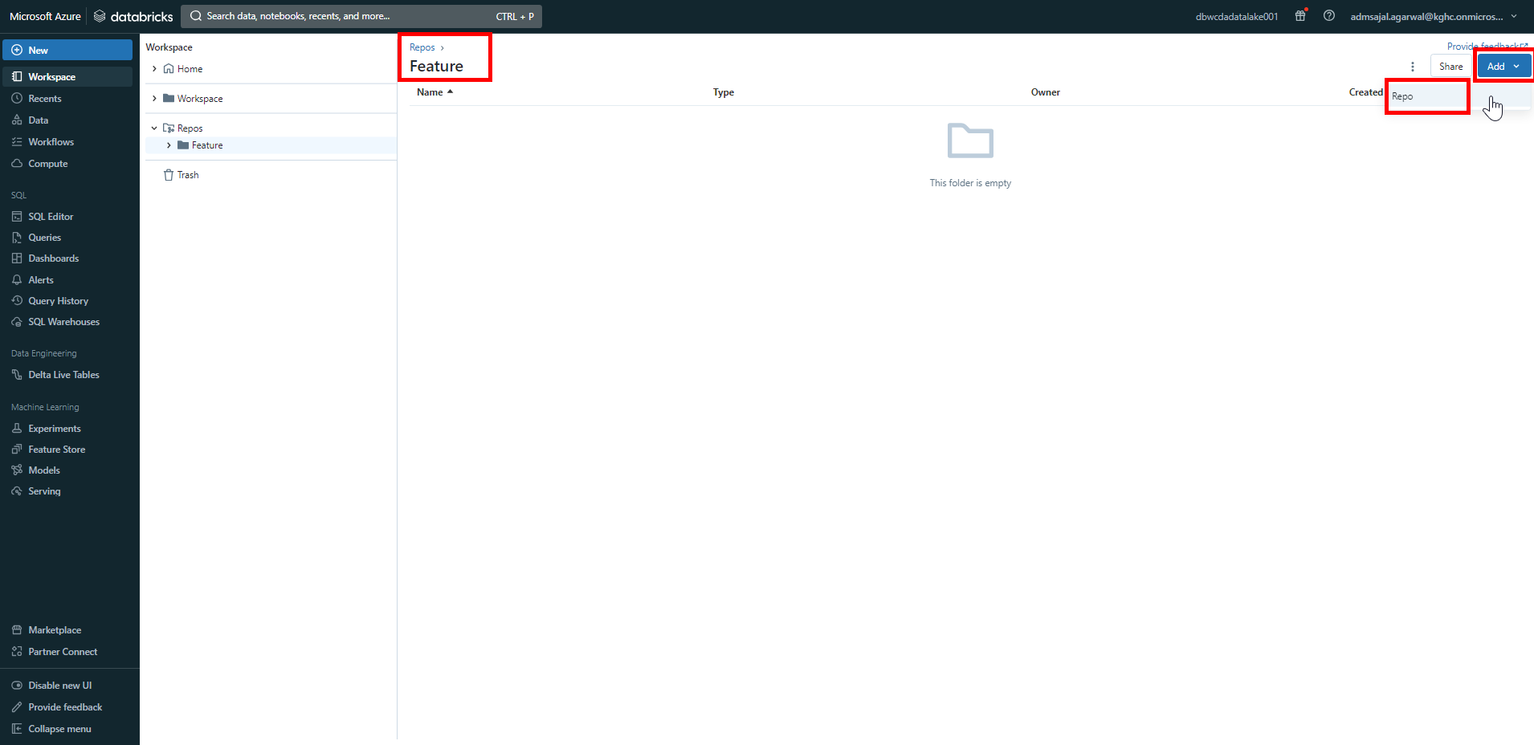

1. Fill the fields as below:

Tick-mark on *Create repo by cloning a Git repository*

Git repository URL: [*https://github.com/Maersk-Global/cda.git*](https://github.com/Maersk-Global/cda.git)

Git provider: *GitHub*

Repository name: *cda*

Tick-mark on *Sparse checkout mode*

Cone patterns: *solution/Databricks/Notebooks*

Click on *Create repo*.

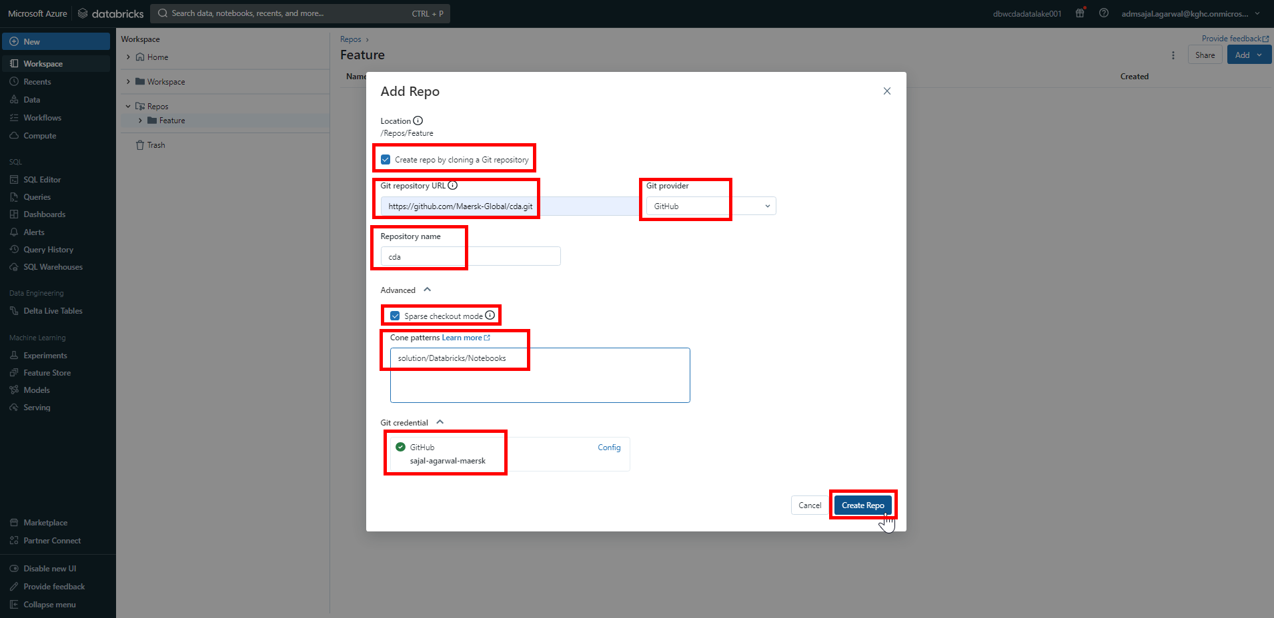

1. Verify that the *solution* folder is now available inside *cda* repository inside *Feature* folder.

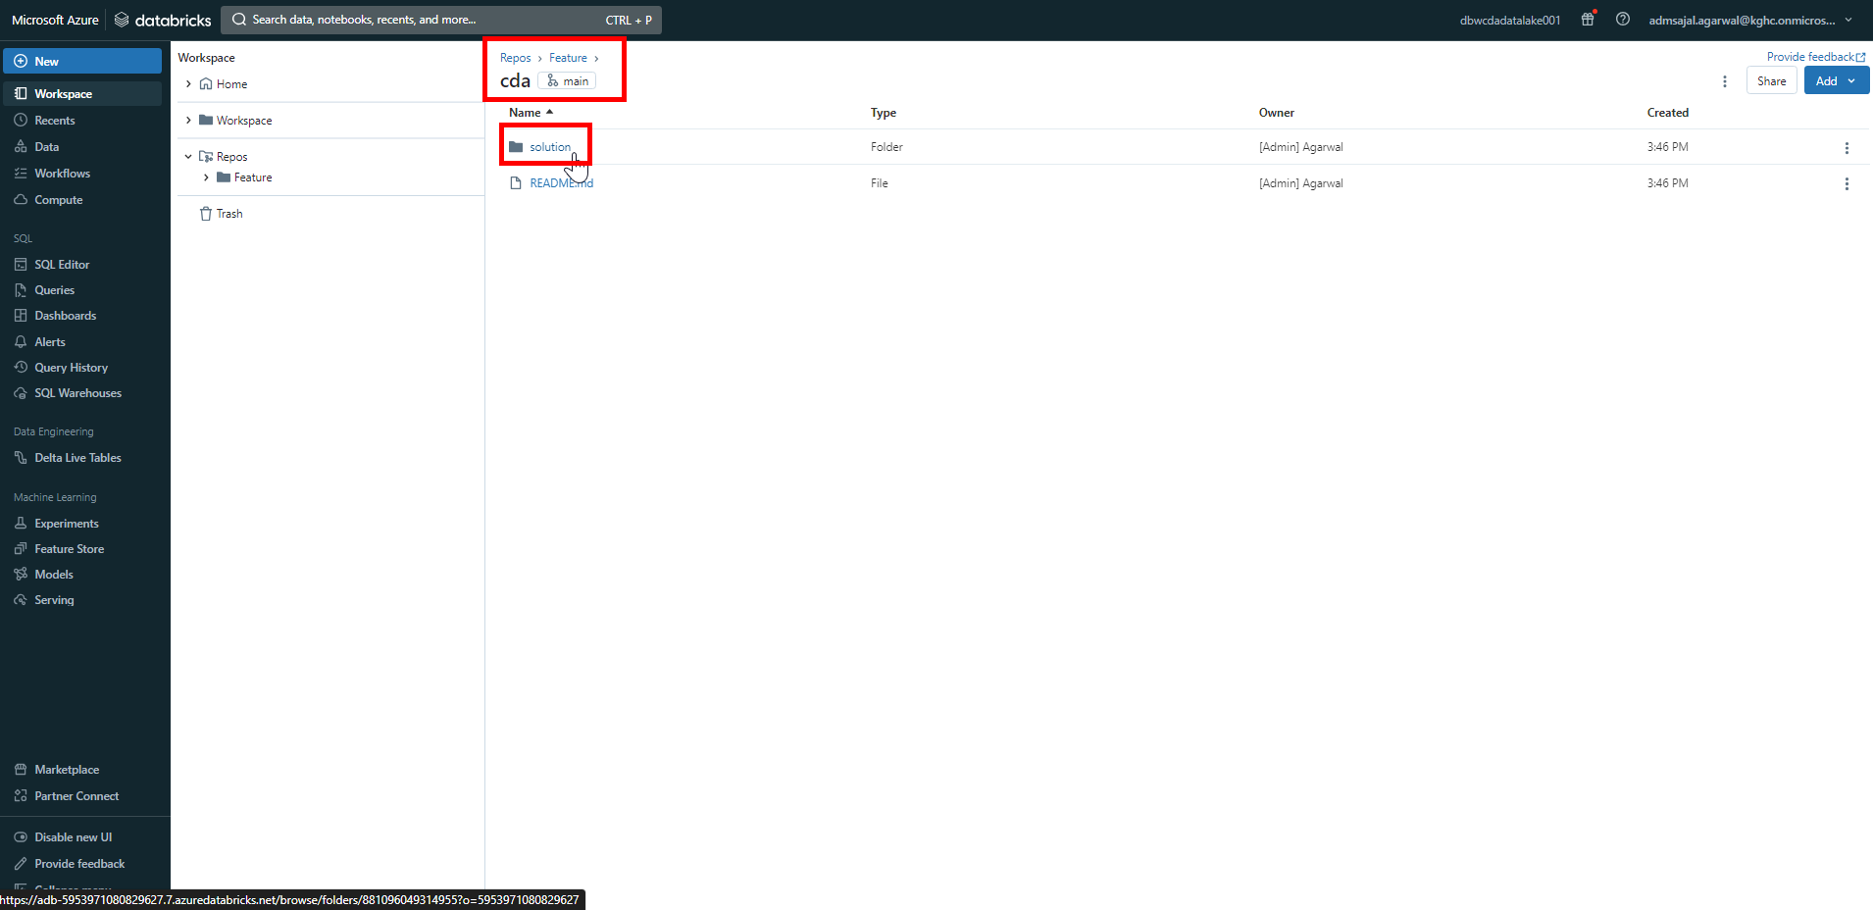

1. From the *Workspace* menu on left side of screen, expand *Repos* 🡪 *Feature* 🡪 *cda*.

Right click on *cda*.

Click on *Git*.

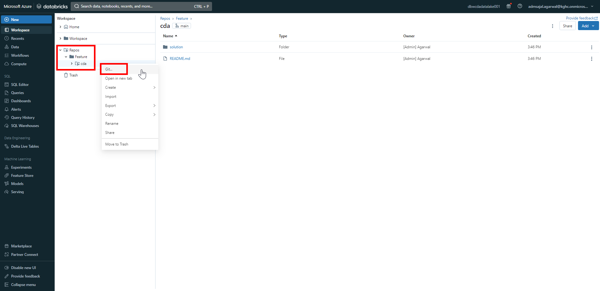

1. Open drop-down and select *dev* branch.

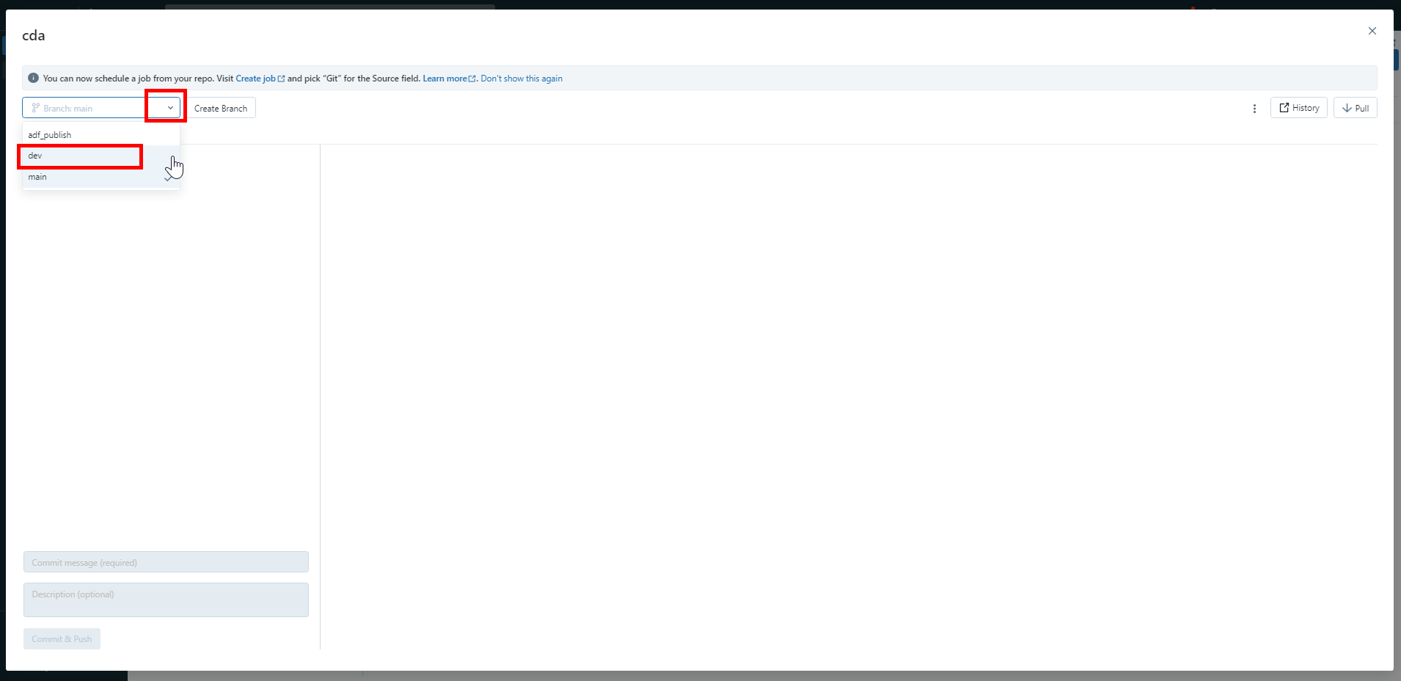

1. Click on *Create Branch*.

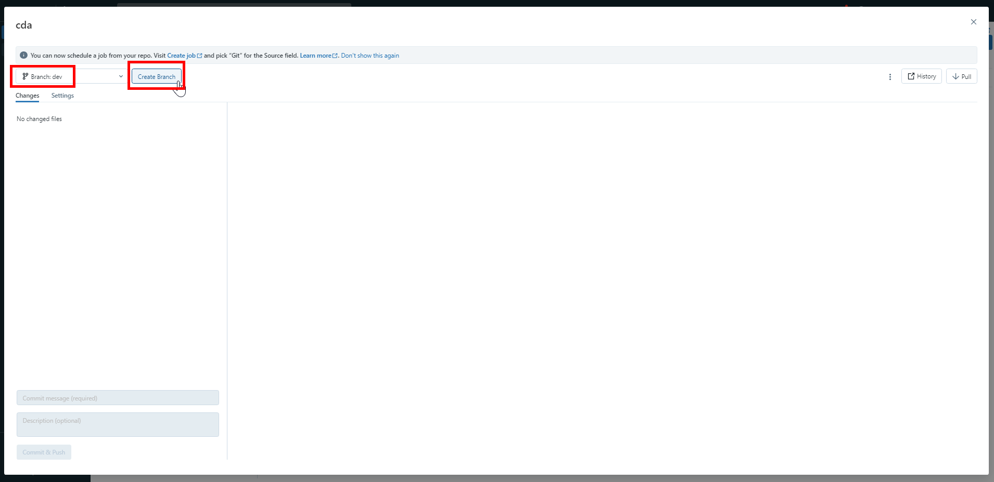

1. Give *Branch name* as *feature_test01*.

Make sure *dev* branch is selected as *Based on*.

Click on *Create*.

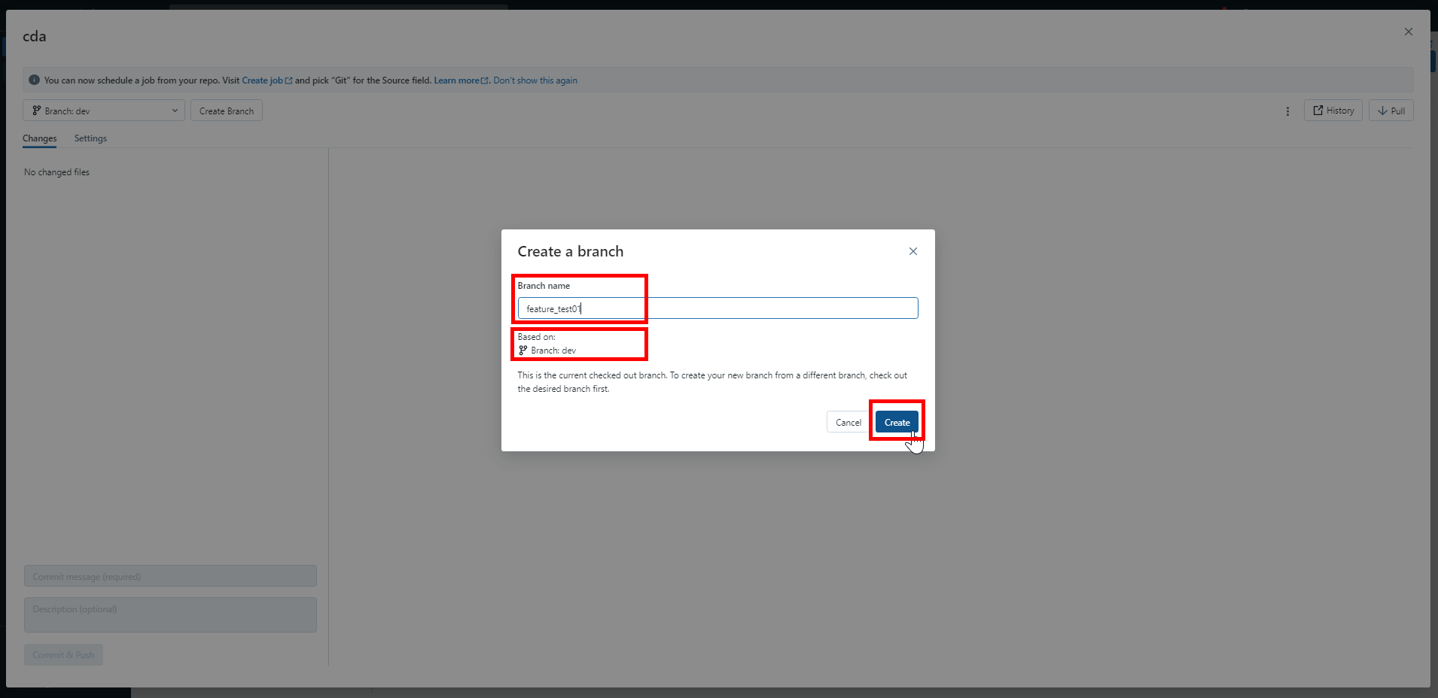

1. With newly created *feature_test01* branch selected, click on *X*.

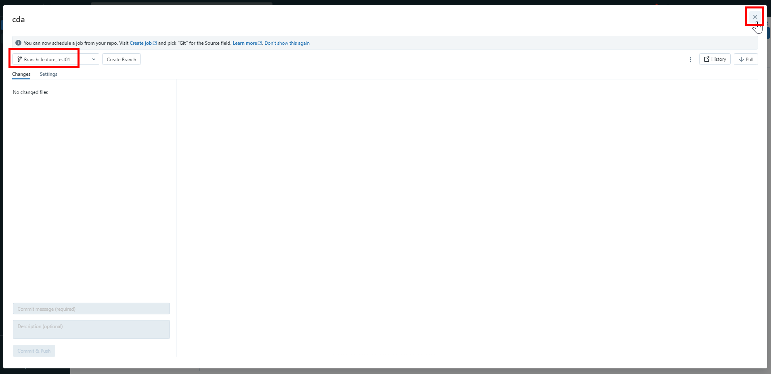

## **Databricks: Continuous Integration (CI)**

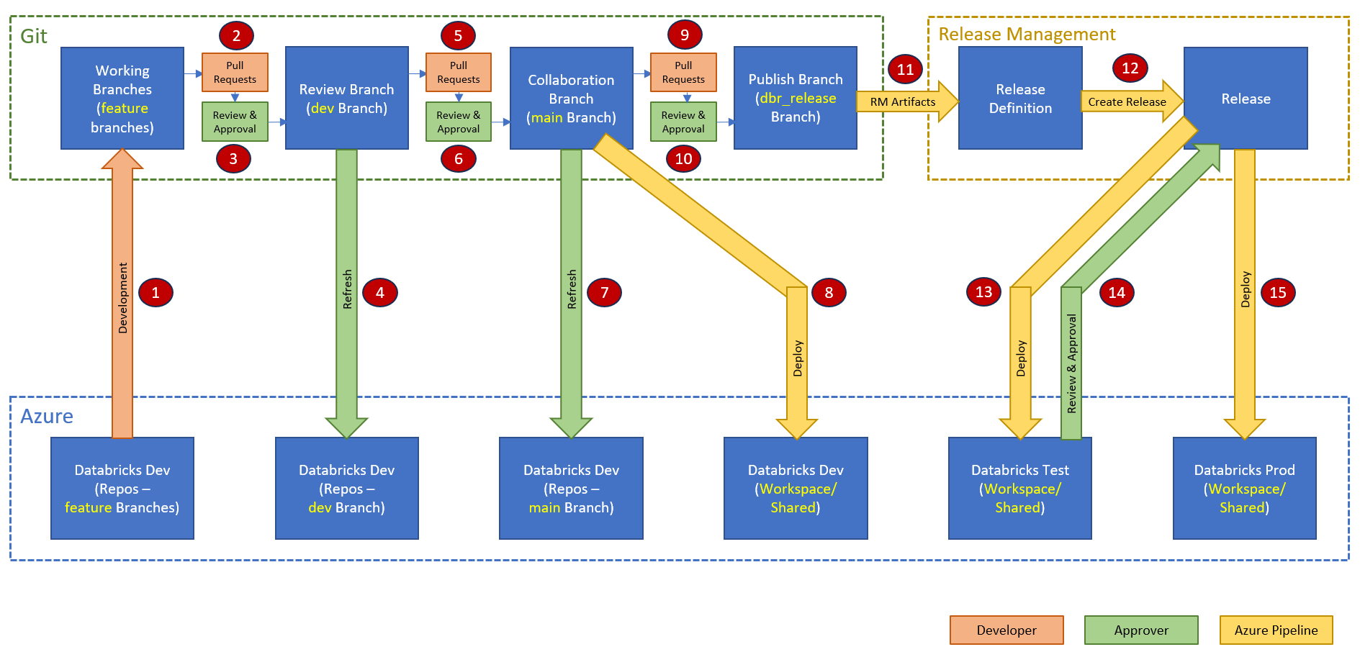

### **Code Development in Working Branch (Responsible: Developer)**

1. Click on *Workspace* 🡪 *Shared* 🡪 *OPDW*.

Right click on *OPDW* folder.

Click on *Clone*.

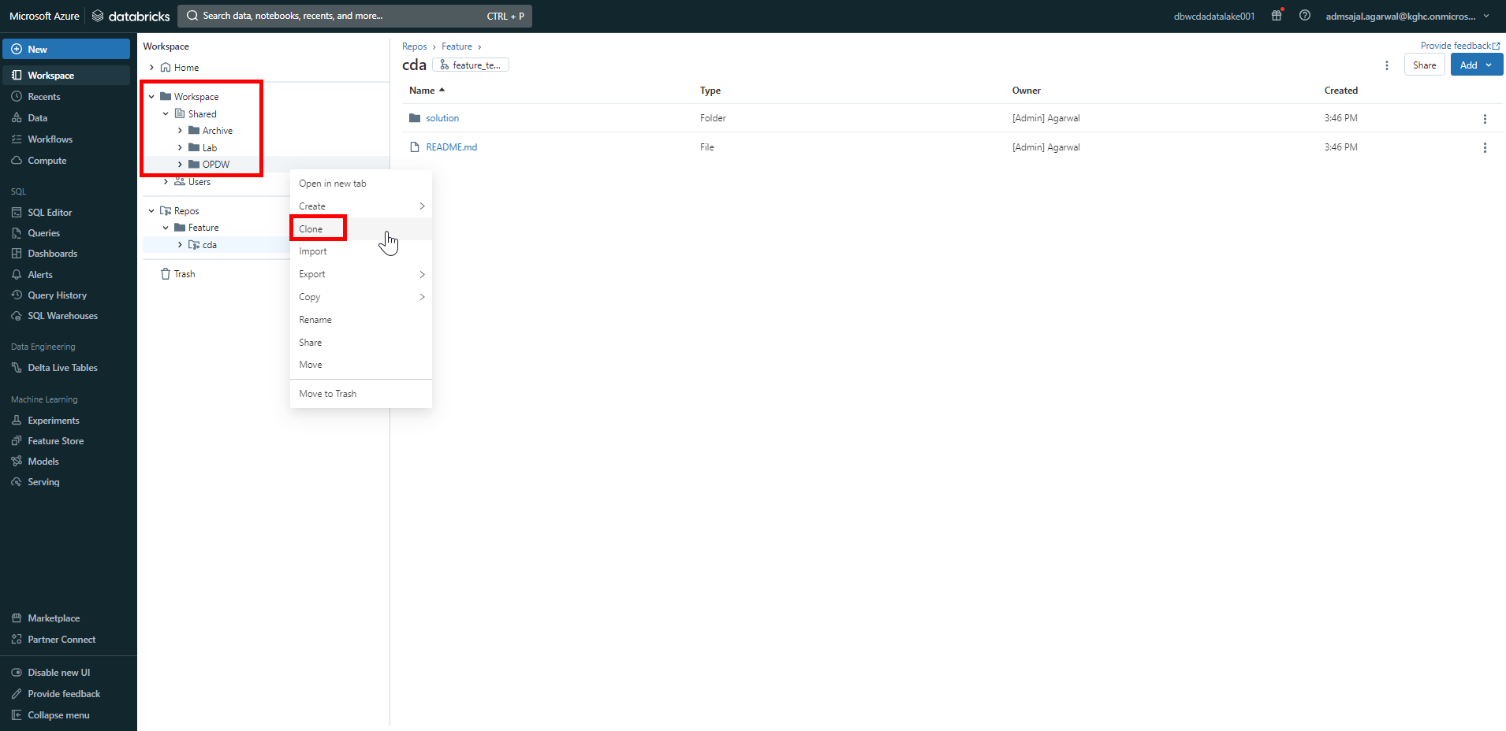

1. Set the target directory as *Repos/Feature/cda/solution/Databricks/Notebooks*.

Give *New name* as *OPDW*.

Click on *Clone*.

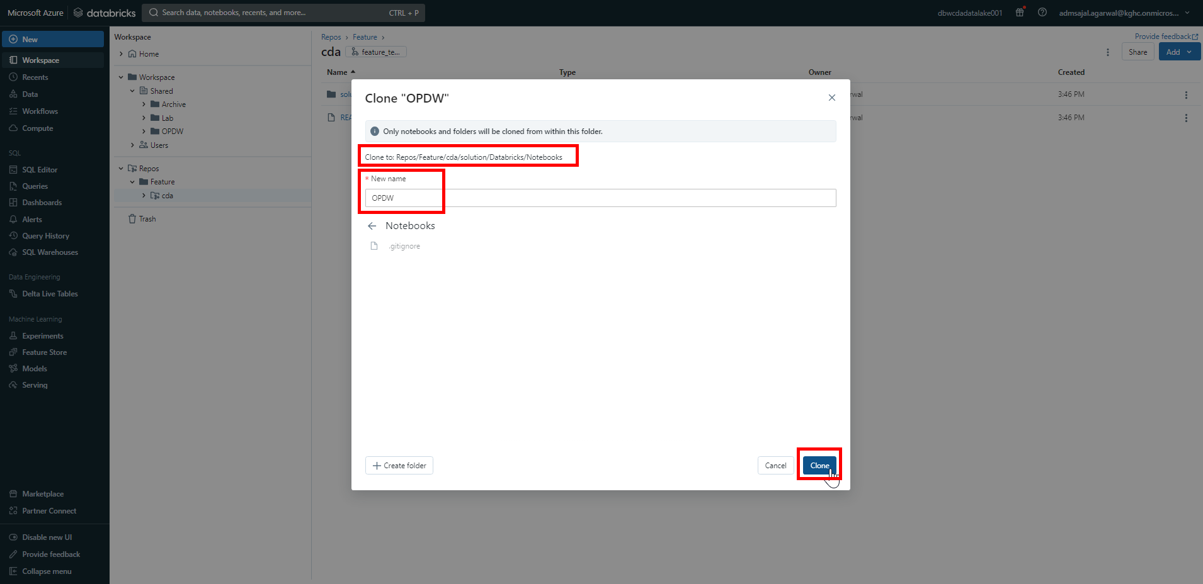

1. Make sure OPDW folder is copied successfully.

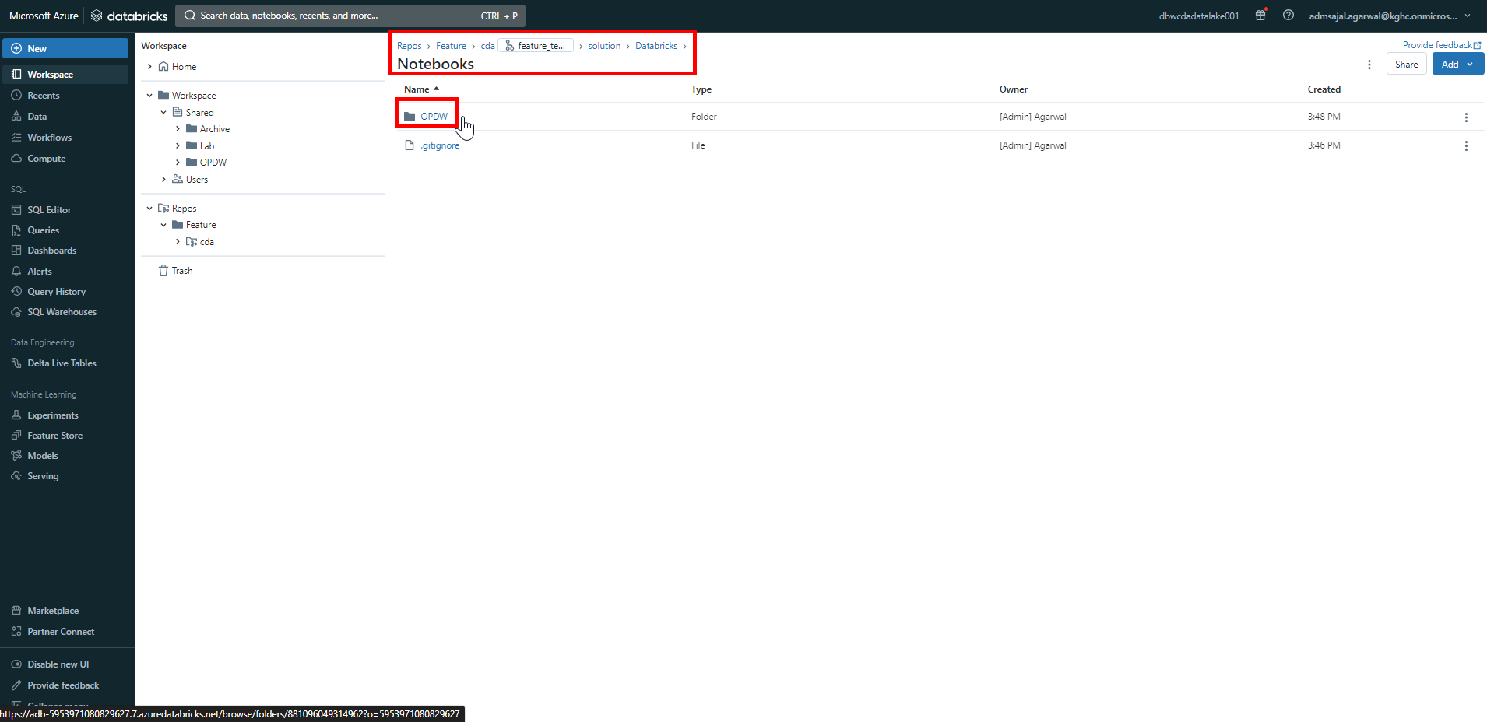

1. From the *Workspace* menu on left side of screen, expand *Repos* 🡪 *Feature* 🡪 *cda*.

Right click on *cda*.

Click on *Git*.

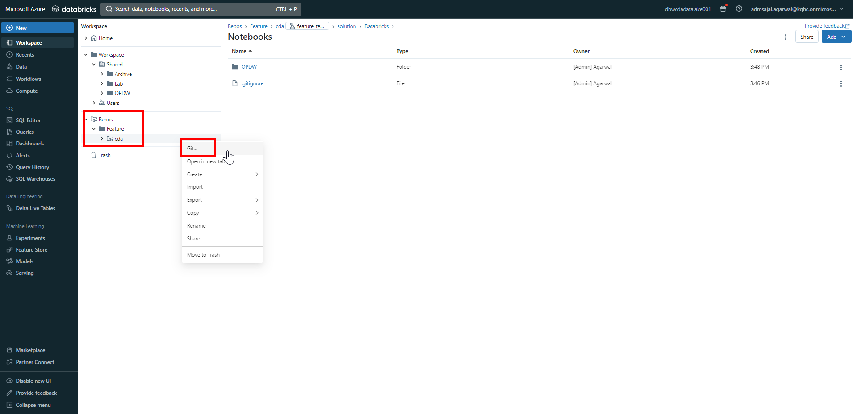

1. Enter a *comment* and *description* describing the changes made.

Click on *Pull* to latest changes from Git.

Click on *Commit & Push*.

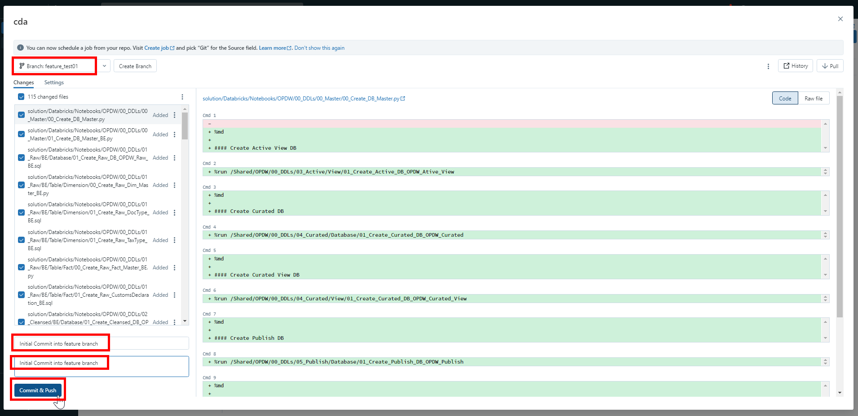

1. It will start pushing changes to Git repository.

Once completed, it will show message as *Successfully committed and pushed changes to branch “feature_test01”* and changes are pushed and committed to *feature_test01* branch in Git.

Click on *X*.

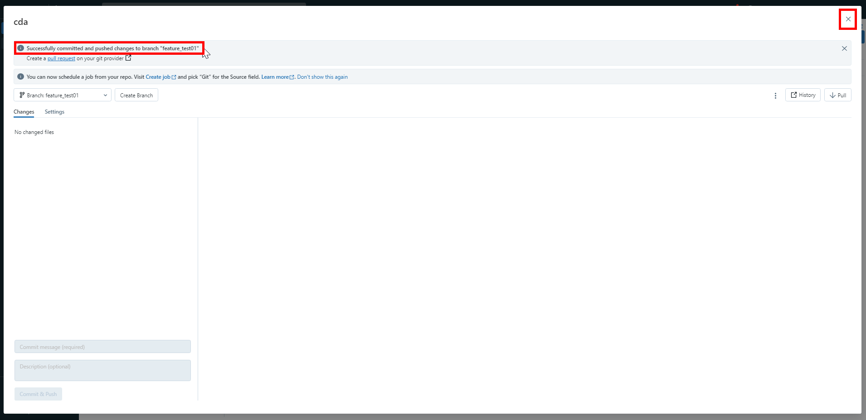

1. Login to Git Repository. Open below link:

[Maersk-Global/cda (github.com)](https://github.com/Maersk-Global/cda)

Verify that all the notebooks are accessible in Git in *feature_test01* branch.

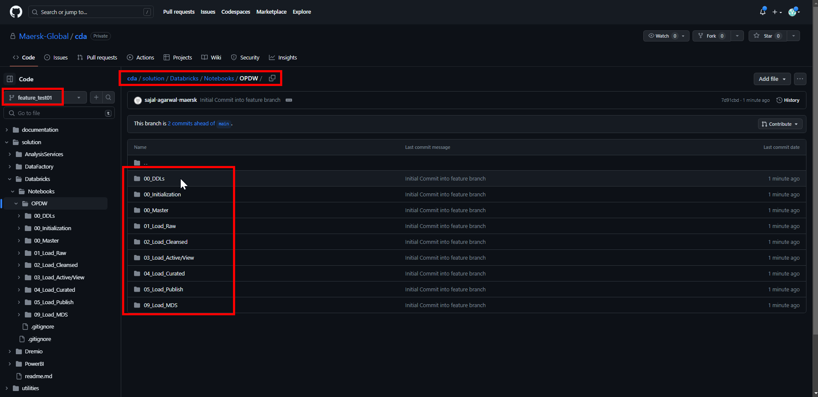

### **Code Pull Request from Working Branch (Responsible: Developer)**

1. Login to Git Repository. Open below link:

[Maersk-Global/cda (github.com)](https://github.com/Maersk-Global/cda)

Click on *Pull requests*.

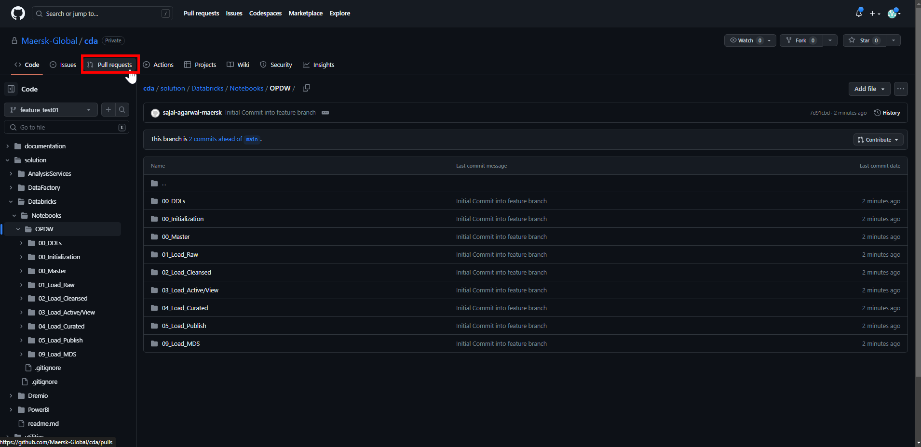

1. Click on *Compare & pull request*.

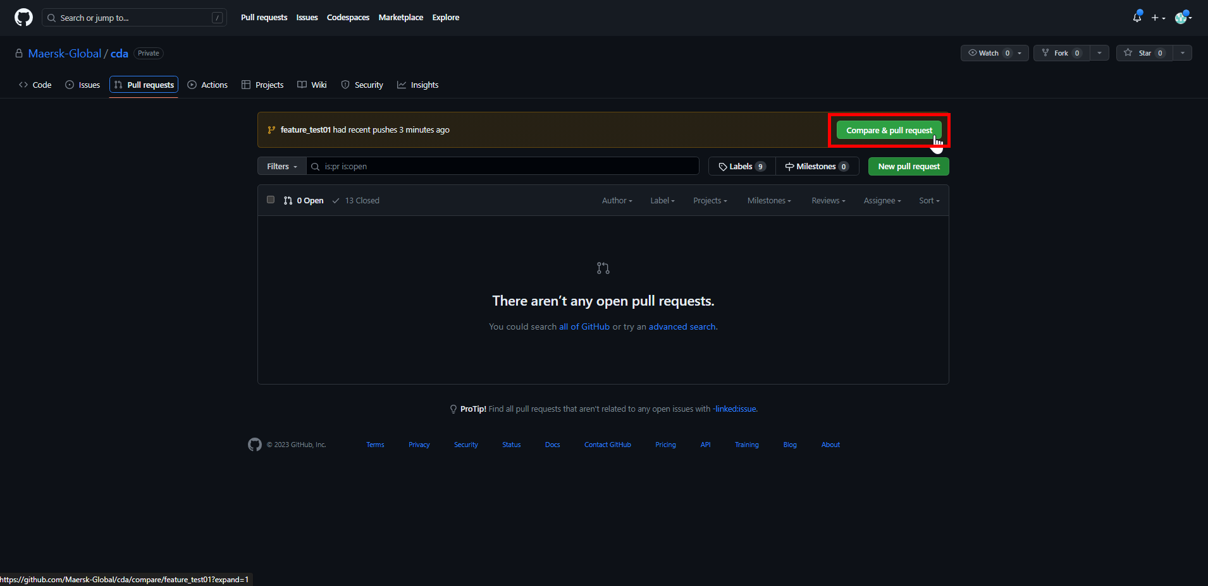

1. Make sure changes are merged from *feature_test01* to *dev*.

Verify the changes and click on *Create pull request*.



1. Enter a *title* and *comment* describing the changes.

Add *Reviewers* and *Assignees* as needed.

Click on *Create pull request*.

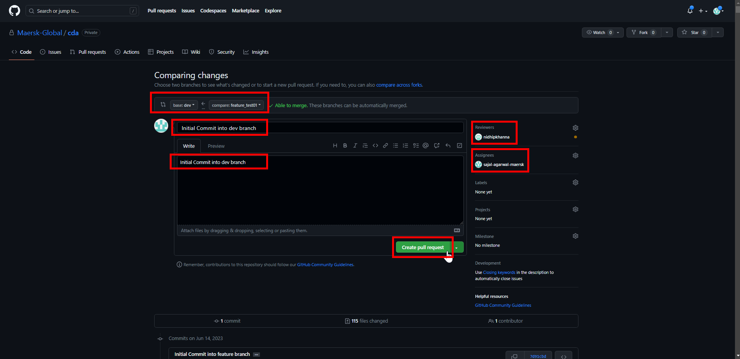

### **Code Review in Review Branch (Responsible: Reviewer)**

1. *Reviewer* will get an email as below:

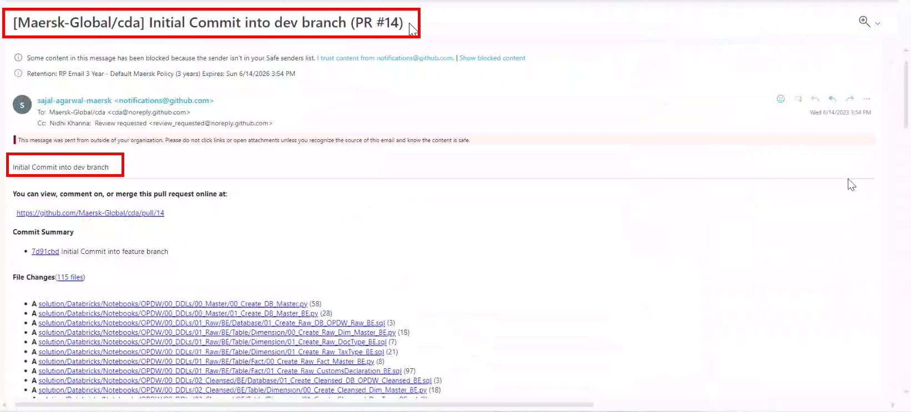

1. Login to Git Repository. Open below link:

[Maersk-Global/cda (github.com)](https://github.com/Maersk-Global/cda)

Click on *Pull requests*.

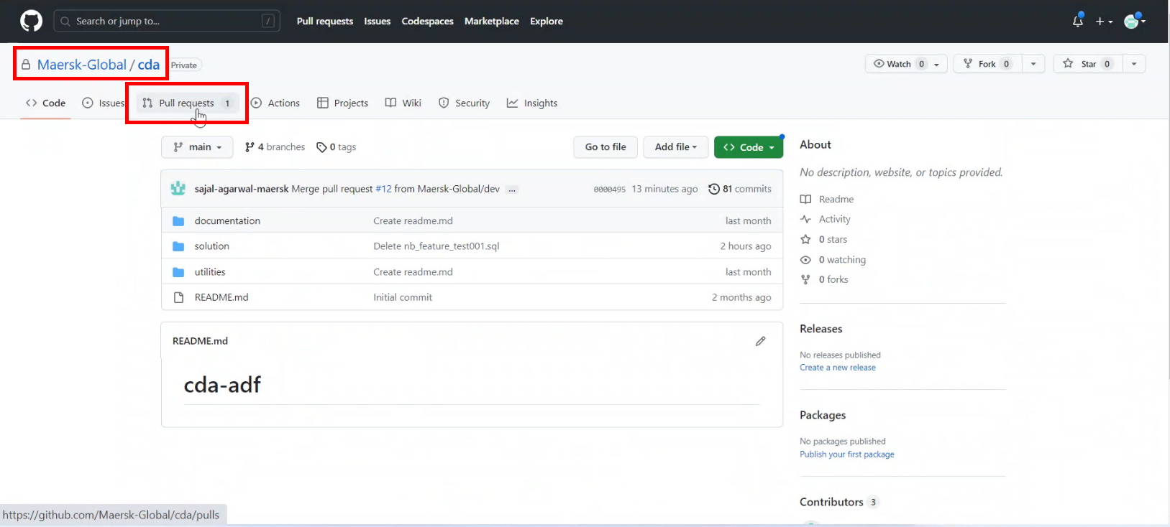

1. Click on pull request.

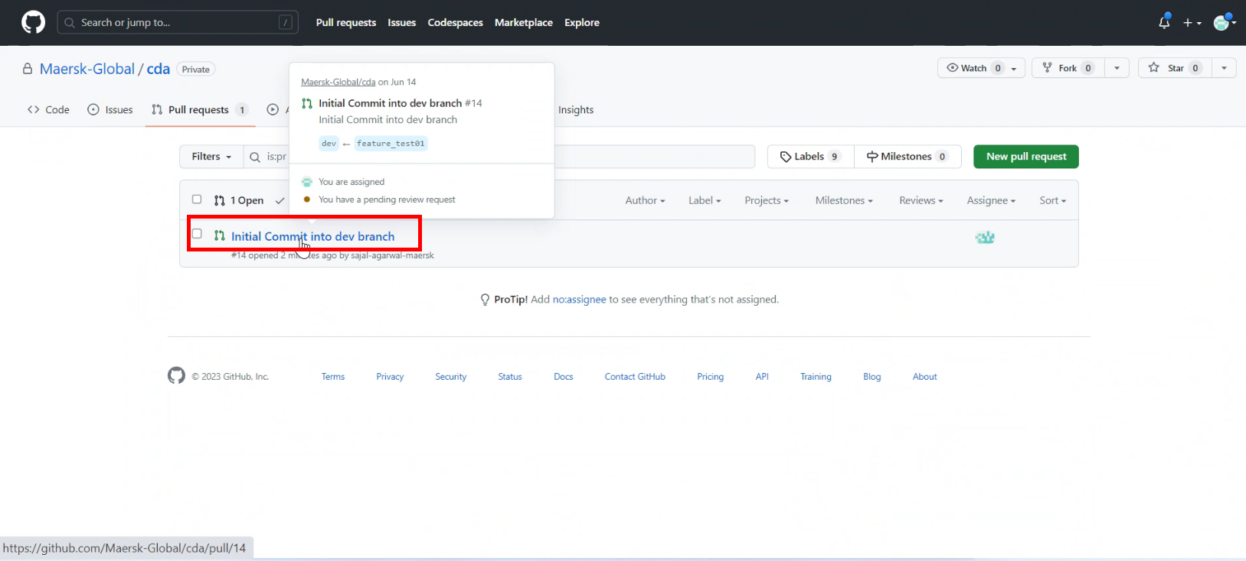

1. Click on *Add your review*.

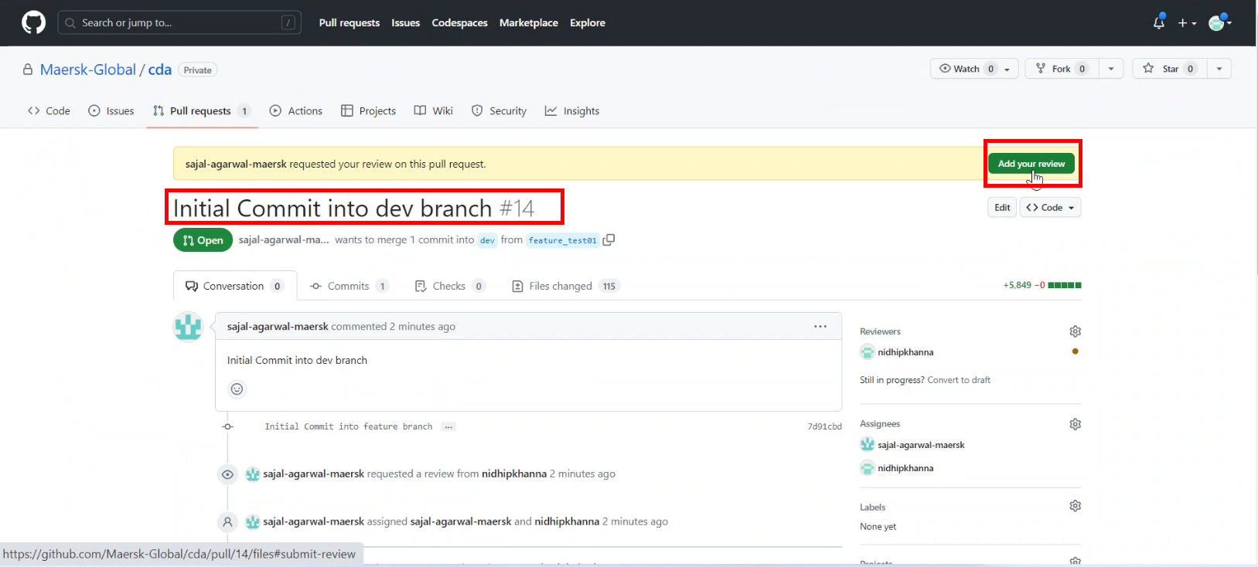

1. Review the changes.

Click on *Review changes*.

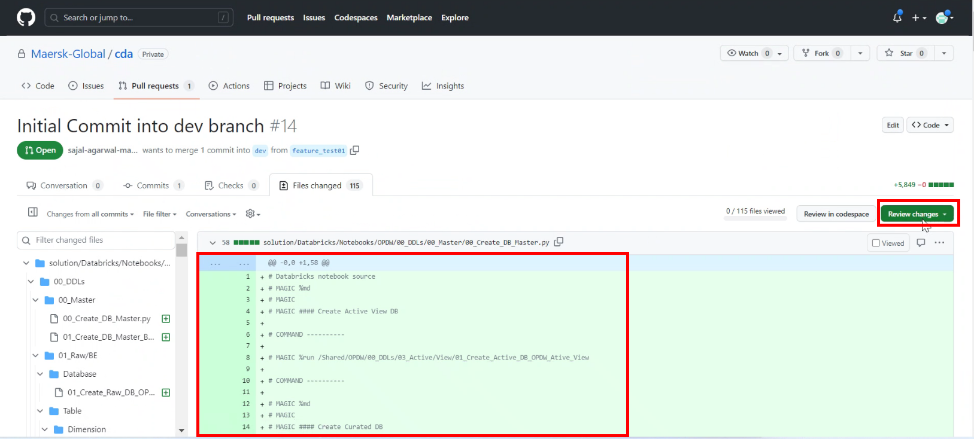

1. Write review comments.

Click on *Comment/Approve/Request changes* as per the case.

Click on *Submit review*.

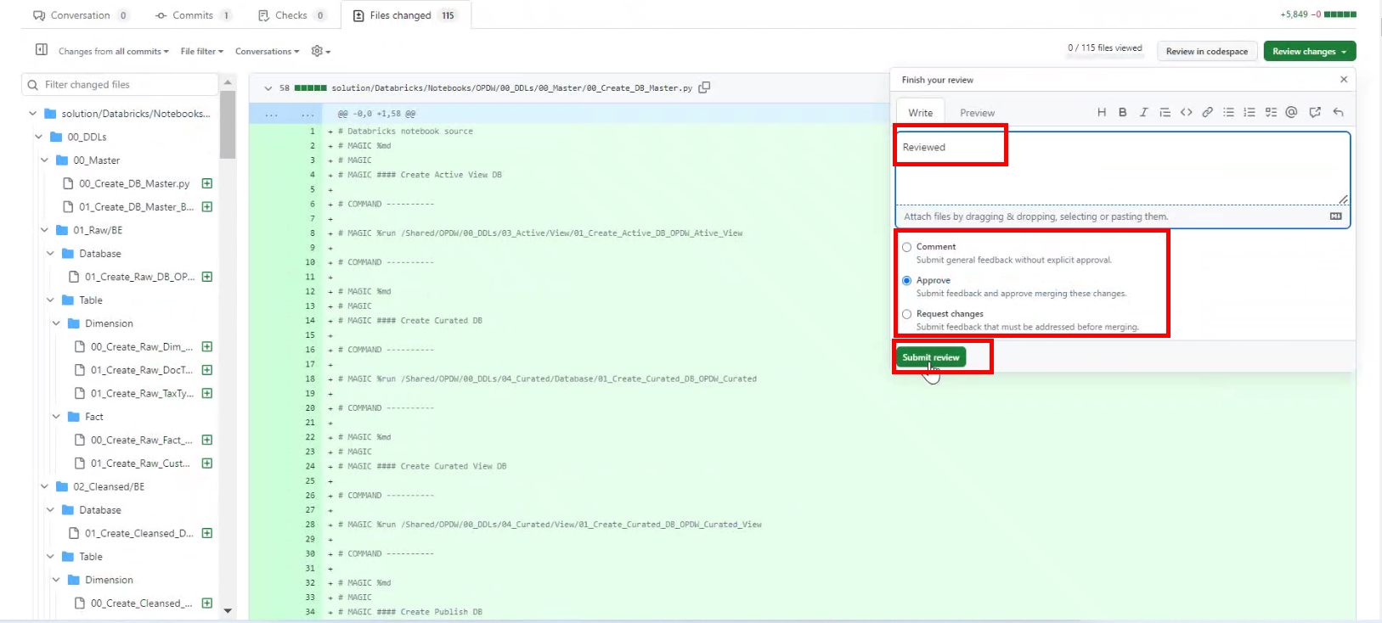

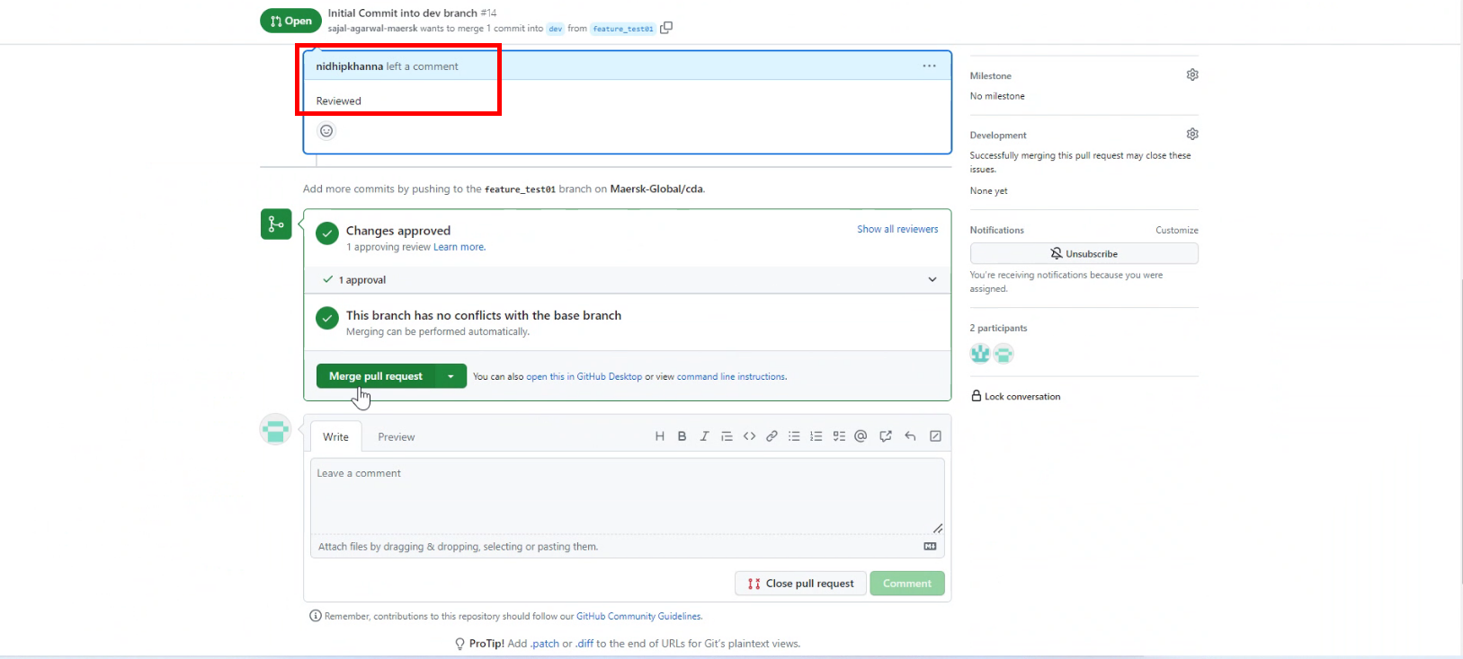

### **Code Merge with Review Branch (Responsible: Approver)**

1. *Approver* will get an email as below:

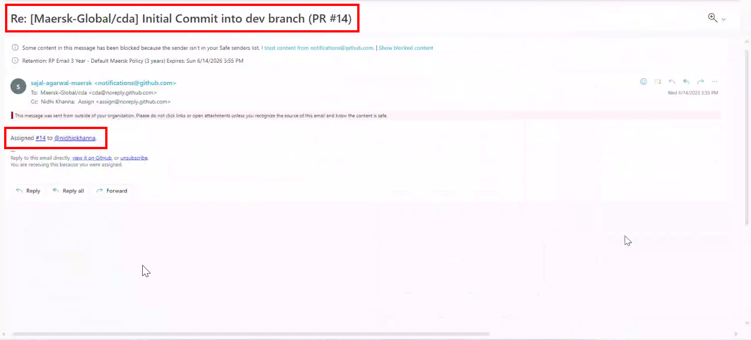

1. Login to Git Repository. Open below link:

[Maersk-Global/cda (github.com)](https://github.com/Maersk-Global/cda)

Click on *Pull requests*.

1. Click on pull request.
2. Click on *Merge pull request*

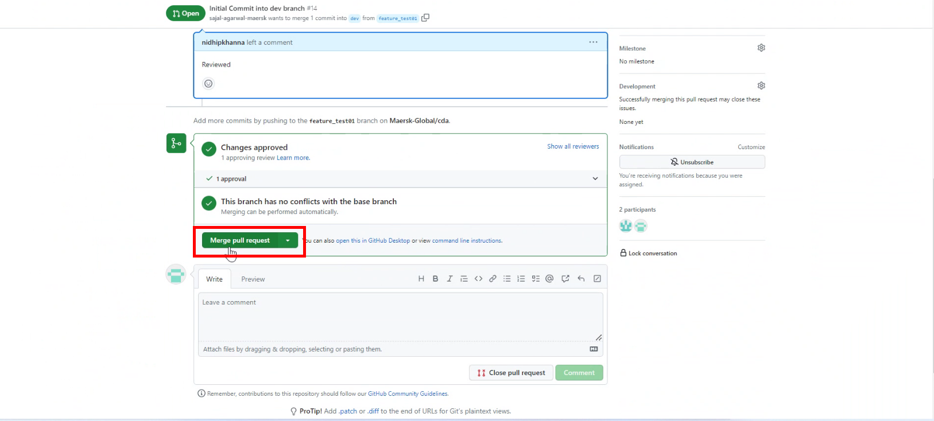

1. Enter a *comment* describing the merge request and click on *Confirm merge*.

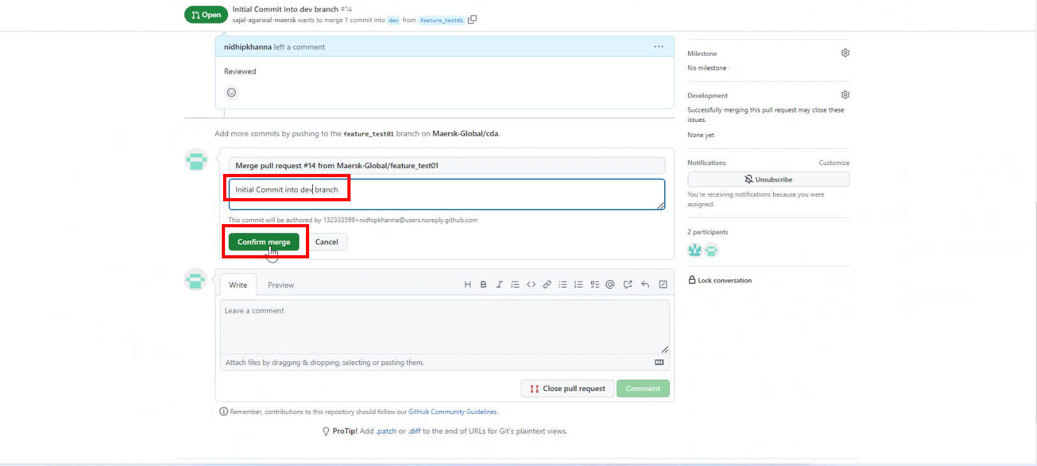

1. Enter a closing *comment* and click on *Comment*.

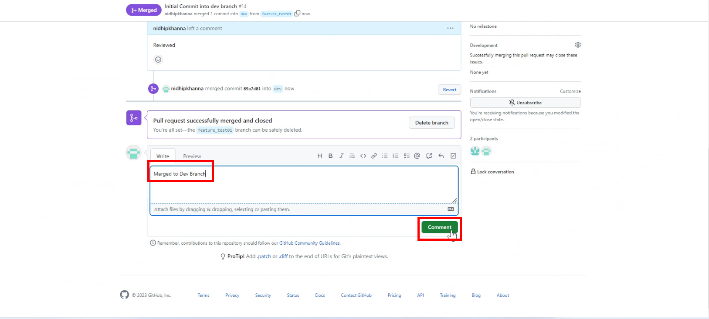

1. In Databricks, click on *Workspace* 🡪 *Add* 🡪 *Folder.*

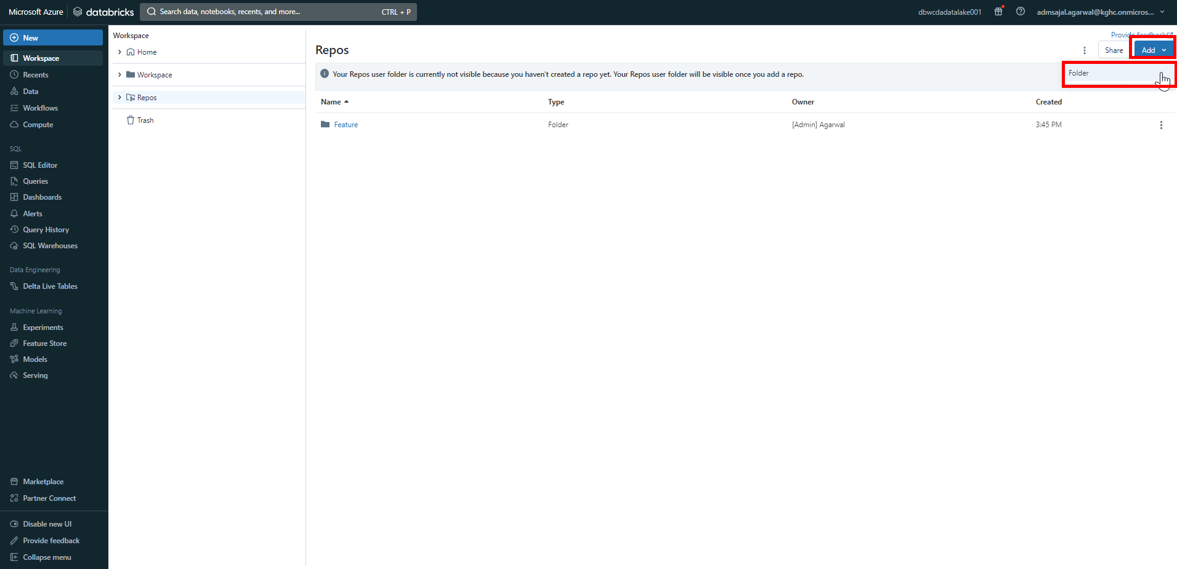

1. Set the folder name as *Development*.

Click on *Create*.

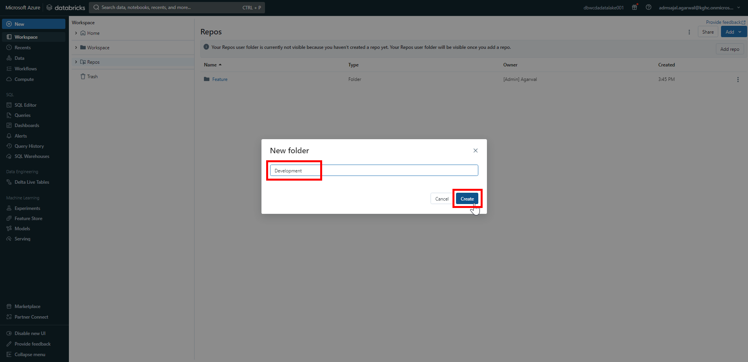

1. Click on *Add* 🡪 *Repo*.

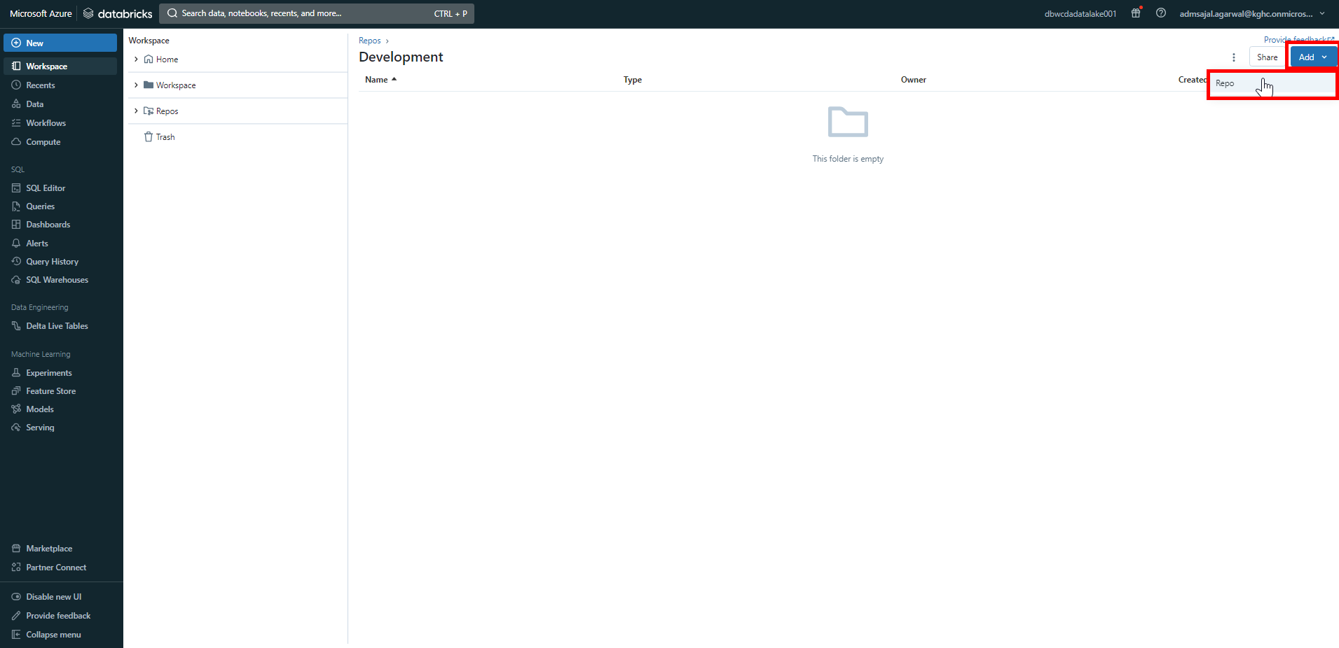

1. Fill the fields as below:

Tick-mark on *Create repo by cloning a Git repository*

Git repository URL: [*https://github.com/Maersk-Global/cda.git*](https://github.com/Maersk-Global/cda.git)

Git provider: *GitHb*

Repository name: *cda*

Tick-mark on *Sparse checkout mode*

Cone patterns: *solution/Databricks/Notebooks*

Click on *Create repo*. 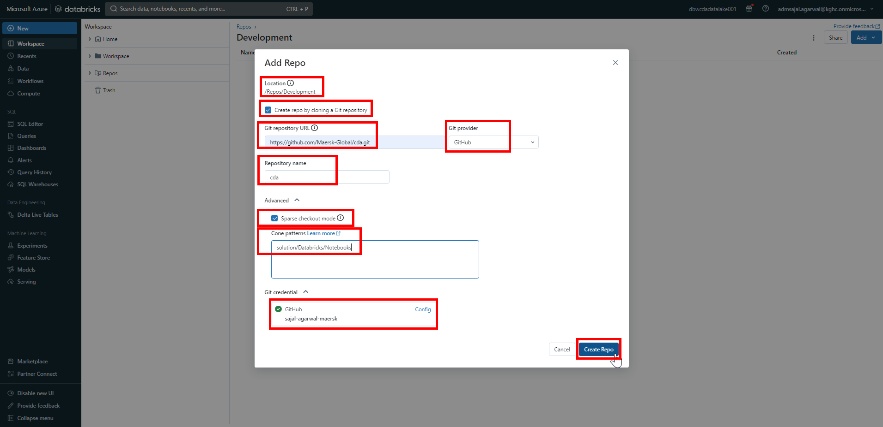

1. Click on *main* branch.

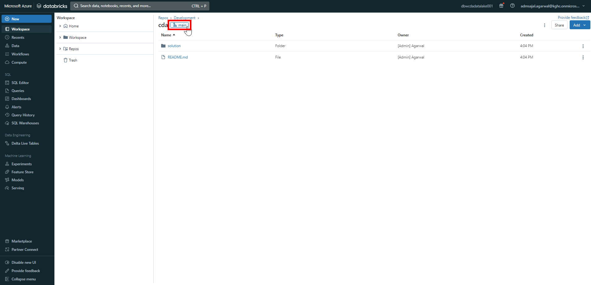

1. Open drop-down and select *dev* branch.

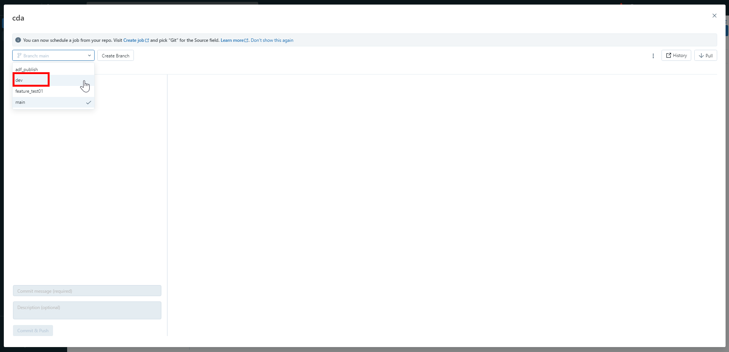

1. With *dev* branch selected, click on *X*.

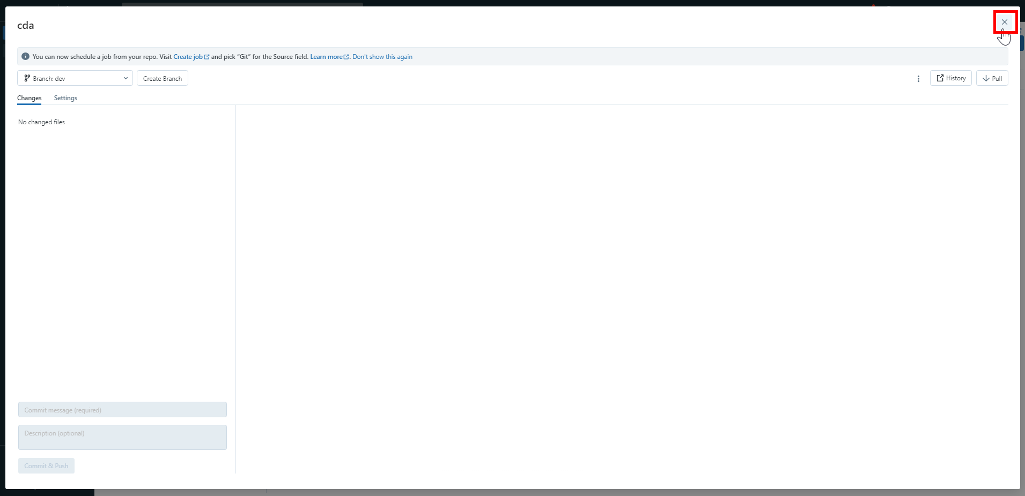

1. Verify that the *dev* branch is added now.

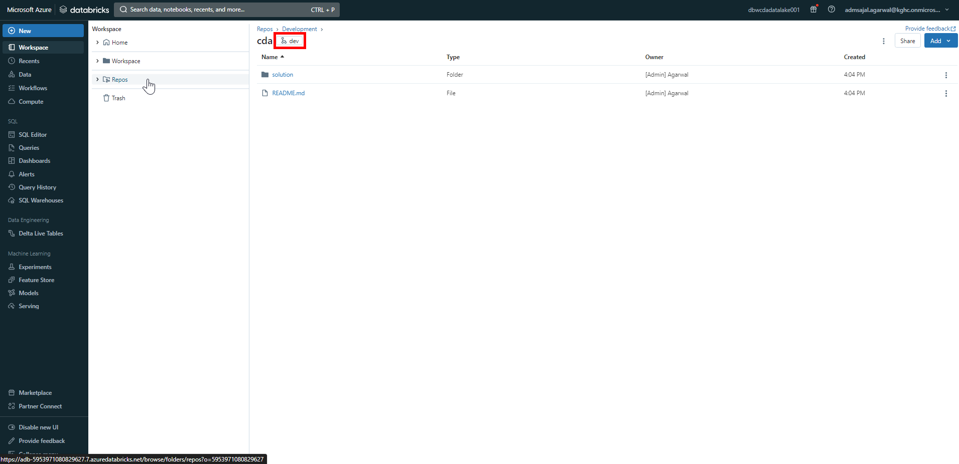

1. Navigate to *Workspace* 🡪 *Repos* 🡪 *Development* 🡪 *cda* 🡪 *dev* 🡪 *solution* 🡪 *Databricks* 🡪 *Notebooks*.

Verify that the *OPDW* folder is present.

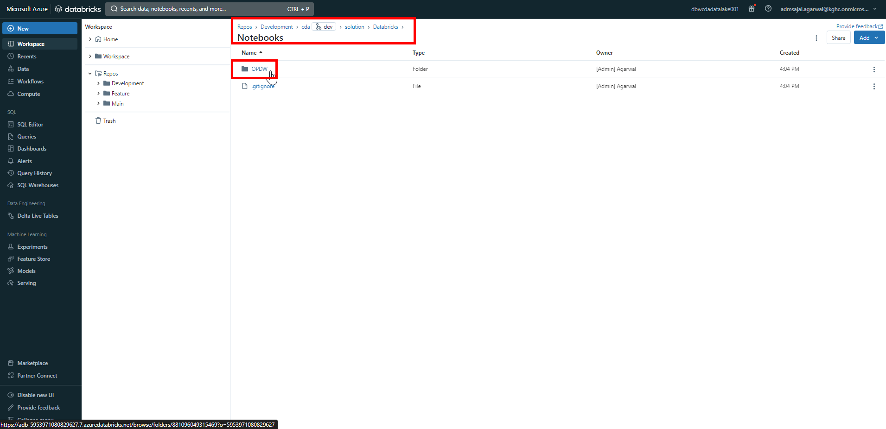

### **Code Pull Request from Collaboration Branch (Responsible: Approver)**

1. Login to Git Repository. Open below link:

[Maersk-Global/cda (github.com)](https://github.com/Maersk-Global/cda)

Click on *Pull requests*.

1. Click on *Compare & pull request*.
2. Make sure changes are merged from *dev* to *main*.

Verify the changes and click on *Create pull request*.

1. Enter a *title* and *comment* describing the changes.

Add *Reviewers* and *Assignees* as needed.

Click on *Create pull request*.

### **Code Review in Collaboration Branch (Responsible: Approver)**

1. Login to Git Repository. Open below link:

[Maersk-Global/cda (github.com)](https://github.com/Maersk-Global/cda)

Click on *Pull requests*.

1. Click on pull request.
2. Click on *Add your review*.
3. Review the changes.

Click on *Review changes*.

1. Write review comments.

Click on *Comment/Approve/Request changes* as per the case.

Click on *Submit review*.

### **Code Merge with Collaboration Branch (Responsible: Approver)**

1. Login to Git Repository. Open below link:

[Maersk-Global/cda (github.com)](https://github.com/Maersk-Global/cda)

Click on *Pull requests*.

1. Click on pull request.
2. Click on *Merge pull request*
3. Enter a *comment* describing the merge request and click on *Confirm merge*.
4. Enter a closing *comment* and click on *Comment*.
5. In Databricks, click on *Workspace* 🡪 *Repos.*

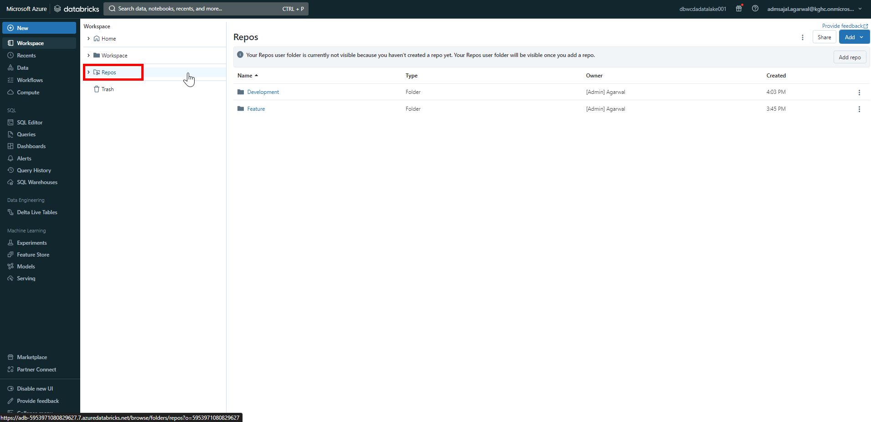

1. Click on *Add* 🡪 *Folder.*

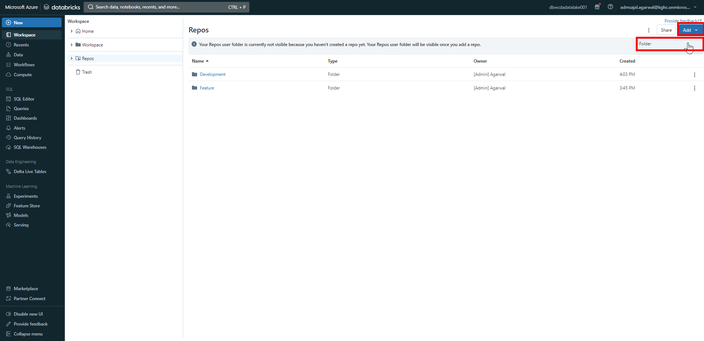

1. Set the folder name as *Main*.

Click on *Create*.

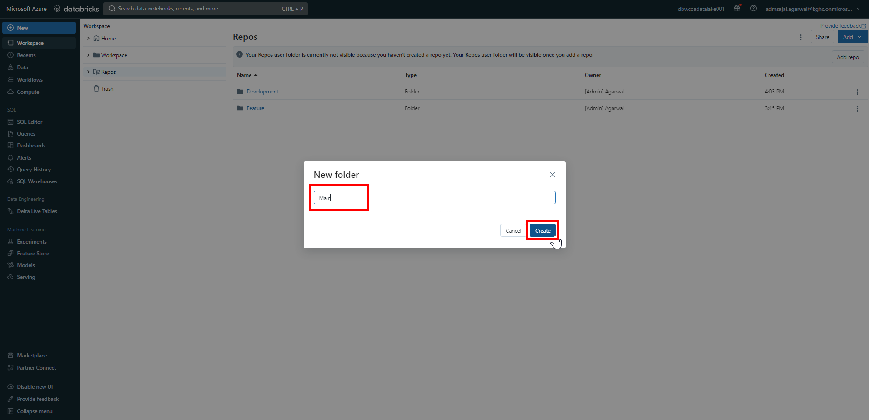

1. Click on *Add* 🡪 *Repo*.

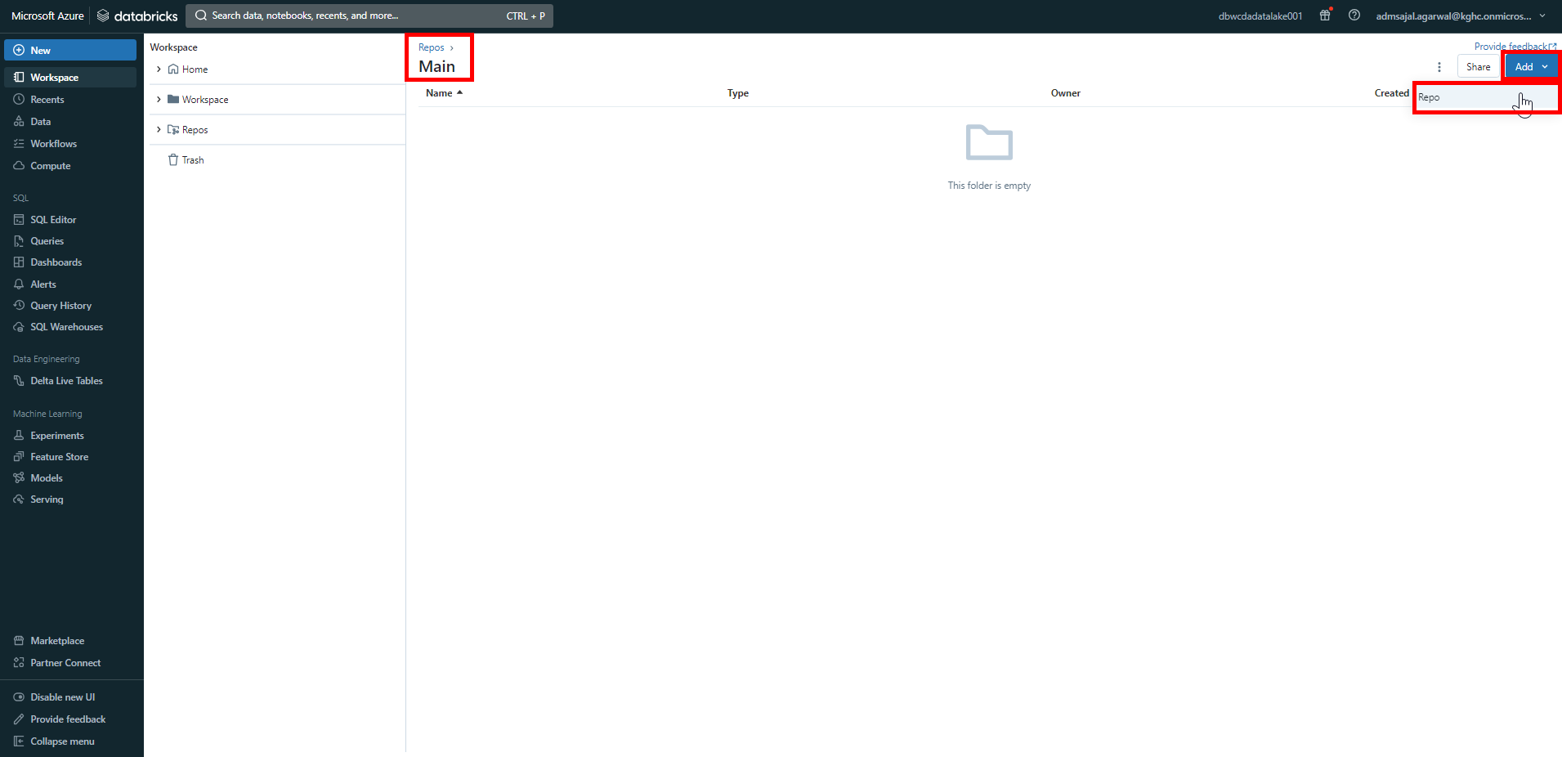

1. Fill the fields as below:

Tick-mark on *Create repo by cloning a Git repository*

Git repository URL: [*https://github.com/Maersk-Global/cda.git*](https://github.com/Maersk-Global/cda.git)

Git provider: *GitHb*

Repository name: *cda*

Tick-mark on *Sparse checkout mode*

Cone patterns: *solution/Databricks/Notebooks*

Click on *Create repo*. 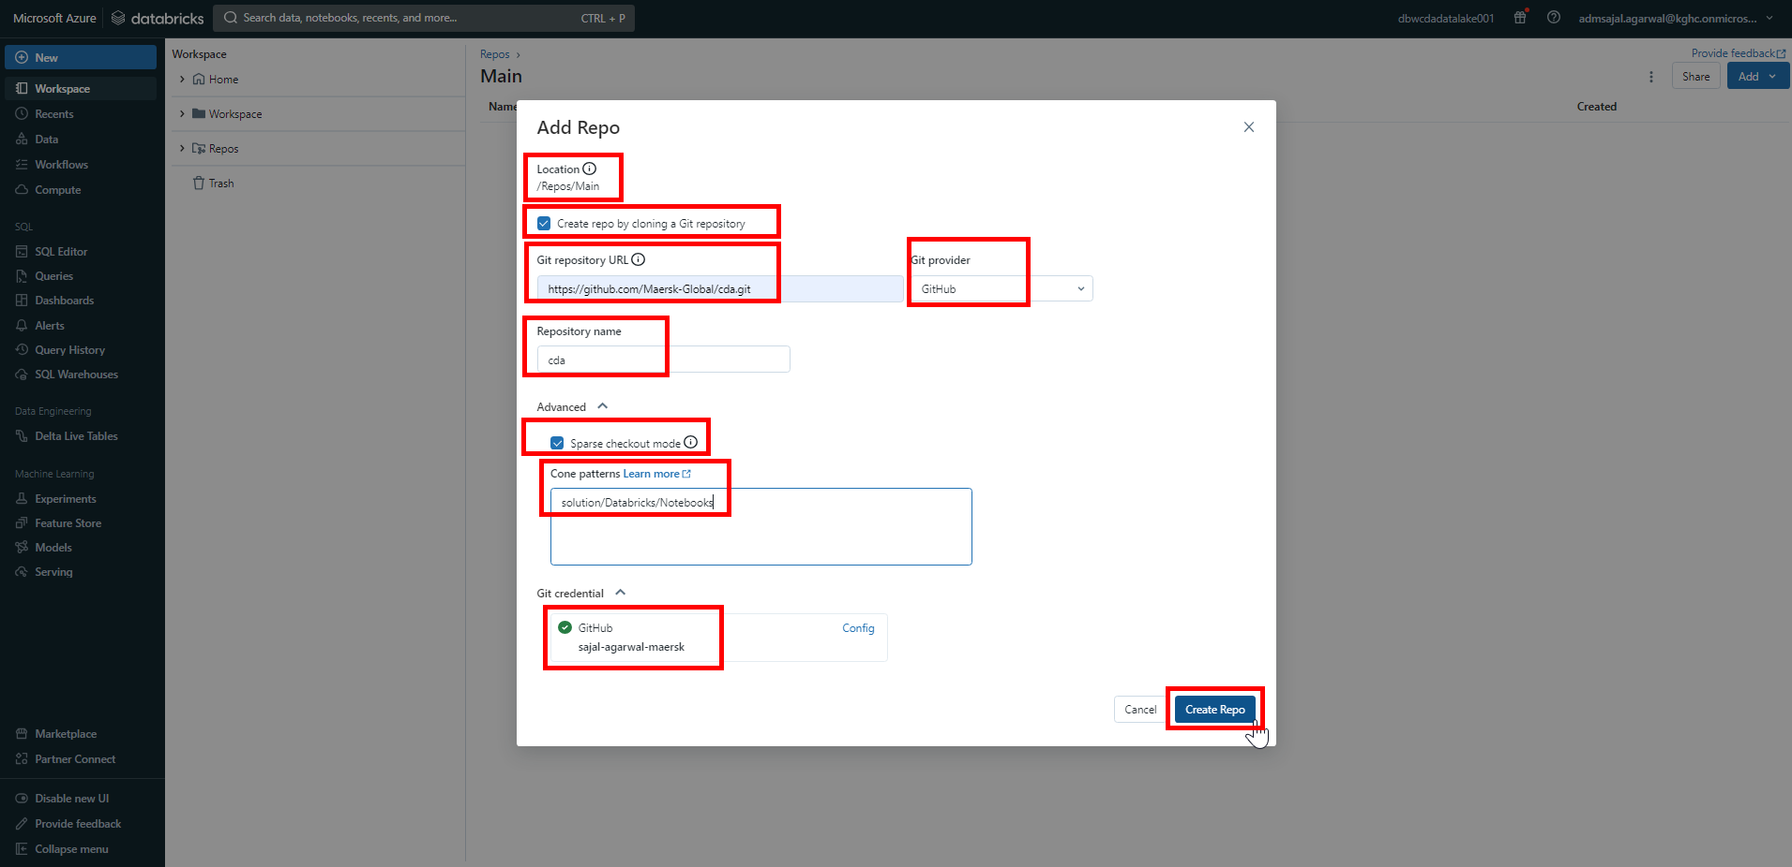

1. Verify that the *main* branch is added now.



1. Navigate to *Workspace* 🡪 *Repos* 🡪 *Main* 🡪 *cda* 🡪 *main* 🡪 *solution* 🡪 *Databricks* 🡪 *Notebooks*.

Verify that the *OPDW* folder is now present.

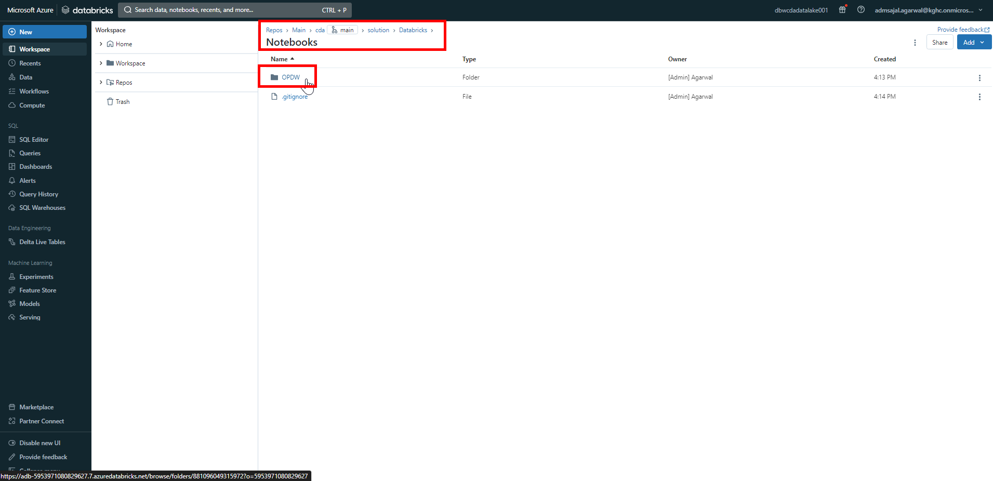

# **CI/CD Configuration – Azure DevOps Git**

GitHub Link: <https://dev.azure.com/>

Owner/Organization Name: kgh-digital

Owner/Organization Link: [Projects - Home (azure.com)](https://dev.azure.com/kgh-digital/)

Project Name: CDA

Project Link: [Summary - Overview (azure.com)](https://dev.azure.com/kgh-digital/CDA)

Repository Name: CDA

Repository Link: [CDA - Repos (azure.com)](https://dev.azure.com/kgh-digital/_git/CDA)

Master Branch: main

Review Branch: develop

Working Branch: <feature>

Git Branch Hierarchy Structure:



Reference Links:

* [Continuous integration and delivery - Azure Data Factory | Microsoft Learn](https://learn.microsoft.com/en-us/azure/data-factory/continuous-integration-delivery)
* [Source control - Azure Data Factory | Microsoft Learn](https://learn.microsoft.com/en-us/azure/data-factory/source-control)
* [What is CI/CD on Azure Databricks? - Azure Databricks | Microsoft Learn](https://learn.microsoft.com/en-us/azure/databricks/dev-tools/index-ci-cd)
* [CI/CD techniques with Git and Databricks Repos - Azure Databricks | Microsoft Learn](https://learn.microsoft.com/en-us/azure/databricks/repos/ci-cd-techniques-with-repos)
* [What is Azure Pipelines? - Azure Pipelines | Microsoft Learn](https://learn.microsoft.com/en-us/azure/devops/pipelines/get-started/what-is-azure-pipelines?view=azure-devops)

## **Data Factory: Git Configuration**

1. Login to Git Repository. Open below link:

[CDA - Repos (azure.com)](https://dev.azure.com/kgh-digital/_git/CDA)

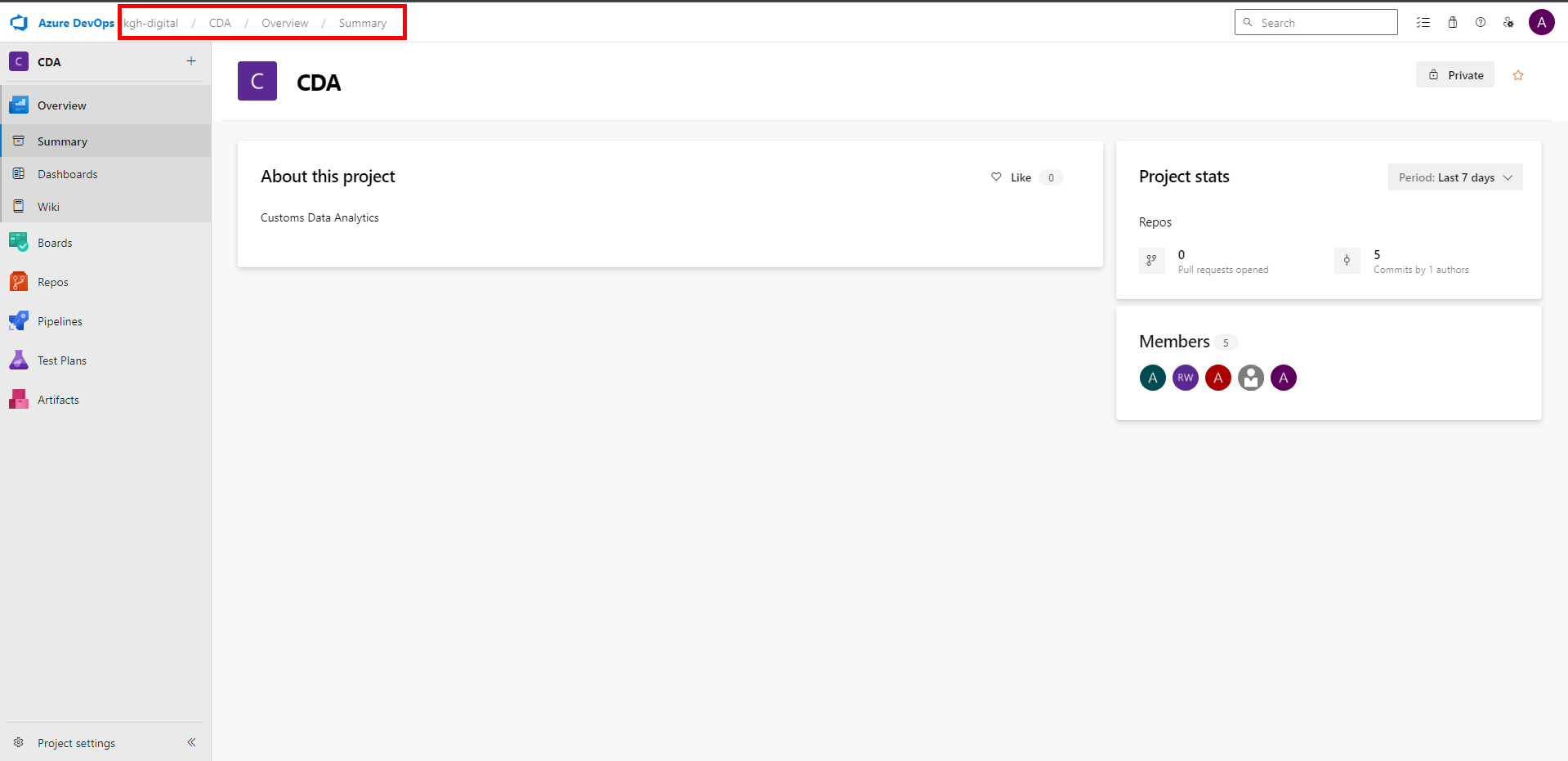

1. Click on *Repos*.

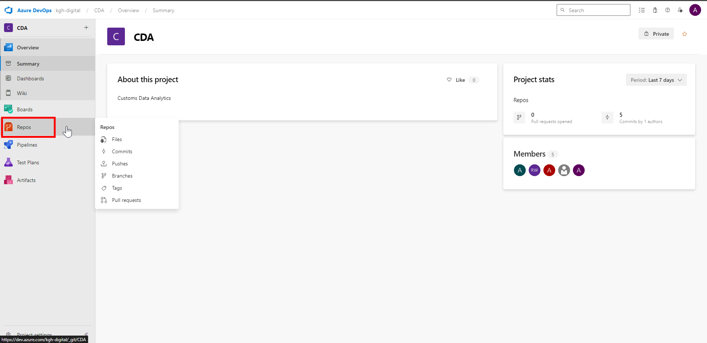

1. Click on *Clone*.

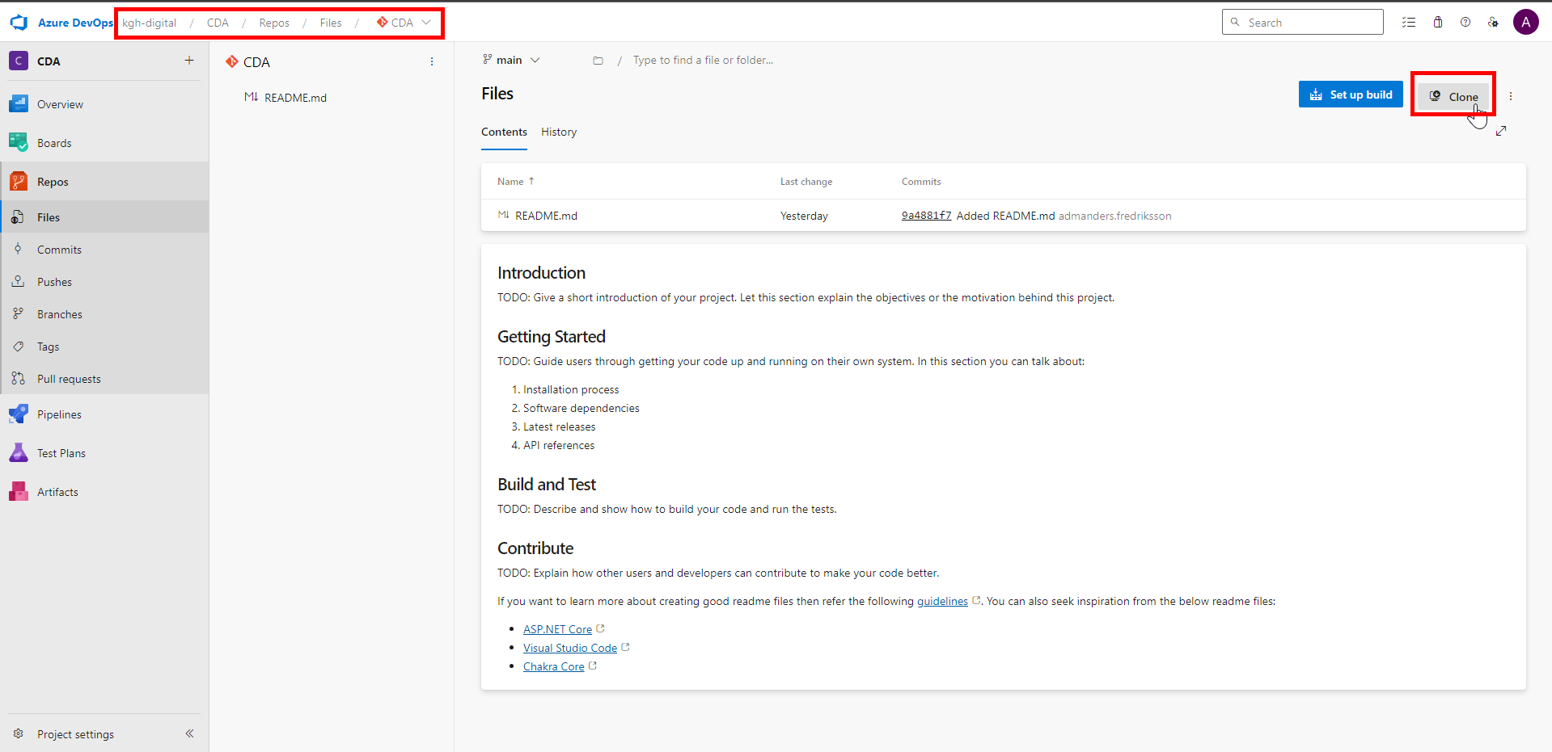

1. Under *HTTPS*, copy the *URL*.

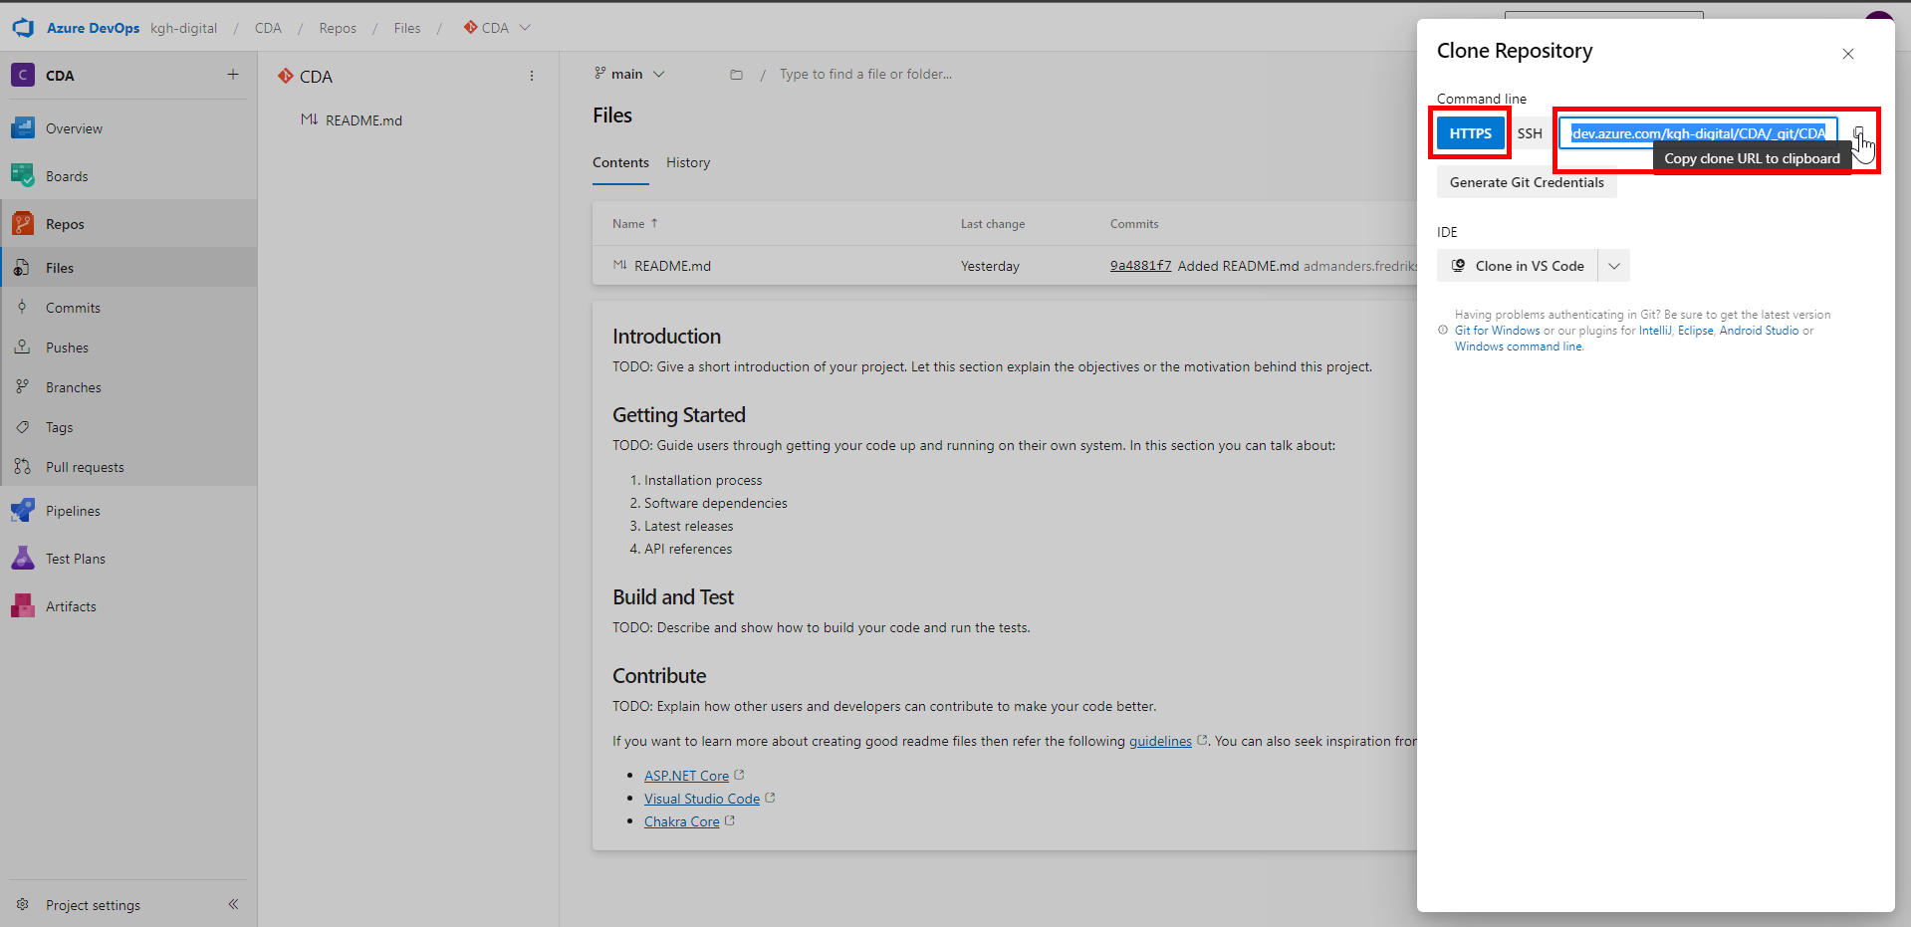

1. Open Azure Data Factory resource.

Click on *Manage*.



1. Click on *Git configuration* under *Source control*.



1. Click on *Configure*.



1. Fill the details as below:

Repository type à *Azure DevOps Git*

Azure Active Directory à *KGH Customs Services*

Click on *Continue*.

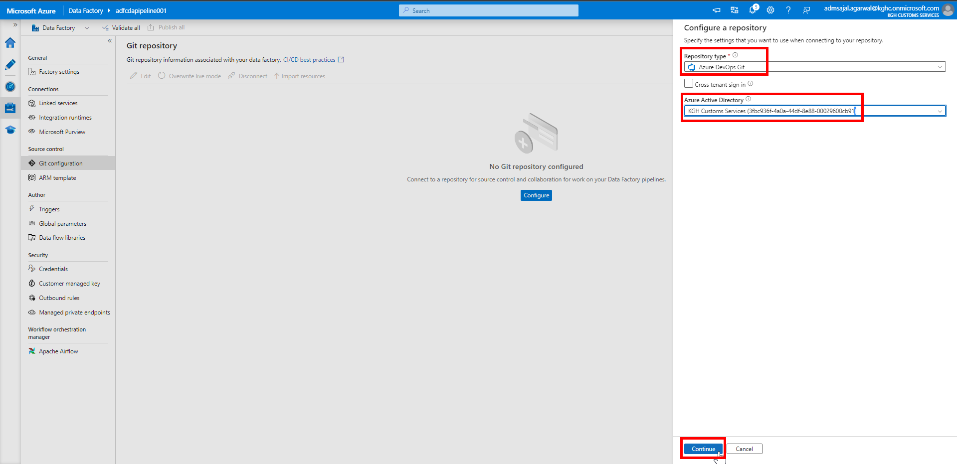

1. Fill the details as below:

Select *Select Repository*

Azure DevOps organization name: *kgh-digital*

Project Name: *CDA*

Repository name: *CDA*

Collaboration branch: *main*

Publish branch: *adf_publish*

Root folder: */solution/DataFactory/ADF/adfcdapipeline001/*

Custom comment:Tick-mark on *Use custom comment*

Import existing resources*:* Tick-mark on *Import existing resources to repository*

Import resource into this branch: *main*

Click on *Apply*.

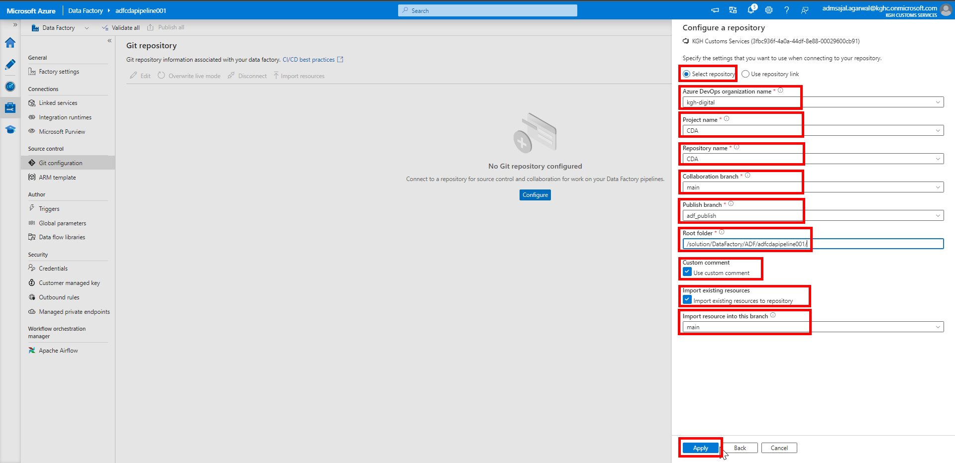

1. It will start applying the changes.

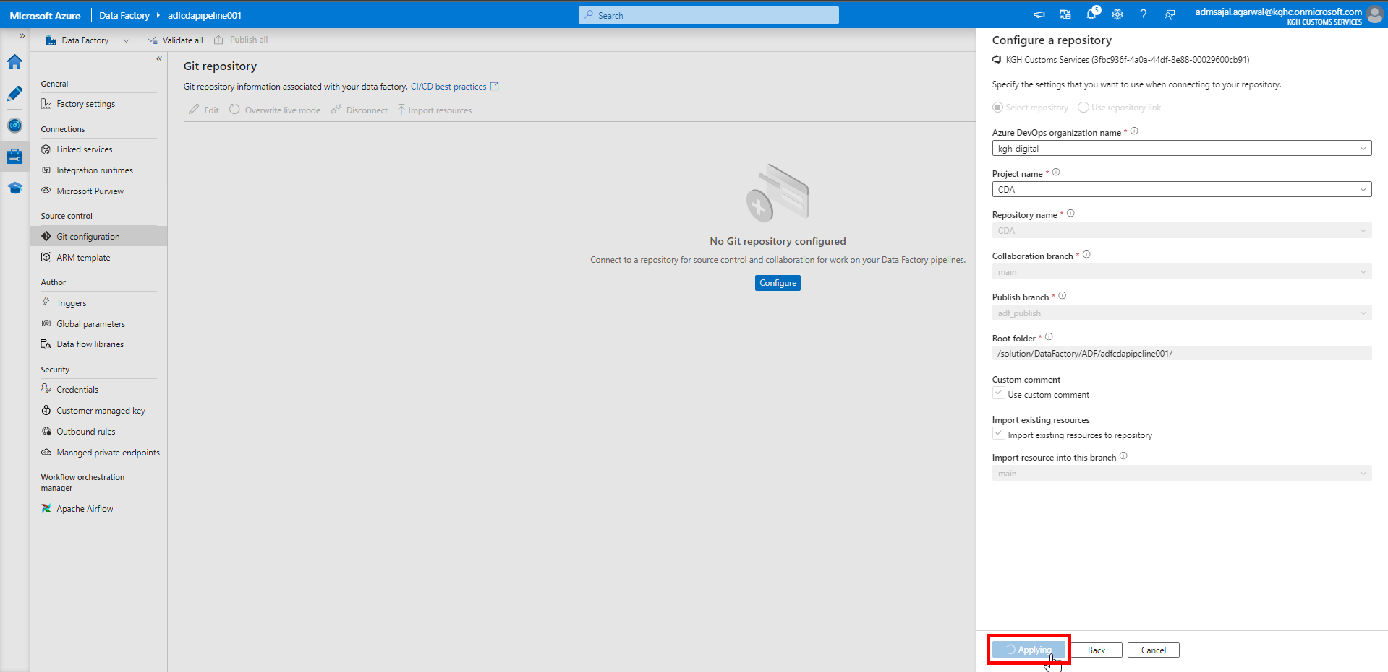

1. It will show notification as *Repo Connected* after the Git repository is connected to Azure Data Factory.

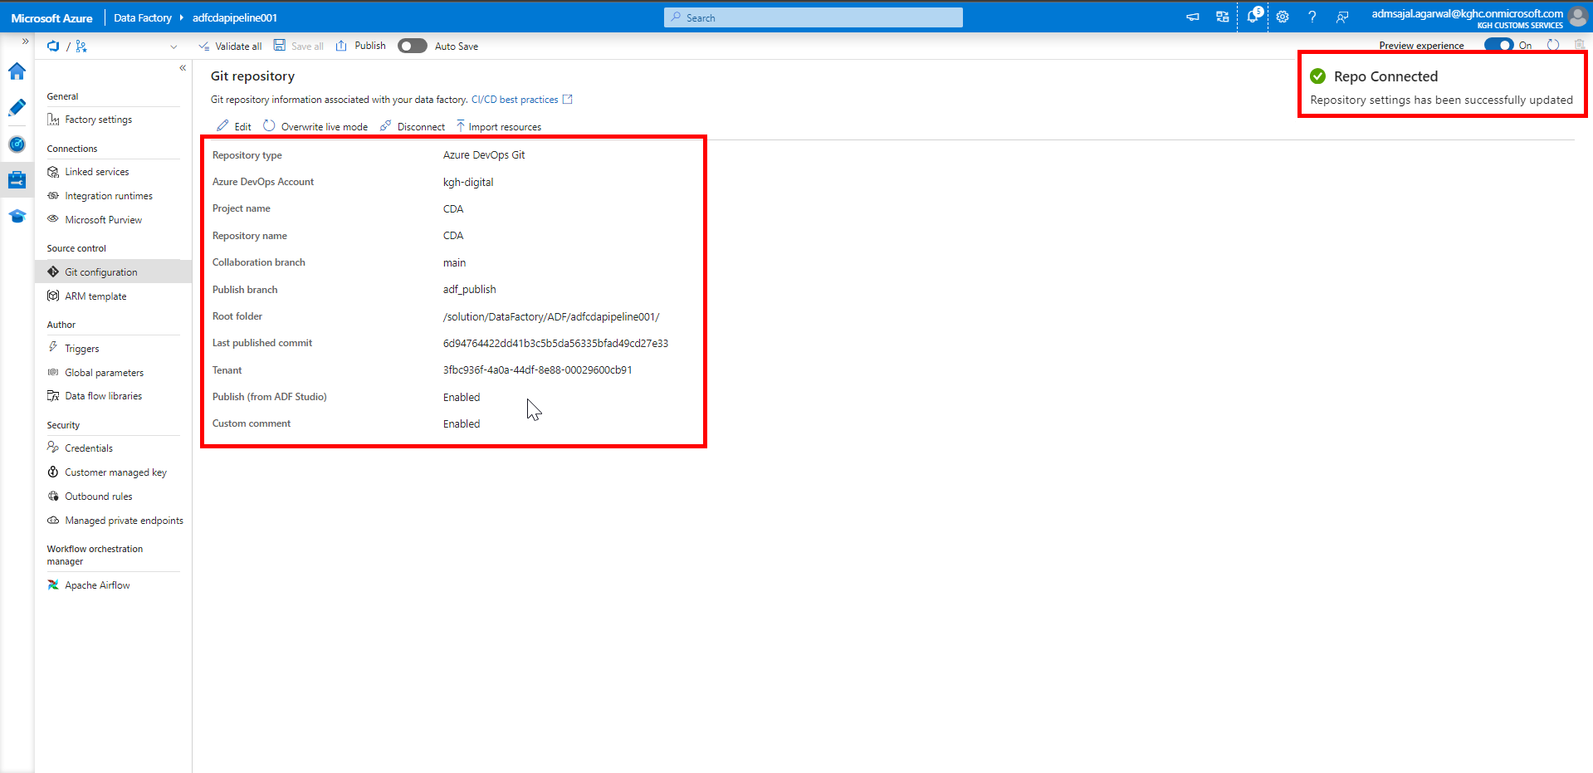

1. Login to Git Repository.

Navigate to *CDA 🡪 solution 🡪 DataFactory 🡪 ADF 🡪 adfcdapipeline001*

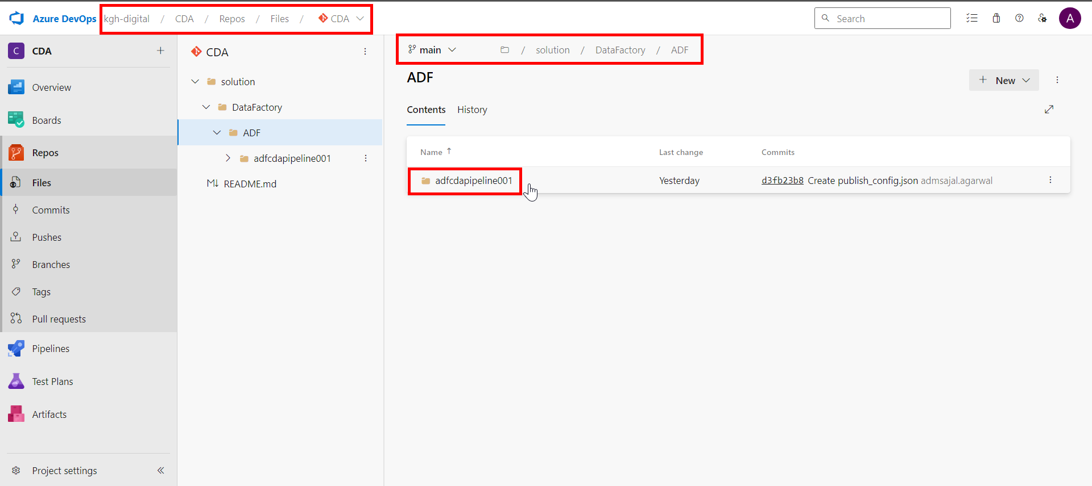

1. Verify that all ADF objects are uploaded and available in Git.

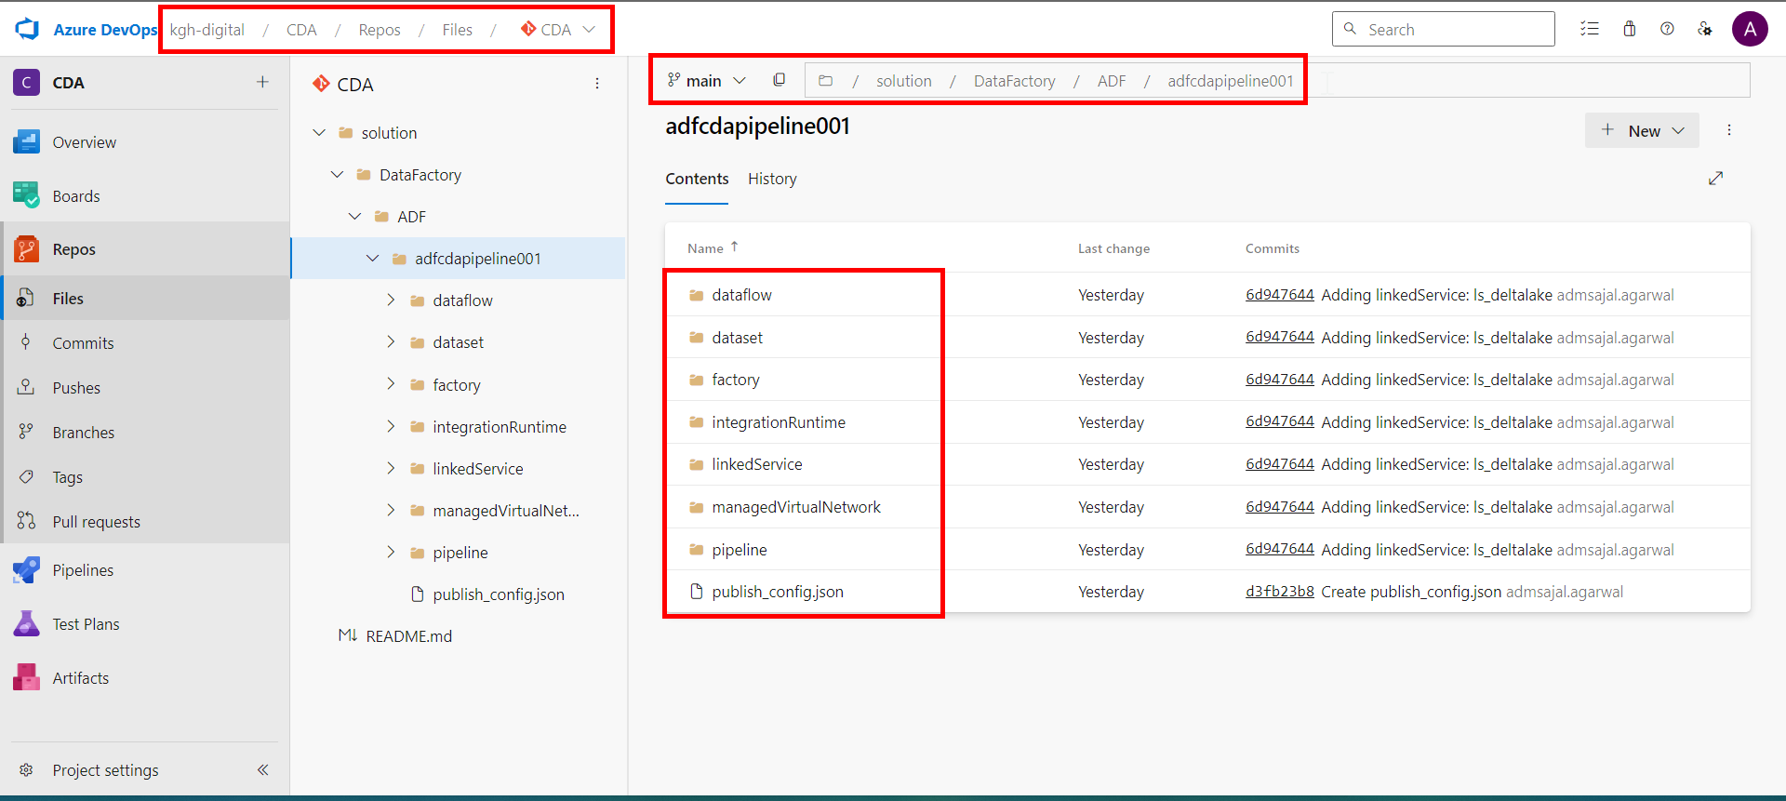

1. In ADF, it should start showing Git menu at top right corner.



1. If it asks to *Set working branch*, then fill the details as below:

Working branch: *Use existing*

Name: *main*

Click on *Save*.

1. Login to Git Repository.

Click on *Pull requests*.

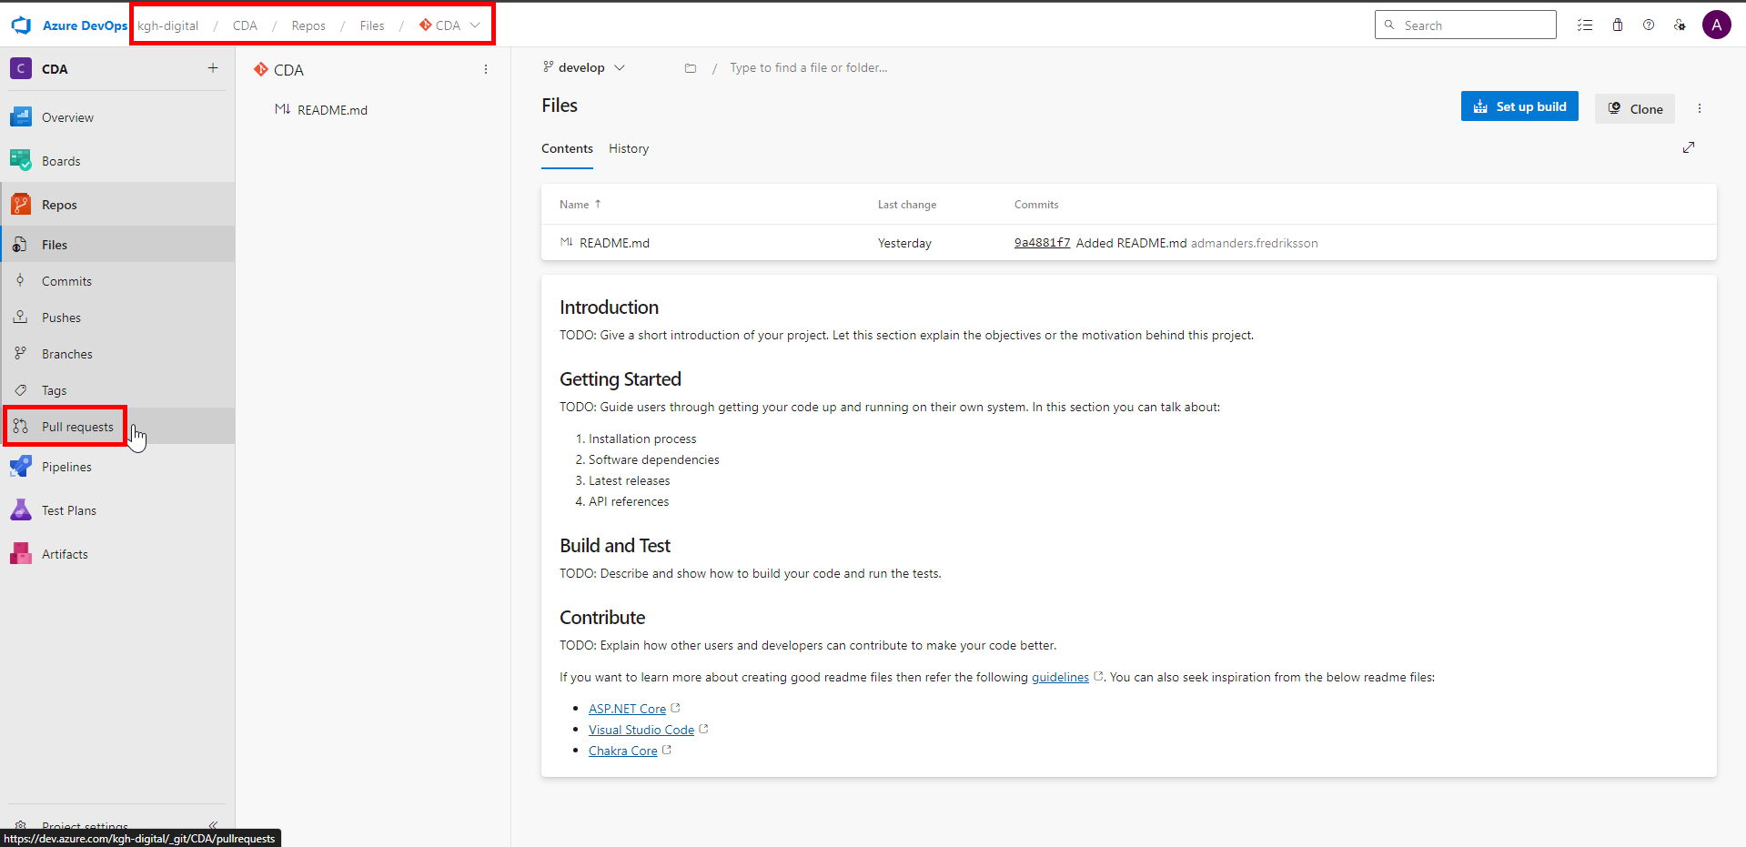

1. Click on *New pull request*.

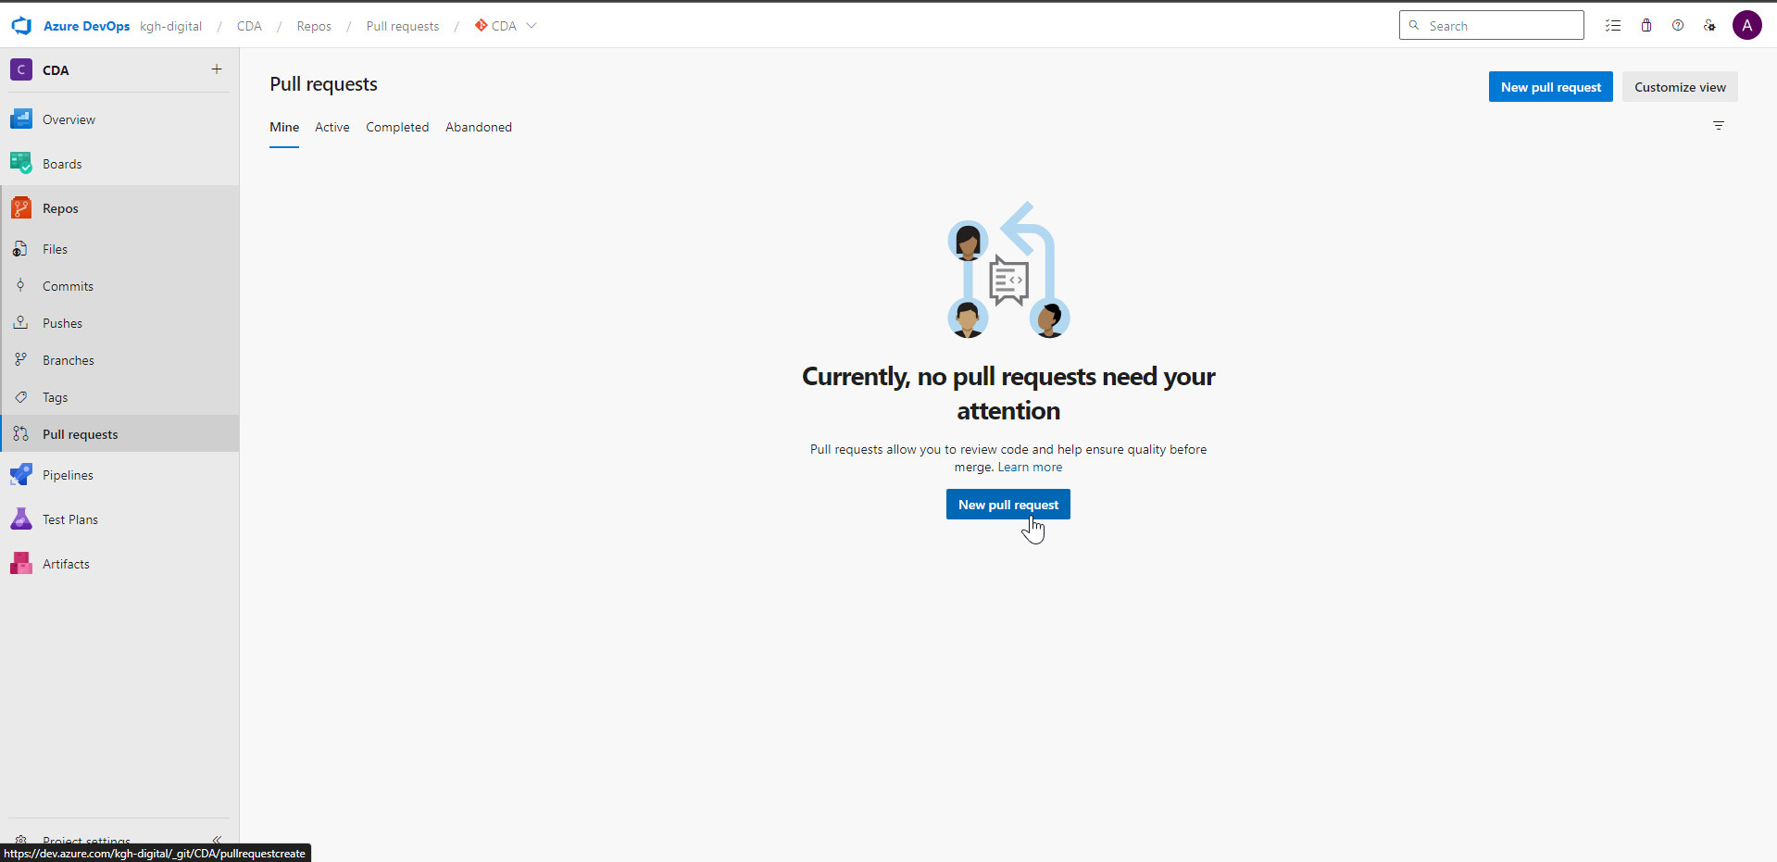

1. Make sure changes are merged from *main* to *develop*.

Enter a *Title* for this change.

Click on *Create*.

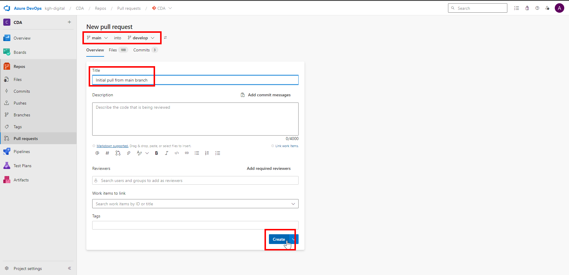

1. Click on *Complete*.

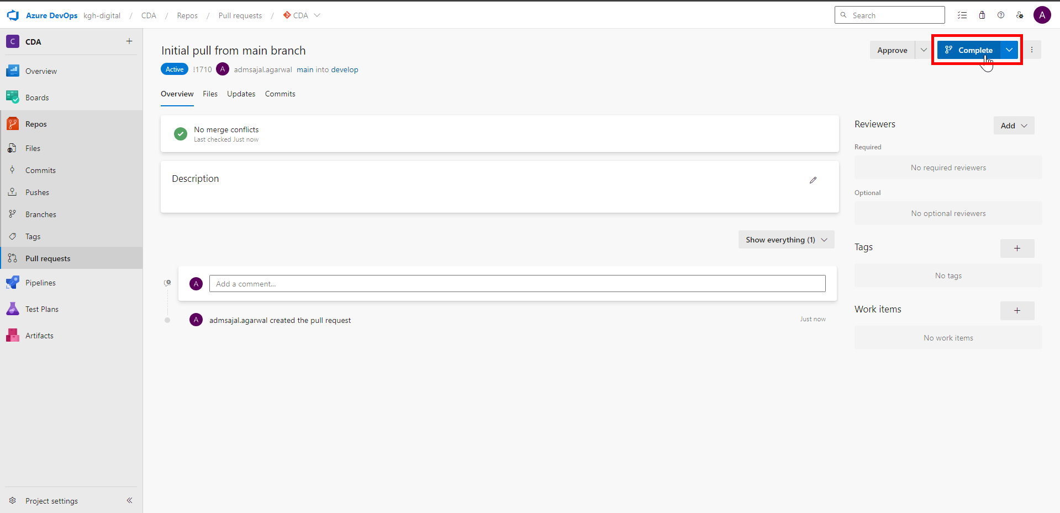

1. Fill the details as below:

Merge type: *Merge (no fast forward)*

Post-completion options:

Tick-mark on *Complete associated work items after merging*

No Tick-mark on *Delete main after merging*

No Tick-mark on *Customize merge commit message*

Click on *Complete merge*.

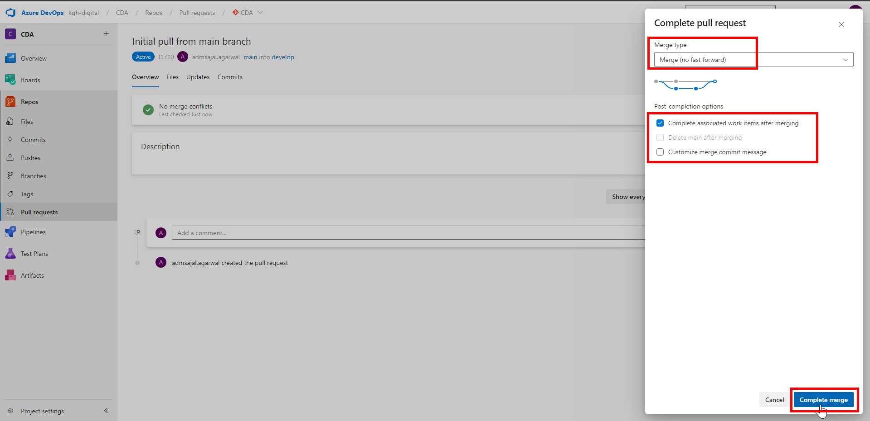

1. Enter a closing *comment* and click on *Comment*.

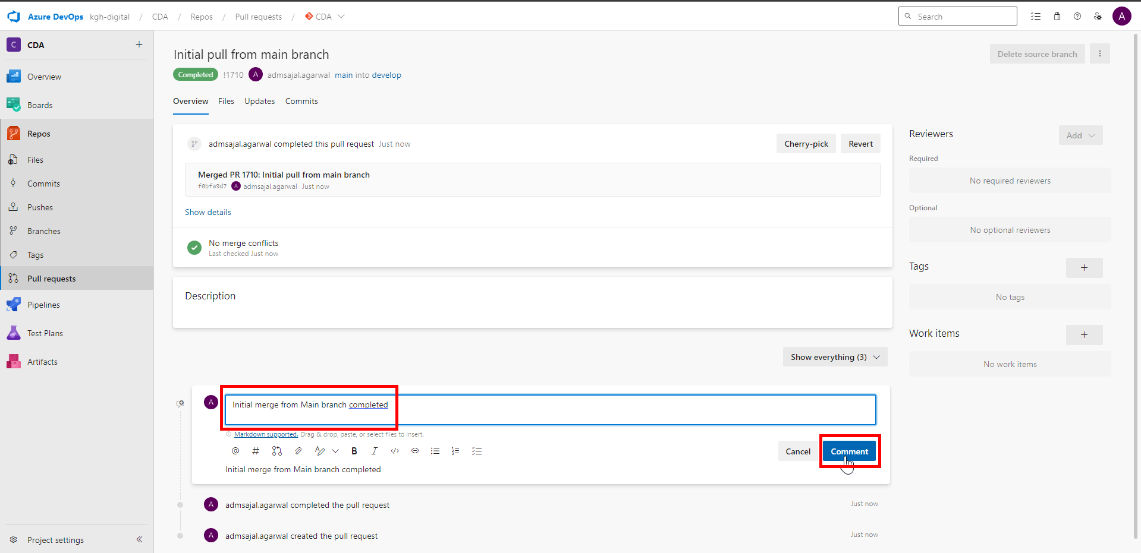

1. Verify that *develop* is now in synch with *main* branch.

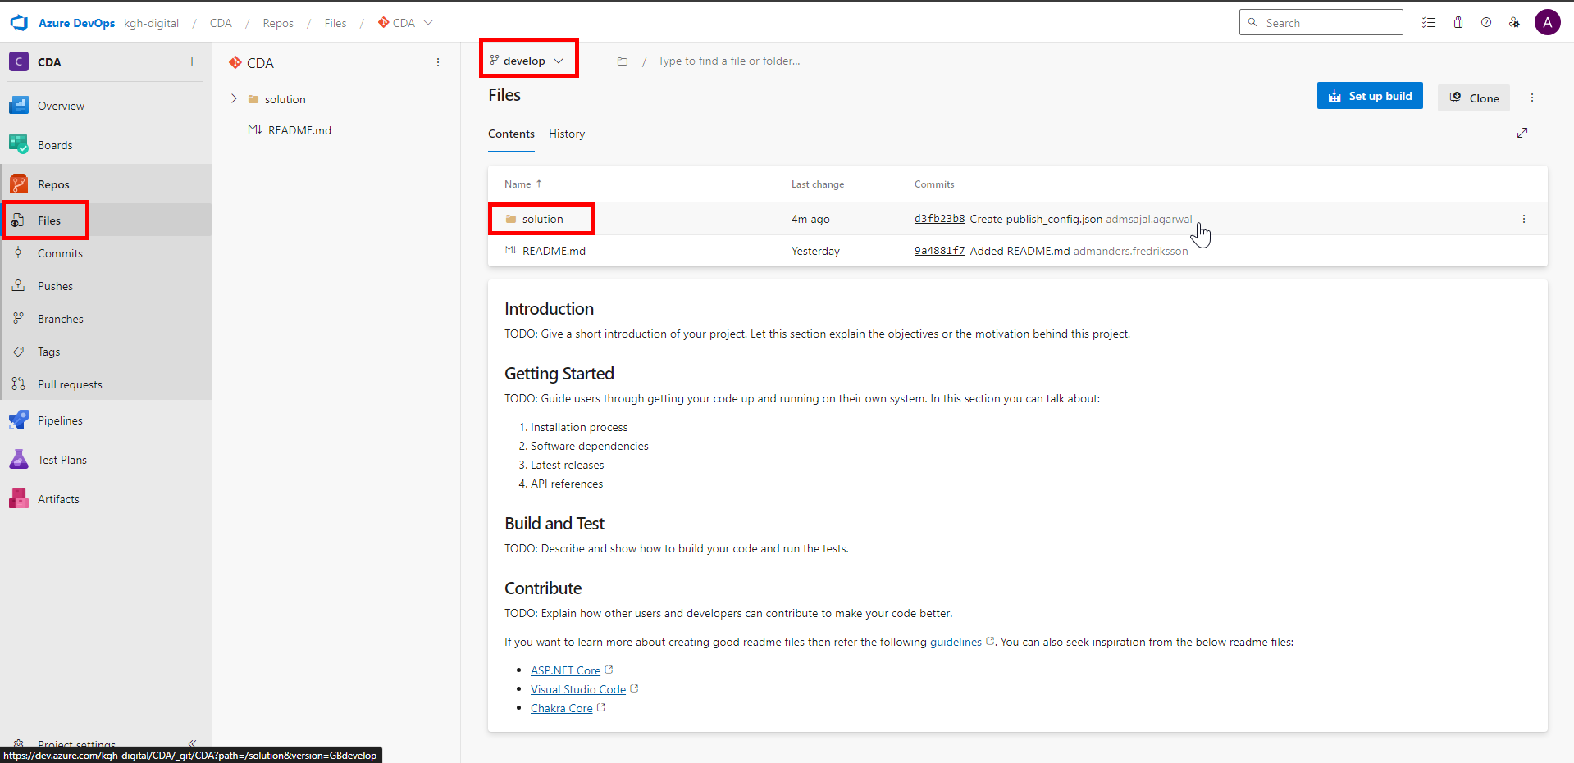

1. In ADF, click on drop down in front of *main* branch.

Click on *New branch*.

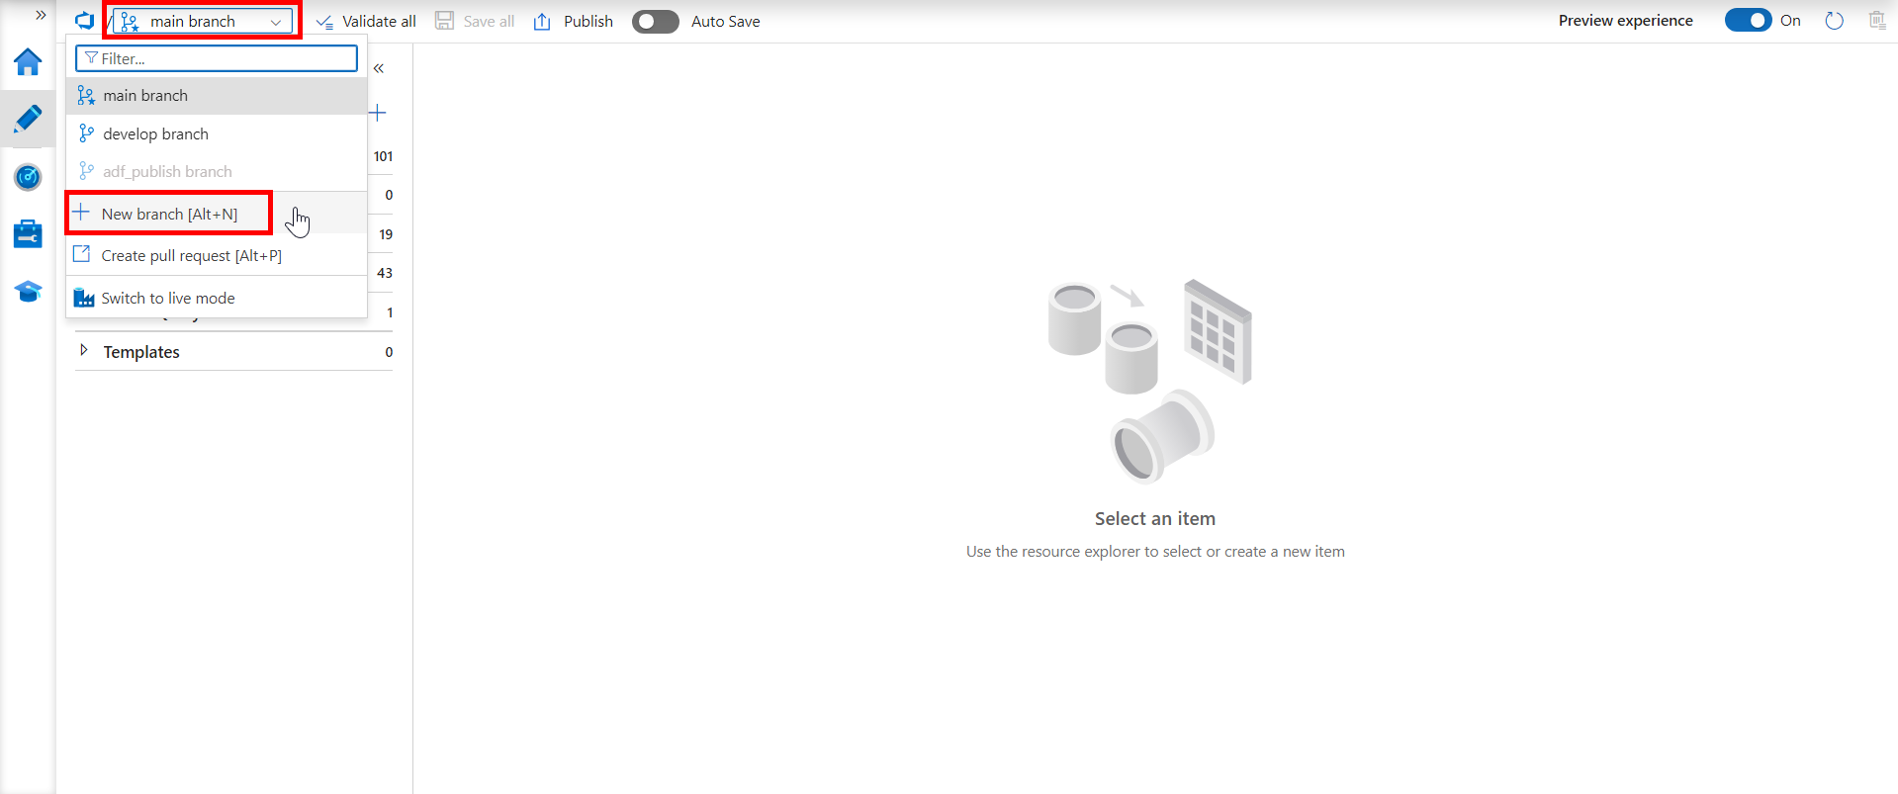

Fill the details as below:

Branch name: *feature_test01* (give any meaningful name as per feature/user/etc)

Base on: *develop branch*

Click on *Create*.

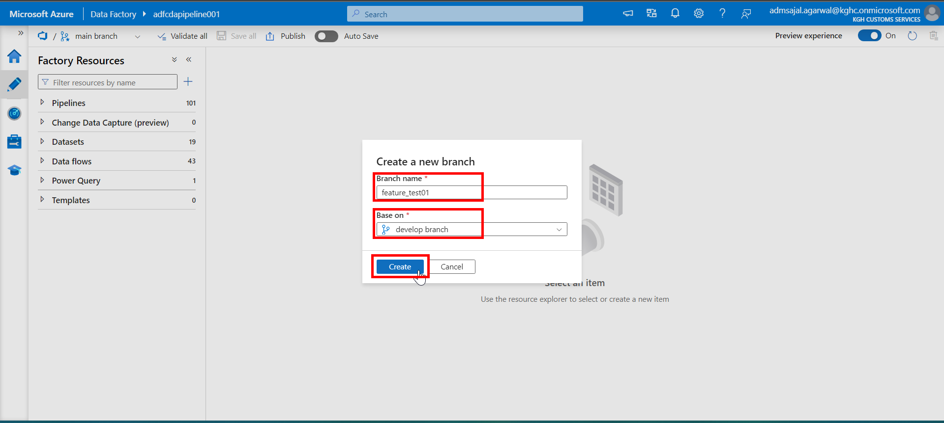

1. Login to Git Repository. Open below link:

[Branches - Repos (azure.com)](https://dev.azure.com/kgh-digital/_git/CDA/branches)

Verify that newly created branch is displayed.

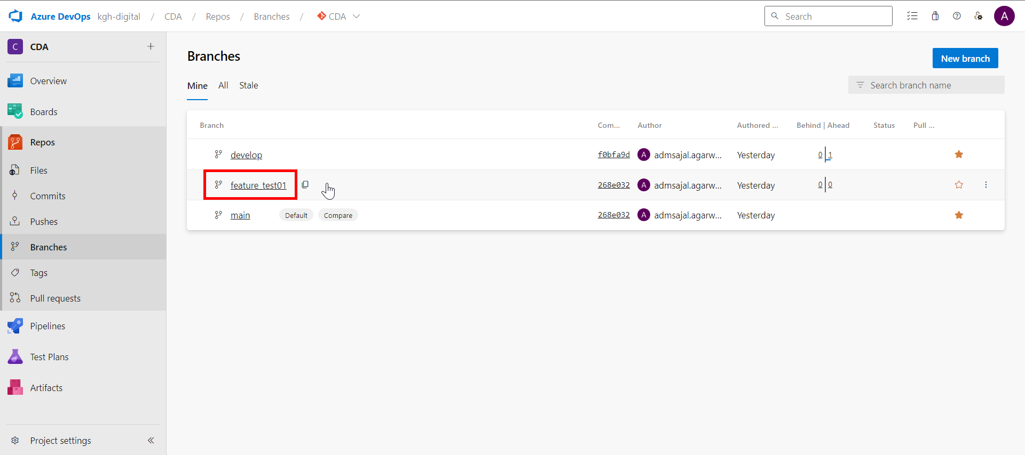

## **Data Factory: *Continuous Integration* (CI)**



### **Code Development in Working Branch (Responsible: Developer)**

1. Select *feature_test01* branch from top right corner of ADF UI.



1. Create a new dummy pipeline as *pl_feature_test01*.



1. Click on *Save all*.



1. Enter a comment describing the changes made.

Click on *OK*.



1. It will start *Saving the Git repository*.

Once completed, changes are pushed and committed to *feature_test01* branch in Git.



### **Code Pull Request from Working Branch (Responsible: Developer)**

Reference Link: [About pull requests - GitHub Docs](https://docs.github.com/en/pull-requests/collaborating-with-pull-requests/proposing-changes-to-your-work-with-pull-requests/about-pull-requests)

1. Click on drop down in front of *feature_test01* branch.

Click on *Create pull request*.



1. It will navigate to Git UI.

Make sure changes are merged from *feature_test01* to *develop*.

Add a *Title* and *Description* describing the changes.

Add *Reviewers* as needed.

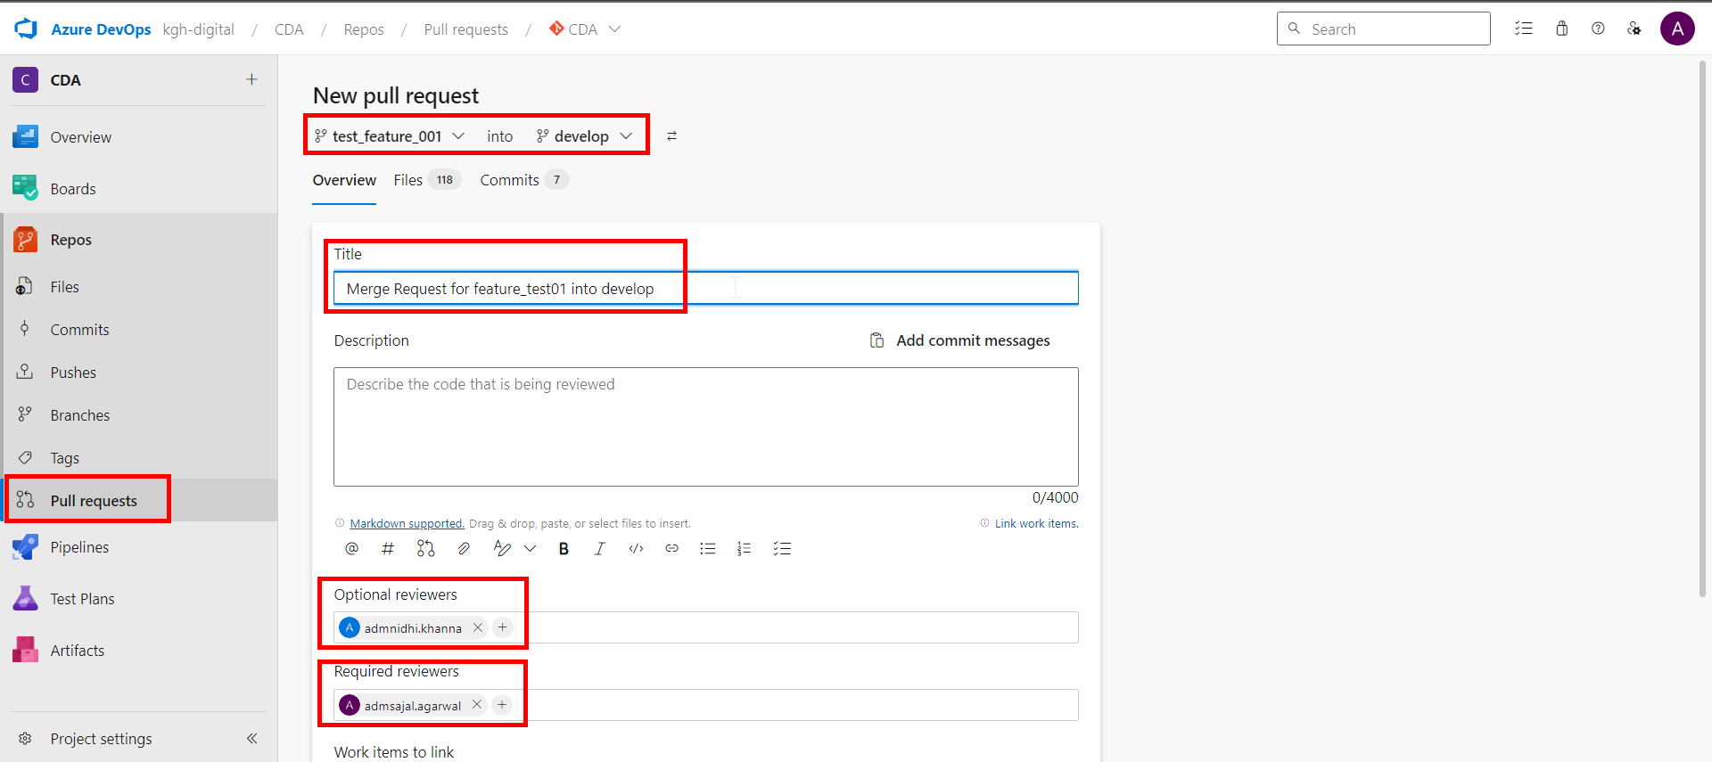

1. Verify the changes from *Files* and *Commit* sections.

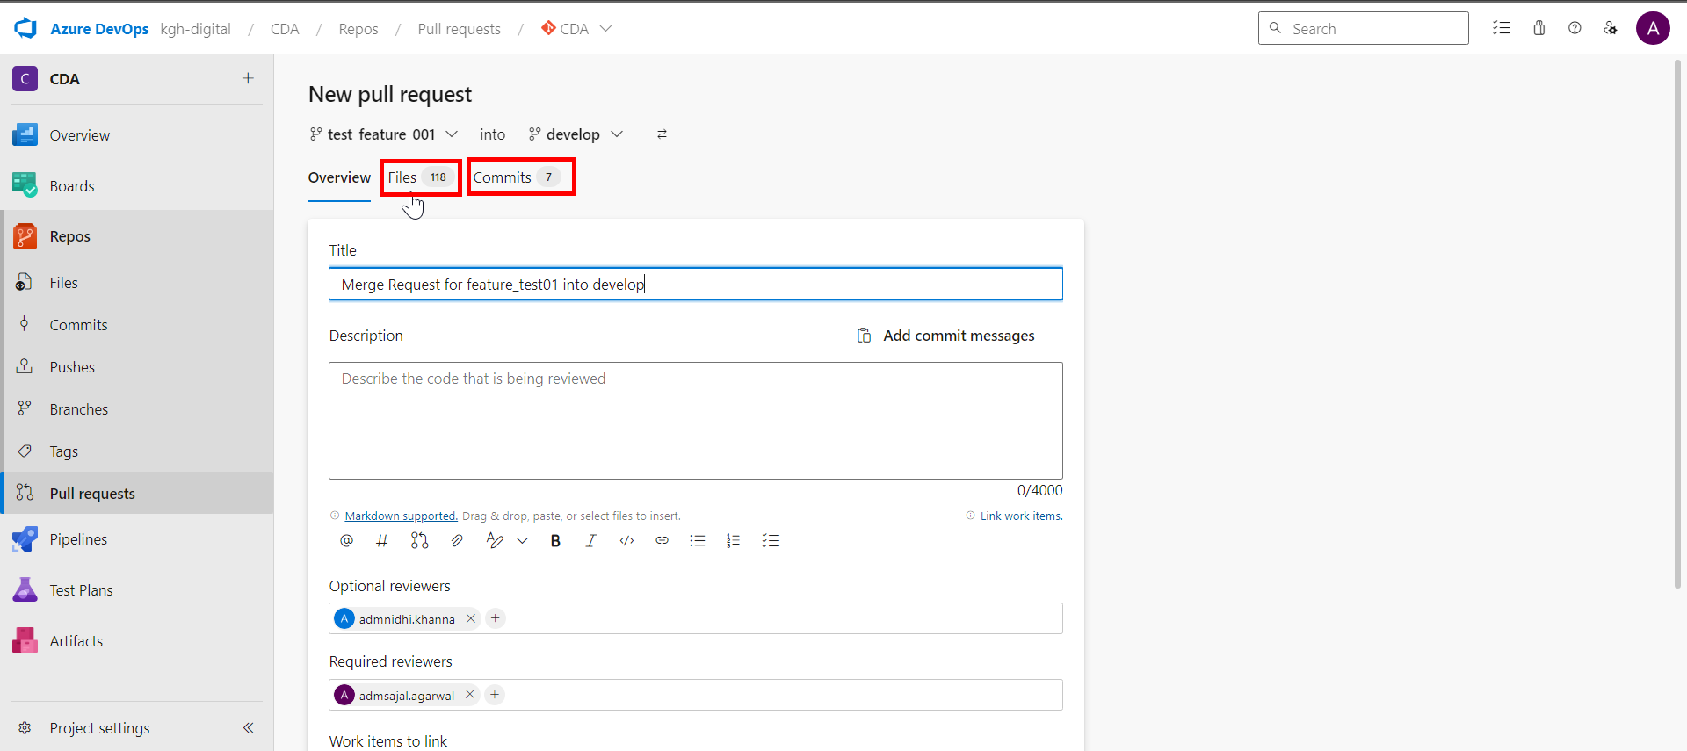

1. Scroll down and click on *Create*.

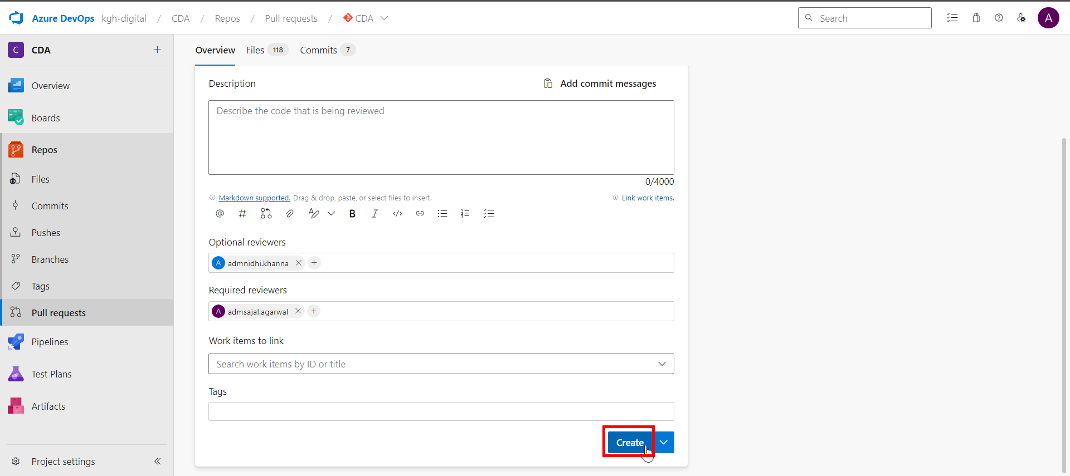

### **Code Review in Review Branch (Responsible: Reviewer)**

1. Login to Git Repository. Open below link:

[CDA - Repos (azure.com)](https://dev.azure.com/kgh-digital/CDA/_git/CDA)

Click on *Pull requests*.

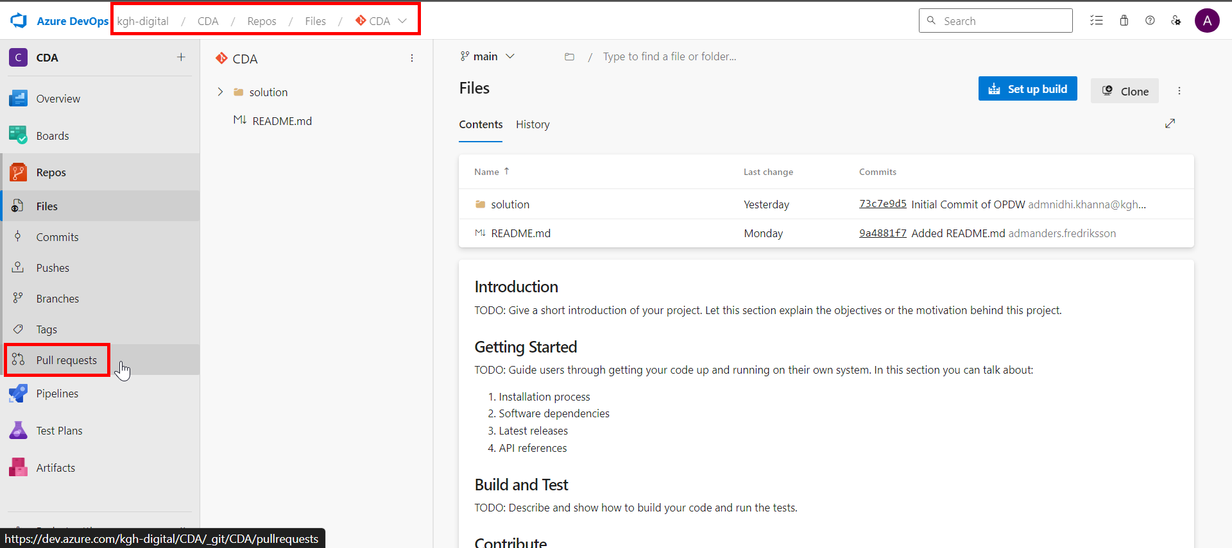

1. Click on pull request.

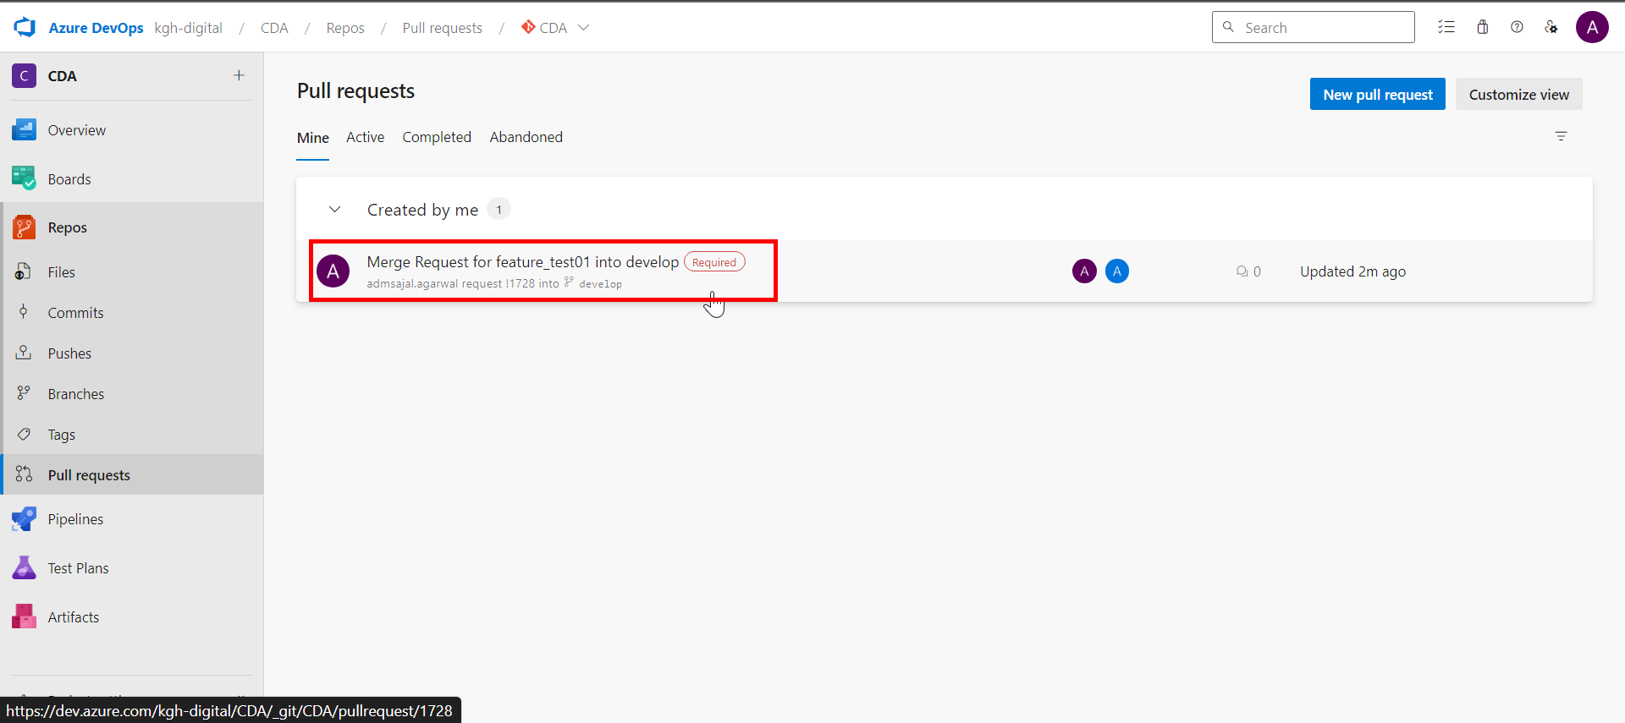

1. Review the changes under *Files*, *Updates* and *Commit* sections.

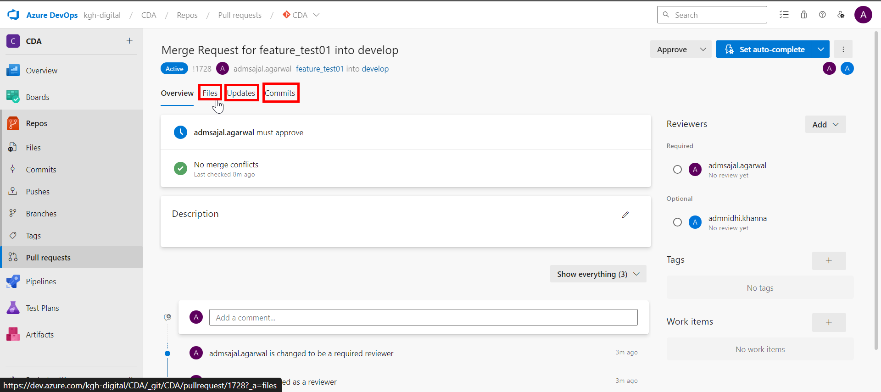

1. Add review comments.

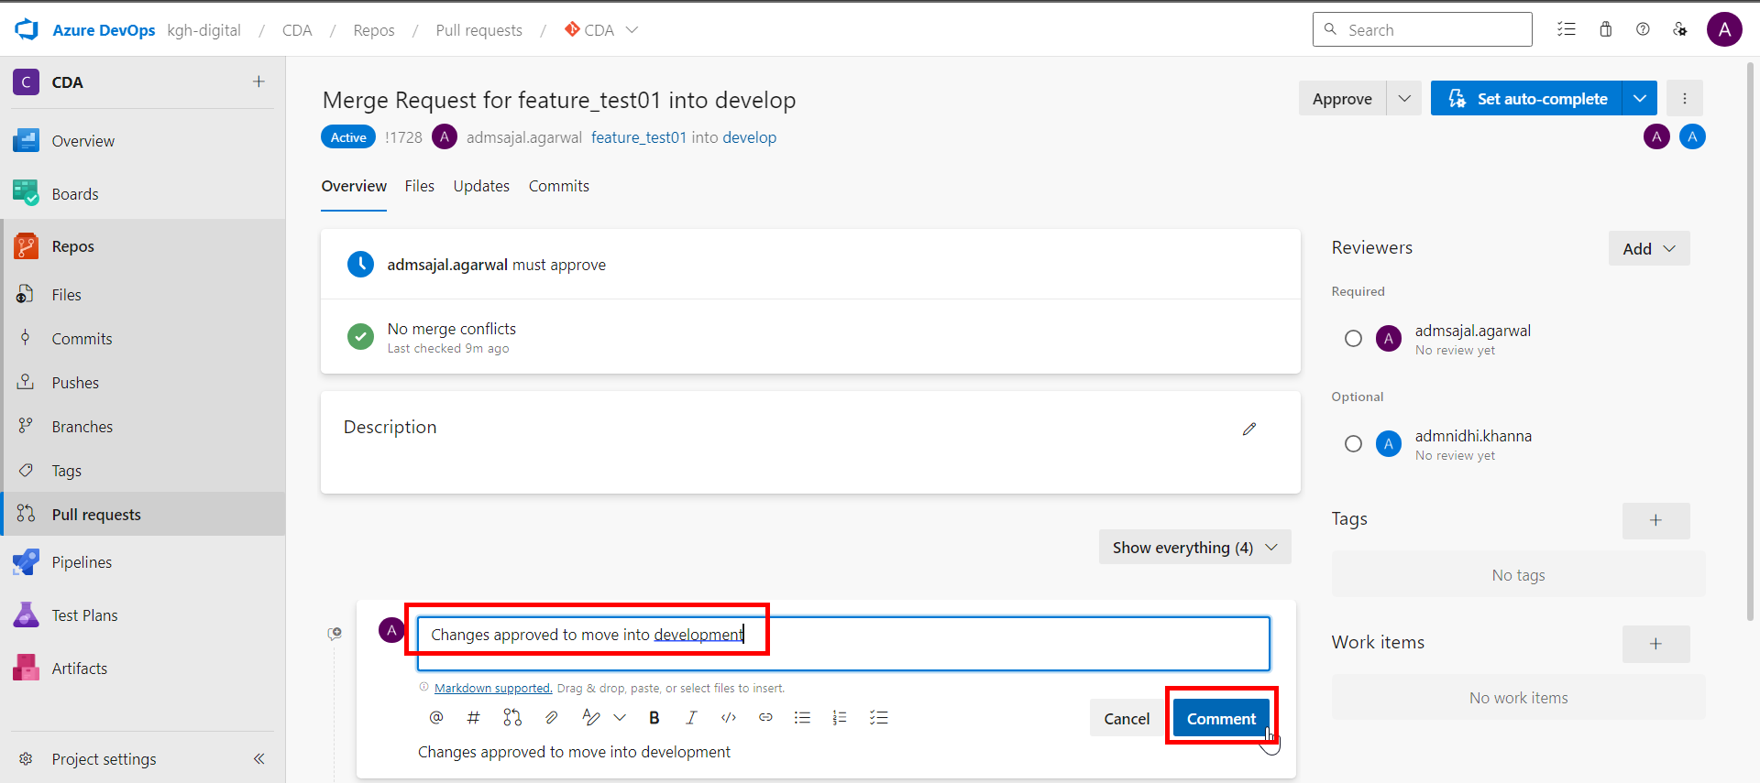

1. Click on *Approve/Approve with suggestions/Reject* as per the case.

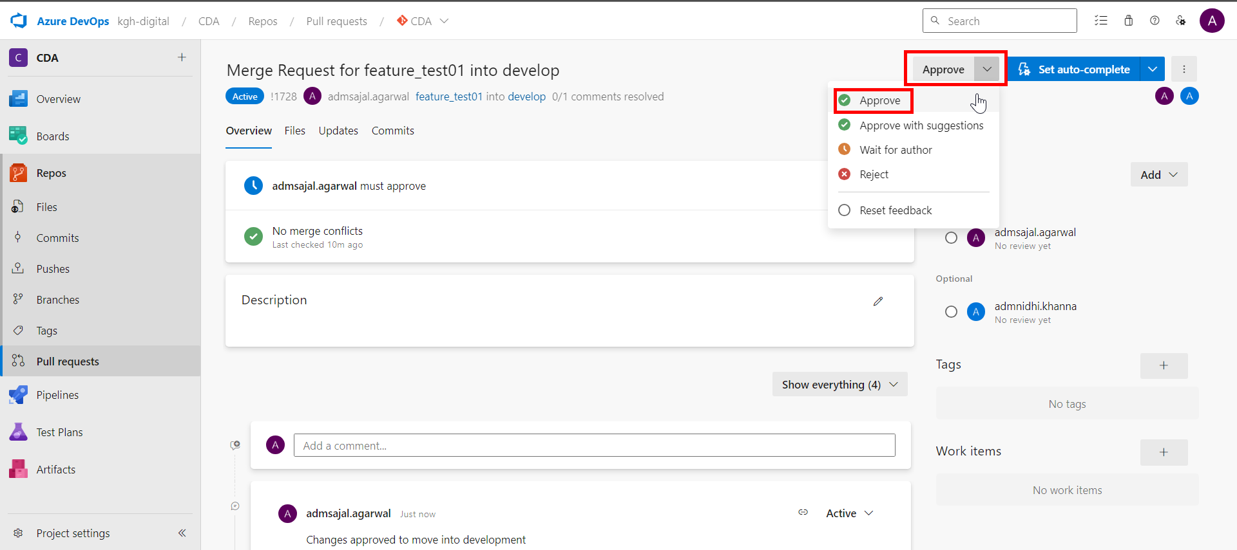

### **Code Merge with Review Branch (Responsible: Approver)**

1. Login to Git Repository. Open below link:

[CDA - Repos (azure.com)](https://dev.azure.com/kgh-digital/CDA/_git/CDA)

Click on *Pull requests*.



1. Click on pull request.

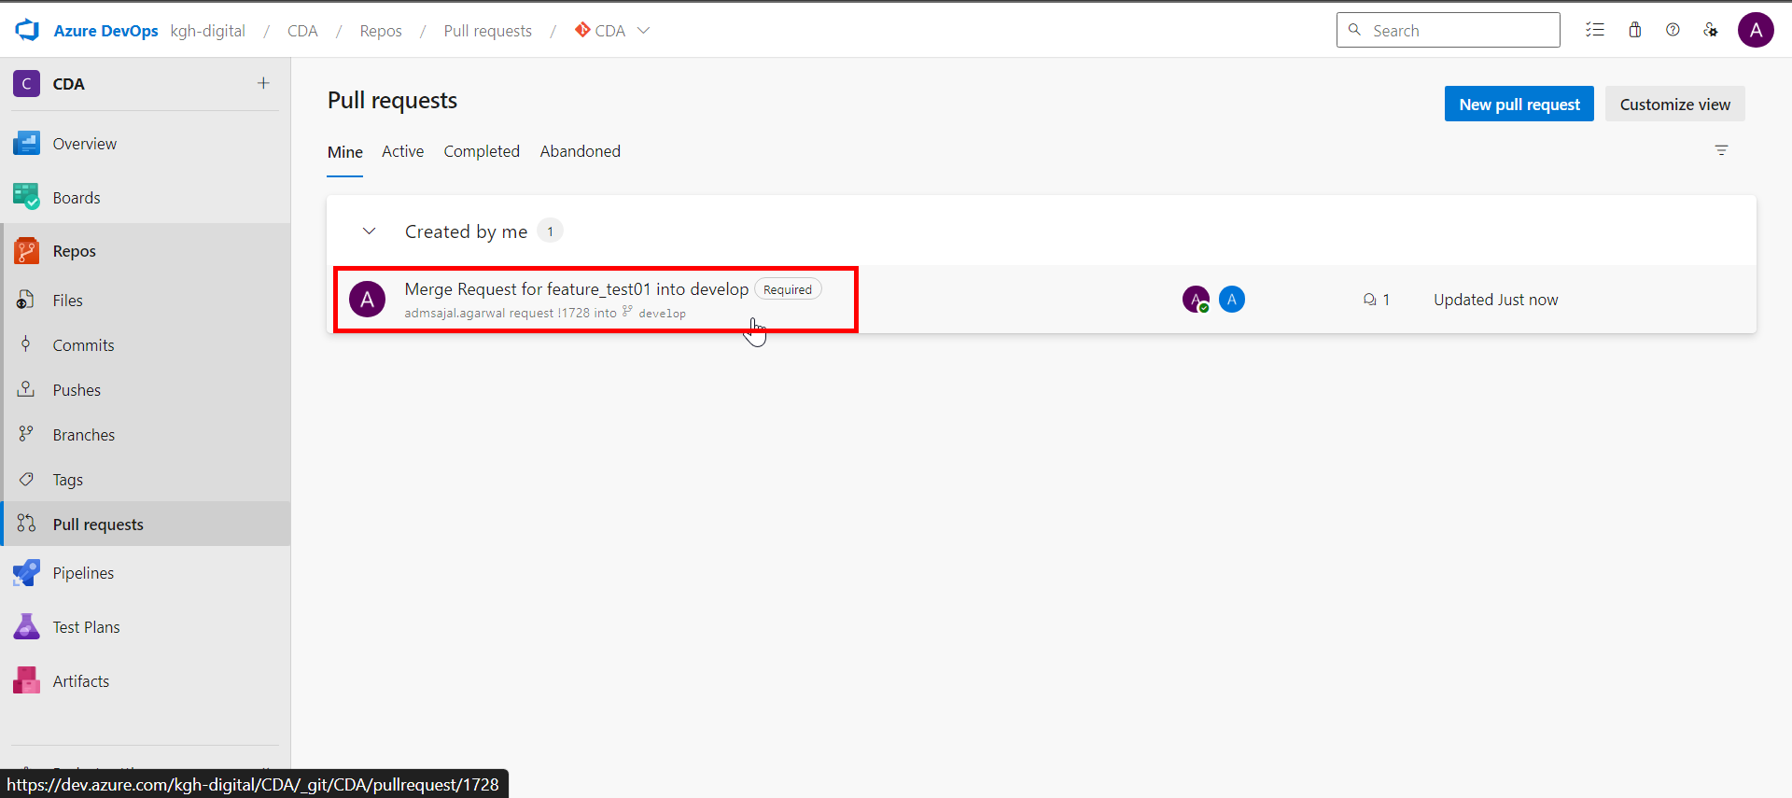

1. Click on *Complete*.

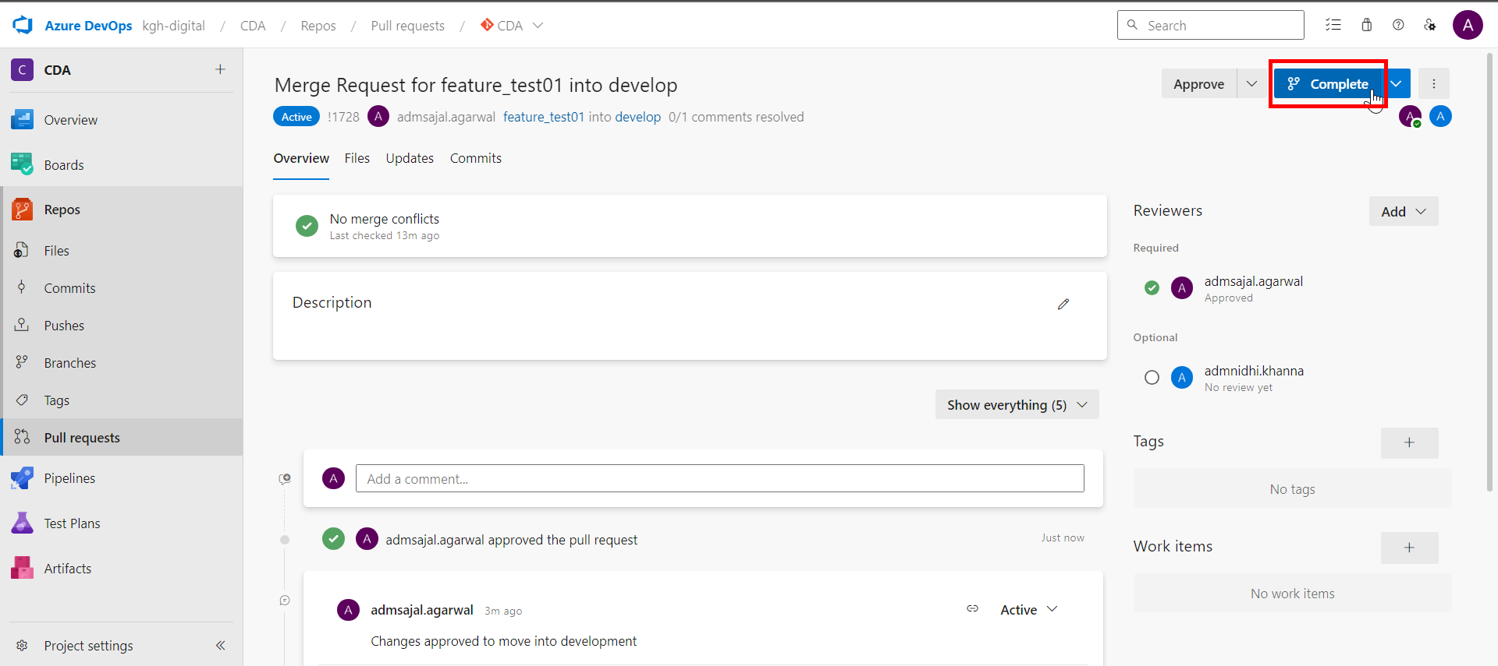

1. Click on *Customize merge commit message*.

Enter a *Comment* and *Description* describing the merge request.

Click on *Complete merge*.

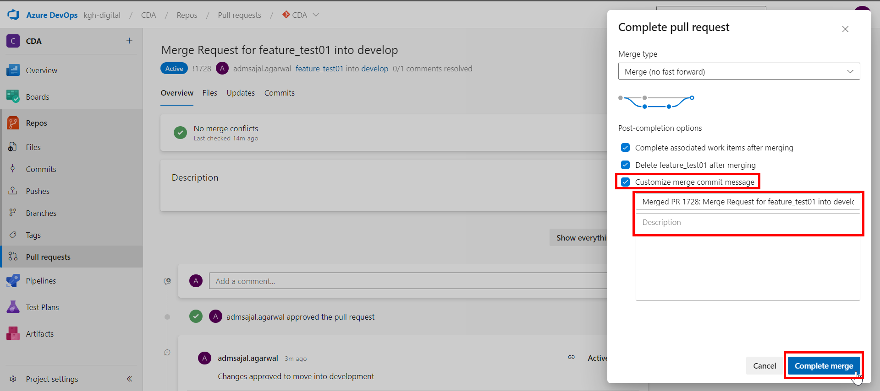

1. Pull request will now be shown as *Completed*.

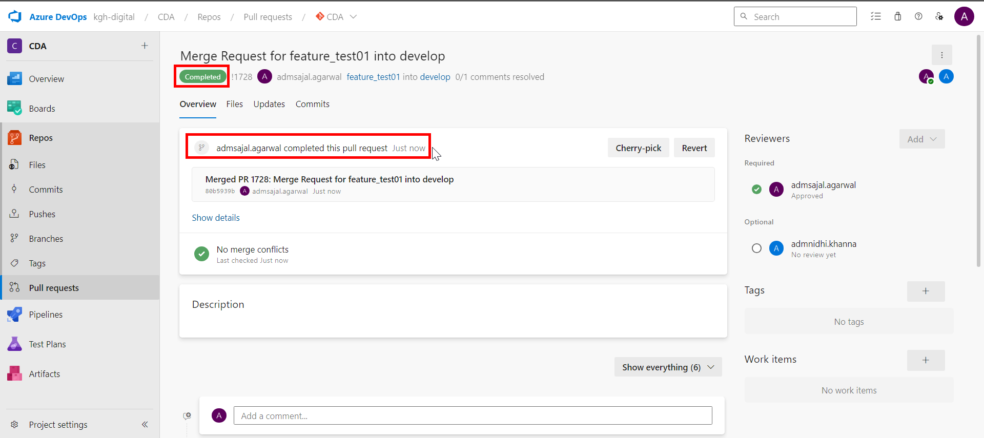

1. In ADF, click on drop down in front of *feature_test01* branch*.*

Click on *develop* branch*.*

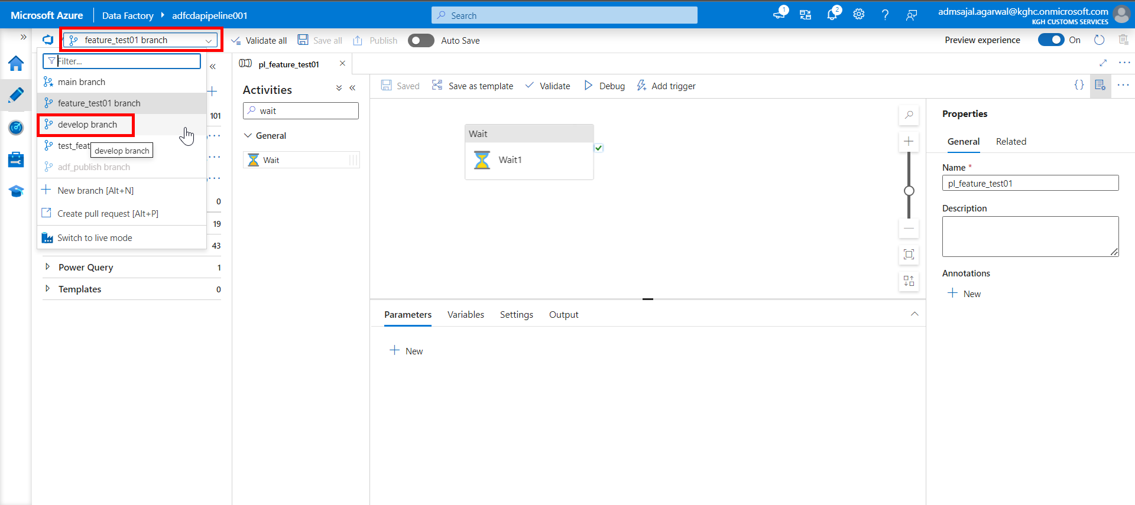

1. Click on *Refresh*.

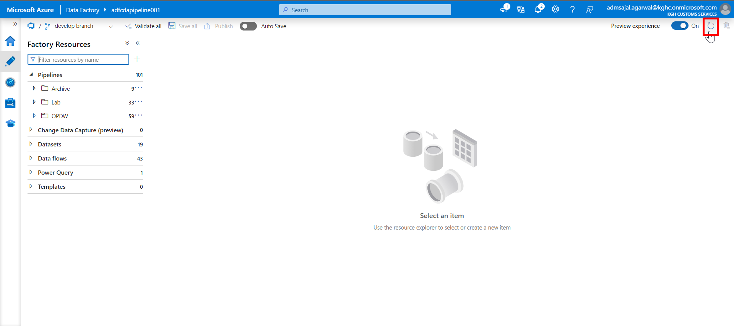

1. Verify that the recently made changes are available in *develop* branch now.

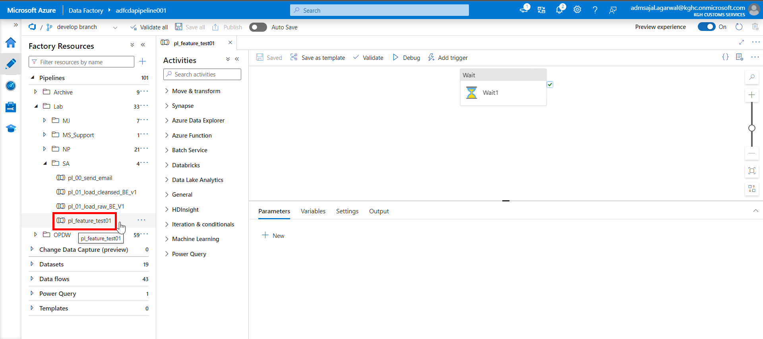

### **Code Pull Request from Collaboration Branch (Responsible: Approver)**

1. In ADF, click on drop down in front of *develop* branch*.*

Click on *Create pull request.*

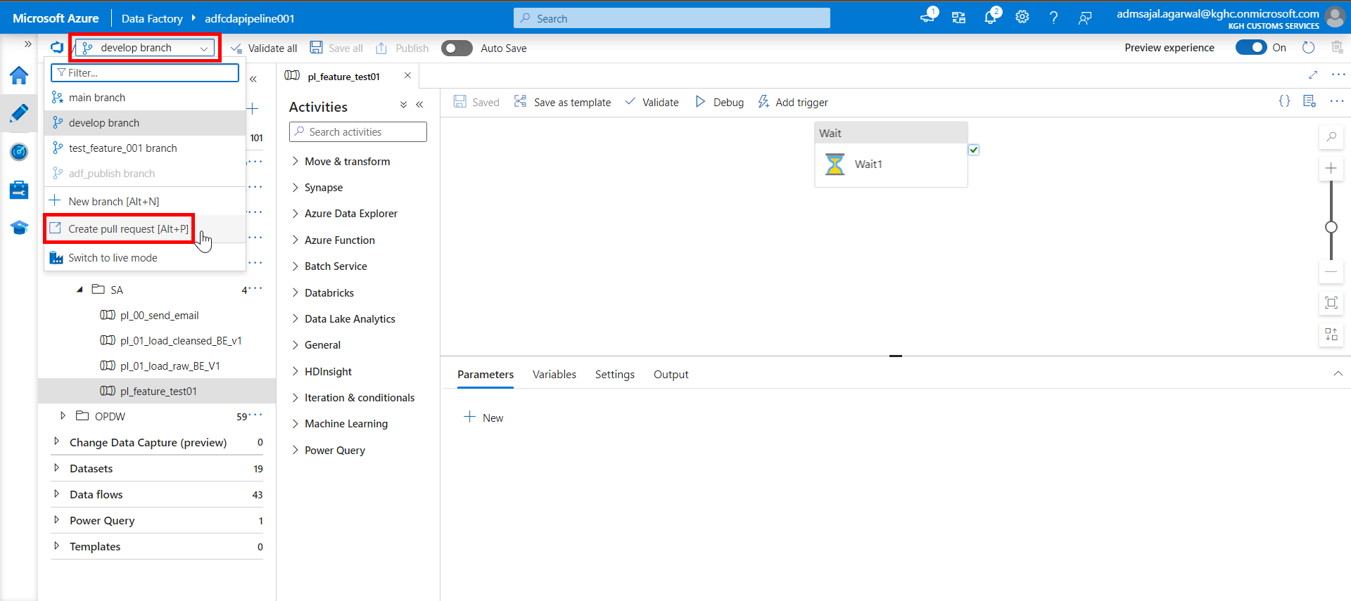

1. It will navigate to Git UI.

Make sure changes are merged from *develop* to *main*.

Add a *Title* and *Description* describing the changes.

Add *Reviewers* as needed.

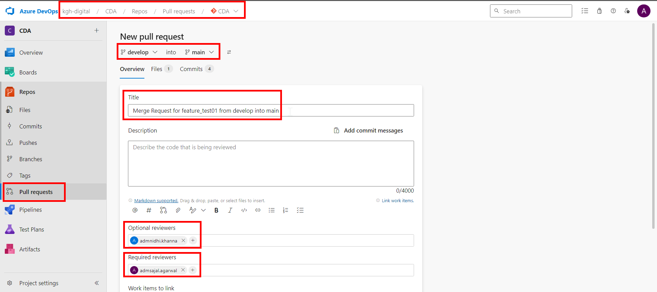

1. Verify the changes from *Files* and *Commit* sections.

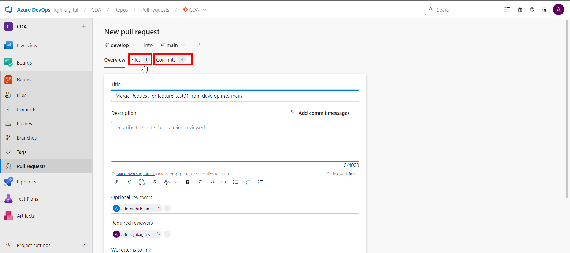

1. Scroll down and click on *Create*.

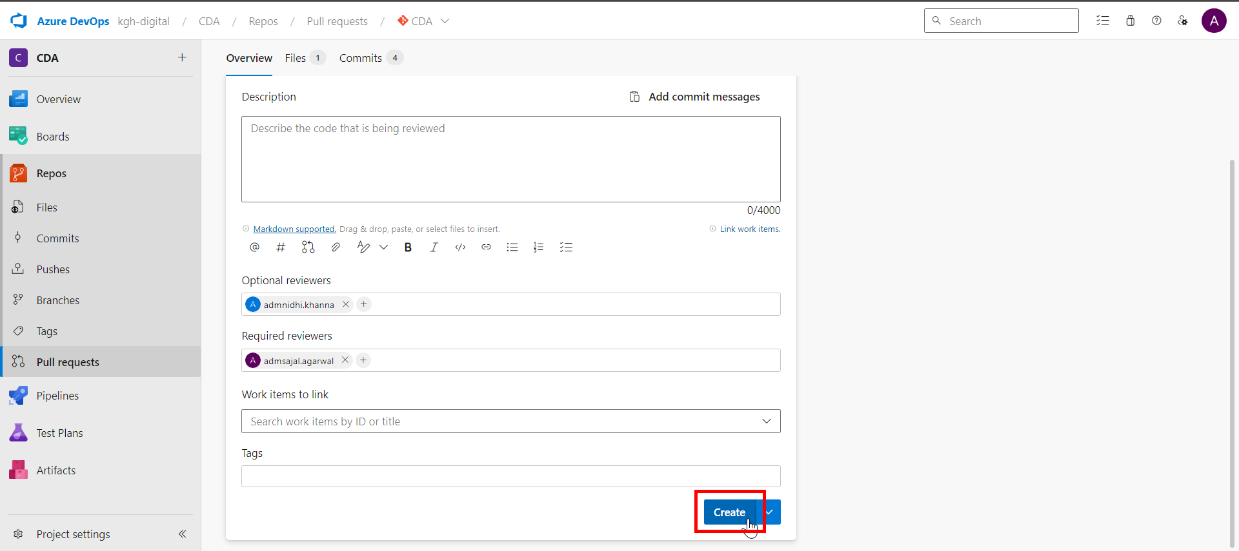

### **Code Review in Collaboration Branch (Responsible: Approver)**

1. Login to Git Repository. Open below link:

[CDA - Repos (azure.com)](https://dev.azure.com/kgh-digital/CDA/_git/CDA)

Click on *Pull requests*.

1. Click on pull request.
2. Review the changes under *Files*, *Updates* and *Commit* sections.
3. Add review comments.
4. Click on *Approve/Approve with suggestions/Reject* as per the case.

### **Code Merge with Collaboration Branch (Responsible: Approver)**

1. Login to Git Repository. Open below link:

[CDA - Repos (azure.com)](https://dev.azure.com/kgh-digital/CDA/_git/CDA)

Click on *Pull requests*.



1. Click on pull request.

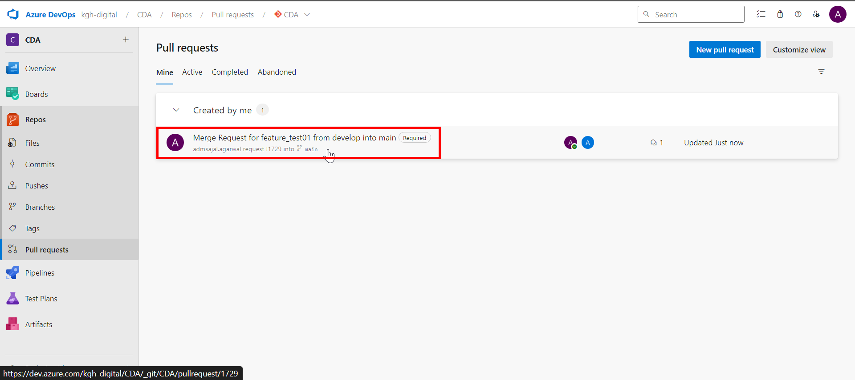

1. Click on *Complete*.

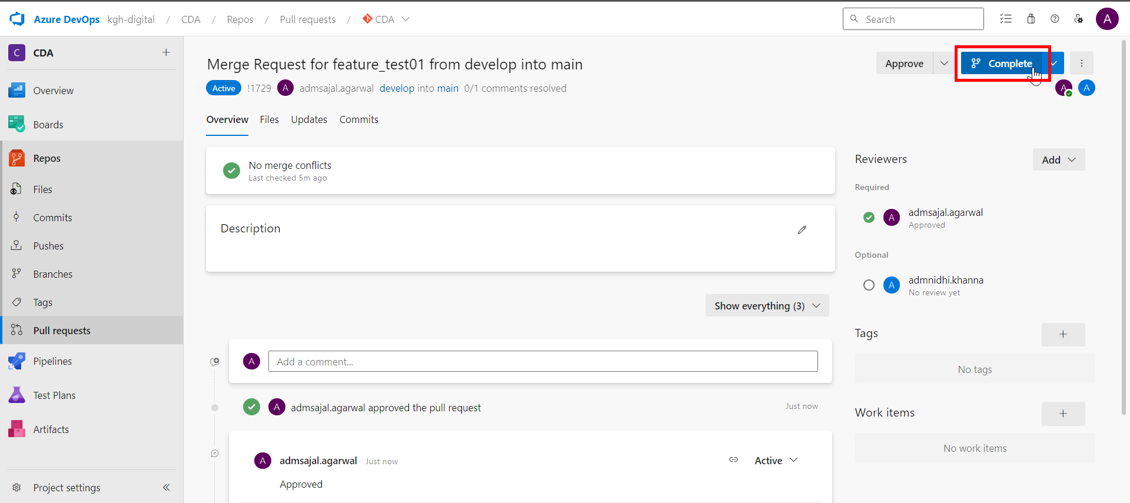

1. Click on *Customize merge commit message*.

Enter a *Comment* and *Description* describing the merge request.

Click on *Complete merge*.

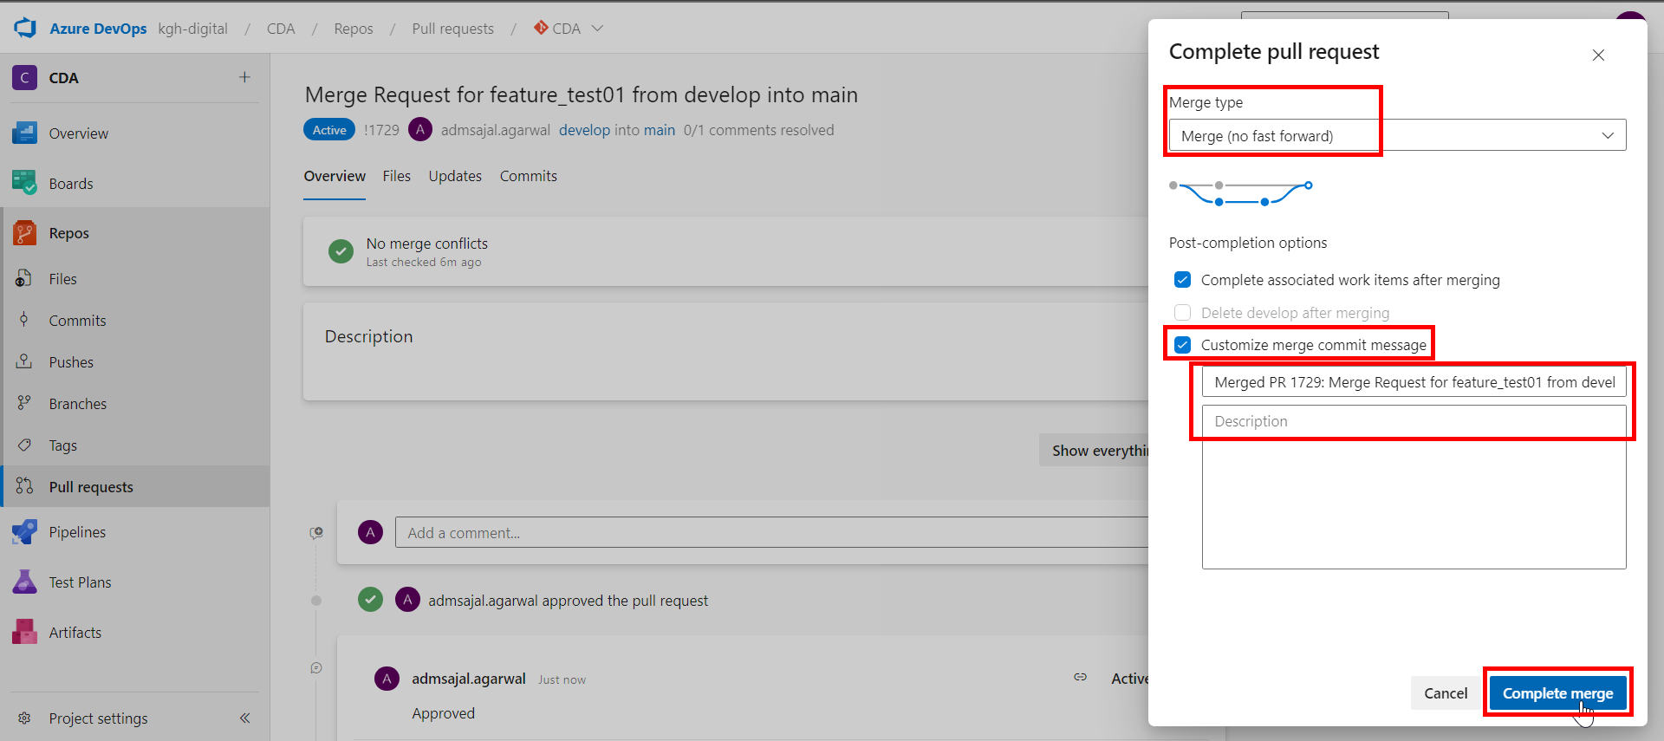

1. Pull request will now be shown as *Completed*.

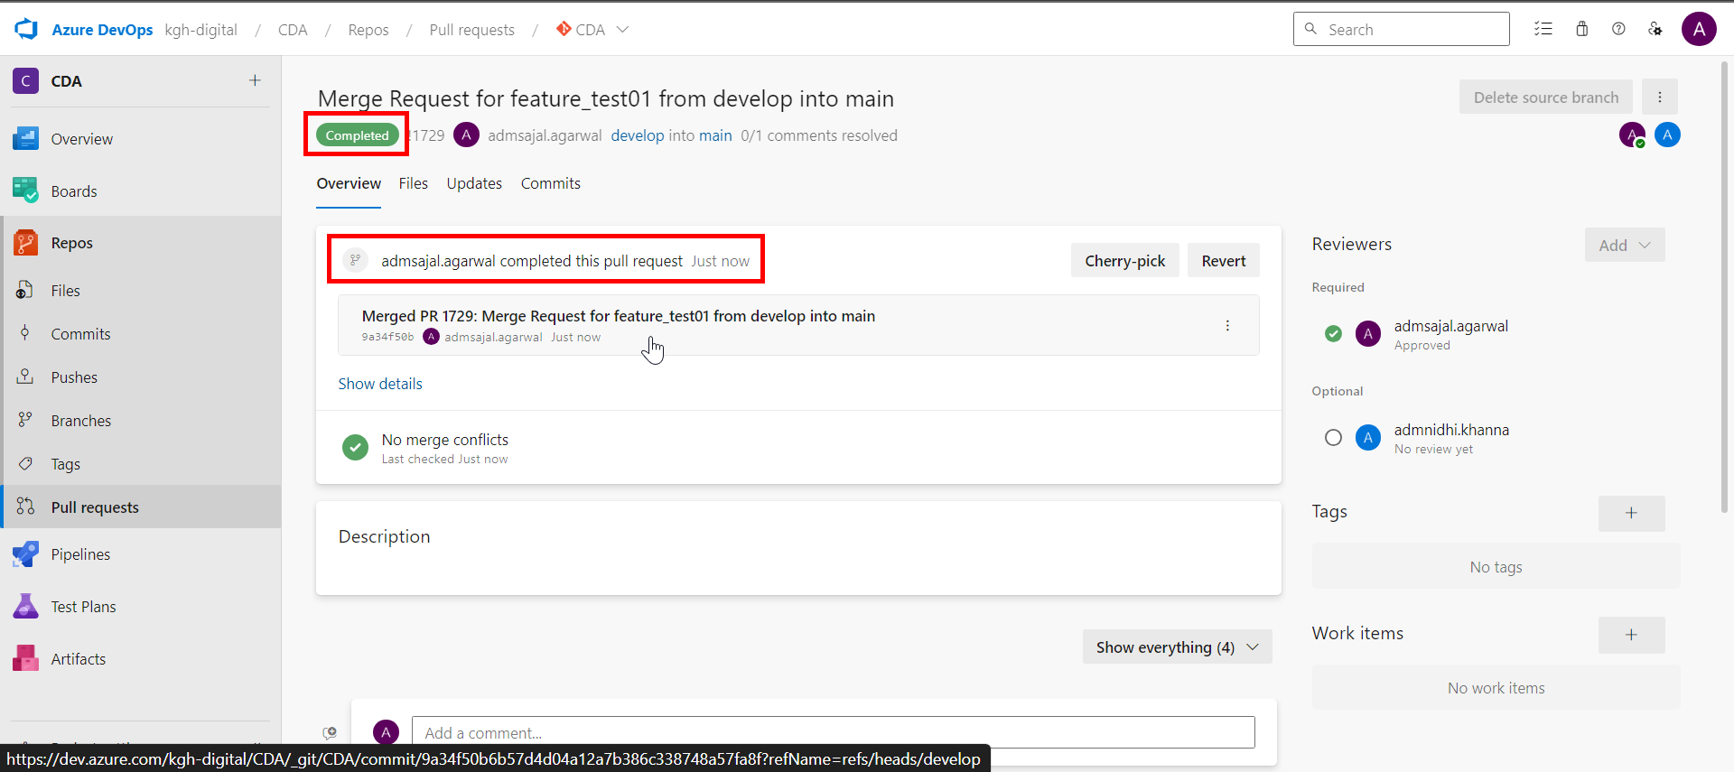

1. In ADF, click on drop down in front of *develop* branch*.*

Click on *main* branch*.*

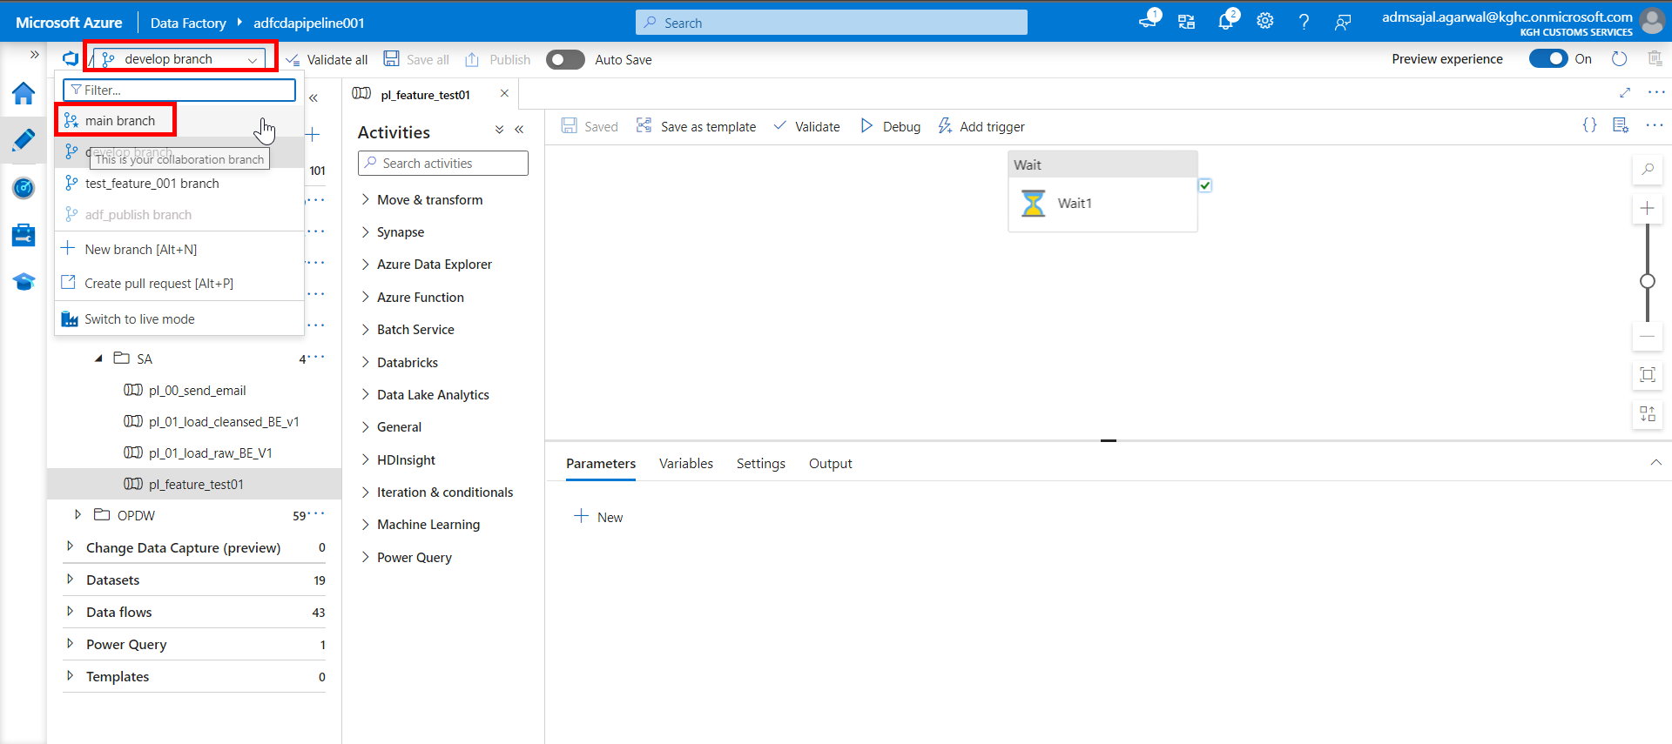

1. Click on *Refresh*.

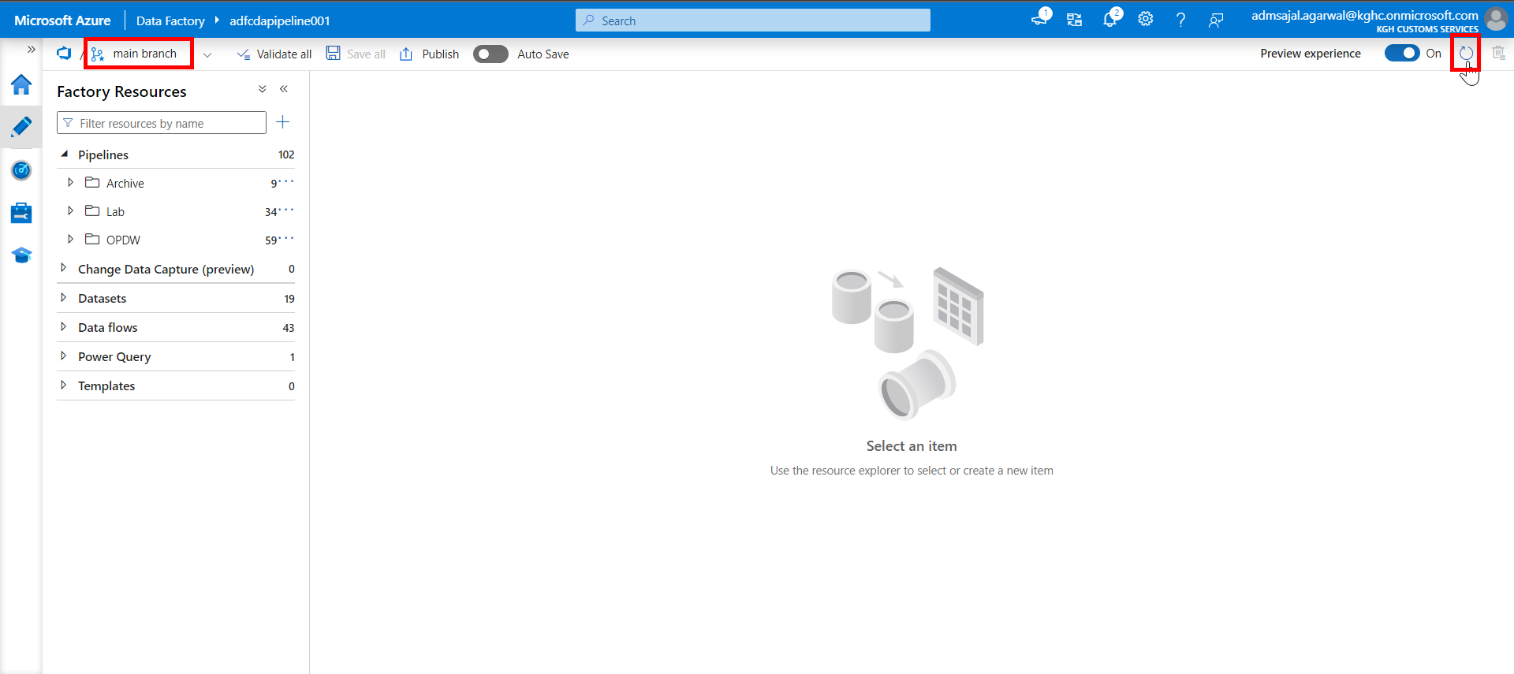

1. Verify that the recently made changes are available in *main* branch now.

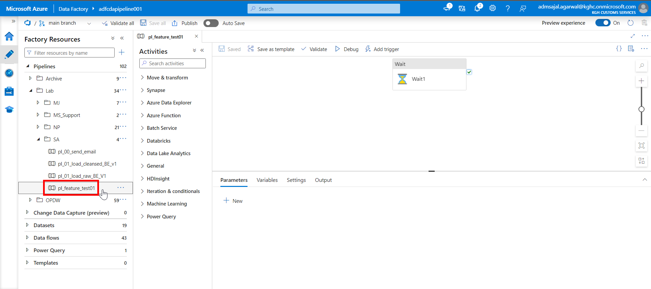

### **Code Push to ADF (Responsible: Approver)**

1. With *main* branch selected, click on *Publish*.

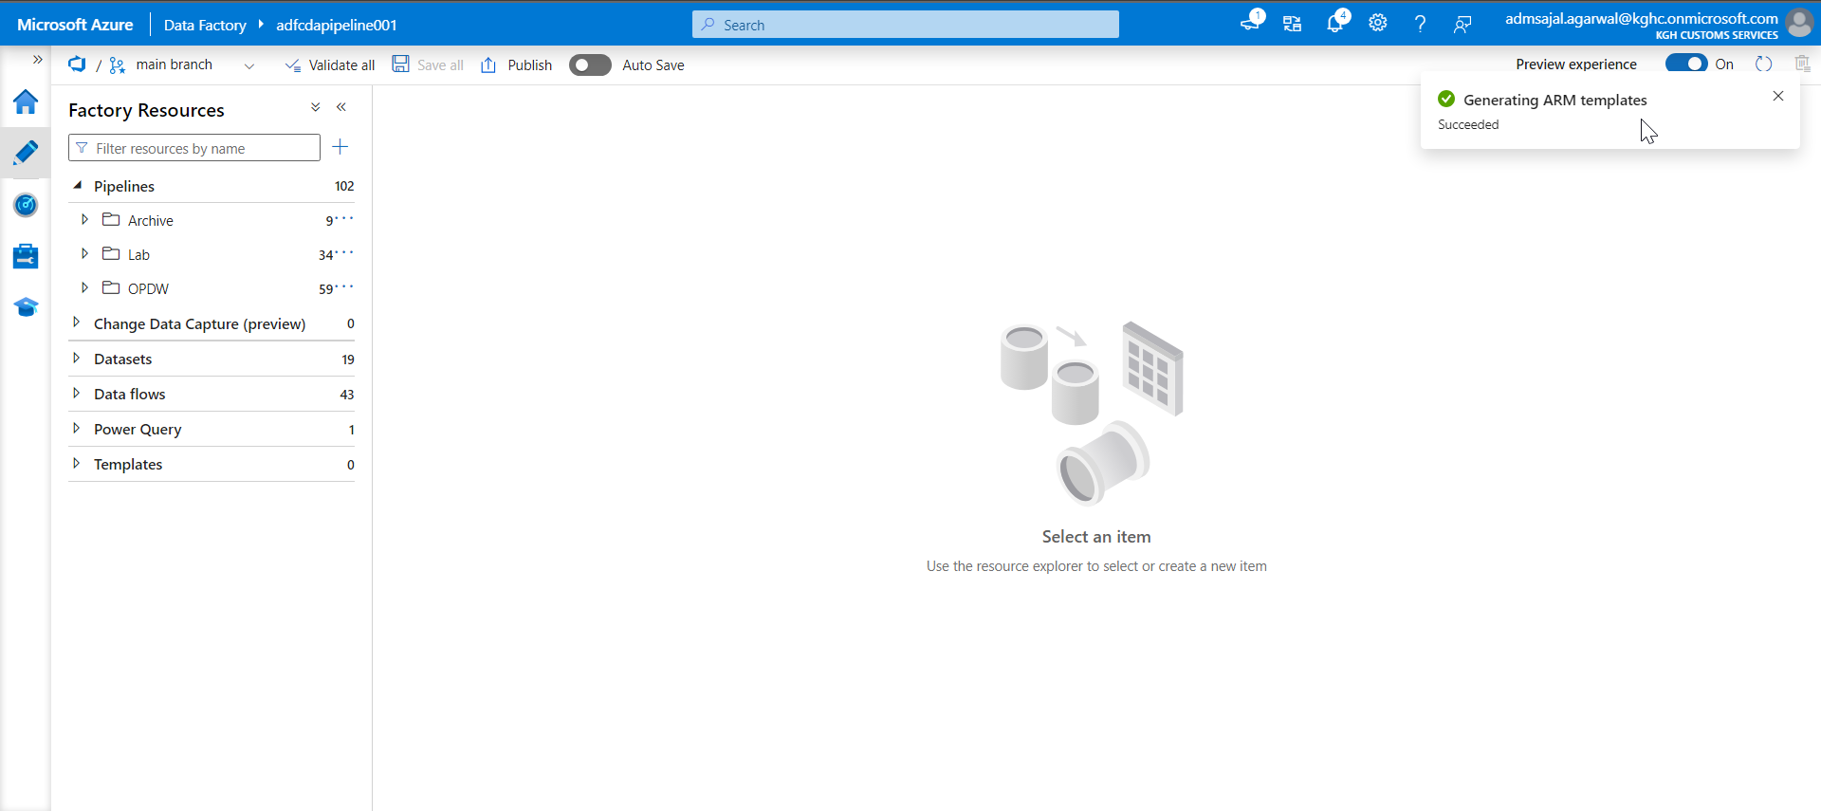

1. It will start *Publishing*.

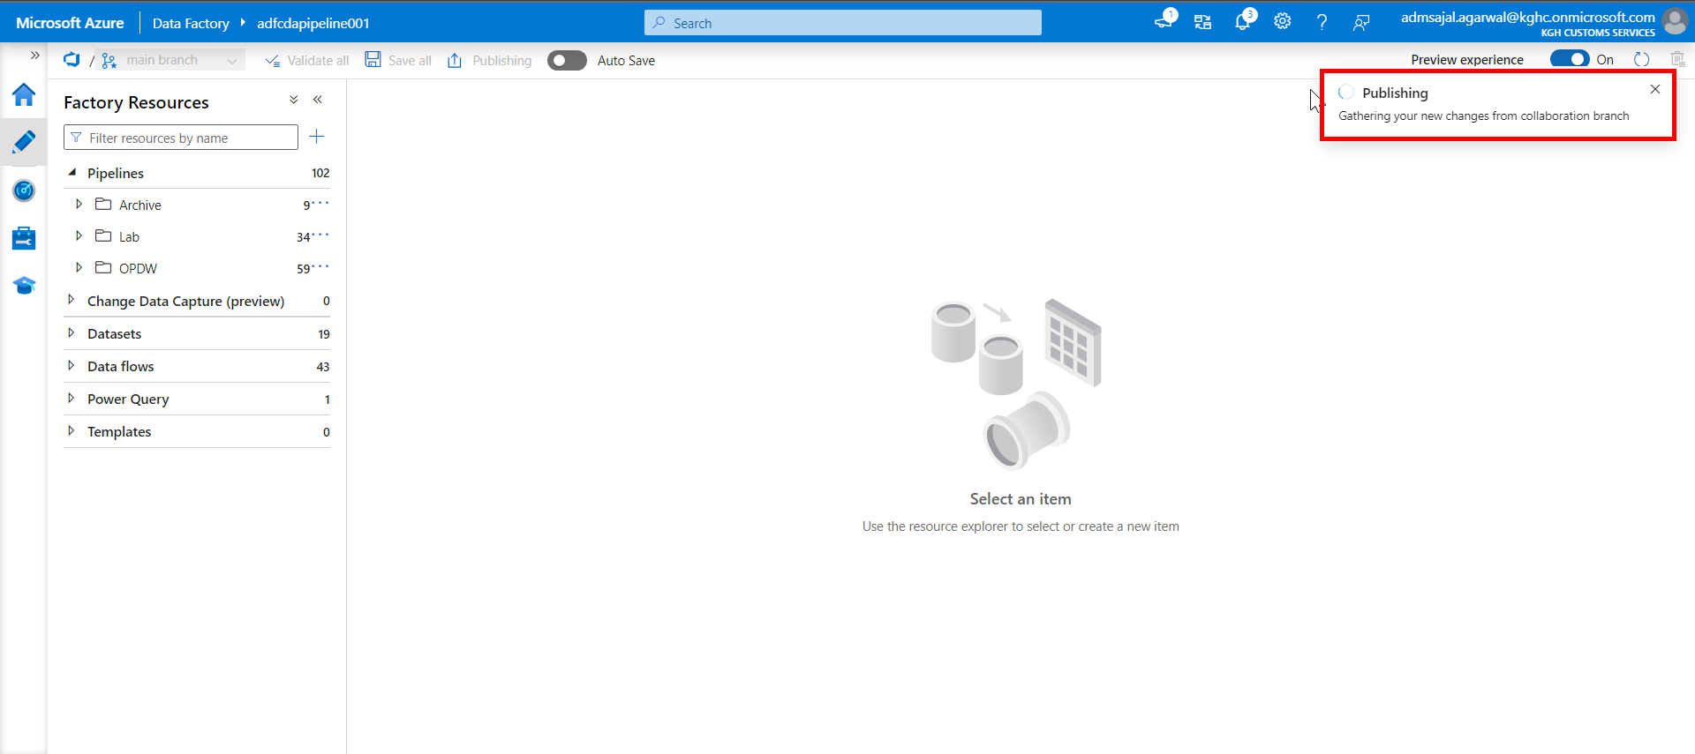

1. Verify the changes and click on *OK*.

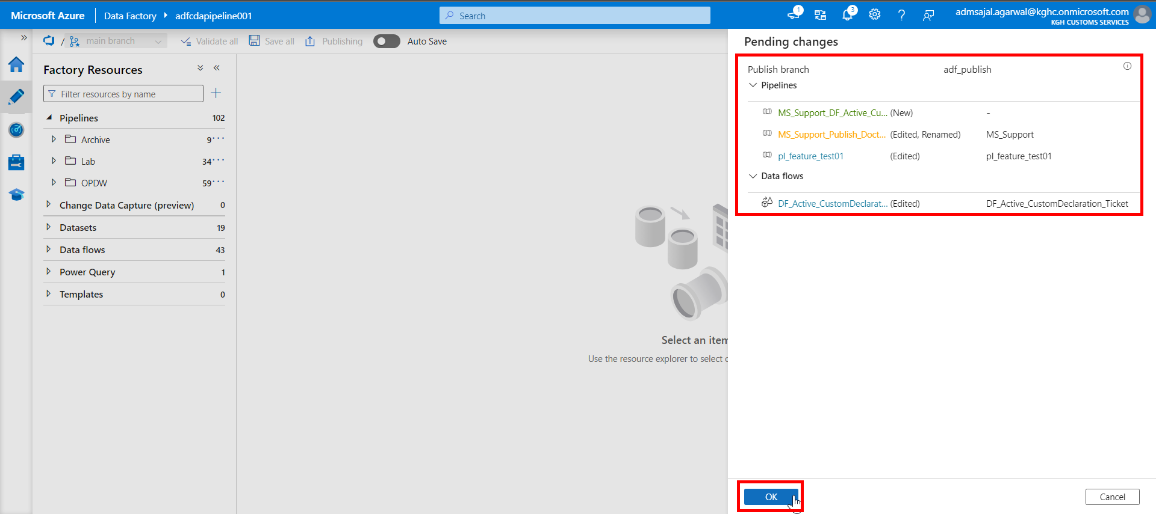

1. It will start *Deploying changes* to the Azure Data Factory.

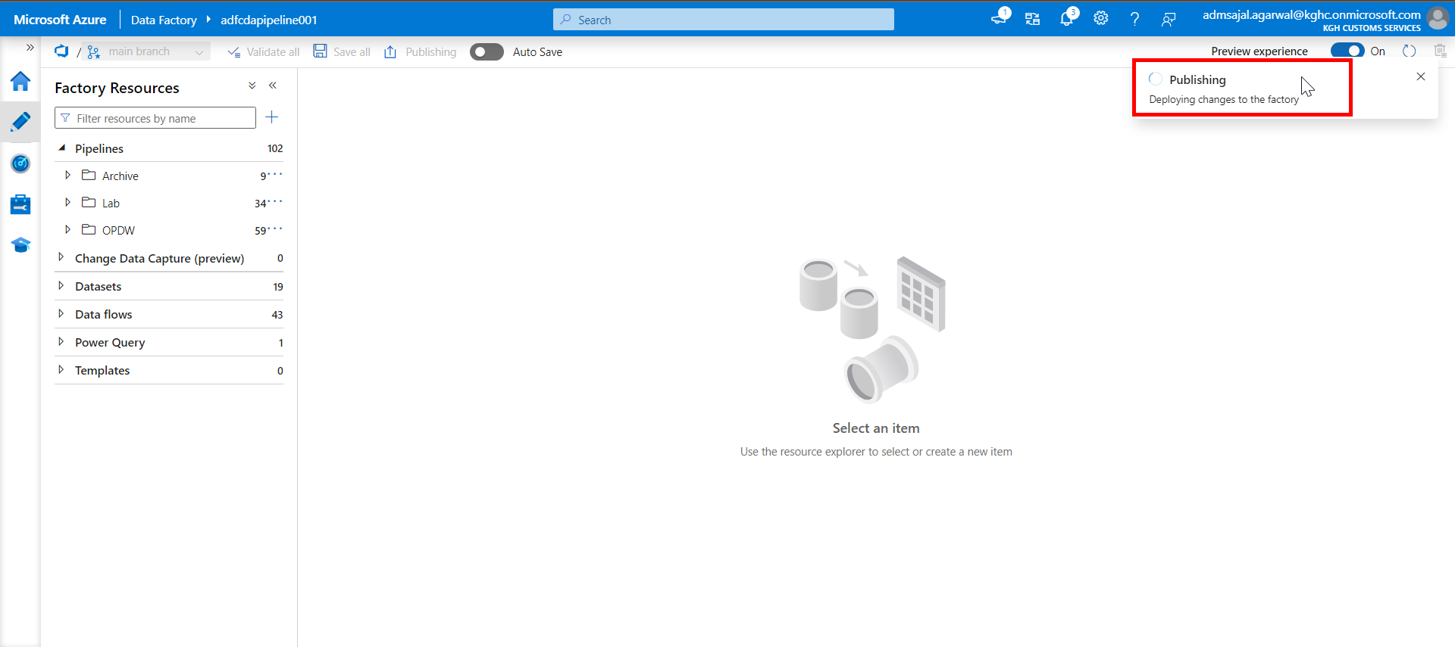

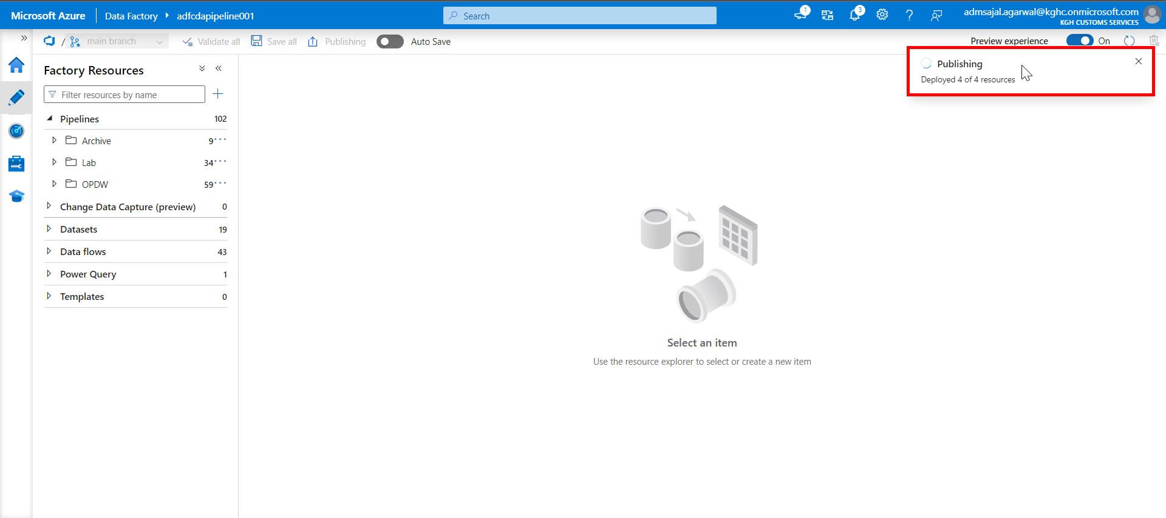

1. When the *Publishing completed* notification is shown, all new changes are pushed to *Data Factory* from *main* branch.

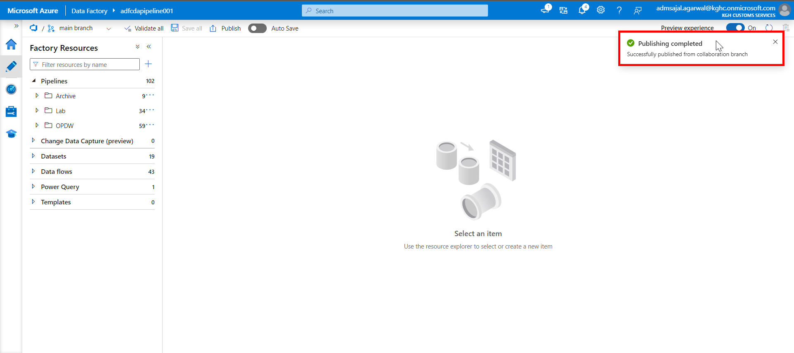

1. It will now start *Generating ARM templates*.

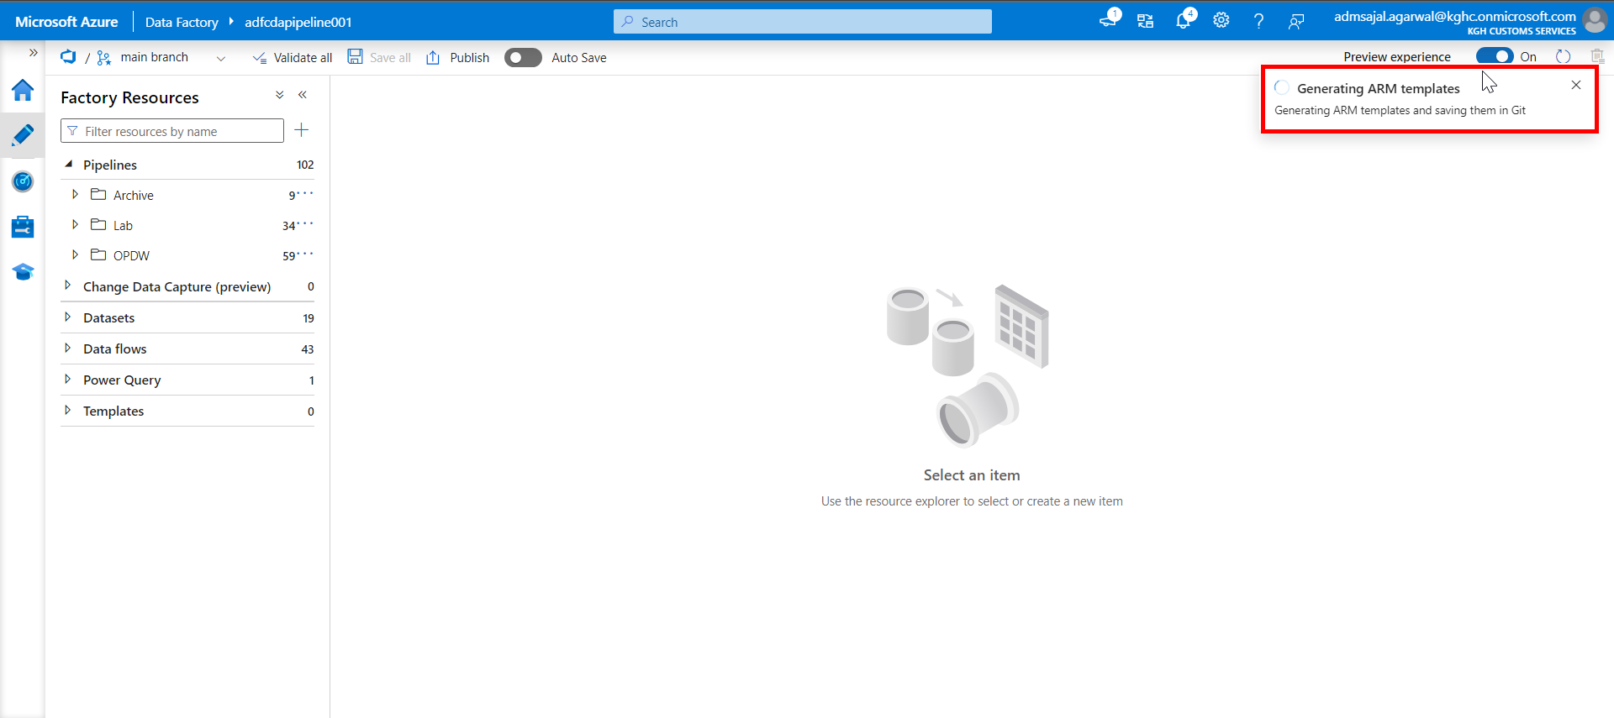

1. When the *Generating ARM templates Succeeded* notification is shown, current state of ADF is pulled and merged into a branch called as *adf_publish* in Git.

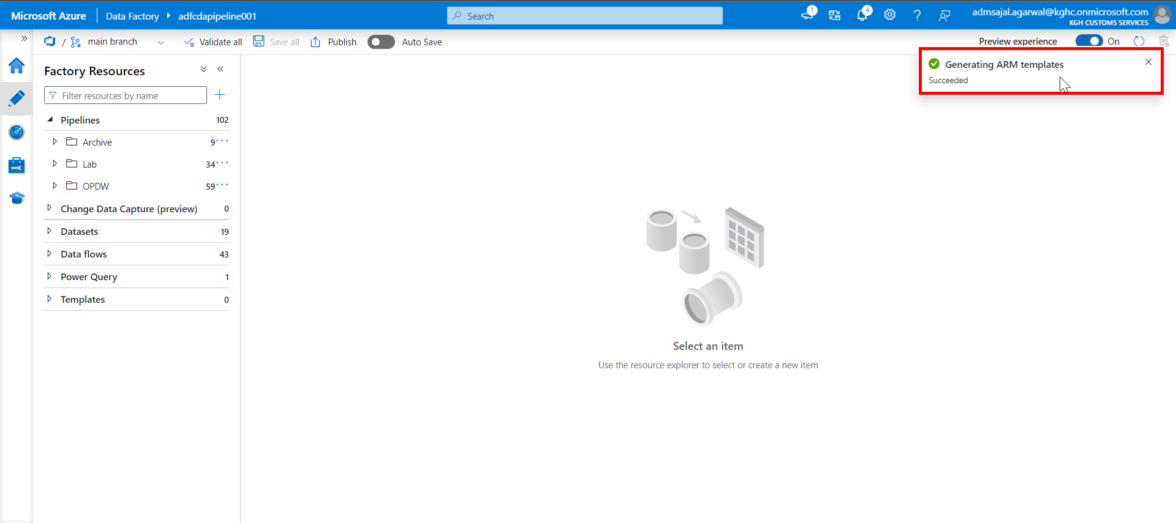

1. In ADF, click on drop down in front of *main* branch*.*

Click on *Switch to live mode.*

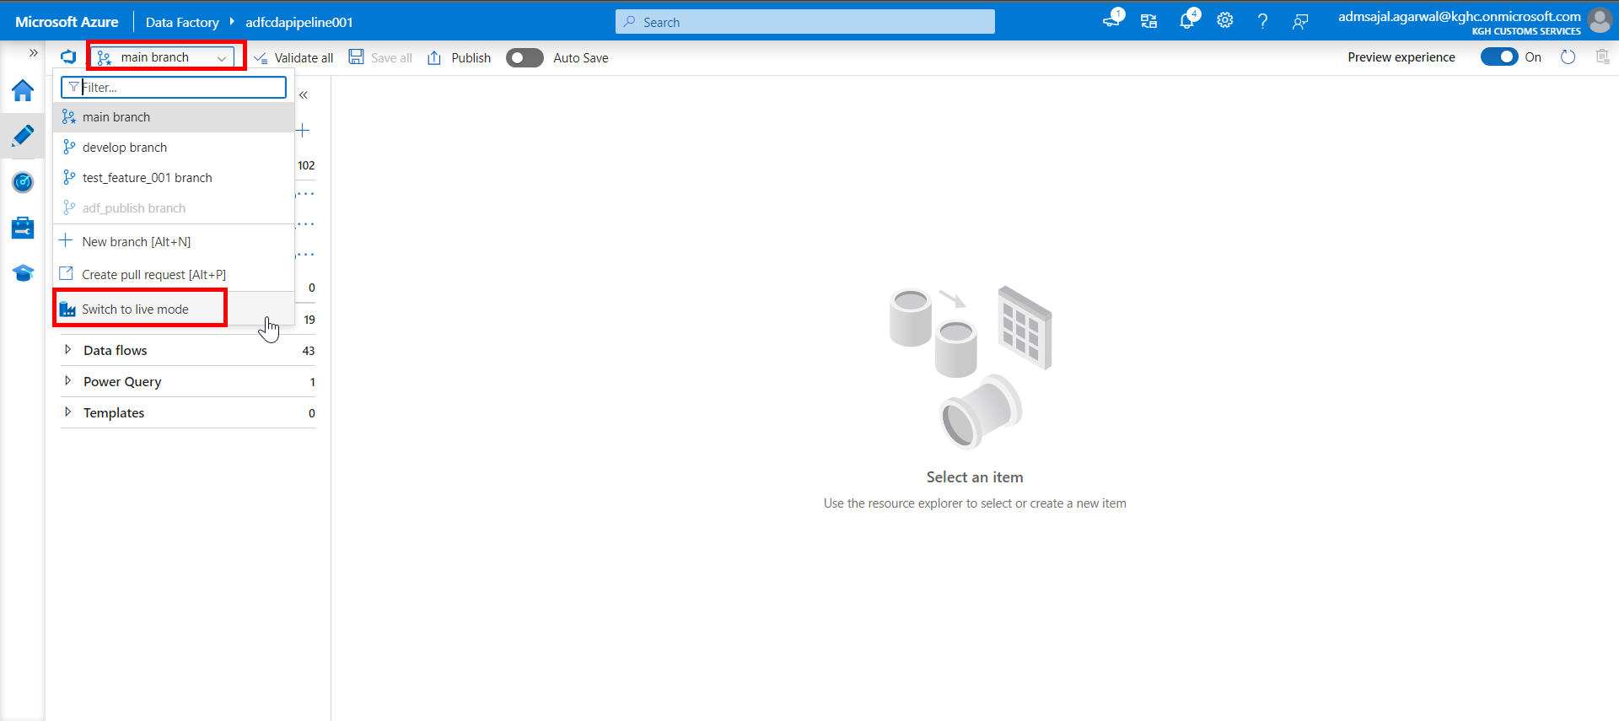

1. Click on *Refresh*.

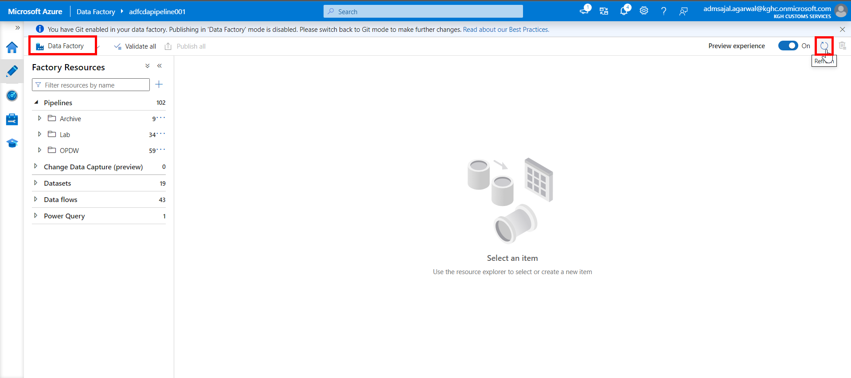

1. Verify that the recently made changes are available in *Data Factory* now.

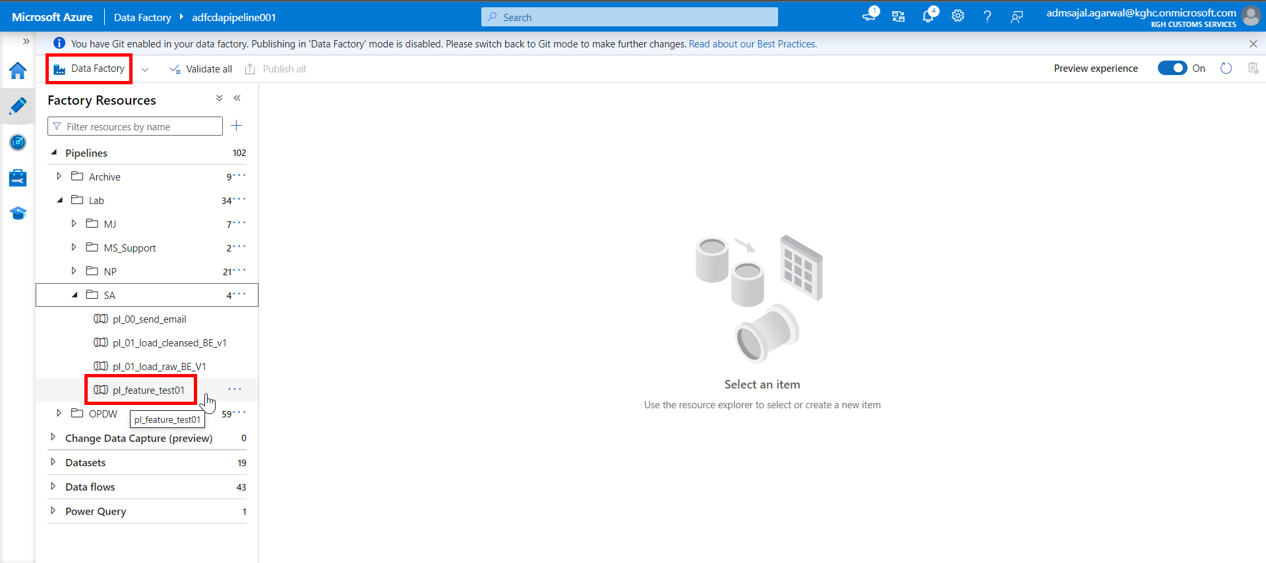

1. Login to Git Repository. Open below link:

[Branches - Repos (azure.com)](https://dev.azure.com/kgh-digital/CDA/_git/CDA/branches)

Verify that newly created branch *adf_publish* is displayed.

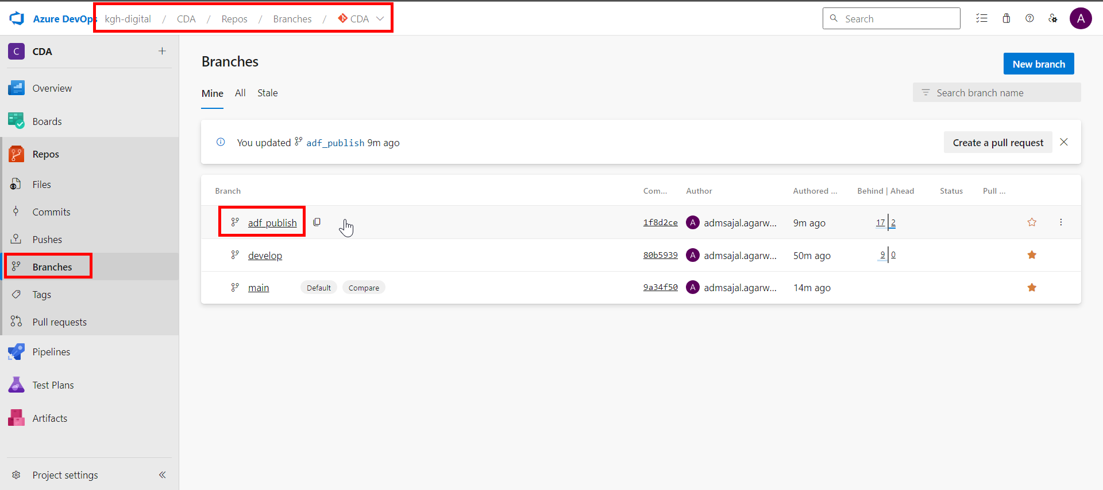

1. Open the folder *adfcdapipeline001* in *adf_publish* branch.

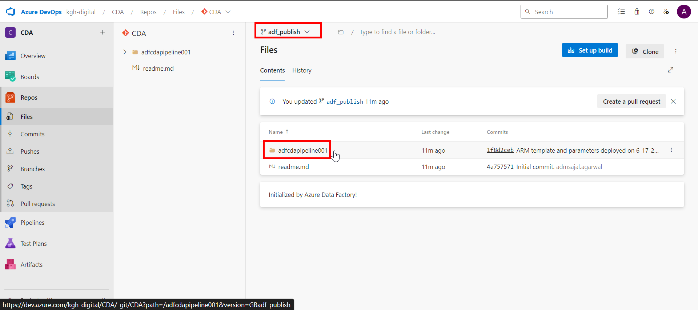

1. Verify that the *ARM template* is uploaded.

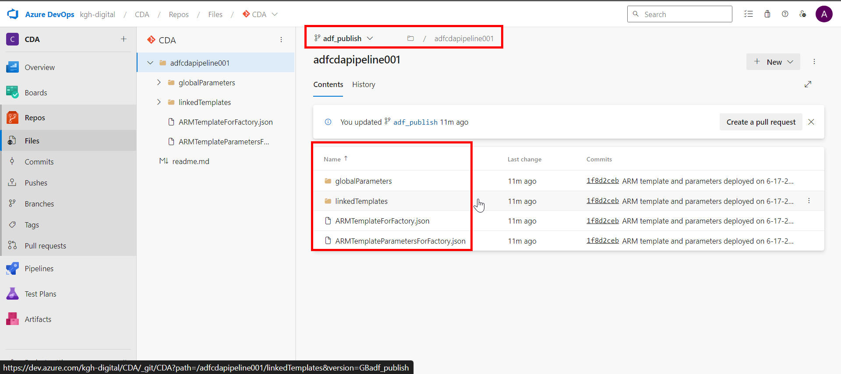

## **Databricks: Git Configuration**

1. Login to *Databricks*.

Click on *username* 🡪 *User Settings*



1. Click on *Git integration*



1. Fill the details as below:

Git provider: *Azure DevOps Services (Azure Active Directory)*

Click on *Save*.

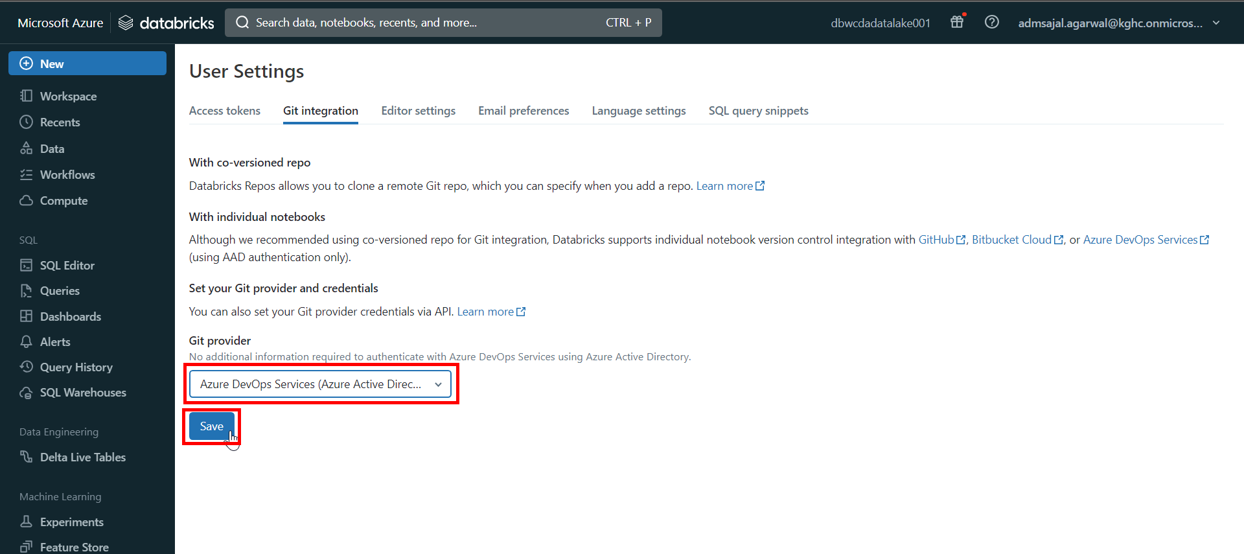

1. On successful save, it will show the notification as *Credentials update* 🡪 *Successfully saved.*

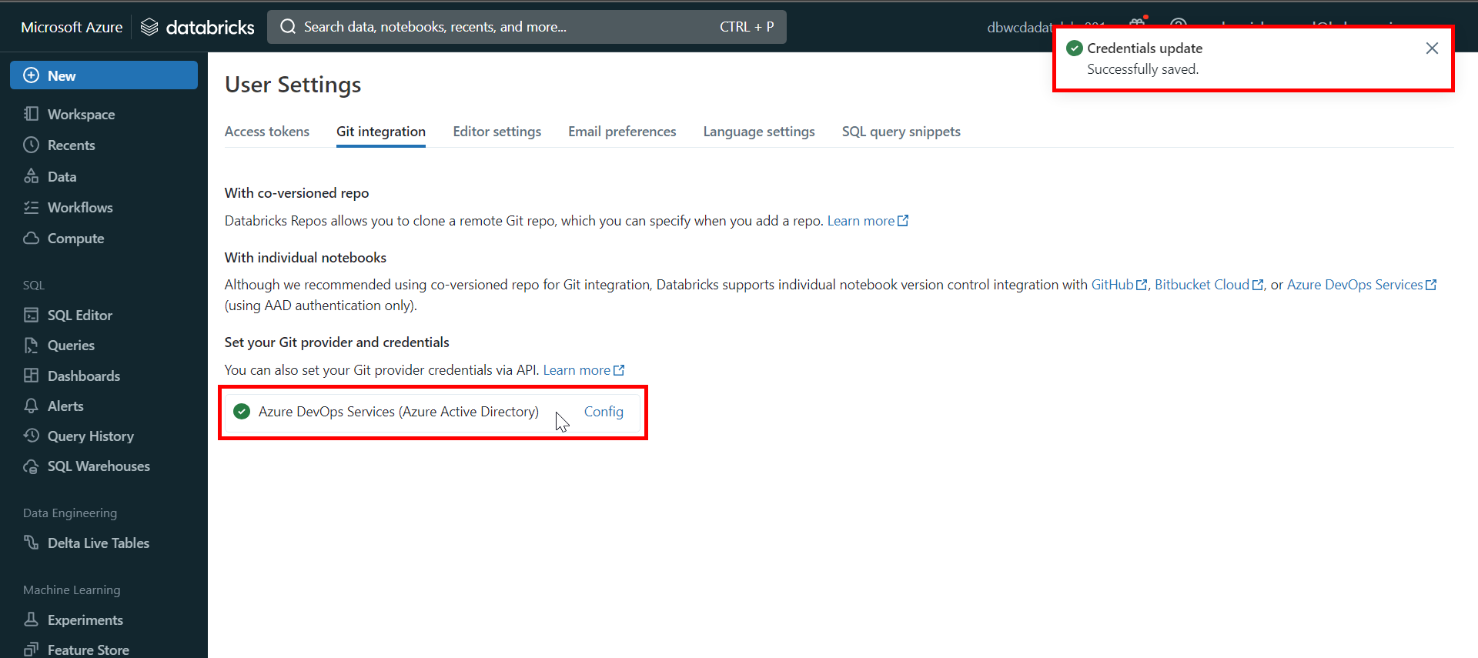

1. Click on *Workspace* 🡪 *Repos*.



1. Click on *Add* 🡪 *Folder*.



1. Set the folder name as *feature*.

Click on *Create*.



1. Click on *Add* 🡪 *Repo*.



1. Fill the fields as below:

Tick-mark on *Create repo by cloning a Git repository*

Git repository URL: *https://kgh-digital@dev.azure.com/kgh-digital/CDA/_git/CDA*

Git provider: *Azure DevOps Services*

Repository name: *CDA*

Tick-mark on *Sparse checkout mode*

Cone patterns: *solution/Databricks/Notebooks*

Click on *Create repo*.

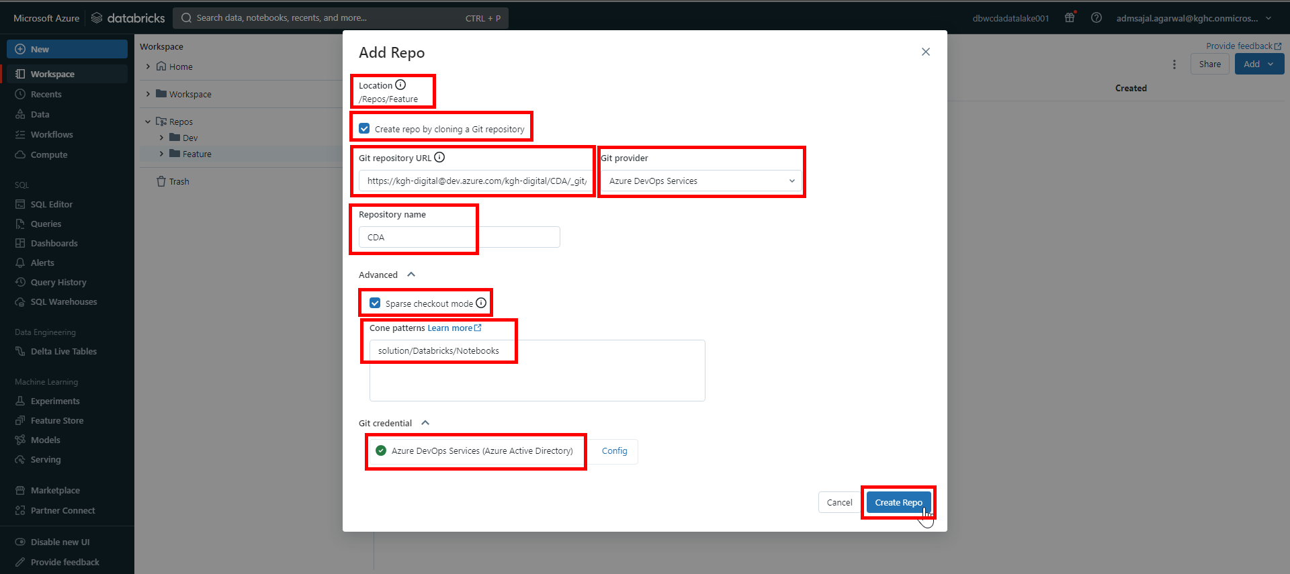

1. Verify that the *README.md* folder is now available inside *CDA* repository inside *main* branch.

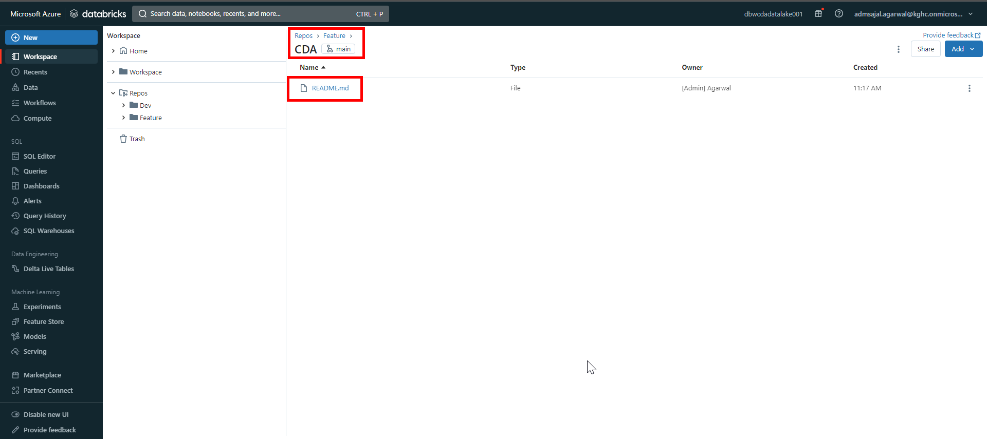

1. From the *Workspace* menu on left side of screen, expand *Repos* 🡪 *Feature* 🡪 *CDA*.

Right click on *CDA*.

Click on *Git*.

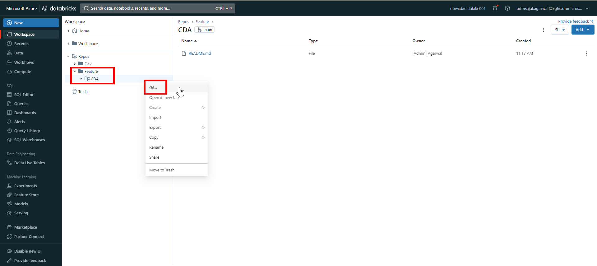

1. Open drop-down and select *develop* branch.

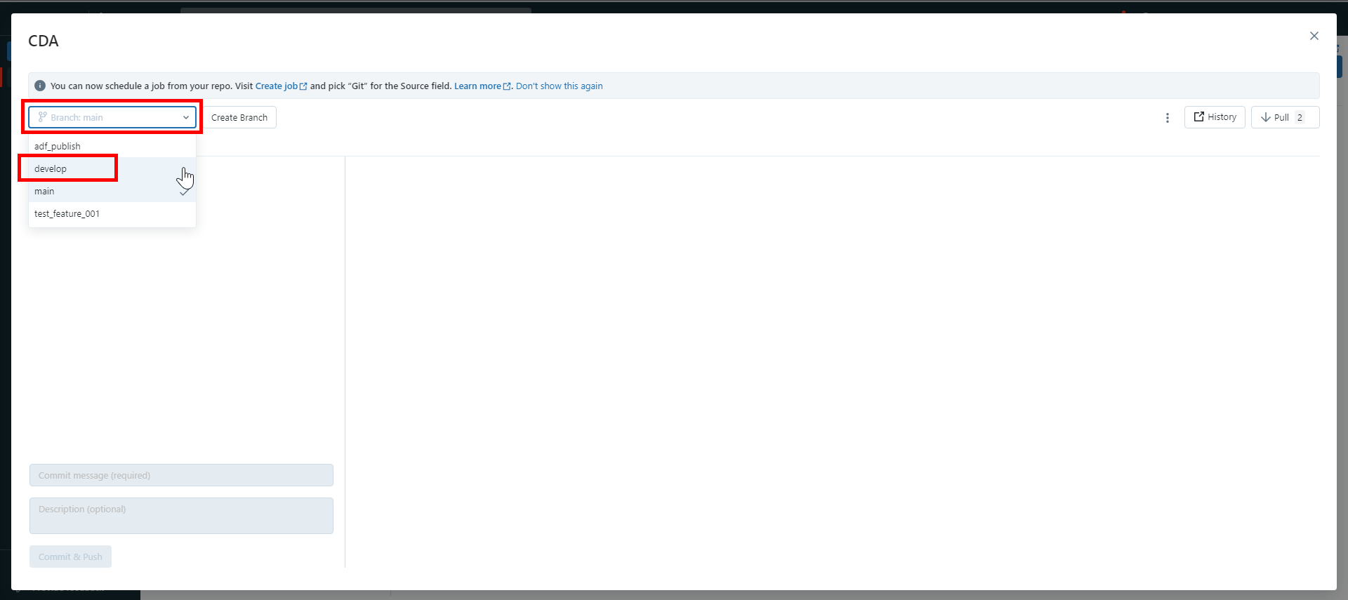

1. Click on *Create Branch*.

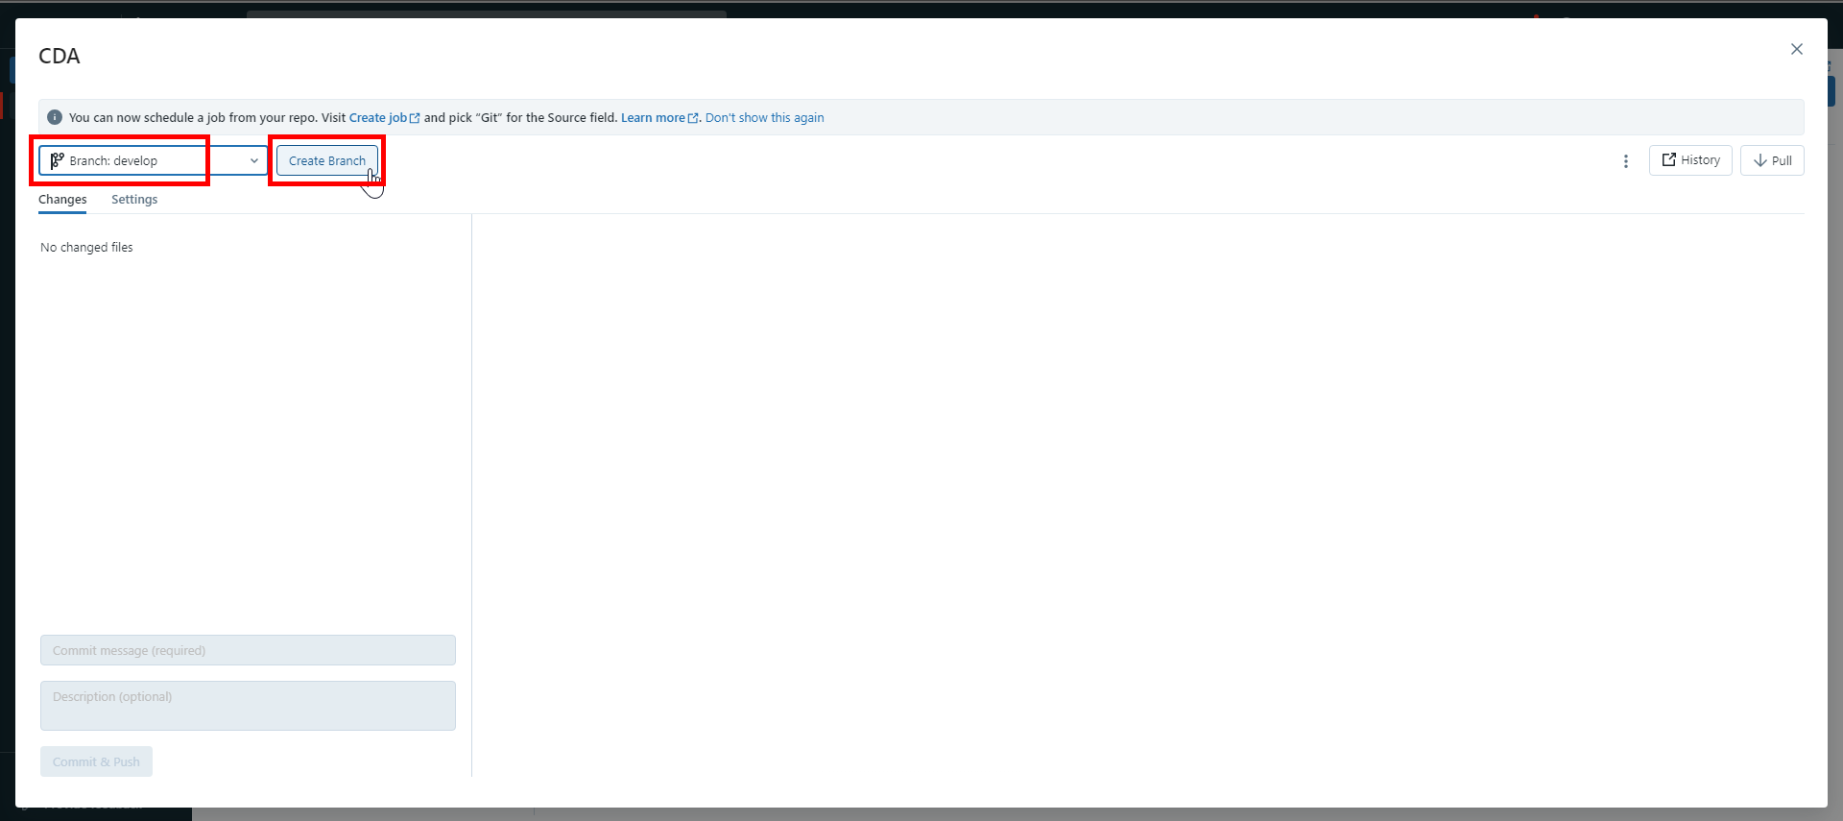

1. Give *Branch name* as *feature_test01*.

Make sure *develop* branch is selected as *Based on*.

Click on *Create*.

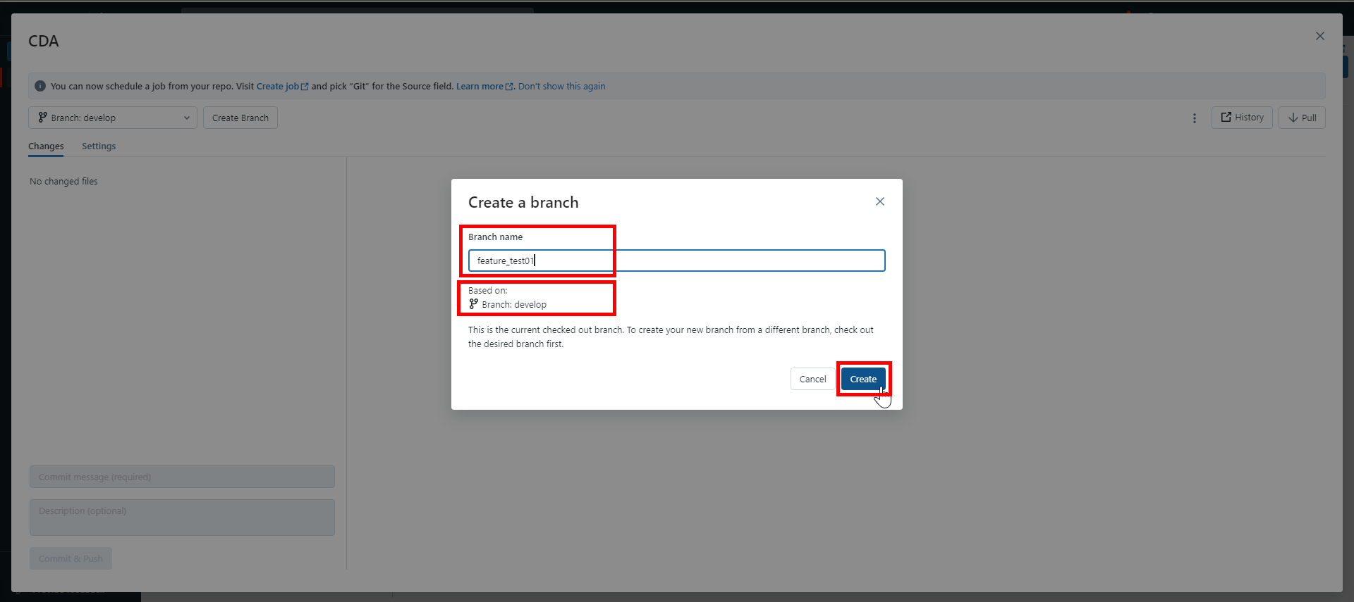

1. With newly created *feature_test01* branch selected, click on *X*.

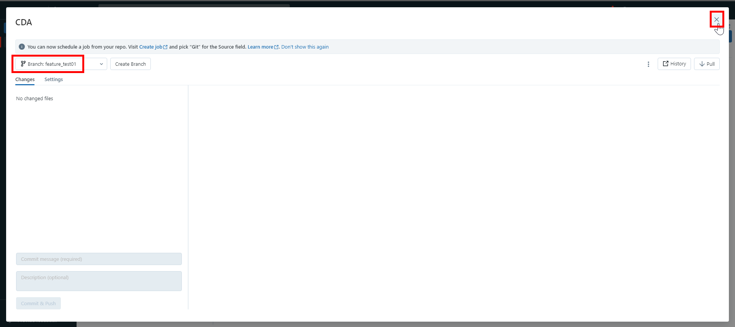

## **Databricks: Continuous Integration (CI)**



### **Code Development in Working Branch (Responsible: Developer)**

1. Click on *Workspace* 🡪 *Shared* 🡪 *OPDW*.

Right click on *OPDW* folder.

Click on *Clone*.



1. Set the target directory as *Repos/Feature/CDA/solution/Databricks/Notebooks*.

Give *New name* as *OPDW*.

Click on *Clone*.

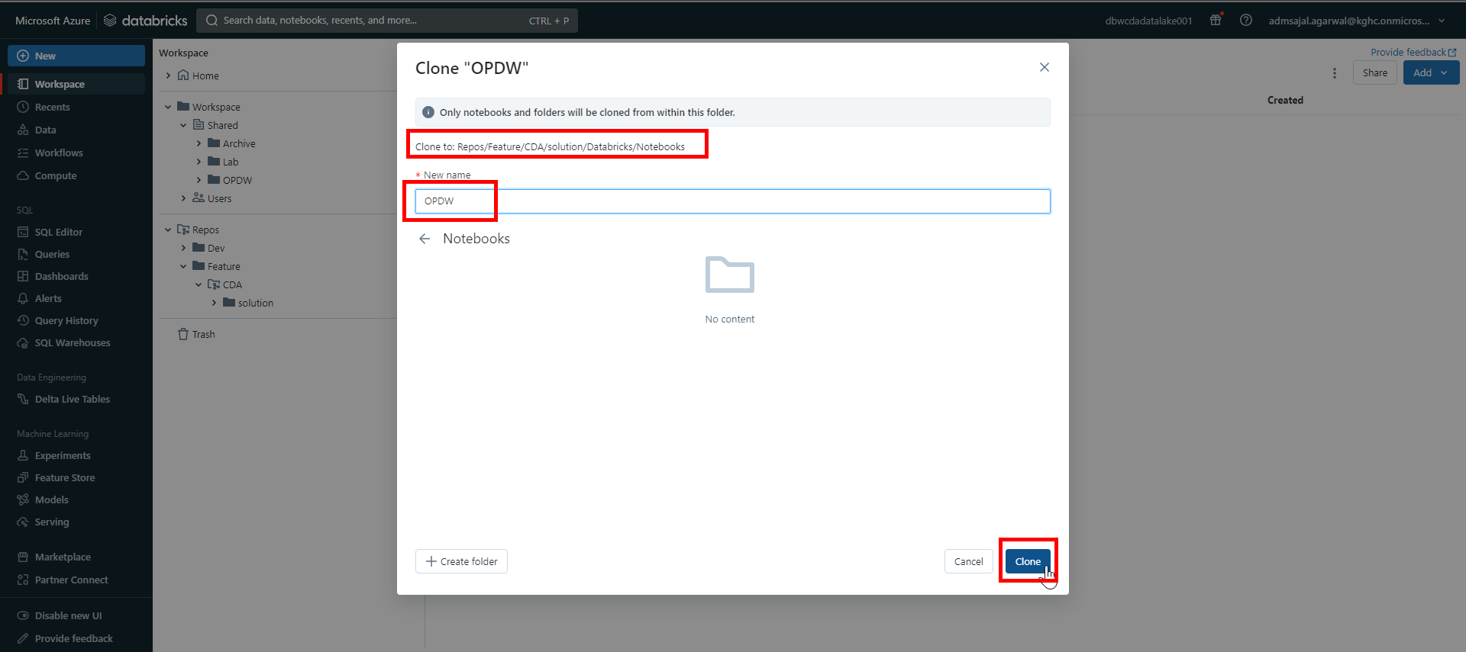

1. Make sure OPDW folder is copied successfully.

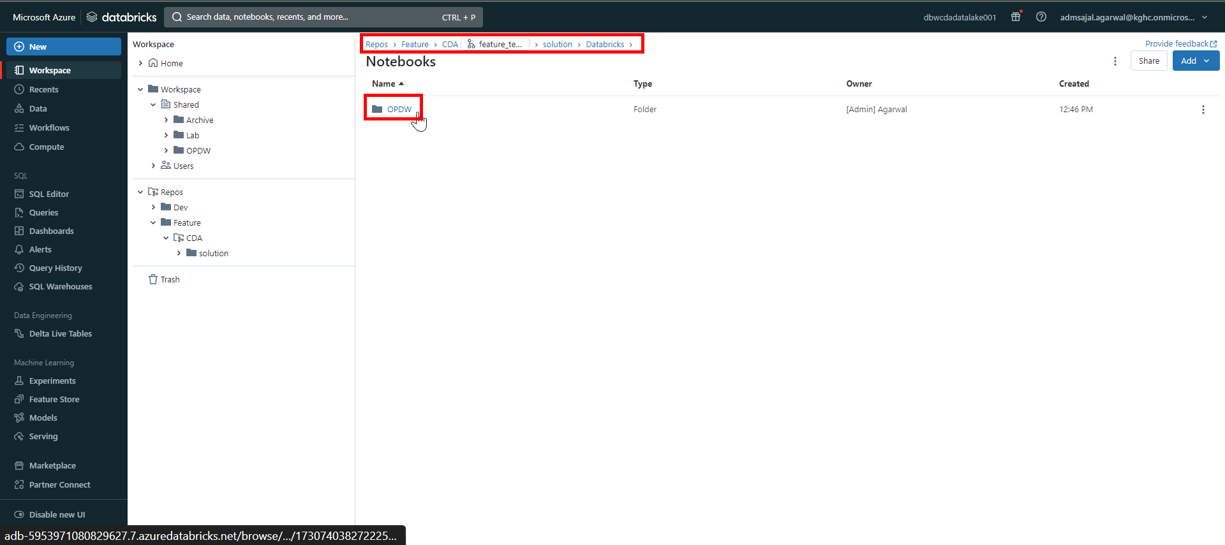

1. From the *Workspace* menu on left side of screen, expand *Repos* 🡪 *Feature* 🡪 *CDA*.

Right click on *CDA*.

Click on *Git*.

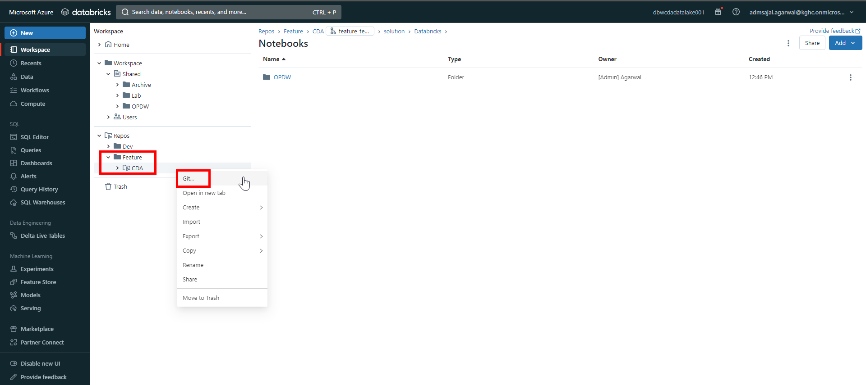

1. Enter a *comment* and *description* describing the changes made.

Click on *Pull* to latest changes from Git.

Click on *Commit & Push*.

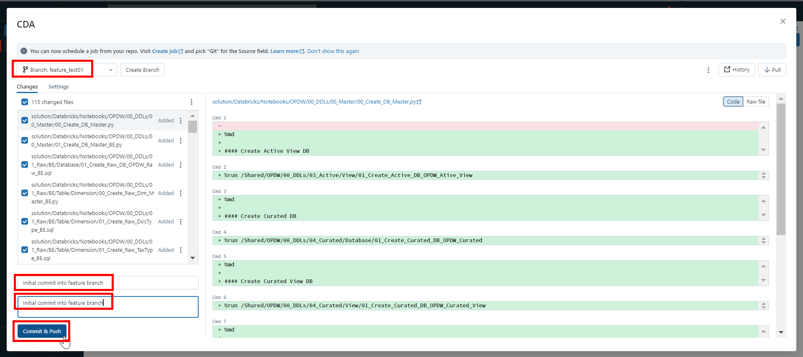

1. It will start pushing changes to Git repository.

Once completed, it will show message as *Successfully committed and pushed changes to branch “feature_test01”* and changes are pushed and committed to *feature_test01* branch in Git.

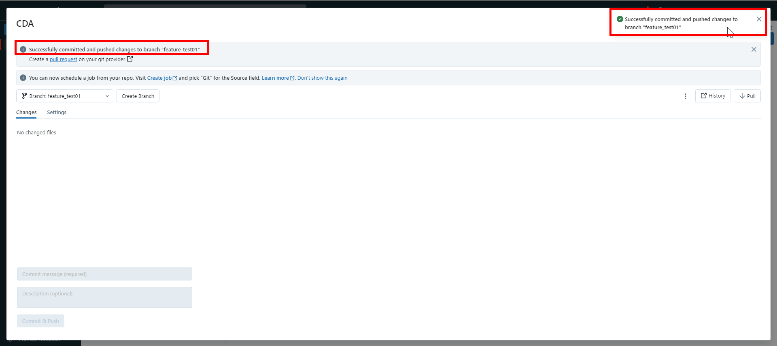

1. Click on *X*.

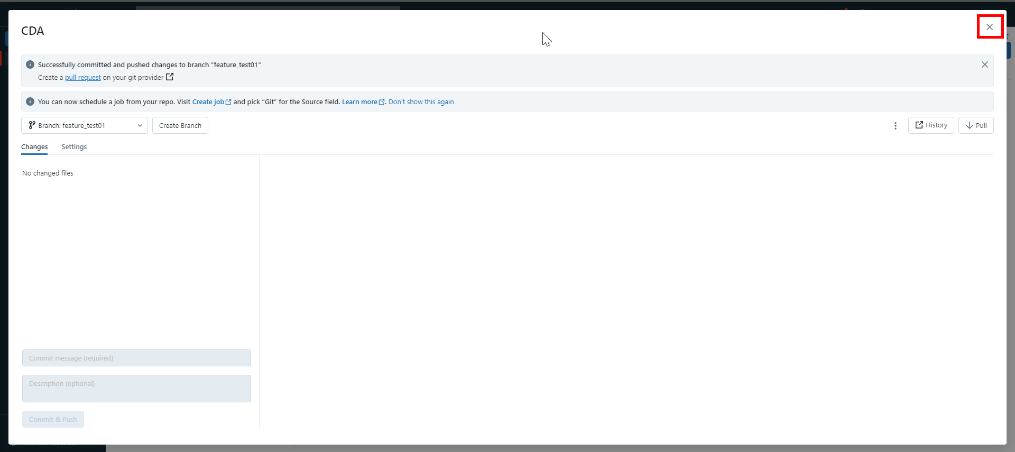

1. Login to Git Repository. Open below link:

[CDA - Repos (azure.com)](https://dev.azure.com/kgh-digital/CDA/_git/CDA)

Verify that all the notebooks are accessible in Git in *feature_test01* branch.

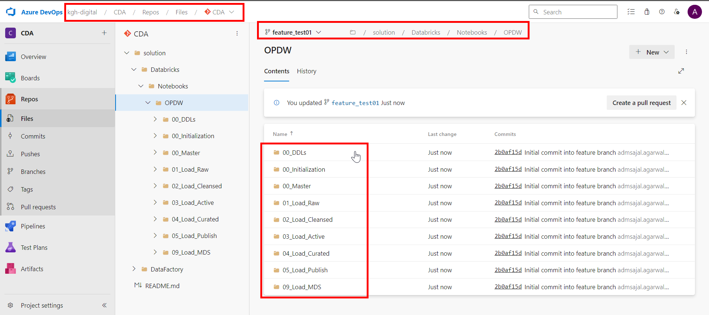

### **Code Pull Request from Working Branch (Responsible: Developer)**

Reference Link: [About pull requests - GitHub Docs](https://docs.github.com/en/pull-requests/collaborating-with-pull-requests/proposing-changes-to-your-work-with-pull-requests/about-pull-requests)

1. Login to Git Repository. Open below link:

[CDA - Repos (azure.com)](https://dev.azure.com/kgh-digital/CDA/_git/CDA)

Click on *Pull requests*.

1. Click on *New pull request*.
2. Make sure changes are merged from *feature_test01* to *develop*.

Add a *Title* and *Description* describing the changes.

Add *Reviewers* as needed.

1. Verify the changes from *Files* and *Commit* sections.
2. Scroll down and click on *Create*.

### **Code Review in Review Branch (Responsible: Reviewer)**

1. Login to Git Repository. Open below link:

[CDA - Repos (azure.com)](https://dev.azure.com/kgh-digital/CDA/_git/CDA)

Click on *Pull requests*.

1. Click on pull request.
2. Review the changes under *Files*, *Updates* and *Commit* sections.
3. Add review comments.
4. Click on *Approve/Approve with suggestions/Reject* as per the case.

### **Code Merge with Review Branch (Responsible: Approver)**

1. Login to Git Repository. Open below link:

[CDA - Repos (azure.com)](https://dev.azure.com/kgh-digital/CDA/_git/CDA)

Click on *Pull requests*.

1. Click on pull request.
2. Click on *Complete*.
3. Click on *Customize merge commit message*.

Enter a *Comment* and *Description* describing the merge request.

Click on *Complete merge*.

1. Pull request will now be shown as *Completed*.
2. In Databricks, click on *Workspace* 🡪 *Add* 🡪 *Folder.*
3. Set the folder name as *Development*.

Click on *Create*.

1. Click on *Add* 🡪 *Repo*.
2. Fill the fields as below:

Tick-mark on *Create repo by cloning a Git repository*

Git repository URL: *https://kgh-digital@dev.azure.com/kgh-digital/CDA/_git/CDA*

Git provider: *GitHb*

Repository name: *CDA*

Tick-mark on *Sparse checkout mode*

Cone patterns: *solution/Databricks/Notebooks*

Click on *Create repo*.

1. Click on *main* branch.
2. Open drop-down and select *develop* branch.
3. With *develop* branch selected, click on *X*.
4. Verify that the *develop* branch is added now.
5. Navigate to *Workspace* 🡪 *Repos* 🡪 *Development* 🡪 *CDA* 🡪 *develop* 🡪 *solution* 🡪 *Databricks* 🡪 *Notebooks*.

Verify that the *OPDW* folder is present.

### **Code Pull Request from Collaboration Branch (Responsible: Approver)**

1. Login to Git Repository. Open below link:

[CDA - Repos (azure.com)](https://dev.azure.com/kgh-digital/CDA/_git/CDA)

Click on *Pull requests*.

1. Click on *New pull request*.
2. Make sure changes are merged from *develop* to *main*.

Add a *Title* and *Description* describing the changes.

Add *Reviewers* as needed.

1. Verify the changes from *Files* and *Commit* sections.
2. Scroll down and click on *Create*.

### **Code Review in Collaboration Branch (Responsible: Approver)**

1. Login to Git Repository. Open below link:

[CDA - Repos (azure.com)](https://dev.azure.com/kgh-digital/CDA/_git/CDA)

Click on *Pull requests*.

1. Click on pull request.
2. Review the changes under *Files*, *Updates* and *Commit* sections.
3. Add review comments.
4. Click on *Approve/Approve with suggestions/Reject* as per the case.

### **Code Merge with Collaboration Branch (Responsible: Approver)**

1. Login to Git Repository. Open below link:

[CDA - Repos (azure.com)](https://dev.azure.com/kgh-digital/CDA/_git/CDA)

Click on *Pull requests*.

1. Click on pull request.
2. Click on *Complete*.
3. Click on *Customize merge commit message*.

Enter a *Comment* and *Description* describing the merge request.

Click on *Complete merge*.

1. Pull request will now be shown as *Completed*.
2. In Databricks, click on *Workspace* 🡪 *Add* 🡪 *Folder.*
3. Set the folder name as *Main*.

Click on *Create*.

1. Click on *Add* 🡪 *Repo*.
2. Fill the fields as below:

Tick-mark on *Create repo by cloning a Git repository*

Git repository URL: *https://kgh-digital@dev.azure.com/kgh-digital/CDA/_git/CDA*

Git provider: *GitHb*

Repository name: *CDA*

Tick-mark on *Sparse checkout mode*

Cone patterns: *solution/Databricks/Notebooks*

Click on *Create repo*.

1. Click on *main* branch.
2. Verify that the *main* branch is added now.
3. Navigate to *Workspace* 🡪 *Repos* 🡪 *Main* 🡪 *CDA* 🡪 *main* 🡪 *solution* 🡪 *Databricks* 🡪 *Notebooks*.

Verify that the *OPDW* folder is present.

## **Databricks: Continuous Deployment (CD)**

### **Security Configuration (Responsible: DevOps Admin)**

1. Login to Git Repository.
2. Click on Project settings.

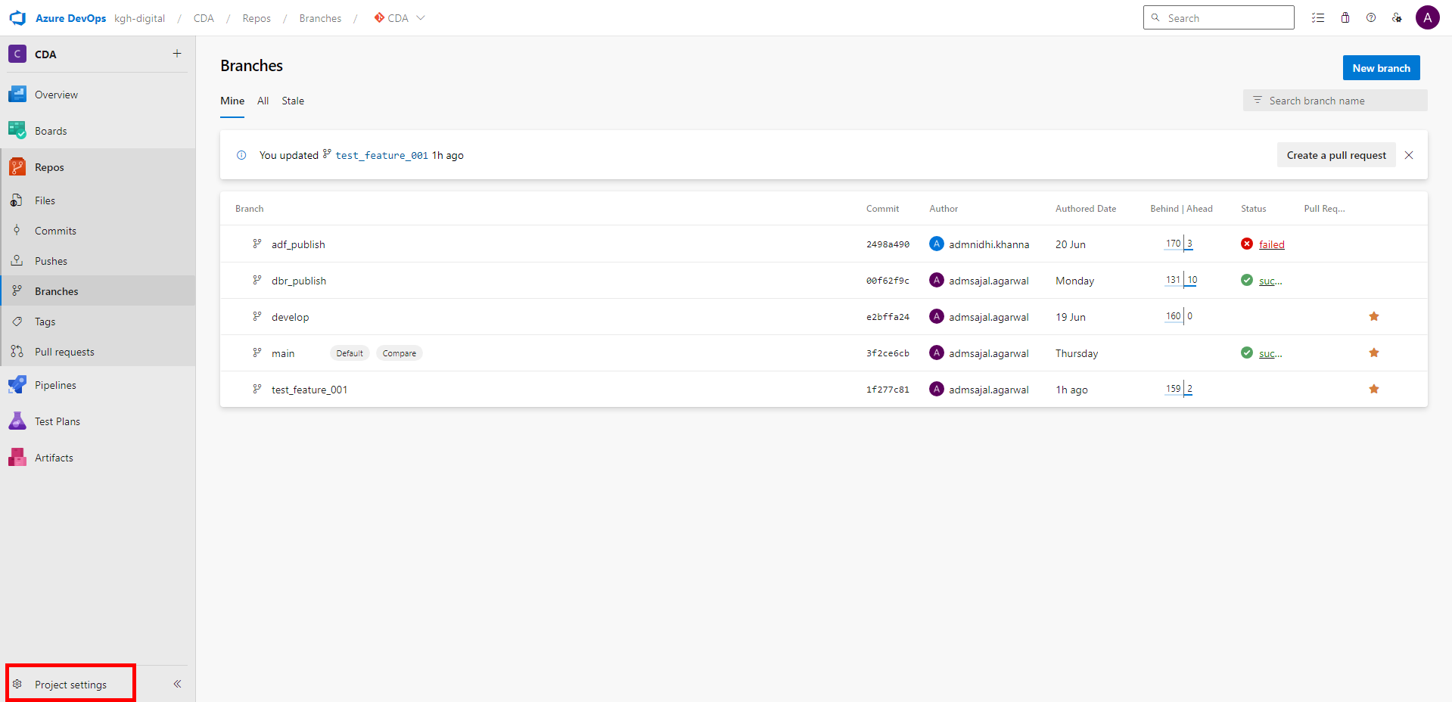

1. Click on Repositories

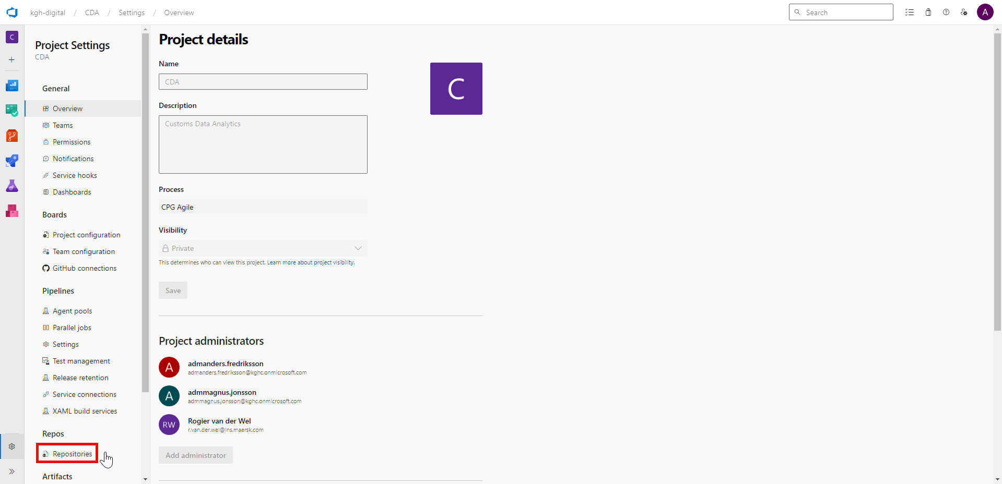

1. Click on CDA 🡪 Security.

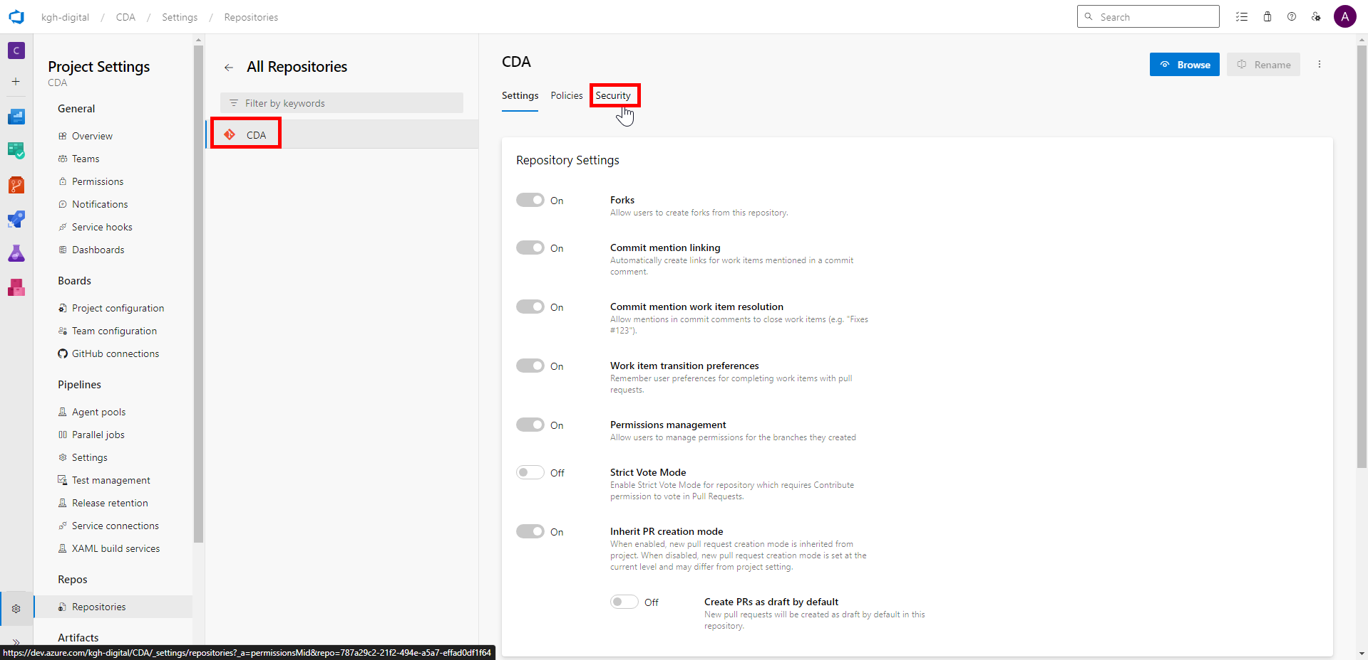

1. Make sure Contribute, Contribute to pull requests, Create branch and Create tag are set as Allow or Allow (inherited) for below Users:

Azure DevOps Groups: Project Collection Build Service Accounts

Users: CDA Build Service (kgh-digital)

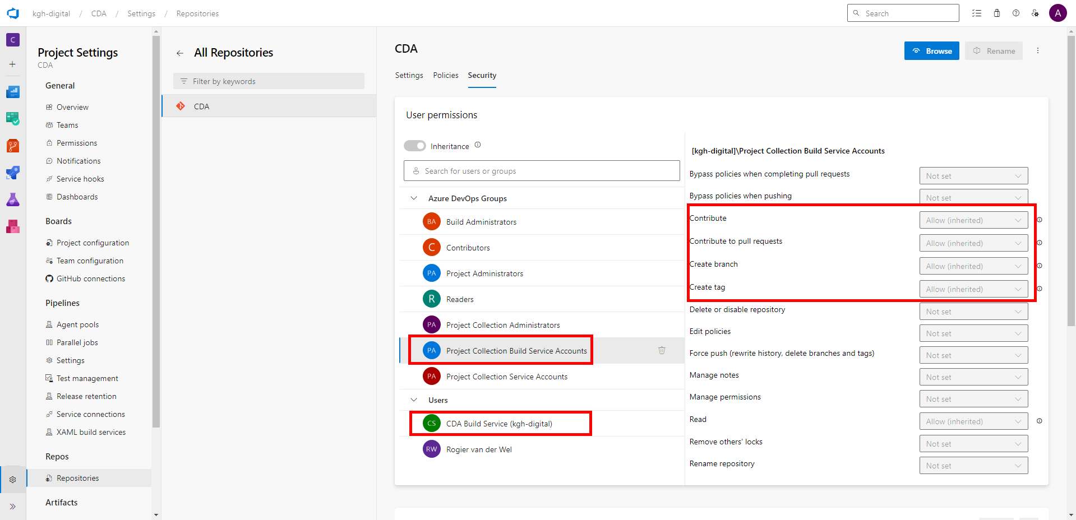

### **Pipeline Development (Responsible: DevOps Admin)**

1. Login to Git Repository. Open below link:

[Pipelines - Recent (azure.com)](https://dev.azure.com/kgh-digital/CDA/_build)

1. Click on Library.
2. Create a Variable Group with name Databricks.

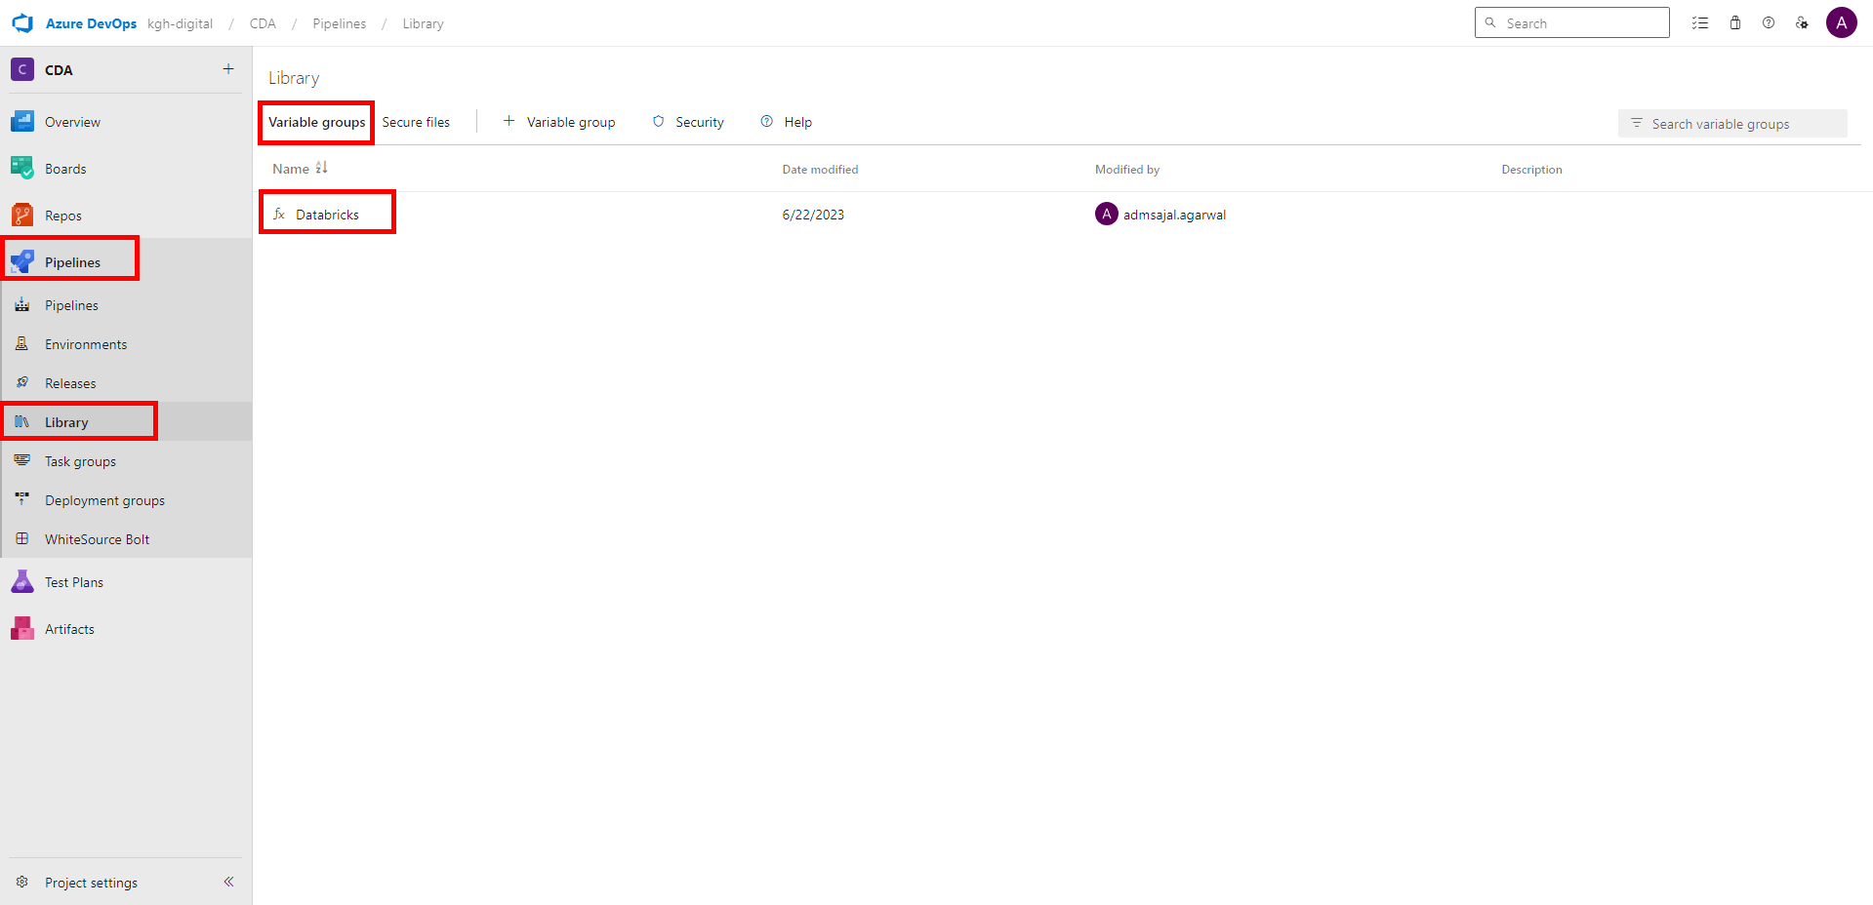

1. Create new variables inside the variable group:

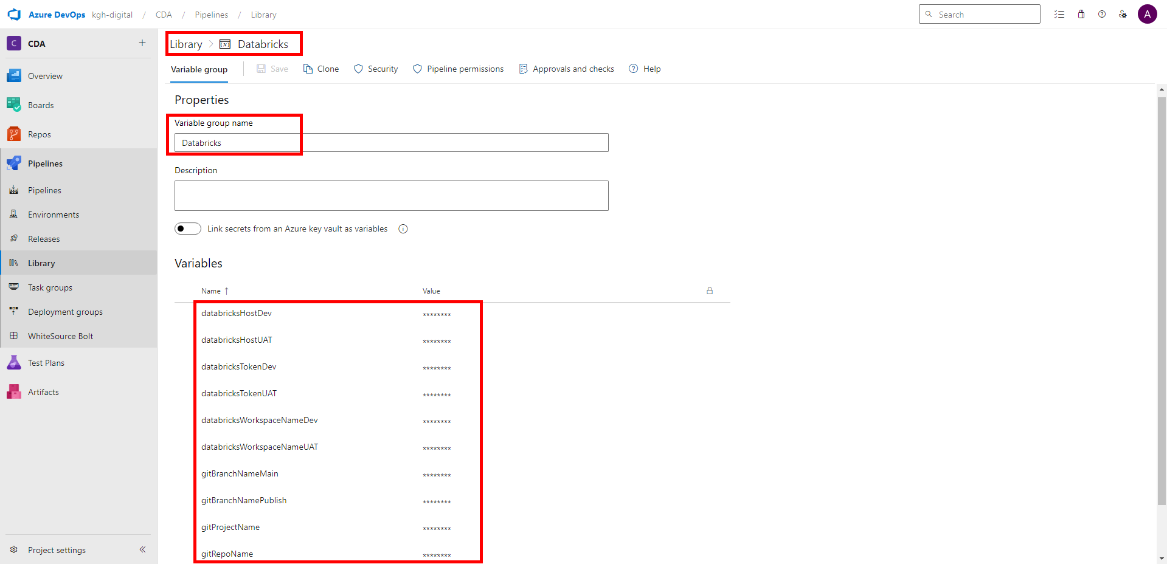

Click on Save.

1. Click on Pipelines.
2. Create a new Pipeline as below:

Name: Push from Main to Development (Live Mode)

Repository: CDA

Branch: main

YAML file path: release_pipelines/Databricks/Push from Main to Development (Live Mode).yml

Code:



1. Create a new Pipeline as below:

Name: Push from Main to DBR_Publish

Repository: CDA

Branch: main

YAML file path: release_pipelines/Databricks/ Push from Main to DBR_Publish.yml

Code:



1. Create a new Pipeline as below:

Name: Push from DBR_Publish to UAT (Live Mode)

Repository: CDA

Branch: dbr_publish

YAML file path: release_pipelines/Databricks/ Push from DBR_Publish to UAT (Live Mode).yml

Code:

